Financial Management
Comparison of Mandarin Oriental Hotel Group and Premier Inn Report
Syeda Samia Begum
2130491
Tristan Hawkins
BMIH5007
2,100

Table of Contents
Introduction 1
Total revenue 1
Market position 3
Evaluation of growth potential 5
Financial commitment to CSR 7
Recommendations 8
Conclusion 8
References 9

Introduction
The business report aims to make a comparison of the Mandarin Oriental Hotel Group and Premier Inn Hotel. It will also assess the hotel's total revenue, for instance, the revenue generated, sources of revenue, revenue trends and what factors drive the revenue growth or decline. It will also assess the market position of both the hotel and its growth potential. Both the organization's financial commitment to corporate social responsibility will be assessed briefly.
Overview of Premier Inn Hotel
A subsidiary private limited company is Premier Inn Hotel which was founded by Whitbread in 1987. The organization serves internationally and the headquarters is in Dunstable, England in the UK. Around 40000 employees are working in the organization which helped the organization perform greatly and the organization is also focused on making their service current (Premier Inn, 2023). It influences the customers' purchases and helps the organization generate great revenue.
Overview of Mandarin Oriental Hotel Group
A public limited company is Mandarin Oriental Hotel Group which was founded in 1963. The organization have their branch in around 34 branches in the domestic and international markets. It is a Hong Kong-based hotel (mandarinoriental.com, 2023). The organization is always focused on innovation which makes its service attractive to the customers and helps the organization perform greatly. In addition, around 12000 employees are working with the organization and are performing their roles and responsibilities effectively which is assisting the organization in generating great revenue.

Total revenue
Revenue generated
The procedure that includes the organization planning, promoting and selling the goods or services to achieve income and enhance profit is known as revenue generation (Shonk and Weiner, 2022). Last year Premier Inn Hotel generated revenue of around 2.62 billion pounds and Mandarin Oriental Hotel Group generated revenue of around 150.31 million pounds.
Income statement of Premier Inn Hotel
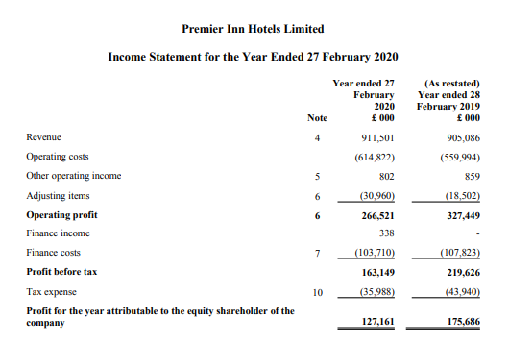
Figure 1: Premier Inn Hotel financial statement.
Source: (John, 2020).
Mandarin Oriental Hotel Group income statement
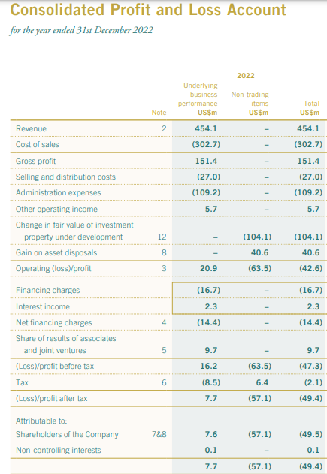
Figure 2: Mandarin Oriental Hotel Group financial statement.
Source: (Bishop, 2022)
Sources of revenue
Mandarin Oriental Hotel Group provides great dining facilities to the customers which involves the guests investing a high amount in the dining service that helps the organization receive the revenue (Cetin, Demirciftci and Bilgihan, 2021) e. Premier Inn Hotel sell their customers great facilities of rooms beverages and food which helps them receive prices in exchange for these facilities. Through these sources both the hotel receives their revenues.
Revenue trends
Premier Inn Hotel receive high revenue by selling the room facilities. As the beds are comfortable, ensure hygiene and also have a friendly environment for the guests (Freedman et al., 2022). This influences the customers to focus on purchasing their room service more than other services.
The demand for Mandarin Oriental Hotel Group's dining facility is high and the guests focus on their restaurant facility which helps the organization generate revenue but the revenue is not sufficient as a decline in sales in the other sectors is measured.
Factors that drive revenue growth or decline
During the COVID-19 situation the decrease in sales of the service of Premier Inn Hotel and Mandarin Oriental Hotel Group and the cost of the organization enhanced. As a result, the revenue declined due to high operational costs (Narver and Slater, 2021). However, after the pandemic, the demand of the organization increased but the operational costs remained the same as similar raw materials were used by Premier Inn Hotel. As high sales and low costs took place it ensured revenue growth of the organization. However, Mandarin Oriental Hotel Group faced a sales decline as the operational cost of the organization increased which impacted negatively and sales decline was measured.

Market position
Market Share
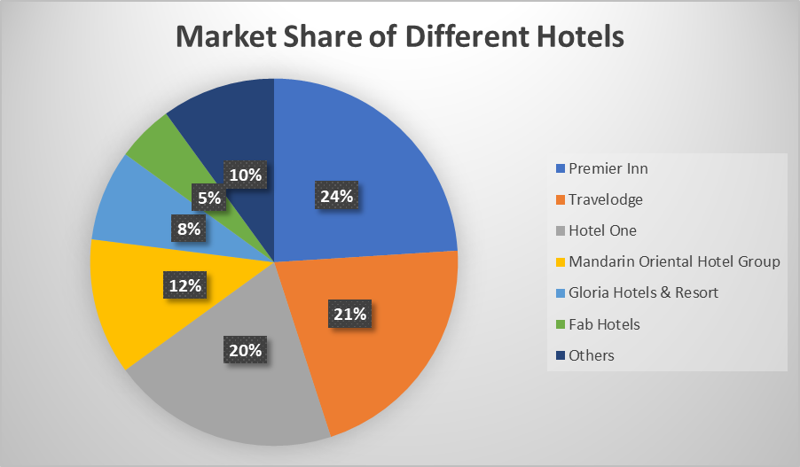
Figure 3: Competitors analysis.
Source: (Capron and Chatain, 2020).
In the UK, Premier Inn Hotel obtained the highest market share in the UK market as the organization serves guests with quality room service and also ensures the comfort of the guest by providing a friendly environment. In addition, the organization is serving the guests with a range of facilities which assist the organization in receiving high sales and remain in demand helping the organization gain 24% market share (Narver and Slater, 2021). Travelodge is the competitor of Premier Inn and the organization obtained a 21% market share. The hotel is focused on bringing up innovation which attracts the customers to make purchasing intention by grabbing their focus. As a result, it helped the organization receive high demand and grab the market. Hotel One, Gloria Hotels & Resort, and Fab Hotels obtained 20%, 8% and 5% market share in the UK market as they only focus on enhancing the room facilities rather than other services. As a result, they only attract customers with their accommodation services which helped them grab the market share. However, Mandarin Oriental Hotel Group is a Hong Kong-based organization they are focused on bringing innovation but lacks to adapt to the marketing trends (Capron and Chatain, 2020). The organization obtained a 12% market share in the UK and also puts its best effort into practice for attracting customers and influencing their purchasing intention. As a result, it helps the organization grab the customers' attention and market share.
Customers demographics
Premier Inn Hotel mainly focuses on the middle-high-standard family for their service (Capron and Chatain, 2020). It involves them focusing on increasing the facilities of the rooms that will help the guests have comfortable and friendly room service.
Mandarin Oriental Hotel Group focuses on people aged around 15-40. The organization is grabbing guest attraction by serving their unique dining service by serving unique food items entertainment shows are available which attracts the guests influences the purchasing intention of the guests and helps generate revenue (Martins and Swanson, 2021).
Brand perception
Premier Inn Hotel provides quality service to its guests at a reasonable cost as the organization implements the cost-focus strategy. The rooms' services are commendable which ensures high quality. But the other services, for instance, food and beverage, gym, play zone and so on are good for the organization and need improvement.
Mandarin Oriental Hotel Group provides high-quality dining service to guests at average costs by implementing a competitive pricing strategy (Martins and Swanson, 2021). However, the other services, for instance, room, conference resources, lobby, play zone and so on need to be improved which will help in ensuring the overall performance of the organization.

Evaluation of growth potential
Market expansion strategies
The focus of Mandarin Oriental Hotel Group and Premier Inn is on offering quality service to the customers but the differences in customer demographics, local culture and so on impact the market position of these hotels in their home country and global platform (Robinson and Lundstrom, 2021). However, both hotels rely on market development strategies. As per McCann and McCarren (2019), the market development strategy is focused on offering the same products and services to the customers of the new market. Based on this strategy, the hotels have expanded their business in other regions. The Mandarin Oriental Hotel prefers opening new branches in prime locations and city centres near tourist attractions by targeting the high-class Gen X. On the other hand, the Premier Inn chooses locations near airports, and city centres but targets the middle-class people who require budget-friendly offers. Again, both the hotels also implement the diversification strategy as part of their successful expansion. The Mandarin Oriental Hotel diversifies its services by offering a spa and leveraging social media. On the other hand, the Premier Inn diversifies its services by offering ancillary services. Again, the Mandarin Oriental Hotel engages in partnerships and franchises to expand its market.
Market opportunities
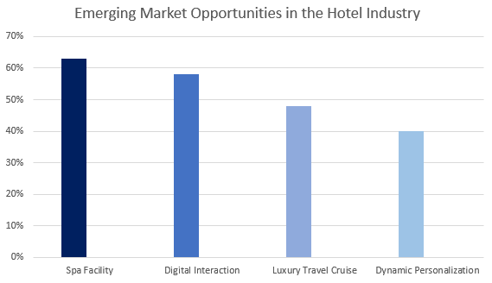
Figure 4: Emerging market opportunities in the hotel industry.
Source: (Kayaman and Arasli, 2021).
The hotel industry is continuously evolving and companies are looking for market opportunities to differentiate their services. Considering the consumers’ trend, the demand for spa facilities is 63%, 58% for digital interaction, 48% for luxury travel cruises, and 40% for dynamic personalisation (Mars and Mitchell, 2021). Considering these demands, the Mandarin Oriental Hotel has the opportunity to arrange luxury travel cruises for the niche market as the customers prefer premium pricing. Besides, the hotel also has the opportunity to adopt dynamic personalisation to meet the customers’ demands. On the other hand, the Premier Inn has the opportunity to grab all the market opportunities due to the lack of such services (Melissen et al., 2021). The adoption of these market opportunities may help the company differentiate its services from other traditional budget-friendly hotels.
Potential barriers
The COVID-19 pandemic, war, and so on have led the hotel industry to economic uncertainty, shortage of skilled labour, and so on. In the case of Premier Inn, the hotel may face a labour shortage to offer quality spas to the target customers at affordable prices (Kayaman and Arasli, 2021). Besides, the hotel may also face a lack of technical skills in maintaining digital interaction with the customers which may result in customer dissatisfaction. On the other hand, the Mandarin Oriental Hotel may face a financial crisis due to the negative impact of economic uncertainty on the disposable income of the target customers. Besides, the hotel may also have to face high operating costs for leveraging big data to adopt dynamic personalisation for the customers.

Financial commitment to CSR
The following is the application of Carrol’s CSR pyramid model for analysing the financial commitment of Mandarin Oriental Hotel and Premier Inn to Corporate Social Responsibility (CSR) initiatives is as follows:
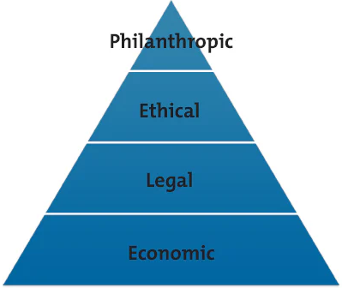
Figure 5: Carrol’s CSR pyramid model.
Source: (Sigmund, 2021)
Economic responsibility is focused on attaining profitability and using it for social betterment (Kim et al., 2019). Under this responsibility, both hotels have used several sources of revenue to generate income and ensure profitability. Besides, the Premier Inn hotel allots 12% of its earnings for all-purpose social betterment (Gardetti and Torres, 2021). On the other hand, the Mandarin Oriental Hotel allots 16% of its total earnings to a similar purpose (Melissen et al., 2021).
Ethical responsibility is focused on operating the business ethically to put the least negative impact on the environment (Wang, 2019). The Premier Inn hotel allocates 5% of its total earnings for environmental benefits. Besides, the hotel has taken several sustainability initiatives such as solar panels, recycling waste, planting trees and so on. On the other hand, the Mandarin Oriental Hotel allocates 9% of its earnings for environmental protection. The hotel has also adopted some green practices such as reducing energy consumption, electronics stewardship, water diversion, and so on.
Legal responsibility means complying with the legislation effectively (Sigmund, 2021). The Mandarin Oriental Hotel complies with health and well-being legislation and allocates 3% of its total earnings to arrange occupational safety training for the employees (Chung and Kinsey, 2020). On the other hand, the Premier Inn also complies with such legislation and allots 3% of its earnings for employee training and medical costs (Robinson and Lundstrom, 2021).
Philanthropic responsibility means engaging in community engagement and betterment initiatives such as charity, upskilling, and many more (Chung and Kinsey, 2020). The Mandarin Oriental Hotel has donated above £65,000 as communal charity. Besides, this hotel has also given above £1.5 million to support the diversity and inclusion campaigns (Melissen et al., 2021). On the other hand, the Premier Inn hotel allots 4% of its earnings for such initiatives. The hotels had donated £11 million to a hospital for ensuring better treatment of children (Wang, 2019).

Recommendations
Considering the overall analysis, the recommendations for each hotel are as follows –
- The Premier Inn Hotel should form a balanced financial portfolio to offer a quality spa to its customers (Chung and Kinsey, 2020). Besides, this portfolio will also support the hotel in engaging in digital interaction with the customers.
- The Mandarin Oriental Hotel should focus on outsourcing to reduce the cost of big data and grab the market opportunity of providing dynamic personalization to the niche market.

Conclusion
The purpose of this report was to make a comparison of the Mandarin Oriental Hotel Group and Premier Inn Hotel. Room occupancy, beverages food, and so on are the key sources of revenue for these hotels. In the UK market, the Premier Inn has the highest market share (24%) and the Mandarin Oriental Hotel has a 12% market share. Market development strategy, locational strategy, and so on are the key market expansion strategies of both hotels. Spa facility and digital interaction are the market opportunities for Premier Inn whereas luxury travel cruise and dynamic personalisation are opportunities for Mandarin Oriental Hotel. Economic uncertainty, lack of technical skills, and so on are the potential barriers. However, both hotels showcase their high commitment to CSR activities.

References
Bishop, M. (2022) Annual report 2022 - photos.mandarinoriental.com, Mandarin Oriental Hotel Group. Available at: https://photos.mandarinoriental.com/is/content/MandarinOriental/_Corporate/PDFs/Investors/Analyst%20Presentations/corporate-22arMOIL.pdf (Accessed: 17 October 2022).
Capron, L. and Chatain, O. (2020). Competitors’ Resource-Oriented Strategies: Competitors’ Analysis. SSRN Electronic Journal.
Cetin, G., Demirciftci, T. and Bilgihan, A. (2021). Revenue management: Knowledge, skills and abilities. International Journal of Hospitality Management, 57, pp.132–142.
Chung, A. and Kinsey, D.F. (2020). An examination of different perspectives on philanthropic corporate social responsibility. Journal of Global Responsibility, 10(4), pp.382–394.
Freedman, D.A., Faye, A., Alia, K., Guest, M.A. and Hebert, J.R. (2022). Market Revenue Trends. Preventing Business Challenges, 11.
Gardetti, M.A. and Torres, A.L. (2021). Sustainability in Hospitality. Routledge.
John, P. (2020). Premier Inn Hotels Limited Contents. [online] Available at: https://cdn.whitbread.co.uk/media/2021/02/12122648/pihl-accounts-final-signed.pdf.
Kayaman, R. and Arasli, H. (2021). Customer-based brand equity: evidence from the hotel industry. Managing Service Quality: An International Journal, 17(1), pp.92–109.
Kim, H. (Lina), Woo, E., Uysal, M. and Kwon, N. (2019). The effects of corporate social responsibility (CSR) on employee well-being in the hospitality industry. International Journal of Contemporary Hospitality Management, 30(3), pp.1584–1600.
Mandarinoriental.com (2023). Luxury 5-Star Hotel | Lake Como | Mandarin Oriental, Lago di Como. [online] Corporate Site. Available at: https://www.mandarinoriental.com/en/lake-como/blevio?src=ps.brand.mocmo.ggl&content_id=cg20514073627_ag151684818143_kwkwd-358603946383_cr673632237548_ex_spa%20hotel%20mandarin_&gclid=Cj0KCQjw4bipBhCyARIsAFsieCz4ayq_x0Bg4LRC7FknN5Gw21ApF0xsqe0Uweq8lbJYOKaqQcR_OOEaAi9vEALw_wcB&gclsrc=aw.ds [Accessed 17 Oct. 2023].
Mars, G. and Mitchell, P. (2021). The hotel industry. Verlag: Milton Keynes: Open University Press.
Martins, J.M. and Swanson, D.A. (2021). Consumer demographics and behaviour: markets are people. Dordrecht; New York: Springer.
McCann, J. and McCarren, D. (2019). Emerging market strategy development and implementation. J. for International Business and Entrepreneurship Development, 6(3/4), p.244.
Melissen, F., Cavagnaro, E., Damen, M. and Düweke, A. (2021). Is the hotel industry prepared to face the challenge of sustainable development? Journal of Vacation Marketing, 22(3), pp.227–238.
Narver, J.C. and Slater, S.F. (2021). The Effect of a Market Demand on Business Profitability. Journal of Marketing, 54(4), pp.20–35.
Premier Inn (2023). Premier Inn Home. [online] Premier Inn. Available at: https://www.premierinn.com/gb/en/home.html.
Robinson, G.J. and Lundstrom, W.J. (2021). Market expansion strategy: development of a conceptual market expansion decision scorecard. Strategic Change, 12(5), pp.259–272.
Shonk, D.J. and Weiner, J.F. (2022). Sales and revenue generation in the business. Champaign, Il: Human Kinetics.
Sigmund, W.-T. (2021). In search of ethics: from Carroll to integrative CSR economics. Social Responsibility Journal, 15(4), pp.469–491.
Wang, C.-J. (2019). Do ethical and sustainable practices matter? International Journal of Contemporary Hospitality Management, 26(6), pp.930–947.

