Socket Programming- Report

Introduction
A socket is a communication point that can be identified in a network. Expanded by Kalita (1), sockets are mostly used in client-server-based architecture to enable communication between multiple applications and are the foundation of socket programming.
Briefly, socket programming entails creating a socket object, binding it to a specific network address and port, and establishing a connection between computers. Within a client-server model, the server listens for incoming connections, while the client initiates the connection. Data is sent and received through the sockets in the form of byte streams or packets, then after the data exchange is complete the connection is closed. Socket programming has provided a standardised and flexible approach to network communication, enabling the development of various networked applications.
In order to create such application, a range of topics should be considered with relevance to how they impact design and development decisions of networked applications.

Transmission Control Protocol
TCP or Transmission Control Protocol is a transport layer protocol providing reliable communication between networked devices, Clark (2). TCP is implemented to ensure data transmitted from sender to receiver and is formatted in an ordered, reliable manor whereby no data is lost or corrupt during transit. Before data transit, the connection is established between the source and its destination, ensuring a live connection until communication begins. When initiating a connection, a three-way handshake occurs for reliability.
Hau-Hsu (3) suggests the three-way handshake or TCP handshake requires both server and client to exchange synchronization and acknowledgement packets before data communication. In other terms, it entails three steps: Firstly, establishing a connection between both parties. The target server must have an open port whereby requests can be accepted. The request from the client node sends a SYN (synchronize sequence number) data packet over the IP network to a server on the same or external network. The SYN packet is a random sequence number that requests the recipient acknowledges the request and infer if it is open for new connections. Then, after receiving the SYN packet, it responds by sending a confirmation, in this instance a SYN/ACK packet. These include two sequence numbers, first is an ACK or Acknowledgement Sequence Number and is sent by the server as one more than the sequence originally sent, for example X+1. Doing so indicates that the client packet has been accurately recognised and sending its own to display acknowledgement. Finally, the client node receives the previous SYN/ACK and reciprocates with own ACK. Like previous, each side must acknowledge the sequence number by incrementing by one. Within this stage, the client sends ACK to the client for example Y+1 and resends to server. After this process is complete, the connection is created, and the host and server can communicate. Using this process allows necessary verification of serial numbers that are authentic of each side to guarantee the stability of a connection. From a security perspective, addressing parameters of both sides of the connection allows detection of missing or troublesome segments before data transfer.
As each segment of data is provided a sequence number by sender, it can be utilised to ensure data packets are retrieved in the correct order and that no data has been lost or distorted in transit. Additionally, from this process it provides a time limit for a segment to be acknowledged, otherwise it will be retransmit.
Explained by Ammar (4), in addition to sequence numbers and a SYN-ACK system TCP assures data delivery by implementing flow control and congestion control mechanisms to ensure data is transmitted efficiently and without overwhelming the network. It works by regulating the rate data transmitted and is based on network conditions and receiver capabilities. Application design can be improved by taking advantage of full-duplex communication. Meaning simultaneous bidirectional transmission to send/receive concurrently.
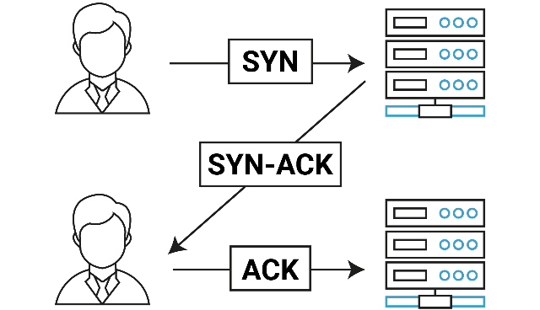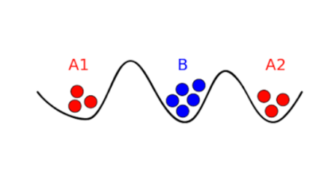
Moreover, despite efforts there are issues and possibly negative consequences to transmitting data packets. The ‘two generals’ problem’, implied by Jakub (5), is a theoretical issue in computer science that considers reliable communication between two parties in the presence of uncertainty and potential failure. The problem is often used to analogise challenges faced by TCP, ensuring reliable data transmission.
The issue was originally conceived from an antidote about two generals that tried to coordinate attacks via messaging but were unsure about possible intercepts and overall failure of the message being received. The parallel to this is there is chance packet are lost or corrupt, leading to uncertainty. However, TCP implements sequence numbers, acknowledgements, and retransmissions to address this issue and guarantee dependable communications.
Summarising, TCP is a reliable, connection-oriented protocol that provides a stream-based channel for data exchange. It ensures reliable data delivery through mechanisms- acknowledgments and retransmissions- and supports full-duplex communication. However, application designers should consider connection setup, teardown, flow control, congestion control, and the design of application-layer protocols to optimize performance and ensure compatibility with different network environments.

Transferring Data
Suggested by Moldeklev (6), the maximum transmission unit or MTU is the largest size of a packet that can be transmitted over a network. MTU is a measurement in bytes that an internet-connected device will handle. The size of this can have a significant impact on the transfer of data as it results in size of packets outputted and how they are handled by the network.
Moldeklev (6) continues, the MTU size typically is determined by an underlying network technology, like an ethernet or Wi-Fi. For example, an ethernet usually has a default size of 1500 bytes where Wi-Fi has 2312. However, this can be configured to allow larger/smaller packets. With larger MTU sizes it allows an operating system to send fewer packets of larger size to reach the same network throughput, reducing the processing required.
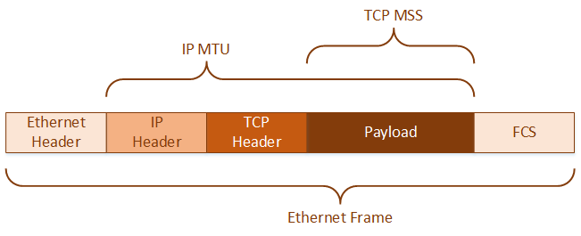
In accordance with Taquiqui (7), PDUs or protocol data units are a basic unit of exchange between entities that communicate using a specified network protocol and provide a standard format for communicating data across different types of networks. The size of which also effects the transfer of data. A PDU is the data unit that is transmitted between layers of an OSI model, usually differing in size depending on the layer. Networking protocols like OSI and TCP/IP frameworks define units of data exchange between networked entities. For example, at the transport layer the PDU is a segment in the case of TCP whereas at the network layer the PDU is a packer in the case of IP. As displayed below, the PDU name against the OSI layers and few common protocols.
PDU Name | OSI Layer | TCP/IP Layer | Protocol | Additional Notes
Message | Application | Application | Many protocols, HTTP, HTTPS, SMTP, SSH | Application PDUs are standardised as messages
Segment | Transport | Transport | TCP
Datagram | Transport | Transport | UDP
Packet | Transport | Transport | SCTP | SCTP packets are composed of additional units- called ‘chunk’
Packet | Network | Internet | IP | IP packets also known as datagrams
Frame | Data link | Network interface | Ethernet
Cell | Data link | Network interface | ATM
Bit | Physical | Physical hardware | Physical network media

Moreover, displayed by Murat (8), PDUs work by sending encapsulated data across a network in one or more PDUs dependant on the protocol implemented. They are then transmitted to the destination device where they can be de-encapsulated, and the original data received. The specific structure changes with protocol used. As an example, in TCP, PDU is called a segment, consisting of header and payload and control information like source and destination ports, sequence and acknowledgement sequences, among other data.
When a PDU size exceeds the MTU of a network, fragmentation can occur. Explained by Frankenfield (9), IP fragmentation is an internet protocol process that breaks packets into smaller pieces or fragments so the smaller packets can be transmitted through a link with a smaller MTU. The recipient host then reassembled the fragments to showcase the original data. Fragmentation is necessary for data transmission to manoeuvre around limits. However, it can have a negative impact on the network performance as it increases number of packets and can consequent in delays and more network overhead. Additionally, this process can also result in data taking different transmission paths, arriving out of order.
Alternatively, to avoid fragmenting packets, protocols like TCP use the technique path MTU discovery or PMTUD to determine a maximum MTU size of the network path between sender and recipient. In accordance with Owens (10), PMTUD works by setting a ‘do not fragment’ tag within the IP header of packets and gradually reduces the packet size until the packet can transmit without separating. Doing so provides the largest possible packet size and improves network performance.
In summary, MTU has a considerable influence on how data is transferred over the network, including size of packets, fragmentation, network performance, among others. Therefore, it should be considered important to select an appropriate MTU size and use protocols and techniques to avoid unnecessary fragmentation. Developers should be aware of MTU limitations are design accordingly to ensure a reliable communication.

Synchronicity and Asynchronicity
Briefly, synchronous means multiple things happen at the same time, whereas asynchronous means it does not. Both are important concepts in network protocols, predominantly in the context of application programming or APIs and I/O dispatch models.
Bevans (11) states, synchronicity and asynchronicity can be used to determine how data transfer occurs between different applications, and for selecting an appropriate network protocol and approach dictating timing and coordination of communication, affecting the efficiency, responsiveness, and scalability of networked systems.
Explained by IBM (12), synchronous protocols are those whereby the client waits for a response from the server before continuing processing requests and the client and server must have a synchronized communication. Continuing, network protocols operate using blocking I/O, meaning that a process halts until a specific event or condition is fulfilled. This synchronous approach is well-suited for applications where precise timing and coordination are crucial, such as real-time systems, gaming, and interactive multimedia applications. These applications require strict adherence to deadlines and time constraints. In these systems, synchronicity ensures that data is processed and delivered within predetermined time frames. Synchronicity guarantees that the data is processed in a predictable and timely manner, minimizing the risk of delays that could have problematic consequences. Additionally, multimedia applications, such as video conferencing or live streaming, require synchronized transmission and playback to maintain smooth and uninterrupted communication.
On the other hand, asynchronous protocols allow the client to send requests to a server without wating for a response, IBM (13). In this, the server process requests in the background without interrupting user experience and responds when the client is ready. Asynchronous protocols are often used in applications where response time is not fundamental, like email applications, web servers, distributed systems, and file transfer protocols.
Asynchronous network protocols follow a non-blocking I/O model, where processes can continue executing while waiting for events or data. This approach allows for parallelism and enhances the scalability and responsiveness of networked systems. For example, this format of communication allows the server to accept and process requests in parallel without waiting for each individual request to complete before moving on to the next one, allowing multiple transfers to occur concurrently, improving efficiency.
Suggested by Ali (14), input and output dispatch method differ between methods. In synchronous protocols, input dispatch involves blocking and waiting for incoming data or events. The process pauses until the expected input is received, limiting the processing capacity until an event occurs. Similarly, output dispatch in synchronous protocols blocks the process until the data is successfully transmitted, potentially causing delays if network conditions are unfavourable. Conversely, asynchronous employs event-driven input and output dispatch. In the input, the process continues executing and registers callbacks or handlers for specific events or data. When the expected event occurs or data arrives, the registered callbacks are triggered, allowing the process to handle the event without blocking. Similarly, in the output, the process can continue execution after initiating an output operation, and a callback is triggered when the operation completes or encounters an error.
Furthermore, the format of data also differs. Within synchronous transmission data is sent as blocks or frames, whereas asynchronous data is sent in the form of bytes or characters. Below illustrates communication between the alternate sequences.
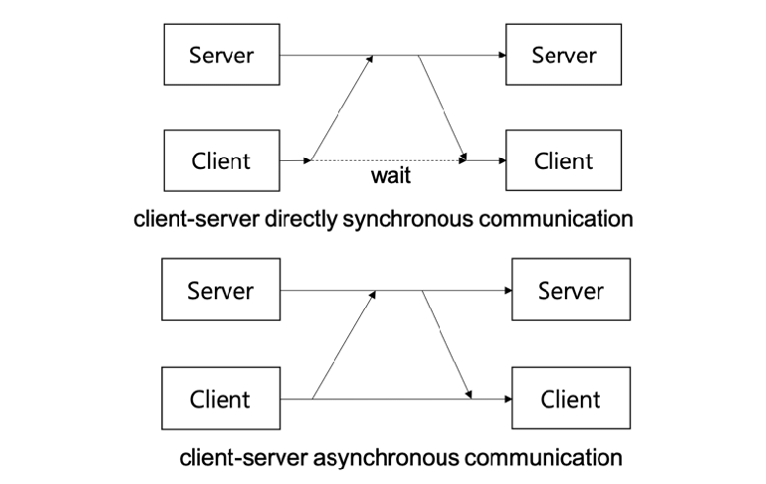

Interoperability
Defined by Kiljander (15), interoperability is the ability of different networks or programs to communicate together without additional need of tools or interfaces. The purpose is to ensure diverse components can interact and interoperate without conflicts or barriers, regardless of their underlying technologies, platforms, or implementations. Achieving this is necessary for developing scalable, flexible, and efficient networked applications.
Protocols, data formats and APIs need to be compliant and used across systems and platforms to achieve interoperability. For example, HTTP is widely acknowledged for web-based applications meanwhile TCP/Ip is common for network communication protocol.
Lewis (16) continues, interoperability can encompass a range of segments. For example:
- Protocol Interoperability: ensure different systems or devices can understand and communicate using common network protocols. Standardized protocols like HTTP, TCP/IP, or MQTT enable interoperability by identifying a shared language for communication. Application developers need to adhere to these protocols and leverage established standards to facilitate interoperability across those different platforms.
- Data Interoperability: Ability to exchange and interpret data effectively between applications and systems. It requires using common data formats, structures, and encoding schemes that all recipients can interpret. Like JSON, XML, or CSV. These help achieve data interoperability by providing a universal syntax for representing and exchanging data
- Platform Interoperability: Compatibility of applications across different operating systems, hardware architectures, or software frameworks. It ensures that applications can run and function correctly irrespective of the underlying platform. Interoperability can be achieved by using cross-platform frameworks, virtualization technologies, or adopting web-based technologies that run on various devices and operating systems.
- Service Interoperability: Focuses on integrating varying components to work together seamlessly. Services should be designed with well-defined interfaces, using industry standards like REST or SOAP, and following established service-oriented architectures (SOA) or microservices principles. Service interoperability enables applications to leverage and integrate services from different providers, enhancing overall flexibility and scalability.
Moreover, Kiljander (15) states interoperability should greatly impact the design and development of applications. Considerations of requires should be gathered at an early stage, ensuring appropriate protocols, data formats, and integration approaches with modularity, flexibility, and compatibility allows for easier integration and enhances interoperability. An additional influence extends to the security aspects of application design. Applications should support standardized authentication and authorization mechanisms, such as OAuth or OpenID Connect. Applying encryption and secure communication protocols, like HTTPS, is essential when transmitting sensitive data between different applications or devices. Mezgar (17) suggests, evolving standards and technologies is crucial for maintaining interoperability long term as methods evolve, developments need to adapt to ensure applications are compatible with updates.
Continued by Varnadat (18), there are various methods of which interoperability can be best achieved. These include following standards- ensuring compatibility and ease of integration with other systems. This can be achieved using middleware to provide a layer between different applications, allowing them to exchange data in a standard way. Use of open APIs- allowing other applications or developers to easily interact with and integrate your application. By having a well-documented and intuitive API, it facilitates interoperability and enable seamless data exchange between different systems. Also, compatibility testing is essential to validate the interoperability, and should test across platforms, operating systems, and network configurations to identify and resolve compatibility issues early within development. Designing applications with modularity and loose coupling by breaking down complex systems into smaller, independent modules, developers can achieve flexibility, scalability, and reusability. These can be later integrated with other systems or devices, fostering interoperability. Finally, clear and comprehensive documentation is necessary. By providing detailed documentation on APIs, data formats, protocols, and integration guidelines, it helps other developers understand the application. Additionally, incorporating communication and collaboration with multiple developers or stakeholders utilises an exchange of knowledge and best practices, again enhancing interoperability.

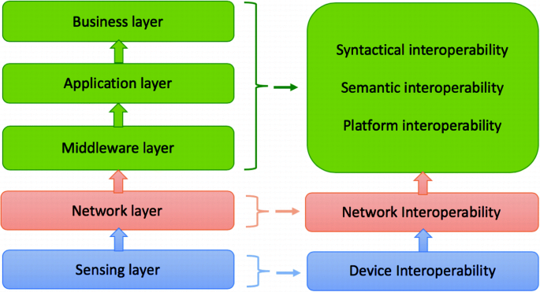

Conclusion
To conclude, socket programming is a significant technique for network communications, allowing applications to establish connections, send and receive data, communicate over a network through protocols and enables client-server applications. Like previously discussed, there are many aspects that can influence the design of a network application.
A thorough understanding of socket programming, TCP, MTU, synchronicity, asynchronicity, and interoperability is necessary to design robust, efficient, and compatible network applications. By considering these factors early in the development process and adapting to evolving standards and technologies, developers can create network applications that meet the requirements of modern communication systems.

Bibliography- Report
- Kalita.L. Socket Programming. (2014) [accessed 28 April] Available at: https://citeseerx.ist.psu.edu/document?repid=rep1&type=pdf&doi=54dc78a981c2e3dcd2f9aacb59491831cf7d5401
- Clark.D. An analysis of TC processing. (2001) [accessed 28 April] Available at: https://ieeexplore.ieee.org/abstract/document/29545
- Hau-Hsu.F. A three-way-handshake for TCP. (2016) [accessed 29 April] Available at: https://www.mdpi.com/2076-3417/6/11/358
- Ammar.M. TCP: challenges and solutions. (2011) [accessed 29 April] Available at: https://jwcn-eurasipjournals.springeropen.com/articles/10.1186/1687-1499-2011-198
- Jakub. Two generals problem. (2018) [accessed 30 April] Available at: https://finematics.com/two-generals-problem/
- Moldeklev.K. MTU deadlocks and TCP data transfers. (1995) [accessed 2 May] Available at: https://ieeexplore.ieee.org/abstract/document/413215
- Taquiqui.M. PDU. (2011) [accessed 2 May] Available at:https://citeseerx.ist.psu.edu/document?repid=rep1&type=pdf&doi=4645d6b07cf672073c7509cb2b1db1f45e238131
- Murat.I. Concurrent protocol data unit encoding/decoding. (1992) [accessed 5 May] Available at: https://spectrum.library.concordia.ca/id/eprint/35/
- Frankfield.J. Fragmentation. (2023) [accessed 5 May] Available at: https://www.investopedia.com/terms/f/fragmentation.asp
- Owens.B. Inferring PMTUD. (2005) [accessed 5 May] Available at: https://www.usenix.org/legacy/event/imc05/tech/full_papers/luckie/luckie.pdf
- Bevans.D. Asynchronous vs Synchronous programming. (2023) [accessed 5 May] Available at:https://www.mendix.com/blog/asynchronous-vs-synchronous-programming/#:~:text=Asynchronous%20programming%20is%20the%20multitasker,time%20in%20a%20rigid%20sequence.
- IBM. Synchronous transmission. (2023) [accessed 6 May] Available at: https://www.ibm.com/docs/en/aix/7.2?topic=synchronization-synchronous-transmission
- IBM. Asynchronous transmission. (2023) [accessed 6 May] Available at: https://www.ibm.com/docs/en/aix/7.2?topic=synchronization-asynchronous-transmission
- Ali.N. I/O framework for computing. (2018) [accessed 10 May] Available at: https://ieeexplore.ieee.org/abstract/document/5289188
- Kiljander.J. Interoperability architecture. (2015) [accessed 10 May] Available at: https://ieeexplore.ieee.org/abstract/document/6879461
- Lewis.G. Role of standards in Interoperability. (2014) [accessed 10 May] Available at: https://ieeexplore.ieee.org/abstract/document/6480040
- Mezgar.I. The challenge of interoperability. (2018) [accessed 10 May] Available at: https://www.sciencedirect.com/science/article/abs/pii/S0166361514000335
- Vernadat.F. Issues of interoperability and networking. (2009) [accessed 10 May] Available at: https://www.sciencedirect.com/science/article/abs/pii/S1367578810000155

