BMWS6104
Porter – 5 Forces

Introduction

Porter’s 5 Forces Model is used to analyse the competition facing an organisation. Although it has its critics, it remains a useful tool for helping to choose a competitive strategy. In brief, the five forces are:

- Threat of new entrants. How easy is it for newcomers to enter the market/industry?
- Threat of substitutes. How easily can the product/service be replaced by a competing product/service?
- Bargaining power of customers. How much power is held by customers?
- Bargaining power of suppliers. How much power is held by suppliers?
- Industry rivalry. What threat do existing competitors pose?

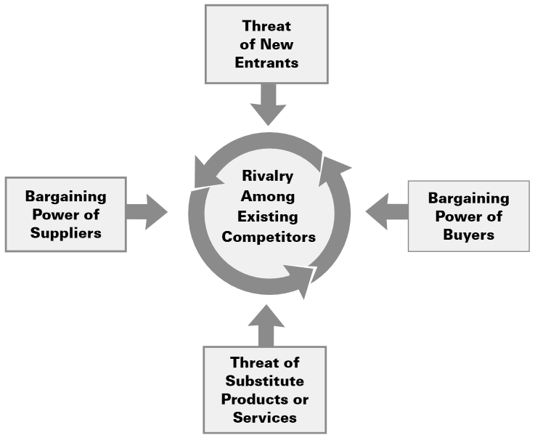

Porter’s 5 Forces Model

There are three main competitive strategies available to an organisation: cost reduction, differentiation and focus. Cost reduction focuses on reducing costs to below those of competitors. This allows the company to lower prices and invest resources in areas such as product development. Differentiation relies on producing unique products or services. As an example, we assume cars produced by Ford and Rolls Royce to be very different from one another. Focus involves specialising in a niche market. This can mean creating products that meet the needs of customers very closely or creating products that cost less than those from comeptitors. This often results in strong customer loyalty, making the market unattractive to competitors.

An important aspect of competitive strategy is the ability to predict the likely actions of competitors. Porter’s Four Corners Model provides a framework for doing this.

- Drivers are the competitor’s goals; what are they trying to achieve and what are their motivations?
- Management Assumptions are how the competitor sees itself and the industry.
- Current Strategy is the competitor’s current competitive strategy, that is, how it is currently competing with the market and how successful its approach is.
- Capabilities are the competitor’s strengths and its ability to act or react in relation to industry competition.

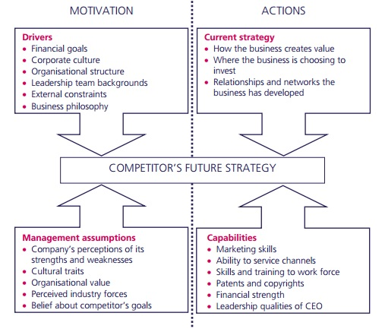
Porter’s Four Corners Model

Tasks

- Use the 5 Forces Model to analyse the competitive position of a company like Netflix.

- Use the 4 Corners Model to predict the likely actions of a competitor to Netflix, like Sky or Amazon Video.

5 Forces Template

Force | Risk H/L | Notes
Threat of new entrants

Threat of substitutes

Bargaining power of customers

Bargaining power of suppliers

Industry rivalry

Four Corners Template

Motivation | Actions
Drivers | Current Strategy
Management Assumptions | Capabilities

References

Porter, M.E., 2008. “The five competitive forces that shape strategy”. Harvard Business Review, 86(1), pp.25-40. Available at: http://www.academia.edu/download/32580687/HBR_on_Strategy.pdf#page=25

Resources

A critique of Porter’s model:
- Grundy, T., 2006. “Rethinking and reinventing Michael Porter's five forces model”. Strategic Change, 15(5), pp.213-229. Available at: http://www.ftms.edu.my/images/Document/MOD001074%20-%20Strategic%20Management%20Analysis/WK5_SR_MOD001074_Grundy_2006.pdf

How Porter’s model can be used to provide competitive advantage:
- Porter, Michael E., and Michael E. Porter, 1979. "How competitive forces shape strategy." Harvard Business Review, 57(2), March-April 1979, pp.21-38. Available at: http://faculty.bcitbusiness.ca/KevinW/4800/porter79.pdf
- See also: https://hbr.org/1979/03/how-competitive-forces-shape-strategy

Applying Porter’s ideas to information:
- Porter, Michael E., and Victor A. Millar. "How Information Gives You Competitive Advantage." Harvard Business Review 63, no. 4 (July–August 1985): 149–160. Available at: http://www.gospi.fr/IMG/pdf/how_information_gives_you_competitive_advantage-porter-hbr-1985.pdf

Examples, including Starbucks, McDonalds and more:
- http://panmore.com/mcdonalds-five-forces-analysis-porters-model
- http://panmore.com/starbucks-coffee-five-forces-analysis-porters-model
- http://panmore.com/pepsico-five-forces-analysis-porters-model
- http://panmore.com/costco-wholesale-five-forces-analysis-porters-model
- https://www.forbes.com/sites/greatspeculations/2014/11/24/ebay-through-the-lens-of-porters-five-forces/#2f62a527dd14

A CIMA guide covering several tools including Porter’s Four Corners Model:
- http://www.cimaglobal.com/Documents/ImportedDocuments/cid_tg_strategic_analysis_tools_nov07.pdf.pdf

Source: Porter, 2008
Source: https://www.mbaknol.com/strategic-management/michael-porters-four-corners-model/

