
Waste Management and Pollution Reduction Strategies for Wildlife Protection in Natural and Urban Ecosystems: Evidence and Insights from Cardiff, Wales

Submitted by: Foyajul Karim Rimon
ID: 2504503

Module Code: ACFA7004 | Research Methods and Professional Developments
University of Wales Trinity Saint David
Academic Year: 2025-26

Contents
1 INTRODUCTION 5
1.1 Waste Mismanagement as an Ecological and Wildlife Protection Issue 5
1.2 Global Scale and Policy Significance of Waste and Plastic Pollution 5
1.3 Limitations of Existing Waste Management Metrics 6
1.4 Need for Integrated, Wildlife-Protective Waste Management Strategies 7
1.5 Research Focus, Questions, and Analytical Approach 8
1.6 Study Scope and Delimitations 8
1.7 Aim of the Research 9
1.8 Objectives 9
2 LITERATURE REVIEW 10
2.1 The Global Plastics Problem and Its Ecological Dimensions 10
2.2 Wildlife Exposure Pathways 11
2.3 Evaluation of Management Strategies 15
2.4 Literature Gap 19
3 METHODS 20
3.1 Research Design 20
3.2 Source Selection and Search Strategy 20
3.3 Analytical Framework 21
3.4 Indicative Work Plan: 23
4 EXPECTED RESULTS 24
4.1 Evidence Matrix and Strategy Comparisons 24
4.2 Integrated Monitoring Framework 24
4.3 Cardiff Case Study Findings 25
5 EVALUATION 27
5.1 Potential Impact and Contribution 27
5.2 Limitations 27
6 ETHICS CONSIDERATION 28
7 CONCLUSION 29
8 REFERENCES 30

List of Table

Table 1: Selected global waste and plastic statistics, with Cardiff context. 7
Table 2: Main wildlife exposure pathways associated with waste and pollution. 14
Table 3: Comparative evaluation of waste management strategy types for wildlife protection, with Cardiff application. 17
Table 4: Analytical framework components applied at global and Cardiff scales. 22
Table 5: Proposed wildlife-centred indicators for monitoring waste management performance. 25

List of Figure
Figure 1: Global municipal solid waste generation (2023 and 2050). Source: UNEP (2024) 6
Figure 2: Estimated annual cost of poor waste management (2020 and 2050). Source: UNEP (2024) 6
Figure 3: Fate of global plastic waste in 2019. Approximately 22% was uncontrolled or leaked into the environment. Source: OECD (2022) 11
Figure 4: Plastic litter accumulation in a Cardiff river channel illustrating uncontrolled leakage into freshwater habitat. Source: Inter Cardiff (2023) 13
Figure 5: Weathered plastic fragments collected from a beach surface illustrating how macroplastics break down into diffuse pieces that are increasingly difficult to manage. Source: Scientific American (2019). 13
Figure 6: Reported marine plastic entanglement incidents by animal group. Source: Issifu and Sumaila (2020) 16
Figure 7: Keep Wales Tidy volunteers conducting a community litter pick on the River Taff, Cardiff, illustrating the role of public participation in urban waste governance. Source: Nation Cymru (2023) 17
Figure 8: Waste management and wildlife protection logic linking drivers, pressures, ecological state change and management responses. Source: author synthesis 22
Figure 9: Gantt Chart 23

INTRODUCTION

Waste Mismanagement as an Ecological and Wildlife Protection Issue
The environmental consequences of mismanaged waste now extend well beyond public health concerns. Discarded materials have migrated into drains, riparian corridors, wetlands and peri-urban habitats, where they interact directly with ecological processes and wildlife populations. This transition from a sanitation concern to an ecological challenge has been confirmed by a growing body of evidence linking waste accumulation to species injury, habitat degradation and bioaccumulation of persistent pollutants (MacLeod et al., 2021; United Nations Environment Programme and International Solid Waste Association, 2024). Effective policy must therefore move beyond operational targets and engage directly with the ecological consequences of system failures.

Global Scale and Policy Significance of Waste and Plastic Pollution
UNEP (2024) estimates that municipal solid waste generation could rise from approximately 2.1 billion tonnes in 2023 to 3.8 billion tonnes by 2050, with the sharpest growth in regions where infrastructure and regulatory capacity have not kept pace with consumption (Figure 1). As Figure 1 illustrates, this increase is concentrated in low- and middle-income regions where even modest leakage rates will generate substantially greater wildlife exposure over coming decades. UNEP (2024) showed that of the 353 million tonnes of plastic waste generated in 2019, an estimated 22 million tonnes leaked into the environment, adding to legacy stocks of approximately 109 million tonnes in rivers and 30 million tonnes in the ocean. The projected annual cost of poor waste management is expected to reach USD 640.3 billion by 2050 (Figure 2).

Figure 1: Global municipal solid waste generation (2023 and 2050). Source: UNEP (2024)

Figure 2: Estimated annual cost of poor waste management (2020 and 2050). Source: UNEP (2024)

Limitations of Existing Waste Management Metrics
Waste management policy has historically prioritised operational metrics over ecological outcomes, assessing performance by tonnage collected and recycling rates rather than by reductions in wildlife exposure. (Geyer, Jambeck and Law, 2017) show that 79 per cent of all plastics ever produced have accumulated in landfills or the natural environment. This persistent shortfall, combined with long environmental residence times, creates chronic wildlife risks that conventional metrics are ill-equipped to capture. Table 1 summarises the key statistics framing this research.

Table 1: Selected global waste and plastic statistics, with Cardiff context.
Indicator | Value | Wildlife Relevance | Source | Scale
Municipal solid waste generation | 2.1 billion tonnes (2023); 3.8 billion by 2050 | Rising volumes increase leakage risk where systems do not scale | UNEP (2024) | Global
Annual cost of poor waste management | USD 361bn (2020); USD 640.3bn by 2050 | Ecological damage carries significant economic cost | UNEP (2024) | Global
Global plastic waste | 353 million tonnes in 2019 | Scale of persistent material available for leakage | OECD (2022) | Global
Plastic waste fate | 9% recycled; 19% incinerated; ~50% landfilled; 22% leaked | Current systems remain inadequate for biodiversity protection | OECD (2022) | Global
Plastic leakage and legacy stocks | 22m tonnes leaked (2019); 109m in rivers; 30m in ocean | Wildlife faces current and long-lived legacy pollution | OECD (2022); (Meijer et al., 2021; OECD, 2022) | Global
Cardiff household recycling rate | 58.19% in 2021-22, below the Welsh Government statutory target of 64% | Illustrates gap between high operational performance and ecological outcomes | (Cardiff Council, 2022) | Cardiff

Need for Integrated, Wildlife-Protective Waste Management Strategies
The central argument of this proposal is that effective wildlife-protective waste strategy cannot rely on downstream cleanup alone. The strongest ecological outcomes emerge from integrated approaches spanning the full causal chain: reducing material generation upstream, ensuring reliable collection at the municipal level, intercepting waste at leakage hotspots, and designing cleanup operations that are sensitive to biodiversity. Governance quality, accountability and public participation are structural conditions for success, not supplementary concerns.

Research Focus, Questions, and Analytical Approach
- What are the most effective waste management strategies to reduce wildlife exposure to plastic pollution in terrestrial, freshwater, and urban ecosystems?
- How can governance quality and public participation influence the success of waste management strategies in mitigating plastic pollution impacts on wildlife?
- What specific wildlife exposure pathways are most harmful, and how can waste management practices be targeted to interrupt these pathways effectively?
- To what extent do the waste management strategies currently operating in Cardiff, Wales reflect the evidence-based priorities identified in this review, and what gaps in wildlife-centred ecological protection do they reveal?

Study Scope and Delimitations
The study is bound to terrestrial, freshwater and near-coastal urban systems, drawing on published evidence from both high-income countries (global north) and low- and middle-income countries (global south) to allow comparative evaluation across differing governance and infrastructure contexts. The temporal scope prioritises work published after 2019, though methodologically significant earlier contributions are retained where appropriate.

To ground the analytical framework in an applied context, Cardiff, Wales is incorporated as an illustrative case study. The city is traversed by the River Taff and the River Ely, both of which flow through densely populated urban areas before discharging into Cardiff Bay and the Severn Estuary, creating direct pathways through which mismanaged waste can reach freshwater and near-coastal habitats (Natural Resources Wales, 2020). Wales operates under the Beyond Recycling strategy, which targets zero waste to landfill by 2025 and sets sector-specific requirements for collection, segregation and material recovery (Welsh Government, 2021). Cardiff Council reported a household recycling rate of 58.19 per cent in 2021-22, below the Welsh Government statutory target of 64 per cent, indicating that even relatively high-performing authorities face challenges in meeting national ambitions (Cardiff Council, 2022)making it a productive case through which to evaluate whether strong operational performance translates into measurable wildlife-centred ecological outcomes.

Aim of the Research
The aim of this research is to systematically assess the effectiveness of waste management strategies in reducing wildlife exposure to plastic pollution in terrestrial, freshwater, and urban environments, and to apply the resulting evidence-based framework to Cardiff, Wales as an illustrative case study evaluating the relationship between operational waste management performance and wildlife-centred ecological outcomes.

Objectives
- To identify and evaluate key wildlife exposure pathways associated with plastic pollution across terrestrial, freshwater and urban ecosystems.
- To assess the effectiveness of various waste management strategies in mitigating wildlife exposure to plastic, with reference to evidence from both high-income and low- and middle-income country contexts.
- To explore governance factors and their impact on the success of waste management strategies in delivering measurable ecological outcomes.
- To produce a structured assessment of Cardiff municipal waste governance using the evidence-based framework, identifying specific policy gaps and recommending wildlife-centred indicator additions to existing performance measurement systems.

LITERATURE REVIEW

The Global Plastics Problem and Its Ecological Dimensions
Plastics have become the defining material of the contemporary waste challenge owing to their persistence, mobility and high exposure potential. Jambeck et al. (2015) estimated that between 4.8 and 12.7 million metric tonnes of plastic entered the ocean from land in 2010 alone, with projections indicating continued growth under business-as-usual trajectories. OECD (2022) demonstrates that the global plastics economy remains structurally linear, with recovery rates insufficient to interrupt environmental leakage even where collection systems operate as designed. Geyer et al. (2017) show that cumulative plastic production has overwhelmingly outpaced recycling capacity, leaving the natural environment as a de facto long-term repository. Figure 3 illustrates how only a small fraction of global plastic waste was recycled in 2019, with the majority landfilled, incinerated or entering the environment through uncontrolled pathways.

Awino and Apitz (2024) review the international application of circular economy frameworks and the waste hierarchy, finding that while conceptual alignment is strong, implementation remains fragmented across governance systems. MacLeod et al. (2021) characterise plastic pollution as a global threat that interacts with climate change and biodiversity loss in ways that amplify harm beyond what any single stressor would produce independently. UNEP (2024) draws a direct connection between municipal waste growth and biodiversity pressure, projecting total annual costs of poor waste management at USD 640 billion by 2050, representing compounding ecological debt rather than a simple service-delivery shortfall.

A distinction critical for conservation is that between visible macroplastic litter and diffuse microplastic pollution. Policies that successfully reduce visible litter may leave particle pollution unaddressed, because tyres, textiles and fragmenting packaging generate microplastics that enter runoff, soils and food webs through pathways that conventional municipal waste services cannot easily intercept (OECD, 2022; Siña et al., 2025)This distinction determines both the range of policy tools required and the indicators used to measure success. In a UK urban context, this is particularly relevant: despite Wales achieving some of the highest municipal recycling rates in Europe, microplastic contamination of urban river systems such as the River Taff in Cardiff remains a documented concern, illustrating the gap between operational performance and ecological outcomes (Natural Resources Wales, 2020).

Figure 3: Fate of global plastic waste in 2019. Approximately 22% was uncontrolled or leaked into the environment. Source: OECD (2022)

Wildlife Exposure Pathways
The literature identifies five principal pathways through which waste causes wildlife harm. Each requires a different management response, and strategies that address one pathway effectively may leave others unresolved (Table 2).

The first pathway is direct physical injury through ingestion. Jams et al. (2020) demonstrate that the size distribution of plastic particles likely to be ingested can be estimated systematically across animal groups, enabling more precise ecological risk assessment and allowing source-control and cleanup priorities to be allocated more efficiently. Rochman et al. (2016) reviewed evidence across multiple taxa showing that ingestion of debris causes physical harm, obstruction and chemical exposure, with effects ranging from reduced feeding efficiency to reproductive impairment.

The second pathway is entanglement and entrapment. Flexible items including nets, strapping, rings and films can remain hazardous in wetlands and shorelines for extended periods. Borrelle et al. (2020) confirm that entanglement remains a leading cause of injury and death across a range of taxa, while Issifu and Sumaila (2020) show that turtles, eared seals and polar bears face particularly elevated exposure (Figure 6). Their analysis underlines that cleanup interventions alone are unlikely to keep pace with material leakage under current production trends.

The third pathway is chemical exposure through additives, leachates and combustion residues. Sigmund et al. (2023) argue that the mixture complexity of leachate and contaminated runoff creates assessment challenges that conventional single-substance toxicology cannot fully address. Bean et al. (2024) extend this by noting that wildlife toxicological methods must account for sublethal effects on physiology, behaviour and reproduction. Open burning of waste adds further risk by generating persistent organic pollutants that deposit across wide areas, often in regions lacking environmental monitoring capacity.

The fourth pathway is habitat alteration. Milner et al. (2025) provide direct evidence from urban waterways showing that anthropogenic litter alters macroinvertebrate assemblages, with littered reaches exhibiting lower diversity and a shift towards pollution-tolerant taxa. This evidence is particularly relevant to Cardiff, where the River Taff and River Ely traverse densely populated urban areas; both watercourses carry litter loads from urban runoff directly into Cardiff Bay, which is designated as a Site of Special Scientific Interest on account of its internationally important populations of overwintering waterfowl and migratory waders (Natural Resources Wales, 2020). Sheng et al. (2024) show comparable pressures in agricultural landscapes, where plastic pollution threatens pollinators and biocontrol agents by disrupting plant-insect interactions.

A fifth pathway, diffuse microplastic exposure, operates independently of visible litter management. Tyres, textiles and fragmenting packaging release particles that move through runoff, soils and food webs, increasing persistent exposure even where visible litter appears limited (OECD, 2022; Siña et al., 2025).
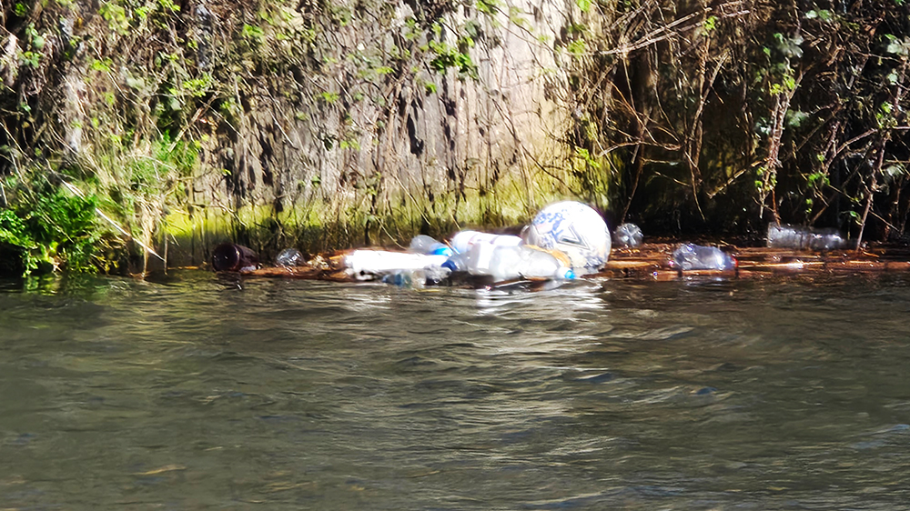
Figure 4: Plastic litter accumulation in a Cardiff river channel illustrating uncontrolled leakage into freshwater habitat. Source: Inter Cardiff (2023)
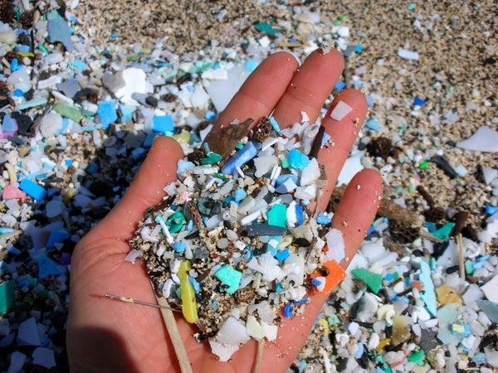
Figure 5: Weathered plastic fragments collected from a beach surface illustrating how macroplastics break down into diffuse pieces that are increasingly difficult to manage. Source: Scientific American (2019).

Table 2: Main wildlife exposure pathways associated with waste and pollution.
Pathway | Mechanism | Evidence Base | Wildlife Implication | Cardiff Relevance
Ingestion | Animals consume fragments or fibres overlapping with food size ranges | Jams et al. (2020); Rochman et al. (2016) | Reduces feeding efficiency; blocks digestive tracts; transfers pollutants | Waterbirds and fish in River Taff and Cardiff Bay
Entanglement and entrapment | Flexible items trap or injure animals in wetlands and shorelines | Borrelle et al. (2020); Issifu and Sumaila (2020) | Injury, reduced mobility, drowning or death before cleanup | Waterbirds in Cardiff Bay SSSI
Chemical exposure | Additives, leachates, combustion residues enter soils and water | Sigmund et al. (2023); Bean et al. (2024) | Chronic ecological stress affecting physiology and reproduction | Urban runoff into River Ely and River Taff
Habitat alteration | Litter accumulation changes physical structure and substrate conditions | Milner et al. (2025); Sheng et al. (2024) | Altered community composition; reduced habitat quality | River Taff macroinvertebrate communities
Diffuse microplastic exposure | Tyres, textiles and fragmentation release particles through runoff and food webs | OECD (2022); Sina et al. (2025) | Persistent exposure even where visible litter is limited | Urban stormwater and river systems across Cardiff

Evaluation of Management Strategies
The most fundamental finding in the intervention literature is that downstream cleanup alone cannot resolve the wildlife harm problem. Borrelle et al. (2020) confirm that entanglement and ingestion incidents are unlikely to decline under cleanup-only approaches, while Lau et al. (2020) modelled global plastic pollution trajectories and demonstrated that even significant improvements in waste collection would reduce ocean plastic accumulation by less than half without simultaneous upstream reduction in production. This has direct conservation implications: an animal that has already ingested a fragment or become entangled is not protected by a later cleanup operation.

Upstream prevention encompasses product redesign, reduction of single-use materials, extended producer responsibility and reuse systems. These approaches carry the greatest conservation advantage by reducing the total volume of persistent material available for leakage. However, they are institutionally demanding, requiring sustained regulatory capacity and market reform. Between upstream design and downstream handling, targeted product instruments offer an intermediate layer. Picuno et al. (2025) show that deposit return schemes can substantially reduce the prevalence of common leakage items when deposit values are sufficient and return infrastructure is convenient. Extended producer responsibility works through a related logic, making producers accountable for end-of-life management and creating incentives for recovery system improvement.

Collection reliability and controlled disposal remain essential because material already in circulation will require management for decades. Wildlife harm occurs most predictably at the edges of underperforming service systems, including overflowing bins, irregular collection schedules and disposal sites lacking leachate control. Wang et al. (2025), examining twenty-six community waste management programmes in Chinese cities, identify institutional learning, community participation and adaptive management as consistent factors distinguishing successful from failed programmes. Sasahara et al. (2024) develop a governance index for municipal solid waste in global south contexts, finding that ecological performance diverges sharply when governance quality falls below a critical threshold, even where technical resources are comparable.

The Cardiff context provides an instructive counterpoint from a high-income governance setting. Wales has achieved household recycling rates exceeding fifty per cent under the Beyond Recycling strategy (Welsh Government, 2021; Cardiff Council, 2022) placing it among the highest-performing jurisdictions in the United Kingdom. However, (Natural Resources Wales, 2020) reports that urban river systems in Cardiff continue to receive litter inputs from stormwater and informal disposal, indicating that high operational recycling performance does not automatically translate into reduced wildlife exposure in ecologically sensitive corridors. This pattern directly reflects the argument made by Borrelle et al. (2020) and Lau et al. (2020) that collection-oriented metrics are insufficient indicators of ecological protection.

Targeting specific locations is as important as targeting products. Meijer et al. (2021) show that more than 1,000 rivers account for eighty per cent of global riverine plastic emissions into the ocean, supporting interventions at hydrological hotspots such as drains, stormwater outfalls and small rivers. In Cardiff, the River Taff and River Ely function as precisely such hotspots, channelling urban waste from surrounding residential and commercial areas into the protected habitats of Cardiff Bay (Natural Resources Wales, 2020). Milner et al. (2025) caution that cleanup at such sites should be paired with habitat restoration, as indiscriminate removal can strip physical complexity without ecological replacement.
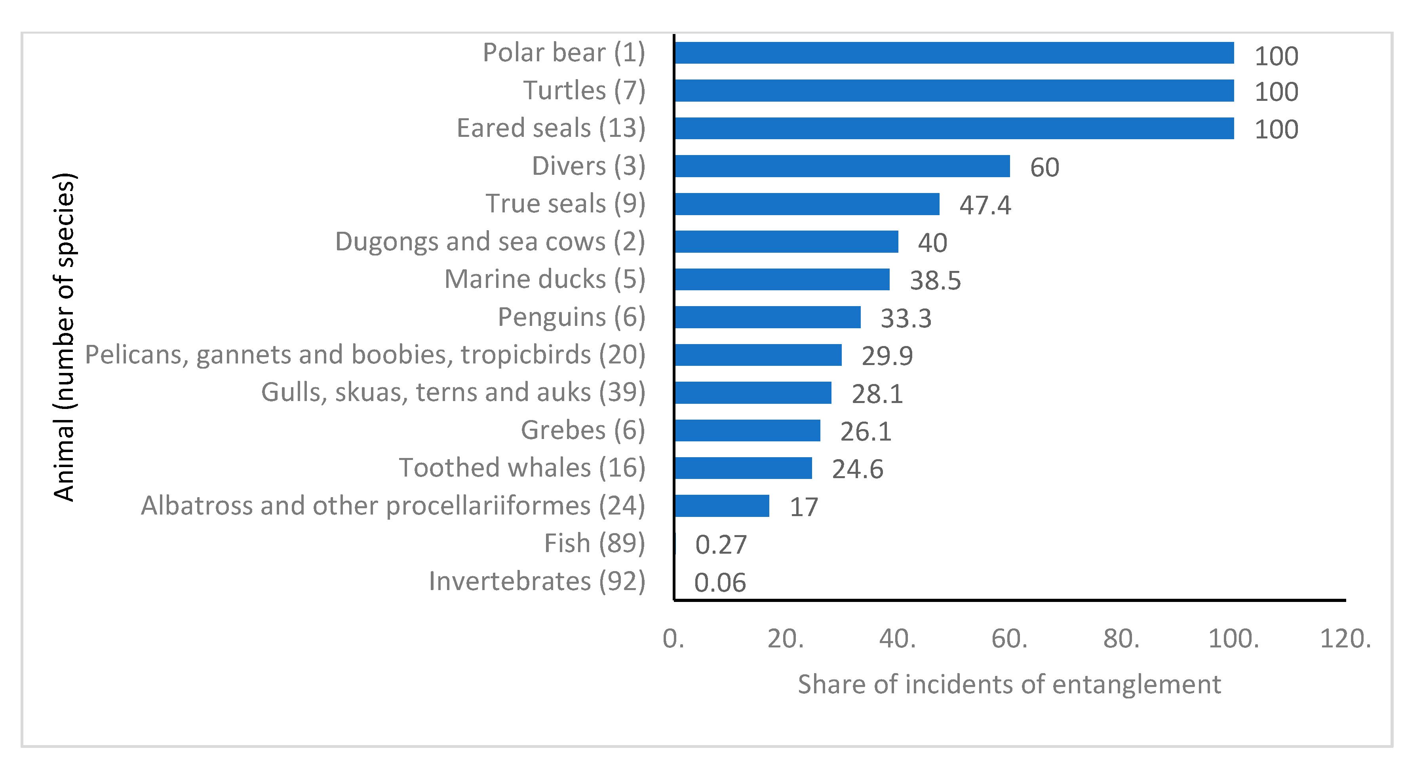
Figure 6: Reported marine plastic entanglement incidents by animal group. Source: Issifu and Sumaila (2020)

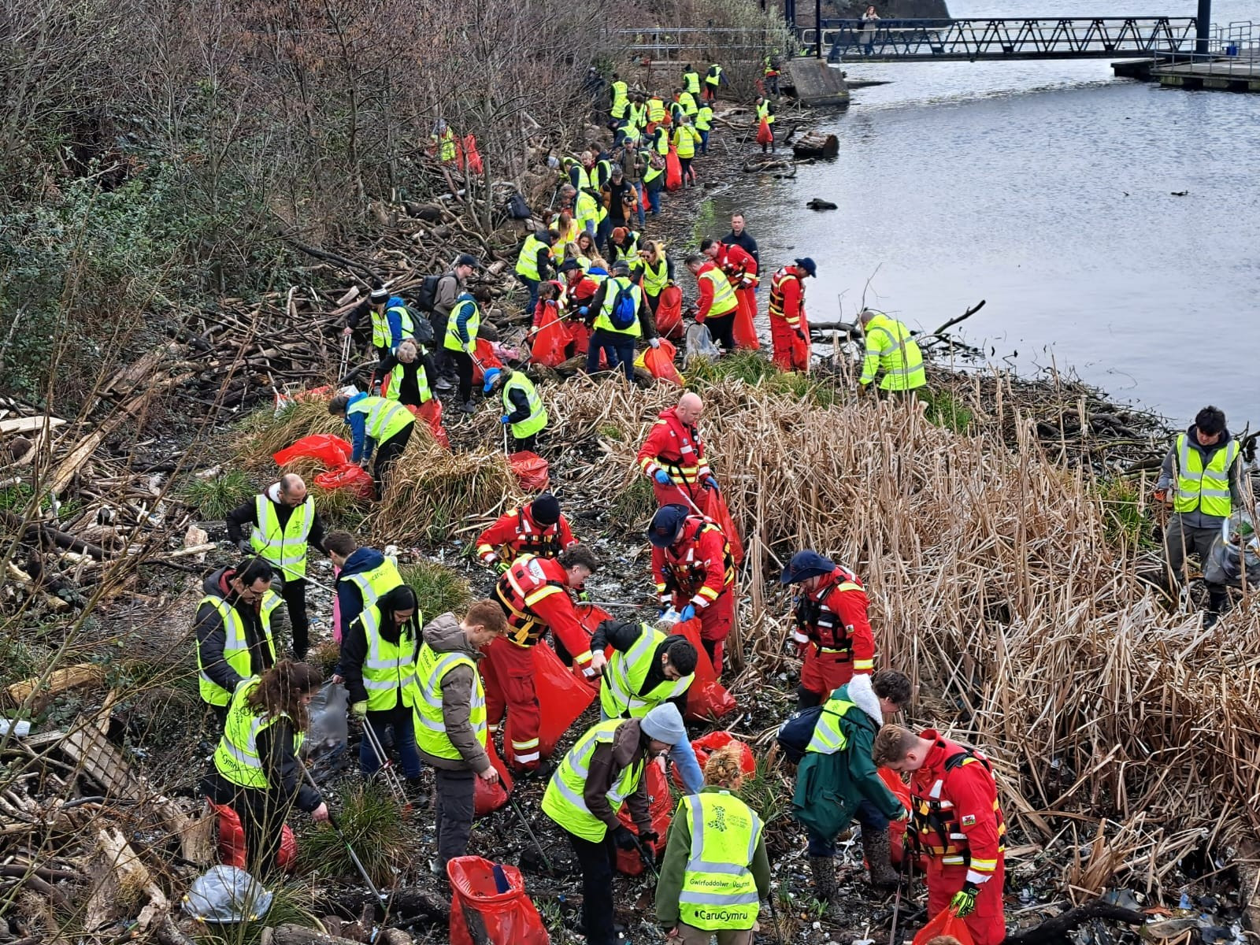
Figure 7: Keep Wales Tidy volunteers conducting a community litter pick on the River Taff, Cardiff, illustrating the role of public participation in urban waste governance. Source: Nation Cymru (2023)

Table 3: Comparative evaluation of waste management strategy types for wildlife protection, with Cardiff application.
Strategy Type | Where It Acts | Preventive Strength | Likely Wildlife Value | Main Limitation | Cardiff Application
Prevention and product redesign | At source, before waste is created | Very high | Very high: reduces volume of material that can escape and fragment | Requires producer responsibility, regulation and market change | Welsh Government Beyond Recycling targets single-use reduction
Segregation and reliable collection | Before leakage, during handling and transport | High | High: prevents routine escape from households, markets and streets | Fails where service continuity and public trust are weak | Cardiff Council kerbside sort scheme achieving above 50% recycling
Controlled disposal and landfill upgrading | After collection, at final containment stage | Medium | High for preventing secondary leakage and leachate pollution | Contains damage but does not reduce material throughput | Wales zero waste to landfill target by 2025
Deposit return schemes and producer responsibility | Product and recovery system level | Medium to high | Medium to high, especially for bottles and caps (Picuno et al., 2025) | Performance depends on scheme design and convenience | Wales DRS under development; not yet operational in Cardiff
Hydrological hotspot interception | At drains, streams, rivers and outlets | Medium | High in targeted locations with concentrated leakage (Meijer et al., 2021) | Needs maintenance; cannot substitute for upstream reform | River Taff and River Ely as primary urban leakage conduits to Cardiff Bay
Cleanup linked to habitat restoration | After leakage has occurred | Low as prevention; necessary for recovery | Medium to high where legacy pollution already harms habitat | May create ecological trade-offs if restoration is absent (Milner et al., 2025) | Cardiff Bay SSSI restoration potential following litter reduction

Literature Gap
Despite the growing evidence base, a systematic gap persists in the literature. The ecological effectiveness of waste management strategies has rarely been evaluated using wildlife-centred outcome measures. Most comparative studies rely on operational indicators, such as collection coverage and recycling rates, rather than on changes in wildlife exposure, habitat condition or species-level impacts. This limits the capacity of conservation practitioners to engage with waste policy reform using biodiversity evidence and makes it difficult to identify which combinations of interventions generate the best ecological outcomes per unit of investment.

This gap is particularly visible in high-income urban governance contexts. While a substantial body of research examines waste management performance in global south settings where service failures are acute, comparatively little published work evaluates whether strong operational performance in high-income cities translates into measurable wildlife benefits. Cardiff represents precisely this under-examined scenario: a well-governed city with documented recycling achievement operating within an ambitious national policy framework, yet lacking systematic evidence of whether those achievements reduce wildlife exposure along its principal river corridors. This proposal addresses the broader gap by constructing a systematic, evidence-based framework linking strategy type, implementation context and ecological outcome, and applies that framework to Cardiff as an illustrative case study to generate transferable insights for urban wildlife-protective waste governance.

METHODS

Research Design
This research adopts a structured critical literature review design combined with an illustrative case study application to Cardiff, Wales. The literature review component is appropriate because primary field data collection would require multi-site ecological monitoring over extended timeframes that exceed the scope of this proposal. A rigorously conducted literature review can nonetheless generate original insights by identifying evidence patterns, resolving contradictions and producing transferable analytical frameworks (Awino and Apitz, 2024), consistent with established methods in environmental governance research. The review follows a structured methodology adapted from systematic review principles, with search strategies, inclusion criteria, analytical categories and evidence-grading procedures defined in advance to reduce selection bias.
The Cardiff case study component applies the evidence-based framework produced by the literature review to a specific urban governance context. Rather than generating new primary data, the case study draws on publicly available policy documents, ecological assessments and municipal performance reports to evaluate the alignment between Cardiff's existing waste management strategies and the wildlife-centred indicators developed through the review. This mixed approach strengthens the research by grounding the analytical framework in a real and verifiable governance setting, directly addressing the gap between operational metrics and ecological outcomes identified in Section 2.4.

Source Selection and Search Strategy
The search strategy covers four source groups:
- Institutional reports from UNEP and OECD, providing authoritative global baseline data on waste generation, plastics flows and environmental leakage.
- Peer-reviewed ecological literature from journals including Environmental Pollution, Nature Communications, Science, Science Advances and Integrated Environmental Assessment and Management, searched through Web of Science, Scopus and Google Scholar using terms combining waste management, wildlife, pollution, biodiversity, plastic, exposure and governance.
- Governance and policy studies addressing municipal solid waste systems, circular economy instruments, extended producer responsibility and community-level programme evaluation. Sources from low- and middle-income country contexts are actively sought to counteract the publication bias that disproportionately represents high-income country experiences.
- Cardiff and Wales-specific sources including Natural Resources Wales ecological assessments, Welsh Government policy documents (particularly the Beyond Recycling strategy), Cardiff Council annual waste performance reports, and regional environmental journalism documenting observed pollution conditions along the River Taff and River Ely corridors.
Sources are included where they meet the following criteria: published in English; peer-reviewed or produced by a recognised statutory or intergovernmental body; relevant to at least one of the four research questions; and, for empirical studies, based on field, experimental or systematic review evidence rather than opinion alone. Studies published before 2010 are excluded unless they represent foundational contributions that remain widely cited in current literature. Sources that address only deep-sea or open-ocean pollution dynamics, without reference to land-based waste management systems, are excluded as outside the defined scope of the study.

Analytical Framework
The analytical framework integrates three perspectives, as illustrated in Figure 8. The first is the driver-pressure-state-impact-response (DPSIR) model, which establishes the logical chain from social and economic drivers to ecological change and management responses, preventing waste management from being treated as an isolated service function. The second is the waste hierarchy, which provides a normative structure for evaluating where in the causal chain each strategy type acts and how prevention, reuse, recycling, recovery and disposal compare in their conservation value. The third is a wildlife exposure lens, which categorises harm across five pathways, namely ingestion, entanglement, chemical exposure, habitat alteration and diffuse microplastic exposure, and evaluates strategies by their capacity to interrupt specific mechanisms of harm.

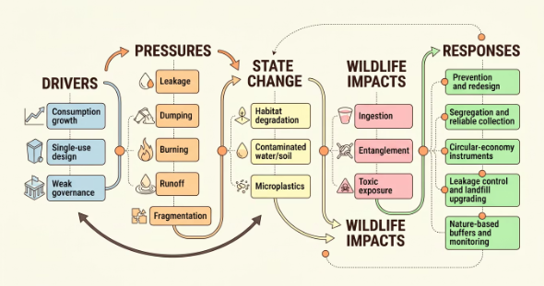
Figure 8: Waste management and wildlife protection logic linking drivers, pressures, ecological state change and management responses. Source: author synthesis
For the Cardiff case study, these three perspectives are applied specifically to the municipal governance context of Cardiff, using the River Taff and River Ely as the primary ecological reference corridors. The DPSIR model maps Cardiff's urban development pressures onto documented litter inputs; the waste hierarchy positions the Beyond Recycling strategy within the causal chain; and the wildlife exposure lens evaluates which pathways remain unaddressed despite high operational recycling performance. Table 4 summarises the framework as it applies to both the global literature review and the Cardiff case study.

Table 4: Analytical framework components applied at global and Cardiff scales.
Framework Component | Purpose in Global Review | Application to Cardiff | Key Sources
DPSIR Model | Maps social and economic drivers to ecological state change and management responses | Links Cardiff urban growth, stormwater inputs and River Taff litter loads to Cardiff Bay wildlife impacts | Awino and Apitz (2024); UNEP (2024)
Waste Hierarchy | Evaluates where each strategy type acts across prevention, reuse, recycling, recovery and disposal | Positions Beyond Recycling strategy and Cardiff kerbside scheme within the causal chain | Welsh Government (2021); Cardiff Council (2022)
Wildlife Exposure Lens | Categorises harm across five pathways: ingestion, entanglement, chemical exposure, habitat alteration and diffuse microplastic exposure, and evaluates strategies by capacity to interrupt each mechanism | Identifies which pathways remain active in River Taff and River Ely despite high recycling rates | Natural Resources Wales (2023); Milner et al. (2025)

Indicative Work Plan:
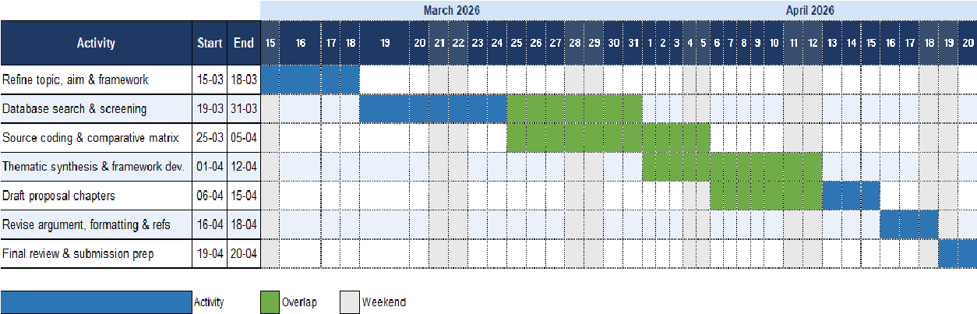
Figure 9: Gantt Chart

EXPECTED RESULTS

Evidence Matrix and Strategy Comparisons
The review is expected to produce four categories of output. The first is an evidence-graded matrix mapping waste management strategy types against wildlife exposure pathways and ecosystem contexts. This matrix will identify which interventions have the strongest and most consistent evidence base, which are promising but under-tested, and which are commonly promoted but weakly supported by ecological outcome data. The matrix directly addresses research questions one and two and will form the empirical foundation for the practical recommendations arising from this proposal.

The second output is an analysis of implementation conditions explaining variation in ecological outcomes across comparable policy contexts. Drawing on Wang et al. (2025) and Sasahara et al. (2024), it is anticipated that service reliability, accountability structures, community participation and the integration of biodiversity monitoring into programme evaluation will emerge as consistent differentiators between effective and ineffective programmes. The systematic review will test this interpretation across a wider range of geographical and institutional contexts, including high-income urban settings such as Cardiff where governance capacity is strong but ecological monitoring of waste impacts remains limited.

Integrated Monitoring Framework
The third output is an integrated analytical framework structured around four questions for each strategy type: where in the causal chain does it act; which exposure pathways does it interrupt; what implementation conditions does it require; and what ecological indicators should be used to measure success. Table 5 presents the proposed wildlife-centred indicator framework. It is anticipated that the review will confirm that the most robust wildlife-protective strategies are not necessarily the most technically complex, but those implemented consistently within accountability structures capable of detecting and responding to ecological change.

Table 5: Proposed wildlife-centred indicators for monitoring waste management performance.
Indicator Domain | Examples | Why It Matters | Cardiff Application
Exposure indicators | Litter density on riparian transects; storm-drain capture loads; counts of leakage-prone items at river outlets | Shows whether waste is still entering ecological pathways despite collection activity | Litter transects along River Taff and River Ely from Pontypridd to Cardiff Bay
Biological indicators | Entanglement records; faecal microplastic occurrence in sentinel species; macroinvertebrate community condition | Links management activity to organism-level outcomes rather than waste tonnage alone | Macroinvertebrate monitoring data from Natural Resources Wales river assessments
Habitat indicators | Riparian vegetation cover; wetland condition; substrate quality following cleanup and restoration | Reveals whether ecological quality is recovering after pollution control | Cardiff Bay SSSI habitat condition reports from Natural Resources Wales
Governance indicators | Collection reliability; source-segregation participation rates; complaint resolution time; enforcement against illegal dumping | Measures enabling conditions that determine whether technical strategies deliver in practice | Cardiff Council annual recycling performance reports and compliance data

Cardiff Case Study Findings
A further anticipated finding is that conventional operational indicators, such as collection coverage and recycling rates, frequently decouple from ecological outcomes because they measure inputs and throughput rather than the interruption of exposure pathways. The Cardiff case study is expected to illustrate this decoupling clearly: despite Cardiff Council reporting household recycling rates above fifty per cent (Cardiff Council, 2022) and Wales operating under the Beyond Recycling strategy (Welsh Government, 2021), Natural Resources Wales (2020) documents continued litter inputs to the River Taff and River Ely, indicating that high recycling performance has not eliminated wildlife exposure risk along these corridors. This finding would provide concrete, locally grounded evidence for the broader argument that wildlife-centred ecological indicators must supplement operational metrics in waste governance evaluation.

EVALUATION

Potential Impact and Contribution
This research makes an original contribution by constructing an evidence-graded framework that evaluates waste management strategies against wildlife-centred ecological outcomes rather than operational metrics alone. The framework will be relevant to environmental regulators, conservation organisations, municipal waste managers and researchers working at the interface of ecology and policy. By integrating evidence from terrestrial, freshwater and peri-urban contexts that are frequently treated in isolation, the research also contributes to the emerging literature on cross-ecosystem waste governance.

The Cardiff case study adds a further layer of original contribution by demonstrating how the framework can be applied to a specific high-income urban governance context. The findings are expected to be transferable to other UK and European cities operating under ambitious waste policy frameworks but lacking systematic wildlife-centred evaluation of their performance. For Welsh policymakers, the research offers evidence-based guidance on how the Beyond Recycling strategy could be extended to incorporate biodiversity monitoring as a routine performance indicator alongside existing recycling and landfill diversion targets (Welsh Government, 2021).

Limitations
Several limitations should be acknowledged. The literature review methodology cannot establish causal effectiveness with the certainty of controlled field experiments, and ecological monitoring data directly linked to specific policy interventions remain sparse in many regions, particularly across the global south. The Cardiff case study is limited to secondary data sources; primary field surveys of litter density or macroinvertebrate assemblages along the River Taff would strengthen the evidence base but exceed the scope of this proposal. The study scope is bounded to terrestrial, freshwater and peri-urban systems, meaning that deep-sea and oceanic pollution dynamics are not comprehensively addressed. Grey literature from national waste agencies may be underrepresented relative to peer-reviewed sources. These limitations will be addressed transparently in the final dissertation through explicit statements of evidence strength and scope boundaries.

ETHICS CONSIDERATION
This research adopts a secondary, desk-based methodology based entirely on the critical review and synthesis of existing, publicly available literature and official policy documents. The study does not involve primary data collection, direct interaction with human participants, experimentation on animals, or access to confidential or sensitive datasets.
All sources consist of published academic journal articles, institutional reports and publicly accessible policy documents produced by recognised organisations including UNEP, OECD, Natural Resources Wales, Welsh Government and Cardiff Council. No personal data, identifiable human information or proprietary materials this research collects, stores or analyses no personal data at any stage. Risks relating to informed consent, anonymity, confidentiality or data security are therefore minimal.
From an animal welfare perspective, the study does not involve observational or experimental research on wildlife. This research draws on peer-reviewed studies exclusively for any references to wildlife exposure, injury or ecological harm conducted under established ethical and legal frameworks, and from publicly available ecological assessments produced by statutory bodies. The research poses no direct or indirect ethical risk to animal populations.
This research maintains academic integrity through rigorous Harvard referencing conventions, accurate representation of original authors' findings and transparent synthesis of evidence. The Cardiff case study applies the same standards, drawing only on verified public documents and citing all sources fully. The research does not promote policy advocacy but evaluates waste management strategies on the basis of documented ecological effectiveness.
In accordance with the University of Wales Trinity Saint David ethical requirements, an ethics approval form will be completed and submitted alongside this proposal. Given the entirely desk-based nature of the study and the absence of human or animal subjects, the research qualifies as low-risk.

CONCLUSION
Waste mismanagement is now a fundamental driver of wildlife harm, yet waste policy evaluation rarely reflects this ecological priority. The existing literature suggests that harm occurs through multiple and distinct exposure pathways, that the most effective strategies act early in the causal chain, and that governance quality is as important as technical design in determining whether ecological outcomes will be achieved. Conventional metrics such as recycling rates and tonnage collected will remain insufficient indicators of biodiversity benefit as long as they measure operational throughput rather than the interruption of specific exposure mechanisms.
This research will address that gap by constructing a systematic, evidence-based framework linking strategy type, implementation context and ecological outcome. The Cardiff case study will apply this framework to a specific urban governance setting, using the River Taff and River Ely corridors as reference sites to examine whether strong municipal recycling performance under the Beyond Recycling strategy translates into reduced wildlife exposure risk in ecologically sensitive habitats. The anticipated finding, that operational performance and ecological outcomes decouple in the Cardiff context, will provide locally grounded evidence for the broader argument that wildlife-centred indicators must be integrated into waste governance evaluation.
This research will offer transferable guidance for conservation practitioners, environmental regulators and municipal waste managers seeking to align waste policy reform with measurable biodiversity outcomes, both in Wales and in comparable urban governance contexts internationally.

REFERENCES
Awino, F.B. and Apitz, S.E. (2024) “Solid waste management in the context of the waste hierarchy and circular economy frameworks: An international critical review,” Integrated Environmental Assessment and Management, 20(1), pp. 9–35. Available at: https://doi.org/10.1002/ieam.4774.
Bean, T.G. et al. (2024) “Toxicological effects assessment for wildlife in the 21st century: Review of current methods and recommendations for a path forward,” Integrated Environmental Assessment and Management, 20(3), pp. 699–724. Available at: https://doi.org/10.1002/ieam.4795.
Borrelle, S.B. et al. (2020) “Predicted growth in plastic waste exceeds efforts to mitigate plastic pollution,” Science, 369(6510), pp. 1515–1518. Available at: https://doi.org/10.1126/science.aba3656.
Cardiff Council (2022) Recycling Strategy for Cardiff 2022–25: Cleaner and Greener. Strategy Document. Cardiff: Cardiff Council. Available at: https://cardiff.moderngov.co.uk/documents/s63555/Cabinet%2028%20Sept%202022%20Recycling.pdf.
Geyer, R., Jambeck, J.R. and Law, K.L. (2017) “Production, use, and fate of all plastics ever made,” Science Advances, 3(7), p. e1700782. Available at: https://doi.org/10.1126/sciadv.1700782.
Issifu, I. and Sumaila, U.R. (2020) “A Review of the Production, Recycling and Management of Marine Plastic Pollution,” Journal of Marine Science and Engineering, 8(11), p. 945. Available at: https://doi.org/10.3390/jmse8110945.
Jambeck, J.R. et al. (2015) “Plastic waste inputs from land into the ocean,” Science, 347(6223), pp. 768–771. Available at: https://doi.org/10.1126/science.1260352.
Jâms, I.B. et al. (2020) “Estimating the size distribution of plastics ingested by animals,” Nature Communications, 11(1), p. 1594. Available at: https://doi.org/10.1038/s41467-020-15406-6.
Lau, W.W.Y. et al. (2020) “Evaluating scenarios toward zero plastic pollution,” Science, 369(6510), pp. 1455–1461. Available at: https://doi.org/10.1126/science.aba9475.
MacLeod, M. et al. (2021) “The global threat from plastic pollution,” Science, 373(6550), pp. 61–65. Available at: https://doi.org/10.1126/science.abg5433.
Meijer, L.J.J. et al. (2021) “More than 1000 rivers account for 80% of global riverine plastic emissions into the ocean,” Science Advances, 7(18), p. eaaz5803. Available at: https://doi.org/10.1126/sciadv.aaz5803.
Milner, V.S. et al. (2025) “What a load of rubbish: The impact of anthropogenic litter on urban freshwater diversity,” Environmental Pollution, 373, p. 126097. Available at: https://doi.org/10.1016/j.envpol.2025.126097.
Natural Resources Wales (2020) State of Natural Resources Report (SoNaRR) for Wales 2020. Government Report. Cardiff. Available at: https://cdn.cyfoethnaturiol.cymru/695923/sonarr2020-executive-summary.pdf.
OECD (2022) Global Plastics Outlook: Economic Drivers, Environmental Impacts and Policy Options. OECD Publishing. Available at: https://doi.org/10.1787/de747aef-en.
Picuno, C. et al. (2025) “The potential of Deposit Refund Systems in closing the plastic beverage bottle loop: A review,” Resources, Conservation and Recycling, 212, p. 107962. Available at: https://doi.org/10.1016/j.resconrec.2024.107962.
Rochman, C.M. et al. (2016) “The ecological impacts of marine debris: unraveling the demonstrated evidence from what is perceived,” Ecology, 97(2), pp. 302–312. Available at: https://doi.org/10.1890/14-2070.1.
Sasahara, C. et al. (2024) “Municipal solid waste governance: development and application of an index embodying the Global South context,” Frontiers in Sustainability, 5, p. 1409418. Available at: https://doi.org/10.3389/frsus.2024.1409418.
Sheng, D. et al. (2024) “Plastic pollution in agricultural landscapes: an overlooked threat to pollination, biocontrol and food security,” Nature Communications, 15(1), p. 8413. Available at: https://doi.org/10.1038/s41467-024-52734-3.
Sigmund, G. et al. (2023) “Addressing chemical pollution in biodiversity research,” Global Change Biology, 29(12), pp. 3240–3255. Available at: https://doi.org/10.1111/gcb.16689.
Siña, M. et al. (2025) “A comparative analysis of microplastics in feces of terrestrial mammalian wildlife around Hong Kong,” Scientific Reports, 15(1), p. 23516. Available at: https://doi.org/10.1038/s41598-025-07672-5.
United Nations Environment Programme and International Solid Waste Association (2024) Global Waste Management Outlook 2024 - Beyond an age of waste: Turning rubbish into a resource. United Nations Environment Programme. Available at: https://doi.org/10.59117/20.500.11822/44939.
Wang, S., Truffer, B. and Bai, X. (2025) “Pathways towards successful urban community waste management: Insight from 26 experiments in China,” Environmental Innovation and Societal Transitions, 57, p. 101032. Available at: https://doi.org/10.1016/j.eist.2025.101032.
Welsh Government (2021) Beyond recycling: A strategy to make the circular economy in Wales a reality. Strategy Document. Cardiff. Available at: https://www.gov.wales/sites/default/files/publications/2021-03/beyond-recycling-strategy-document.pdf.

