

Lecturer: Brynanch Hefferman
Student: Florin- Ciprian Bucur

Table of content

Introduction......................................................................................................page 5
Findings............................................................................................................page 6-13
task 1............................................................................................page 6
task 2............................................................................................page 9
task 3............................................................................................page 12
Conclusion........................................................................................................page 14
References........................................................................................................page15-16

Introduction
The word motivation is most often used to explain people's behavior.Providing a good training and combined with motivation, to the members of an organization is impetuously necessary for them to reach a certain level of performance. The benefits of training and motivation are not limited, and more you invest in them, more benefits your company can have. Both combined gives the opportunity to progress through the rank. Solutionica(2017)All this leads us to the conclusion that, although motivation and training can be easily identified, its implementation is a complex process, with many variables, but those success has a clear impact on the performance of the staff, as well as on their satisfaction.

Findings

In today’s raport, the researcher is talking about motivation and training, and how combined, can make every employees to develop their skills, to be involved and to do everything with pleasure.
Task 1:
What is motivation and training??!
„Motivation comes from the word „motive” and is actualy a desire to achieve a goal. It is a crucial element to stimulate employees, and how to perform in theirs best capabilities.” tutor2u. (2019).
Motivation shows the exact type of environment, activities and task that employees will be motivated to do, and what exacly need to be engaged and successful. It is the factor that determine the behavior of employers. It can be reflected by the commitment and enertgy of a group when doing a certain task. Their performance is is a product of combination between abilities and motivation. Employers motivation is a crucial fact for any business.
Motivation designates all the factors that trigger human activity, selectively orientates it to certain purposes and energetically supports it. This is the factor that provides the energy needed for the activity.
In short, how employees behave is determined by how business encourage their people, to do their best.
A motivated workplace is the result of:
- Non-monetary factors: for example, a good improval of the work condition, or the chance to win a promotion.
- Monetaty factory: higher pay for staff that work harder
- Quality improvement: staff can be pride of their own work
- Increase output: staff can do extra hours at work, extra effort.
- Better productivity
- Low level of staff turnover
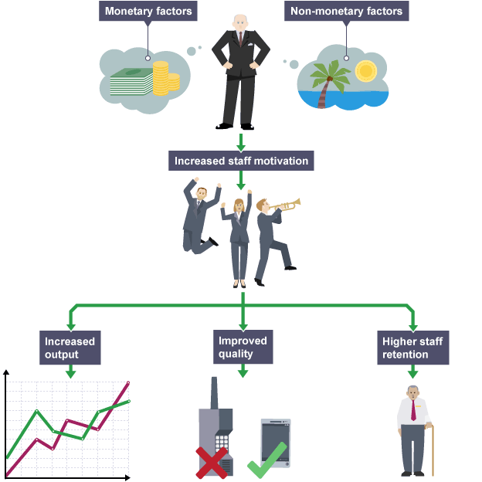
Communication is another form by which the employee finds his motivation. Permanent communication between employees and managers, between colleagues, helps in the correct transmission of information and in achieving the proposed goals. Richards, L. (2019).
Theories of motivation:
- Instincts- this teories suggest that behaviors are motivatesd by instincts. Sigmund Freus belived that this instincts or „id” as he called them, are a „part of mind that respond immediatly to what you want”. Freud(1999)
- Drives and needs- Maslow(1943) says that: „ motivation to fulfill a goal takes time and becomes stronger as time pass” Maslow(1943). He also suggested that managers need to know wich emplyee is more motivated and how to move all up into hierachy, all being equal motivated. Although, some employees can be self motivated, most of them need to be „pushed for the back”, and chalenged to perform thier tasks as best they can.
- Arousal levels: according to this theory every person has his own level of motivation. If our aurosal level is down, we sort some kind of stimulation to elevate them.
This theories are used in organisations as a model on understanding the human behavior, and there are crucial for management to run effectly the workplace. Therefore, employers should allways be offered different stimulant to workers to help the achieve their needs and climb into hierachy. Cherry, K. (2019)
A good way to motivate staff is by training. Having a multi task skill can increase productivity and motivation can be higher.
Training is an basic concept that helps to develop a particular skill by practice and instruction. Is very important because can help employees to increase productivity. To do his job more efficient and corectly. Training and development allows every company, big or small, to enjoy the benefits of well trained and skilled worplace. The medium allows itself for training to be made quikly and the cost to be spread widley. Collin Barrow(2003)
Training done properly, is a first trigger of motivation. The theory and practice, calmly transmitted, understood and adapted according to the level of each understanding, makes the individual feel appreciated and involved. Chand, S. (2016)
Definition of training: „Organized activity aimed at imparting information and/or instructions to improve the recipient's performance or to help him or her attain a required level of knowledge or skill.” BusinessDictionary.com. (2019)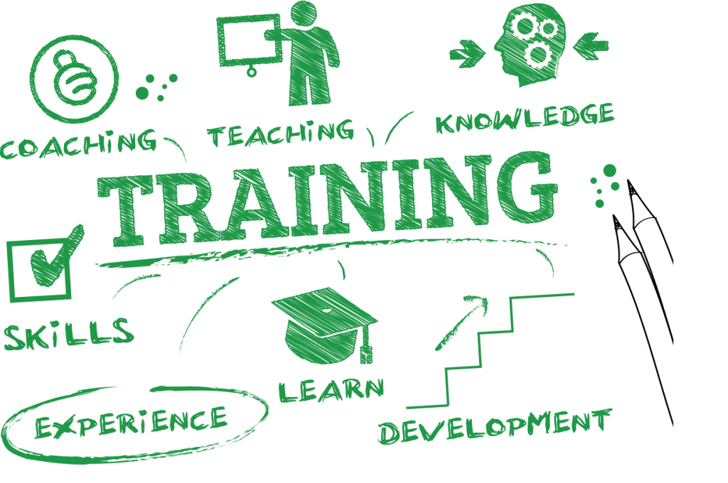
Companies today use more as they call: CPD wich stands as Continuing Professional Development and it is used to describe who professional activities can enhance with their abilities. This combines more methologies of learning such as: workshop activities, e-learning programes, conferences and ideas sharing. Doing that companies, ensure that qualification and academic are not out-dated. The CPD Certification Service. (2019)
By training people can learn new tehniques, information, methology and can refresh their skills. Equaly as important is how the training is delivered.
In the same time, there are disadvantages of training. Training employers can be costly, takes time and materials. Not just that they are mission importantly hours from work but can be additional costs aswell. Some companies reject the ideea of offering new trainig to employers, because of their past training experience. Sometimes past training was done poorly.
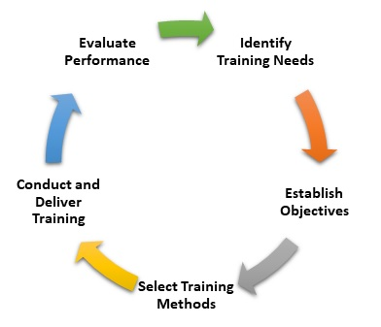

Relation between training and development:
Training | Development
Aim to develop skills | Aim to develop personality
Short term | Long term
Reactive process | Pro-reactive process
Initiative taken by manager | Initiative taken by individual
Meet the present need of employee | Meet the future need of employee

Task 2
2.1The benefits of motivation!
At Amazon, one of the most important foctor of motivation are the RSU. The company understands that money is a huge motivator especially if you already earned it. Employees have the chance to get visibility of their pay and this is a huge factor of motivation. And, this is not the only way to get motivated at Amazon. Learning and growth opportunities are as important as money are. He is paying bonuses, pension scheme and he offers a career choice programe whre the company pays 95% of the fee. According to Maslow Hieracy of needs, Amazon fulfills psyhological need. Medium. (2019)
A different way to keep staff motivated happends inside Google company. Google takes into account dependability. Every member of the team must be able to count into each other to do a qualify work. They do one to one mentoring and teach professional coursing for skill ranking. Google allows employees to spend 20% of their working time in developing their own innovative ideas. Fast Company. (2019)
Importance of motivation for employee!
There are lots of reasons that motivation is important for employee but the main one is for meet company’s goals. Without it company’s can lean to a risky situation. Employee motivation is important because of the benefits that comes with it:
- Increase commitment: when motivation is present, employee give their best on the specific task;
- Improve employee satisfaction: positive day at work, positive growth of company;
- Employee development: facilitate the development of employee and helps to reach his/hers personal goal.
- Employee efficiency: Efficiency of the employee is based on their skills and knowledge. Improving them can increase productivity and creates a balance between them.
A good reward sistem identify the employers who are doing the best on the specific job. Many employees need reward for motivation and to produce a quallity work. Public recognition, food, parties are one of many ways to motivate employees.
Importance of motivation for organisation!
The process of motivation has an important role in a company. This is mainly ensured by managers, and increase in employees mind the desire to work.
- Increase productivity: Motivation means the process to increase productivity. Combined with employee needs creates better effort on delivering into organisation his best
- Organisational efficiency: Motivation can change attitude into organisation. This allows the organisation be succesful
- Essure loyal workforce: An motivated employee is the best workforce. Motivation reduce turnovers and there is no need for new inductions;
- Reactive workplace: Adapting in a changing workplace is important. An organisation allways requires loyal and commintment for his employees. This helps organisation to adapt in changing situations.
The role of motivation is a simple way of understanding human behavior and mind. This stimulates employee and help to maintain his action. Importance of Motivation(2018)
2.2The importance of training:

For many years, Amazon has invested more in training all over the world, to create career ad live skill that employees need. Career skilll is a new and on-site programe that allows Amazon emplyees to improve at communication skills, interview and time management. They are responsible to upskill and train employees with living skills that offer higher pay. Having multiple training programs as career choice, leader orientation and softwer development and many others, they managed to promote more staff into higher position.
On Google, most of the training is related with IT skills. Employees, on 80% of the time, learn from emplyee-employee network and is called g2g( google to google). They participate to teaching courses, create design materials. Focused more on developing professional skills like leadership and negotiation, help employee to upskill for new opportunities. The rest of 20% are as they are called „vendors”, Google hired professional trainers that help the others, but only for content that are highly specialised.

For Organisation:
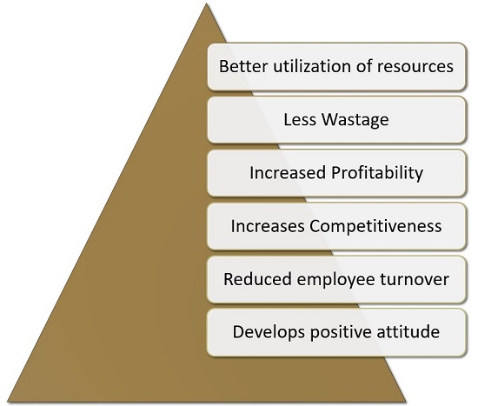
- It helps for a better ulizisation of resources: machine, money, etc;
- When employees are having a good and efficient training, the amount of waste in reduced as well as learning time;
- By improving performance of the employee results profitability;
- Having new and improve method to perform an activity, employee can help company to grow and compete;
- It will be no idle time and no absenteeism from employee;
- Shows positive attitude in employee morale, reduce turn overs, wich help them to adapt in changing environment.

For employee:
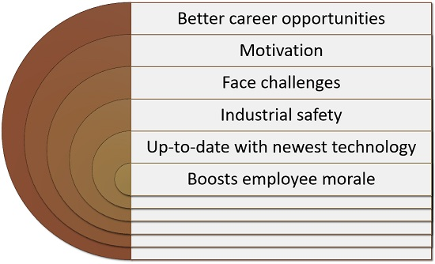
- Employee are focused more on their career and add new skill and knowledge to resume;
- Use motivation to improve performance, wich help them to perform much better and to increase their productivity and to contribute to company’s succes;
- Having a good training can help employee to face challenges in a better way;
- New technology can reduce the number of incedents in a company;
- Results a job satisfaction for employee and keep his morale up.

Task 3
Create a PDP!

Objectives | Measures | Priority | Support and Development | Review dates | Other comments
Improve communication between employees and manager | Managers to have a course where they can improve their communication skills | High | External | 04.12.2019 | Having more meeting between manager and employee is very important. Every week will be a 5 to 1 meeting, where employees can say theirs concerns.
Developing I.T skills | Attend a high level of Excell courses, face to face or online. | High | External | 20.02.2020 | Research for a good course that can up-level every employee I.T skill. To find a team member to be the shadower.
Employees to become more motivated | Offer employee an extra 15 min break+ a cup of coffee in the morning | Medium | Internal | 15.01.2020 | Free cofee and the 15 min break will be offered mid shift. This will motivate employees and will create a good relationship between them. This is very important when you want a trustful work environment.
Improve technology into company | Technology can improve the way staff carry out work. This can speed up the process, and employee to be more flexible | Medium | Internal | 18.06.2021 | Research what companies can offer the best prices and wich is available. It is very important to consider security and to manage cyber threaths. Smith, L. (2018)
Employees to have at least 3 trainings into different departments | Trainings will be offered in employee to employee method. After training shadow will be taken. | Medium | Internal | 16.04.2020 | When develop employees career, they became more motivated and more engage. This also helps the company when strugle with staff and reduce weariness.
Offer employees a play room. | Having playroom at workplace reduce fatigue, and it is a significant benefit for employee and employer. | Low | Internal | 09.11.2019 | Playroom at workplace enhace productivity due the stress free environment. This keep employees relaxed and happy. Hamptom, S. (2018)

Conclusion
In conclusion, the most important thing to consider, beyond all the solutions you have available, is to show openness and to always pay attention to your employees. This way you will make it much easier to choose the best approach for each one. Motivational techniques, regardless of how they are classified or used, start from the following premise: the greater the feelings of belonging and involvement in a company the more loyal and happy will be the employees at work. !
„Motivation needs are related to work itself, and how chaleenging the work is” Sharlyn J Lauby(2004)

References

- Barrow, C. (2003). E-training and development. 1st ed. Oxford, United Kingdom: Capstone Publishing.
- BusinessDictionary.com. (2019). What comes after those ellipses?. [online] Available at: http://www.businessdictionary.com/definition/training.html [Accessed 4 Dec. 2019].
- Chand, S. (2016). 7 Benefits of Training Employees for an Organization. [online] Your Article Library. Available at: http://www.yourarticlelibrary.com/employee-management/7-benefits-of-training-employees-for-an-organization/27914 [Accessed 9 Dec. 2019].
- Cherry, K. (2019). 6 Key Ideas Behind Theories of Motivation. [online] Verywell Mind. Available at: https://www.verywellmind.com/theories-of-motivation-2795720 [Accessed 5 Dec. 2019].
- Clayton Alderfer(1969)- Organizational Behavior and Human Performance
- CPD - The CPD Certification Service. (2019). CPD Explained. [online] Available at: https://cpduk.co.uk/explained [Accessed 7 Dec. 2019].
- Fast Company. (2019). This is how Google motivates its employees. [online] Available at: https://www.fastcompany.com/90230655/how-google-motivates-its-employees [Accessed 1 Dec. 2019].
- Freud, Sigmund. The Standard Edition of the Complete Psychological Works of Sigmund Freud. Vol. XIX (1999) James Strachey
- Hamptom, S. (2018). Benefits of Having a Playroom for Employees at Work. [online] Indramarketing.com. Available at: https://www.indramarketing.com/benefits-of-having-a-playroom-for-employees-at-work/ [Accessed 9 Dec. 2019].
- Janowiak, A. (2018). 5 Ways to Show Professionalism in the Workplace | The Conover Company. [online] The Conover Company. Available at: https://www.conovercompany.com/5-ways-to-show-professionalism-in-the-workplace/ [Accessed 1 Dec. 2019].
- Lauby, S. (2004). INFOrmation liveLINE. 1st ed. Florida: ASTD Press
- Management Study HQ. (2018). Importance of Motivation in an Organisation - Management Study HQ. [online] Available at: https://www.managementstudyhq.com/importance-of-motivation-in-an-organisation.html [Accessed 8 Dec. 2019].
- Maslow, A.H. (1943). "A theory of human motivation". Psychological Review.
- Medium. (2019). How Amazon uses money to motivate employees. [online] Available at: https://medium.com/@objoutlook/how-amazon-uses-money-to-motivate-employees-8e059f5a9698 [Accessed 4 Dec. 2019].
- Rework.withgoogle.com. (2019). re:Work - Guide: Create an employee-to-employee learning program. [online] Available at: https://rework.withgoogle.com/guides/learning-development-employee-to-employee/steps/introduction/ [Accessed 8 Dec. 2019].
- Richards, L. (2019). How Effective Communication Will Help an Organization. [online] Smallbusiness.chron.com. Available at: https://smallbusiness.chron.com/effective-communication-organization-1400.html [Accessed 9 Dec. 2019].
- Saylordotorg.github.io. (2019). Theories of Motivation. [online] Available at: https://saylordotorg.github.io/text_organizational-behavior-v1.1/s09-theories-of-motivation.html [Accessed 27 Nov. 2019]
- Smith, L. (2018). 7 Ways to Improve Workplace Productivity Using Technology - Thrive Global. [online] Thriveglobal.com. Available at: https://thriveglobal.com/stories/7-ways-to-improve-workplace-productivity-using-technology/ [Accessed 9 Dec. 2019].
- Stafftrainingsolutions.co.uk. (2017). Benefits of Training to Employees and Employers | benefits of training and development in an organisation. [online] Available at: https://www.stafftrainingsolutions.co.uk/sts-blog/benefits-of-training-to-employees [Accessed 9 Dec. 2019].
- tutor2u. (2019). Motivation - Introduction | Business | tutor2u. [online] Available at: https://www.tutor2u.net/business/reference/motivation-introduction [Accessed 28 Nov 2019].

