2029760@student.uwtsd.ac.uk
[Email address]
UNIVERSITY OF WALES-TRINITY SAINT DAVID
SCHOOL OF BUSINESS-LONDON CAMPUS
MANAGEMENT ECONOMICS-LCBB5008
TAUGHT BY MR. RIAZ BHATTI
ASSESSMENT 1

STUDENT: XENIA MARIANA PAUN-2029760
HP Inc.
Company’s history
Hewlett Packard was formed in a one-car garage in Palo Alto when two electrical engineers, Bill Hewlett and David Packard, were inspired by their professor after attending a scientific talk (Hewlett-Packard 2023). This was back in the year 1939 (Hewlett-Packard 2023). The company initially produced a line of electronic test and measurement equipment (Hewlett-Packard 2023). Its first deal was with the Walt Disney company when the company was producing the movie Fantasia, whereby the HP’s oscillator HP 200A was used in the film (Hewlett-Packard 2023). This contract helped establish HP as a go to technology company for all hardware and software business and personal needs.
The company went on to grow into a multinational company serving not only the people of USA but also becoming one of the leading computers and print manufacturers and distributors. The company however had a spin off affecting its structure and composition on 1st November 2015 into two companies that is HP Inc. that deals in the manufacture of personal computers (PCs), printers and other related supplies not forgetting its operation and involvement in 3D printing solutions (Hewlett-Packard 2023). The other company is Hewlett Packard Enterprise Company which is a multinational information technology company (Hewlett Packard Enterprise 2023).
The company delves in a number of industries namely computer hardware and software together with having a footing in IT services and consulting (Hewlett-Packard 2023). Its major product lines include personal computing devices, enterprise and industry standard servers, related storage devices, networking products and a range of printers as well as other imaging devices (Hewlett-Packard 2023). The markets that HP majorly deals in are households, small to medium sized businesses and enterprises, online distribution, consumer electronics and office supply retailers not forgetting other software partners and major tech vendors (Hewlett-Packard 2023). This certifies HP as a leading technology company that not only has a huge market share but is also key on the quality of its products and services.
The product of choice from this company is Personal computers (PCs) product line. This encompasses notebooks and desktops developed and sold by HP. The reason behind this product selection is because this product has over the last three or so years gained popularity in usage and demand across a wide demographic thus necessitating the need to determine how factors affecting demand including price and consumer tastes and preferences affect the demand of PCs in the wider technology market. this will help shine a light on how PCs market is fluctuating and operating in the economy.
Demand and market equilibrium
This is used to demand the demand of a certain commodity and how this demand in comparison to supply brings about the market equilibrium of a product or service. The following are some of the factors affecting demand and the effect that they have on the commodity in question which in this case are HP PCs.

Price of substitute
The product substitute for this PCs is those offered by Dell which is also an American company that closely competes with HP for market share and dominance. Dell was established in 1984 by Michael Dell in Round Rock Texas and has grown to become one of the leading providers in computer tech. the price difference between that of HP and Dell PC products is not that big and it is as a result of them being close substitutes. This however does not mean that their products are identical in pricing. HP PCs are slightly expensive as compared to Dell but this has not deterred consumers from purchasing HP PC products (White, 2022). This difference in price is attributed to the fact that HP does not compromise in terms of the quality of its products be it in the design or even in it hardware and software components (White, 2022).
From current market trends it is evident that although Dell products may not be as optimal in quality as those offered by HP, and thus the lower pricing, this does not mean that it has been slacking and letting HP take the lead (White, 2022). Dell has been working tirelessly to offer cheap and quality products and they are not far behind in claiming the top spot in terms of market share considering the 1% difference in market size. This goes to show that a decrease in price of Dell products while not compromising in quality will mean a reduction in demand for HP PCs in favor of those sold by Dell.

Company | 2Q21 Shipments | 2Q21 Market Share (%) | 2Q20 Shipments | 2Q20 Market Share (%) | 2Q21-2Q20 Growth (%)
HP Inc. | 4,292 | 28.4 | 4,960 | 31.6 | -13.5
Dell | 4,190 | 27.7 | 4,095 | 26.1 | 2.3
Apple | 2,427 | 16.1 | 2,325 | 14.8 | 4.4
Lenovo | 2,080 | 13.8 | 2,290 | 14.6 | -9.2
Microsoft | 651 | 4.3 | 716 | 4.6 | -9.0
Others | 1,482 | 9.8 | 1,317 | 8.4 | 12.6
Total | 15,123 | 100.0 | 15,703 | 100.0 | -3.7
(Gartner says worldwide PC shipments grew 4.6% in second quarter of 2021 2021)

Price of complements
PC complements include but are not limited to storage devices, pointing devices, detachable keyboards and mice, audio devices and even gaming accessories such as gaming pads and joysticks. In this particular case we will look at two compliments in particular. The first one in consideration is external storage devices or HDDs that have been on the rise in demand due to increase in data and creating the need for detached storage that acts as backup in case the PC crushes. With the US in particular being the largest consumer of computer accessories their value is bound to increase due to increased demand (Computer accessories market by product, end-user, and geography - forecast and analysis 2023-2027 2022). However, due to the advent of cloud services there is the possibility that demand for HDDs may stagnate or reduce in the near future indicating a drop in prices (Computer accessories market by product, end-user, and geography - forecast and analysis 2023-2027 2022).
The second complimentary good is gaming accessories which have risen in popularity due to the popularization of E-gaming which so far has 2 billion participants (Computer accessories market by product, end-user, and geography - forecast and analysis 2023-2027 2022). This number of users is bound to increase over the coming years as more and more people take it up as a career that they can earn from. This is just but an indication that the price of these gaming accessories is bound to increase if the laws of demand are to be applied. The increase in price will not affect the demand of PCs as gamers are in need for higher processing powers in their PCs and thus are willing to sacrifice an extra dollar for such indulgence.

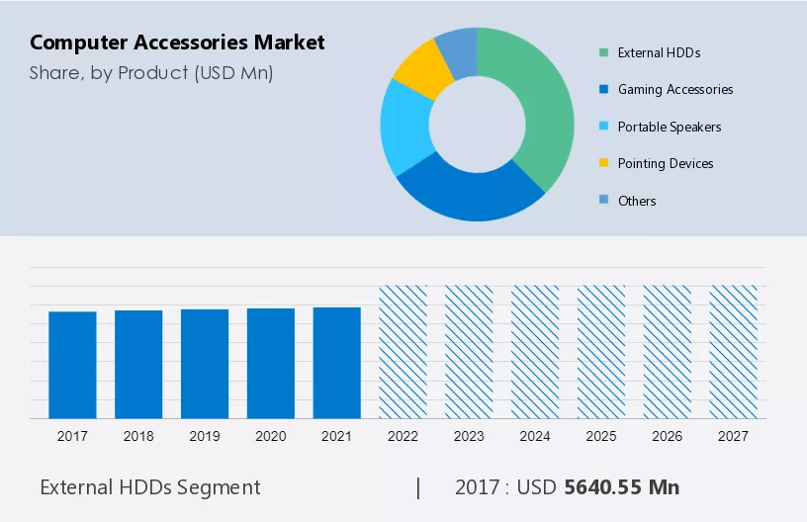
(Computer accessories market by product, end-user, and geography - forecast and analysis 2023-2027 2022)

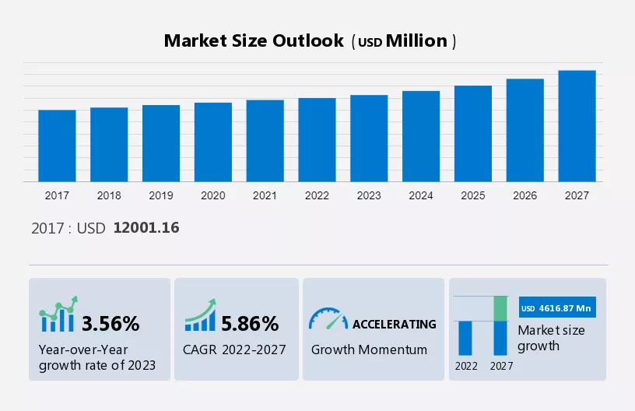
(Computer accessories market by product, end-user, and geography - forecast and analysis 2023-2027 2022)

Consumer income
With governments actively involved in restructuring and regulating monetary policy in order to deal effectively with the effects caused by rising inflation and increased political instability, it is the citizens income that suffers the most. if the government decides to increase the disposable income of its citizens for them to be able to buy just as much commodity as they did pre-inflation it would not make for a significant difference in terms of the demand for PCs. However, if the increase in disposable income remains the same even after inflation rates have been regulated then it means that their purchasing power would have been increased and that demand for PCs would increase in the long run.
This increase also applies to corporates who are forced to make salary increments in order to maintain top talent in their companies. The increment makes it possible for employees or possible consumers of the PCs to have enough income to be able to afford one.

Consumer tastes and preferences
The tastes and preferences of consumers has been changing over the last couple of years. There has been a tremendous inkling towards gaming and e-gaming in particular. This has necessitated a need for gaming laptops and desktops which have a higher processing power and accompanying accessories. This has led to increased demand for this PCs but due increased manufacturers of the same this demand has not led to an accompanying increase in prices but has led to reduction of these prices. This is not necessarily a bad thing for PC companies such as HP Inc as this gaming PCs fetch a significant sum of money despite the slightly lower prices. They can therefore be termed as high-income earners of the company.
The working at home craze that began during the covid pandemic has seen to it that most consumers have seen the need for desktops and portable notebooks so as to accomplish such functions. Remote learning also saw an increase in demand for PCs on a worldwide scale making manufacturers such as HP Inc to milk great revenue from it. This change in tastes and preferences is just but a plus to HP as revenue generation is at its peak owing to the fact that PC consumption grew by the highest proportion in 2021 with over 341 million PCs being shipped worldwide (Rubino, 2022). This has been the highest shipment of PCs since 2012.

Consumer expectation of price
The price of PCs is expected to decrease as the years go by due to the fact that there are a variety of developers who have greatly widened the supply of PCs in the market. consumers thus have plenty to choose from and they have the luxury of purchasing according to their desired quality and amount they are willing to spend. This should however be considered in line with the fact that there have been semiconductor shortages due to disruptions of the supply chain caused first by the covid 19 pandemic and further escalated by the war n Ukraine. Demand has however increased irrespective of the underlying detrimental factors. So, despite the mishaps price is expected to remain stable and unaffected but it has the potential of increasing to cater for changes in cost incurred due to unforeseeable circumstances such as the pandemic.

Demographics
The number of potential customers has seen a tremendous increase over the years as both the young and the old are host to the technological wave that has taken over the world by storm. This require individuals to purchase PCs may it be for academic purposes for the young who are undertaking remote classes or even for work related purposes for those required and permitted to work from home. This wider demographic reach has seen the demand for PCs skyrocket since 2020 and even the easing of movement restrictions has not dampened the momentum gained. Demand is coming not only from businesses and institutions of learning but also from personal consumers who see the need to keep tabs with the needs and requirements of the digital age.

Price elasticity of demand
This is a measurement by which change in demand of a good or service is measured in relation to a change in its price (Team, 2022). The analysis below aims to highlight if HP PCs are a luxury product or if they are a necessity and if the product is elastic or inelastic in terms of its price elasticity of demand. The analysis will further go on to show if the good represents a large or small portion of their income. Finally, a pricing policy shall be proposed that will best fit the needs of this product.

Luxury or necessity?
The above product range which is HP PCs is what can be categorized as a luxury commodity. This is attributed to the fact that its purchase signifies a large portion of consumer income. It is also worth mentioning that having a PC is not a matter of life and rather but rather it’s a case of preference and desire for a certain level of comfort or higher utility from an economic perspective. However, despite it not being a necessity people have a high affinity towards purchasing one. This is due to some factors such as educational purposes such as remote learning as was evidenced during the pandemic. Work was also affected and PCs had to be bought by those required to work from home due to workplace restrictions. This was made possible by the advancement in technology and growth in technological knowhow in the general population.
It is indeed a luxury due to the significant dent in a persons income once one acquires a PC but all the same people have the need for it though not as an essential commodity.

Elastic or inelastic
The above product range is without a doubt inelastic in demand. This is due to the fact that a change in the price of a HP PC product does not severely affect its change in demand. This change in price can be drastic that they may end up affecting the demand of the product. consumers will now prefer to purchase a close substitute instead of breaking the bank to purchase a HP PC.
Price elasticity is very important as it works as a guide to market analysts who would wish to introduce a product in the market or improve one already in the market. the aim is always to have a price elasticity that favors the product whether or not the price is inflated or not. Demand either remains the same or increases in favor of the parent company. Seeing as the product is a luxury commodity its price elasticity of demand is definitely an inelastic demand. This can be explained by the fact that if someone desires to buy a certain type of PC for a particular reason and functionality then that person will see it fit to purchase it at whatever cost. However if he or she desires to just upgrade an increase in the price of that commodity might deter the consumer from purchasing it at that particular point in time. The consumer might decide to buy it later when there is a discount or just look for another cheaper brand. As can be seen above despite the PCs being relatively costly, they are still essential and crucial in the current digital age. sales are on the up yet prices are still relatively high. This can be attributed to increase in production costs and delays in the supply chain as a result of the semiconductor shortage.

Impact on consumer income
This impact refers to how significant a portion of ones disposable income subject to be spent when one decides to purchase a PC. Of course, there are cheaper PCs available but they do sometimes falter on quality making the more of a liability than an investment. However, PCs are not cheap and they are thus not affordable to everyone. This may soon be a long forgotten issue due to the fact that institutions and various offices tend to do the heavy lifting in terms of equipment provision for their students and staff respectively. Governments are also intervening to provide subsidies for the consumer to work as an incentive to buy.
The product line requires one to put in a huge investment for one to access better quality and durability in the product. this makes the product a luxury and is dependent on whether the consumer really needs it or just wants to improve the quality of their lives. This is indicative of the fact that the product is inelastic in nature and thus its demand is not affected as much by a change in price.

Pricing policy
Based on the above findings the business that is HP Inc should implement a value-based pricing policy (Everything you need to know about pricing policy | indeed.com 2022). This is because it operates in an ecosystem by which other products in the market are just as competitive and thus the pricing should be in lieu as that of the competitors (Everything you need to know about pricing policy | indeed.com 2022). For example HP should do a market research on the pricing model of Dell and make informed decisions on how to price their own products.
The value-based pricing policy is effective in that it keeps prices at a competitive level and even enables competitors to learn from each other as the technology industry is ran by Research and Development and what better way to learn than from your opponents. The value in the word is also significant as the products are priced as per the value of its components and overall costs incurred in its production. It is the value being priced not just the product. HP will be able to build a competitive advantage by not only offering quality products but also pricing them very well.
The comparison was done against Dell instead of Lenovo, which is the leading manufacturer and supplier of PCs in the world. This is because HP and Dell are both in USA and thus the competition is stiffer and easily observed. This pricing policy will enable HP to take back its top spot and topple Lenovo while at it.

Bibliography
31 -May -2022 hp, inc. - s2.q4cdn.com (2022) HPQ. Available at: https://s2.q4cdn.com/602190090/files/doc_financials/2022/q2/HPQ-Q2'22-Earnings-Transcript.pdf (Accessed: March 31, 2023).
Alsop, T. (2022) HP Inc's net revenue 1998-2021, Statista. Available at: https://www.statista.com/statistics/265001/hewlett-packards-net-revenue-since-1998/ (Accessed: March 31, 2023).
Alsop, T. (2023) HP PC market share by quarter 2022, Statista. Available at: https://www.statista.com/statistics/298967/pc-shipments-worldwide-hp-market-share/ (Accessed: March 31, 2023).
Alsop, T. (2023) PC vendor market share by quarter 2022, Statista. Available at: https://www.statista.com/statistics/269703/global-market-share-held-by-pc-vendors-since-the-1st-quarter-2009/ (Accessed: March 31, 2023).
Alsop, T. (2023) PC vendor market share worldwide 2022, Statista. Available at: https://www.statista.com/statistics/267018/global-market-share-held-by-pc-vendors/ (Accessed: March 31, 2023).
Computer accessories market by product, end-user, and geography - forecast and analysis 2023-2027 (2022) Technavio. Available at: https://www.technavio.com/report/computer-accessories-market-industry-analysis (Accessed: March 31, 2023).
Everything you need to know about pricing policy | indeed.com (2022) indeed.com. Available at: https://www.indeed.com/career-advice/career-development/pricing-policy (Accessed: March 31, 2023).
Hewlett Packard Enterprise (2023) Wikipedia. Wikimedia Foundation. Available at: https://en.wikipedia.org/wiki/Hewlett_Packard_Enterprise (Accessed: March 31, 2023).
Hewlett-Packard (2023) Wikipedia. Wikimedia Foundation. Available at: https://en.wikipedia.org/wiki/Hewlett-Packard (Accessed: March 31, 2023).
HP Inc 's (2022) CSIMarket. Available at: https://csimarket.com/stocks/compet_glance.php?code=HPQ (Accessed: March 31, 2023).
HP Inc.. (2023) Wikipedia. Wikimedia Foundation. Available at: https://en.wikipedia.org/wiki/HP_Inc. (Accessed: March 31, 2023).
Miller, K. (2022) Detailed and meticulous pestle analysis of Hewlett-Packard, Crowjack. Available at: https://crowjack.com/pestle-analysis/hp (Accessed: March 31, 2023).
Rubino, D. (2022) Report: Record-breaking 341 million pcs shipped in 2021, highest since 2012, with 'digital acceleration' for 2022, Windows Central. Windows Central. Available at: https://www.windowscentral.com/canalys-pc-market-2021-report (Accessed: March 31, 2023).
Team, T.I. (2022) Price elasticity of demand meaning, types, and factors that impact it, Investopedia. Investopedia. Available at: https://www.investopedia.com/terms/p/priceelasticity.asp (Accessed: March 31, 2023).
White, S. (2022) Dell vs. HP: Which Brand is better and why in 2023, Comeau Computing. Available at: https://www.comeaucomputing.com/dell-vs-hp/ (Accessed: March 31, 2023).
Gartner says worldwide PC shipments grew 4.6% in second quarter of 2021 (2021) Gartner. Available at: https://www.gartner.com/en/newsroom/press-releases/2021-07-12-gartner-says-worldwide-pc-shipments-grew-4-point-six-in-second-quarter-of-2021 (Accessed: March 31, 2023).

