AN EXEMPLAR OF MODERN ARCHITECTURE - THE SCHRODER HOUSE BY GERRIT REITVELD
(FIGURE 1 -theartstory.org, n.d)
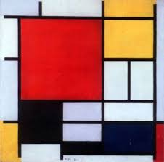
DE STIJL
The De Stijl movement originated in the Netherlands in 1917.The style includes the use of only a limited palette of primary colours and horizontal and vertical lines. Piet Mondrian’s artwork greatly influenced the movement – seen on the right, and so he became one of the leading activists of the movement along designer Theo Van Doesburg and furniture designer Gerrit Reitveld (Sveiven, M, 2010).

HISTORICAL BACKGROUND
The Schroder House is a globally well-known icon of modern architecture, the only building seen as a true embodiment of the De Stijl style in the world. The house was built in 1925 in Utrecht, The Netherlands, designed by Gerrit Reitveld – a Dutch furniture designer (Lisa, 2012).
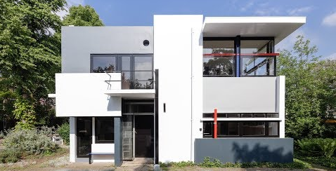
Truss Schroder approached Reitveld to design the house, after her husband passed away, for her and her three children. She wanted a house designed to fit with her unconventional ideas about what a home should be, which can explain why she chose to work with Reitveld who was known for his disregard for tradition in his designs.
Mrs Schroder lived in the house from 1925 until 1985. After her death, the house was left to the Reitveld Schroder House Foundation and the Centraal Museum. The building was added to the UNESCO World Cultural Heritage list in 2000 (iDesign, 2018).
(FIGURE 2 – REITVELDSCHRODERHUIS.NL, n.d)

PLAN AND SECTION
GROUND FLOOR
(FIGURE 3 – archdaily.com, n.d)
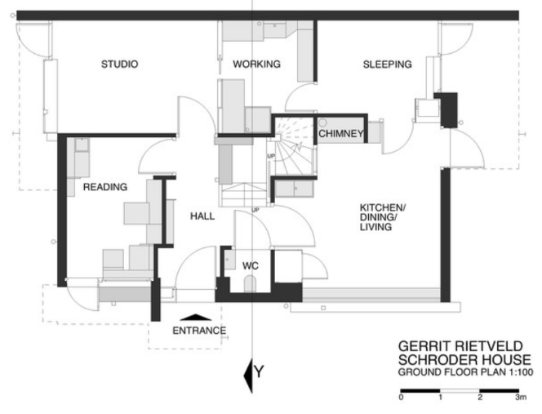
The ground floor layout is the most conventional part of the design, having a more closed off ‘traditional’ fixed layout (as seen on the right) consisting of a studio/working area, a bedroom, reading room and a large multi-use kitchen/dining/living area, all of which is placed around a central fireplace and staircase (Lane, 2014). He also ensured that all main areas of the ground floor had access to the outdoors. The static layout of the downstairs was kept simple as Reitveld knew the design needed to pass the building regulations in Utrecht at the time (Merchant, S, 2012).
However, this in no way defines the ground floor as traditional, in fact many elements of the design were revolutionary for the 1920s. One example of this is the staircase being concealed behind a sliding door, a red lever can be pushed to reveal the hidden stairway (Panda, C, 2019) – a feature likely never seen before in a small domestic house This not only created a quiet spot for the occupants to use the telephone but also acts as a draft stop between both floors.

FIRST FLOOR
Upstairs, there are three bedrooms and a living area placed around a central staircase. Moveable partition walls enabled the family to create a dynamic open plan space for the children to play in throughout the day, and when evening came the partition walls could be slid back into place to divide up the space for privacy. This is the main design feature of the house, Mrs Schroder did not want a static layout, but instead an open interactive zone that could adapt to her family’s needs. This idea of open plan living was a very new concept in the 1920s and is now used in most modern homes and building today.
The walls provided a wide variety of possible layouts, with each providing its own unique spatial experience. When the partition walls were closed, this led to the creation of new spaces including a hallway, which led into 2 large bedrooms, a living dining space and a small private bedroom at the back of the house for Mrs Schroder. The change in layout can be seen in the plans below, closed partitions on the left and open on the right.
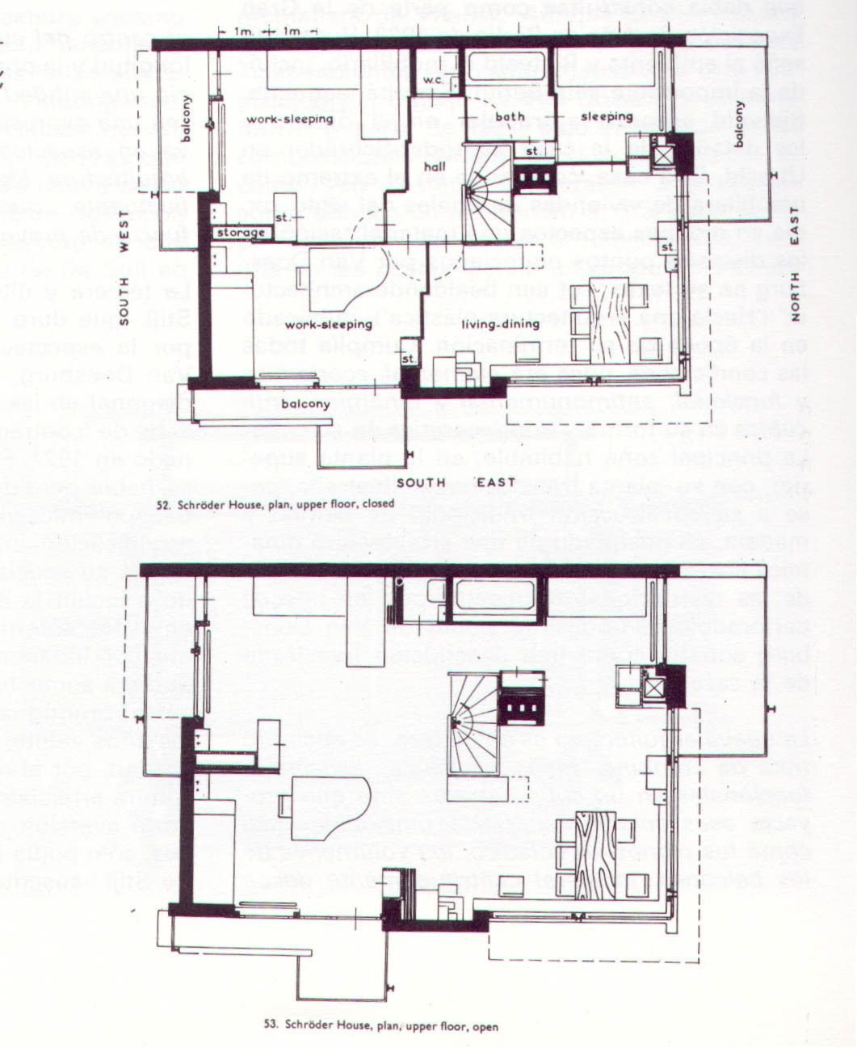
(FIGURE 4 – plansofarchitecture.tumblr.com, n.d)

Lots of the furniture pieces designed for the house were interactive, Mrs Schroder had a very ‘active attitude to life’, so the beds were designed to turn into sofas during the day and pop up tables were created to be able to maximise space when they were not in use (Hill, A, 2010). Reitveld’s famous red and blue chair, which became a symbol of the De Stijl design, was a feature of the house. Just like the architecture, the chair consists of simple linear pieces of wood, in the primary colours of De Stijl (Romeo, A, n.d.).
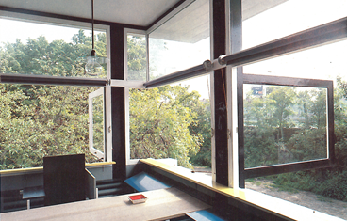
The first floor features the iconic corner less window, that can swing open leaving no corner post – shown in figure 5. This is one of the most unique features of the design, which dissolves the corner boundary of the room to bring the outside in. It can be seen throughout the design, that Reitveld’s aim was to make the transition between the inside and out blur (Vinci, R, 2018). To uphold the De Stijl style, the windows opened to a 90-degree angle, this was to ensure that the windows remained perpendicular to the building to maintain the standard of intersecting planes (Panda, C, 2019).
(FIGURE 5 – Lane, J, 2014)
EXTERIOR
Reitveld made no attempt to design the house to blend in with the neighbouring ‘traditional’ buildings, in fact he wanted to create something with quite the opposite effect.
The facades of the building is merely a collage of planes and lines, all seemingly gliding past each other. Symmetry has no place in the design, with no 2 elements being of the same size or shape - each element has its own colour and form. The house consists of neutral tones of white, black and grey, with primary coloured components such as window transoms , mullions and steel beams .
From the front of the house overlooking what once was an undeveloped field, noticeably a horizontal plane projects out over a strip of windows, providing shade from the sun into the main living space. Reitveld carefully considered how the planes would not only work aesthetically in elevation but also how they would work three dimensionally (in this case, to provide a beneficial function by stopping too much direct sunlight entering).
(FIGURE 6 – author, 2020)
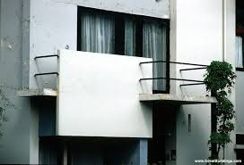
When designing the house, Mrs Schroder requested that all bedrooms must have access to the outdoors (Panda, C, 2019) – Reitveld achieved this by carefully planning the intersection of rectangular planes to form small balconies. The most extraordinary element of the structure is undoubtedly the balcony on the front of the building, where a cantilevered concrete slab appears to be floating between the two floors -a ground-breaking design for the 1920s – this can be seen in the sketch to the left and a close up view in photo below.

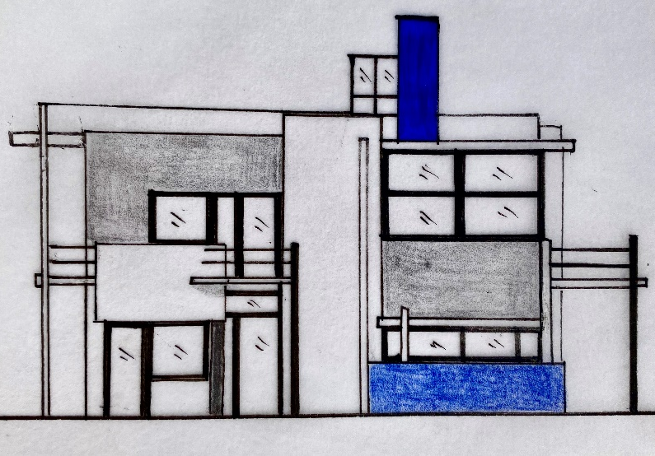
(FIGURE 7 – greatbuildings.com, n,d)
One criticism for the building may be the lack of utilization of the roof space, while a ladder is fitted to the house to reach the roof, it was not widely used. Rather than just simply enclosing the interior space, most other pioneering buildings of this time optimised space beyond the walls of the house with roof terraces – e.g. shown in the Villa Savoye, but the Schroder House lacked this (architecture.org.nz, 2016).

MATERIALS COLOURS AND LIGHT
Concrete was a new material during this time, so it would have been too costly to construct the whole house from this, like Reitveld initially intended. The architect did not have much experience with this material either, which may be another reason why so little of it was used. Only the balcony slabs and foundations were made from concrete, while the rest of the house made from traditional brick with plaster. The balcony slabs however could not be supported by the brick walls alone, so therefore a steel beam was used to support this (Merchant, S, 2012).
(FIGURE 8 – Bekker, H, 2017)
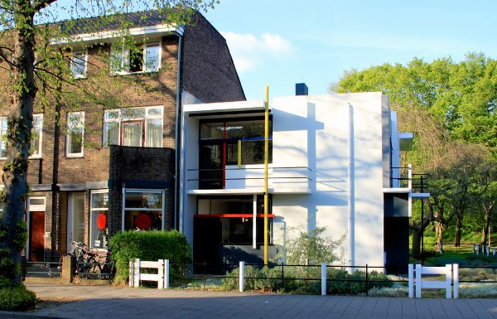
Unlike the surrounding traditional buildings, the house has large doors and strip windows which allows a vast amount of natural light into the living spaces, and with the partition walls open, this light travels throughout the whole of the upper floor. The house also features a rectangular roof light above the staircase which adds to the natural light within the room and shines light into what would otherwise be a dark staircase. The contrast between the Schroder House and the neighbouring building can be seen on the right.
Reitveld was also very clever with the use of paint, much of the interior is painted white to give the illusion of space, with splashes of primary colours along windowsills, ceiling rails and small sections of the wall.
(FIGURE 9 – archdaily.com, n.d)
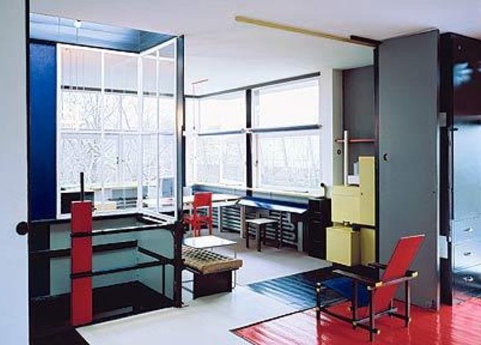
He craftily painted surfaces that were touched often in black, to prevent them getting stained such as rails and door frames, including the kitchen doors which had strips of black paint where they would be frequently touched (Turtle, 2019). The floor was also painted, with different colours marking different sections, so while the space remained open planned, the parameters of each space were marked out. De Stijl architecture does not permit the inclusion of sculptures and paintings, instead the colours of the walls and elements within the design is the decoration in itself (architecture.org.nz, 2016).

Overall, from first glance at the Schroder House it is clear that this building is anything but a traditional home. The Schroder House is unlike any other pioneering modern buildings at the time. Reitveld’s design was ahead of its time in the 1920s and yet still seems as futuristic now, 100 years later.
This style of architecture has done away with static separation of space, to create open plan living, an idea which is widely used today. ‘Form follows function’ within his design, so much so that every element has a practical mean. The building lacks any form of symmetry and order, the facades are simply collage of planes which work together to become a Mondrian painting come to life in 3D.
Reitveld was able to design the house in line with Mrs Schroders dreams of ‘living without walls’ and created her ideal zone by bringing the outdoors inside. The Schroder House perfectly encapsulates the key principles of De Stijl architecture and is the only building in the world to do so.
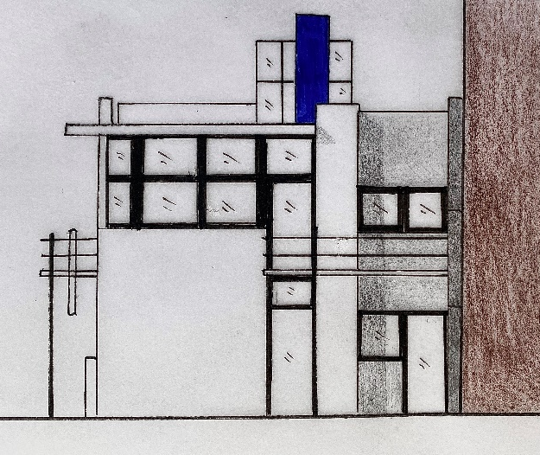
(FIGURE 10 - AUTHOR, 2020)

REFERENCES
IMAGES
FIGURE 1 – theartstory.org, n.d. Piet Mondrian Composition 1921 painting
FIGURE 2 – REITVELDSCHRODERHUIS.NL, n.d. Photograph of the front façade of the Schroder House
FIGURE 3 – archdaily.com, n.d. Schroder House ground floor plan
FIGURE 4 – plansofarchitecture.tumblr.com, n.d. Schroder House first floor plans open and closed partitions
FIGURE 5 – Lane, J, 2014. Schroder House corner less window
FIGURE 6 – AUTHOR, 2020. Sketch of the Schroder House facade
FIGURE 7 - greatbuildings.com, n.d. Schroder House balcony
FIGURE 8 – Bekker, H, 2017. Schroder House and the neighbouring building
FIGURE 9 – archdaily.com, n.d. Interior of the Schroder House
FIGURE 10 – AUTHOR, 2020, Schroder House sketch
WEBSITES
Sveiven, M., 2010. AD Classics: Rietveld Schroder House / Gerrit Rietveld. [online] ArchDaily. Available at: <https://www.archdaily.com/99698/ad-classics-rietveld-schroder-house-gerrit-rietveld> [Accessed 19 April 2020]
Lisa, A., 2012. Supermodern 1920'S Rietveld Schröder House In Utrecht Is A Simple, Elegant And Completely Transformable Home. [online] Inhabitat.com. Available at: <https://inhabitat.com/1920s-rietveld-schroder-house-in-utrecht-is-a-simple-elegant-and-completely-transformable-home/gerrit-rietveld-adaptable-rietveld-schroder-house-utrecht-9/> [Accessed 19 April 2020]
Idesign.wiki. 2018. Schröder House (1925) – I Design. [online] Available at: <https://www.idesign.wiki/schroder-house-1925/> [Accessed 19 April 2020]
Lane, J., 2014. Rietveld-Schroder House. [online] Art-now-and-then.blogspot.com. Available at: <https://art-now-and-then.blogspot.com/2014/01/rietveld-schroder-house.html> [Accessed 19 April 2020]
Merchant, S., 2012. DIAGRAMS: AN IN-DEPTH ANALYSIS OF THE DESIGN OF THE RIETVELD-SCHRODER HOUSE. [online] Rietveldschroderhouse.blogspot.com. Available at: <http://rietveldschroderhouse.blogspot.com/2012/12/diagrams-in-depth-analysis-of-design-of.html> [Accessed 19 April 2020]
Panda, C., 2019. Rietveld Schroder House In Utrecht: The Only De Stijl Building In.... [online] The Adventures of Panda Bear. Available at: <https://www.theadventuresofpandabear.com/de-stijl-architecture-rietveld-schroder-house-utrecht-netherlands/> [Accessed 19 April 2020]
Hill, A., 2010. Interior Design: The Schröder House In Utrecht. [online] Telegraph.co.uk. Available at: <https://www.telegraph.co.uk/lifestyle/interiors/7036984/Interior-design-The-Schroder-House-in-Utrecht.html> [Accessed 19 April 2020]
Romeo, A., n.d. Gerrit Rietveld's Red And Blue Chair & What I Learned About Rest And Motion In Myself - TERRAIN GALLERY. [online] TERRAIN GALLERY. Available at: <https://terraingallery.org/art-criticism/gerrit-rietvelds-red-and-blue-chair-what-i-learned-about-rest-and-motion-in-myself/> [Accessed 19 April 2020]
Vinci, R., 2018. Iconic Houses: Rietveld Schröder House. [online] Archilovers. Available at: <https://www.archilovers.com/stories/27133/iconic-houses-rietveld-schroder-house.html> [Accessed 19 April 2020]
Architecture.org.nz. 2016. My Favourite Modernist Building … Rietveld-Schroder House – Architectural Centre. [online] Available at: <https://architecture.org.nz/2016/10/20/my-favourite-modernist-building-...-rietveld-schroder-house/#_ftn1> [Accessed 19 April 2020]
Turtle, M., 2019. Rietveld Schroder House, Utrecht, The Netherlands. [online] Time Travel Turtle. Available at: <https://www.timetravelturtle.com/rietveld-schroder-house-utrecht/> [Accessed 19 April 2020]

