Effective Team Work and Communication

Module Code: BMSK4002
Student Name: Corneliu Iacoban
Student ID:1813024
Lecture’s Name:Christopher Mafuva

Contents
Introduction 1
1. Discussing the performance of employers at communicating in the workplace through different communication situation. 2
1.1 Discussing different organisation's communication situation. 2
1.2 Concluding the communication situation. 4
2. How to improve workplace communication and performance of teamwork. 6
2.1 Applying 7 C’s communication model to improve workplace communication and performance. 6
2.2 Applying theory on effective teamwork. 8
Conclusion 10
References 11

Introduction
Communication in businesses refers to the transportation of information among individuals and groups within the organization or how the company share information to promote its products and services to potential customers (Cartwright, 2012). The capability of effective communication with superiors, colleagues and staff is crucial for any industry no matter where you work. Employers who invest time and energy in a clear line of communication are able to produce efficient employees with good communication skills and have better influences with communicating outside the organisation. This report deals with employers performances at communicating within an organisation and applying theory to understand workplace communication. Then it will conclude how employer performance and teamwork can be improved.

1. Discussing the performance of employers at communicating in the workplace through different communication situation.

1.1 Discussing different employers' communication situation.
Employer responsibility is not only the outline of policies and procedure but also communicate with rest of team to be understood (Gilsdorf, Vik and Vik, 2013). Lack of good communication skills make an employer inefficient and there is likely to be misinterpreted and misapplied.The employer takes a decision about employees to run the business at ease. To a work as a team with employees, employer communicates ideas to employees how to deal with clients, make complaints if problems arrive and answering the question effectively (Krizan, 2011). For example, Toyota gives an overview of handling clients to employees before sending into the field and the employer check employees on a regular basis to share ideas and thoughts and to get the feedback. Being a new employee, it is difficult to work with a new environment and operating system because every company has its own unique operating programme.
For the employer, it is must adopt new employees to the organisation and policies, rules, ethics and history (Krizan, 2011). For example, In Toyota, the employer sets a built-in training program and documentation such as company overview via the intranet to increase internal knowledge about the organisation. Employers often have the duty to deal with sensitive information which concerns the business most. As an employer, it is very crucial how to communicate sensitive information or refuse to communicate on it (Ober, 2009). The employer needs to deal with many parties like managers to employees, customers and clients and with the appropriate approach and medium (Cartwright, 2012). In General, Motors, which is an automotive company, the employer use mail for communicating documents, mail and phone call with clients, face to face meeting with suppliers, customers and employees. Communication is crucial to success in both professional and personal life and employer need to be careful and concentrate on proper communicating (Johnson and Bayless, 2010). Internal communication of an organisation says a lot about company strength and weakness. Now organisations are seeking to adopt new ways and method to improve communication both employers and employees.

Organisations continuously face different communication situation in operating the business and employers try to tackle these issues through a crisis communication plan (Christian, 2005). About 80% of British employees think that continuous communication of employees is a key thing to earn the trust of employees and also say bad communication create an unpleasant working culture for the organisation. The layout of the office can be the cause of damaged internal communication. Mercedes-Benz, an automotive Germain company once developed an open-plan office for their employees so that it can break down barriers to enable teams to communicate freely and also to reduce overhead cost (Walter, 2014). But unfortunately, close proximity with superiors and employees creates communication difficult as it is lack of privacy and noises around make the working environment uncomfortable. This causes employees to work with physical barriers like putting headphone and this also creates collision among employees which leads to communication breakdown (Gilsdorf, Vik and Vik, 2013). Both of these company create a communication crisis in the organization due to errors in organisational function and inefficient innovative work arrangement system in offices.

1.2 Concluding the communication situation.
Through the stages of crisis communication, the employers are able to find the risk associated with crisis and the potential reason that causes communication barriers and with Honda and Mercedes-Benz are able to find errors among employees and employers communication (Cartwright, 2012).
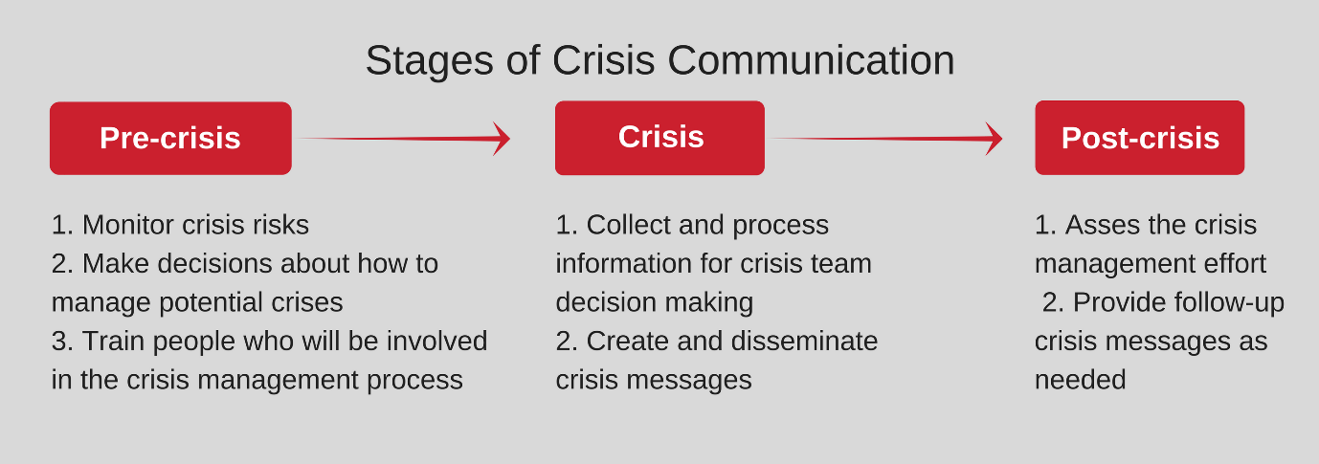
Figure 1 Stages of crisis communication (Ober, 2009)
Pre-crisis: Honda developed a communication crisis team to reduce the hierarchical barriers in interaction. Before solving the crisis, the team looks for potential reasons for the communication crisis and risk associated with it (Cartwright, 2012). The employer sets a team of train employees with the crisis management process.Mercedes-Benz’s superiors try to understand the failure of its innovative work arrangement system through monitoring the crisis. It makes the decision to fight the communication crisis by setting a team with experience in management.
Crisis: The crisis communication team of Honda find that 80% of worker is unhappy with managers as they are not engaging with the work and for not giving feedback on the work (Ober, 2009). The team comes with a solution of regular feedback program from employer to employees and also to arrange one to one meeting with team members.After the team analysing the employees, the Mercedes-Benz’s employer finds out that there is a need semi-close quiet work area where employees and employers can work in silenced and comfortable (Gilsdorf, Vik and Vik, 2013). Therefore, the employer of that company set a work setting by asking employees in what work setting they feel comfortable and productive. The company can solve the problem by setting different work arrangement for introverts and extroverts employees because the comfortable criteria are not the same for them.
Post-crisis: In this stage, the employer should assess the team effort in the success of removing crisis communication. The employers can achieve it in many methods like communicating the employees, weekly feedback program and surveying the employee's preferences (Ober, 2009). Honda can simply measure it by communicating with the employees and the feedback on the initiative taken by employees. The employer of Mercedes-Benz can assess the initiatives of the team after crisis communication through analysing the employee's productivity and their communicative approach with managers. They can also asses through arranging different methods survey to introverts and extroverts employees. The company need to complete follow up its program to revise it finding any errors.

2. How to improve workplace communication and performance of teamwork.

2.1 Applying 7 C’s communication model to improve workplace communication and performance.
Communication holds a very strong position in the organisation and without clear and precise communication a business cannot stand (Donohue, 2011). The 7 C’s model of effective communication which is applicable for both oral and written communication provides a checklist to pass-off message in clear, plain, target oriented and well-structured manner.
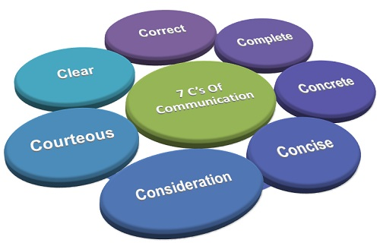
Figure 2 7 C's of communication (Jacobson, 2014)
1. Completeness: Completeness refers message should convey all facts that are necessary to understand by the receiver (Jacobson, 2014). For example, in General Motors the messages from employer follow detailing all the facts to the product development team about customer’s trends and pattern.
2. Conciseness: Conciseness refers to the use of less word as possible without compromising other C’s of communication (Walter, 2014). For example, the employers need to follow conciseness while communicating client as its time-saving and cost-effective and also highlighting the specific facts without use of needless words.
3. Consideration: The employers should write or give message considering viewpoints of receivers which means stepping into shoes of others (Forbes.com, 2019). For example, many organization now follow you viewpoints while transmitting the message in order to give respect without hurting the emotions of receivers.
4. Clarity: Clarity refers message should emphasize a specific goal for which it sending rather than more achieving too much at once (Forbes.com, 2019). For example, if employers give message employees to corrective action on work, it should focus on corrective action than anything irrelevant.
5. Concreteness: Concreteness means message should have a clear meaning rather than fuzzy and general (Walter, 2014). For example, employers can use the research date or figure while communicating the message with employees and client.
6. Courtesy: Courtesy in message describes that the message should show the expression of sender and respects to the receiver (Walter, 2014). The employer in transmitting message should give respect and provide it in a polite manner to employees.
7. Correctness: This refers message should not contain any grammatical errors in communication and what is in the message should contain the right instruction and guidelines (Johnson and Bayless, 2010). The employer must give an exact, correct and well-timed message to employees and this also refers allocate right message to the right person.

2.2 Applying theory on effective teamwork.
Business needs new, fresh and innovative ideas to survive in a competitive world and it can achieve through proper teamwork (Viswanathan, 2010). Teamwork also aids in solving problems because members come with different ideas which help find a better solution to problems.
Tuckman Teamwork Theory
Tuckman teamwork theory describe team develop with maturity and ability, establish a relationship and perform through participating in sharing an opinion (Krizan, 2011). It first starts with directing from the employer, then coaching and participating and finishing with delegating.
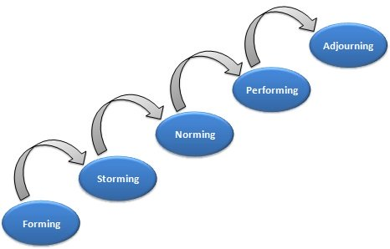
Figure 3 Stages in Tuckman teamwork theory (Bloomberg.com, 2019)
Forming: During forming members of the team meet each other and got to know about the tasks they need to perform (Bloomberg.com, 2019). In this stage, team members are unsure about their roles in the group and they are looking to the leader for guidance and instruction. For example, General motors develop teamwork product development on customer changing trends.
Storming: In this stage, a team member will challenge each other including the team leader and members will ask what they are doing and how it will be done (Walter, 2014). The team members look for an excuse to not doing the tasks and they will be concerned about their position in the group. The team leader should deal it with skills like active listening, feeling positive and relationship building.
Norming: During the norming stage, team members are getting to know each other and the conflicts are reducing (Bloomberg.com, 2019). The members begin to come together and able to perform together on the project objectives and goals. Norming is essential when a team is formed with different cultural people and it will members to solve their personal conflict and collision.
Performing: In this stage, the group members only concern about how to get the job done and the performance level of the group is high as the team are comfortable with each other and accepted the group norms (Viswanathan, 2010). Team members will support each other task and group leader can give more leadership skills rather supervising the group.
Adjourning: This stage occurs when the team successfully achieve its goal and objectives and it creates a sense of loss to the member as they became close to each other for a period of time (Bloomberg.com, 2019). For example, product development a team of General Motors can call it adjourning after they successfully launch a new product in markets.

Conclusion
Communication skill is a topmost skill in the modern professional world and this skill is indispensable for both employees and employers. Good communication in business increase the flexibility in work and ease the work for employers. Effective communication within depends on many factors like medium, the content of message, clarity and presenting approach. The employer should maintain a good communication relationship with employees and requires skill like listening, open-mindedness, friendliness and empathy. Now businesses encourage regular interaction among employees and employers to build a good communication system in an organisation.

References
Bloomberg.com. (2019). Bloomberg - how to build winning team?. [online] Available at https://www.bloomberg.com/news/articles/2007-12-20/how-to-build-a-winning-team [Accessed 16 Apr. 2019].
Cartwright, R. (2012). Communication. 2nd ed. Oxford, U.K.: Capstone Pub.
Christian, R. (2005). Journal of Business Communication. Journal of Business Communication, 42(2), pp.109-109.
Donohue, J. (2011). Professional communication skills for business studies.1st ed. San Francisco, Calif.: Jossey-Bass.
Forbes.com. (2019). Why Communication Is Today's Most Important Skill. [online] Available at: https://www.forbes.com/sites/gregsatell/2015/02/06/why-communication-is-todays-most-important-skill [Accessed 16 Apr. 2019].
Gilsdorf, J., Vik, G. and Vik, G. (2013). Business communication. New York: Primis Custom Pub Press.
Jacobson, S. (2014). Communication Skills for Conservation Professionals. Washington: Island Press.
Johnson, B. and Bayless, M. (2010). Business communication. 3rd ed. Mason, Ohio: Thomson.
Krizan, A. (2011). Business communication. Australia: South-Western Cengage Learning Press.
Ober, S. (2009). Contemporary business communication. 4th ed. Boston: Houghton Mifflin.
Viswanathan, R. (2010). Business communication. Mumbai [India]: Himalaya Pub House Press.
Walter, s. (2014). Research in Communication Skills. College Composition and Communication, 8(3), p.143.

