Name student : Patricia Constandache
Student id : 2020640
Marketing Fundamentals

Assessment 2

Marketing Fundamentals Analysis and Evaluation

Table of Contents
1. Introduction 3
2. A brief overview of the chosen organisation 3
3. Conducting internal and external analysis of Starbucks considering the impact of Covid-19 pandemic 4
3.1 SWOT analysis 4
3.2 PESTLE analysis 7
3.3 Segmentation-Targeting-Positioning analysis of Starbucks 9
3.4 Marketing Mix strategies 10
4. Conclusion 12
Reference list 14

1. Introduction
In the current period, business organisations irrespective of any size, type, or operating industry worldwide, are witnessing the devastating power of the Covid-19 pandemic. With the arrival of this pandemic and its rapid growth, national governments all over the world have imposed safety protocols and closed down national or international business operations. Therefore, organisations are facing huge financial and sustainability threats and all the internal stakeholders associated with them are also facing substantial economic uncertainties (Buchheim et al., 2021). Amidst this scenario, leaders of every organisation are investigating different internal and external issues along with the impact of the Covid-19 pandemic to find out the strategic business position and its effectiveness in the global business arena. Similarly, as a marketing manager, this report will be developed to critically analyse and evaluate the internal and external situations of Starbucks, a leading multinational coffeehouse chain, to determine its current and future business prospects.

2. A brief overview of the chosen organisation
Having its headquarters in Seattle, Washington, since 1971, Starbucks remains strongly focused on ethically sourcing and delivering high-quality different kinds of rare coffee to customers (starbucks, 2021). With a strong commitment to conducting a legal and ethical business, Starbucks has become able to increase its reach globally by leaping beyond the domestic markets and earned a robust global reputation by establishing the largest coffee shop chains worldwide. While offering rarest quality coffee and various kinds of beverages to customers, this organisation emphasizes providing a unique experience to them and taking utmost care for the associated people and planet as well. Thereby, the company becomes successful in expanding its venture into more than 80 countries with approximately 33,833 stores as of 2021. With a steady growth of business globally, in 2019, the company has earned the highest revenue over $26.5bn. Though in 2020, with the outbreak of the Covid-19 pandemic annual revenue of the company has dropped massively to $19.16 bn (Lock, 2021).
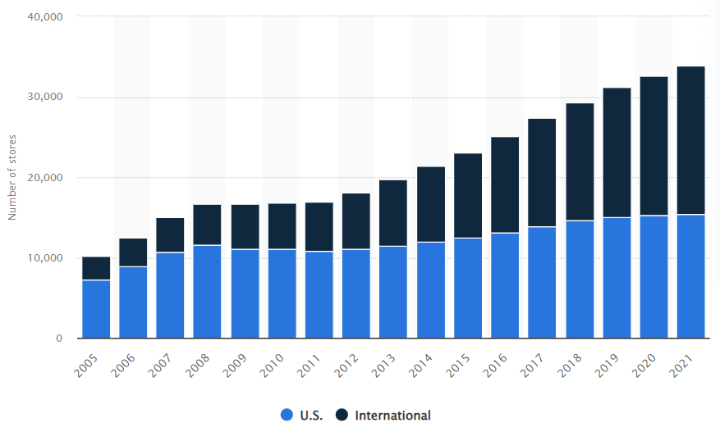
Figure 1: The stores of Starbucks worldwide
(Source: Lock, 2021)

3. Conducting internal and external analysis of Starbucks considering the impact of Covid-19 pandemic
Though Starbucks has become a globally recognized brand, the current pandemic situation has created a critical condition for the business to maintain and improve its financial structure and continue business operations with utmost safety. Therefore, it is essential to find out the internal and external business situations with the application of relevant models as well as the marketing strategies of this company to address the changes internally as well as externally.

3.1 SWOT analysis
According to Herman (2021), SWOT analysis is an important analytical framework, applying which the competitive position earned by an organisation can be evaluated and, at the same time, strategic planning can be developed to improve current internal strengths and negate the weaknesses as well as to exploit external opportunities by eradicating existing or potential threats. Therefore, here the SWOT framework has been implemented to determine the strengths and weaknesses of Starbucks, based on which it can achieve future business opportunities or face threats.
Strengths: Hashemi et al. (2017), have mentioned that strengths are those internal factors that help improve the weaknesses and safeguard the business from facing intense competition. Therefore, Starbucks has successfully acquired the position of the biggest coffeehouse chain worldwide through its most innovative strategies which is a key strength factor for this company. Moreover, it has established a positive global brand image and reputation as well as strong popularity which enables the company in improving its loyal customer base and attain the necessary stability to drive quality business operations in different parts of the world. Besides, the agile, ethical, and flexible global supply chain offers relevant strength and support to diverse organisational operations (Lombardo, 2019). Therefore, the strong global suppliers’ network keeps the brand able to acquire rare quality products such as Arabica beans and offer unique tastes and experiences to customers compared to its competitors. Dhir and Dhir (2015), have mentioned that business diversification is essential to minimize the adverse impacts of markets and decrease industry-related risks. Similarly, by developing or acquiring subsidiaries like Teavana, Seattle’s Best Coffee, Ethos Water, etc. this company goes on diversifying its business portfolio and acquiring necessary strengths and competitive advantages to keep a stronghold on the attained industry position globally.
Weaknesses: While considering the factor of weakness in the SWOT model Namugenyi et al. (2019), have stated that these are the internal factors possessed by an organisation that demerit or reduce the capabilities for operating a strategic business. The high price point is the most evident weakness of Starbucks that though increases the profit margins but significantly reduces products’ affordability. Faith (2018), has stated that this is one of the most crucial weaknesses for organizations as it restricts market shares especially in the areas with low disposable incomes. Moreover, Starbucks with high price points is generating a negative perception among low-income groups, which have increased strongly during this pandemic period, and due to it, revenue is going down, giving a major blow to the financial capabilities of the firm. On the other hand, generalized standards reduce flexibility for the food and beverage industry and Starbucks possesses this weakness strongly with the generalization of beverage products that restrict cultural alignment of the brand with local target markets as well as the domestic preferences (Lombardo, 2019). Apart from the rare quality coffee beans, most of the beverage products of Starbucks are imitable, even the ambiance and facilities of the stores. Therefore, it is another crucial weakness that can increase customer switch rates.
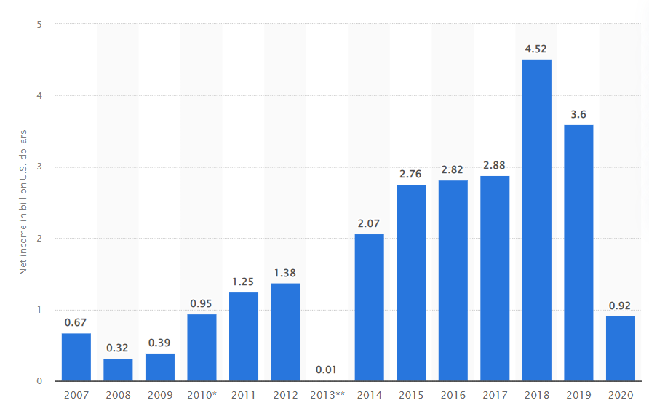
Figure 2: Decrease of the annual profit of Starbucks
(Source: Lock, 2021)
Opportunities: As per Vlados (2019), the element of opportunity helps organizations determine the external scopes for achieving further substantial business growth and sustainability. Therefore, Starbucks can achieve this growth opportunity by diversifying its revenue streams as diversification has currently been considered as a minor competitive or growth strategic area for Starbucks. Besides, Starbucks can avail the opportunity to expand its business into developing markets that will further help in boosting the sales volume and profitability that is drooping due to the pandemic. By modifying organisational culture and marketing strategies and aligning them with local demands e.g., with Italian culture, Starbucks can enhance its brand image and business profile which will make its position stronger globally. Moreover, the company can strengthen its presence and market share more by making strategic alliances with other firms, retailers, or distributors (Lombardo, 2019).
Threats: In international markets, Starbucks is exposed to intense competition arising from diverse areas like other cafeterias or low-cost coffee brands. On the basis of low prices, such companies can offer a major threat to Starbucks regarding the reduction of market share. Besides, due to the weakness of high-priced products and imitability, Starbucks can face immense financial threats with the reduction of demand and higher customer switch to the competitors. Besides, the local socio-cultural trend regarding the independent coffeehouse movement to support local small coffee shops by rejecting multinational coffee-shop chains is also providing sustainability threats to this brand (Lombardo, 2019). Additionally, the current Covid-19 pandemic, government protocols, and customers’ reluctance to visit coffeehouses decreasing profit levels intensely, that can even lead to an existential crisis in many nations if the brand fails in adopting proper marketing and branding strategies.

3.2 PESTLE analysis
While defining the PESTLE framework, Perera (2017) has stated that it is a strategic planning tool used to assess and evaluate the impacts of various macro-environmental factors upon a particular business or industry environment within which an organisation operates. Therefore, Starbucks being a multinational brand, it is essential to analyse the global business environment to determine the impacts of external environmental elements upon the strategic business management.
Political factors: The major political factor for Starbucks is the stability of the nations to maintain strategic and ethical sourcing. However, Starbucks has already gathered strong monitoring and attention from all the politicians of the sourcing nations as well as the West which forces the company to maintain ethical practices by fulfilling environmental and social norms. Moreover, it offers great opportunities for Starbucks to conduct fair trade practices and improve its brand reputation image. However, the stringent regulatory pressure in the domestic market especially related to taxation and employment rules is increasing administrative and operational charges for the company (Azriuddin et al., 2020). During this pandemic condition when the financial structure has been disrupted massively, bearing such costs is putting tremendous pressure on organisational growth. Still, the factors like market integration or governmental support are providing major growth opportunities to Starbucks.
Economic factors: In the current times, the entire world is going through a global economic recession and the pace of economic slowdown has been accelerated with the emergence of the Covid-19 pandemic (Debata et al., 2020). However, in every country, GDP has dropped dramatically and lowered down the amount of disposable income. Therefore, customers significantly cut down their coffee consumption rate or switch to low-cost service providers which decreased the profit level of Starbucks. Also, the inflation rates and rising labour, as well as operational costs, impact adversely on organisational profits.
Social factors: The demand for affordable yet quality products is increasing at all levels especially after the Covid-19 pandemic that has impacted adversely on disposable income levels and created economic uncertainties. Therefore, to offer cheaper products to customers, Starbucks may need to compromise with quality which can further put negative impacts on business reputation. Also, the high-priced products of Starbucks are currently not in demand especially in the developing nations which is why the sales volume and net profit are decreasing rapidly. Besides, green, sustainable, and ethical operations are in-trend and customers especially the younger generations prefer those brands more who are able to operate in this way (Smithson, 2021). This is a major opportunity for Starbucks as the company with its fair trade, C.A.F.E. programme, green supply chain, etc. can improve its loyal customer base and retain them for longer. However, the demand for local sourcing or supporting the growth of local sellers can impact adversely the growth of Starbucks in foreign markets.
Technological factors: From a technological perspective, Starbucks is enjoying enormous opportunities. The increasing adoption of mobile technologies for online payments, purchases, etc. is offering Starbucks positive scope to improve business practices. Moreover, the implementation of advanced automation, AI, Blockchain technologies, etc. in the supply chain have made organisational operations more agile, flexible, and efficient. Also, the implementation of advanced technologies has transformed the store ambiance and helped the business attract customers effectively and drive revenue (Kumaresan, 2019). However, the continuous improvement in technology can make the existing technologies of Starbucks obsolete and make the business practices inconvenient and unreliable. Therefore, it can offer grave threats to the company in maintaining a superior business position.
Legal factors: Currently, Starbucks operates in multiple nations with different legal structures and major regulatory changes are occurring with the Covid-19 pandemic. Therefore, this company has higher chances to face issues to cope with the changed legal rules and align the business activities properly. However, there are several regulations like product safety laws, Genetically Modified Organisms (GMO) regulations, etc. which are advantageous for Starbucks in setting and maintaining quality standards and fulfilling the business commitments (Smithson, 2021). Still, different employment, taxation, or operational laws are creating issues for Starbucks due to which several lawsuits have been filed against the company which caused severe financial and reputational damages.
Environmental factors: From the environmental perspective also, Starbucks’ business enjoys a plethora of opportunities to improve performance. Vojtovic et al. (2016), have stated that it has become a trend to make sustainable business processes highly available among marketers. Therefore, Starbucks receives greater scope to improve its sustainability practices, standards, and applications and operate an environment-friendly business. Moreover, responsible sourcing and eco-friendly products are high in demand globally, especially among young customers. Here, Starbucks has further opportunities to innovate new ways to improve the eco-friendliness of the products and the current responsible sourcing as well as operational policies to demonstrate social responsibilities, strengthen brand image and attract more customers.

3.3 Segmentation-Targeting-Positioning analysis of Starbucks
To define market segmentation, Armstrong and Kotler (2016), have stated that it is a strategic process of subdividing the entire market into various distinct buyers' groups based on their needs, characteristics, or behavioural aspects and developing marketing programmes or products accordingly. The prime marketing approach of Starbucks is to acquire a substantial market share within the operating industry by focusing closely on different market segments. While segmenting the market, Starbucks considers all the four areas, like, demographic, psychographic, geographic, and behavioual. The demographic segmentation of Starbucks first emphasizes the age group of 25 to 40 years with high and stable disposable income as well as the group of 18 to 24 years belonging from affluent family backgrounds (Khan, 2018). The major customer group of Starbucks belongs to Gen Y who are health, brand, and environment-conscious highly.
Besides, while selecting the store locations, that is conducting geographic segmentation, the company strictly considers urban populated areas that are centralized and connected by all modes of transports. The psychographic segmentation of this brand considers the people from upper-middle-class and elite groups as well as who are educated. This particular segmentation helps in targeting the customers who are educated, environment-conscious, and prefer quality coffee and boost up sales volume strategically. On the other hand, while considering the behavioural aspect, Starbucks prioritizes loyalty, regularity, ambitious and easy-going people who prefer having a place to relax and a connector between their homes and workplaces (Dudovskiy, 2017). By targeting this area, Starbucks has designed its stores more uniquely to attract young and conscious customers and provide them with a unique experience of relaxing, gathering, and interacting with others over quality coffee and food. However, in the time of the Covid-19 pandemic when economic uncertainties have captured every nation, purchasing high-priced premium products is not a viable choice for customers. Also, Bhatti et al. (2020), have stated that non-essential leisure items purchases have decreased significantly during this pandemic, and thus, offering rare quality coffee to elite customer groups can never provide necessary financial support to Starbucks.
Armstrong and Kotler (2016), have mentioned market targeting as a process to evaluate the interests and needs of all the segments and select the most beneficial areas to enter. Therefore, the target market of Starbucks consists of high-income people who hold a strong desire to purchase premium quality products. However, while targeting this chosen segment globally, Starbucks considers a mass marketing or homogenous approach without paying attention to the differences among different customer segments. Since its first establishment, the company goes on using undifferentiated or standardized marketing strategies by considering markets as a single entity and using marketing mix elements with the belief to satisfy every customer around the world (Khan, 2018). When competition is increasing fiercely and from different areas, single standardized strategies for targeting the whole market seem irrelevant. Though the brand never compromises with quality offerings, no such focus on developing distinct marketing strategies, products, or programs creates gaps in local cultural alignments, and due to this, maintaining relationships especially the customers from different socio-cultural backgrounds is a challenge for the company.
At the same time, while positioning the brand in the premium category, Starbucks selects the mono-segment positioning through which it offers products only to those customers who prefer quality and rarity over price and are highly conscious regarding health, people, and planet (Dudovskiy, 2017). Though this particular positioning benefits the brand in maintaining a high-profit margin and achieving greater competitive advantages, the current global economic condition is not suitable for it. Therefore, the company needs to modify its positioning strategies and look for targeting diversified market segments by adapting local cultural elements and aligning them with the business practices, marketing strategies, and products accordingly.

3.4 Marketing Mix strategies
As per the definition outlined by Kotler and Armstrong (2018), the marketing mix can be regarded as the set of controllable marketing variables that organisations use to influence buyers’ responses and actions. Therefore, as per Kotler’s identification, these marketing mix elements consist of four factors, i.e., product, price place, and promotion.

Figure 3: The Marketing Mix Elements
(Source: Created by the learner)
Products: Since the beginning of Starbucks’ journey the company continues to innovate the product mix to grab a major proportion of the coffeehouse chain industry as well as the food and beverage market. Necessary additions and modifications have been made by Starbucks in its product line aiming at increasing its market reach and market share. Though the company offers a wide variety of coffee, food, and beverage products, most of them are high-priced. To offer premium quality to diverse international customers, Starbucks maintains a continuous innovative approach and holds a strong preference for providing rare products to achieve necessary business advantages over the competitors (Greenspan, 2019). However, the products of Starbucks are imitable which are impacting significantly on sales volume, revenue generation, and customer retention.
Price: Starbucks uses the premium pricing strategy with the purpose of cultivating a sense among the customers that its offerings are superior compared to the competitors. Deshpande (2018) has mentioned that from behavioural perspective, this strategy is highly beneficial to develop an assumptive correlation between high price and high value. Therefore, this pricing strategy remains beneficial for Starbucks in becoming a status symbol for the buyers and standing ahead of the competition by offering a unique experience and superior quality to them (Greenspan, 2019). However, during this economic slowdown, premium-priced products are less likely to be sold like before especially in developing nations. Therefore, based on the current situation, Starbucks can be overpowered by its low-cost affordable competitors.
Place: Starbucks has more than 33000 stores across 80 countries worldwide through which it offers most of its products to customers. Also, the company started offering some of its products through online platforms to adopt the e-commerce approach but closed it in 2017 and focused on revamping the physical stores more with advanced technological features and systems. Still, it has made partnerships with online retailers or provides customers with online ordering facilities that are effective for diversifying the distribution channels and increasing products’ accessibility (Greenspan, 2019). Moreover, during this pandemic time when nationwide lockdowns have been imposed and visiting public places is strictly prohibited, to keep up the sales volume intact, Starbucks has partnered with Uber Eats to offer doorstep deliveries to customers and take care of their health and safety (Santos, 2020). Thus, these distribution strategies clarify how the brand modify its marketing practices with changing time, needs, and external conditions.
Promotion: The promotional strategies are based on brand communication that triggers purchase intentions and loyalty among customers (Thabit and Raewf, 2018). Therefore, here, Starbucks uses the word-of-mouth technique through social media platforms that not only encourage new buyers to purchase this brand’s product but also help in maintaining a strategic relationship with the existing customers. Moreover, developing strategic advertising and sharing them on various online and offline platforms benefits the brand in targeting its desired customer group and letting them know about the quality offerings offered by the brand. Also, Starbucks made extensive usages of public relations campaigns to improve organisational relationships with the wider communities and sales promotions to provide customers attractive discounts, loyalty points and offers that help to increase the attachments with customers and keep them committed for longer (Greenspan, 2019).

4. Conclusion
Thus, from the entire discussion, it is evident that the marketing strategies adopted by Starbucks are effective enough to keep the brand at a superior market position and offer it proper advantages to compete efficiently with the core industry rivals. Therefore, with the help of strategic marketing, Starbucks has gained its superiority in the coffee shop chain industry and won the hearts of millions of customers globally. However, as per the current situational context, this brand needs to modify certain areas like product development, pricing strategy selection, brand positioning and targeting, marketing programme development, etc. to regain financial strength that is dropping due to the pandemic condition. Thus, necessary changes in those areas will benefit the organization in improving its position and market share more as well as eliminating financial and existential threats effectively.

Reference list
Azriuddin, M., Kee, D.M.H., Hafizzudin, M., Fitri, M., Zakwan, M.A., AlSanousi, D., Kelpia, A. and Kurniawan, O., 2020. Becoming an international brand: A case study of Starbucks. Journal of the Community Development in Asia (JCDA), 3(1), pp.33-43.
Bhatti, A., Akram, H., Basit, H.M., Khan, A.U., Raza, S.M. and Naqvi, M.B., 2020. E-commerce trends during COVID-19 Pandemic. International Journal of Future Generation Communication and Networking, 13(2), pp.1449-1452.
Buchheim, L., Krolage, C. and Link, S., 2021. Sudden Stop: When Did Firms Anticipate the Potential Consequences of COVID-19?. German Economic Review.
Debata, B., Patnaik, P. and Mishra, A., 2020. COVID‐19 pandemic! It's impact on people, economy, and environment. Journal of Public Affairs, 20(4), p.e2372.
Deshpande, D.S.S., 2018. Various pricing strategies: A review. Journal of Business and Management, 20(2), pp.75-79.
Dhir, S. and Dhir, S., 2015. Diversification: Literature review and issues. Strategic Change, 24(6), pp.569-588.
Dudovskiy, J., 2017. Starbucks Segmentation, Targeting and Positioning – Targeting Premium Customers with Quality Products and Service - Research-Methodology. [online] Research-Methodology. Available at: <https://research-methodology.net/starbucks-segmentation-targeting-and-positioning-targeting-premium-customers-with-quality-products-and-service/> [Accessed 13 December 2021].
Faith, D.O., 2018. A review of the effect of pricing strategies on the purchase of consumer goods. International Journal of Research in Management, Science & Technology (E-ISSN: 2321-3264) Vol, 2.
Greenspan, R., 2019. Starbucks Corporation’s Marketing Mix (4Ps) Analysis - Panmore Institute. [online] Panmore Institute. Available at: <http://panmore.com/starbucks-coffee-marketing-mix-4ps-analysis> [Accessed 13 December 2021].
Hashemi, S.M., Samani, F.S. and Shahbazi, V., 2017. Strengths, Weaknesses, Opportunities and Threats (SWOT) Analysis and Strategic Planning for Iranian Language Institutions Development. Journal of Applied Linguistics and Language Research, 4(2), pp.139-149.
Herman, D.A.A., 2021. Competitive Strengthening of Socio Entrepreneurs in Facing Industrial Revolution 4.0 Through SWOT Analysis Identification. Journal of Business and Economics, p.608.
Khan, S., Yusop, Y. and Baharudin, F., 2018. Starbucks Market Segmentation and Targeting. [online] Ijbmi.org. Available at: <https://www.ijbmi.org/papers/Vol(7)5/Version-1/F0705014445.pdf> [Accessed 13 December 2021].
Kotler, P. and Armstrong, G., 2016. Principles of Marketing Sixteenth Edition: Global Edition. England: Pearson Education Limited.
Kotler, P. and Armstrong, G.M., 2018. Marketing Mix: Selected Chapters From: Principles of Marketing, Philip Kotler and Gary Armstrong. Pearson.
Kumaresan, R., 2019. The Effects of Macroeconomics Factors towards the Starbucks Corporation.
Lock, S., 2021. Starbucks net income | Statista. [online] Statista. Available at: <https://www.statista.com/statistics/219502/starbucks-net-income/> [Accessed 13 December 2021].
Lock, S., 2021. Starbucks stores: U.S. and international | Statista. [online] Statista. Available at: <https://www.statista.com/statistics/218366/number-of-international-and-us-starbucks-stores/> [Accessed 13 December 2021].
Lombardo, J., 2019. Starbucks Coffee Company SWOT Analysis & Recommendations - Panmore Institute. [online] Panmore Institute. Available at: <http://panmore.com/starbucks-coffee-swot-analysis> [Accessed 13 December 2021].
Namugenyi, C., Nimmagadda, S.L. and Reiners, T., 2019. Design of a SWOT analysis model and its evaluation in diverse digital business ecosystem contexts. Procedia Computer Science, 159, pp.1145-1154.
Perera, R., 2017. The PESTLE analysis. Nerdynaut.
Santos, L.A., 2020. Starbucks’ digital strategy pays off as industry evolves (Doctoral dissertation).
Smithson, N., 2021. Starbucks Coffee PESTEL/PESTLE Analysis & Recommendations - Panmore Institute. [online] Panmore Institute. Available at: <http://panmore.com/starbucks-coffee-pestel-pestle-analysis-recommendations> [Accessed 13 December 2021].
Starbucks.com. 2021. About Us: Starbucks Coffee Company. [online] Available at: <https://www.starbucks.com/about-us/> [Accessed 13 December 2021].
Thabit, T. and Raewf, M., 2018. The evaluation of marketing mix elements: A case study. International Journal of Social Sciences & Educational Studies, 4(4).
Vlados, C., 2019. On a correlative and evolutionary SWOT analysis. Journal of Strategy and Management.
Vojtovic, S., Navickas, V. and Gruzauskas, V., 2016. Sustainable business development process: the case of the food and beverage industry. Zeszyty Naukowe Politechniki Poznańskiej. Organizacja i Zarządzanie.

