Development and application of manufacturing automation
ACMA5001

Gavin Williams
1503534

Table of Contents
List of figures 3
Introduction 4
The emergence and history of automation and control 5
Fixed manufacturing automation 5
Programmable automation 7
Flexible automation 9
Flexible automation and its application in the use of flat-packing material 10
Summary 12
References 12

List of figures
- Image 1. Water-Mill (Angelakis, A.N., Krasilnikoff, J. and Tzanakakis, V.A. 2022).
- Image 2. Henry Ford's assembly line (Sorensen, C.E. & Williamson, S.T. 2006).
- Image 3. PLC Block Diagram, PLC Block Diagram (Tree, C. 2020).
- Image 4. Rolling Mill using hot rolling techniques: A Guide to Hot Rolling Mill Scheduling (2024).
- Image 5. Structure of a robotics system (Geradin, M. and Duysinx, P. 2018).
- Image 6. Tesla’s modern robotic factory. (Improve efficiency with flexible automation, 2023).

Introduction
The principle of manufacturing automation started centuries before the commonly associated industrial revolution (Landes, 2003). The use of mechanisms that work together automatically to achieve an output reflected the available resources of the age. Initially, tools and mechanisms were used that work together to facilitate everyday tasks more constructively with less human input. As demand increased, the peak being the first industrial revolution, manufacturing automation began to require less human input with the goal of using technology to maximise production and decrease the need for manual labour. The development from the production of generic everyday processes to extensive technological CNC machining, capable of creating exceptional pieces from scratch is an example of the capabilities of manufacturing automation based on the advancing technologies of the industry. Automation is a staple in companies relying on production lines to achieve higher output, cost-saving efficiency, reducing overall waste compatibility and reducing any inefficiencies that human factors may contribute to (Altintas & Ber, 2001).
The current use of robotic processes and cognitive automation is suggested to have its own costs and benefits, which stem from fixed, programmable and flexible automation (Fasth et al., 2010). Therefore, these processes will be described and evaluated in this paper with an acknowledgement of the historical development and achievement of the industry. The scope of manufacturing automation across industries, from everyday automated appliances to the very machines that build them on an industrial, commercial and personal level, demonstrates the magnitude of this process in today's society. The advancement in these fields has allowed modern-day industries to proceed and expand at unprecedented levels, improving quality, increasing output, decreasing downtime, and increasing profitability (Adam et al., 2018).

The emergence and history of automation and control
The earliest signs of control and automation are documented centuries ago, believed to be for astrological timekeeping alongside the sun's positioning (Ardeshiricham, Hu & Kastner, 2017). The water-powered clocks from ancient civilisations, also known as the “clepsydra”, were the first mechanical automation around the 3rd century. The “clepsydra” allowed the flow of water, which was constricted, through a hole at the bottom of the pot. (Hwang, Yan & Lin, 2021). This led to the establishment of the Greek water mills, used around the 7th century, which were driven by animals or livestock to grind grain and reduce manual labour. Over time, the watermill turned into a windmill, with the power to harness wind energy and its reusability (Schaffarczyk, 2023; Angelakis, Krasilnikoff, & Tzanakakis, 2022).
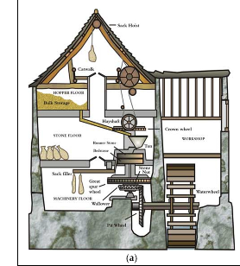
Image 1. Water-Mill (Angelakis, Krasilnikoff & Tzanakakis, 2022).
The transition from water and wind energy to steam power, in combination with the discovery of electricity and how to harness it, sparked the Industrial Revolution in the 1700s (Bowden, 2020). Among many leading engineers, James Watt, were able to make breakthroughs that would capitalise on streamlined processes (Stearns, 2020). These processes would usually require manual labour or skilled workers. Many of the early stages of steam power and electricity were used mostly due to agricultural expansion and an increase in demand for coal mining. Present day, three recognised types of manufacturing automation are used in the industry.

Fixed manufacturing automation
Of the three established types of manufacturing automation, fixed automation was the first to be fully integrated into industries. The conveyor belt was a new autonomous line that kept materials moving along fixed paths, making the manufacturing lines more effective as they were smoother and more efficient. This automated process also led to more control over machinery, which gained popularity around the 1880s. The accelerated popularity of using fixed automation was propelled when Henry Ford was able to build a car in less than 8 hours, in accordance with factory assembly lines thus the layout and foundation for fixed automation had been conceived and was already reaping rewards for new innovators and innovations (Allen, 2018; Kanger et al., 2022).
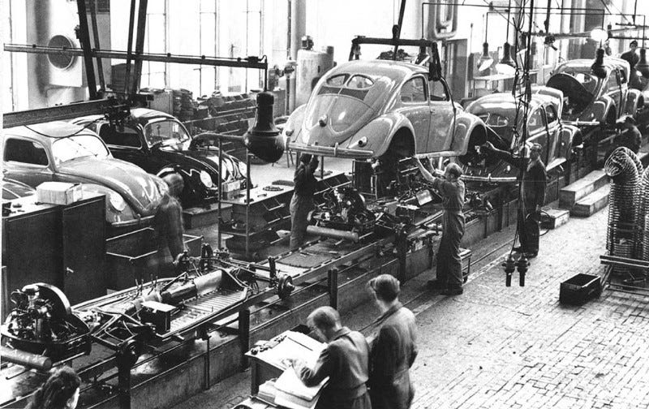
Image 2. Henry Ford's assembly line (Sorensen & Williamson, 2006).
During World War II, between the years of nineteen-thirty-nine and nineteen-forty-five, many thought that due to the destruction and the loss of lives, manufacturing itself and, therefore, the use of automation would slow down. However, quite the opposite occurred (Crafts, 2019). The demand for goods manufactured materials and construction materials drove growth at an enormous rate. Due to this demand, researchers were also looking into technological advancements that could speed up certain processes where human labour was at its maximum output. An additional reason for this was that there were fewer people for manual labour due to the war, with women entering the factory industry as workers in replace of men who were called to service (Stearns, 2020). At the time, women were not able to meet the same labour demands as men and therefore, the pressure was on to establish ways to still meet or even exceed previous output (Wyatt III, 2008).
In consideration of the purpose and demand for fixed automation at the time, its advantages far outweighed any disadvantages. It was progressive and innovative for its time, changing the way the industry operated (Crafts, 2019). Once installed, it performs operationally very well. The expenditure to start the high-volume production line was far outweighed by the output achieved. The constant output and flow of the production line meant that the labour costs were also minimal (Corrà et al., 2021; Fletcher et al., 2020). When applying fixed automation in current times, it is still widely used and relied upon across industries; food, steel, textiles, packaging, and pharmaceuticals. These are just a few of the industries that rely on this type of manufacturing automation. Where the product design remains consistent, fixed automation can be easily relied on to produce in mass volumes (Niku, 2020).
In the current climate of advancing technology, fixed automation poses limitations. Its limited flexibility to adapt to new product designs or amendments is of the most importance. This can lead to costly changes having to be made to the equipment, along with upgrades required to keep up with the evolving industry. With the costly expenditure when purchasing fixed automation systems and the ongoing risk of further expenditure, it is often not feasible for smaller businesses to front the cost. In addition, a business when transitioning from manual labour to more automated process may need multiple systems in order to achieve a finalised product. This can either result in only part of the process becoming automated or a significant expense, including training staff on how to operate the systems (Adam et al., 2018).

Programmable automation
As technology and industries advanced, there was a demand for less manual input and continuous automation. In the 1960s, the PLC (programmable logic controller) was invented by Richard E Morely, better known as Dick Morely, who first implemented the PLC into a unit within the automotive industry (Kanger et al., 2022). The PLC became the cutting-edge technology that every manufacturing company wanted. It had the capability to keep a production line fully automated if everything was running smoothly, but it also could shut it down due to monitoring software built within. Rather than manually switching gear and relay systems, the PLC was able to monitor the majority of the manufacturer's systems and conditions once programmed in. Although a very high cost to start with inputting such devices and software to all critical plants that needed to be maintained, the advantages once installed, greatly outweigh the initial start-up cost (Kanger et al., 2022).
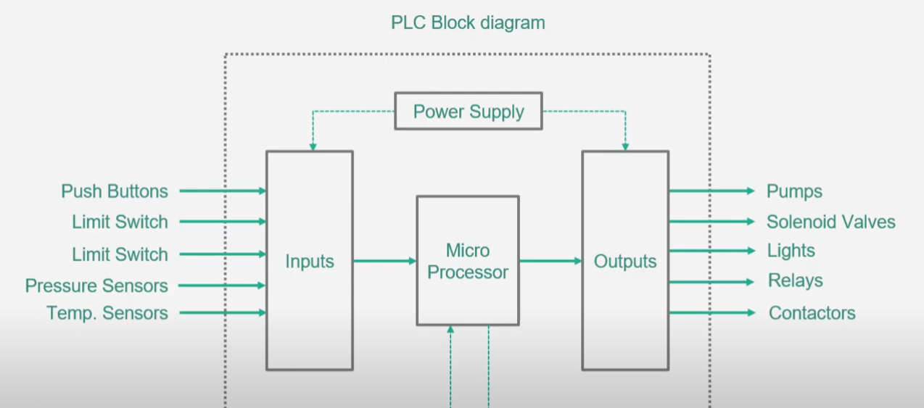
Image 3. PLC Block Diagram, PLC Block Diagram (Tree, 2020).
Once the PLC had been established in the automotive industry, many innovators sought to capitalise on what else could be programmed into the manufacturing industry that could become automated rather than having human labour input, this would not only be more efficient but allow for a greater yield, cost efficiency and less wastage (Dey & Sen, 2020). PLC’s were further added to Computer numerical control (CNC) to allow for detection of faults, allowing machines to self-monitor. CNCs were actually developed before PLCs in the 1950s; however, they had to be inputted manually by engineers or highly skilled individuals, rendering the advantage of using this across industries less effective until the introduction of PLCs. The Introduction of PLCs combined with CNC, allowed for a new spark of automated and controlled manufacturing. It enabled skilled engineers to input coordinates, feedback sensors and measurements into a system that would then interact with the application (Badet, 2021). In the evolution of programmable automation, Computer-aided design (CAD) was later developed in the 1960s-1970s, allowing the CNC machine to receive instructions from another machine and produce work without the input of a worker controlling it (Dey & Sen, 2020). CAD was developed independently from CNC; however, they are often used in collaboration due to the above advantages.
After implementing these automated programmes across the industrial community improved automation, PLCs became a base for controlling all systems that could contribute to efficiency within the production line. The invention and introduction of robotics came not so long after, a fixed automated programmable controller that could be used for high-performance and precision tasks (Kent, 1992). Initially, they were adopted for welding in the automotive industry (please see image 4), as the demand for automobiles rose.
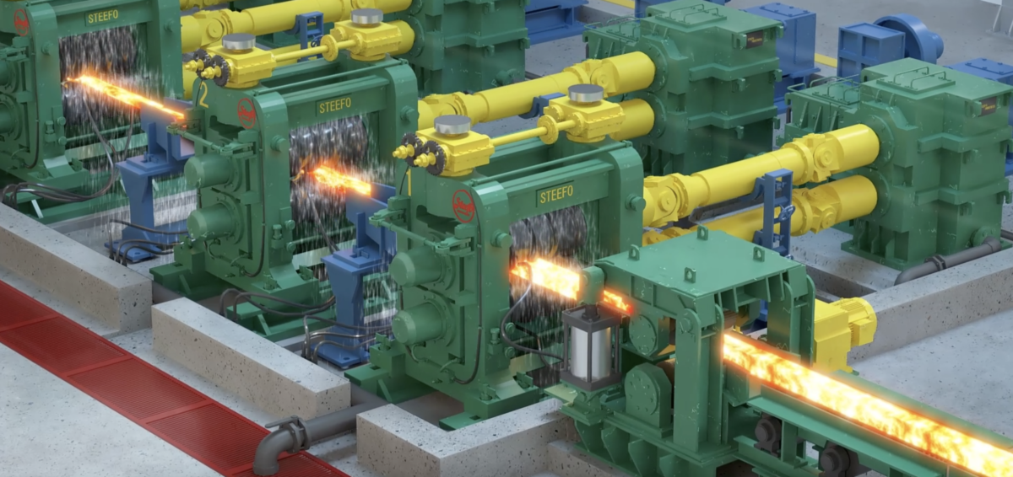
Image 4. Rolling Mill using hot rolling techniques: A Guide to Hot Rolling Mill Scheduling (2024).
In this present day, they are equipped with the latest laser and precision technology, sensors that can send back key information for measuring and adjustment, and tooling equipment that can sense when the tool itself is no longer fit for purpose. However these advantages post a high price for the companies implementing them (Geradin & Duysinx, 2018). The implementation of robotics, although at an extremely high cost and long start-up time due to the programming required to do the specific job it was created for, produces the highest specification finish at a much faster rate than any human could. Its efficiency allows it to work twenty-four hours a day with no stop needed, robotics have enough sensors and PLCs that they could also detect their own problem and would stop working and shut themselves down to avoid causing more damage, therefore less risk and a higher level of safety in the industry (Garcia et al., 2007). Health and safety being a staple of current workplace requirements, this process allows for companies to meet not just production output and specification but also the necessities to meet health and safety standards (Lutter & Morrall, 1994).
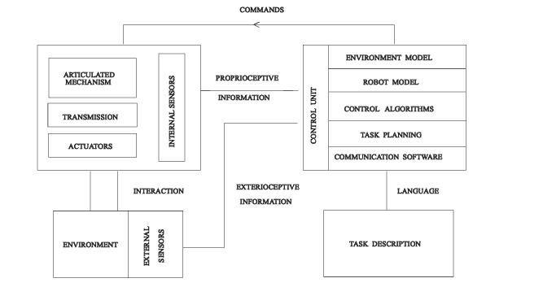
Image 5. Structure of a robotics system (Geradin & Duysinx, 2018).
Despite the clear advantages and changes to the industry, disadvantages prevailed through high initial set-up costs for parts and software if there was a change to that system. It would take a reasonable amount of time for engineers to re-programme the software and adjust accordingly (Wang et al., 2020). Therefore, there was a demand to find the next technology to mitigate the disadvantages of these systems.

Flexible automation
There was a widespread call for enhanced manufacturing systems that could be adapted to suit the control system. The need for flexible automation and computer control would allow advanced robotics to change their programme into another (Zhong et al., 2022). PLCs were able to take and record pressures and temperatures without encountering hot metals. The new flexible automation robots are able to lift, sample and roll the material with sensors accurately correcting the thickness to the correct dimension without any human manual labour (Ionescu et al., 2022). However, engineers would still need to monitor for breakdowns. In Pharmaceuticals, the robot would be able to identify different tablets using its probes, sensors, feedback sensors and computer programs to make sure the tablets went into the correct packaging. In the shift from robotics designed to lift heavy goods and processes of material handling, smaller robots were designed to be used for lighter assembly tasks (Misiti, 2020).
Robotics and flexible automation have paved the way for innovation by analysing and programming the use of advanced sensors and artificial intelligence (AI) (Bartneck et al., 2021). Robots can work in environments that humans cannot, they can withstand intense pressures and heat, and their manual handling is able to lift heavy objects. Now that advancements since the 1980s till the present day use motion control systems, laser sensors, incorporated machine learning and artificial intelligence, they are able to detect, adapt and move more effectively. However, the cost was severe, and no ordinary skilled worker could be able to program the robot using sophisticated software. Once appropriately coded, however, the robot could, therefore, learn from its own mistakes (Misiti, 2020).
Flexible automation came at the very end of the 20th century thanks to advancements in technology. The adaptiveness of AI allowed for a creation that would replicate human movement without fault and limiting human factors. Robotics could be programmed for a large variety and scale of applications. With the advancement in technology, the price followed suit. Increasing costs for precision materials and components spiralled. The labour costs rose due to the need for engineers who were competent enough to use this sophisticated software to adjust for the operation required (Soori, Arezoo & Dastres, 2023; Niku, 2020). However, for companies that are able to outweigh the cost of the equipment with the benefits as can be seen in Image 6, production is highly streamlined.
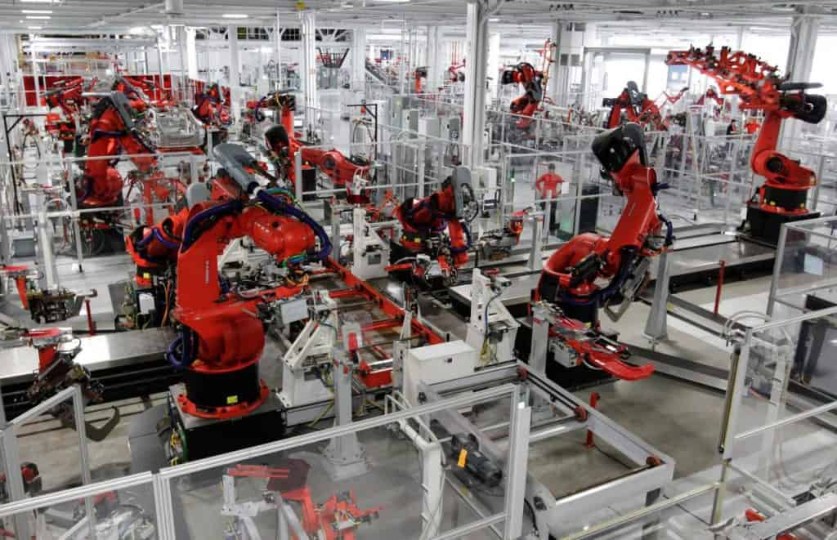
Image 6. Tesla’s modern robotic factory. (Improve efficiency with flexible automation, 2023).

Flexible automation and its application in the use of flat-packing material
Flat-packing furniture increases consumer flexibility, enabling them to build their own furniture at home. Thus, eradicating labour costs for building the furniture in-store. By designing furniture that was easy to assemble and disassemble with instructions, many more consumers could access new furniture. Many manufacturing companies sort after ways that would cut shipping costs and labour costs (Dahlborg & Johnsson, 2006). Flexible automation allows robots to detect dimensions, width, length and weight, allowing them to automatically package the product using sustainable materials (Roy, 2022). Robotics technology is able to monitor and adapt as needed to the different furniture being shipped along its fixed assembly line. Machines can be programmed for each specific task with certain measurements, with advanced sensors and screening for codes able to identify what task was required for each stage (García-Arca, Prado-Prado & Garrido, 2014). With the implementation of this technology, companies could save time, manual labour shipping costs, and waste costs and also be able to ship the product to the consumer quickly. Flexible automation now leads the industry for flat-packaging due to the nature of the enhanced efficiency and customisation options, allowing the specifications of any parts to be designed and manufactured in one assembly line. Automating the machinery by using sensory technology to identify different parts and equipment, allows it to be more streamlined in the process (García-Arca et al., 2020).
When considering fixed and programmable automation for this industry it would be less effective due to the nature and change of each component. Fixed and programmable would be used if the component was being mass-produced, whereas flexible automation allows for a change in components for different sizes and dimensions. Due to the adaptability of flexible automation, it utilises different mechanisms, whereas fixed is normally used for one continuous process line, and PLCs are used to control the processes of that process line rather than changing components (García-Arca et al., 2020).

Summary

It has since then seen great transformation and new machinery has been implemented to help establish the staggering consumer needs. From a single machine belt to a robotic model army, all for the purpose of efficiency and profitability. The need to relinquish human labour as its limited functionality can halt production. Automated control systems are the process that keeps giving. Without key and innovative systems, the economy certainly would not be as advanced as it is in the present day. The adaptation of limits so that if these limits were reached, a machine would switch itself off as a safety precaution enabling more factors that could be seen as new safety features and barriers to protect against any danger or more damage. Flexible and programmable automation improved nearly every aspect of manufacturing output, leading to improved time efficiency, reduced costs, material wastage and product quality and a much higher competitive market. Ultimately, all three manufacturing automation have their place in today's industry despite when they were developed.

References

Adam, A., Yusof, Y., Iliyas, M., Saif, Y. and Hatem, N. (2018). Review on manufacturing for advancement of industrial revolution 4.0. International Journal of Integrated Engineering, 10(5). Available at: https://publisher.uthm.edu.my/ojs/index.php/ijie/article/view/3013 (Accessed on 18 April 2024)
Agnantopoulou, E., Barboutis, I. and Kamperidou, V. (2023). ‘Wood utilization in windmill mechanisms on Sikinos Island (Greece)’, Applied Sciences, 13(16), p. 9216. doi:10.3390/app13169216.
Allen, R.C. (2018). The British Industrial Revolution in Global Perspective. 1st edn. Cambridge, United Kingdom: Cambridge University Press.
Angelakis, A.N., Krasilnikoff, J. and Tzanakakis, V.A. (2022). ‘Evolution of water technologies and corresponding philosophy and sciences focusing on the Hellenic world through the millennia’, Water, 14(19), p. 3149. doi:10.3390/w14193149.
Altintas, Y. and Ber, A.A., (2001). Manufacturing automation: metal cutting mechanics, machine tool vibrations, and CNC design. Appl. Mech. Rev., 54(5), pp.B84-B84.+
Ardeshiricham, A., Hu, W. and Kastner, R., (2017). November. Clepsydra: Modeling timing flows in hardware designs. In 2017 IEEE/ACM International Conference on Computer-Aided Design (ICCAD) (pp. 147-154). IEEE.
Badet, J. (2021). ‘AI, automation and New Jobs’, Open Journal of Business and Management, 09(05), pp. 2452–2463. doi:10.4236/ojbm.2021.95132.
Bartneck, C., Lütge, C., Wagner, A. and Welsh, S. (2021). An introduction to ethics in robotics and AI (p. 117). Springer Nature.
Bowden, B. (2020). Transformation: The First Global Economy, 1750–1914. The Palgrave Handbook of Management History, pp.271-306.
Corrà, M., Sousa, M., Reis, I., Tanganelli, F., Vila-Chà, N., Sousa, Ana., Magalhàes, R., Sampaio, P., Taipa, R and Maia, L. (2021). ‘Advantages of an automated method compared with manual methods for the quantification of intraepidermal nerve fiber in skin biopsy’, Journal of Neuropathology &amp; Experimental Neurology, 80(7), pp. 685–694. doi:10.1093/jnen/nlab045.
Crafts, N. (2019). ‘The sources of British economic growth since the Industrial Revolution: Not the same Old Story’, Journal of Economic Surveys, 35(3), pp. 697–709. doi:10.1111/joes.12349.
Dahlborg, H. and Johnsson, C. (2006). Evaluating packaging logistics development at IKEA for Improvements in Product and Packaging Development. Available at: https://lup.lub.lu.se/luur/download?func=downloadFile&recordOId=1328814&fileOId=1328815 (Accessed: 16 April 2024).
Dey, C. and Sen, S.K. (2020). ‘Industrial Automation Technologies’, Programmable Logic Controller (PLC), 1, pp. 14–82. doi:10.1201/9780429299346.
Fasth, Å., Stahre, J., Dencker, K., Karwowski, W. and Salvendy, G. (2010). Level of automation analysis in manufacturing systems. Advances in human factors, ergonomics, and safety in manufacturing and service industries, pp.233-242.
Fletcher, S.R., Johnson, T., Adlon, T., Larreina, J., Casla, P., Parigot, L., Alfaro, P.J. and del Mar Otero, M. (2020). Adaptive automation assembly: Identifying system requirements for technical efficiency and worker satisfaction. Computers & Industrial Engineering, 139, p.105772. doi:10.1016/j.cie.2019.03.036.
García-Arca, J., Prado-Prado, J.C. and Garrido, A.T.G.P., (2014). “Packaging logistics”: promoting sustainable efficiency in supply chains. International Journal of Physical Distribution & Logistics Management, 44(4), pp.325-346.
Garcia, E., Jimenez, M., De Santos, P., Armada, M. (2007). ‘The evolution of robotics research’, IEEE Robotics &amp; Automation Magazine, 14(1), pp. 90–103. doi:10.1109/mra.2007.339608.
García-Arca, J., Comesaña-Benavides, J., González-Portela Garrido, A and Prado-Prado, J. (2020). ‘Rethinking the box for Sustainable Logistics’, Sustainability, 12(5), p. 1870. doi:10.3390/su12051870.
Geradin, M. and Duysinx, P. (2018). An introduction to robotics - mechanical aspects | semantic scholar, AN INTRODUCTION TO ROBOTICS: MECHANICAL ASPECTS. Available at: https://www.semanticscholar.org/paper/An-introduction-to-robotics-mechanical-aspects-Duysinx-Bruls/28c67ee95fe6d3ba23cc61bfc7a1a3e7ea6550c9 (Accessed: 07 April 2024).
Hwang, Z.-H., Yan, H.-S. and Lin, T.-Y. (2021). ‘Historical development of water-powered mechanical clocks’, Mechanical Sciences, 12(1), pp. 203–219. doi:10.5194/ms-12-203-2021
Ionescu, D., Filipescu, A., Simion, G., Mincă, E., Cernega, D. and Solea, R. (2022). ‘Communication and control of an assembly, disassembly and repair flexible manufacturing technology on a Mechatronics Line assisted by an autonomous robotic system’, Inventions, 7(2), p. 43. doi:10.3390/inventions7020043.
Kanger, L., Bone, F., Rotolo, D., Steinmueller, W. and Schot, J. (2022). ‘Deep transitions: A mixed methods study of the historical evolution of mass production’, Technological Forecasting and Social Change, 177, p. 121491. doi:10.1016/j.techfore.2022.121491.
Kent, D. (1992). ‘Measurement and control 1950s–1990s: A view from the inside’, Measurement and Control, 25(7), pp. 213–222. doi:10.1177/002029409202500704.
Kurfess, T.R. (2015). Robotics and automation handbook. 1st edn. Boca Raton, Florida: CRC Press.
Lutter, R. and Morrall, J.F., 1994. Health-health analysis: A new way to evaluate health and safety regulation. The Mortality Costs of Regulatory Expenditures: A Special Issue of the Journal of Risk and Uncertainty, pp.43-66.
Improve efficiency with flexible automation (2023). CrossCo. Available at: https://www.crossco.com/resources/technical/fixed-versus-flexible-automation/ (Accessed: 14 April 2024).
.
Landes, D.S. (2003). The unbound Prometheus: technological change and industrial development in Western Europe from 1750 to the present. Cambridge University Press.
Misiti, A. (2020). A history of industrial robots, Wevolver. Available at: https://www.wevolver.com/article/a-history-of-industrial-robots (Accessed: 13 April 2024).
Niku, S.B., (2020). Introduction to robotics: analysis, control, applications. John Wiley & Sons.
Roy, R. (2022). ‘Sustainable packaging practices across various sectors: Some innovative initiatives under the spotlight’, Operations and Supply Chain Management: An International Journal, pp. 461–473. doi:10.31387/oscm0510359.
Schaffarczyk, A.P. (2023). Wind Power Technology An Introduction. 2nd edn. Cham: Springer International Publishing.
Stearns, P.N. (2020). The Industrial Revolution in World History, 5th edn. doi:10.4324/9781003050186.
Sorensen, C.E. and Williamson, S.T. (2006). My forty years with Ford. Wayne State University Press..
Soori, M., Arezoo, B. and Dastres, R. (2023). ‘Artificial Intelligence, Machine Learning and deep learning in advanced robotics, a review’, Cognitive Robotics, 3, pp. 54–70. doi:10.1016/j.cogr.2023.04.001.
Optimizing Production Efficiency: A Guide to Hot Rolling Mill Scheduling (2024) Importance of Scheduling in Hot Rolling Mills. Steefo Group. Available at: https://www.thesteefogroup.com/importance-of-rolling-mill-scheduling-factors-involved/ (Accessed: 13 April 2024).
Tree, C. (2020). PLC Block Diagram, PLC Block Diagram Basics | PLC Function Blocks Explanation | PLC Basics. Creative Tree. Available at: https://www.youtube.com/watch?v=ixOV1AzvTXI (Accessed: 08 April 2024).
Walker, M.J. (2012). The programmable logic controller: its prehistory, emergence and application. Open University (United Kingdom).
Wang, h., Liang, x., He, m., Li, x and Fu, s. (2020). ‘analysis of application of plc technology in automation control of electrical engineering’, 2020 ieee conference on telecommunications, optics and computer science (tocs). doi:10.1109/tocs50858.2020.9339623.
Wyatt III, L.T., (2008). The industrial revolution. Bloomsbury Publishing USA.
Zhong, Z., Zhang, J., Qiu, C. and Huang, S. (2022). ‘Design of a framework for implementation of industrial robot manipulation using PLC and ROS 2’, 2022 2nd International Conference on Computer, Control and Robotics (ICCCR), pp. 90–103. doi:10.1109/icccr54399.2022.9790107.

