

Exploring if Self-Esteem and Social Comparison are Predictors of Envy whilst viewing Positive Instagram Posts
1702887
Dissertation in Psychology
April 2020
University of Wales Trinity Saint David

Dissertation submitted in partial fulfilment of the requirements for the degree of: Bachelor of Arts (hons) in Counselling Studies and Psychology.
DECLARATION

This work has not previously been accepted in substance for any degrees and is not being concurrently submitted in candidature for any degrees.

Signed BFarmer
Date 28.04.2020

STATEMENT 1:
This dissertation is being submitted in partial fulfilment of the requirements for the degree of Counselling and Psychology (insert degree title)
Signed BFarmer
Date 28.04.2020

STATEMENT 2:
This dissertation is the result of my own independent work/investigation, except where otherwise stated. Other sources are acknowledged by giving explicit references. A reference list is appended.

Signed BFarmer
Date 28.04.2020

STATEMENT 3:
I hereby give consent for my dissertation, if accepted, to be available for photocopying and for inter-library loan, and for the title and summary to be made available to outside organisations.

Signed
BFarmer
Date 28.04.2020

Acknowledgements

The process of completing this dissertation has been the most challenging yet rewarding experience of my academic journey. With this, I believe it is important to acknowledge the people that have helped me along the way.
Firstly, to my dissertation supervisor Stacey Coleman, thank you for answering every single question I asked no matter how minute I thought they were! Thank you for always being approachable and instilling the belief in me that I was capable of completing this, without your support and wealth of knowledge I do not know where I would have been.
To the academic staff of University of Wales Trinity Saint David, thank you for the incredible support system you have provided over the duration of the year. This has been a challenging climate to provide a university tuition in and you have done a stellar job. To my course leader Ruth Groff, thank you for all your support, your kindness and understanding was appreciated immensely.
To my fellow students and peers, we did it! I remember our first day like it was yesterday. There has been ups, there has been downs, maybe a lot of downs, but we have always supported each other, and our group chat has been an incredible source of knowledge for all of us. Finally, to my family, thank you for always believing in me even when I did not believe in myself, I am dedicating this piece of work to you.

Table of Contents
Declaration 2
Acknowledgements 3
Abstract ………………………………………………………………………………………….…… 5
Chapter 1 – Literature Review..…………………………………………………………………….. 6
Chapter 2 – Method
2.1 Participants ……………………………………………………………………………………. 11
2.2 Design ………………………………………………………………………………………… . 11
2.3 Materials ……………………………………………………………………………………….. 12
2.4 Procedure ……………………………………………………………………………………… 14
Chapter 3 – Results
Table 1 – Descriptive Statistics ………………………………………………………………… 15
Table 2 – Correlations between variables ..…………………………………………………… 15
Table 3 – Beta Coefficients ……………………………………………………………………… 16
Chapter 4 – Discussion …………………………………………………………………………. 17
References ……………………………………………………………………………………….. 26
Appendix A – Consent Form …………………………………………………………………… 29
Appendix B – Rosenberg Self-Esteem Scale (1979) …………………………………………… 30
Appendix C – Social Comparison Scale ……………………………………………………….. 31
Appendix D – Envy Scale ………………………………………………………………………. 32
Appendix E – Pregnant Influencer Positive Instagram Post ……………………………….... 33
Appendix F – Manor House Owner Positive Instagram Post ……………………………….. 33
Appendix G - Expensive Car Owner Positive Instagram Post ……………………………… 34
Appendix H – Coffee Jar Neutral Instagram Post …………………………………………… 34
Appendix I – Cup of Sweets Neutral Instagram Post ………………………………………… 35
Appendix J – Rainbow Canvas Neutral Instagram Post ……………………………………… 36
Appendix K – Debrief Form ……………………………………………………………………… 36
Appendix L – Dissertation Proposal ……………………………………………………………... 37
Appendix M – Ethics Form ………………………………………………………………………. 44
Appendix N – SPSS Output ……………………………………………………………………… 72

Abstract

A multiple regression study was conducted to explore if levels of social comparison and self-esteem were predictors of a level of envy whilst viewing positive Instagram posts. Previous research has suggested that there is a link between envy, social comparison and mental health (Appel, Crusius, & Gerlach, 2015). Using this as a basis, the study required participants to complete the Rosenberg self-esteem scale (1979), and then respond to six different fictitious Instagram posts, three positive and three neutral. 40 participants took part in the study from a pool of psychology students at the University of Wales Trinity St David. The results showed that social comparion was a signifcant predictor of envy (r = .44, p <.05), whereas self-esteem was seen as a nonsignificant predctor (r = -.08, p >.05). Further research should seek to increase the sample size as well as fine tune the materials used for the Instagram posts.
Chapter 1 – Literature Review

Envy is a word that very few would like to be associated with, but unfortunately it lives within everyone. It is an unpleasant and vicious emotion, often too complex to be tangible as often those who experience it do not like to express it. It procures negative feelings of shame, rage, greed and hostility (Barth, 1988). Parrott and Smith (1993) suggest that envy arises from negative social comparisons, and that envy is rooted in ones realizaton that they do not possess a desirable attribute or quality that someone else does e.g. beauty, wealth or marital status. When people begin to compare themselves to others based on attributees such as these, it is suggested that envy is triggered as a result of ones social position or self-worth becoming threatened (Salovey & Rodin, 1984).
When discussing envy, it is important to distinguish between the two categories that envy can fall under. ‘Benign envy’ is described as the desire to lift one’s self up to obtain the attributes that a superior person may have (Vrabel, Southard, & Zeigler-Hill, 2018). On the other side, ‘malicious envy’ is defined as the desire to remove the superior persons advantage, or pull them down to the inferior person’s level (Vrabel, Southard, & Zeigler-Hill, 2018). The purpose of this study was to explore malicious envy in particular as it is the most researched and studied. In essence, malicious envy and social media profiles both can be viewed as shrouded in a level of anonymity so it is an interesting parallel to be explored.
Instagram, an image and video sharing mobile application, is one of the most popular social media platforms in the world today. It provides a platform for users to share instantaneous images, videos and milestones with family, friends, and followers. The images can be posted in its original form or be altered through a selection of preprogramed filters and visual effects. The image and video sharing site launched in October 2010 and has skyrocketed in popularity. Statistics show that Instagram has over 1 billion users (Instagram, 2020) and continues to grow. However, it is important to question social media platforms roles in our mental health. Are they providing a momentary relief from everyday life, or are the ultra-glamorous and lavish photos and lifestyles providing a false sense of reality to impressionable viewers?
With its huge accessibility and prominence in everyday life to the general population, it is important to explore the detriments that social media may have. Whilst there have been studies in the past that have been conducted to explore variables of social comparison, self-esteem and envy (Salovey & Rodin, 1991) (Salovey, 1991), the technological advances have altered everyday culture to the point where internet access is now a necessity, so it is important to recognise this as a point of interest for research.
The emergence of social media in recent years is seen to have had a profound effect on public mental health, a report by the Royal Society for Public Health (2017) suggests that increased usage of social media can lead to anxiety disorders and poor self-esteem. They also suggested that Instagram in particular was the most negative social media platform of them all in terms of its effects on young people’s mental health.
It is suggested that social comparison is a factor in affecting one’s mental health whilst using social media platforms. One of the key studies that underpins this was by Appel, Crusius and Gerlach (2015). They believed that envy and social comparison were predictors of depression whilst looking at an attractive person’s Facebook profile. Their studied involved participants completing the Rosenberg self-esteem scale (Rosenberg, 1979) and the Beck Depression Inventory (Beck, Ward, Mendelson, Mock, & Erbaugh, 1961). They then viewed Facebook profiles that contained either an attractive or unattractive profiles pictures and were asked to score themselves on seven ‘envy’ subcategories e.g. bitterness, inferiority etc. They also completed a social comparison task which recorded their responses based on the generalised topic of happiness. Their results supported their hypothesis and showed that higher levels of envy and social comparison are a predictor for depressive symptoms whilst viewing attractive Facebook profiles. The implications for this research suggest that there is a link between levels of envy, social comparison and mental health issues when viewing attractive social media profiles.
A similar study by Krasnova et al (2013) referred to Facebook as a “hidden threat to life satisfaction” in its title. Their study surveyed 584 Facebook users paying particular attention to how incidents on Facebook can procure feelings of envy. From the study they discovered a behavioural pattern. They defined the self-promoting and narcissistic behavioural pattern in play on social media sites as the “self-promotion envy-spiral”. The self-promotion envy-spiral suggests that when others feel envious of other users’ self-promotion they then in turn engage in self-promotion too. The results of their study showed that Facebook is a ‘stressful environment’ that decreases life satisfaction due to envious feelings. Krasnova however recognised the role that culture may have in one’s social media consumption. They suggested that as all of the participants of the study were German students, specific sharing behaviours may be distinct to this group only, and any emoting of envy may be salient.
Culture is an important factor to include recognise when researching previous literature. A study on women’s social media usage by Jiyoung (2018) found that one’s levels of social comparison and self-esteem influenced envy whilst viewing social media influencers Instagram profiles. Female smartphone users between the ages of 20 and 39 took part in a two-wave survey relating to social media influencers with independent variables of social comparison self-esteem. The results found that the independent variables were predictors of envy across both stages. With this, it shows that females
However, envy on social media does not always procure negative emotions. Studies have also shown that benign envy, or a small amount of envy in regard to positive Instagram posts can mediate a positive effect on inspirational traits, proving that not all social media interactions are negative (Meier & Schafer, 2018). The researchers however admitted that different factors can ultimately have a negative effect on well-being on Instagram depending on the participants background e.g. an overweight person viewing ‘#fitspiration’ posts. They also noted that the number of strangers followed may also affect the study outcome.

Linking with the study, a study by Lup et al (2015) in Indonesia found that the number of strangers followed on Instagram mediated a higher social comparison effect. They also found that the less strangers followed made it more likely for positive associations. They found that the more time spent on the app also had a significant effect on negative outcomes.
The aforementioned studies have shown that there are common correlations between self-esteem, social comparison. and envy whilst using social media sites such as Facebook. Instagram is one of the largest social media platforms in the world, however it is one of the least researched and studied. As such, the purpose of the study is to strengthen and increase the amount of research within the field of Instagram in regard to feelings of envy, social comparison and self-esteem. Therefore, the purpose of this study, utilising a multiple regression design, is to explore if levels of self-esteem and social comparison are predictors of envy levels whilst viewing positively contented Instagram posts rather than attractive or unattractive profiles.

Chapter 2 – Method
2.1 - Participants
A total of 40 participants were selected for this study from an undergraduate student population. All participants were student studying on a psychology related degree at the University of Wales Trinity Saint David, Swansea. The participants ranged in age from 18 and 62 (M =30, SD =12.06) with 29 females, nine males, one non-binary and one preferred not to say. Each participant was provided with a unique numeric code to remain anonymous, no personal data was recorded, only age and gender. The only pre-requisite for participants was that they needed to be familiar with Instagram to take part in the study.
2.2 - Design
The study utilised a regression design, in order to assess whether levels of self-esteem and social comparison were predictors of levels of envy whilst viewing positively contented Instagram posts. The independent variables were levels of self-esteem, measured using the Rosenberg Self Esteem scale (Rosenberg, 1979), and levels of social comparison, using an adapted Likert social comparison scale based on Appel, Crusius, & Gerlach (2015) focused on happiness.
The dependent variable was levels of envy, measured by using an adapted envy Likert scale adapted from (Appel, Crusius, & Gerlach, 2015) which included sub-topics of envy, inferiority, bitterness, how much they want to change their lives, and how much they wish to be like the owner of the Instagram profile.

2.3 Materials
Participants were provided with a consent form (see Appendix A) which provided details of the study and the researchers.
The Rosenberg self-esteem scale (see Appendix B) was used to measure participants self-reported levels of self-esteem using tailored statements directed towards self-esteem. Participants were provided with ten statements and asked to respond in the way they felt best related to them, for example, “I feel that I have a number of good qualities”. The responses were scored as followed; “Strongly Agree” = 4, “Agree” = 3, “Disagree” = 2, “Strongly Disagree” = 1 & “N/A” = 0. Five items were negatively worded and needed to be reverse scored prior to analysis. The possible scoring range was between 0 and 40, with higher scores relating to higher levels of self-esteem.
An adapted Likert scale based on Appel, Crusius, & Gerlach (2015) was utilised to measure participants self-reported levels of social comparison using tailored statements relating to social comparison (see Appendix C). As social comparison is a broad spectrum to measure, like the aforementioned study, the topic of happiness was used as it is a universal point of comparison experienced by all. The participants were asked to respond to two questions for each post, ‘how happy is the profile owner’ and ‘how happy is the profile owner compared to themselves?’ The first question utilised a 7-part Likert scale ranging from 0 ‘very unhappy’ to 6 ‘very happy’. The second question utilised an 8-part Likert scale with responses ranging from -4 ‘much unhappier’ to 4 ‘much happier.
An adapted Likert scale based on Appel, Crusius, & Gerlach (2015) was created to measure participants levels of self-reported envy using tailored questions relating to envy (see Appendix D). Envy sub-topics of inferiority, bitterness, enviousness, the participants desire to change their life and desire to be like the Instagram user were included to measure the levels of envy.

The study was created using the Super lab computer software available in the psychology laboratories. The six fictitious Instagram posts provided in the study were created by the researcher, three positive and three neutral posts. Images were selected from legitimate Instagram posts for the positive posts and photos taken from the researcher’s personal smartphone for the neutral posts. The posts were made to be as accurate to an Instagram post as possible, including number of likes and verification ticks. The first of the three positive images were of a pregnant social media influencer in a bikini at a luxurious spa resort (see Appendix E). The caption was written to reflect the user’s luxurious lifestyle and the number of likes were high to maintain the authenticity of her celebrity. The second positive post (see Appendix F) was of a manor house owner and her dog captured on her grounds. The caption was created to place importance on the users lavish home. The third positive post (see Appendix G) was of a male social media influencer standing next to his sports car in Monte Carlo. The caption and fabricated comments were included to reinforce the social media influencer culture present on Instagram. Parrott & Smith (1993) had previously defined envy as arising in social comparisons to one’s attributes such as beauty and wealth, so the three positive posts all display those in some form.
The first neutral Instagram post was of a picture of a jar of coffee (see Appendix H). The second neutral Instagram post was of a picture of a pic and mix (See Appendix I). The third neutral Instagram post (see Appendix J) was a picture of a canvas with an inspirational quote on it. The captions and images created for the neutral posts were chosen to contrast the lavish lifestyles presented in the positive posts.
For each Instagram post, the scales for social comparison and envy appeared next to them on screen and participants were asked to respond using specific number keys on a keyboard which were also on screen. Participants were then provided with a debrief form (Appendix K) informing them of the purpose of the study and reminding them of their right to withdraw.

2.4 - Procedure
Participants were firstly invited into a private laboratory room and asked to provide their unique identification code. Upon receiving this, the participants were provided with a consent form. Once consent was provided, the participants were then provided with the Rosenberg Self-esteem scale questionnaire to complete, which also required them to document their age and gender. After this, the researcher began the experiment on Superlab. The researcher informed all participants to follow the instructions on screen, whilst reminding them of their presence outside of the lab should there be any questions. The participants then viewed six different Instagram posts, three positive and three neutral in a random order. On each post, the participants were provided with the opportunity to respond rating their levels of envy and social comparison using the specified keys. After this was completed, the participants were provided with a debrief form, informing them of their right to withdraw, contact details and information on the purpose of the study.

Chapter 3 – Results
A multiple regression was conducted to assess whether the variables of social comparison and self-esteem, were predictors of envy when participants viewed positive Instagram posts. Scores for the Rosenberg Self-esteem scale, and the adapted Likert scales for envy and social comparison were totalled up to create total scores and analysed using a multiple regression on SPSS. Table 1 shows the means and standard deviations for each of the variables.
Table 1
Means and standard deviations for all of the variables included within analysis
 | M | SD | N
Self-Esteem | 24.10 | 3.65 | 40
Social Comparison | 32.58 | 4.91 | 40
Envy | 35.70 | 12.09 | 40

Table 2 highlights the correlations between the predictor variables and the dependent variable. As shown, there was a positive relationship with social comparison and envy (r = .44, p <.05). Higher levels of social comparison are significantly related to higher levels of envy. A negative correlation was found between self-esteem and envy (r = -.08, p >.05). Between social comparison and self-esteem, the predictor variables, a moderate negative correlation was found (r = -.02, p >.05).
Table 2
Correlations between variables
 | Self- Esteem | Social Comparison | Envy
Self-Esteem | - | -.02 | -.08
Social Comparison | -.02 | -- | .44
Envy | -.08 | .44 | -

The analysis showed that as a model, the independent variables were significant (F (2, 39) = 4.61, p < .05) with an adjusted R-squared value of 0.156. As a result, combining the independent variables explains that 15.6% of the variance in envy scores was explained by social comparison and self-esteem.
Table 3
Beta coefficients for the independent variables on the dependent variable envy
Variable | Beta Value
Self-esteem | -.07
Social comparison | .44

Table 3 displays the beta coefficients for each of the independent variables in the analysis. The independent variable social comparison was a significant independent predictor (p <.05) with a Beta value of .44. This indicates a positive prediction, meaning an increase of .44 standard deviations for the dependent variable found for every increase in one in standard deviation in social comparison scores. The independent variable self-esteem was not found to be significant statistically in contributing to envy scores (p > .05).
The results show that the hypothesis is rejected as only one independent variable was reported significant. From this result it can be concluded that social comparison is a significant predictor of levels of envy when viewing positive Instagram posts, whereas self-esteem is non-significant in its role as a predictor.

Chapter 4 – Discussion
Key Findings
This study intended to assess if levels of social comparison and self-esteem were predictors of envy whilst viewing positively contented Instagram posts. The key findings of the study were that the social comparison is a significant predictor of levels of envy whilst viewing the positive Instagram posts. Significant links between self-esteem and envy were not found. Whilst the hypothesis was not supported, it is important to recognise the significant data as this can now be further explored as the data further strengthens the existing research that suggests there is a correlation between social comparison and envy.
The study was based on Appel, Crusius, & Gerlach’s (2015) study on social comparison and envy as a predictor of depressive symptoms in Facebook users viewing attractive profiles. The results of that study showed that envy and social comparison were predictors of depressive symptoms whilst viewing attractive Facebook profiles. Linking with the results of this study, the results support the research as social comparison was shown to be a significant predictor of envy whilst viewing positive Instagram posts. However, it is important to note the reversal of variables within this study. Whilst in this case the altering of independent and dependent variables still supported the previous research by Appel, the intent of the study was not to replicate but to support whilst also exploring a new angle that had not been factored before. Also, this study replaced depressive symptoms with self-esteem as a way of integrating a new factor that has reported to have shown negative links to social media usage (Royal Society for Public Health, 2017).
The change from Facebook profile pictures to Instagram posts may have influenced the outcome of this study. The original study by Appel only utilised Facebook profiles which in essence are vague and do not provide much information or context to what the user is like. Research by eMarketer (2018) states Facebook is losing popularity amongst young people, with almost 2 million users under the ages of 24 leaving Facebook per year. In contrast to this, eMarketer is predicting that Instagram will gain 1.6 million users this year under the age of 24. They claim that social media platforms such as Instagram and Snapchat are more ‘cool’ in comparison to Facebook. This is an interesting point to discuss in terms of the results of this study and Appel’s study. It can be suggested that people (in particular young people) are less envious of Facebook profiles as is it not the ‘cool’ thing at the moment, and with millions leaving the site, it is important to recognise the decreased popularity as a factor.
The definition of envy is in itself related to social comparison. Parrott & Smith (1993) had previously stated that envy arises in the face of negative social comparisons. The results from this study support this claim, as social comparison was shown to be a significant predictor for levels of envy. This result helps support the original definition as well as solidifying its validity in the modern day. It is important to note that this study as well as the definition was based on malicious envy in particular rather than benign envy. Parrott & Smith had also recognised attributes such as wealth and beauty impacted ones levels of envy, as all of the positive posts included those factors in some form, their definition is supported oncemore.
However, Salovey & Rodin (1984) defined envy as being triggered from a threat to ones self-worth. The results from the study potentially argue this. Self-esteem was shown to be non-significant in being a predictor of envy. This argues that envy is not always linked to a threat to ones self-worth and makes the case for categorising of types of envy e.g. benign and malicious. It is important to note that that definition was made in 1984, in a culture prior to the creation of the internet, and as research shows, social media platforms exasturbate pre existing self-esteem problems (Valkenbur, Peter, & Shouted, 2006).
The Royal Society of Public Health’s (2017) report suggested that increased social media usage, in particular Instagram, the results of this study showed no significant correlation between self-esteem and Instagram posts. It is important to note however the specifity of this study in the grand scheme of the population. The RSPH study was based on a survey of 1479 14-24 year olds, in comparison to the 40 participants taking part in this study.
It can also be suggested that self-esteem is too vague of a trait to narrow down for the purpose of this study. The Rosenberg Self-Esteem Scale (1979), whilst reliable, is a selection of ten generic questions relating to self-esteem. It has been suggested that self-esteem fluctuates more in response to either positive or negative stimuli each individual is faced with, based on where they prioritise their self worth (Crocker & Wolfe,2001; Kernis and Waschull, 1995). For example, a high profile employee whos self-esteem is contingent on their business performance will experience a boost in self-esteem when their business is performing well, and a decrease in self-esteem when their business is performing at a loss. For the purpose of this study, someone who may not have their self-esteem contigent on social media affifrmation may not feel that their self-worth is threatened. Due to the nature of the study being outlined prior to the participation, a participant may feel positive about their self-worth when being tasked about social media because they’re self esttem may not be contrigent on social media affirmation. The results of the study showed that self-esteem was not a significant predictor of envy, from this it can be suggested that the Rosenberg Self-Esteem Scale (1971) should be adapted if the study is repeated to target social media more in particular.
Krasnova et al’s (2013) previous research into social media suggested that the ‘self-promotion envy-spiral’ was too blame for users lowered life satisfaction. They also suggested that the German culture may have made the participants responses to envy related questions more salient in nature. The results on this study do not correlate with the self-promotion envy-spiral, as the self esteem result returned non-significant. It can however be suggested that because the Rosenberg Self-Esteem Scale (1979) was completed at the beginning of the study before the fake Instagram posts were shown, that if they were to fill it in afterwards they may have answered differently as a way of self-promoting in response to feelings of envy. This is an interesting change that can be implemented if the study is to be replicated.
The results of this study also support Jiyoung (2018). Their study showed that social comparison and self-esteem were predictors of envy whilst viewing social media influencer Instagram profiles. Their study was on female students between the ages of 20 and 39. The majority of participants in this study were female (29 female participants) as well as having a mean of age 30 across all genders. This supports Jiyoung’s research in that female students in a younger age range are more likely to allow social comparison and self-esteem to be predictors of levels of envy whilst viewing positive or infleuncer instagram posts.
Meieir et al (2018) suggested that different social media content can be influential in ones levels of envy. They suggested that an overweight person viewing a ‘#fitspiration’ post may feel more malicious envy than someone who is athetically fit, who may feel benign envy. Factors like this were not taken into account with this study on ethical grounds, however it may provide an point of interest for future research if it can be approached ethically and morally. The three positive posts chosen for this study were that of glamorous, fit and wealthy people, however, there was a pregnant infleuencer chosen for one as it was more relatable and differentiated itself from just being about slim-bodied (see Appendix E). Also, the captions were curated with specific intention to provide content to the posts, rather than the participant just basing their repsonses on face-value.
Methological Considerations
Though the research yielded some strong results, it is important to recognise both the strengths and the weaknesses of the study. One of the main weaknesses of the study is the scale of the participant pool. In comparison to the world population, 40 people is a small sample size, so to suggest that the results from this study can be applied to a larger population is illogical. Knofczynski & Mundfrom (2008) suggest that to procure a multiple correlation coefficient at the excellent level would need around 1,000 participants, much higher than the 40 participants who took part in this study. However, it is important to recognise that this study only seeks to reinforce the preexisting research as well as providing a jump off point for anyone hoping to explore this area.
Another limitation of the study was some technilogical errors that took place during the study. On a handful of occasions, the Suberlab software crashed and needed to be reset midway through the task, meaning the researcher needed to come into the laboratory and restart the study manually. Interruptions to studies can break a participants trail of thought or remove them from the experiement setting, so their answers may have reflected this, as well as cause frustration that they had to complete the experiment again. Research suggests that task interruption can lower decision making performance when completing complex tasks (Speier, Valacich, & Vessey, 1999). To prevent this, the Instagram posts and scales used on the Superlab experiment potentially can be printed out and any repsonses recorded using pen and paper. However, the researcher has previously decided that the Instagram posts should be displayed digitally as this helps keep authenticity as Instagram is a digital platform.
Though the researcher sought to keep authenticity to the instagram posts, ultimately it is almost impossible to truly replicate the instagram layout artificially. Due to the nature of the post creation process, it can be implied that the instagram posts were not accurate to real life. The participants were not told if the posts were real or not before the study, the only infromation provided was that they will view Instagram posts. The creation process is very complicated in that most standard computers do not have the default Instagram font supplied as well as there being a lack of legitimate blank post templates. The researher tried to replicate the posts as accurately as possible but due to technological restraints such as image size and composition some images were slightly stretched to fit the frame as well as the text being out of place minorly in comparison to leigitimate posts. In future research, a researcher should try to find legitimate instagram posts to use for the experiment or alternatively pay particular attention in making the posts look as accurate as they can, both of which may be time consuming.
One of the strengths of the research however was its directness in its approach in getting the data it needed as well as its attempt to remain faitfhul to the original experiment in which it was based. The adapted scales for envy and social comaprison were both featured on the screen at the same time as the instagram post, meaning participants were directly repsonding to each instagram post as its appeared rather than what information they recalled about them. This mirrored the procedure of the orginal experiment by Appel, Crusius, & Gerlach (2015) as they also kept the Facebook profiles accesible at all times throughout. It is important that this factor was followed through as asking participants to recall information about the posts wouldve inadvertantly created a new dimension to the study that it wasn’t seeking to explore. Redish & Mizumori (2015) suggest that decision making relies on ones compurterization of memories, for example if someone memorises something with a general representation with little specifity, they are then more inclined to make quick and inflexible decisions in regard to it. In contrast, if someone memorises something with specific details included, they are more likely to make a slow but informed decision in regard to it. With this in mind, it can be suggested that placing the posts in constant view allowed the participant to make informed responses to each question as participants did not need to recall from their memory.
Furthermore, as self-esteem was measured prior to the start of the experiment, it can be claimed that self-esteem was measured on a general scale rather than in repsonse to the Instagram posts themselves. It could be argued that in this case, self-esteem could have been measured as the dependent variable because the other variables were measured in direct response to the instagram post stiumuli presented in front of it. Self-esteem was shown to be non-significant in its role as a predictor, the procedure of the experiment may have influenced this. Further research may want to explore this as a possibility, potentially rearranging the experiment to explore if envy and social comparison are predictors of self-esteem whilst viewing positive Instagram posts.
It is also important to note that whilst the content of the fictitious instagram posts was chosen specifically to influence ones responses, it begs the question, what is a ‘positive’ instagram post? Personal taste and life experience may produce a different level of envy or social comparison, e.g. a richer person may not be jealous of a social media influencer or someone who may not be contingent on that culture may not feel they need to compare themsleves, due to the often fakery of the content creators.
A final limitation of the research was the procedure to complete the Superlab experiment. Feedback was provided to the researcher stating that the scale used to measure social comparison and envy were repetitive in nature and provided participants with an idea of what the research was trying to find. Further research should include more questions to steer participants away from knowing the true purpose of the study. Envy is not a trait many want to be associated with so participants may have not wanted to share this information if they felt the study was seeking to explore this.

Implications for further research
Relating to the research on social media’s effect on mental health, the results of this study provide a platform for further exploration on how to combat social comparison and envy on social media. The results showed that social comparison was a predictor of envy, it would be important to research if the envy could therefore manifest itself negatively within one’s mental health. It is also of note that the study succeeded in its attempt to strengthen the existing research whilst adding a different variable, which was one the main aims of the study overall.
Further research may want to use a different social media platform as a basis for a study, as social media is an evergowing entity that is constantly changing and updating with every second. It is also now incredibly important to modern society so it would be advantegous to continue research in this field. Perhaps linking to the split definition of envy (Vrabel, Southard, & Zeigler-Hill, 2018), it may be of importance to clearly define the usage of malicious or benign envy as a variable. Previous research had suggested that benign envy can procure a positive effect on social media usage, so by adapting the envy scale to feature more postiviely worded terms may produce a different result if repeated again.
Conclusion
To conclude, the study was seen as a success, as a first time dissertation students year long project, the study produced a significant result, something not found commonly amongst peers. The study also was successful in that it strenghtnened the existing research as well as created oppurtunity for further research. The study also was performed without many errors, even though room for improvement was still recognised.
This research opens up a lot of potential doors to research social comparison and envy in other fields, if there is a significant link here then it may be applicable to other fields.

References
Appel, H., Crusius, J., & Gerlach, A. L. (2015). Social Comparison, Envy, and Depression on Facebook: A study looking at the effects of high comparison standards on depressed individuals. Journal of Social and Clinical Psychology, 277-289.
Barth, D. F. (1988). The role of Self-Esteem in the Experience of Envy. The American Journal of Psychoanalysis, 198-210.
Beck, A., Ward, C. H., Mendelson, M., Mock, J., & Erbaugh, J. (1961). An inventory for measuring depression. Archives of General Psychiatry, 561-571.
Crocker, J., & Wolfe, C. T. (2001). Contigencies of self-worth. Psychological Review, 593-623.
De Vries, D. A., Möller, A. M., Wieringa, M. S., Eigenraam, A. W., & Hamelink, K. (2018). Social Comparison as the Thief of Joy: Emotional Consequences of Viewing Strangers’ Instagram Posts. Media Psychology, 222-245.
eMarketer. (2018). Faceook losing younger users. Retrieved from emarketer.com: https://www.emarketer.com/content/facebook-losing-younger-users-at-even-faster-pace
Instagram. (2020, April 20). Instagram - About Us. Retrieved from Instagram.com: https://about.instagram.com/about-us
Jiyoung, C. (2018). Explaining Females’ Envy Toward Social Media Influencers. Media Psychology, DOI: 10.1080/15213269.2017.1328312.
Kernis, M. H., & Waschull, S. B. (1995). The interactive roles of stability and level of self-esteem: Research and theory. Advances in experimental social psychology, 93-141.
Knofczynski, G. T., & Mundfrom, D. (2008). Sample Sizes when using Multiple Linear Regression for Prediction. Educational and Psychological Measurement, 431-442.
Krasnova, H., Krasnova, W., Thomas, H., Thomas, W., & Buxmann, P. (2013). Envy on Facebook: A Hidden Threat to Users’ Life Satisfaction? International Conference on Wirtschaftsinformatik.
Lumban, G. e. (2018). The relationship between social comparison and depressive symptoms among Indonesian Instagram users., (pp. 10.2991/uipsur-17.2018.19).
Lup, K., Trub, L., & Rosenthal, L. (2015). Instagram #Instasad?: Exploring Associations Among Instagram Use, Depressive Symptoms, Negative Social Comparison, and Strangers Followed. Cyberpsychology, behavior and social networking, 247-252.
Meier, A., & Schäfer, S. (2018). The Positive Side of Social Comparison on Social Network Sites: How Envy Can Drive Inspiration on Instagram. Cyberpsychology, Behavior, and Social Networking, 411-417.
Parrott, W. G., & Smith, R. H. (1993). Distinguishing the experiences of envy and jealousy. Journal of personality and social psychology, 906-920.
Redish, A. D., & Mizumori, S. J. (2015). Memory and decision making. Neurobiology of learning and memory, doi.org/10.1016/j.nlm.2014.08.014.
Rosenberg, M. (1979). Concieving the Self. New York: Basic Books.
Royal Society for Public Health. (2017). #Statusofmind: social media and young people's mental health. London: RSPH.
Salovey, P. (1991). Social comparison processes in envy and jealousy. In J. Suls, & A. T. Wills, Social comparison: Contemporary theory and research (pp. 261–285). Lawrence Erlbaum Associates, Inc.
Salovey, P., & J, R. (1984). Some antecedents and consequences of social-comparison jealousy. Journal of Personality and Social Psychology, 780-792.
Salovey, P., & Rodin, J. (1991). Provoking Jealousy and Envy: Domain Relevance and Self-esteem Threat. Journal of Social and Clinical Psychology, 395-413.
Speier, C., Valacich, J. S., & Vessey, I. (1999). The Influence of Task Interruption on Individual Decision Making: An Information Overload Perspective. Decision Sciences, 337-359.
Valkenbur, P. M., Peter, J., & Shouted, A. P. (2006). Friend Networking Sites and Their Relationship to Adolescents’ Well-Being and Social Self-Esteem. Cyberpsychology and Behaviour, 584-590. Retrieved from https://www.researchgate.net/profile/Patti_Valkenburg/publication/6761621_Friend_Networking_Sites_and_Their_Relationship_to_Adolescents%27_Well-Being_and_Social_Self-Esteem/links/5422d8660cf26120b7a63756/Friend-Networking-Sites-and-Their-Relationship-to-A
Vrabel, J. K., Southard, A., & Zeigler-Hill, V. (2018). Self-esteem and envy: Is state self-esteem instability associated with the benign and malicious forms of envy? Personality and Individual Differences, 100-104.

Appendix A
Academic Discipline of Psychology and Counselling
SA1 Campus
Swansea


Study Consent Form

I understand that this research study is being carried out by a 3rd year Psychology Student for their dissertation, and that taking part in this study will involve the completion of a questionnaire, viewing Instagram posts and then providing responses to them.
This study will take approximately 15 minutes to complete.
I understand that participation in this study is voluntary and I am free to withdraw participation during or at the end of the study without giving a reason. I understand that once I leave the study, I will not be able to withdraw my data, as it will be anonymised. I am aware that if I have concerns about the study, I can discuss these concerns with the researcher at any time during or after the study. I understand that I will be provided with the contact details of the research supervisor at the end of the study, should I have any concerns.
I understand that the information provided by me will be held confidentially, with a code assigned in place of my name. These data will be stored indefinitely in accordance with the Data Protection Act.
I also understand that at the end of the study I will be provided with a debrief form and the opportunity to discuss any issues with the researcher.

I, ___________________________________(NAME) consent to participate in the study conducted by Bobby Farmer, Academic Discipline of Psychology and Counselling, University of Wales Trinity Saint David, Swansea under the supervision of Stacey Coleman.

Participant Signature:________________________________________________
Date:___________________
Name and signature of researcher taking consent
___________________________________________________________________

 | Strongly Agree | Agree | N/A | Disagree | Strongly Disagree
- On the whole, I am satisfied with myself. | □ | □ | □ | □ | □
- At times I think I am no good at all. | □ | □ | □ | □ | □
- I feel that I have a number of good qualities. | □ | □ | □ | □ | □
- I am able to do things as well as most other people. | □ | □ | □ | □ | □
- I feel I do not have much to be proud of. | □ | □ | □ | □ | □
- I certainly feel useless at times. | □ | □ | □ | □ | □
- I feel that I'm a person of worth, at least on an equal plane with others. | □ | □ | □ | □ | □
- I wish I could have more respect for myself. | □ | □ | □ | □ | □
- All in all, I am inclined to feel that I am a failure. | □ | □ | □ | □ | □
- I take a positive attitude toward myself. | □ | □ | □ | □ | □
Appendix B

Gender: Age:

Using the scale below, please indicate the degree to which you agree with the following statements, according to your own feelings.

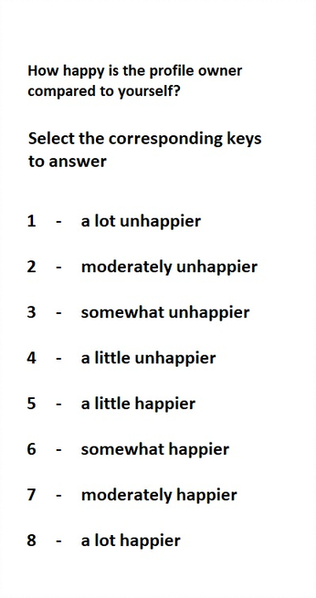
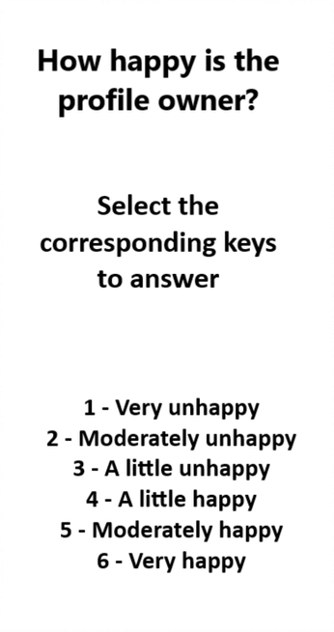
Appendix C

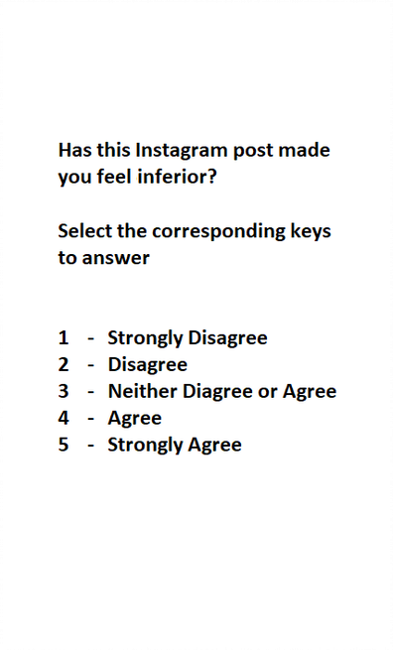
Appendix D
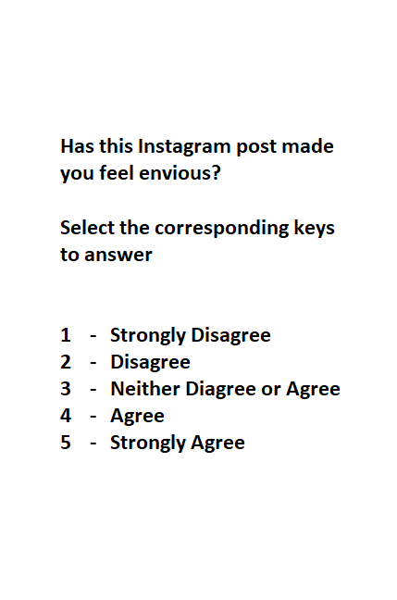

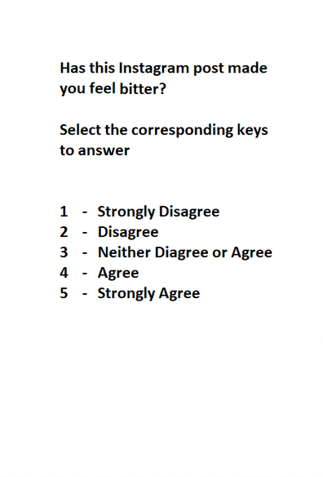
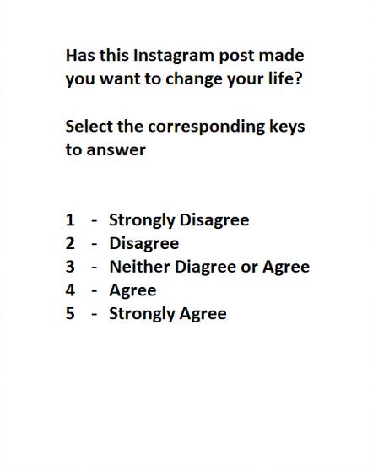

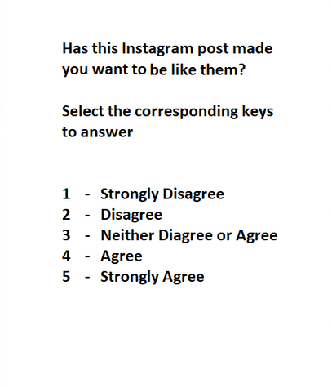

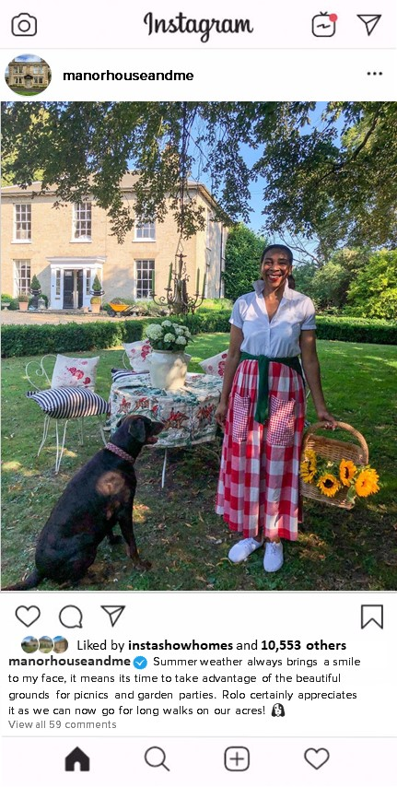
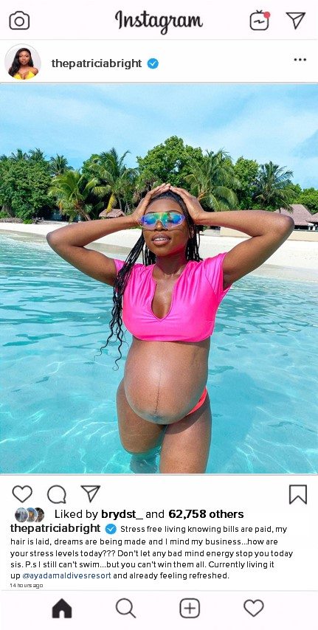
Appendix E Appendix F

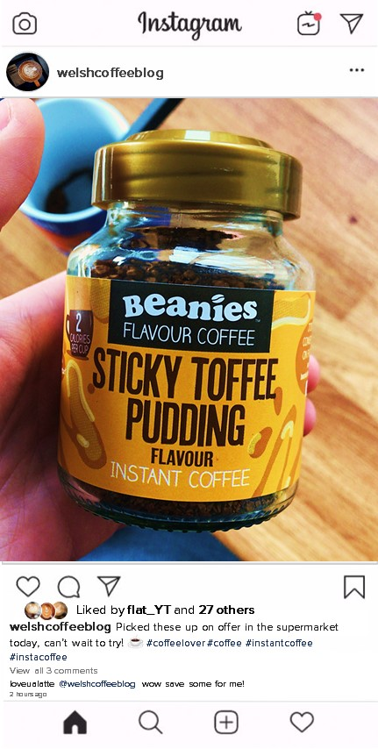

Appendix G Appendix H

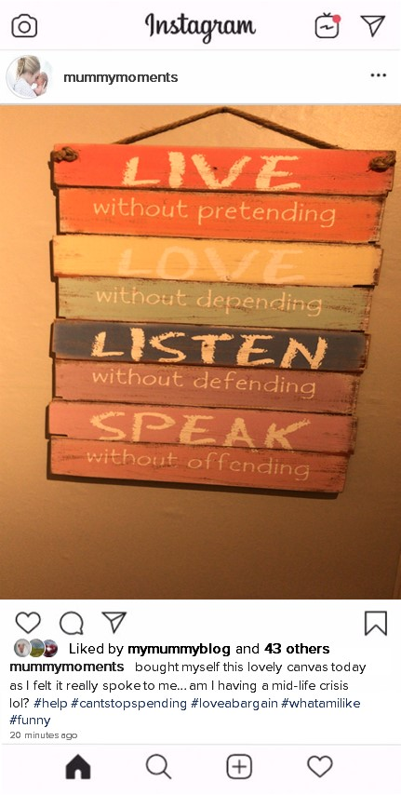
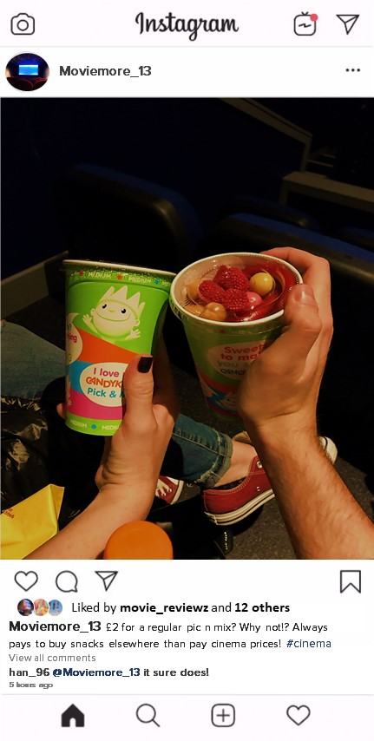
Appendix I Appendix J

Appendix K

Academic Discipline of Psychology and Counselling
SA1 Campus
Swansea

Study Debrief Sheet
#DislikeForLike: A multiple regression study exploring if levels of self-esteem and social comparison are a predictor of envy whilst viewing positively contented Instagram posts

Thank you for taking part in the study.

The aim of this study was to explore whether levels of self-esteem and social comparison are predictors of envy levels when viewing positively contented Instagram posts We specifically wanted to find out whether higher levels of social comparison and lower levels of self-esteem lead to higher levels of envy.

If you wish to withdraw your data from the study, you must tell the researcher now. After this point, all of your data will be anonymised, and we will not be able to trace it back to you.

If taking part in this study has raised any questions, please speak to the researcher on Bobby Farmer (1702887@student.uwtsd.ac.uk) or contact the academic supervisor Stacey Coleman (stacey.coleman@uwtsd.ac.uk)

Thank you once again for taking time to participate in this study.

Bobby Farmer

BA Honours Psychology and Counselling Studies

University of Wales Trinity Saint David, Swansea

Appendix L
Dissertation proposal 2019-2020

Student Name | Bobby Farmer
Dissertation Supervisor | Stacey Coleman
Date submitted | 11.10.19

Title of Research (this must reflect the essence of your proposed research question, study design and study population and should be more specific than the broad topic area provided in the dissertation topics selection book).
#DislikeForLike: A multiple regression study exploring if levels of self-esteem and social comparison are a predictor of envy whilst viewing positively contented Instagram posts

Please state your main research question(s) and hypothesis/hypotheses

Are levels of self-esteem and social comparison predictors for envy whilst viewing positively contented Instagram posts?

The hypothesis is that those with higher levels of social comparison and lower levels of self-esteem will result in higher levels of envy.

What empirical evidence supports your research question? (Please provide a 1500-word review of relevant psychological literature and theory and a minimum of eight references). If you have already drafted a review of literature, please attach it to the end of this document – you do not need to complete this section if so).

There have been lots of studies into the effect that envy has on mental health. The emergence of social media in recent years is seen to have had a profound effect on public mental health. One of the key studies underpinning this was by Appel, Crusius and Gerlach (2015). They believed that envy and social comparison was a predictor of depression whilst looking at attractive Facebook profiles. Their studied involved participants completing the Rosenberg self-esteem scale and the Beck Depression Inventory (SES & BDI). They then viewed attractive and unattractive Facebook profiles and were asked to score themselves on seven ‘envy’ subcategories e.g. bitterness, inferiority etc. They also completed a social comparison task which recorded their responses based on the generalised topic of happiness. Their results supported their hypothesis and showed that higher levels of envy and social comparison are a predictor for depressive symptoms whilst viewing attractive Facebook profiles.
A similar study by Krasnova et al (2013) described Facebook as a “hidden threat to life satisfaction”. The results of their study showed that Facebook is a ‘stressful environment’ that decreases life satisfaction due to envious feelings. They defined the self-presentation and narcissist behaviour as the “self-promotion envy-spiral”. Krasnova however recognised the role that culture may have in one’s social media consumption.

However, envy on social media does not always procure negative emotions. Studies have also shown that benign envy on Instagram can mediate a positive effect on inspiration, proving that it not all social media interactions are negative (Meier et al, 2018). The researchers however admitted that different factors can ultimately have a negative effect on well-being on Instagram depending on the participants background e.g. an overweight person viewing ‘#fitspiration’ posts. They also noted that the number of strangers followed may also affect the study outcome.
Linking with the study, a study by Lup et al (2015) in Indonesia found that the number of strangers followed on Instagram mediated a higher social comparison effect. They also found that the less strangers followed made it more likely for positive associations. They found that the more time spent on the app also had a significant effect on negative outcomes. However, another Indonesian study by Goal et al (2018) debated this and found that social comparison occurs despite the amount of time spent on the app, they however did agree that the more strangers followed led to a higher social comparison effect.
The aforementioned studies have shown that there are common correlations between self-esteem, social comparison. and envy whilst using social media sites. Therefore, the purpose of this study is to explore the correlation between self-esteem and social comparison on envy levels whilst viewing positively contented Instagram posts rather than attractive or unattractive profiles.

References
Krasnova, Hanna & Wenninger, Helena & Widjaja, Thomas & Buxmann, Peter. (2013). Envy on Facebook: A Hidden Threat to Users’ Life Satisfaction?. International Conference on Wirtschaftsinformatik.

Lup, Katerina & Trub, Leora & Rosenthal, Lisa. (2015). Instagram #Instasad?: Exploring Associations Among Instagram Use, Depressive Symptoms, Negative Social Comparison, and Strangers Followed. Cyberpsychology, behavior and social networking. 18. 247-252. 10.1089/cyber.2014.0560.

Lumban Gaol, Las Asimi & Mutiara, Amira & Saraswati, Nimas & Rahmadini, Rizqika & Hilmah, Maulidia. (2018). The relationship between social comparison and depressive symptoms among Indonesian Instagram users. 10.2991/uipsur-17.2018.19.

Meier, Adrian & Schäfer, Svenja. (2018). The Positive Side of Social Comparison on Social Network Sites: How Envy Can Drive Inspiration on Instagram. Cyberpsychology, Behavior, and Social Networking. 21. 411-417. 10.1089/cyber.2017.0708.

Dian A. de Vries, A. Marthe Möller, Marieke S. Wieringa, Anniek W. Eigenraam & Kirsten Hamelink (2018) Social Comparison as the Thief of Joy: Emotional Consequences of Viewing Strangers’ Instagram Posts, Media Psychology, 21:2, 222-245, DOI: 10.1080/15213269.2016.1267647

Please describe your participant group (including anticipated number of participants required) and any specific inclusion/exclusion criteria.

Participants will be recruited through the psychology Experiment Management System (EMS) and will, therefore, be undergraduate students who are currently enrolled on a psychology related degree at University of Wales Trinity Saint David, Swansea.

It is expected that approximately 40-50 participants will be required in order to carry out the proposed analysis (multiple regression with two independent/predictor variables).
There will be no exclusion criteria to take part in this study, however it will be advised that participants should be familiar with the structure of the social media platform Instagram.

Please provide brief details of the anticipated design (e.g., between, within, mixed, regression, focus groups, interviews, experimental, questionnaires) and main procedure for your study (it should be clear from this how you are actually planning to carry out your study, and what will be happening to your participants).

The study will utilise a regression design. Participants will be asked to sign up using the EMS system, where they have all been allocated their own individual ID number. They shall use this to identify themselves when arriving at the labs.

Participants will be provided with brief information regarding the content of the study in the form of a disclaimer that states that it is expected that participants are familiar with Instagram before they sign up to take part in this study.

Participants will then be given a consent form to read that documents what they are required to do to take part in the study and to provide information regarding their right to withdraw at any point during the study without fear of penalty. Participants will be asked to document their age and gender too.

The first IV in this study will be levels of self-esteem. Participants will be asked to complete the Rosenberg self-esteem scale in order to assess their level of self-esteem. They will then be asked to view 6 structured Instagram posts; 3 positive and 3 neutral posts that will be displayed in a random order. Structured Instagram posts will be created using picture files shown from the perspective of Instagram users. Captions for the pictures will describe either be overly positive e.g. new job or home or neutral e.g. a cup of tea.

For each Instagram post, participants will be asked to respond to a number of questions to assess social comparison (IV 2) and envy (DV). Questions used to measure social comparison will focus primarily on happiness. The participants will be asked to respond to two questions for each post, ‘how happy is the profile owner’ and ‘how happy is the profile owner compared to themselves?’ The first question will utilise a 7-part Likert scale ranging from 0 ‘very unhappy’ to 6 ‘very happy’. The second question will utilise an 8-part Likert scale with responses ranging from -4 ‘much unhappier’ to 4 ‘much happier.

Participants will then record their responses using an adapted envy Likert scale which includes envy, inferiority, bitterness, how much they want to change their lives, and how much they wish to be like. The responses for this will be a scale of 1 strongly disagree to 5 strongly agree. Like the base study, neutral options will be mixed in with these e.g. how similar are you or questions on Instagram’s layout et to veil the focus on envy. Posts will remain on the screen with no time limit but at least 1 minute. Once complete the participants will then be given a debrief form to describe the purpose of the study, contact details and reminding them of their right to withdraw.

What measures are you planning to use for data collection and how will this data be used in the analysis in order to answer your research question? (Be as specific as possible here – what type of data will you be obtaining, what specific topics/measures/scales/instruments will you be using and what will you do with this data?)

The Rosenberg self-esteem scale to measure self-esteem (1979). Questions 2, 5, 6, 8 and 9 will be reverse scored. Responses will be on a scale of 1-4 (range 10-40). The sum of all the scores will be added together on a continuous scale. Higher scores indicate higher self esteem.
(1997)
Adapted envy scale –envious, inferior, bitter, wish to be like and felt inspired by (0-6 Likert scale) items averaged to form central dependant variable (Cronbach’s a =.88)
Adapted social comparison scale – how happy is the profile owner? (0 very unhappy – 6 very happy happy) how happy is profile owner compared to themselves? (-4 much happier – 4 much happier).
Results will be run through SPSS as a standard multiple regression.

Rosenberg, M. (1979). Conceiving the Self. New York: Basic Books.

What are the main ethical issues that you will need to address in this study? (Please note all students will need to complete the full ethics form prior to final approval for data collection being given).

BPS code of ethics will be followed strictly throughout. Participants will be provided with consent and debrief forms telling them of their right to withdraw from the experiment or withdraw their data. Any fabricated Instagram posts will be generic and non-offensive to reduce discomfort. Any data will be only viewed by myself whilst generating results and destroyed immediately after. All participants will be given a unique numeric ID code and will only be referred to by this and no personal details such as names will be used or shared. The study should not envoke negative emotions or require a post-study exercise. If any participant is uncomfortable with the study material they can withdraw from the study at any time with their data removed and will not be penalised. There is no deception in this study also. A debrief will be provided at the end to explain the purposes of the study and also providing a port of contact for any questions or further information.

Student Name (Please print clearly) __________________________________________

Student Signature ____________________________________________Date_______________

Proposal Outcome |  | Supervisor to tick one only
Satisfactory proposal (all final materials have been approved by the supervisor; proceed to submitting the ethics form to the discipline research ethics committee).

Minor revisions (some areas require clarification before submitting ethics to the discipline research ethics committee - see below for required actions)

Unsatisfactory (proposal lacks significant detail and must be resubmitted to supervisor within seven days following feedback - see below for required actions)

Unsatisfactory - proposal is considered unethical/unworkable in practice. New proposal to be developed following feedback from supervisor (see below)

Proposal is satisfactory but requires full consideration by the Faculty research ethics committee due to the nature of the study

Supervisory team additional comments/feedback:

Action required:

Date of comments/feedback:

Supervisor’s Signature: ___________________________ Date: _______________
Appendix M
APPLICATION FOR ETHICAL APPROVAL
In order for research to result in benefit and minimise risk of harm, it must be conducted ethically. A researcher may not be covered by the University’s insurance if ethical approval has not been obtained prior to commencement.

The University follows the OECD Frascati manual definition of research activity: “creative work undertaken on a systematic basis in order to increase the stock of knowledge, including knowledge of man, culture and society, and the use of this stock of knowledge to devise new applications”. As such this covers activities undertaken by members of staff, postgraduate research students, and both taught postgraduate and undergraduate students working on dissertations/projects.

The individual undertaking the research activity is known as the “principal researcher”.

Ethical approval is not required for routine audits, performance reviews, quality assurance studies, testing within normal educational requirements, and literary or artistic criticism.

Please read the notes for guidance before completing ALL sections of the form.

This form must be completed and approved prior to undertaking any research activity. Please see Checklist for details of process for different categories of application.

Delete the Guidance Notes at the end of the form BEFORE submitting your application

SECTION A: About You (Principal Researcher)
Full Name: |  | Bobby Farmer
Tick all boxes which apply: |  | Member of staff: | ☐ | Honorary research fellow: | ☐
Undergraduate Student | ☒ | Taught Postgraduate Student | ☐ | Postgraduate Research Student | ☐

Faculty/School/Centre: | School of Psychology
Campus: | SA1 Waterfront
E-mail address: | 1702887@student.uwtsd.ac.uk
Contact Telephone Number: | 07538092041
For students:
Student Number: | 1702887
Programme of Study: | Counselling and psychology
Director of Studies/Supervisor: | Stacey Coleman

SECTION B: Approval for Research Activity
Has the research activity received approval in principle?  (please check the Guidance Notes as to the appropriate approval process for different levels of research by different categories of individual) |  | YES | ☒ | NO | ☐
 |  |  |  | Date
If Yes, please indicate source of approval (and date where known): Approval in principle must be obtained from the relevant source prior to seeking ethical approval | Research Degrees Committee |  | ☐
 | Faculty Research Committee |  | ☐
 | Other (write in) |  | ☒ | Dissertation supervisor; November 2019

SECTION C: Internal and External Ethical Guidance Materials
Please list the core ethical guidance documents that have been referred to during the completion of this form (including any discipline-specific codes of research ethics, and also any specific ethical guidance relating to the proposed methodology). Please tick to confirm that your research proposal adheres to these codes and guidelines.
UWTSD Research Ethics & Integrity Code of Practice | ☒
UWTSD Research Data Management Policy | ☒
BPS Code of Human Research Ethics | ☒
BPS Code of Conduct | ☒
UWTSD Student Code of Conduct | ☒

SECTION D: External Collaborative Research Activity
Does the research activity involve collaborators outside of the University? |  | YES | ☐ | NO | ☒
If Yes, please provide the name of the external organisation and name and contact details for the main contact person and confirmation this person has consented to their personal data being shared.as part of this collaboration.
Institution
Contact person name
Contact person e-mail address

Has this individual consented to sharing their details on this form? |  | YES | ☐ | NO |  |  | ☐
Are you in receipt of a KESS scholarship? |  | YES | ☐ | NO |  |  | ☐
Is your research externally funded |  | YES | ☐ | NO |  |  | ☐
Are you specifically employed to undertake this research in either a paid or voluntary capacity? | Voluntary | YES | ☐ | NO |  | ☐
 | Employed | YES | ☐ | NO |  | ☐
Is the research being undertaken within an existing UWTSD Athrofa Professional Learning Partnership (APLP) | If YES then the permission question below does not need to be answered. | YES | ☐ | NO |  |  | ☐
Permission to undertake the research has been provided by the partner organisation | (If YES attach copy)  If NO the application cannot continue | YES | ☐ | NO |  |  | ☐

Where research activity is carried out in collaboration with an external organisation
Does this organisation have its own ethics approval system? | YES | ☐ | NO | ☒
If Yes, please attach a copy of any final approval (or interim approval) from the organisation

SECTION E: Details of Research Activity
Indicative title: | #DislikeForLike: A multiple regression study exploring if levels of self-esteem and social comparison are a predictor of envy whilst viewing positively contented Instagram posts
Proposed start date: | November 2019 | Proposed end date: | March 2020
Introduction to the Research (maximum 300 words)
Ensure that you write for a Non-Specialist Audience when outlining your response to the three points below:
- Purpose of Research Activity
- Proposed Research Question
- Aims of Research Activity
- Objectives of Research Activity
Demonstrate, briefly, how Existing Research has informed the proposed activity and explain
- What the research activity will add to the body of knowledge
- How it addresses an area of importance.
Purpose of Research Activity
This research activity is part of a third year BA Counselling and Psychology students’ dissertation at the University of Wales Trinity St David. The project seeks to explore the link between social comparison and self esteem and whether they are predictors for levels of envy, whilst looking at positively contented Instagram posts.

(this box should expand as you type)
Research Question
Are levels of self-esteem and social comparison predictors of envy whilst viewing positively contented Instagram posts?

(this box should expand as you type)
Aims of Research Activity

The aim is to explore if levels of self esteem and social comparison are a predictor for level of envy whilst viewing positively contented Instagram posts.

(this box should expand as you type)
Objectives of Research Activity
The objective of this study is to capture data in order to identify if people become envious of positively contented Instagram posts because of their self-esteem or level of social comparison.

(this box should expand as you type)
Proposed methods (maximum 600 words)
Provide a brief summary of all the methods that may be used in the research activity, making it clear what specific techniques may be used. If methods other than those listed in this section are deemed appropriate later, additional ethical approval for those methods will be needed.
The study will utilise a regression design. Participants will be asked to sign up using the EMS system, where they have all been allocated their own individual ID number. They shall use this to identify themselves when arriving at the labs.

Participants will be provided with brief information regarding the content of the study in the form of a disclaimer that states that it is expected that participants are familiar with Instagram before they sign up to take part in this study.

Participants will then be given a consent form to read that documents what they are required to do to take part in the study and to provide information regarding their right to withdraw at any point during the study without fear of penalty. Participants will be asked to document their age and gender too.

The first IV in this study will be levels of self-esteem. Participants will be asked to complete the Rosenberg self-esteem scale in order to assess their level of self-esteem. They will then be asked to view 6 structured Instagram posts; 3 positive and 3 neutral posts that will be displayed in a random order. Structured Instagram posts will be created using picture files shown from the perspective of Instagram users. Captions for the pictures will describe either be overly positive e.g. new job or home or neutral e.g. a cup of tea.

For each Instagram post, participants will be asked to respond to a number of questions to assess social comparison (IV 2) and envy (DV). Questions used to measure social comparison will focus primarily on happiness. The participants will be asked to respond to two questions for each post, ‘how happy is the profile owner’ and ‘how happy is the profile owner compared to themselves?’ The first question will utilise a 7-part Likert scale ranging from 0 ‘very unhappy’ to 6 ‘very happy’. The second question will utilise an 8-part Likert scale with responses ranging from -4 ‘much unhappier’ to 4 ‘much happier.

Participants will then record their responses using an adapted envy Likert scale which includes envy, inferiority, bitterness, how much they want to change their lives, and how much they wish to be like the owner of the Instagram profile. The responses for this will be a scale of 1 strongly disagree to 5 strongly agree. Like the base study, neutral options will be mixed in with these e.g. how similar are you or questions on Instagram’s layout etc to veil the focus on envy. Posts will remain on the screen with no time limit (but at least 1 minute). Once completed, the participants will then be given a debrief form to describe the purpose of the study, contact details and reminding them of their right to withdraw.

(this box should expand as you type)

Location of research activity
Identify all locations where research activity will take place.
University of Wales Trinity St David
SA1 Waterfront
Psychology Lab J
(this box should expand as you type)
Research activity outside of the UK
If research activity will take place overseas, you are responsible for ensuring that local ethical considerations are complied with and that the relevant permissions are sought. Specify any local guidelines (e.g. from local professional associations/learned societies/universities) that exist and whether these involve any ethical stipulations beyond those usual in the UK (provide details of any licenses or permissions required). Also specify whether there are any specific ethical issues raised by the local context in which the research activity is taking place, for example, particular cultural and/or legal sensitivities or vulnerabilities of participants.
N/A

(this box should expand as you type)
Use of documentation not in the public domain: Are any documents NOT publicly available? | NO | ☒
 | YES | ☐
If Yes, please provide details here of how you will gain access to specific documentation that is not in the public domain and that this is in accordance with prevailing data protection law of the country in question and England and Wales.

(this box should expand as you type)

SECTION F: Scope of Research Activity
Will the research activity include: | YES | NO
Use of a questionnaire or similar research instrument? | ☒ | ☐
Use of interviews? | ☐ | ☒
Use of diaries? | ☐ | ☒
Participant observation with their knowledge? | ☐ | ☒
Participant observation without their knowledge? | ☐ | ☒
Use of video or audio recording? | ☐ | ☒
Access to personal or confidential information without the participants’ specific consent? | ☐ | ☒
Administration of any questions, test stimuli, presentation that may be experienced as physically, mentally or emotionally harmful / offensive? | ☐ | ☒
Performance of any acts which may cause embarrassment or affect self-esteem? | ☐ | ☒
Investigation of participants involved in illegal activities? | ☐ | ☒
Use of procedures that involve deception? | ☐ | ☒
Administration of any substance, agent or placebo? | ☐ | ☒
Working with live vertebrate animals? | ☐ | ☒
Other primary data collection methods, please explain in this box  For example, ‘focus groups’. Please indicate the type of data collection method(s) in this box and tick the accompany box. | ☐ | ☒
Details of any other primary data collection method:  (this box should expand as you type) | ☐ | ☒
If NO to every question, then the research activity is (ethically) low risk and may be exempt from some of the following sections (please refer to Guidance Notes).

If YES to any question, then no research activity should be undertaken until full ethical approval has been obtained.

SECTION G: Intended Participants
Who are the intended participants: | YES | NO
Students or staff at the University? | ☒ | ☐
Adults (over the age of 18 and competent to give consent)? | ☒ | ☐
Vulnerable adults? | ☐ | ☒
Children and Young People under the age of 8? (Consent from Parent, Carer or Guardian will be required) | ☐ | ☒
Prisoners? | ☐ | ☒
Young offenders? | ☐ | ☒
Those who could be considered to have a particularly dependent relationship with the investigator or a gatekeeper? | ☐ | ☒
People engaged in illegal activities? | ☐ | ☒
Others (please identify specifically any group who may be unable to give consent) please indicate here and tick the appropriate box. | ☐ | ☒
Other – please indicate here:  (this box should expand as you type) | ☐ | ☒

Participant numbers and source
Provide an estimate of the expected number of participants. How will you identify participants and how will they be recruited?
How many participants are expected? | 40- 50 participants in order to satisfy assumptions for the specific proposed regression analysis  (this box should expand as you type)
Who will the participants be? | School of Psychology students at the University of Wales Trinity St David (either those studying on BSc Psychology or BSc Psychology and Counselling programmes)  (this box should expand as you type)
How will you identify the participants? | Participants will be able to sign up to take part in this study via the disciplines Experiment Management System (EMS). EMS provides each student with a unique five-digit code and they are able to sign up for a timeslot that they are able to attend via EMS.  (this box should expand as you type)

Information for participants: | YES | NO | N/A
Will you describe the main research procedures to participants in advance, so that they are informed about what to expect? | ☒ | ☐ | ☐
Will you tell participants that their participation is voluntary? | ☒ | ☐ | ☐
Will you obtain written consent for participation? | ☒ | ☐ | ☐
Will you explain to participants that refusal to participate in the research will not affect their treatment or education (if relevant)? | ☒ | ☐ | ☐
If the research is observational, will you ask participants for their consent to being observed? | ☐ | ☐ | ☒
Will you tell participants that they may withdraw from the research at any time and for any reason? | ☒ | ☐ | ☐
With questionnaires, will you give participants the option of omitting questions they do not want to answer? | ☒ | ☐ | ☐
Will you tell participants that their data will be treated with full confidentiality and that, if published, it will not be identifiable as theirs? | ☒ | ☐ | ☐
Will you debrief participants at the end of their participation, in a way appropriate to the type of research undertaken? | ☒ | ☐ | ☐
If NO to any of above questions, please give an explanation
(this box should expand as you type)

Information for participants: | YES | NO | N/A
Will participants be paid? | ☐ | ☒ | ☐
Is specialist electrical or other equipment to be used with participants? | ☐ | ☒ | ☐
Are there any financial or other interests to the investigator or University arising from this study? | ☐ | ☒ | ☐
Will the research activity involve deliberately misleading participants in any way, or the partial or full concealment of the specific study aims? | ☐ | ☒ | ☐
If YES to any question, please provide full details
(this box should expand as you type)

SECTION H: Anticipated Risks

Outline any anticipated risks that may adversely affect any of the participants, the researchers and/or the University, and the steps that will be taken to address them.

If you have completed a full risk assessment (for example as required by a laboratory, or external research collaborator) you may append that to this form.
Full risk assessment completed and appended? |  | Yes | ☐
 |  | No | ☒
Risks to participants
For example: emotional distress, financial disclosure, physical harm, transfer of personal data, sensitive organisational information
Risk to Participant:  Procuring of envious feelings  Participants may feel that they are likely to be judged based upon their assessed levels of envy or social comparison.  Participants may wish to withdraw their data following completion of the study.  (this box should expand as you type) | How will you mitigate the Risk to Participant  Participants will be informed at the end of the study that all posts were created by the researcher for the purpose of the study (this information will be contained within the debrief form).  It will be made clear that no identifiable information will be provided by participants that would enable the researcher to trace back any individual data/scores to any participant. It will also be clearly stated that the EMS code provided by participants will not be used as identifiers; following completion of the study, the researcher will allocate a random three-digit number to each participant.  Participants will be told before the study begins, and at the end of the experiment of their right to withdraw their data. They will also be informed that data collected if they choose not to withdraw will adhere to the Data Protection Act (2018). Participants will also be informed that the researcher will be unable to withdraw their data after the participant leaves the research facility. Participants will be provided with a debrief form providing further insight of the experiments goals and also give clarity to the data that will be used for the analysis.  (this box should expand as you type)
If research activity may include sensitive, embarrassing or upsetting topics (e.g. sexual activity, drug use) or issues likely to disclose information requiring further action (e.g. criminal activity), give details of the procedures to deal with these issues, including any support/advice (e.g. helpline numbers) to be offered to participants. Note that where applicable, consent procedures should make it clear that if something potentially or actually illegal is discovered in the course of a project, it may need to be disclosed to the proper authorities
N/A
(this box should expand as you type)
Risks to investigator
For example: personal safety, physical harm, emotional distress, risk of accusation of harm/impropriety, conflict of interest
Risk to Investigator:  Potential conflict of interest  It is possible that the researcher may be in one-to-one contact with participants for some time.  Potential for a researcher to be asked for information that is outside of their knowledge as an undergraduate researcher.  (this box should expand as you type) | How will you mitigate the Risk to Investigator:  There has been no conflict of interest identified by the researcher and therefore this should not be an issue throughout the research process. Participants will also take part in the study in privacy with as little interference from researcher as possible.  Data collection will take place during business hours of the psychology labs; Monday – Friday, 9-5 to ensure a member of the psychology team is always available if required.  If this arises, the researcher would contact the dissertation supervisor at the earliest opportunity for guidance and feedback.  (this box should expand as you type)
University/institutional risks
For example: adverse publicity, financial loss, data protection
Risk to University:  Potential risk of personal data being exposed, damage to university research reputation.  (this box should expand as you type) | How will you mitigate the Risk to University:  The researcher will adhere to the UWTSD Research Ethics and Integrity Code of Practice and ensure that data collected will be managed and stored in accordance with the Data protection act. All materials to be used in this study will be signed off by the dissertation supervisor prior to the commencement of any data being collected.  (this box should expand as you type)

Disclosure and Barring Service
If the research activity involves children or vulnerable adults, a Disclosure and Barring Service (DBS) certificate must be obtained before any contact with such participants. | YES | NO | N/A
Does your research require you to hold a current DBS Certificate? | ☐ | ☒ | ☐

SECTION I: Feedback, Consent and Confidentiality
Feedback
What de-briefing and feedback will be provided to participants, how will this be done and when?
A debrief form will be provided at the end of the experiment to all participants containing information about the full purpose and aims of the research. Contact details for the researcher and the supervisor will be provided for any questions or information needed.

(this box should expand as you type)
Informed consent
Describe the arrangements to inform potential participants, before providing consent, of what is involved in participating. Describe the arrangements for participants to provide full consent before data collection begins. If gaining consent in this way is inappropriate, explain how consent will be obtained and recorded in accordance with prevailing data protection legislation.
Participants will be informed, when signing up via EMS, that a requirement to take part in this study is to have some level of familiarity with the social media platform of Instagram. It will be outlined in the consent form that taking part will involve viewing a number of pictures/Instagram posts, also. The consent form will contain information regarding how long participants are expected to be taking part in the study, as well as information outlining participants right to withdraw and contact details for the researcher and supervisor.

(this box should expand as you type)
Confidentiality / Anonymity
Set out how anonymity of participants and confidentiality will be ensured in any outputs. If anonymity is not being offered, explain why this is the case.
Participants will only be identifiable to the researcher by their unique 5-digit EMS generated participant code in the first instance. When taking part in the study, this participant number will not be used and, instead, a unique researcher-assigned three-digit number will be allocated to participant’s data.

Consent forms containing participants names will be stored separately from any questionnaire data and these consent forms will be stored within a locked filing cabinet at the earliest opportunity following completion of the study.

All personal data provided by participants (in the form of gender and age information and responses to questionnaires) will be stored confidentially in accordance with data storage protocols. Only the researcher will have access to any data in its fully raw format. Data will be input into a data analysis package (SPSS, specifically) within 3 days of data being collected. Once data has been put into SPSS, it will become anonymous to the researcher and, after this point, there will be no way to trace data back to an individual student, All questionnaires will be locked in storage within the psychology labs.
(this box should expand as you type)

SECTION J: Data Protection and Storage
In completing this section refer to the University’s Research Data Management Policy and the extensive resources on the University’s Research Data Management web pages (http://uwtsd.ac.uk/library/research-data-management/).
Does the research activity involve personal data (as defined by the General Data Protection Regulation 2016 “GDPR” and the Data Protection Act 2018 “DPA”)? | YES | NO
“Personal data” means any information relating to an identified or identifiable natural person (‘data subject’). An identifiable natural person is one who can be identified, directly or indirectly, in particular by reference to an identifier such as a name, an identification number, location data, an online identifier or to one or more factors specific to the physical, physiological, genetic, mental, economic, cultural or social identity of that natural person. | ☐ | x☐
If YES, provide a description of the data and explain why this data needs to be collected:
Participants will sign up to take part in this study via EMS. All students have been allocated a unique five-digit code, This code will be used solely to identify participants entering the lab area to take part in the study. Following completion of the study, a three-digit code (that is not related to the students p-number) will be generated for each participant.

Demographic information (gender and age) will be collected as this data forms a standard reporting measure for reports in psychology, and demographic information is required for the participants sub-section of the method.

(this box should expand as you type)
Does it involve special category data (as defined by the GDPR)? | YES | NO
“Special category data” means sensitive personal data consisting of information as to the data subjects’ –  (a) racial or ethnic origin,  (b) political opinions,  (c ) religious beliefs or other beliefs of a similar nature,  (d) membership of a trade union (within the meaning of the Trade Union and Labour Relations (Consolidation) Act 1992),  (e) physical or mental health or condition,  (f) sexual life,  (g) genetics,  (h) biometric data (as used for ID purposes), | ☐ | ☐x
If YES, provide a description of the special category data and explain why this data needs to be collected:
(this box should expand as you type)
Will the research activity involve storing personal data and/or special category data on one of the following: | YES | NO
Manual files (i.e. in paper form)? | ☒ | ☐
University computers? | ☒ | ☐
Private company computers? | ☐ | ☒
Home or other personal computers? | ☐ | ☒
Laptop computers/ CDs/ Portable disk-drives/ memory sticks? | ☒ | ☐
“Cloud” storage or websites? | ☒ | ☐
Other – specify: | ☐ | ☐
For all stored data, explain the measures in place to ensure the security of the data collected, data confidentiality, including details of password protection, encryption, anonymisation and pseudonymisation:
Paper forms will be kept in a secure envelope and stored in a locked room or kept with the researcher until placed into SPSS. Any data will only be saved on the researchers personal USB stick or student profile which are both password and username protected.

(this box should expand as you type)
All Data Storage
Will the research activity involve any of the following activities: | YES | NO
Electronic transfer of data in any form? | ☒ | ☐
Sharing of data with others at the University? | ☐ | ☒
Sharing of data with other organisations? | ☐ | ☒
Export of data outside the European Union or importing of data from outside the UK? | ☐ | ☒
Use of personal addresses, postcodes, faxes, emails or telephone numbers? | ☐ | ☒
Publication of data that might allow identification of individuals? | ☐ | ☒
Use of data management system? | ☐ | ☒
Data archiving? | ☐ | ☒
If YES to any question, please provide full details, explaining how this will be conducted in accordance with the GDPR and DPA (and/or any international equivalent):
Data collected, in its fully anonymised form only, may be transferred from the laboratory computers to the researchers password-protected USB stick to be put onto a personal computer for data analysis.

(this box should expand as you type)
List all who will have access to the data generated by the research activity:
Bobby Farmer
Stacey Coleman

(this box should expand as you type)
List who will have control of, and act as custodian(s) for, data generated by the research activity:
Bobby Farmer
Stacey Coleman
(this box should expand as you type)
Give details of data storage arrangements, including security measures in place to protect the data, where data will be stored, how long for, and in what form. Will data be archived – if so how and if not why not.
Physical Data will be stored securely in the IQ Buildings research labs within locked cabinets, which are not available for access from anyone apart from psychology university staff.

A password protected USB will be used to store data, in-line with the DPA (2018).

(this box should expand as you type)
Please indicate if your data will be stored in the UWTSD Research Data Repository (see https://researchdata.uwtsd.ac.uk/ ). If so please explain. (Most relevant to academic staff)
(this box should expand as you type)
Confirm that you have read the UWTSD guidance on data management (see https://www.uwtsd.ac.uk/library/research-data-management/) | YES | ☒
 | NO | ☐
Confirm that you are aware that you need to keep all data until after your research has completed or the end of your funding | YES | ☒
 | NO | ☐

SECTION K: Declaration
The information which I have provided is correct and complete to the best of my knowledge. I have attempted to identify any risks and issues related to the research activity and acknowledge my obligations and the rights of the participants.

In submitting this application I hereby confirm that I undertake to ensure that the above named research activity will meet the University’s Research Ethics and Integrity Code of Practice
Signature of applicant: | B Farmer | Date:  18.11.19

For STUDENT Submissions:
Director of Studies/Supervisor: | Stacey Coleman | Date: 21.11.2019
Signature: |  | Date: 21.11.2019

For STAFF Submissions:
Head of School/Assistant Dean: |  | Date:
Signature: |  | Date:

Checklist: Please complete the checklist below to ensure that you have completed the form according to the guidelines and attached any required documentation:
☒ | I have read the guidance notes supplied before completing the form.
☒ | I have completed ALL RELEVANT sections of the form in full.
☒ | I confirm that the research activity has received approval in principle
☐ | I have attached a copy of final/interim approval from external organisation (where appropriate)
☐ | I have attached a full risk assessment (and have NOT completed Section H of this form) (where appropriate) ONLY TICK IF YOU HAVE ATTACHED A FULL RISK ASSESSMENT
☒ | I understand that it is my responsibility to ensure that the above named research activity will meet the University’s Research Ethics and Integrity Code of Practice.
☒ | I understand that before commencing data collection all documents aimed at respondents (including information sheets, consent forms, questionnaires, interview schedules etc.) must be confirmed by the DoS/Supervisor, module tutor or Head of School.
☒ | I have deleted the guidance notes before submitting the PG2 for consideration

RESEARCH STUDENTS AND STAFF ONLY
All communications relating to this application during its processing must be in writing and emailed to pgresearch@uwtsd.ac.uk , with the title ‘Ethical Approval’ followed by your name.
You will be informed of the outcome of your claim by email; therefore it is important that you check your University and personal email accounts regularly.

STUDENTS ON UNDERGRADUATE OR TAUGHT MASTERS PROGRAMMES should submit this form (and receive the outcome) via systems explained to you by the supervisor/module leader.

This form is available electronically from the Academic Office web pages: http://www.uwtsd.ac.uk/academic-office/

Application Process

All staff research projects and all research students must submit the Ethical Approval Form to the University Ethics Committee via the Academic Office (pgresearch@uwtsd.ac.uk). Staff research directly in relation to personal study for taught undergraduate or Masters programmes should be submitted via the Faculty procedures explained below.

Taught masters and taught undergraduate research Ethical Approval Forms are considered within Faculties. Faculties will provide details of the specific processes for this. Where the Ethical issues within any single ethical application are of particular concern the Faculty will refer these to the University Ethics Committee. Any student activity that involves the collection of primary data needs to undergo Ethical approval, this includes assignment work as well as dissertations.

Appendix N



