Cover page

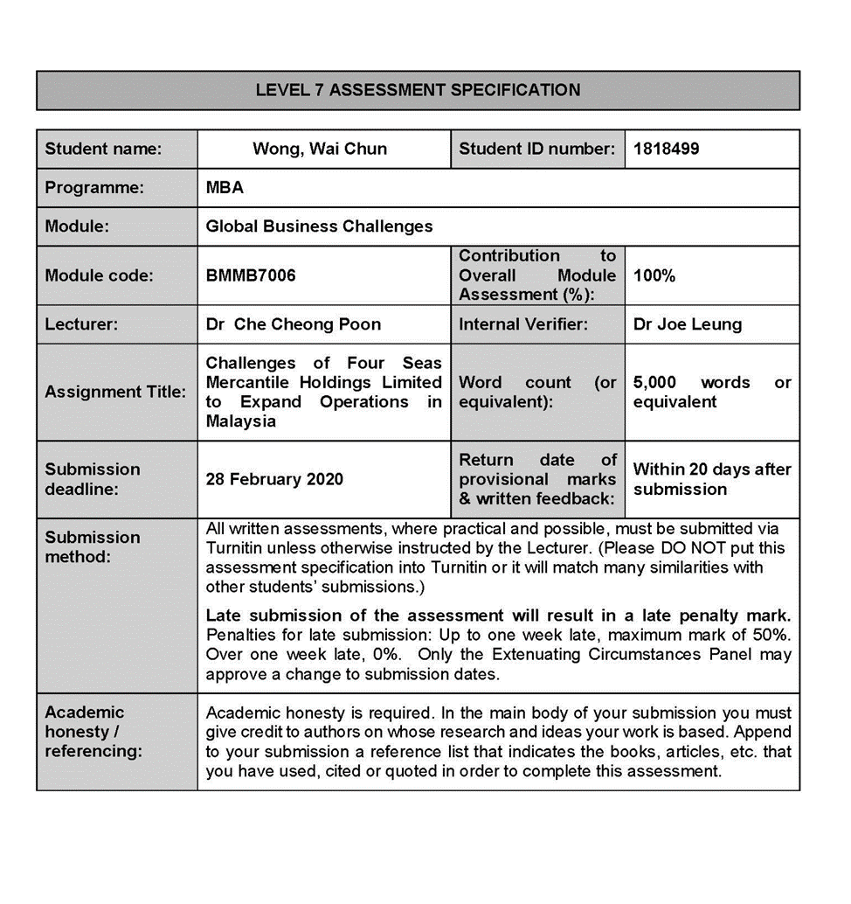

Cover page 2

“I, Wong, Wai Chun and student number 1818499, certify this work is the result of my own investigations, except where otherwise stated. All references have been duly cited”

James Wong
Signed: _____________________

Date: 3 March, 2020.

Cover page 3

Challenges of Four Seas Group to expand operations in Malaysia

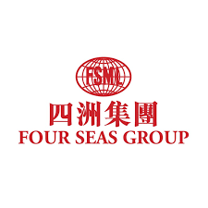
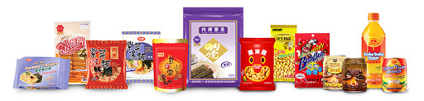

Synopsis

This report analyses the historical performance of Four Seas Mercantile Holdings Limited (or Four Seas Group) and describes the projected profitability in coming three to five years though establishing the sales office and distribution centre in Malaysia. In addition to providing a comprehensive internal and external analysis of the Group’s products and markets profiles, this report uses Porter’s five forces model to investigate the challenges of expanding operations in Malaysia. Research results suggest entry decision, entry strategies and entry criteria to the Group. Furthermore, it explores and discusses the rationale for entering in Malaysia; evaluate the potential challenges, and risks that could be faced by the Group. Lastly, it provides recommendations for implementing the proposal.

Table of Contents
Cover page 1 i
Cover page 2 ii
Cover page 3 iii
Synopsis iv
Table of Contents v
1. Introduction 1
1.1 Research motivation and research design 1
1.2 Research framework 2
2. Company Background 3
2.1 Product portfolio of the company 4
2.2 Foreign and the domestic market environment 6
3. Country background 16
3.1 Economic setting 16
3.2 Sociological setting 17
4. Analysis and discussion 20
4.1 The five forces model 20
4.2 Empirical facts 21
4.3 Challenges identification 24
5. Conclusion and the recommendations 26
References 28

1. Introduction
With the slow growth of the existing markets, the Four Seas Group(we use “the Group” thereafter),the Group needs a plan to expand operations in an emerging country like India, Indonesia, Malaysia, Thailand or Vietnam in order to find new market in order to create growth with the sales of the international market.

1.1 Research motivation and research design
It uses descriptive research and exploratory research (Rangarajan & Shields,2013) to facilitate the phenomena of macroeconomic in emerging countries and also uses deduction research methodology(Sternberg,2009) to approach microeconomic environment of one country to identify the potential opportunity and challenges to Group into the country.
Based on Group audit reports find that profit attributable to equity holders of group was decreased 91.3% comparing to 2018(FMSL,2019,p.17)and recorded beverage and dairy products were declined 15.6% in 2019 comparing to previous year. Snack and confectionery items are continued to be major carried by the Group(FMSL,2019,p.18).
Group needs to expand the business operations in the global market to larger customer base in order to increase its revenue(Hutzschenreuter and Horstkotte,2013).The benefits of business expansion are that it helps the business organization to diversify the company markets(Shenkar, Luo and Chi 2014).The motivation behind the research is to increase knowledge base and gain idea regarding business expansions, the challenges faced during business expansion and the ways to overcome the challenges.Therefore, Group should consider and explore to expand operations in one of emerging country in order to increase revenue and sustain the brand image at global level.

1.2 Research framework
Questions:
(1) Is Malaysia is a country economically viable for Four Sea Group to expand operations?
(2) What are the challenges Four Sea Group face while emerging its business in Malaysia?
(3) Is there any opportunity for Four Sea Group to emerge its business in Malaysia?

In order to answer the above research questions, we use the descriptive research and exploratory research(Rangarajan & Shields, 2013)to analysis secondary data of emerging countries including censuses, information collected by government departments, organizational records, World Bank Group, International Monetary Fund(IMF) and Trans National Corporation(TNC)data. Then, deductive reasoning(Sternberg,2009) compares the finding data and concludes to select one best potential country to expand operation or not.
Further, by applying Porter’s five force model(Porter,2008) evaluates industry competitiveness situation and identify the competitive advantage of market to analysis environmental factor in order to identify any opportunity and challenge to emerge in Malaysia.

2. Company Background
The Group was established 1971 with its mission on satisfying the needs of market demand and also customers who are gender-neutral and any range of age (FSML2019,p6).It has become as one of the popular household food suppliers in the Hong Kong and in the Mainland. The main business of the Group covers the food distribution, manufacturing, catering, and retailing with an aim of bringing the pleasant surprises to the food lovers in Hong Kong. The Group facilitates several kinds of the products from 20 countries and more through their strong network of distribution which covers department stores, convenience stores, distributors, bars, airlines, hotels, supermarkets etc.(FSML2019,p6).The corporation brings the food items all over world like milk powder, health food, snack food, sausage, sauce to the customer through a comprehensive network of distribution, shrewd vision and the effective marketing strategies(FSML2019,p6).The group focuses on extreme care to the food hygiene, quality and the safety for the purpose of living with a motive that relates to Eating happily, Eating safely and devoting a specific care to production and the distribution of the food. It also established comprehensive system for ensuring product safety, building customers, taste and best quality(FSML2019,p11).The Group will keep on introducing different products to consumers and broadening the sales networks to enhance the Group’s leading position.

2.1 Product portfolio of the company

Table 1.Sales revenue of the major items of the Group in 2018 and 2019.
Products | Year 2018 Sales amount of major items | Year 2019 Sales amount of major items | Changed during 2018 to 2019 (%)
Product | Sale revenue (HK$M)
Product | 2018 | 2019
Snacks | 1,270.890  (42.33)* | 1,301.811  (42.98)* | +2.4
Confectionery | 569.076  (18.95)* | 582.269  (19.22)* | +2.3
Ham and Sausage | 364.627  (12.14)* | 369.125  (12.19)* | +1.2
Beverage and dairy products | 264.281  (8.8)* | 223.010  (7.36)* | -15.6
Food materials/ ingredients | 222.408  (7.41)* | 235.048  (7.76)* | +5.7
Other | 311.155  (10.36)* | 317.724  (10.49)* | +30
Total | 3,002.437  (100)* | 3,028.987  (100)* | +0.9

*Note: Figures in parentheses are “percent of total sales revenue” expressed in percentages.
Source: FSML,2019, pp18-24.

Table 1 shows that snacks continued to be the Group’s major items source of sale revenue, it was HKD1,301,811,000 or 42.98% of total sales in 2019 which recorded an increase of 2.4% during the year.Confectionery is the second largest product with total sales amount HKD582,269,000 representing 19.22% of total sales in 2019 which was increased of 2.3% during the year. Since the snacks and confectionery contributed more than 60% of sale revenue to the Group, the promotion of these two items in a newly developed market is sensible.

Table 2.Geographical segments and net revenue (HKD in million).
Year | Segment net revenue in Hong Kong  (HKD in million) | Segment net revenue in Mainland China  (HKD in million)
2017 | 2,030.204  (68.86)* | 918.085  (31.14)*
2018 | 2,031.917  (68)* | 970.520  (32)*
2019 | 2,045.230  (67.52)* | 983.757  (32.48)*
*Note: Figures in parentheses are “percent of total sales revenue” expressed in percentages.
Source: FSML,2018 and 2019.p4.
Table 2 shows that the main geographical segment ratios of net revenue was Hong Kong at HKD2,030.204million(68.86% of total revenue) in 2017, HKD2,031.917million(68% of total revenue) in 2018 and HKD2,045.230million(67.52% of total revenue)in 2019; HKD918.,085million China at HKD918.085million(31.14% of total revenue)in 2017, HKD970.520million(32% of total revenue)in 2018 and HKD983.757million(32.48% of total revenue)in 2019.
Although the both of net revenues and market segments progressed almost unchanged, the Group perspective looks for high growth of revenue to enhance shareholder value(Ataünal, Gürbüz & Aybars,2016).Therefore, Group may only achieve further higher growth through exploring an existing uncertainty in other emerging countries and points to expand business for deliberate investigation.

2.2 Foreign and the domestic market environment.
Group has to select one better country to entry though looking at their macro and micro economic environment of emerging countries by both of Economic growth, consumer inflation rate, GINI index, unemployment rate, corporate income tax rate, HDI, EDOB scores that will identify any competition, innovation and regulation environment facing the Group.

2.2.1 Real GDP growth comparison

Source:IMF,2020.

The real gross domestic product(GDP) are used to measure the macroeconomic of selected emerging countries in Figure 1. Their changed of percentage gives signal of growth rate to the Group may benefit to their total spending including their sum of consumer spending, industry’s investment, government spending and excess of exports over imports due to the overall level of price changed in the economy(Kenton,2019). Their average GDP during year 2010 to 2019 are shown on figure 1 and table 1.

Table 3: Average of real GDP growth from 2010 to 2019.
Source: IMF,2020.

In Table 3, their average real GDP growth percentage of India, Indonesia, Malaysia and Vietnam during 2010 to 2019 were greater growth than World and Hong Kong. These economic growth rates had correlated ratio to Hong Kong in table 4.

Table 4.Correlation matrix of economic growth rates comparison.Source: From this research.

In Table 4,the correlation of economic growth rate of selected countries comparing to Hong Kong find that Malaysia was highest rated at 0.76 that implied highly correlated economic growth with Hong Kong and the Group may consider its positive effects on economic growth and trade cooperation with Hong Kong business.

2.2.2. Inflation rate (CPI) comparison.

Figure 2: Inflation rate (CPI) annual changed % comparison.
Source: IMF, 2020.
In Figures 2 and Table 5,inflation rate(measured in terms of annual change in CPI) showed that all selected countries were declined the purchasing power of a country’s unit of currency comparing 2010 to 2019. Group should consider their deflated and provide inexpensive items.

Table 5:
In figure 2 and table 5, their average inflation rate(CPI) annual changed % at the end of period consumer price index during 2010 to 2019 that Hong Kong at 3.4%, India at 5.2%, Indonesia at 4.8% and Vietnam at 5.9%(IMF,2020). The lowest mean inflation rate(CPI) were Malaysia at 2.2% and Thailand at 1.5% that Group should also consider their lower purchasing power of a country’s unit of currency and provide inexpensive items.

2.2.3. GINI index comparison.
Figure 3:

Source: World Bank Group,2020.
The figures of GINI index recorded that both countries were decreasing inequality level except India and Indonesia from 2004 to 2017. The decreasing GINI index of Malaysia, Thailand and Vietnam can consider their low income individuals decreased of their population and the Group may benefit to have more individuals spending more in goods or services.

2.2.4. Human development index(HDI) comparison.
Table 6: HDI ranking (2019).
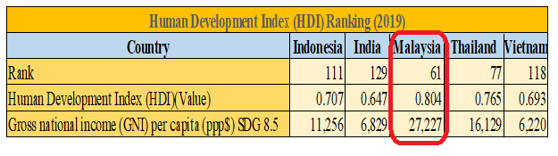
Source: United Nations Development,2019.
United Nations development(2019) reported HDI ranking, HDI(Value) and Gross national income(GNI) per capita that Malaysia ranked 61 with HDI value at 0.804 and SDG 27,227 of GNI per capita which were greater than Thailand ranked 77 with HDI value at 0.765; Indonesia ranked 111 with HDI value at 0.707 and SDG 11,256 of GNI; Vietnam ranked 118 with HDI value at 0.693 and SDG 6,220 of GNI; India ranked 129 with HDI value at 0.647 and SDG 6,829 of GNI, and SDG 16,129 of GNI(United Nations Development,2019).
These conclude that Malaysia had a better human development in education, better life expectancy and gained higher income per capita. Group may easy to hire some good employees and provide better service.

2.2.5. Unemployment rate comparison.
Table 7: Country’s unemployment rate and rank comparison.
Source: CIA,2020.
An unemployment rate were recorded the range from 0.7% to 8.5% to selected countries (CIA,2020). The Low unemployment is often seen as a positive sign of the economy. It may effect stress to increase wage rate, inflation and reduced productivity in Thailand and Vietnam.

2.2.6. Corporate taxation comparison.
Table 8: Countries’ corporate taxation comparison.
Their corporate tax are high than Hong Kong. India at 25.17%, Indonesia at 25% and Malaysia 24%, Thailand and Vietnam at 20% that overall are higher than 16.5% of Hong Kong tax rate(Tradingeconomic,2020).

2.2.7. Ease of doing business comparison.
Table 9: Ease of doing business (EDOB) comparison.
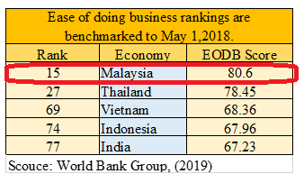

World bank group (2019) was benchmarked that Ease of doing business rankings were Malaysia at 15 with score 80.60, Thailand at 27 with score 78.45, Vietnam at 69 with score 68.36, Indonesia at 74 with score 67.96 and India at 77 with 67.23 implied that Malaysia has better regulatory performance in business than selected countries.

2.2.8. Hong Kong’s merchandise trade with ASEAN.
Table 10: Hong Kong’s merchandise trade with ASEAN in 2018.
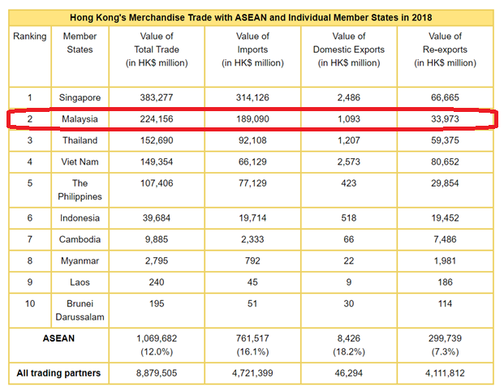
Source: TID,2020.

Hong Kong’s Merchandise trade with ASEAN members were that total trade value was HKD1,069,682million; total value of imports was HKD761,517million; Value of domestic exports was HKD8,426million and value of re-export was HKD299,739million. Malaysia was a second large of dealing amount with Hong Kong in 2018.
Based on above research concludes that although Malaysia implied lower purchasing power of households and high cooperate tax than selected countries, it is still recommended to expand business in Malaysia because it had high business correlation to Hong Kong; greater real GDP than Hong Kong; very low inflation; decreasing inequality level; better human development with highest gross nation income, higher ranking of EODB and top merchandise ASEAN trade partner with Hong Kong.

2.3.Rationales for the expanding the business in Malaysia

Malaysia's demand for snacks is expected to provide convenient snack options. Similar to Hong Kong and China. Figure 4 shows that their demand for snack products are also growing.
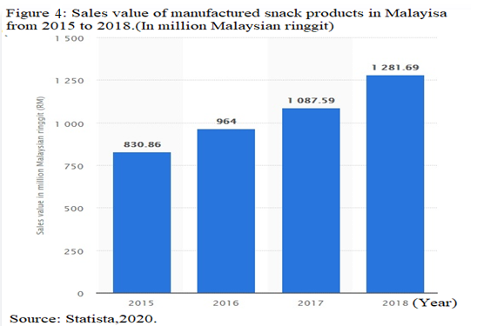
Statista(2020) reported that the sales value of Malaysia’s manufactured snack products were RM830.86million in 2015, RM965million in 2016, RM10873.59million in 2017 and RM1281.69million in 2018 that were increased year on year. On the other hand, Ipsos forecasts that the industry will grow at a strong CAGR of approximately 10.76% from 2018 to 2022 (HKEXnews,2019),
When the exiting market became slow growth, Group should consider to do franchising investment on subsidiaries sales office and distribution centre in Malaysia. It allows that Group has better control market, well production and sourcing decision. Then, new sales office can merge with local wholesaler for quick access into local market.

3. Country background
As the Group wants to expand its business in Malaysia, there is a need to analyse the economic and social aspects of the country in order to decide whether it is worthy to expand business there or not. The major characteristics are listed below:

3.1 Economic setting
The Group has to look at the microeconomic of Malaysia’s issues and trade restriction including tariff of trade, tax rate and regulations related to emerge business.
At the end of 2017, ASEAN and Hong Kong signed the Investment agreement and Free Trade Agreement (FTA). Malaysia and Hong Kong signed a joint declaration on strengthening economic cooperation on 1 December 2009. “These agreements can increase trade and investment flows between the two places, create new opportunities for businesses, and promote economic growth in the long run. The Joint Declaration on Strengthening Economic Cooperation aims to encourage and promote bilateral economic cooperation in the following areas:(A)trade in goods;(B)trade in services;(C)investment;(D)Science and technology;(E) creative industries;(E) SME development; and (F)Tourism.”(TID,2020).
The economy of Malaysia is continuously increases and Fiscal consolidation has also proceed with the government pushing through important initiatives i.e. Goods and Services Tax (GST). Further, in current situation, there is no signs of inflationary pressure, even for the domestic front, Malaysia's strong employment is also boosting private consumption and the investment is also assist to derive growth. Thus, it shows that economy of Malaysia is on its way to attain the high income status. Further, in 2016, the Malaysian Inland Revenue Authority reduced the effective tax rate for businesses with a capital of more than 2.5 million ringgit to 24%. For smaller companies, the ratio is 19%. The Malaysian government also imposes government taxes such as sales and service taxes and real estate taxes. The current GST rate is 6%, and the period for disposing of property depends on the timetable for holding the property (Inland Revenue Board of Malaysia, 2016).
On the other side, it is observed through the secondary research of country economic background that Bank Negara Malaysia is also maintained an accommodative position with its policy rate that keep changing at 3%. In 2017,bank also signal a bias towards reduce accommodation and also justifies that there is a stable inflation and no financial sector stress (Bakari,2017). Moreover, there is a need to compliance all the laws and regulation made by Malaysian government because it may affect the food sector in opposite way such that every country's packaging regulations changed and government also force company to provide range of healthy food products that also creates direct impact upon performance of business and increase the economy as well.
Although the Group might benefit FTA to entry Malaysia, above factors are still influence the additional transaction cost to the Group by changing packaging, fulfil regulation, GST process and products development.

3.2 Sociological setting
The microeconomic of Malaysia is included looking at its social environment about population, languages, religious. social infrastructure and marginal propensity to consume that influences the decision of products and price setting for market(Jacob Filho,2018).
Malaysia' has approximate 32.6million population in 2019(Department of statistics, Malaysia,2019).The official languages are Malay and also free to use English, Cantonese, Mandarin and Tamil(Department of Information, Malaysia,2016). Malaysia is a multicultural and multiracial country that is actually well known for its social and cultural incorporation. Therefore, as per the religious background of Malaysia's, Islam or Muslims is the official and widely extended religion that represents around 61.3% of the total population and 19.8% are belongs to Buddhism in 2019(Shah,2019). With large Muslim population, the pre-packaged foods are required halal certification logo (Image 1) labelling(Shaari et al.,2019).
. Image 1: Halal certification Logo.

Source: Department of Islamic development, Malaysia,2019.

Image 1 is Halal certification logo sample that is issued by department of Islamic development. Halal.is an Arabic word meaning lawful or permitted. The term halal refers to goods or actions that are permitted under Sharia law and Islamic principles. Muslims are allowed or permitted to consume halal goods or services, and haram (the opposite of halal) goods are strictly forbidden to them (Takeshita,2019). Recently, Malaysia is a leading global Halal Food Hub that has become an international halal food center in branding, processing and marketing halal food to the Muslim population (Jaiyeoba, Abdullah & Dzuljastri,2019). The Group will benefits from growing consumer demand from neighbouring countries such as Vietnam, India, Malaysia is visa-friendly country, foreign investors can obtain different types of visas when investing in the country.
Total and private infrastructure investment of Malaysia were amount 52,672 and 9,277 (in USD million last five years of 2017) and average of emerging countries were amount 266,618 and 13,017 (in USD million last five years of 2017) in private in table 11:

Table 11: Social infrastructure of Malaysia and emerging countries in last 5 years of 2017.
Source: Global infrastructure hub,2017.

As result, infrastructure quality was rated 5.4 in Malaysia and 3.9 in average of emerging counties. The Group may benefit that Malaysia had high invested in industrial development, trade competitiveness in global markets, efficient use of natural and human resources, food safety, health, the environment and climate change etc.

Table 12: Marginal Propensity to consume of Malaysia during 2009 to 2017.
Marginal Propensity to consume (MPC) during 2009 to 2017
Year | MPC
2009 | 0.241
2010 | 0.770
2011 | 0.779
2012 | 1.883
2013 | 1.210
2014 | 0.991
2015 | 0.722
2016 | 0.452
2017 | 1.082
Average from 2009 to 2017 | 0.903
Source: From this research.

The average of MPC was 0.903 that implied people were poor. The consumers in the Malaysian economy are highly price sensitive in nature. They are highly responsive to sales promotions, discounts and other offers (Ashraf, Akhter & Noor, 2014). Therefore, Group has to emerge its market in Malaysia that provide range of snack and confectionery products at inexpensive price range and also need to meet their Halal requirements. The food manufacturing industry is dominated by small and medium local food manufacturers especially the local halal food manufacturers.
Overall, Malaysia has a strong and resilient macro-economic fundamentals and it also reflect that it has an ability to manage all challenges and also pursue structural reforms. Therefore, the economy's strength of Malaysia also derive from highly diversified economic structure and has resilient external position with flexible policy that helps to enhance economy and also broadening growth sources as well (Ramlan and Ram, 2018). Hence, this provide many growth option to other company to expand or emerge in Malaysia and sell their products that helps to meet demand of customers and enhance economy of a country as well.
Although the Group benefits large population and social infrastructure to emerge in Malaysia, above factors influence to give inexpensive products but increase the production costs by new flavours with Halal certification .

4. Analysis and discussion
Refer to above descriptive research and exploratory research (Rangarajan & Shields,2013) to study the situation of their Micro and Macro-economic environment of emerging countries conclude that the Group has to emerge in Malaysia because Malaysia was highest correlated economic growth; best trade cooperation with Hong Kong; high scores in human development index and best in EODB starting business implied that Group will has less barriers to run business in Malaysia.
The opportunities of group are that may benefit to promote snacks and confectionery items into Malaysia which is larger market size than Hong Kong. Group may also benefit by leading global Halal Food Hub in Malaysia as halal food center in branding, processing and marketing halal food to the Muslim population in home and emerging to ASEAN countries.
But, the challenges of group has different official languages, different religious culture , tariff tax and high cooperate tax. Thus, the low inflation rate(CPI) and MPC of Malaysia implied its lower purchasing power. The group needs to different local food regulations.
Four Seas can interpret that the companies are finding the market attractive which shows that the time to expand in Malaysia is correct and profitable. It needs to evaluate and assess the competitive strength and position of group to entry Malaysia by applying Porter five forces model (Porter,2008) in order to identify potential challenges and overcome.

4.1 The five forces model
By applying porter five forces analysis, it is analysed that Four Seas group have range of differentiation products and it wants to provide these products at global level. Through Porter generic strategy(Porter,2008), it is also analysed that company uses differentiation strategy while emerging into new market. It is so because Malaysia is high Muslim dominated country where people prefer halal and that is why, by offering healthy products in Malaysia market will help the firm to enhance lifestyle of people. The USP of Four Seas group is its healthy products which is not offered by any other and that is why, this strategy assist the firm to establish goodwill.

Figure 5: Porter’s five forces analysis to Four Sea group expand operation in Malaysia.
↓ Buyer seeks low price
↓ Low switch costs
↑Differentiated products
↑Famous brand
↓High demand on Halal standard
↑large number of supplier
↑Low switching costs
↓High Capital requirement
↓ Different official language
↓Different tax to foreign company
↓Different compliances
↓ Own brand by retailers
↑ High standard product
↑ Differentiation products
↑Require R&D
↑ Need high level hygiene

↓Loss of power for Four Sea group↑Gain of power for Four Sea group Espirt

Sources: From this research.

4.2 Empirical facts
(1) Threat of New Entrants: (Low)
New entrant will be difficult because it needs high initial capital requirement and needs to meet the different compliances and different languages. Non-resident Corporate tax is 24% flat rate on non-resident higher than resident SME (under MYR 2.5million) at 17% on first MYR 500,000 plus 24% above MYR 500,000.(Santandertrade,2020).

(2) Threat of Substitutes (Moderate)
Supermarkets tend to copycat popular confectionery and develop their own brand on the shelves at a cheaper price (Loureiro,2017). Market has large number of substitutes like fruits, bread etc.(Winkler,et al,2016). Confectionery factory like the Group has required high level hygiene production, good in resource and development of production to provide high standard products already (Piwowar-Sulej, Kwil and Podsiadły,2019).

(3) Bargaining Power of Suppliers (Low)
Malaysia has large number of suppliers and buyers have high bargaining power.
Group can buy their raw materials for cheaper.

(4) Bargaining Power of Buyers (Moderate high)
The Group has many differential of products and brand loyalty. There is no switching cost for buyers. Large Muslim population wants halal certificated items. Most Buyers are low price seekers and like on line shopping.

(5) Competitive Rivalry (High)
Competition amongst existing confectionery industries is a high threat. Due to a large number of confectionery industries in Malaysia such as Nestle , Hup Seng Perusahaan Makanan and Munchy Food Industries and more who sell their products through a wide range of distribution channels(SEBSEAM,2015). These companies are selling their items to same type of stores such as Dairy Farm Group, Mydin Mohamed Holdings, Trendcell, Village, Grocer Holdings, and AEON Group (USDA,2019). Due to currency risks brought about by increased exchange rate volatility, Due to currency risks brought about by increased exchange rate volatility that will influence the Group to set the pricing of products against Malaysian’s products(Gherasim and Gherasim,2019).

(6) Summary of Competitive power
Overall of 5 forces is high medium and less attractive to Four Sea Group. The company is suggested to expand food items with Halal certification including noodles, frozen food products, ham products, dairy products, and beverages against local manufactures in Malaysia. The entry strategy will be direct exporting in the country and provide a range of differentiation and healthy products selling in Malaysia by establishing the sales and distribution centre to do financing join venture with local distributors which has a best distribution channels and takes the entire responsibility of transporting the manufactured products to the supermalls and hypermarkets as well as retail stores. The consumers in the Malaysian economy are highly price sensitive in nature. They are highly responsive to sales promotions, discounts and other offers(Ashraf, Akhter & Noor, 2014). Therefore, the company will incorporate rigorous marketing strategies and promotional tactics to reach out to the target audience and face competition. The younger generation is attracted to online shopping (Shahzad et al, 2019).

4.3 Challenges identification
By Porter’s five forces capture the challenges to Group facing retailers’ private brand against suppliers, currency exchanged influencing the costs to export, high cooperate tax rate, import tariff, buyers seeking low price though on line shopping, different official language and also high competition rivalry with local food manufacturers.
The trend of retailers were developed their own brands like wide range of Topvalu brand products by Aeon store(Topvalu,2015) and Tesco brand products by Tesco store(Tesco,2017) in Malaysia. Group will facing competition to local confectionery products and also an own brands of retailers are always on the shelves at a cheaper price against to the Group’s products (Loureiro,2017).
Since 2016, the Malaysian Inland Revenue Authority reduced cooperate tax rate to 24% but smaller Malaysian companies, the ratio is 19% (Inland Revenue Board of Malaysia, 2016).
The trade barriers has 7.5% the import tariff (HKTDC,2019). The Group may pay higher cooperate tax at 24 % comparing local resident SME company of 19% tax for first RM500,000 chargeable income (Department of Information, Malaysia,2016). Although import tariff tax is 7.5%, Malaysia will eliminate customs duties of about 85% of their tariff lines within 10 years and reduce customs duties of about another 10% of their tariff lines within 14 years (TID,2019).
The official languages are Malay and also free to use English, Cantonese, Mandarin and Tamil (Department of Information, Malaysia,2016). The different official languages may cause some miscommunication Group in operation or some lost by failed to meet custom or local regulations.
High dominance of Muslim people needs Halal certification products and the younger generation is attracted to online shopping (Shahzad et al, 2019). The facts also state that there is issue related to halal standards is about halal certification, and Malaysia as a originator in promoting halal food at global level but due to not maintaining quality of food and hygiene, this is converted a biggest issue (Rego and Carvalho, 2020). Due to high dominance of Muslim people with halal, the group have not Halal certification on their products yet that will limit the growth of sales in Malaysia.

Large number of confectionery industries in Malaysia such as Nestle , Hup Seng Perusahaan Makanan and Munchy Food Industries and more who sell their products through a wide range of distribution channels (SEBSEAM,2015).
Group will facing increasingly complex challenges of currency exchange risk in managing their financial performance.

5. Conclusion and the recommendations

By using descriptive research and exploratory research (Rangarajan & Shields,2013) compared the micro and macro-economic environment of emerging countries to conclude that the Group is recommended to emerge operation in Malaysia. By using Porter five force (2008) identify that although there is some challenges such as different official languages, different religious culture, food regulations low purchasing power, high cooperate tax and currency risk etc., the group may still have benefit to increase revenue and brand loyalty by this expand planning. It is because there is less trade restriction than other emerging countries, tariff tax reducing, large market size, forecasts snack market growing and potential to expand to other ASEAN markets as well.
It is recommended to do franchising investment on new subsidiaries sales office and distribution center by using entry strategy that the group is direct exporting to this new subsidiary of joint venture Company with experienced Malaysian distributor company and overcome the challenges facing the Group by recommendation as below.
It is recommended to merge with experienced local company such as First Food Distribution (M) Sdn Bhd located at 47610 Subang Jaya, Selangor, Malaysia (First Food,2020) or other experienced distribution company that will easily increase revenue, increase market share, enhance Brand loyalty in oversea and gain more profit to the Group (Ahmed, Manwani & Ahmed,2018). The experienced local distribution can share their knowledge to understand their customers’ cultural, food regulations, custom clearance, solving tariff issues that may helps the Group to solve some local issues and effective in operations (Javernick‐Will,2009). It may good to use its established networks to promote snacks and confectionery items into Malaysian retailers such as Dairy Farm Group, Mydin Mohamed Holdings, Trendcell, Village, Grocer Holdings, and AEON Group (USDA,2019).
Before establishing new unit, company must hire consultant like Quantum consulting services(Quantum,2019) or other professional consulting company to assist the deal with merging new company and also helps the Group understand the laws and tax tariff of Malaysia so that it avoid issues later (Schuster and Holtbrügge,2017). The consultant should identify the important laws and tax codes, and then comply for the same will help the business to run smoothly(Schuster and Holtbrügge,2017).
Then, the factories and products of the Group must be approved by Halal Department of Islamic development, Malaysia. To do this, the Group should apply Halal approval on own products and factories by The Incorporated Trustees of the Islamic community fung of Hong Kong (Islamictrusthk,2020).
The Group has also need to hire the employees who understand Malaysian languages and company will also recruit candidate who is multi linguistic. Further, by providing training to the candidate, company also reduce challenge.
Furthermore, it is also recommended the Group to development new products to approach Malaysian’s flavour taste such as traditional Muslim taste like tahini-based sauce or a red, harissa based sauce (Allen,2019).
The Group will also take initiative to provide products online shipping and services through Malaysia’s websites. Since the price elasticity are lower in Malaysia market than Hong Kong, it allow the Group to set a higher price that related to the price determined in Hong Kong (Felettigh & Federico,2011). For minimize currency risk, the Group should make a currency forward contract that allows the Group to lock in the price they pay for a currency to hedge currency risk (Bash et al,2018).

References
Ahmed, F., Manwani, A., & Ahmed, S. (2018). Merger & acquisition strategy for growth, improved performance and survival in the financial sector. Jurnal Perspektif Pembiayaan Dan Pembangunan Daerah, 5(4), 196-214.

Allen, G. (2019). Sauces Reconsidered: Après Escoffier. Rowman & Littlefield.

ASEAN, (2020). Overview of The Association of Southeast Asian Nations, or ASEAN. Available at: https://asean.org/asean/about-asean/overview/ (Assessed: 2nd Feb., 2020).

Ashraf, M. A., Akhter, S., & Noor, S. I. (2014). Consumer behavior in fast food marketing in Bangladesh: a case study. Developing Country Studies, 4(9), 34-44.

Ataünal, L., Gürbüz, A. O., & Aybars, A. (2016). Does high growth create value for shareholders? Evidence from S&P500 firms. European Financial and Accounting Journal, 11(3), 25-38.

Bash, A., Al-Awadhi, A. M., Al-Abdulhadi, A. J., Al-Ibrahim, N. F., & Al-Ali, M. S. (2018). Survey of Hedging Techniques to Manage Foreign-Exchange Risk. International Research Journal of Finance and Economics, (167).

Bakari, S., (2017). The impact of domestic investment on economic growth: New evidence from Malaysia.

Bekhet, H. A., & Latif, N. W. A. (2017). Highlighting innovation policies and sustainable growth in Malaysia. International Journal of Innovation, Management and Technology, 8(3), 228-239.

Censtatd (2019) Overview Hong Kong Statistics. Census and statistics Department. Available at: https://www.censtatd.gov.hk/hkstat/sub/so20.jsp (Assessed: 15th Feb., 2020).

CIA, (2020). Country comparison: unemployment rate. The World Factbook. Central Intelligence Agency. Available at: https://www.cia.gov/library/publications/the-world-factbook/fields/220rank.html (Assessed: 24th Feb., 2020).

Department of Information, Malaysia,(2016). Official language, Malaysia information. 2016. Available at: https://www.malaysia.gov.my/portal/content/30118 (Assessed: 29th Feb. 2020)

Department of Islamic development, Malaysia, (2019). The recognised foreign Halal certification bodies & Authorities, February 13, 2019. Available at: http://www.halal.gov.my/v4/ckfinder/userfiles/files/cb2/LATEST%20CB%20LIST%20-%20AS%20OF%20FEBRUARY%2013TH%202019.pdf (Assessed: 15th Feb., 2020).

Department of statistics, Malaysia,(2019).Current Population Estimates,Malaysia,2018-2019. 15 July. 2019. Available at: https://www.dosm.gov.my/v1/index.php?r=column/cthemeByCat&cat=155&bul_id=aWJZRkJ4UEdKcUZpT2tVT090Snpydz09&menu_id=L0pheU43NWJwRWVSZklWdzQ4TlhUUT09 (Assessed: 31st Jan., 2020).

Department of statistics, Malaysia (2019), Statistics of Foreign Dirert Investment in Malaysia,2018. 27 June 2019. Available at: https://www.dosm.gov.my/v1/index.php?r=column/cthemeByCat&cat=322&bul_id=WVozSjdScVpUbUY0TWhPUk5zMnAvQT09&menu_id=azJjRWpYL0VBYU90TVhpclByWjdMQT09 (Assessed: 31st Jan., 2020).

Felettigh, A., & Federico, S. (2011). Measuring the price elasticity of import demand in the destination markets of italian exports. Economia e Politica Industriale.

First food,(2020). First Food Distribution (M) Sdn Bhd. Available at: http://www.firstfood.biz/list_all_product.php (Assessed: 28th Feb, 2020).

FSML, (2018) Four seas mercantile holdings limited annual report 2018. Available at: https://www1.hkexnews.hk/listedco/listconews/sehk/2018/0726/ltn20180726263.pdf (Assessed: 3rd Jan, 2020).

FSML, (2019) Four seas mercantile holdings limited annual report 2019. Available at: http://file.finance.sina.com.cn/hkdata98/hk/hk_realtime_announcement/news/20190725/003567010-0.PDF (Assessed: 3 Jan, 2020).

Gherasim, A., & Gherasim, D. (2019). The Price in International Marketing. Economy Transdisciplinarity Cognition, 22(1), 40-49.

Global infrastructure hub,(2017). Infrastructure market overview – Malaysia. 2017. Available at: https://www.gihub.org/countries/malaysia/ (Assessed 27th Feb., 2020).

HKEXnews (2019). Overview of the snacks industry in Singapore, Malaysia and China, 14 Jan.,2019. Available at: https://www1.hkexnews.hk/listedco/listconews/sehk/2019/0114/a16373/etwhl-20180718-14.pdf (Assessed: 2nd Feb., 2020).

HKTDC (2019). Economic profile of Malayisa. The Hong Kong Trade Development Council. Available at: https://beltandroad.hktdc.com/en/country-profiles/malaysia (Assessed: 15th feb.2020).

HKTDC (2019), Malaysia: Market Profile. The Hong Kong Trade Development Council.
http://emerging-markets-research.hktdc.com/business-news/article/Asia/Malaysia-Market-Profile/mp/en/1/1X000000/1X003IG2.htm (Assessed: 1st March, 2020).

Hutzschenreuter, T., & Horstkotte, J. (2013). Performance effects of international expansion processes: The moderating role of top management team experiences. International Business Review, 22(1), 259-277.

Islamictrusthk,(2020). THE INCORPORATED TRUSTEES OF THE ISLAMIC COMMUNITY FUND OF HONG KONG. Available at: http://www.islamictrusthk.org/halal-certification/ (Assessed: 1st March, 2020).

Inland Revenue Board of Malaysia, (2016). "Inland Revenue Board of Malaysia 2016 Taxation Rates" Inland Revenue Board of Malaysia. Available at: http://www.hasil.gov.my/pdf/pdfam/11_BROCHURE_2016.pdf (Assessed: 21st Feb., 2020).

International Monetary Fund. Asia and Pacific Dept. (2019). Malaysia: 2019 Article IV Consultation-Press Release; Staff Report; and Statement by the Executive Director for Indonesia. IMF Country Report No. 19/71. Available at https://www.imf.org/en/Publications/CR/Issues/2019/03/08/Malaysia-2019-Article-IV-Consultation-Press-Release-Staff-Report-and-Statement-by-the-46651 (Assessed 19th Jan., 2020).

IMF. (2020). Real GDP growth Annual percent change. IMF DataMapper. International Monetary Fund .Available at: https://www.imf.org/external/datamapper/NGDP_RPCH@WEO/WEOWORLD/AUS/CAN/CHN/HKG/JPN/KOR/MAC/IND/SGP/TWN/GBR/USA (Assessed: 22nd Feb., 2020).

Jacob Filho, J. R. (2018). The price of a threat: how social identity threat influences price sensitivity (Doctoral dissertation).

Jaiyeoba, H. B., Abdullah, M. A., & Dzuljastri, A. R. (2019). Halal certification mark, brand quality, and awareness. Journal of Islamic Marketing.

Javernick‐Will, A. N. (2009). Organizational learning during internationalization: acquiring local institutional knowledge. Construction Management and Economics, 27(8), 783-797.

Kenton, Will.(2019). "Real Gross Domestic Product (GDP)". Investopedia.com. Retrieved 2 April 2019.

Loureiro, S. M. C. (2017). Exploring the attractiveness of manufacturer brands and retailer own-brands in supermarket context. International Journal of Retail & Distribution Management.

Piwowar-Sulej, K., Kwil, I., & Podsiadły, K. (2019, September). Barriers to Technological Innovation for Small Local Confectionery Companies. In European Conference on Innovation and Entrepreneurship (pp. 795-XXIV). Academic Conferences International Limited.

Porter, Michael E. (1980). Competitive Strategy. Free Press. ISBN 0-684-84148-7.

Porter, M. E. (2008). The five competitive forces that shape strategy. Harvard business review, 86(1), 25-40.

Quantum, (2019). Corporate Profile. Quantum consulting services. Available at: http://www.quantum.com.my/ (Assessed: 1st March., 2020).

Ramlan, H. & Ram, N. S., 2(018). Determinants of Macroeconomics Indicators on the Economic Growth in Malaysia. Global Business & Management Research.10
.
Rangarajan, N. S., & Shields, P. M. (2013). A playbook for research methods: integrating conceptual frameworks and project management. An extensive discussion of exploratory research.

Rego, M. L., & Carvalho, J. C. (2020). Insurance in Today’s Sharing Economy: New Challenges Ahead or a Return to the Origins of Insurance?. In InsurTech: A Legal and Regulatory View (pp. 27-47). Springer, Cham.

Santandertrade (2020).Malaysia:Tax system. February 2020. Available at: https://santandertrade.com/en/portal/establish-overseas/malaysia/tax-system (Assessed: 17th Feb.2020).

SCMP.(2018). Hong Kong’s industrialists are moving out of mainland China to safer havens in Sino-US trade war. South China Morning Post. 29 Jul,2018. Available at: https://www.scmp.com/business/companies/article/2157331/hong-kongs-industrialists-are-moving-out-mainland-china-safer (Assessed: 4th Feb., 2020).

SEBSEAM, (2015), The Potentiala and Challenges of Confectionery Products in the Malaysian Market 2015. Support for European in South East Asia Markets, Malaysia companies. Available at: http://mblbc.org/wp-content/uploads/The-Potential-and-Challenges-of-Confectionery-Products-in-the-Malaysian-Market-2015.pdf (Assessed: 7th Feb.2020).

Schuster, T., & Holtbrügge, D. (2017). Internationalization of Professional Service Firms. The Case of Rödl & Partner. The Internationalization of Firms. Case Studies from the Nürnberg Metropolitan Region, 159.

Shaari, H., Ahmad, N., Salleh, S. M., Mokhtar, S. S. M., Yusoff, R. Z., Khamwon, A., & Putatchote, N. (2019). CONSUMER PURCHASE INTENTION ON HALAL PACKAGED FOOD PRODUCTS: DOES HALAL LOGO AND INGREDIENTS MATTER?. Journal of Islamic, 4(23), 78-86.

Shah, S. (2019). Ethnicity and the Making of Gay Muslims in Britain and Malaysia. In Young People and the Diversity of (Non) Religious Identities in International Perspective (pp. 183-201). Springer, Cham.

Shahzad, M. A., Jamil, K., Gul, R. F., & Javed, H. (2019). Effects of Online Shopping Trends on Consumer-Buying Behavior. International Journal of Research, 6(3), 271-282.

Shenkar, O., Luo, Y., & Chi, T. (2014). International business. Routledge.
Statista, (2020). Revenue in the Food & Beverages segment in Malaysia. Available at: https://www.statista.com/outlook/253/122/food-beverages/malaysia (Assessed: 28th Jan., 2020).

Statista, (2020). Sales value of manufactured snack products in Malaysia. Available at: https://www.statista.com/statistics/642438/sales-value-of-manufactured-snack-products-in-malaysia/ (Assessed 19th Feb., 2020).

Sternberg, R. J. (2009). Cognitive Psychology. Belmont, CA: Wadsworth. p. 578. ISBN 978-0-495-50629-4.

Takeshita, S. (2019). Halal certification or ingredient disclosure. Journal of Islamic Marketing.Thestar (2019). World Bank Maintain Malaysia's 2019 economic growth at 4.6%. 2019. Available at: <https://www.thestar.com.my/business/business-news/2019/10/10/world-bank-maintains-malaysia039s-2019-economic-growth-at-46>. (Assessed: 25th Jan., 2020).

Tesco, (2017). Variety of Tesco Brands products. Available at: https://www.tesco.com.my/Tesco-Brands/Tesco/ (Assessed: 1st March., 2020).

TID, (2019). Free Trade Agreement between Hong Kong, China and the Association of Southeast Asian Nations. Trade and Industry Department. The Government of the Hong Kong Special Administrative Region Available at: https://www.tid.gov.hk/english/ita/fta/hkasean/index.html (Assessed: 3rd March., 2020).
TID,(2020). HONG KONG – Asean trade relations. Trade and Industry Department. The Government of the Hong Kong Special Administrative Region. Available at: https://www.tid.gov.hk/english/aboutus/publications/factsheet/asean.html (Assessed: 29th Feb., 2020).

Topvalu (2015). TOPVALU is now available in Malaysia. Aeon Topvalu Malaysia. Available at : http://www.topvalu.com.my/our-brands/ (Assessed: 1st March.,2020).

Tradingeconomics, (2019). Malaysia GDP Annual Growth Rate 2017-2019. Available at: https://tradingeconomics.com/malaysia/gdp-growth-annual (Assessed: 2nd Feb., 2020).

Tradingeconomics, (2020). List of Countries by Corporate Tax Rate Trading economicd. Available at: | Asia//tradingeconomics.com/country-list/corporate-tax-rate?continent=asia (Assessed: 22nd Feb., 2020).

UNCTAD,(2019). World Investment Report, 2019. United Nation Conference on trade and development. Available at: https://unctad.org/en/PublicationsLibrary/wir2019_en.pdf (Assessed: 1st Feb., 2020).

United Nations Development,(2019). Human Development Reports. United Nations Development.9 December. 2019. Available at: http://www.hdr.undp.org/ (Assessed: 24th Feb., 2020).

USDA, (2019). Retail foods in Malaysia. United States Department of Agriculture. November 5 , 2019. Available at: https://www.fas.usda.gov/data/malaysia-retail-foods-annual-3 (Assessed: 8th Feb., 2020).

Winkler, L. L., Christensen, U., Glümer, C., Bloch, P., Mikkelsen, B. E., Wansink, B., & Toft, U. (2016). Substituting sugar confectionery with fruit and healthy snacks at checkout–a win-win strategy for consumers and food stores? A study on consumer attitudes and sales effects of a healthy supermarket intervention. BMC public health, 16(1), 1184.

World Bank Group, (2019). Doing Business 2019. A world bank group flagship report 16th Edition. Available at: https://www.doingbusiness.org/content/dam/doingBusiness/media/Annual-Reports/English/DB2019-report_web-version.pdf (Assessed: 2nd Feb., 2020).

World Bank Group, (2020). GINI index (World Bank estimate). World Bank Group, 2020. Available at: https://data.worldbank.org/indicator/SI.POV.GINI (Assessed: 23rd Feb., 2020).



