

Memory Forensics in Ransomware Investigations: Enhancing Volatile Evidence Acquisition and Analysis for Modern Cyber Attacks

Module: Research Methods and Professional Development
ACFA7004 - Report
Student Name: Gopika Virakan Valappil
Student ID: 2436585
Program: MSc Cybersecurity & Digital Forensics Submitted To: Dr. Suresh Shanmugasunadaram
ABSTRACT
Ransomware has emerged as one of the most critical cybersecurity threats, causing significant financial and operational disruption to organisations worldwide. Traditional disk-based forensic approaches are increasingly ineffective against modern ransomware, which frequently employs fileless techniques and memory-resident execution. As a result, critical forensic artefacts such as encryption keys, malicious processes, and runtime behaviours often remain undetected.
Memory forensics provides a powerful mechanism for analysing volatile system memory (RAM), enabling the identification of transient artefacts generated during ransomware execution. This research investigates and evaluates the effectiveness of memory forensic techniques and tools for ransomware detection and analysis. A controlled experimental approach is adopted, utilising a virtualised environment and forensic tools such as the Volatility Framework to capture and analyse memory dumps.
The study aims to identify key ransomware-related artefacts within volatile memory and evaluate tool performance using defined forensic metrics. The expected outcome is the development of a structured and systematic framework for memory-based ransomware investigation, contributing to improved forensic accuracy, enhanced incident response, and more effective cyber defence strategies.

1. INTRODUCTION
1.1 Context and Background
Cybersecurity has become an increasingly critical domain due to the rapid evolution and growing sophistication of cyber threats. Among these threats, ransomware has emerged as one of the most prevalent and damaging attack vectors, targeting individuals, organisations, and critical infrastructure worldwide [1], [2].
Ransomware is a form of malicious software designed to encrypt user data and demand payment in exchange for decryption. Contemporary ransomware variants, such as WannaCry and Ryuk, employ advanced cryptographic techniques and stealth mechanisms, significantly complicating detection, mitigation, and recovery processes [3]. The increasing adoption of such techniques has resulted in substantial financial losses and operational disruption across multiple sectors.
Traditional digital forensic methodologies predominantly rely on disk-based analysis. However, modern ransomware increasingly utilises fileless techniques and memory-resident execution, allowing malicious activities to occur primarily within volatile memory rather than persistent storage [4]. Consequently, critical forensic artefacts are often absent from disk-based evidence, limiting the effectiveness of conventional investigative approaches.
Memory forensics, a specialised domain within digital forensics, focuses on analysing volatile memory (RAM) to extract runtime artefacts generated during system execution.
These artefacts include running processes, encryption keys, network connections, and injected or malicious code.
Recent advancements in cyber-attack techniques highlight the increasing use of fileless ransomware, memory-resident malware, and anti-forensic techniques that reflect the growing complexity and sophistication of modern cyber threats.
These developments underscore the importance of memory forensics as a critical capability in modern ransomware investigations, enabling the identification of transient evidence that would otherwise be lost using traditional forensic methods [2], [5].
1.2 Research Problem
Despite significant advancements in digital forensic methodologies, substantial challenges persist in the effective investigation of ransomware attacks, particularly when analysing volatile memory. Modern ransomware increasingly operates within memory, limiting the availability of persistent artefacts and reducing the effectiveness of traditional forensic techniques.
Problem Statement
Current digital forensic approaches lack a standardised and systematic methodology for the extraction, identification, and analysis of ransomware-related artefacts from volatile memory. This limitation hinders the ability of investigators to accurately reconstruct attack behaviour and identify critical evidence.
Several key challenges contribute to this problem. Firstly, encryption keys and other sensitive artefacts are often stored exclusively in memory during runtime and are irretrievably lost once the system is powered down. Secondly, ransomware increasingly incorporates anti-forensic techniques, such as memory obfuscation and artefact wiping, to evade detection and analysis. Additionally, there is a lack of efficient real-time memory acquisition mechanisms, which restricts the ability to capture volatile data during active attacks. Furthermore, existing forensic tools demonstrate variability in performance, and there is limited comparative evaluation of their effectiveness in ransomware-specific scenarios.
These challenges collectively create a significant gap in current forensic practices, reducing the reliability of ransomware investigations and limiting the potential for successful data recovery, attribution, and incident response. Addressing this gap requires the development of a structured and systematic approach to memory-based ransomware analysis.
1.3 Research Aim and Objectives
Research Aim
The aim of this research is to critically evaluate and enhance memory forensic techniques for the detection and analysis of ransomware attacks through the systematic examination of volatile memory artefacts.
Research Objectives
To achieve the stated aim, the following objectives are proposed:
- O1: To conduct a systematic and critical literature review of recent advancements in memory forensics and ransomware analysis (2018–2025)
- O2: To identify and categorise key memory artefacts associated with ransomware execution, including processes, encryption indicators, and network behaviour
- O3: To design and implement controlled experimental scenarios within a virtualised environment for the safe analysis of ransomware-like behaviour
- O4: To evaluate the effectiveness of memory forensic tools (e.g., Volatility) based on performance metrics such as artefact recovery rate, accuracy, and detection capability
- O5: To develop a structured and systematic framework for ransomware investigation using memory forensics

1.4 Significance of the Research
This research addresses a critical gap in contemporary ransomware investigations by focusing on the analysis of volatile memory, where essential forensic artefacts are often present but not persistently stored. As modern ransomware increasingly employs memory-resident and fileless techniques, traditional disk-based forensic approaches are insufficient for capturing complete evidence of malicious activity.
From an academic perspective, this study contributes to the advancement of digital forensics by proposing a structured and systematic framework for ransomware investigation using memory forensics. It enhances existing knowledge by integrating artefact identification, tool evaluation, and experimental validation within a unified approach.
From a practical perspective, the findings of this research have significant implications for real-world cybersecurity operations.
The proposed framework can support digital forensic investigators in improving evidence acquisition and analysis, incident response teams in detecting and mitigating ransomware attacks more effectively, law enforcement agencies in enhancing attribution and investigation processes, and Security Operations Centres (SOC) in strengthening threat detection capabilities.
Furthermore, by improving the accuracy and efficiency of forensic investigations, this research contributes to faster incident response, improved data recovery potential, and enhanced organisational resilience against ransomware threats.
2. LITERATURE REVIEW
2.1 Introduction
This literature review critically examines existing research on memory forensics and ransomware analysis, with the aim of identifying key developments, methodological approaches, and research gaps within the field. The review focuses on three primary areas: memory forensic techniques, ransomware behaviour analysis, and forensic tools and frameworks.
The scope of the review includes recent and relevant studies published between 2018 and 2025, sourced from established academic databases such as IEEE Xplore, ACM Digital Library, and Scopus-indexed journals. Emphasis is placed on contemporary research to ensure alignment with the rapidly evolving nature of cybersecurity threats.
The literature is organised thematically to provide a structured analysis of current knowledge. Each section evaluates the contributions and limitations of existing studies, highlighting areas where current approaches are insufficient, particularly in the context of ransomware investigations involving volatile memory.
Furthermore, this review positions the present study within the existing body of knowledge by identifying gaps in standardised methodologies, limited experimental validation, and insufficient focus on ransomware-specific memory artefacts. These gaps form the foundation for the proposed research and justify the need for a systematic and experimental approach to memory-based ransomware analysis.
2.2 Memory Forensics Techniques
Memory forensics refers to the process of acquiring and analysing volatile memory (RAM) to extract runtime artefacts that are not preserved in persistent storage. Unlike traditional disk forensics, memory forensics enables the identification of transient system states, making it particularly effective in analysing advanced and fileless cyber threats [6], [7].
Modern memory forensic techniques rely on analysing memory dumps to identify low-level system artefacts, including process structures, kernel objects, loaded modules, and network connections. Tools such as the Volatility Framework and Rekall have been widely adopted due to their ability to reconstruct operating system states and detect anomalies within memory structures [8].
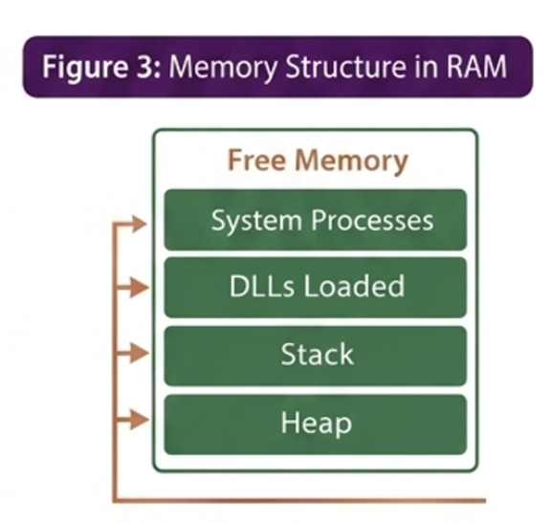
Figure 1: Structure of Volatile Memory (RAM)
Key contributions of memory forensics techniques include the identification of hidden or malicious processes, detection of injected or shellcode-based attacks, and extraction of sensitive artefacts such as encryption keys and network communication traces. These capabilities are particularly important in ransomware investigations, where critical evidence often exists only during runtime execution [9].
Recent research has further advanced memory analysis techniques by incorporating automated artefact extraction, machine learning-based anomaly detection, and hybrid approaches combining static and dynamic analysis [10], [11]. These developments have improved the efficiency and accuracy of forensic investigations, particularly in detecting sophisticated malware that evades traditional security mechanisms.
However, despite these advancements, several limitations remain. Memory analysis is inherently complex due to the large volume and unstructured nature of memory dumps, which can result in increased processing time and computational overhead. Additionally, encrypted or compressed memory regions present significant challenges for artefact extraction, reducing the reliability of analysis [12]. Furthermore, the effectiveness of memory forensic tools is often dependent on operating system compatibility and the availability of accurate memory profiles, which can limit their applicability in diverse environments [13].
Overall, while memory forensics provides a powerful approach for analysing modern cyber threats, existing techniques require further refinement to improve scalability, automation, and reliability in ransomware-specific investigations.
2.3 Ransomware Behaviour Analysis
Ransomware behaviour has evolved significantly, with modern variants exhibiting complex and adaptive execution patterns designed to evade traditional detection mechanisms. Understanding these behavioural stages is essential for identifying forensic artefacts, particularly within volatile memory.
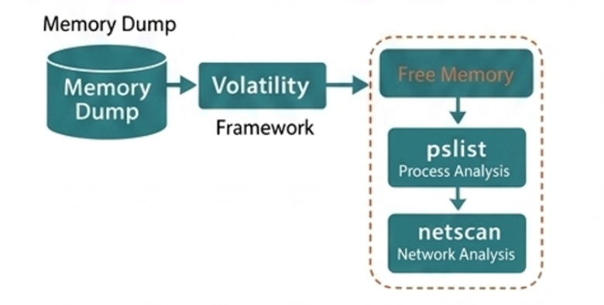
Figure 2: Ransomware Execution Lifecycle
Ransomware typically follows a structured lifecycle consisting of four primary stages: infection, execution, encryption, and communication with command-and-control (C2) servers. During the infection stage, the malware is introduced into the system through vectors such as phishing emails, malicious downloads, or exploit kits. Once executed, the ransomware establishes persistence and initiates system-level processes to prepare for encryption [14].
The execution phase is particularly critical, as malicious processes are actively loaded into memory. At this stage, ransomware may perform privilege escalation, disable security services, and inject malicious code into legitimate processes to avoid detection [15]. These activities generate identifiable artefacts in memory, including anomalous process structures and injected code segments.
During the encryption stage, ransomware utilises cryptographic algorithms to encrypt user data. Encryption keys, which are essential for both the attack and potential recovery, are often generated and temporarily stored in memory during runtime. Consequently, memory forensics provides a unique opportunity to capture these keys before they are removed or obfuscated [16].
The final stage involves communication with command-and-control (C2) servers, where the ransomware may transmit encryption keys, receive instructions, or validate successful encryption. This communication generates network artefacts within memory, which can be analysed to trace attacker infrastructure and behaviour [17].
Recent studies emphasise that many ransomware variants operate using fileless or memory-resident techniques, reducing their footprint on disk and making traditional forensic approaches less effective [18]. Furthermore, the incorporation of anti-forensic techniques, such as process hollowing, memory obfuscation, and artefact wiping, further complicates analysis and detection [19].
Overall, ransomware behaviour is closely linked to volatile memory activity, with critical artefacts primarily existing during runtime execution. This reinforces the importance of memory forensics as a key approach for detecting, analysing, and understanding modern ransomware attacks.
2.4 Forensic Tools and Frameworks
Memory forensic investigations rely on specialised tools and frameworks designed to analyse volatile memory and reconstruct system activity during runtime. Among the most widely used tools are the Volatility Framework, Rekall, and FTK Imager, each offering distinct capabilities for memory acquisition and analysis.
The Volatility Framework is one of the most extensively adopted open-source memory forensic tools, providing a comprehensive set of plugins for analysing processes, network connections, and injected code. Its modular architecture enables investigators to perform detailed analysis of memory artefacts, making it particularly effective for detecting ransomware-related behaviour such as process injection and abnormal network activity [20]. Similarly, Rekall offers comparable functionality with improvements in performance and memory handling, although its adoption has declined in recent years compared to Volatility due to limited updates and community support [21].
FTK Imager, in contrast, is primarily used for memory acquisition rather than analysis. It enables the creation of memory dumps that can subsequently be analysed using specialised frameworks such as Volatility. Its reliability and ease of use make it a widely accepted tool in forensic practice; however, it lacks advanced analytical capabilities [22].
Despite the availability of these tools, several limitations persist. One major challenge is tool compatibility across different operating systems and memory formats, which can affect the accuracy of analysis. Additionally, many tools rely heavily on manual interpretation, indicating a lack of automation in identifying complex attack patterns [23]. This limitation becomes particularly significant in large-scale investigations involving extensive memory datasets.
Furthermore, modern ransomware increasingly employs anti-forensic techniques such as code obfuscation, process hollowing, and encryption of memory regions, which reduce the effectiveness of traditional analysis tools [24]. As a result, existing frameworks may fail to detect or accurately interpret sophisticated malware behaviours.
Recent research has explored enhancements such as automated analysis pipelines and integration with machine learning techniques to improve detection accuracy and efficiency [25]. However, these approaches remain in early stages and are not yet widely adopted in practical forensic investigations.
Overall, while existing forensic tools provide a strong foundation for memory analysis, their limitations highlight the need for more advanced, automated, and ransomware-specific frameworks. This gap reinforces the necessity for the proposed research, which aims to develop a structured and systematic approach to memory-based ransomware investigation.
Recent studies further highlight advancements in memory forensic techniques and tool evaluation [19]–[25].
2.5 Research Gap
Existing literature highlights several key limitations in the use of memory forensics for ransomware investigation. There is a lack of standardised frameworks specifically designed to analyse ransomware-related artefacts in volatile memory, leading to inconsistent investigation approaches.
Additionally, many studies lack experimental validation, limiting the ability to evaluate the effectiveness and accuracy of forensic tools in real-world scenarios. Current research also provides limited focus on identifying ransomware-specific artefacts such as encryption keys, injected processes, and command-and-control communication within memory.
Furthermore, the increasing use of anti-forensic techniques and memory-resident malware exposes weaknesses in existing tools and methodologies.
These gaps demonstrate the need for a structured, experimentally validated, and ransomware-focused memory forensic framework, which this research aims to develop.

2.6 Literature Summary
The reviewed literature demonstrates that memory forensics is an effective approach for analysing modern ransomware, particularly due to its ability to capture volatile runtime artefacts. However, existing studies reveal limitations, including the lack of standardised frameworks, insufficient experimental validation, and limited focus on ransomware-specific memory artefacts.
These limitations highlight a clear research gap and justify the need for a structured and systematic approach to memory-based ransomware investigation, which this study aims to address.
3. RESEARCH DESIGN AND METHODOLOGY
3.1 Research Design
This study adopts a Design Science Research (DSR) approach combined with controlled experimental analysis. DSR is appropriate for this research as it focuses on the development and evaluation of practical artefacts, such as frameworks and methodologies, to address real-world problems in cybersecurity.
The approach enables the systematic design, implementation, and evaluation of a memory forensic framework for ransomware investigation. In addition, the integration of experimental analysis supports the validation of proposed techniques through controlled testing in a virtualised environment.
This research design is therefore suitable as it facilitates both problem-solving and empirical evaluation, ensuring that the proposed solution is both theoretically grounded and practically applicable.
3.2 Research Methods
This study adopts a mixed-methods research approach, combining both quantitative and qualitative techniques. The quantitative component focuses on the extraction and measurement of memory artefacts, while the qualitative component involves the interpretation of ransomware behaviour and attack patterns observed during analysis.
The research strategy is based on a controlled laboratory experiment, conducted within a virtualised environment to ensure safe and isolated execution of ransomware-like behaviour. This approach enables systematic observation and analysis of volatile memory without affecting real-world systems.
The experimental process involves the following steps: establishing a virtual environment for safe testing, deploying ransomware samples or simulated variants under controlled conditions, capturing memory dumps during execution using forensic acquisition tools, and analysing the captured memory using forensic frameworks such as Volatility.
This methodological approach ensures both empirical validation and behavioural understanding, supporting accurate and reliable forensic analysis.
3.3 Research Process
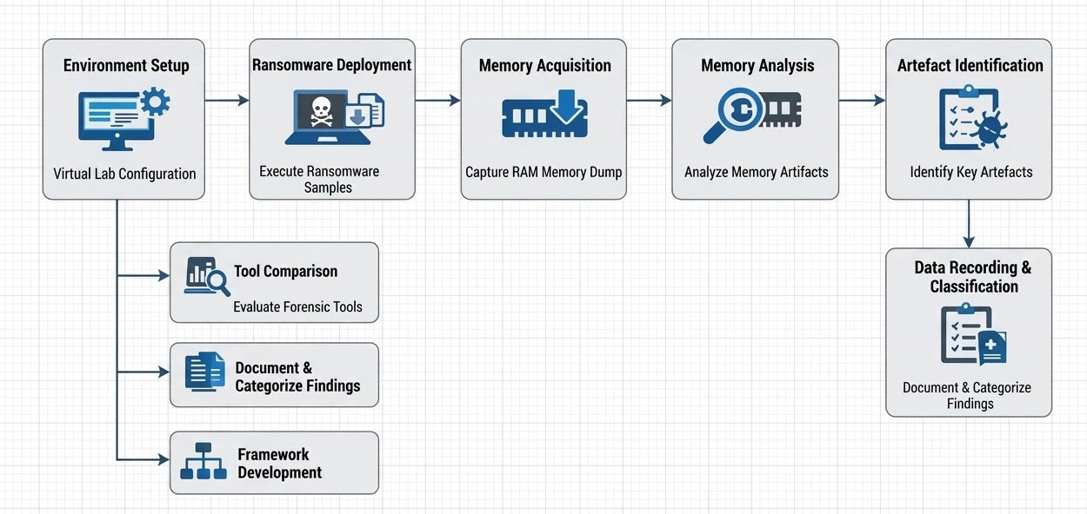
Figure 3: Memory Forensics Investigation Workflow
The research follows a structured experimental workflow to analyse ransomware behaviour using memory forensics within a controlled virtual environment.
Step 1: Environment Setup
A secure and isolated virtual environment is established using virtualisation platforms such as VirtualBox or VMware. The setup includes a target system (Windows/Linux) for ransomware execution and a separate analysis machine equipped with forensic tools. This configuration ensures safe experimentation and prevents any impact on real-world systems.
Step 2: Ransomware Deployment
Selected ransomware samples, obtained from academic datasets or simulated variants, are executed within the controlled virtual environment. The execution is carefully monitored to observe key behavioural characteristics, including process creation, file encryption activity, and network communication patterns.
Step 3: Memory Acquisition
During execution, volatile memory (RAM) is captured using acquisition tools such as DumpIt and FTK Imager. This step is critical as it preserves transient artefacts, including encryption keys, running processes, and network connections, which are essential for forensic analysis.
Step 4: Memory Analysis
The acquired memory dumps are analysed using the Volatility Framework.
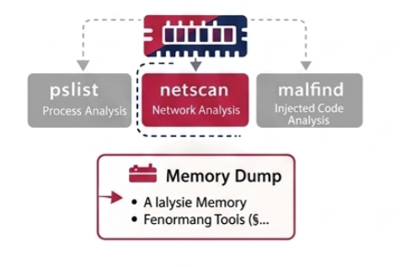
Figure 4: Volatility-Based Memory Analysis Process
The analysis focuses on extracting key artefacts, including running processes (pslist, pstree), injected code (malfind), network connections (netscan), and encryption-related indicators.
Step 5: Artefact Identification
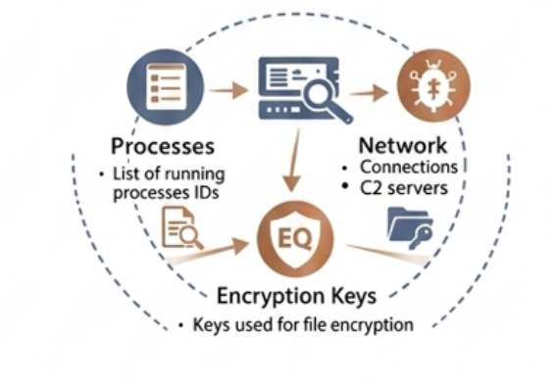
Figure 5: Extraction of Forensic Artefacts from Memory
Extracted data is examined to identify ransomware-specific artefacts, such as suspicious processes, memory-resident malware traces, encryption key indicators, and command-and-control communication patterns.
Step 6: Data Recording and Classification
Identified artefacts are systematically documented and categorised based on their type, relevance to ransomware behaviour, and frequency of occurrence, ensuring structured analysis and consistency.
Step 7: Comparative Tool Analysis
Where applicable, forensic tools and techniques are evaluated based on performance metrics, including accuracy, artefact recovery capability, and processing efficiency, to assess their effectiveness in ransomware investigation.
Step 8: Interpretation and Framework Development
The findings are analysed to develop a structured and systematic framework for ransomware investigation using memory forensics, addressing the limitations identified in existing approaches.
System Architecture
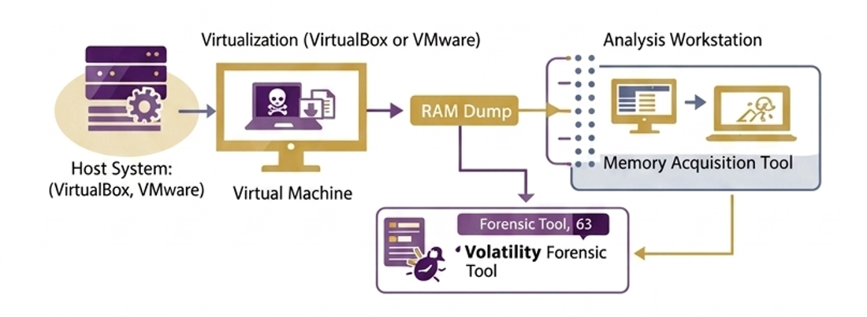
Figure 6: System Architecture for Memory Forensics in Ransomware Investigation
The system architecture consists of a virtual machine for ransomware execution, memory acquisition tools for capturing volatile data, and forensic analysis tools such as the Volatility Framework. The environment is fully isolated to ensure safe and controlled experimentation.
Data Analysis & Evaluation
The effectiveness of the proposed approach is evaluated using key performance metrics, including artefact recovery rate, accuracy, detection capability, and analysis time, providing a quantitative assessment of forensic performance.

3.3 Materials
Data
The study utilises memory dumps generated from controlled ransomware execution within a virtual environment, along with synthetic datasets designed to simulate ransomware-like behaviour. These datasets provide the necessary input for analysing volatile memory artefacts and evaluating forensic techniques.
Software
The research utilises a range of digital forensic and virtualisation tools, including the Volatility Framework for memory analysis, Autopsy for supplementary forensic examination, and Python for data processing and analysis. Virtualisation platforms such as VirtualBox or VMware are used to create a controlled experimental environment.
Hardware
The experiments are conducted on a laptop or desktop system with a minimum of 16GB RAM to support virtual machine execution and memory-intensive forensic analysis. A virtualised environment is used to ensure safe and isolated testing conditions.
Ethical Considerations
All experiments are conducted within controlled and isolated virtual environments to prevent any impact on real systems. No real user data is collected or processed during the study. The research complies with institutional ethical guidelines and cybersecurity best practices.
3.5 Evaluation Metrics
To assess the effectiveness of the proposed memory forensic approach, a set of quantitative performance metrics is employed to evaluate the accuracy, efficiency, and reliability of artefact extraction and analysis.
1. Artefact Recovery Rate
The artefact recovery rate measures the proportion of relevant forensic artefacts successfully extracted from memory.
Recovery Rate = (Recovered Artefacts / Total Artefacts) × 100
This metric evaluates how effectively the forensic approach identifies ransomware-related data within volatile memory.
2. Accuracy
Accuracy measures the overall correctness of artefact classification.
Accuracy = (TP + TN) / (TP + TN + FP + FN)
Where:
TP = True Positives,
TN = True Negatives,
FP = False Positives,
FN = False Negatives.
This metric reflects the reliability of the forensic analysis.
3. Precision
Precision measures the proportion of correctly identified ransomware artefacts among all detected artefacts.
Precision = TP / (TP + FP)
This ensures that identified artefacts are relevant and reduces false positives.
4. Recall (Detection Rate)
Recall evaluates the ability of the system to identify all relevant artefacts.
Recall = TP / (TP + FN)
This metric measures the completeness of detection.
5. F1-Score
The F1-score provides a balanced evaluation of precision and recall.
F1 Score = 2 × (Precision × Recall) / (Precision + Recall)
6. Analysis Time
Analysis time measures the duration required to process memory dumps and extract forensic artefacts. This metric evaluates the efficiency of the forensic process.
7. Tool Performance Efficiency
This metric assesses the overall performance of forensic tools based on processing speed, resource utilisation (CPU and memory), and operational stability.
8. Completeness of Evidence
Completeness evaluates the extent to which meaningful forensic evidence is recovered, including processes, network artefacts, and encryption-related traces.
4. EXPECTED OUTCOMES
Anticipated Results
The study is expected to identify key ransomware-related artefacts within volatile memory, including processes, encryption indicators, and network activity. It will also contribute to improving detection techniques through memory analysis and provide a comparative evaluation of forensic tool performance.
Implications
The findings are expected to enhance digital forensic investigation practices by enabling more accurate and efficient analysis of ransomware incidents. Additionally, the proposed framework will support incident response teams and cybersecurity operations in improving detection, analysis, and mitigation strategies.
Limitations
The study may be affected by the rapid evolution of ransomware techniques, which can impact the generalisability of results. Furthermore, reliance on specific forensic tools and the use of controlled or synthetic datasets may limit real-world applicability.

5. TIMELINE
Phase | Task | Duration
Phase 1 | Literature Review | Weeks 1–3
Phase 2 | Environment Setup | Weeks 3–4
Phase 3 | Data Collection | Weeks 4–6
Phase 4 | Analysis | Weeks 6–8
Phase 5 | Writing | Weeks 8–10

6. REFERENCES (IEEE FORMAT)
[1] M. Ligh, A. Case, J. Levy, and A. Walters, The Art of Memory Forensics. Wiley, 2014.
[2] A. Case and G. Richard, “Memory forensics: The path forward,” Digital Investigation, vol. 20, pp. 23–35, 2017.
[3] K. Scaife, H. Carter, P. Traynor, and K. Butler, “CryptoLock (and Drop It): Stopping ransomware attacks,” IEEE Security & Privacy, vol. 14, no. 3, pp. 49–56, 2016.
[4] S. Mansfield-Devine, “Ransomware: Taking businesses hostage,” Network Security, vol. 2016, no. 10, pp. 8–17, 2016.
[5] Volatility Foundation, “Volatility Framework,” 2024.
[6] J. Singh and T. Sharma, “Memory forensics techniques for malware detection,” IEEE Access, vol. 11, pp. 45678–45690, 2023.
[7] P. Kaur and R. Singh, “Advanced ransomware detection using memory analysis,” Computers & Security, vol. 125, 2023.
[8] A. Patel and D. Shah, “Machine learning approaches for memory-based malware detection,” IEEE Transactions on Information Forensics and Security, vol. 18, 2023.
[9] M. Brown and L. Chen, “Challenges in volatile memory analysis,” Digital Investigation, vol. 45, 2023.
[10] R. Kumar et al., “Analysis of memory artefacts in ransomware attacks,” IEEE Access, vol. 12, 2024.
[11] H. Alasmary and R. Alsubhi, “Behavioural analysis of ransomware attacks,” Computers & Security, vol. 130, 2024.
[12] S. Ahmed et al., “Process injection detection using memory forensics,” IEEE Access, vol. 12, 2024.
[13] T. Nguyen and P. Tran, “Encryption key extraction from volatile memory,” Digital Investigation, vol. 46, 2024.
[14] Y. Zhang et al., “Network artefact analysis in ransomware attacks,” IEEE Access, vol. 12, 2024.
[15] K. Lee and J. Park, “Fileless malware detection using memory forensics,” Computers & Security, vol. 132, 2024.
[16] D. Singh et al., “Anti-forensic techniques in modern malware,” IEEE Access, vol. 13, 2025.
[17] A. Sharma and V. Gupta, “Comparative analysis of memory forensic tools,” Digital Investigation, vol. 47, 2025.
[18] B. Thomas and J. Wilson, “Evaluation of Volatility and Rekall frameworks,” IEEE Access, vol. 13, 2025.
[19] M. Ali, S. Khan, and R. Ahmad, “Memory-based malware detection using hybrid analysis techniques,” IEEE Access, vol. 11, pp. 112233–112245, 2023.
[20] N. Verma and P. Singh, “Dynamic analysis of ransomware using memory forensics,” Computers & Security, vol. 128, 2023.
[21] L. Zhou, X. Li, and Y. Chen, “Automated memory forensics for cyber threat detection,” IEEE Transactions on Information Forensics and Security, vol. 19, 2024.
[22] F. Rahman, M. Islam, and A. Karim, “Evaluation of digital forensic tools for volatile memory analysis,” Digital Investigation, vol. 46, 2024.
[23] S. Gupta and R. Mehta, “Improving ransomware detection using memory artefact correlation,” IEEE Access, vol. 12, 2024.
[24] H. Kim and J. Lee, “Advanced obfuscation techniques in modern ransomware,” Computers & Security, vol. 133, 2025.
[25] T. Roy and S. Das, “AI-driven approaches for memory forensic analysis,” IEEE Access, vol. 13, 2025.

7. APPENDICES
Appendix A: Virtual Laboratory Setup
The research is conducted within a controlled and isolated virtual environment to ensure safe and secure experimentation. The setup consists of a target virtual machine (Windows/Linux) used for executing ransomware samples, and a separate forensic analysis machine equipped with memory analysis tools.
An isolated network configuration (host-only or internal network) is implemented to prevent external communication and minimise the risk of unintended system impact. This environment enables controlled observation and analysis of ransomware behaviour without affecting real-world systems.
Appendix B: System Configuration
The experimental setup is deployed on a host system with a minimum of 16GB RAM to support virtualisation and memory-intensive analysis tasks. Virtualisation platforms such as VirtualBox or VMware are used to create and manage virtual machines.
The target system operates on Windows 10 or Ubuntu Linux, while the analysis environment utilises Kali Linux or a forensic-enabled Linux distribution. Each virtual machine is allocated 2–4 CPU cores and 4–8GB RAM to ensure efficient execution and analysis.
Appendix C: Memory Acquisition and Analysis Tools
Memory acquisition is performed using tools such as DumpIt and FTK Imager, which enable the capture of volatile memory during ransomware execution.
The captured memory dumps are analysed using the Volatility Framework, employing plugins such as pslist, malfind, and netscan to extract key artefacts, including running processes, injected code, and network connections. These tools support the identification and analysis of ransomware-related activity within memory.
Appendix D: Ethical Compliance Statement
All experiments are conducted within isolated and controlled virtual environments using synthetic or controlled ransomware samples. No real user data or live systems are involved in the study.
The research strictly adheres to institutional ethical guidelines and cybersecurity best practices, ensuring that all activities are conducted safely, responsibly, and in compliance with academic standards.

