Material Culture Studies, Materiality, and the New Materialisms Glossary

Actor Network Theory……….. | ANT is an ontology meant to examine the relationships between people and things, focused on building upon the idea of object agency. Latour describes the Actor Network Theory as a web of reactions, emphasizing that humans and objects are nodes which are connected to make up a network of connections and relationships (2005, pp. 43-46). Humans and things are equal actants and they both influence, affect, encourage, and participate in their networks. A network is made of actors or groups interacting and reacting with each other making connections. The nodes in networks are entities both human and non-human with agentive capabilities connected through the web or network.  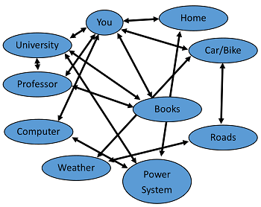  Fig. 1: Example diagram of a network. (https://study.com/academy/lesson/latours-actor-network-theory.html
agency…………………………... | Agency refers to the ability to act or affect something. In Material culture studies, this is most often discussed in relation to agency of objects, their ability to influence and affect their environments extant to humans giving them agency. The New Materialist approach recognizes that objects are not inert, but that they possess agency just as humans do. Both objects and humans possess agential capacities to influence, create, and mediate their social worlds.
agential realism………………. | Agential realism is a relational ontology developed by Karen Barad to question the Cartesian cut and focus attention on nonhumans, matter, materials. It is derived from Bohr’s theory of boundaries, and she suggests that “things do not have inherently determinate boundaries” (Barad, 2003, p. 813). A key part of agential realism is the emphasis on relationships, and intra-actions (see intra-actions), discussing the notion of things-in-phenomena and re-examining how we measure the world (Barad, 2003, p. 815-817) (Alberti & Marshall, 2014, pp. 26-27).
assemblage……………………. | There are two important definitions of assemblage within the scope of material culture studies, the first being the archaeological definition which is the ‘traditional’ definition, and there is the New Materialist definition. An archeological assemblage typically refers to an accumulation of things related by a typology or provenance. The more recently introduced definition refers back to the original French “agencement” coined by Deleuze and Guattari, meaning to come together. This concept of a “coming together” is a key part of New Materialist thought because it refocuses the meaning on the flow of matter and things rather than viewing assemblages as static entities (DeLanda, 2016, pp. 6-7) . Assemblages as active flows of matter in and out of them allows the items within them agency which is also a key part of New Materialism, and Bennett suggests they are living groupings instead of inert collections (2010, pp. 21-24).  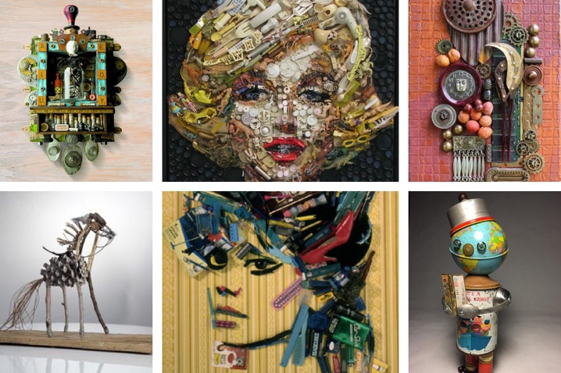  Fig. 2: Assemblage Art. (https://filmlifestyle.com/assemblage-in-art/).
body schema…………………... | A principle of Malafouris’ MET (see Material Engagement Theory) that describes the boundaries of the human body. Within the theory, it refers to the body schema being extended by tools and objects held or worn by the body, such as clothes or items wielded. The body schema softens the boundaries of the body otherwise considered discrete and impermeable by other lines of thought. Within the body schema, tools allow the person to do things it wouldn’t be able to do otherwise.    Fig. 3: The Blind Man’s Stick. (https://www.thenewatlantis.com/text-patterns/the-blind-mans-stick).
entanglement…………………... | This refers to the ineffable relationships between people and things. People and things are connected through recursive relationships and both influence and are influences by each other to create their social worlds and environments.
Fragmentation Theory……..…. | Fragmentation Theory, developed by John Chapman, refers to the deliberate breaking of items. Fragmentation serves to explain or represent social relationships. Fragmented objects are imbued with memories and personhood of the people and places involved with the practice. Personhood is embedded within fragmented objects; people create relationships with objects, and they accumulate their own history and agency as their meanings are passed down through time. These objects can be used to mediate relationships between people, as well as link people to places.
inalienability……………………. | Inalienability is part of Chapman’s fragmentation (see Fragmentation Theory); refers to the inability to detach something from a specific person or persons because of the personhood, memories, identities, etc. that have been associated and imbued into the object. Inalienable possessions are taken out of circulation and can have multiple subsequent owners which inherit the inalienability of the object upon associating themselves with it.
intra-action…………………… | Part of Barad’s theory of vibrant matter and agential realism. Intra-actions refer to the constant and continuous coming together, materialization, and flows of matter to co-produce the material world. Intra-actions serve to blur the boundaries between things and encourage re-examination of the relationships between matter. (See agential realism).
material…………………………... | A material refers to the elements that make up a physical item. Materials are made of matter (see matter) and can exist alone as something or be combined with others to make something.
material culture………………… | Material culture refers to the physical environment around us which we can study and experience with the mind and body; it includes objects and things (see things, objects).
Material Engagement Theory... | MET is a relational ontology developed by Lambros Malafouris as a way to explain the relationship between people and objects. It explores the interactions between the mind and body and objects, particularly noting how the boundaries between people and things are mutable. He discusses how tools extend the body and create a body schema of both people and things interacting and connecting with one another (Malafouris, 2008). An example of this is the blind man’s stick, or metaplasticity of the brains of musicians (Malafouris, 2013, pp. 4-6, 46-47).
materiality……………………...... | Materiality of a thing refers to the character or material makeup of it, “the quality or character of the material of which a thing is made. Its material-ness” (Attala & Steel, 2019, p. ix), as well as the recursive relationship it has with people. The materiality of an object involves the continuous flow of matter, and this process of materialization is what creates the material world.
matter………………...…………... | Matter refers to the elements that make up physical items and take up physical space (Attala & Steel, 2019, p. xvii).
New Materialisms………………. | New Materialisms is a relational ontology introduced to examine and critique previously established approaches about archaeology and material culture studies. It was developed to decenter the anthropocentric approach and focus on recognizing that objects and humans are equal participants in the world. The New Materialist approach “gives voice to ‘others’ and recognizes the part non-human other play in the creation of our worlds” (Attala & Steel, 2019, p. 1). The New Materialist approach involves discussion of hierarchies and relationships between people and things, object agency, as well as the role of matter in material and social worlds.
object biography……………...... | An object biography refers to a concept developed by Kopytoff (1986) to recognize the “social life of things” and thus examine and understand their histories. The idea of an object having a biography is entwined with it, granting it meaning and agency via social praxis. They also can become deeply personal “biographical objects,” as described by Hoskins (2006, p. 78), when imbued with specific meanings by one or more of their owners at a given point in the object’s life. To understand an object’s biography is to approach it like an anthropologist, “one would ask questions similar to those one asks about people” (Kopytoff, 1986, p. 66).    Fig. 4: Brand new stuffed lamb and a worn-out stuffed lamb, part of Katja Kemnitz's “Too Much Love” Series. (https://www.boredpanda.com/old-plush-toys-before-after-katja-kemnitz/).
object itinerary………………….. | A spatial and temporal approach to the history of objects which looks at the flow of things through space and time. An object’s itinerary considers each movement and state of the object during its history to better understand it. Joyce’s concept of things in motion is a foundational principle to object itinerary as it focuses on rejecting the restrictive, anthropocentric approach that object biographies (see object biography) present (2015, p. 23).
object…………………………...... | There are many contesting definitions of an object by scholars’ commonly recognized but a general consensus among them includes an object described as items that are defined, discrete, and alienable. The concept of objecthood and thingification are entangled and foundational concepts in the New Materialism approach to material culture studies (see thing). Objects are bounded entities, and they are definable.
Sensory Archaeology………….. | Sensory archaeology is involved with focusing on the bodily senses within the study of material culture. It is an approach focused on decentering sight as the primary way to engage with things and bringing the other 4 senses into the foreground. The theory surrounding sensory archaeology was primarily developed by Heidegger and his concept of Dasein (1962) and Merleau-Ponty (1945) as well as notable contributions from Bailey’s (2014) cheirotic approach. Sensorial approaches to archaeology aim to step away from the Cartesian cut and acknowledge that material culture can be experienced with the body as well as the mind, that all 5 senses provide essential information about the material world and archaeological studies. Sensory archaeology questions the western focus on visuality and aims to emphasize the usefulness of engaging with the material world with the whole body. Using all five senses and immersing the body and mind can provide insight into the past that visualization-only approaches cannot. Technology is also discussed as a tool to enhance the sensorial approach to archeology and engagement with material culture, including 3D models or haptic experiences to enhance tourist experiences in museums.  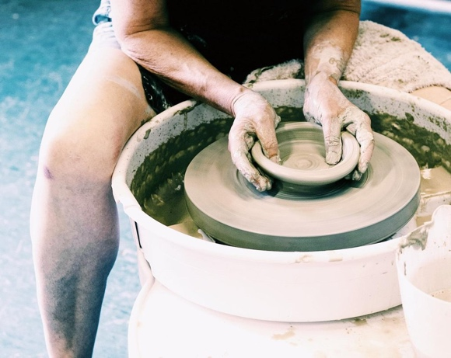  Fig. 5: Someone throwing pottery on a wheel. (https://www.clayworksstudios.co.uk/shop-weekly-throwing-course-mixed-ability/learn/to/throw/pots/on/wheel/beginners).
thing………………………………. | There are several definitions for a thing, but the common agreement across them all is that things are fluid, ambiguous, and undefinable. Things are one of the most important elements of New Materialism thought. They are what people spend their time with and around, shaping the world around them and vice versa. Some examples of scholars’ definitions:  - Heidegger (1971) describes a thing as being anything that affects people, “[a gathering] that in any way bears upon men” (p. 172). His definition is based upon a German word “ding” which means gathering.  - Ingold describes things as being in constant movement, they are themselves gatherings of materials (2010, p. 10). Ingold takes after Heidegger’s concept of things being gatherings or matter coming together, which is supported by New Materialist thinkers. The fluidity of matter allows things to be constantly moving and changing and creating.  - Knappett in his 2010 book takes a more spatial stance and suggest things exist in the cognitive realm. The mind engages with things and the body engages with objects (pp. 81-83).  - Govier and Steel suggest things are assemblages, they are fluid entities not bounded. They focus on the matter of things, and their flow and vibrancy (2021, p. 7). Things come together, flow into and out of assemblages continuously, shaping and reshaping the world around them.

Bibliography

Attala, L., & Steel, L. (2019). Introduction. In L. Attala & L. Steel (Eds.), Body Matters: Exploring the Materiality of the Human Body (pp. 1-17). University of Wales Press.
Attala, L., & Steel, L. (2019). Preface. In L. Attala & L. Steel (Eds.), Body Matters: Exploring the Materiality of the Human Body (pp. xvii-xviii). University of Wales Press.
Bailey, D. (2014). Touch and the cheirotic apprehension of prehistoric figurines. In P. Dent (Ed.), Sculpture and Touch (pp. 27-44). Ashgate.
Barad, K. (2003). Posthumanist Performativity: Toward an Understanding of How Matter Comes to Matter. Women, Science, and Technology, 28(3), 801–831. https://doi.org/https://www.jstor.org/stable/10.1086/345321.
Bennett, J. (2010). The Agency of Assemblages. In J. Bennett, Vibrant Matter: A Political Ecology of Things (pp. 20-38). Duke University Press.
Bennett, J. (2010). The Force of Things. In J. Bennett, Vibrant Matter: A Political Ecology of Things (pp. 1-19). Duke University Press.
Chapman, J. (2000). Two Ways of Relating: Enchainment and accumulation. In J. Chapman, Fragmentation In Archaeology: People, places and broken objects in the prehistory of south-eastern Europe (pp. 23-48). Routledge.
DeLanda, M. (2016). Introduction. In M. DeLanda, Assemblage Theory (pp. 1-8). Edinburgh University Press.
Govier, E. & Steel, L. (2021). Beyond the ‘thingification’ of worlds: Archaeology and the New Materialisms. Journal of Material Culture pp. 1-20.
Heidegger, M. (1962). Being and Time (J. MacQuarrie & E. Robinson, Trans.). Blackwell Publishers. (Original Work Published 1927).
Heidegger, M. (1971). The Thing (A. Hofstadter, Trans.). In M. Heidegger, Poetry, Language, Thought (pp. 163-180). Harper & Row.
Hoskins, J. (2006). Agency, Biography and objects. Handbook of Material Culture, 1, 74–84. https://doi.org/10.4135/9781848607972.n6.
Ingold, T. (2010). Bringing Things to Life: Creative Entanglements in a World of Materials. https://eprints.ncrm.ac.uk/id/eprint/1306/1/0510_creative_entanglements.pdf.
Joyce, R. (2015). Things in Motion: Itineraries of Ulua Marble Vases. In R. Joyce & S. Gillespie (Eds.), Things in Motion: Object Itineraries in Anthropological Practice (pp. 21-38). SAR Press.
Knappett, C. (2010). Communities of things and objects: a spatial perspective. In C. Renfrew, & L. Malafouris (Eds.), The Cognitive Life of Things: recasting the boundaries of the mind (pp. 81-89). McDonald Institute for Archaeological Research.
Kopytoff, I. (1986). The cultural biography of things: commoditization as process. In A. Appadurai (Ed.), The social life of things: Commodities in cultural perspective (pp. 64-91). Cambridge University Press.
Latour, B. (2005). Reassembling the Social: An Introduction to Actor-Network-Theory. Oxford University Press.
Malafouris, L. (2013). How Things Shape the Mind: A Theory of Material Engagement. The MIT Press.
Malafouris, L. (2008). Is it ‘me’ or is it ‘mine’? The Mycenaean sword as a body-part. In J. Robb & D. Boric (Eds.), Past Bodies (pp. 1-15). Oxbow Books.
Marshall, Y., & Alberti, B. (2014). A Matter of Difference: Karen Barad, Ontology and Archaeological Bodies. Cambridge Archaeological Journal, 24(1), 19–36. https://doi.org/doi:10.1017/S0959774314000067.
Merleau-Ponty, M. (1962). Phenomenology of Perception. London: Routledge & Kegan Paul.

