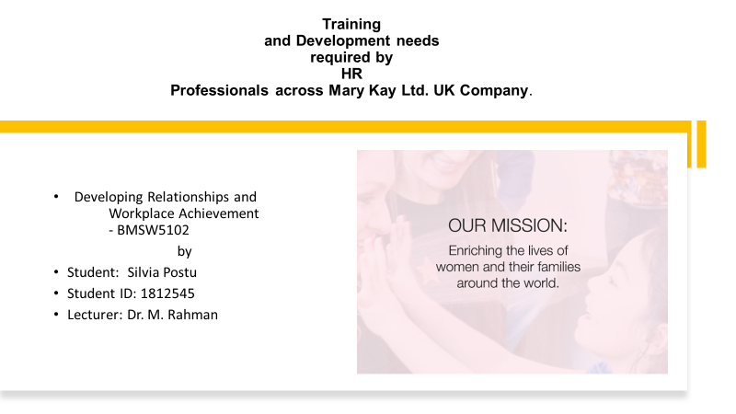
1
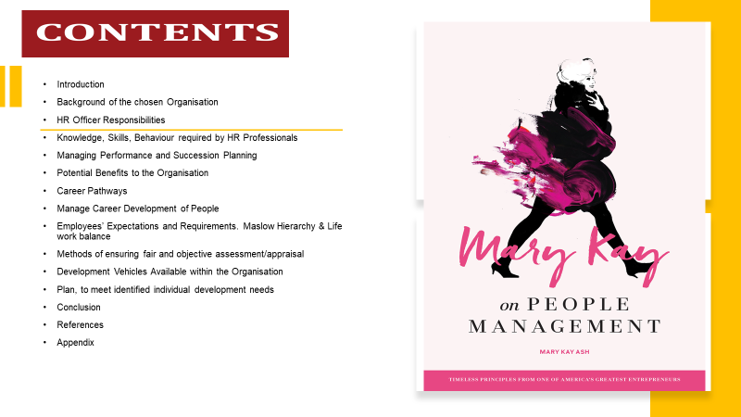
2

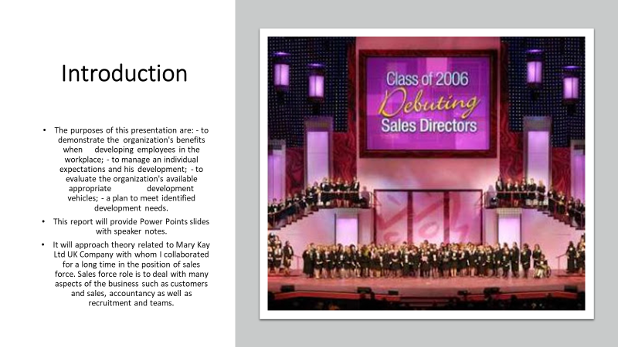
3
Speaker notes - slide 3. This report aims to approach the individual development within the organisation through career pathways. It will develop the methods and the strategies that are available to an organisation in order to develop individuals relating to potential benefits to the organisation. The methods of ensuring fair and objective appraisal of the individual at the workplace will be analysed.
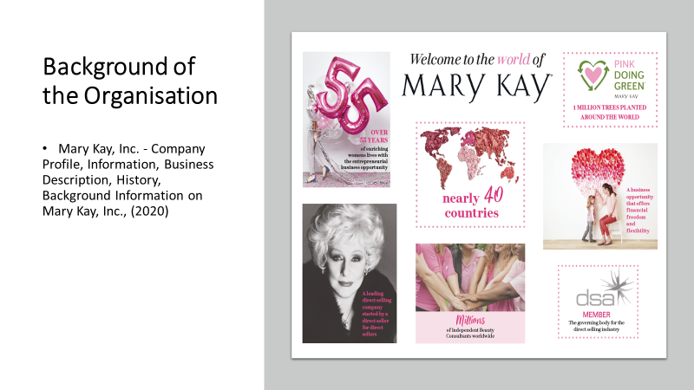Speaker notes - slide 4. Mary Kay Inc. Company is a large cosmetic American corporation which has spread its branches in 37 countries all over the world as well as in United Kingdom. It has been on the world market for more than 50 years. Its organisation structure is people oriented. Mary Kay Ash is the cofounder of the Company. She wrote 3 books and one of them called “On People Management” inspires many organisations in managing people development. Mary Kay is a DSA (Direct Selling Agency) member.
4

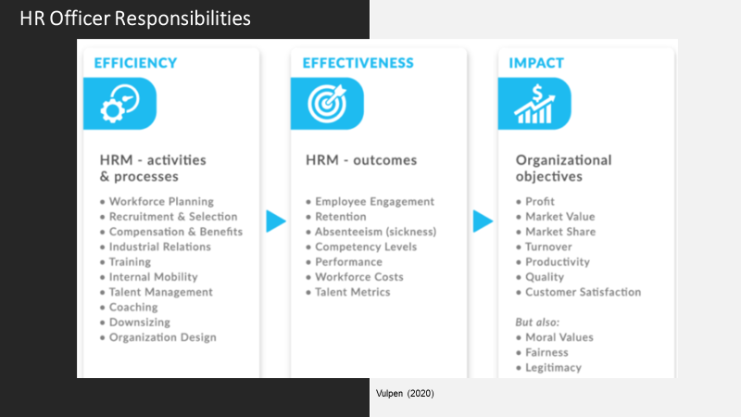
5
Speaker notes - slide 5. HR Officer responsibilities are focused on their effectiveness and impact to the organisation. Academic literature offers many HR Models such as: Standard Causal Model, 8-Box Model by Paul Boselie, HR Value Chain, HR Value Chain Advanced, Harvard Framework for HR. According to HR Value Chain Model, practices lead to productivity, innovation and quality which in turns these ones lead to financial gain, payback, interest, better margins and ROI (Vulpen, 2020). However, the difference is that in DSA companies the sales force to develop his /her business-team must start with planning to hire, go further counselling policies and company’s agreement, provide a business development plan and keep on supporting during the development process.

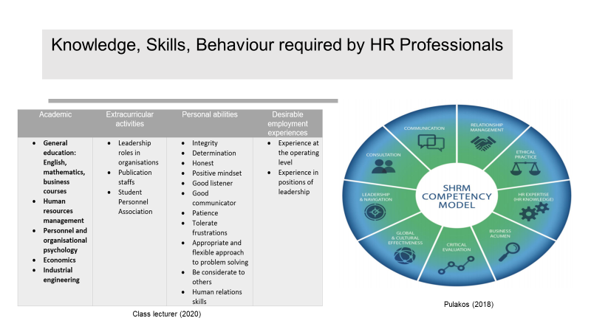
6
Speaker notes - slide 6. Another favourite HR organisation model is SHRM Competency Model that help the organisation to run properly. To be able to match the model activities and to avoid frustrations and misunderstandings among its employees and activities in HR departments, HR professionals require a list of skills and qualifications for the role of HR from innate and acquired qualities in home education and life practice to higher education and experience in similar positions in other work areas (Society for Human Resource Management, 2012). However, paradoxically and totally opposite to this standard, MK Company receives and offers the possibility of this position to any person who only wants opportunities to develop his/her own business and his/her own personality without having innate talents or any special studies and practices. It helps the person in this position to acquire the skills that match the above given model in the process of developing his/her own business teams.

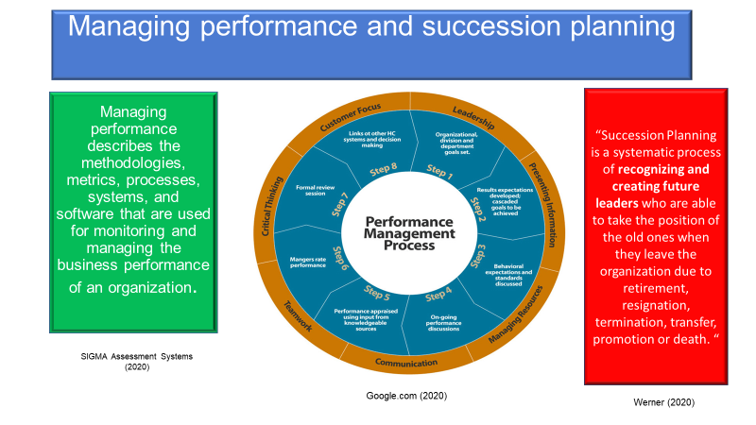
7
Speaker notes - slide 7. Performance management is about tools, methods and techniques used to measure, track, analyse, scale the organisation performance which is directly related to succession planning. Challenges might occur at this point in organisations because planning the future is a focus for them. Talent management is the key focus for the organisation. The process of succession planning is not easy even if there are many candidates available for leader positions (Miller, 2018). 81% of companies use a software to develop and maintain their succession plan (Baker, 2018). Related to Mary Kay Company, succession planning is done on three levels: corporate, subsidiary and sales force. In the first two levels, the typical methods and techniques of performance management are applied, but at the level of sales force there are two aspects to emphasize. In the position of Sales Force business-HR Manager, the team is working on the continuous idea "who is the next potential Leader". And another aspect is when the Sales Force - National Director must retire, then the Company offers the inheritance program, so that the Leader leaves his business-team to a family member.

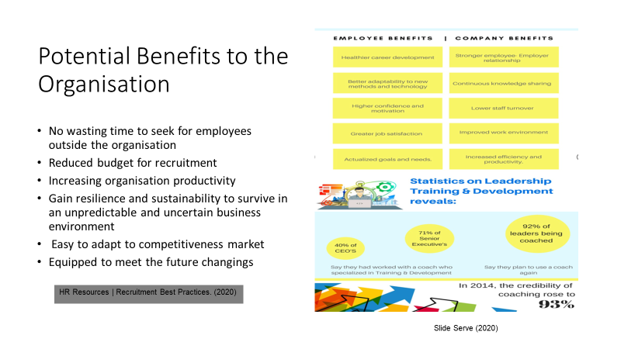
8
Speaker notes - slide 8. Training and development for employees is a worth investment. The benefit is obvious – facing all unpredictable market challenges, changes and surprises prolongs the life of the company for decades and even centuries, which will make it indestructible for future generations and will generate continuous profit and income. The benefit is double sided: to company and to people as well. When employee benefits of healthier carrier development, greater job satisfaction, the company benefits of lower staff turnover, improved work environment and increased efficiency and productivity (Jehanzeb and Bashir, 2013). This is the only way MK can open new branches. Development process for other roles leads to employee’s loyalty and enthusiasm about their future career with the organisation and provide the organisation with future leaders.

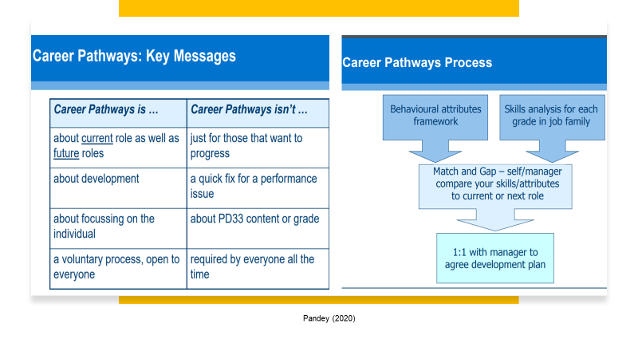
9
Speaker notes - slide 9. A career path is a range of jobs that help to achieve the goals. It is not necessarily linear. Some people achieve their goal within the same field, others need to change many jobs to achieve their goal. The career path within the organisation starts with the current role and keeps tracking progress through next steps to future role. It is focused on individual development (Doyle, 2020).
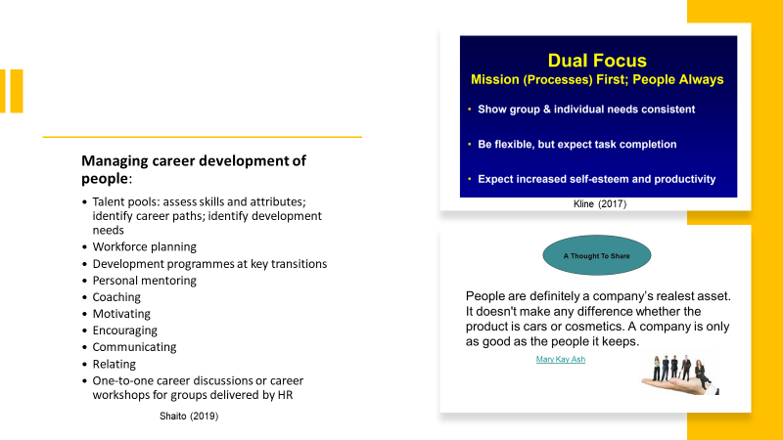
10
Speaker notes - slide 10. 30% of employees in U.S. and 13% outside U.S. are tied-up to their organisation. (Gallup, 2012 cited in forbes.com, 2020). Researches suggests that only well shaped talented managers can influence employees to stay engaged. According to Gallup (2012) researches, only 1 of 10 people is a talented manager. According to Mary Kay writings in “On People Management”, she believes that every person can become a Sales Force. However, statistics show that the Company encounter 3.5 million of Independent Beauty Consultants worldwide and only 150000 of Sales Force.

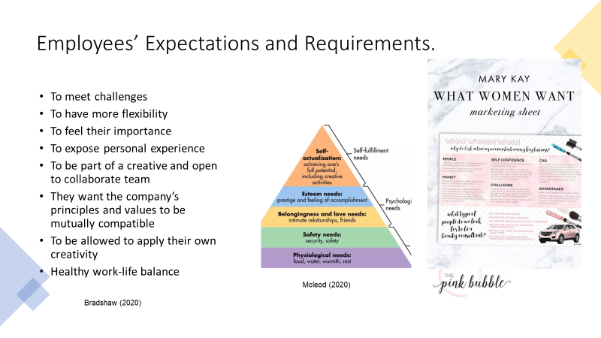
11
Speaker notes - slide 11. Mary Kay Company treats Independent Beauty Consultants beginning with Maslow’s (1943) hierarchy of needs and applies Tuckman (1965) formula in their development focusing on building mental, moral, spiritual, emotional strong teams. It starts with young teams’ in formation - forming, keeps overcoming them through trials and challenges - storming, balances – norming them and concludes with the peak stage of their performance - performing. It also places great emphasis on life-working balance, being aware that it considerably increases employee efficiency, therefore one of the company’s priorities are God on the first place, secondly is the family and career is the last.

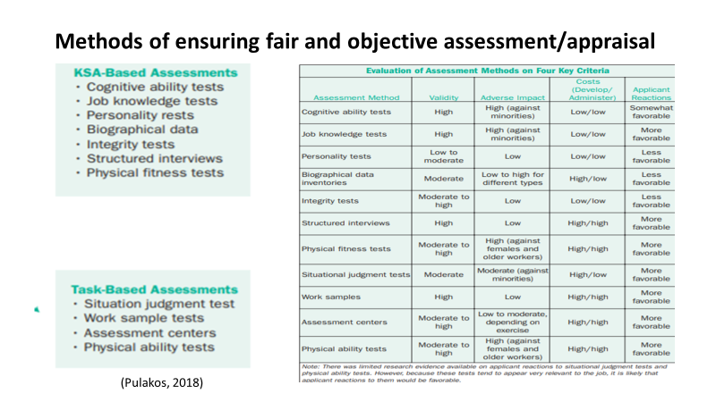
12
Speaker notes - slide 12. John Harvey-Jones (former TV and Chair of ICI) says, ‘a lot of the job of a leader is just to keep jollying things along’. Theoretically the organisation must use some methods and techniques to assess objectively its employees like a series of knowledge, moral, psychological, physical, judgement tests and structured interviews. However, Girling (2016) recommends being aware of the tension that arise while assessing someone’s performance and to do it fair it is better to follow the next 5 steps:
- Don’t allow someone else to influence your appraisal structure
- Both appraisee and appraiser to be involved equally in the conversation
- Avoid abstract opinions; set up clear activities
- Understand the root that causes the underperformance and adjust them to be improved
- Understand the attitude to be a symbol of hope.

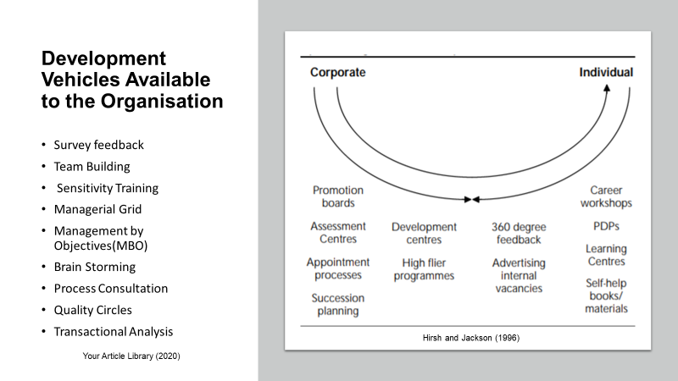
13
Speaker notes - slide 13. A strategical approach might be firstly closing the gaps about career development such as unclear message, career development processes differently stated and reality about development. The relationship between employment and development deal is a characteristic of a secure career development. The development initiative comes from both sides, the employer and the employee (Hirsh and Jackson, 1996). In Mary Kay Company the new recruiter is guided since he stated his willing of a career development. The strategies applied starts with identifying his needs through a survey feedback, then he gets his practical trainings starting to learn where, whom and how to sell MK cosmetic products, meanwhile getting insight all about working with customers: database, profiles, needs, feedback, understanding. In this coaching process he is also involved in team brain storming to share knowledge and experience and get more motivated.

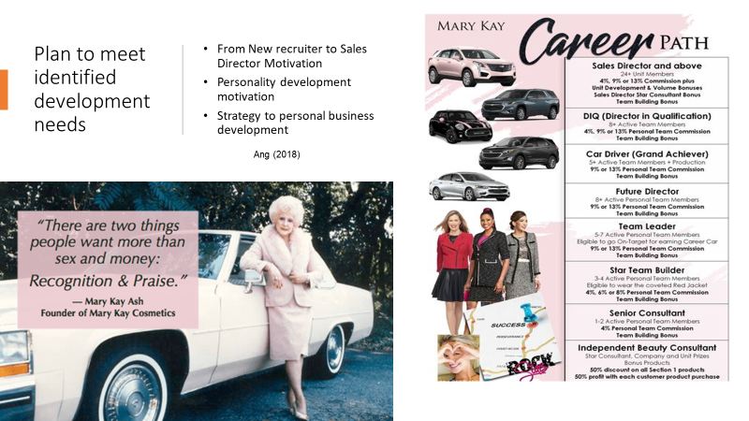
14
Speaker notes - slide 14. Mary Kay career development plan is structured on stages:
- Welcome kit, motivation stories,
- Test cosmetics and learn
- Register on your own selling software program
- Start selling
- Customers and data base
- Start recruiting
- Train your team
Every stage contains special development programs or projects being setup a time limit and objectives to achieve thus motivating the new recruiter to thrive. They also include reward programs an appreciation. Rewards can be money, cars, trips, computing devices, jewelleries, etc.

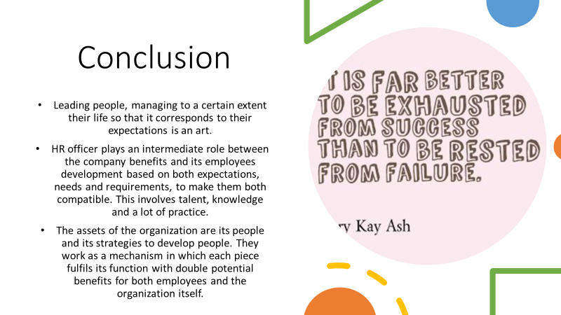
15
Speaker notes - slide 15. Mary Kay Ash strong belief was that people “Can do it”. Thus, she introduced in her company well structured motivating development programs, easy to follow step by step strategies, techniques and methods.

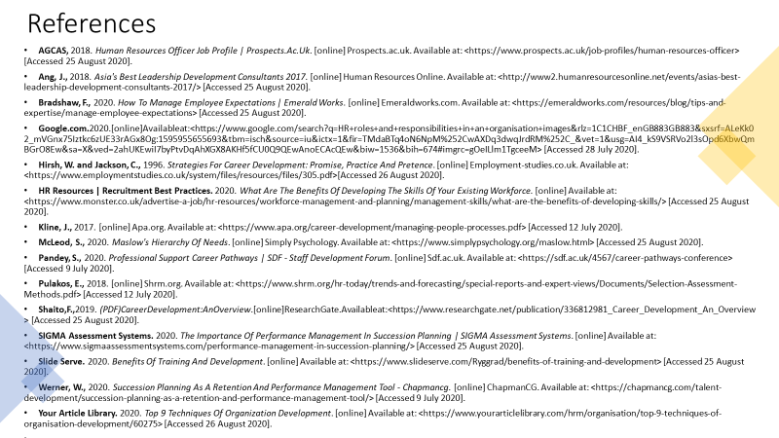
16
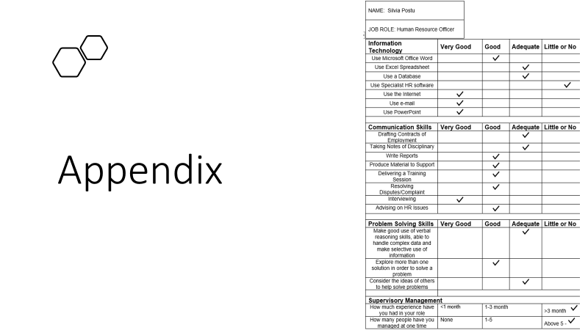
17

