

Synthesize a Solution to a Potential Real-Life Scenario

Author: Michael Andrew Elliott

Student No.: 1809306

Module: Internet Technology and Security (ACCA4018)

Date: Thursday January 10th, 2019

Table of Contents
Introduction 3
1. Related Work 3
1.1. Bring Your Own Device (BYOD) 3
1.1.1 Corporate Responsibility 3
1.1.2. Advantages 4
1.1.3. Disadvantages 4
1.2. Mobile Device Management (MDM) 4
1.2.1 What is MDM 4
1.2.2 Unified Endpoint Management 5
2. Problem Formulation 6
3. Implementation 6
3.1. 6
3.2. 6
4. Results/Findings & Discussions 6
5. Conclusion Recommendation & Future Work 6
6. Appendices 6
7. References 8

Introduction
The following report will discuss and provide a comprehensive Bring Your Own Device (BYOD) framework that covers all aspects of Hyper-fort’s enterprise network. This will include guidelines on an appropriate security policy which will include online and offline resources.
The framework will assess the following issues and mitigate the threats emanating from them when used in the proposed BYOD. The issues addressed are:
- What type of data is retained by the mobile devices connecting to Hyper-fort network?
- What is the potential for data leakage when the participating devices leaves the office environment?
- How to address the blending of personal and business usage when devices are in office.
- What strategy to deploy to deal with different brands of devices.
- What strategy to deploy to deal with different Operating System platforms.
- What strategy to deploy to deal with different application on user devices.
- What mitigating strategy will be deployed when the owner of a participating device leaves their employment, or the device is lost, stolen, or fails.

Related Work

Bring Your Own Device (BYOD)
The term Bring Your Own Device or BYOD refers to employees who use their own devices within the working environment as an addition to corporate supplied devices. This includes personal laptops, smartphones and tablets, in addition these devices will generally include different operating systems to the corporate devices.

1.1.1 Corporate Responsibility
Under the previous Data Protection Act (1998) and the new General Data Protection Regulation (GDPR) organisations have a legal responsibility to protect their customer data. In terms of BYOD this will include the processing or personal data, protecting data in event of a loss or theft of the device, and to remain mindful of the personal usage of these devices, plus the technical measures used to protect any personal data is proportionate to the benefits being delivered.[1]
In their 2017 Annual Market Survey SailPoint discovered that out of the organisations that had adopted BYOD only half had formal policies in place to protect their corporate data.[2]. The survey also identified that around a quarter of organisations in the UK had suffered a data breach due to their employee’s non-compliance of their security policies.
Organisations have a responsibility to protect customer data. Failure of a BYOD policy could result in fines of up to £17 million or 20% of annual turnover from the Information Commissioner's Office (ICO) under GDPR.
So, what are the advantages and disadvantages to BYOD. The following section discusses this issue. The information is based on the articles ‘Bring Your Own Device (BYOD)’[1] from the Information Commissions Office and ‘The Advantages and Disadvantages of BYOD’[3] from the website Your-ITDepartment.co.uk

1.1.2. Advantages
The advantages of BYOD can include the reduce cost of hardware costs to the organisation, increased job satisfaction amongst employees which is a result of flexible working, which in turn can lead to increase in efficiency. In addition organisations may find an improvement in communication due to the availability of its staff outside of normal office hours. Finally, organisations can find BYOD can lead to less demand on IT systems and support due to staff taking more care in looking after their own devices.

1.1.3. Disadvantages
Although the advantages of BYOD may seem attractive to organisations there are downsides that should be taken in to account before implementing such a policy. Organisations must consider what are the implications of allowing their data being accessed on personal devices which they may have little or no control over. The security of this data should be the primary concern for the organisation especially when dealing with a large number and the wide range of different devices. When implementing a BYOD policy, organisations need to seriously address the security implications of allow personal devices on to their corporate network. This will include guarding against data loss or leakage and ensuring that the appropriate technical measures are in place.

Mobile Device Management (MDM)

1.2.1 What is MDM
Just having a BYOD framework in place will not be enough to protect an organisation’s data. As stated above under 1.1.1 organisations have a responsibility to protect this data, in fact under the Information Commissioners Office publication ‘Bring Your Own Device (BYOD) under paragraph 5 it states organisations that hold personal data “….must take appropriate technical and organisational measures against unauthorised or unlawful processing of personal data and against accidental loss or destruction of, or damage to, personal data.”
In order to deploy these technical measures many organisations use a Mobile Device Management (MDM) system. MDM is a range of products and services which are used to monitor, manage and secure mobile devices. An MDM solution can either be carried out in-house or purchased as a service. Usually there is a client that is installed on to the mobile device.
Under a typical MDM configuration devices are not automatically considered trustworthy until particular security policies have been passed. This is particularly relevant for personally owned devices as they may contain malware and be managed by other authorities (such as the mobile operator)[4].

1.2.2 Unified Endpoint Management
Since the introduction of MDM there has been an evolution in this type of security software. This has been driven by the needs of the employee as well as the development of operating systems in mobile devices, which includes Windows devices.
The limit of the traditional MDM solution is that security measures can include locking out a device or wiping data from the device. This security measure does not sit well with employees as this would include the wiping off all data on the device including personal data including photographs, messages, etc [5].
Unified Endpoint Management (UEM) takes MDM to new level, as well as providing MDM features, there are the additional features such as Mobile Information Management, Bring Your Own Device, Mobile Application Management and Mobile Content Management. In addition, UEM can be applied to endpoints such as desktops, printers, Internet of Things (IOT) devices, etc. As Lucas Mearian states in his article ‘What's the difference between MDM, MAM, EMM and UEM?’ “..UEM brings hardware under a single management strategy …..is aimed at all of the various software management tools under a single umbrella” [5]

Problem Formulation
The problem that the report will address is to develop a comprehensive BYOD framework that will cover all the company’s enterprise network, this will include Hyper-fort’s enterprise network. In addition, the report will indicate the MDM solution to apply the BYOD framework.
The BYOD is required to identify the countermeasures employed to demonstrate the secured and restricted access to the company which includes (but not restricted to) services, email, blogging, social interaction.
Finally, the BYOD framework design will be required to assess particular issues and mitigate threats emanating from them when used in the proposed BYOD employed at Hyper-fort.

Implementation

Assumptions
From the information supplied in the task description the following assumptions have been made
- With 95% of company’s network being wireless it has been assumed that the remaining 5% wired network relates to the key core infrastructure, telephones and printers of multifunctional devices.
- As the company uses cloud services to deliver IT services to it staff and clients, it is assumed that company is using a cloud-based provider such as Microsoft Azure or Amazon Web Services. For this task the author has presumed that the company is using Microsoft Azure, in conjunction with Office 365 and OneDrive for Business. The author has also assumed that this would be as a ‘hybrid model’.
- The uuthor also made the assumption that all networking equipment are Cisco appliances.

Administrative Security
When considering a BYOD policy an organisation must consider the separation of its data. This would entail what is classed as personal data and what data will need to be held in a more restrictive environment. Access policies could then be created to either deny or restrict access to this data using high levels of encryption. This would enable the organisation to protect against data leakage.
In any BYOD policy it is important to outline and clarify clearly the responsibilities of both the organisation and the employee. In addition, a major component of any BYOD policy will be continual auditing and monitoring of compliance.
The National Cyber Security Centre in its guidance “BYOD: Executive Summary” suggests eight key security aspects important for a successful implementation of BYOD whilst at the same time minimising the risks. These key security aspects have been encompassed in an infographic which is included in Appendix 1.
In addition to the legal obligations that an organisation must address, it must consider whether the adoption of BYOD would have a major impact on any commercial or third-party agreements.
The BYOD policy must not be too restrictive as this will result in staff not adhering to the policy and finding workarounds which will increase the security risks. The policy should address and highlight the risks of sharing the organisations data with unauthorised users.
It is important that the BYOD policy is effectively communicated to staff. This can be achieved via training and education. Staff must fully understand what is required from them when using their own personal device for business purposes. The policy must also address what happens when a staff member either replaces their device, if the device is stolen, or leaves the organisation. This would include the use of technical solutions to ensure that all organisational data is removed as well as revoking access to systems.
The BYOD policy should compliment other policies already in existence within the organisation, this would include policies such as Information Security, Internet and Email Acceptable use, Social Media. Reference to the BYOD policy should be added to the Information Security policy. In addition, a statement could be added to the BYOD policy that it works in conjunction with the other policies relating to information security, giving the examples as stated above.
Where the organisation is subject to legal or regulatory requirements this must be taken in to account within the BYOD policy.[1]
If the BYOD solution includes an ability to track a device through say GPS, and the organisation is going to use this facility, this must be made clear in the BYOD policy.
The policy should also address security incidents and may require a separate Incident Response Plan on what steps should be taken when a BYOD device is either lost, stolen or compromised.
A good example of a BYOD policy template can be found on the NHS Digital website.[6]

Physical Security
For the purposes of physical security, the report has concentrated on the main network core infrastructure and the server areas.
Where possible the critical infrastructure and server areas should be in areas that are not usually accessible by individuals not employed by the company. Procedures should be in place where visitors should not be able to access any areas unless they have been granted access by a member of the organisation. This could be from a manned reception area, where visitors sign in and out, and are provided with guest ID badges. Individuals who require access to the core infrastructure and server areas e.g. support contract technical engineers, must be accompanied by a member of IT.
Access to these areas should have door access controls such as RFID cards which should be limited only to those employees of the organisation who require access as part of their duties. This includes members of IT who should not have access to these areas if it is not part of their duties.
The areas should also be protected by CCTV and security alarms. IT will be dependent on the organisations financial resources whether the CCTV is being constantly monitored. At the very least the organisation should have a policy on how long CCTV footage should be kept before being written over. The alarm systems should not be standalone but should be linked back to a manned secure area during business hours. Regarding outside hours the organisation should have either a security resource onsite or have a contract with an external provider.
Finally, the organisation should consider whether to have a security presence onsite where regular security checks could be carried out around the premises.

Logical Security
Firewalls
Perimeter Firewalls within the core network should be configured to allow standard or known traffic in and out (such as traffic on ports for http, https, smtp, etc), and other known applications and devices as required for the business to function. All other access would be automatically blocked, whereby access would only be configured through standard firewall requests. These requests should be checked and agreed by the individuals who are responsible for IT security. There should also be a procedure to regularly check and review all firewall rules and removing any redundant ones. These checks should be documented and signed off.
The company should look to add additional security to their firewall architecture by introducing security appliances such as CheckPoint Firewall Security solution. These next generation firewall features enable include Intrusion Prevention System (IPS)/Intrusion Detection System (IDS) threat prevention, internet access filtering, application control, and data loss prevention[7]. In addition, these security appliances can also guard against attacks such as denial of service attacks.
In addition to hardware firewalls at the perimeter software firewalls should be configured on all user end devices that connect to the corporate network. The firewall could either be the operating system firewall or a security vendor as part of the overall malware protection.
Routers & Switches
All routers and switches should be secured, this includes enabling the secret password to access the device (enable secret is used instead of enable command as the password is encrypted), and password and encrypting the console port. Remote access to any routers and switches should be configured to use the Secure Shell (SSH) network protocol instead of telnet. SSH use encryption and is more secure.
On switches any unused ports should be shut down for added security.
Anti-Malware product
All corporate devices should have a good enterprise anti-malware product installed. There are many vendors out there and the market is evolving with added features such as application control, encryption and removable media access controls. These additional features can be employed to provide added security to corporate endpoint devices.
Security Updates
In a corporate environment ensuring that your devices are kept up to date with the latest critical and security patches is vital for securing the network. Security updates should be applied to all devices connecting to a corporate network. This includes both operating system and application updates. An update procedure should be in place which should include the testing of patches prior to installation on any critical devices, where possible. Technical solutions can be deployed to help in the administration of these patches such as Microsoft’s System Centre Configuration Manager (SCCM), which not only administers patches but also manages devices on the network for compatibility.
Access Controls
Access controls on access to devices connected to the network is essential to the security of information. Access to resources would be controlled via a Authentication, Authorisation and Accounting (AAA) server. First of all, there should be controls in place for staff to authenticate themselves on to the corporate network. The use of multi-factor authentication would ensure tighter security as users would use two methods of verification, an example would be a smart card with use of a password. In terms of password security policies should be in place with a standard baseline security for standard users but different policies for those users who are designated administrators of the computer network and the devices connected to it.
Role-based access controls should also be adopted so that users only have access to the resources they need to have for their specific function. This could be for access to information resources such as specific folders and files e.g., staff within Human Resources Department only having access to information stored under Human Resources folder area. Role-based can also be used to restrict access to certain areas of the network e.g., staff having to be members of a specific group in order to remotely access the network.
Role-based access can also be extended to the administrators of the computer network with restricting access to particular networking devices.

Wireless Access
Controlling access to the wireless network would be via a Wireless Access Points. Each wireless network would be secured using Service Set Identifiers (SSID). This would work along with the strong encryption protocol WPA2 (Wi-Fi Protected Access). The SSID would not be broadcast but hidden for all company wireless networks. The Guest network would not be hidden as guests need to be able to view and connect to it.
Differing networks such as the corporate network, BYOD network and guest network would be controlled by using separate VLANs. Within the corporate network various office areas would be segregated using subnets which would be configured on the Dynamic Host Configuration Protocol (DHCP) servers
Wireless Access Points would be controlled using a Wireless LAN controller to authenticate access to the wireless networks. This would be controlled using both certificates along with user authentication role-based access.
All default configuration settings should be changed, and access to the WLAN controller by administrators would be restricted based on roles.
To administer the security and access policies for the WLAN the use of a network administration product would be recommended, something such as Cisco’s Identity Services Engine (ISE)[8]. Cisco ISE could also be configured to be used with all the company’s routers and switches.
Remote Access
Remote access would be via a RADIUS server using a Virtual Private Network (VPN), along with rule based access controls such as Access Control Lists (ACL). Polices can be applied on what remote users can access with differing policies for different remote users e.g., different ACLs for standards and IT remote users.
The administration of remote users can be via a RADIUS server using two factor authentication. A product such as RSA SecurID can be deployed which uses two factor authentication via a token which can either be by a hard or soft token. RSA SecurID can be configured to work with Microsoft’s Active Directory to authenticate remote users.[9]
System log
Logging of events via a Syslog server is integral in being able to troubleshoot network related issues as well as possible cyber threats or breaches. Email and Internet monitoring and control systems will enhance the cyber security posture of the company. These systems can either be administrated locally or as a managed service

Redundancy/Resilience
The configuration of the Hyper-fort enterprise network has been based around the basic components of a resilient network (see Appendix 2)[10]. This includes a core, distribution and access layer with resilient links between network devices.
Routers and switches (including the firewalls) at the core and distribution layer should be physically in separate locations in separate fire zones. The routers and firewalls should be configured so that one device is active, and one is passive, with a heartbeat protocol set up between the two devices. Any configuration changes on one device should be replicated on the other. In addition, copies of the configuration files for routers and switches should be taken regularly for disaster recovery purposes.
The Server room contains two switches for resilience with each device fitted with two network ports configured for redundancy.
All network devices and servers should be connected to Uninterruptible Power Supply (UPS) devices. Tis will add protection from both power outages and power surges. In addition, if possible, the devices should be on dual power feeds with all devices having dual power supplies. This will provide resilience if there is an internal power outage or disruption. To provide further resilience for external power outages the company could install a power generator. If a generator is installed regular generator tests will have to be carried out to ensure that it is in working order for when it is called upon.
If the company’s premises are in an area at risk of flooding the networking and server rooms should not be situation on the ground floor. In addition, the rooms should not have water pipes running through them especially at ceiling level.
All networking and server rooms should be fitted with both fire alarms and fire suppression systems. Audits and tests should be regularly carried out on these systems.
Hardware monitoring systems should be installed on devices such as routers, firewalls, switches, servers, and UPS. This will enable any hardware issues to be identified prior to any failures.
A comprehensive backup regime should be implemented as part of the disaster recovery policy and procedure. The existing cloud service would provide a virtual backup server using a which would backup both system and data files. The connection would be controlled via a separate encrypted VPN tunnel.
As the company uses cloud services it can make use of Microsoft’s Azure Disaster Recovery as a Service (DRaaS). This would be a virtual environment which would replicate the current enterprise configuration. As with any Disaster Recovery plan it must be regularly tested.
In order to prevent loopbacks on switches due to redundant paths the company should deploy the Spanning Tree Protocol (STP). This protocol is available on all Cisco switches that support STP.[11]

MDM Configuration
The following section is based on the recommendations by the National Cyber Security Centre, specially the documents ‘BYOD: Enterprise Considerations’[4] and ‘BYOD: Architectural Approaches’[12].
The key principle of the configuration of the MDM is that of defence whereby any personally owned device is managed via a service mediation layer, and there are solutions in place to monitor and deter attacks from any compromised devices.
By network separation the company can protect its sensitive information and use technical controls to only allow personally owned devices access to data and services it has agreed. Read-only access can be used to protect from data leakage, and there should be a distinction between the personally owned user accounts and those user accounts used on corporate endpoints.
By use of a ‘walled garden approach’ the company will be able to control access to particular content and services. Under the guidance document ‘BYOD: Enterprise Considerations’ the National Cyber Security Centre recommends that any internal services provided via BYOD should perform the steps indicated in figure 1 below.
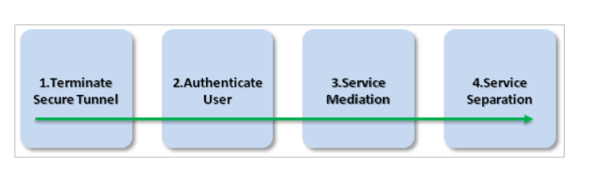
Figure 1[4]
- Terminate Secure Tunnel – a secure tunnel provide by the BYOD device terminates the encrypted session between the device and the corporate network.
- Authenticate User – the user is authenticated to the corporate network including only accessing data the user is allowed to view on the personal device.
- Service Mediation – this layer restricts access to only those services the user is allowed to access. In addition, protective monitoring solution can be applied at the is layer. This layer is typically carried out b a reverse proxy.
- Service Separation – here services are separated so that the user only has access to data that the company has agreed under their BYOD policy.
In order to support this approach services should be split into separate network zones whereby agreed applications would be accessible either via URLs or IP addresses that are segregated from the corporate network.
An example of applications that could be used in tis approach is web and mailboxes services. For web browsing the more secure and easily configurable option would be to separate internet browsers, the devices native browser to be used for personal browsing only, and a separate internet browser within the MDM product for access to corporate web services.
To ensure a robust security policy for mailboxes (email, Calendar, etc.) the sharing of one application for both personal and corporate use is not recommended. This can lead to data leakage and cross infection. The most secure option is to have a separate corporate mailbox only accessible within the MDM product. This will ensure that a secure connection is established to the corporate resource and limits data between the personal owned device.
By using a dedicated MDM container within the personally owned device the company can secure against data leakage, cross infection, and policies that stop access from devices that have been compromised such as a ‘Jailbroken’ device. In addition, if the personal device is either lost, stolen or replaced the company can easily remove access to the corporate network via the applications without affecting the native applications and services on the personal device.

MDM Selection
The MDM solution chosen by the author for Hyper-fort is Microsoft Intune. Intune was specifically chosen as it has been assumed that the company is currently using Microsoft Cloud services such as Office 365. As a Microsoft customer Intune can be integrated with Microsoft System Centre Configuration Manager (SCCM).
When integrated with Microsoft’s Enterprise Mobility Suite (EMS) the company can take advantage of threat detection, data protection and device management features. In addition, Intune can be integrated with existing Office 365 configuration.
Intune will work on several operating systems such as Apple and Android devices. It can also be extended to the existing corporate end user devices which are all managed via a single administration console.
Intune enables users to enrol their personal devices and instal corporate applications via a self-service portal. Once a device is successful enrolled access to corporate resources is controlled via security certificates and profiles. It can also execute remote action such as passcode reset, device lock, data encryption, and a full wipe of corporate data from the device.
Figure 2 below provides a graphical overview of Intune and its features.
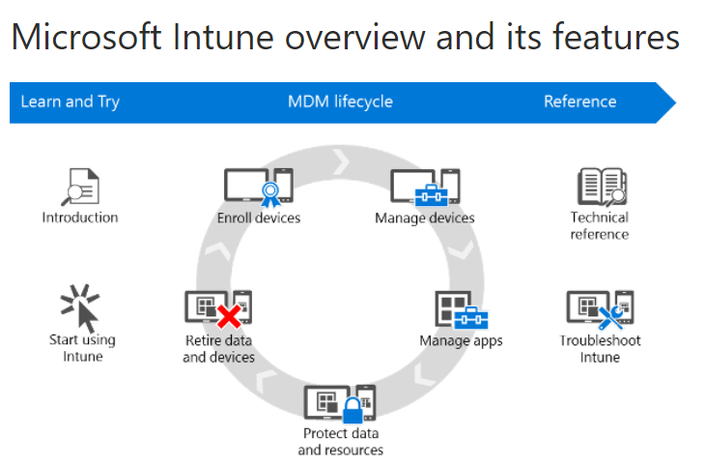
Figure 2[13]

Results/Findings & Discussions

Conclusion Recommendation & Future Work

Appendices

Appendix 1 – NCSC Key Security Aspects
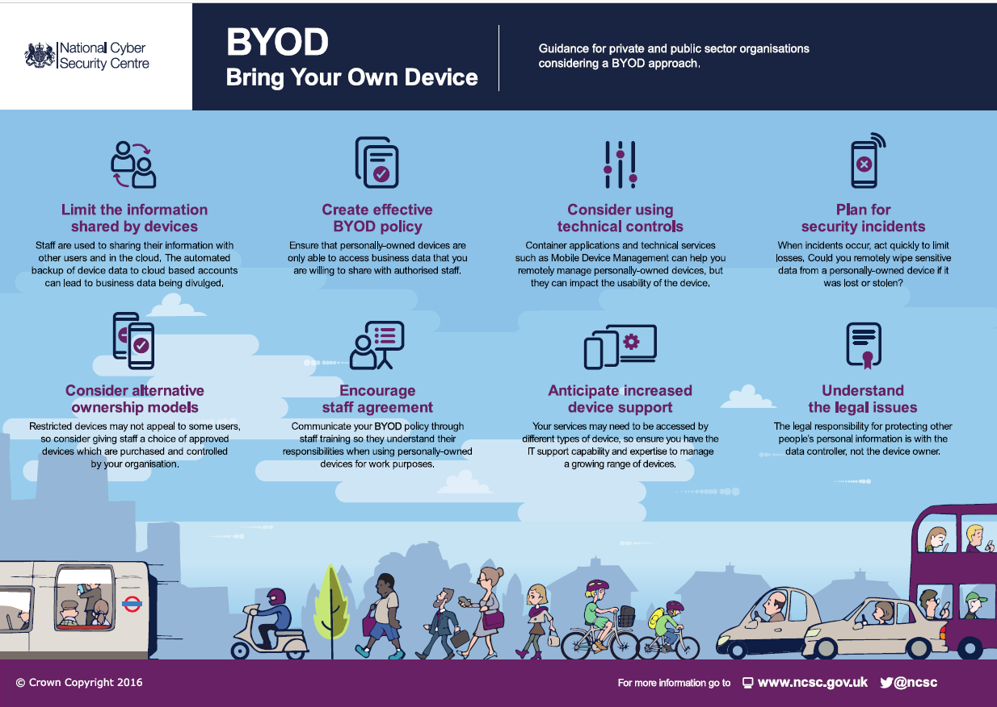

Appendix 2 – Basic Components in a Resilient Network Design
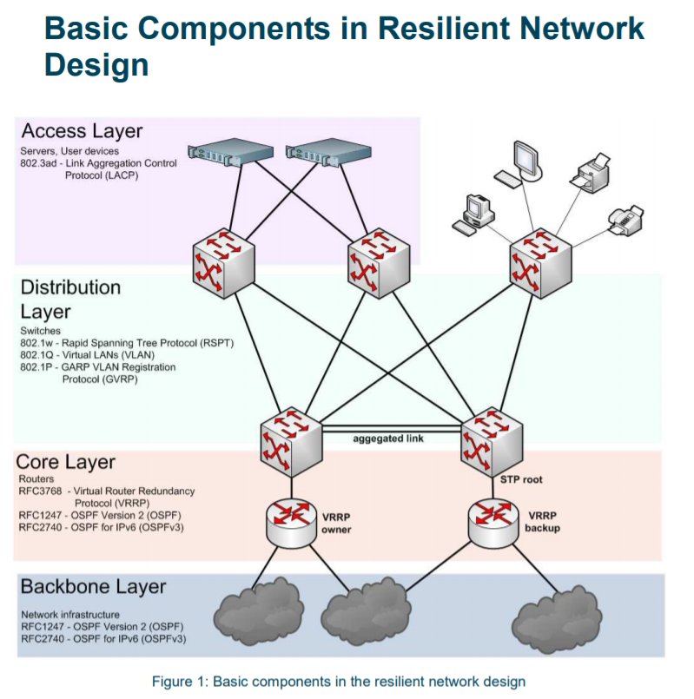

References
[1] I. Commissioner, “Bring your own Device (BYOD).” [Online]. Available: https://ico.org.uk/media/1563/ico_bring_your_own_device_byod_guidance.pdf. [Accessed: 30-Nov-2018].
[2] “Are UK firms violating GDPR by not implementing BYOD policies?” [Online]. Available: https://www.teiss.co.uk/information-security/byod-policies-uk-firms-gdpr/. [Accessed: 01-Jan-2019].
[3] “The Advantages and Disadvantages of BYOD | Your IT Department.” [Online]. Available: https://www.your-itdepartment.co.uk/news/advantages-disadvantages-byod/. [Accessed: 01-Jan-2019].
[4] NCSC, “BYOD: Enterprise Considerations,” 2015. [Online]. Available: https://www.ncsc.gov.uk/guidance/byod-enterprise-considerations.
[5] “MDM, mobile app management and enterprise mobility management defined | Computerworld.” [Online]. Available: https://www.computerworld.com/article/3206325/mobile-wireless/whats-the-difference-between-mdm-mam-emm-and-uem.html. [Accessed: 02-Jan-2019].
[6] “Bring Your Own Device: example policy - NHS Digital.” [Online]. Available: https://digital.nhs.uk/services/data-and-cyber-security-protecting-information-and-data-in-health-and-care/cyber-and-data-security-policy-and-good-practice-in-health-and-care/bring-your-own-device-byod-guidance-for-health-and-care-organisations/bring-your. [Accessed: 05-Jan-2019].
[7] “Check Point Firewall Security Solution.” [Online]. Available: https://sc1.checkpoint.com/documents/R77/CP_R77_Firewall_WebAdmin/92746.htm. [Accessed: 05-Jan-2019].
[8] “What is Cisco Identity Services Engine (ISE)? - Definition from WhatIs.com.” [Online]. Available: https://searchmobilecomputing.techtarget.com/definition/Cisco-Identity-Services-Engine-ISE. [Accessed: 05-Jan-2019].
[9] “What is the difference between a RADIUS server and Active Directory? - Information Security Stack Exchange.” [Online]. Available: https://security.stackexchange.com/questions/130095/what-is-the-difference-between-a-radius-server-and-active-directory. [Accessed: 05-Jan-2019].
[10] T. Podermanski and V. Zahorik, “Recommended Resilient Campus Network Design Best Practice Document Produced by CESNET led working group on Network monitoring (CBPD114),” 2010.
[11] “Understanding and Configuring Spanning Tree Protocol (STP) on Catalyst Switches - Cisco.” [Online]. Available: https://www.cisco.com/c/en/us/support/docs/lan-switching/spanning-tree-protocol/5234-5.html. [Accessed: 06-Jan-2019].
[12] G. O. V Uk, “BYOD Guidance : Architectural Approaches,” 2015. [Online]. Available: https://www.ncsc.gov.uk/guidance/byod-architectural-approaches.
[13] “What is Microsoft’s Intune – and how well does the UEM tool really work? | Computerworld.” [Online]. Available: https://www.computerworld.com/article/3304583/microsoft/what-is-microsofts-intune-and-how-well-does-it-really-work.html. [Accessed: 30-Dec-2018].

