Cert. HE S4BA Assignment
TURNITIN Submission Template

Use the following Template structure in Microsoft Word to create the word document to submit to the ‘TURNITIN ASSIGNMENT SUBMISSION LINK – FINAL’ link on Moodle. Include the details below and submit to the TURNITIN ASSIGNMENT SUBMISSION LINK – FINAL’ link on Moodle.
Title page.
> Include here: (CERTHE) Software & Apps for Business, Maria Alexandra Michea, 223221, Digital Skills course, level 4.
Task 1: e-Portfolio.
- Include here: Maria Alexandra @ University of Wales Trinity Saint David
- 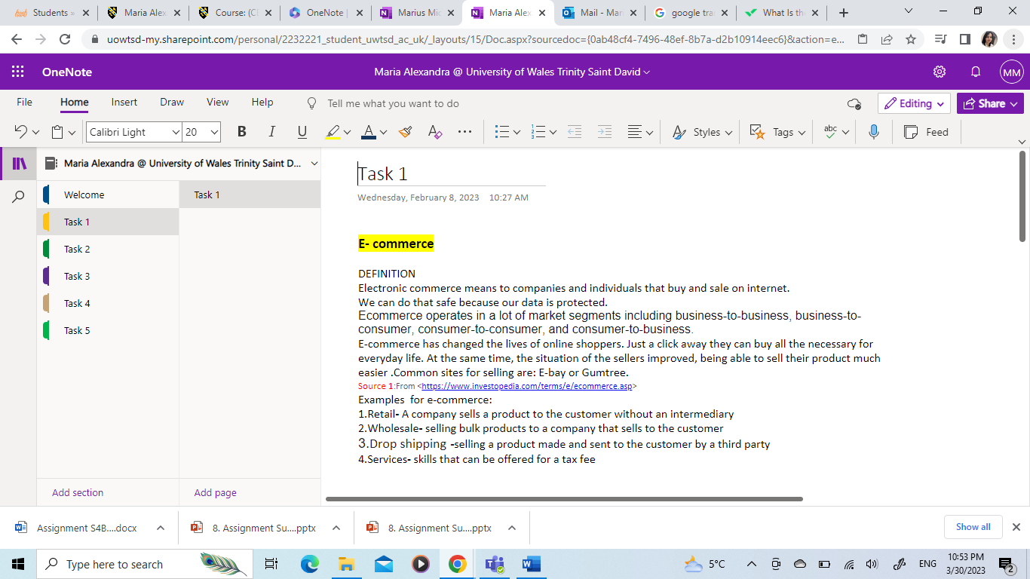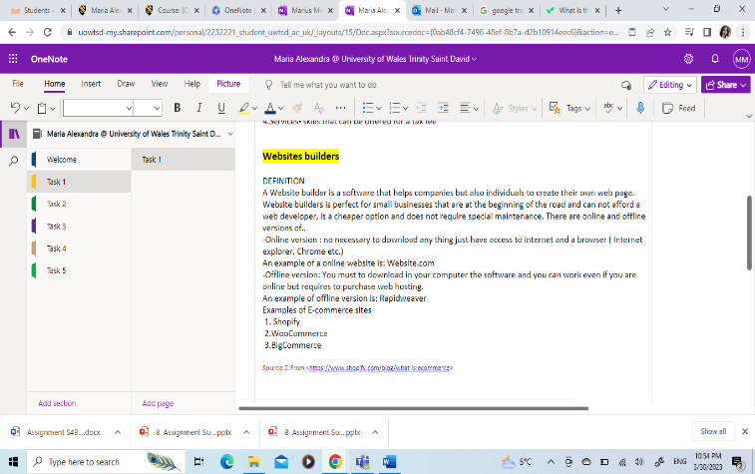
Task 2 – Mind-map.
- 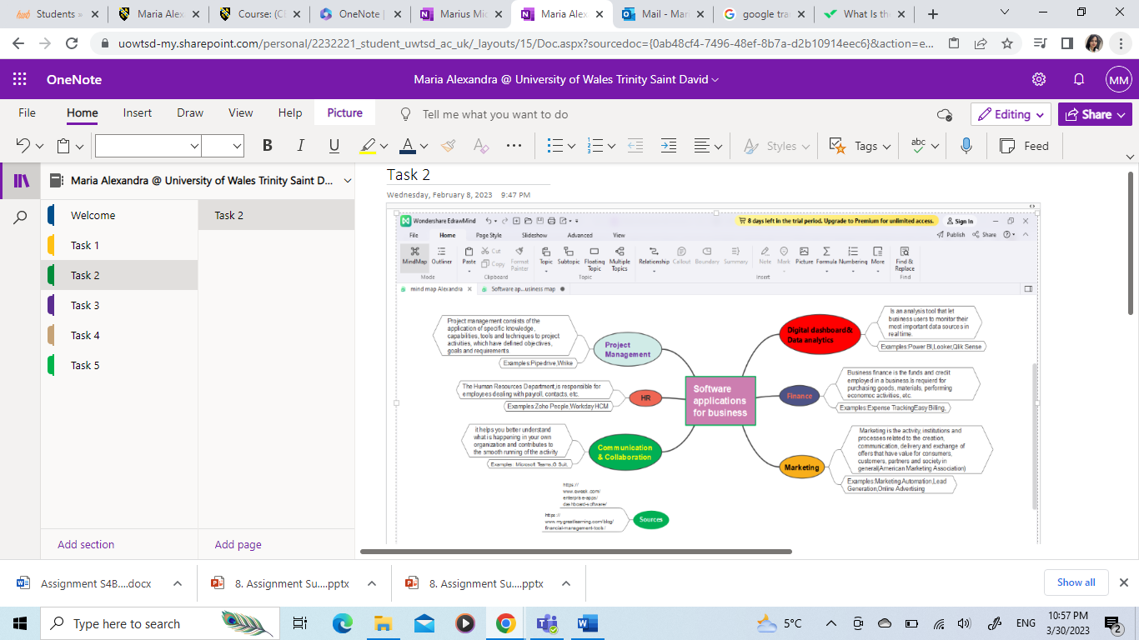
Task 3 – Office Applications.
- A)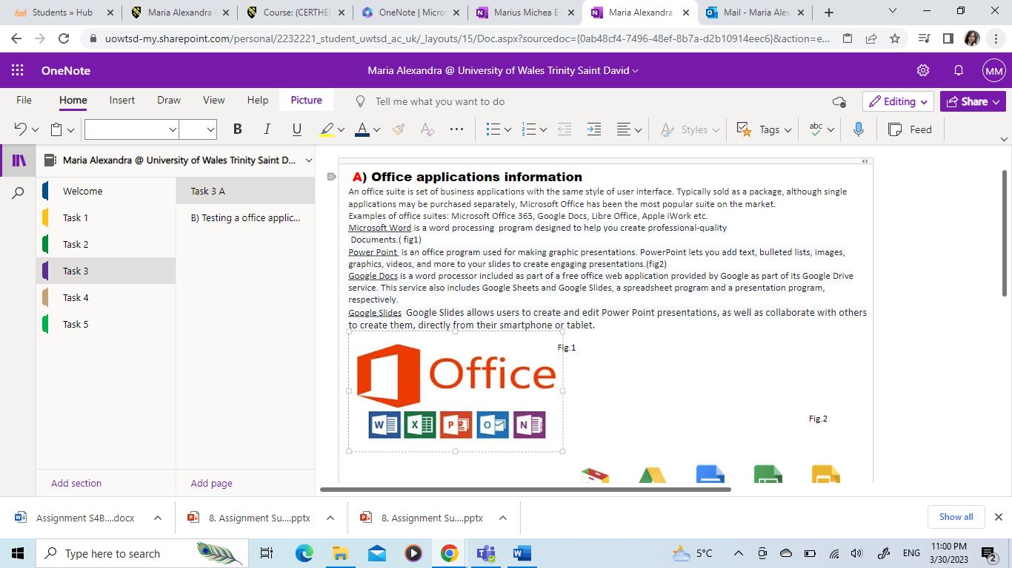 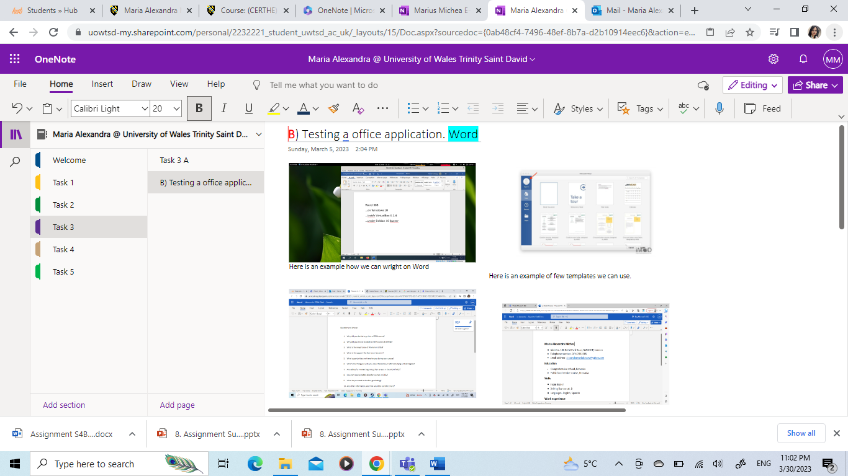 Task 4- Digital Dashboard and Data Analytics software.
- 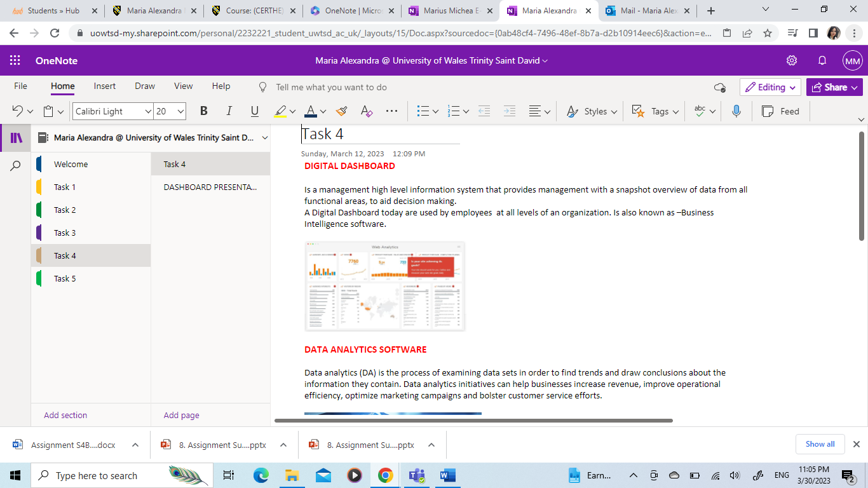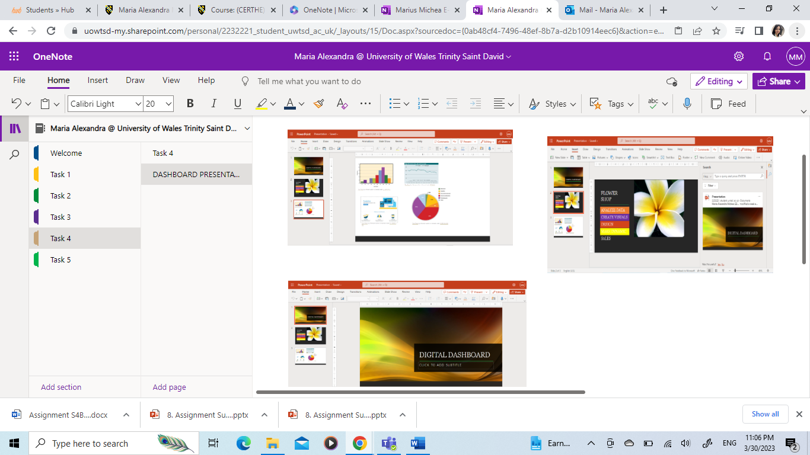

Task 5 - Communication, Collaboration & Project Management
- 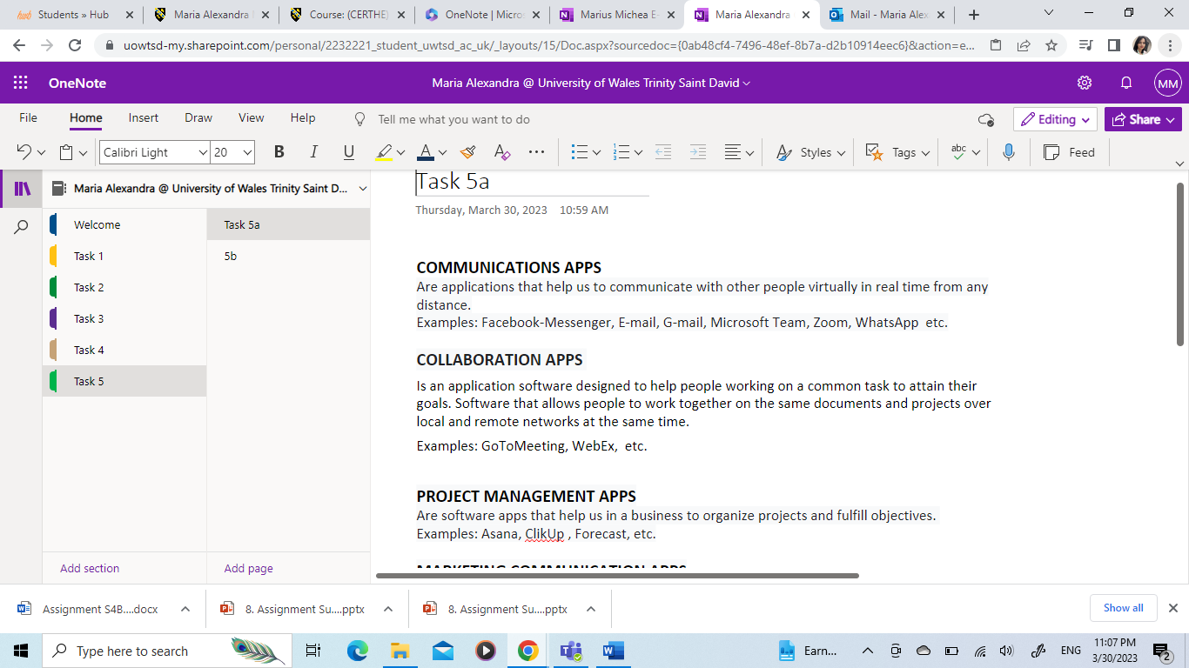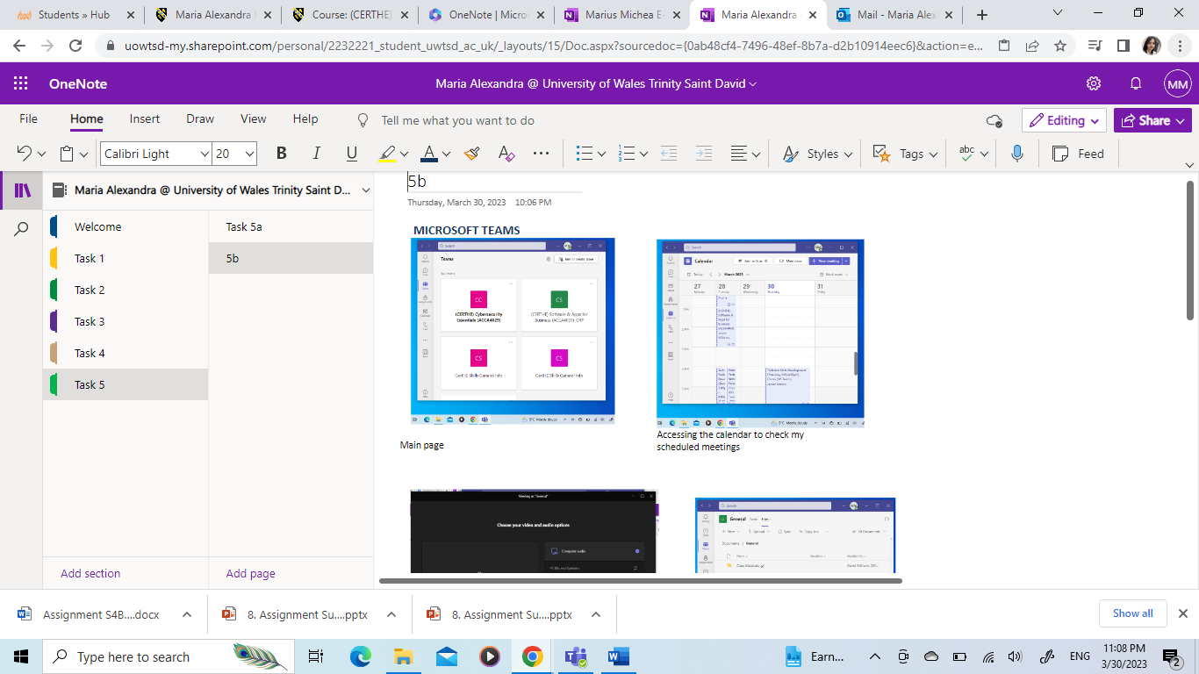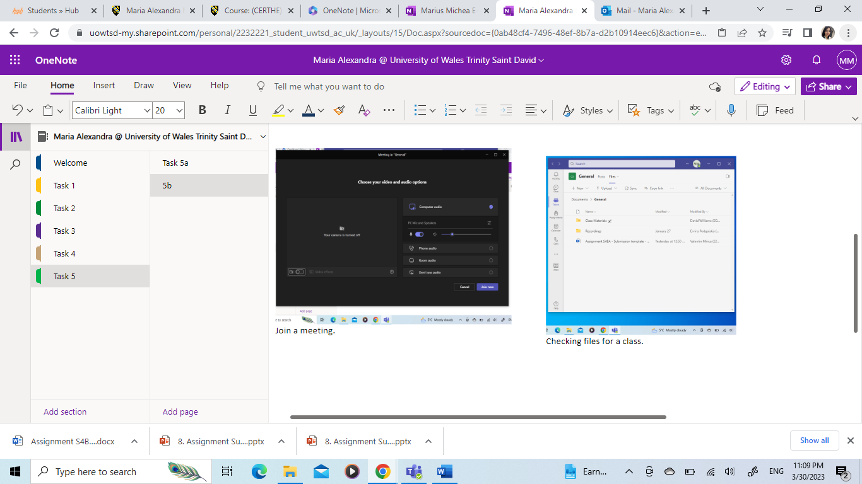
IMPORTANT LINK TEST REMINDER: to ensure your work is accessible for marking it is important to test your work can be accessed by the tutors. To do this either try opening the e-portfolio link in a private/incognito tan in a web browser or sign out of the e-portfolio and to try to open it in a web browser with the link you are providing in this document.

