Application Development (Games)
  - Lecture 1 Lab Tutorial Exercise

Perky Penguin Game Part II

Objectives
The aim of this lab exercise is to introduce you to game development in Unity. You will create a basic 2D Game, Perky Penguin, which is a Jetpack Joyride-based game.
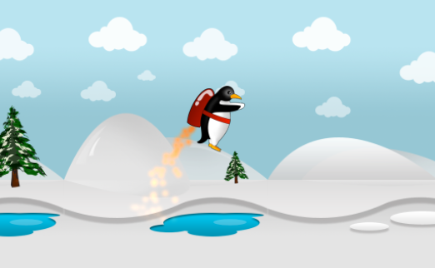

Adding Particle Effects
- Open up your Perky Penguin Unity project from the last exercise.
- From the main menu, select GameObject Effects Particle System. See more
- As we want the particle effect to be below the rocket, drag the Particle system on to the Perky game object, so that it becomes a child of Perky.
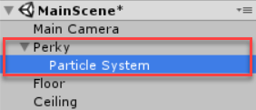
- Rename the particle system to rocketFire
- Adjust the Transform properties of the particle system:
  - Position: (-0.62, -0.33, 0)
  - Rotation: (65, 270, 270)
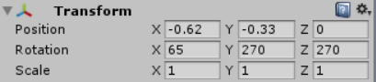
- Locate the Particle System component on rocket fire and make the following changes:
  - Set Start Lifetime to 0.5
Start Lifetime is the total lifetime in seconds that particles will have when emitted
  - Set Start Size to 0.3
Start Size is the initial size of particles when emitted
  - Click on Start Color and set Red to 255, Green to 135, Blue to 40 and Alpha to 255, this will turn our white particles into orange ones
Start Color is the initial colour of particles when emitted
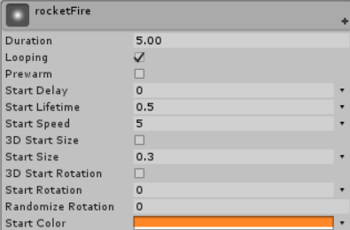
  - Expand the Emission section and set Rate to 300
Emission Rate is the number of particles emitted per unit of time or distance moved
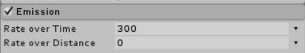
  - Expand the Shape section and set Shape to Cone, Angle to 12 and Radius to 0.1
    - Shape is the shape of the emission volume. Options include sphere, hemisphere, cone, box, mesh, circle and edge.
    - Angle is the angle of the cone at its point (only available for cones)
    - Radius is the radius of the circular aspect of the shape
  - Set the Randomize Direction value to 1 to create randomness in fire particles
Setting to 1 means that the particles’ initial direction will be chosen randomly.
- You need to adjust the rocket fire, so that the fire fades out over time, rather than ending abruptly.
  - Check the Colour over lifetime
  - Click the little drop down arrow beside the Color picker box.
  - Change the setting to Gradient.
  - Change the colour option, so it starts at white (RGB: 255, 255, 255) and ends as transparent.
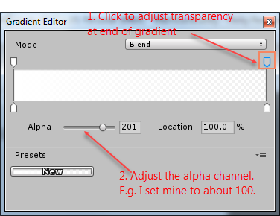

- If you hit play, you will see Perky fall out of the game world quite quickly. You will adjust the gravity settings now even though you will not really notice the effect till we do some coding.
  - Go to Edit Project Settings Physics2D
  - Set the Gravity to -15 as shown.
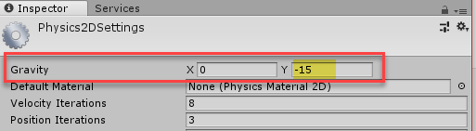

Game Level Backgrounds
- Download the following assets available on Moodle and import it into your project.
  - 2D Northland Side-Scrolling Platformer Asset
  - The Arctic – Platformer Tileset
- From the main menu, go to Edit Project Settings Tags and Layers.
- Expand the Sorting Layers section and create four new layers as follows. 2D has no concept of a z-axis. You use the sorting layers to position objects behind or in front of each other. You have a Default layer, which is the lowest layer and it will be behind everything else.
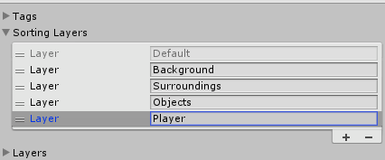
- Add a new empty Game Object to your scene and call it Platform Block 1 or something similar.
- Using the graphics in the downloaded package, create a background of your choice. You may add more layers if needed.
  - Make the background game objects children of the game object created in the last step.
Note: you may need to scale the graphics down (especially if you set up the Android build settings).
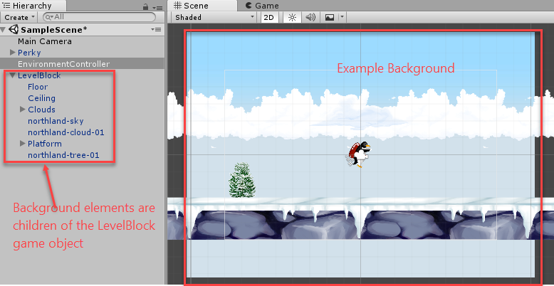
- For each of your background images, add them to the appropriate layers and remember to move Perky the Penguin to the Player layer, so it is visible.
For example, the clouds, platform and tree are part of the surroundings, while the skyn is part of the background.
- You will also need to adjust the penguin’s rocket fire layer.
  - Select the rocket fire child object of the Penguin
  - Under the particle system component, scroll down and locate the Renderer and expand it. It should have a Sorting Layer property – change this to Player.
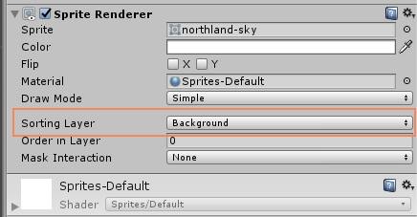

Adding a Ceiling and a Floor
As you have probably noticed, Perky falls out of the game world – disappears out of the screen display area.
You need to add a floor and ceiling to the game i.e. limit Perky between the screen bounds.

Adding a Floor
- Create a new empty game object from the menu GameObject Create Empty.
- Rename the game object to floor.
  - Set its transform properties as shown below.
  - From the Inspector window, add a Box Collider 2D component to it. Click Add Component Physics 2D Box Collider 2D.
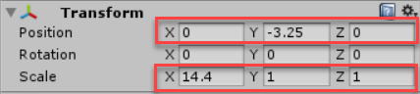
- Save your changes and test. Perky should now not fall out of the screen and will stop when it collides with the floor.

Adding a Celing
- Add another game object called ceiling.
  - Set its transform properties as shown below.
  - Add a Box Collider component to it as you did before.
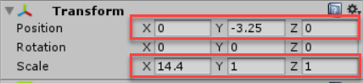
- Save your changes. Note: you will not notice the effect of the ceiling until Perky’s Swim behaviour has been scripted.
- Create a new folder in the Assets folder called Prefabs.
- Drag your Level Block game object from the hierarchy window to the prefabs folder to create a prefab.

Challenge Exercise
- Create multiple background environments:
  - Add a floor and ceiling to all of them.
  - For some of them, add gaps in the floor to create a more challenging game play.
    - You will need to add child game objects to the floor that are shorter than the floor and add the box collider to these.
    - Note: you still need the long floor (but no box collider on it) as this will be used to generate the environment later.
  - Save your background environment as a prefab.
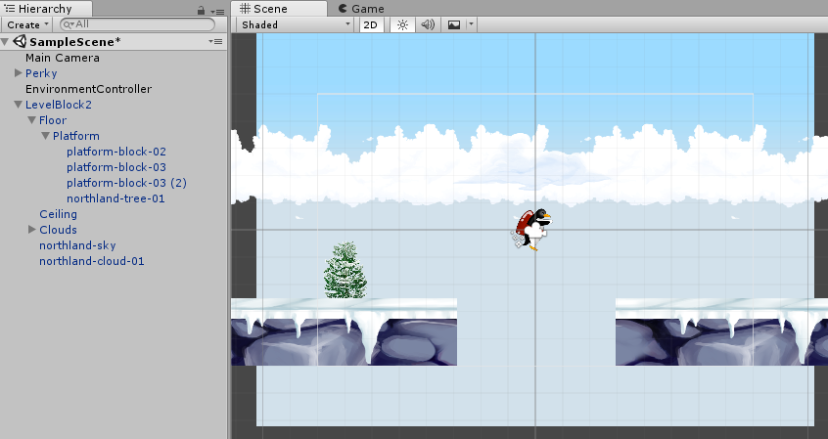
- To be Continued

Adapted from: Mastering Android Game Development with Unity, Packt (2017), By Siddharth Shekar, Wajahat Karim.

