

Programme: Master of Business Administration
Module: International Marketing: Principles and Practices
Module code: LCMB7026
Assignment Title: Assessment Component 1: Individual Report of KFC

Name of Student: Iyappan Balakrishnan
Student ID: 2434791
Lecturer: Dian Mayasari

Table of Contents
Section 1: Report 4
1. Introduction 4
2. Comparative Market Analysis (PESTEL) 5
2.1 Political Factors 5
2.2 Economic Factors 5
2.3 Social Factors 6
2.4 Technological Factors 7
2.5 Environmental Factors 8
2.6 Legal Factors 8
3. Consumer Behaviour and Cultural Analysis 9
4. STP Analysis 10
4.1 Segmentation 10
4.2 Targeting 11
4.3 Positioning 12
5. Marketing MIX: 7Ps comparison 12
5.1 Product 12
5.2 Price 13
5.3 Place 14
5.4 Promotions 15
5.5 People 15
5.6 Process 15
5.7 Physical Evidence 15
6. Directional Development Strategy of KFC in the United Kingdom 16
6.1 Market Penetration through Value, Convenience, and Digital Expansion 16
6.2 Product Development and Localisation Strategy for UK Consumers 16
7. Ethical Issues in the Marketing Mix of KFC in the United States and United Kingdom 17
7.1 Health, Nutrition, and Advertising Ethics 17
7.2 Sustainability, Packaging, and Supply Chain Responsibility 19
8. Recommendations 19
8.1 Recommendation 1: Strengthen Health-Oriented Menu Innovation and Responsible Marketing (US & UK) 19
8.2 Recommendation 2: Enhance Sustainability Leadership and Digital-First Customer Experience 20
9. Conclusion 20
Section 2: Reflection 21
References 25

List of Figures and Table
Figure 1: A KFC Store 4
Figure 2: Food Price Inflation during 2025 6
Figure 3: Country Comparison 7
Figure 4: Global Restaurant Digitalisation Market Size 8
Figure 5: Percentage of adults consumed fast food on a given day in the United States 9
Figure 6: KFC estimated cumulative GVA effects 2014-2023 on the UK 13
Figure 7: KFC’s incredible rise 14
Figure 8: Brand Value of KFC from 2014 to 2024 across the world 17
Figure 9: Americans on Healthy Food and Eating 18
Figure 10: Gibbs Reflective Model 21
Table 1: Action Plan for Self-improvement 24

Section 1: Report

1. Introduction
KFC is well-known for its quick-service restaurants that are under its parent company and are ranked among the top-selling brands in the world, Yum! Brands. It has a substantial presence in the world market, and it operates almost 32,000 restaurants in over 150 countries and collects more than 34 billion system sales, which underlines its superiority in the fast-food market (Statista Research Department, 2025a). The aspect of international marketing is critical in facilitating such firms to grow, diversify, and continue to be competitive in different markets that have different economic, cultural, and regulatory factors.
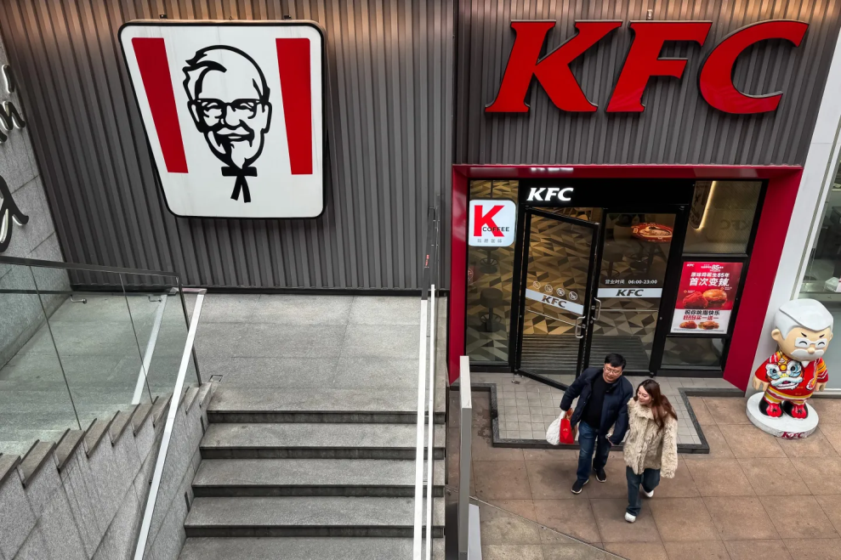

Figure 1: A KFC Store
(Source: Fortune, 2026)
This report will concentrate on the United States and the United Kingdom since they are both developed markets, but the strategies of KFC vary between these two nations, regardless of their having equal economic maturity. As an example, the UK market has been projected to significantly grow in the recent past, with KFC registering double-digit growth in terms of sales, a signifier of a responsive market. This report aims to critically review the international market environment and marketing strategies of KFC in terms of models like PESTEL Analysis, STP Model and 7Ps of Marketing Mix.

2. Comparative Market Analysis (PESTEL)

2.1 Political Factors
The political climate of the United States is very stable and conducive to business, and the regulatory systems are very stable, thus favouring multinational corporations like KFC. However, in the case of the United Kingdom, Brexit and consequent change of regulations have brought about much transformation of food standards, and trade regulations and businesses are left with more uncertainty. The alterations post-Brexit has placed the decision-making powers in the home country and regulatory divergence, which has affected the food supply chains and regulatory requirements (Food Standards Agency, 2023). Therefore, both markets are politically stable, but the UK has a more complicated and dynamic regulatory situation than the US.

2.2 Economic Factors
Both the economies of the United States and the United Kingdom encourage high demand in the area of the fast-food business, but there are primary differences in the consumer purchasing capacity and inflation rates. The consumer demand is relatively stable with high disposable incomes, which benefits the United States; the inflation is relatively low, and it is approximately 2.4% in 2024, which will relieve the pressure on prices and the consumption of food (Wearden, 2024). Conversely, the United Kingdom has had a long-lasting cost-of-living crisis in which inflation has soared to 11.1% in 2022 and continues to affect it even in the year 2025 (Francis-Devine, 2026). Food prices that rose by 4.2% in 2025 still limit consumer spending, thus affecting the prices and affordability of fast food (Harari, 2026).
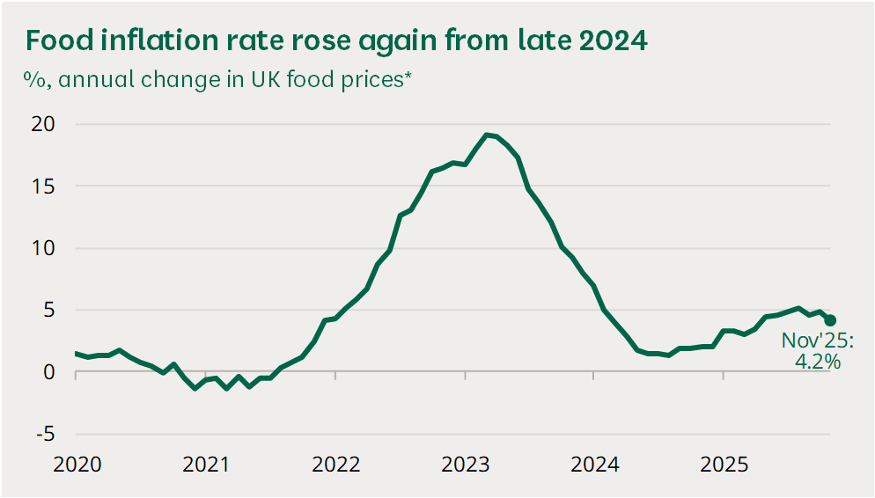

Figure 2: Food Price Inflation during 2025
(Source: Harari, 2026)

2.3 Social Factors
The United States and the United Kingdom have a social aspect that affects the consumption of fast food, due to their cultural values. Giving reference to Hofstede Cultural Dimensions, the two countries are extremely individualistic, the United States rated 91, and the United Kingdom 89, which implies that both countries like convenience and personal choice very much (Geert Hofstede, 2025). This contributes towards the excessive consumption of fast food in the US because of a fast-paced lifestyle. Nevertheless, the UK is more aware of health and changing towards a healthier diet despite its similar cultural characteristics, as the country has a higher uncertainty avoidance (46 vs 35), making its drinking and eating habits more hesitant and choosier than those in the USA.
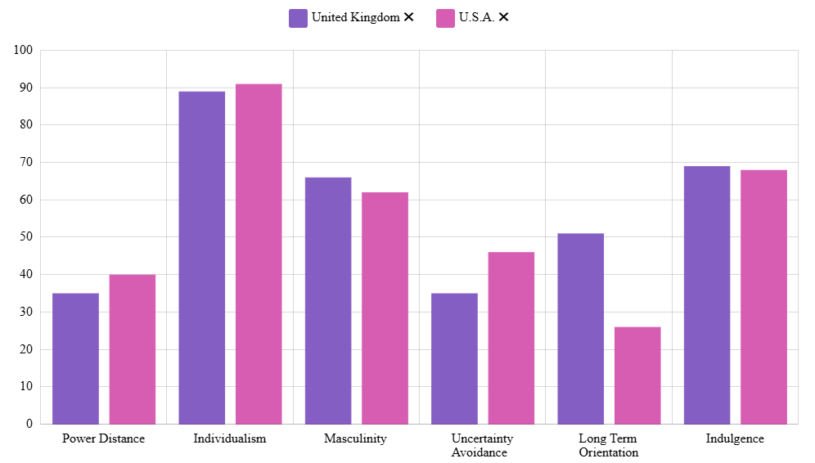

Figure 3: Country Comparison
(Source: Geert Hofstede, 2025)

2.4 Technological Factors
The fast-food industry has undergone a great evolution of technological developments, both in the United States and the United Kingdom, especially in terms of online delivery and mobile ordering systems. In the United States alone, it is one of the most substantial markets in the world, and the online food delivery market is expected to grow to about 353 billion dollars by 2024 due to the presence of such giants as Uber Eats and DoorDash (Statista Research Department, 2025b). On the same note, the United Kingdom boasts of a fast-growing online food shop worth approximately 48 billion in 2024, with apps such as Deliveroo and Just Eat (Statista, 2025). As a result, both of the markets have high levels of digital penetration, with the United States doing so on a much larger scale.
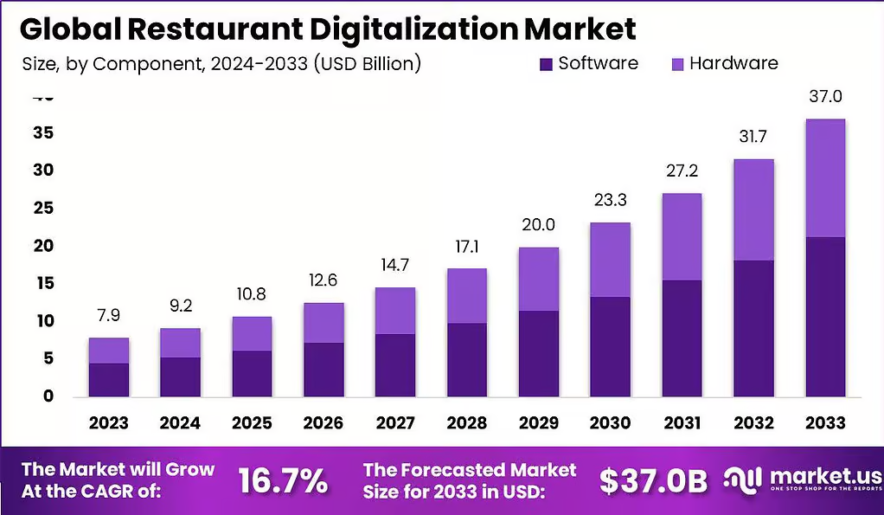

Figure 4: Global Restaurant Digitalisation Market Size
(Source: Market.us, 2026)

2.5 Environmental Factors
The environmental issues are also becoming an influencer in the fast-food business operations in the United States and the United Kingdom, especially on packaging waste. In the US, food packaging has been almost half of the municipal solid waste, which means that, under the applied pressure of environmental preservation, there is a strong interest for businesses to embark on adopting environmentally friendly practices. Likewise, the packaging of food and beverages contributes 83% of plastic household waste in the United Kingdom, which increases regulatory and consumer pressure (Business Waste Ltd, 2025). In turn, these two markets exhibit a decreased demand for single-use packaging, but the UK displays a stronger regulatory impetus in terms of sustainability.

2.6 Legal Factors
Both the United States and the United Kingdom have legal systems that have a great impact on the KFC business, especially in food safety and labour laws. In America, stringent federal bodies govern food safety grants, such as the FDA, as well as labour regulations such as the Fair Labour Standards Act, and place a federal minimum wage of $7.25 at an hour (Notshe, 2026). The United Kingdom, on the contrary, has stricter food safety standards implemented on national levels, and a more rigid statutory wage system, where the National Living Wage will be 12.21 in 2025 (The Food Foundation, 2025). As a result, the labour cost environment in the UK is more controlled than it is in the US.

3. Consumer Behaviour and Cultural Analysis
The consumer behaviour within the United States and the United Kingdom has been shown to exhibit a similar pattern as well as a critical dissimilarity due to the cultural values, lifestyle patterns, and changing health awareness. In the Consumer Behaviour Theory, the influence on buying choices is mediated by psychological, social, and cultural factors and how they influence individuals in choosing, purchasing, and consuming a product (Chen, 2024). Convenience-oriented behaviour is a strong determinant of fast-food consumption in the United States, as it can be attributed to the fast-paced lifestyle and lack of time. As evidenced empirically, the prevalence of fast food dieters among U.S. adults is around 32% on average, who ingest about 11.7% of daily calories as a result of fast food diets (Shah et al. 2025). This brings out the point of situational factors in consumer decision making, with convenience taking precedence over health concerns.
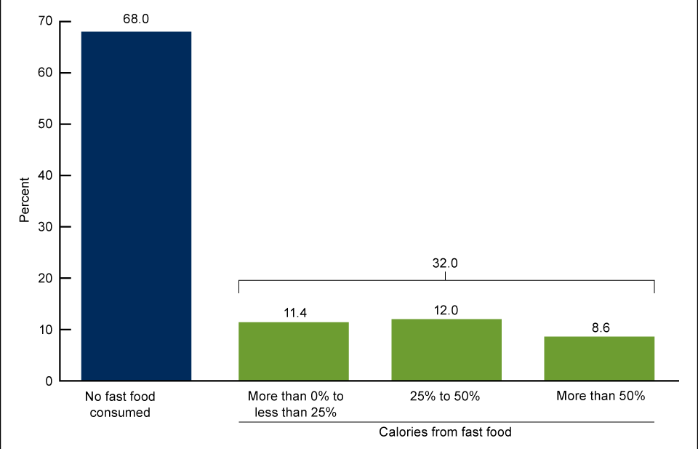

Figure 5: Percentage of adults consumed fast food on a given day in the United States
(Source: Shah et al. 2025)
Theoretically, this is a depiction of low-involvement decision-making in the Consumer Behaviour Theory, where consumers take fast and automatic decisions with little consideration. Moreover, the loyalty of brands within the U.S. market is another force that has been strengthening the aspect of repeated purchasing due to the familiarity, a sense of taste consistency and attachment to an existing brand like KFC. This behaviour is also reinforced by the pre-eminence of the drive-thru culture and on-the-go consumption, which means that the functional value (speed and accessibility) is cherished more than the health value.
Conversely, convenience is a factor that is also critical in the United Kingdom, but consumer behaviour is becoming health-conscious and complex in its decision-making process. It is noted that more than two-thirds of consumers in the UK are actively trying to eat healthily, which reflects a change in consumption behaviour towards more thoughtful and conscious consumer behaviours (Statista Research Department, 2025c). This comes in line with Consumer Behaviour Theory, where the more information and social one has, the more they get engaged in the decision of consuming products with higher levels of involvement in the decision-making process, especially in regard to nutritional and ethical product information. But such a change is not complete. It helps to overcome behavioural contradictions, even with increased awareness among consumers. An example of this is that 69% of consumers in the UK say they struggle to eat better at fast-food establishments (Food Standards Agency, 2025). This would indicate that cognitive dissonance exists; in which consumers are aware of their health risks but consume them due to convenience, taste, and situational factors.
Importantly, although both markets show convenience-based behaviour, the UK is showing a shift away to a more high-involvement decision making, especially driven by health and sustainability issues. Calorie transparency and sustainable sourcing are some of the ethical messages that consumers in the UK are increasingly sensitive to, compared to the relative speed and brand recognition that are more important to U.S. consumers.

4. STP Analysis

4.1 Segmentation
Demographic Segmentation
KFC is aimed mostly at young adults (18-35), families, students and working individuals in the middle-income category, cutting across both genders. Consumption patterns are also affected by education and occupation; urban, educated consumers in the United Kingdom are showing a greater preference towards healthier and morally responsible food products than consumers in the United States.
Geographic Segmentation
KFC is present in the United States in large numbers, both in the city and the suburbs, with the culture of drive-thru being strong. Conversely, in the United Kingdom, the brand pays more attention to larger urban areas with a high population density, which will correspond to changing consumption patterns and a demand based on delivery.
Psychographic Segmentation
KFC is aimed at busy people who like to have their meal quickly, with a certain taste and a certain style. This is closely associated with time-saving behaviour in the United States, but it is important to note that in the United Kingdom, psychographic segmentation is evolving to more heavily rely on health awareness and ethical concerns.
Behavioural Segmentation
The brand is allocating consumers into segments based on purchasing behaviour, such as how often they eat fast food, brand loyalty, and sensitivity to price promotions. Whereas most U.S. consumers are showing more routine consumption behaviour, UK consumers are showing more selective and health-based behaviour.

4.2 Targeting
KFC has a differentiation targeting strategy, where the targeting is varied depending on the market features. The brand in the United States is focused more on the mass market, with a wide customer population aiming to get fast, inexpensive, and consistent food. This strategy would go hand in hand with the high frequency of fast-food consumers and high brand loyalty in the U.S. market. Conversely, KFC has a more selective targeting strategy in the United Kingdom, targeting younger adults and urban residents. This can be seen in its growth policy and venture into city stores, which have continued to increase the demand for fast food (Reuters Staff, 2025). Targeting health-conscious consumers and those who react to new dietary trends is also needed in the UK market.

4.3 Positioning
KFC uses its positioning strategy to focus on taste, low cost and brand heritage, although this is different in the markets. KFC presents itself as a source of affordable, convenient, and tasty fast food to everyone in the world who acknowledges the presence of KFC and values its iconic original recipe and good brand name (Murtaza, 2026). The brand, in the US, is offered as a classic fast-food serving quickly, high-indulgence meals that resonate with the consumer's preferences of expedience and familiarity. Conversely, KFC takes a more contemporary stance in the United Kingdom, adding a variety of menu items and adjusting to changing consumer tastes, such as healthy and more alternative foods. More importantly, it is shown as an incomplete approach to adaptation, in which the core brand identity is preserved, and positioning is modified to indicate local consumer expectations. This strategy allows KFC to achieve brand equity at a global level with increased local relevance in an ever-competitive market.

5. Marketing MIX: 7Ps comparison

5.1 Product
KFC’s core product which is the fired chicken remained as a standardised offering across the globe, but the local adaptations differ significantly between US and UK, where KFC emphasis traditional Southern-style items, such as Original Recipe Chicken, Sandwiches and family buckets (Mylonakis and MichalisEvripiotis, 2016).
The menu is highly focused on the value meals and large portions, which reflects American consumption habits. In contrast to this, the UK market shows a greater localisation and diversification. KFC UK offers different items like; rice boxes, wraps, and healthier alternatives which are aligned with changing customer preferences (KFC, 2026). This also reflects the UK’s increasing demand for varied and healthier fast-food options.
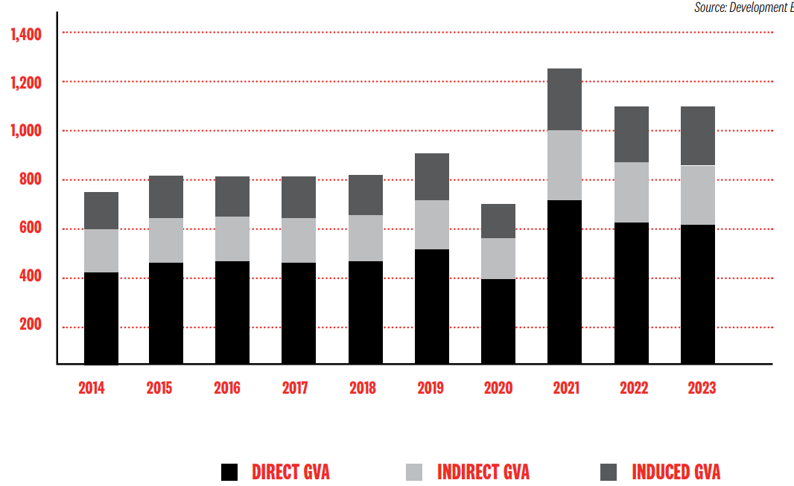

Figure 6: KFC estimated cumulative GVA effects 2014-2023 on the UK
(Source: KFC, 2026)
On the other hand, the UK’s consumers are more sensitive to the quality and taste variations, which needs KFC to adapt the ingredients and sourcing practices, with having 60% of chicken sourced from domestic markets and ensures freshness and trust (Martin, 2026).

5.2 Price
The pricing strategies differ due to the economic conditions and competition. In the United States KFC uses the value-based pricing strategy while offering meal deals and discounts for competing with chains, like McDonald’s and Wendy’s (Sievert et al. 2025). However, some recent data shows that KFC has struggled with the value perceptions while contributing to a 5% decline in same-store sales in the US (Maze, 2025).
Also, in the United Kingdom, pricing is higher due to the operational costs and consumer’s willingness to pay against the food. On the other hand, affordability remains a critical aspect as the UK's fast-food market is highly competitive and price sensitive. Aziz (2021) has suggested that 57.78% of UK consumers are satisfied with KFC’s pricing options.

5.3 Place
KFC has a strong global distribution presence across 31980 outlets across the globe, for which the strategy of distribution differs significantly (Global.KFC. 2024). In the United States, KFC operates in a mature and saturated market, with slower growth. The expansion is limited and focus is given on the optimisation of current locations and digital delivery channels. The United States also noted higher reliance on the co-branded outlets, like KFC with Taco Bell or Pizza Hut for the maximisation of revenue per location and reduction of operational costs (Shekhar, 2026).
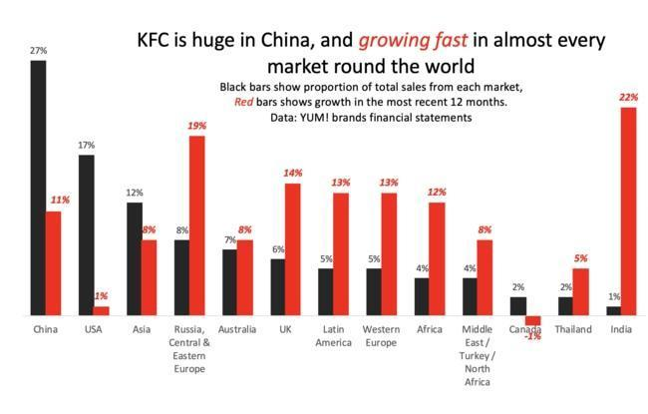

Figure 7: KFC’s incredible rise
(Source: Murphy, 2019)
In the UK, KFC demonstrated an aggressive expansion strategy. The brand operates across 1000 outlets and plans to make an investment in £1.49 billion for expanding further, which includes 500 new outlets (Sweney, 2025). Almost 70% of the UK based outlets are noted as franchise-owned, while supporting rapid expansion while maintaining local market responsiveness (Franchise Company, 2020). At the same time, KFC UK has expanded in the delivery infrastructure, while partnering with the platforms such as Deliveroo and Just Eat, along with enhancing digital ordering systems.

5.4 Promotions
In the United States the promotion process is focused on mass advertising with celebrity endorsements, and brand nostalgia, which is the Colonel Sanders Campaigns. On the other hand, the declining engagement and increased competition have created an impact on the business performances.
In the UK, KFC uses creative and culturally relevant campaigns, while a notable example can be of KFC’s “FCK campaign” that has improved the brand perception after the cries and the awareness has been increased from 7% to 29% (Jolly, 2023; Novoa, 2025). Additionally, the UK campaign has been highly localised and humorous which targets younger consumers who show 57% of preferences for big fast-food chains.

5.5 People
In the US, KFC faces several challenges with service level consistency due to the intense competition and labour turnovers. This has affected the customer satisfaction and loyalty of the brands. In the United Kingdom, KFC has employed more than 30,000 people, who emphasise structured training and service quality (Cui and Ting, 2009). The research has addressed relatively lower satisfaction levels in the service and quality perceptions, while addressing operational challenges.

5.6 Process
In the United States, there is a strong focus on efficiency and drive-through services that reflect a fast-paced lifestyle (Severson, 2023). The digital ordering and delivery platforms are necessary for the completion of this stage.
In the UK, KFC has adopted the processes for the inclusion of delivery and take away expansion, while aligning with the changing consumer behaviours. Across the globe, KFC has noted a shift towards off-premise consumption with a massive growth of delivery and take-away options.

5.7 Physical Evidence
In the United States, KFC outlets maintained a classic fast-food design while emphasising the heritage, and familiarity. On the other hand, some of the locations are outdated, and affect the brand perceptions.
In the United Kingdom, KFC has made investment in decorating modern store formats, and refurbishment, while enhancing the customer experiences (Jordan, 2025). The planned investments include upgrading 200 existing stores, while indicating a shift towards the premium physical environment (Abdelmeguid et al. 2024).

6. Directional Development Strategy of KFC in the United Kingdom

6.1 Market Penetration through Value, Convenience, and Digital Expansion
Market penetration is the main directional strategy of KFC in the UK, which focuses on raising the frequency of purchase and capturing the customers of competitors like McDonald and Burger King. The UK is a highly mature market, therefore, instead of generating new demand, expansion is done by stimulating the existing demand. Therefore, the current yearly revenue is estimated to be $4.6B per year with KFC UK and Ireland (Growjo, 2025). One of the most important aspects of this strategy is the value-based pricing and intensity of promotion. KFC UK has a high frequency of introducing limited-time offers, sharing buckets, and meal deals that are aimed at appealing to consumers with a low cost of living, in times of economic stress like inflation and a rise in cost of living. This would enhance the repeat buying behavior and position KFC as a cheap indulgence. The combination of these efforts will help in customer retention and more often orders without necessarily altering the core product offering.

6.2 Product Development and Localisation Strategy for UK Consumers
In combination with penetration, another strategy deployed by KFC is its product development strategy to suit the evolving consumer preference in the UK especially with regards to health awareness, ethics in consumption as well as diversification of flavours. In Britain and Ireland, KFC has committed to spend 1.49 billion pounds (2.0 billion dollars) of its money in the next five years that would generate more than 7,000 employment opportunities within its business and through its supply chain (Reuters, 2025). The brand has implemented menu innovation to meet the local preferences and eating expectations, such as plant-based options (vegan burgers created jointly with outside providers), lower-calorie or grilled alternatives. These are developments that are in response to the growing demand of healthier fast-food options and regulatory actions with respect to better nutrition labeling. Moreover, KFC UK also introduces local and restricted products periodically, such as spicy ones and flavours that have certain cultural influence, and which attract the diverse population in the UK. KFC reported that the market size in the UK was expanding with regards to fried chicken, and the market size stood at 3.1billion pounds (Reuters, 2025). This assists the brand to be relevant in a market where consumers want diversity and something new.

7. Ethical Issues in the Marketing Mix of KFC in the United States and United Kingdom
KFC marketing mix efforts in the United States and the United Kingdom cause various ethical issues, especially those that involve health effects, advertising and sustainability. Although in both countries the brand meets the legal requirements, the brand value of KFC has been wavering throughout the globe, as shown in the figure below.
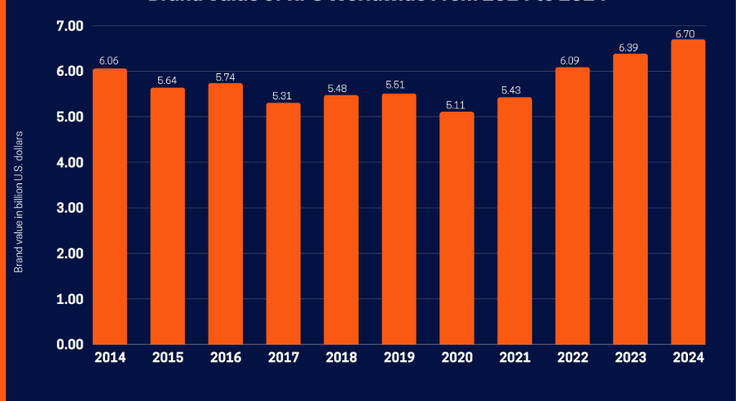

Figure 8: Brand Value of KFC from 2014 to 2024 across the world
(Source: Bajj, 2025)

7.1 Health, Nutrition, and Advertising Ethics
One of the major ethical concerns in the United States and the United Kingdom is the role of product offerings by KFC in increasing the worries on obesity and diet related diseases. Since KFC is a fast-food brand where fried and high-calorie foods got most of the popularity, there has been a tendency to blame it for promoting unhealthy eating habits.
In the United States, with relatively lax advertising laws, the encouragement of high-calorie meal plans and the use of large portions are ethical issues. When Americans indicate that healthiness is very or extremely important in food, 35% of those who attest to the same degree indicate that their own diets are of high healthiness with only 3% of adults who say that healthiness is not too or not important (Pew Research Center, 2025). Marketing initiatives that promote indulgence and value pricing can promote excessive consumption especially in younger and low-income consumers. In the United Kingdom, despite the more stringent rules in the sphere of advertising, particularly in advertising to children, the ethical discussion of the promotion of unhealthy food in the general media and in Internet resources remains open. Promotional campaigns are such that even in cases of being in line with regulations, concern can be raised whether the long-term encouragement of an unhealthy diet needs to be encouraged by the persuasive power of such campaigns.
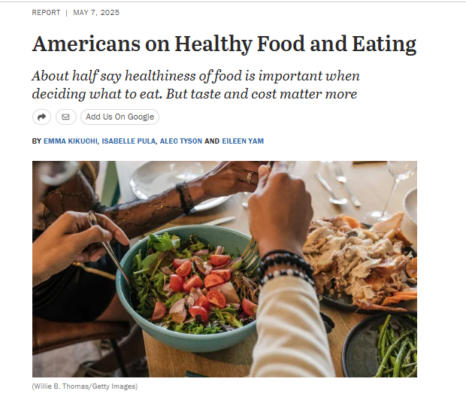

Figure 9: Americans on Healthy Food and Eating
(Source: Pew Research Center, 2025)

7.2 Sustainability, Packaging, and Supply Chain Responsibility
The other significant ethical concern is the environmental sustainability and the supply chain practices. In the two nations, KFC has been attacked over the use of single-use packaging, sourcing of poultry and carbon emission of massive supply chains.
In the United Kingdom, where the consumers and regulators are more emphasis on sustainability, packaging waste is treated with more ethical uncertainty and agreements to include recyclable or biodegradable material. Although KFC has undertaken certain environmental conservation efforts, critics accuse it of making gradual as opposed to radical changes (Zhang, 2024). Ethical issues are more divided in the United States, but they still exist, especially with the consumer groups that are more environmentally conscious. In general, despite the steps taken by KFC to adopt responsible marketing practices, in both markets, there are still ethical issues to be resolved by striking a balance between profitability and social responsibility in terms of health and environment.

8. Recommendations

8.1 Recommendation 1: Strengthen Health-Oriented Menu Innovation and Responsible Marketing (US & UK)
KFC ought to focus on introducing more healthy products both in the United States and the United Kingdom to support the growing consumer need for nutritious and balanced fast-foods. This involves the launch of increased grilled options, low calorie meal packages, vegetarian proteins and open nutritional labelling on all menu items (Stewart et al. 2026). In the UK, where regulatory and social pressure on the topic of obesity and childhood nutrition is even more pronounced, KFC must do even more to limit the aggressive advertising of high-fat high-salt food in the digital and broadcast media. In the US where consumer autonomy is greater but health issues are still important, the brand may consider the concept of promoting the idea of balanced indulgence that would enable consumers to consume products and at the same time be conscious about their nutritional intake. Also, responsible marketing approaches, including not direct marketing of unhealthy foods to children, will contribute to increasing brand trust in the long-term and decreasing the level of ethical criticism in both markets.

8.2 Recommendation 2: Enhance Sustainability Leadership and Digital-First Customer Experience
KFC ought to move faster in the sustainability fronts by switching to fully recyclable or compostable packs, becoming more carbon efficient in its supply chain, and be more transparent in its sourcing practices, especially in poultry production. This is more so in the UK where consumers are the most sustainability-aware but it is also coming to be the case in the US as more people become environmentally conscious. Together with sustainability, KFC can also improve its digital ecosystem by improving the personalisation of mobile apps, loyalty reward systems, and AI-assisted ordering and demand forecasting in both markets. A digital-first strategy will be a single strategy to enhance efficiency in operations, retention of customers, and help in promoting more targeted and ethical (Sikder, 2024). Sustainability leadership and enhanced digital interaction will enable KFC to consolidate its worldwide brand name as well as adapt efficiently to the developing international consumer requirements.

9. Conclusion
The comparative assessment of KFC in the United States and United Kingdom addresses the critical need of making alignment with international marketing strategies with local market dynamics. The findings have demonstrated that while KFC maintains a highly standardised global brand identity, its success is dependent on the ability of differing macroenvironmental conditions, regulatory frameworks and consumer behaviours. The US represents a highly mature and highly saturated market where the business faces intense competition and decline of growth, and needs to have stronger assessment of value-based pricing, operational efficiency and brand revitalisation. In contrast to that, the UK offers a highly dynamic growth environment, including creative promotions and sustainability initiatives for aligning with more health-conscious and ethically aware consumers.
Furthermore, the research has further addressed that socio-cultural factors play a decisive role to shape the consumer expectations, while influencing product development and ethical considerations. In this case, the issues, such as health concerns, environmental impact, and responsible marketing have become a significant area of consideration specifically in the UK based markets.

Section 2: Reflection
The Gibbs Reflective Cycle is a framework used to examine learning experiences in six steps: description, feelings, evaluation, analysis, conclusion, and action plan (Ocampo et al. 2025). The model facilitates critical thinking and self-brainstorming by helping any individual look back into experiences and see areas of improvement in the course of academic and professional work in the future.
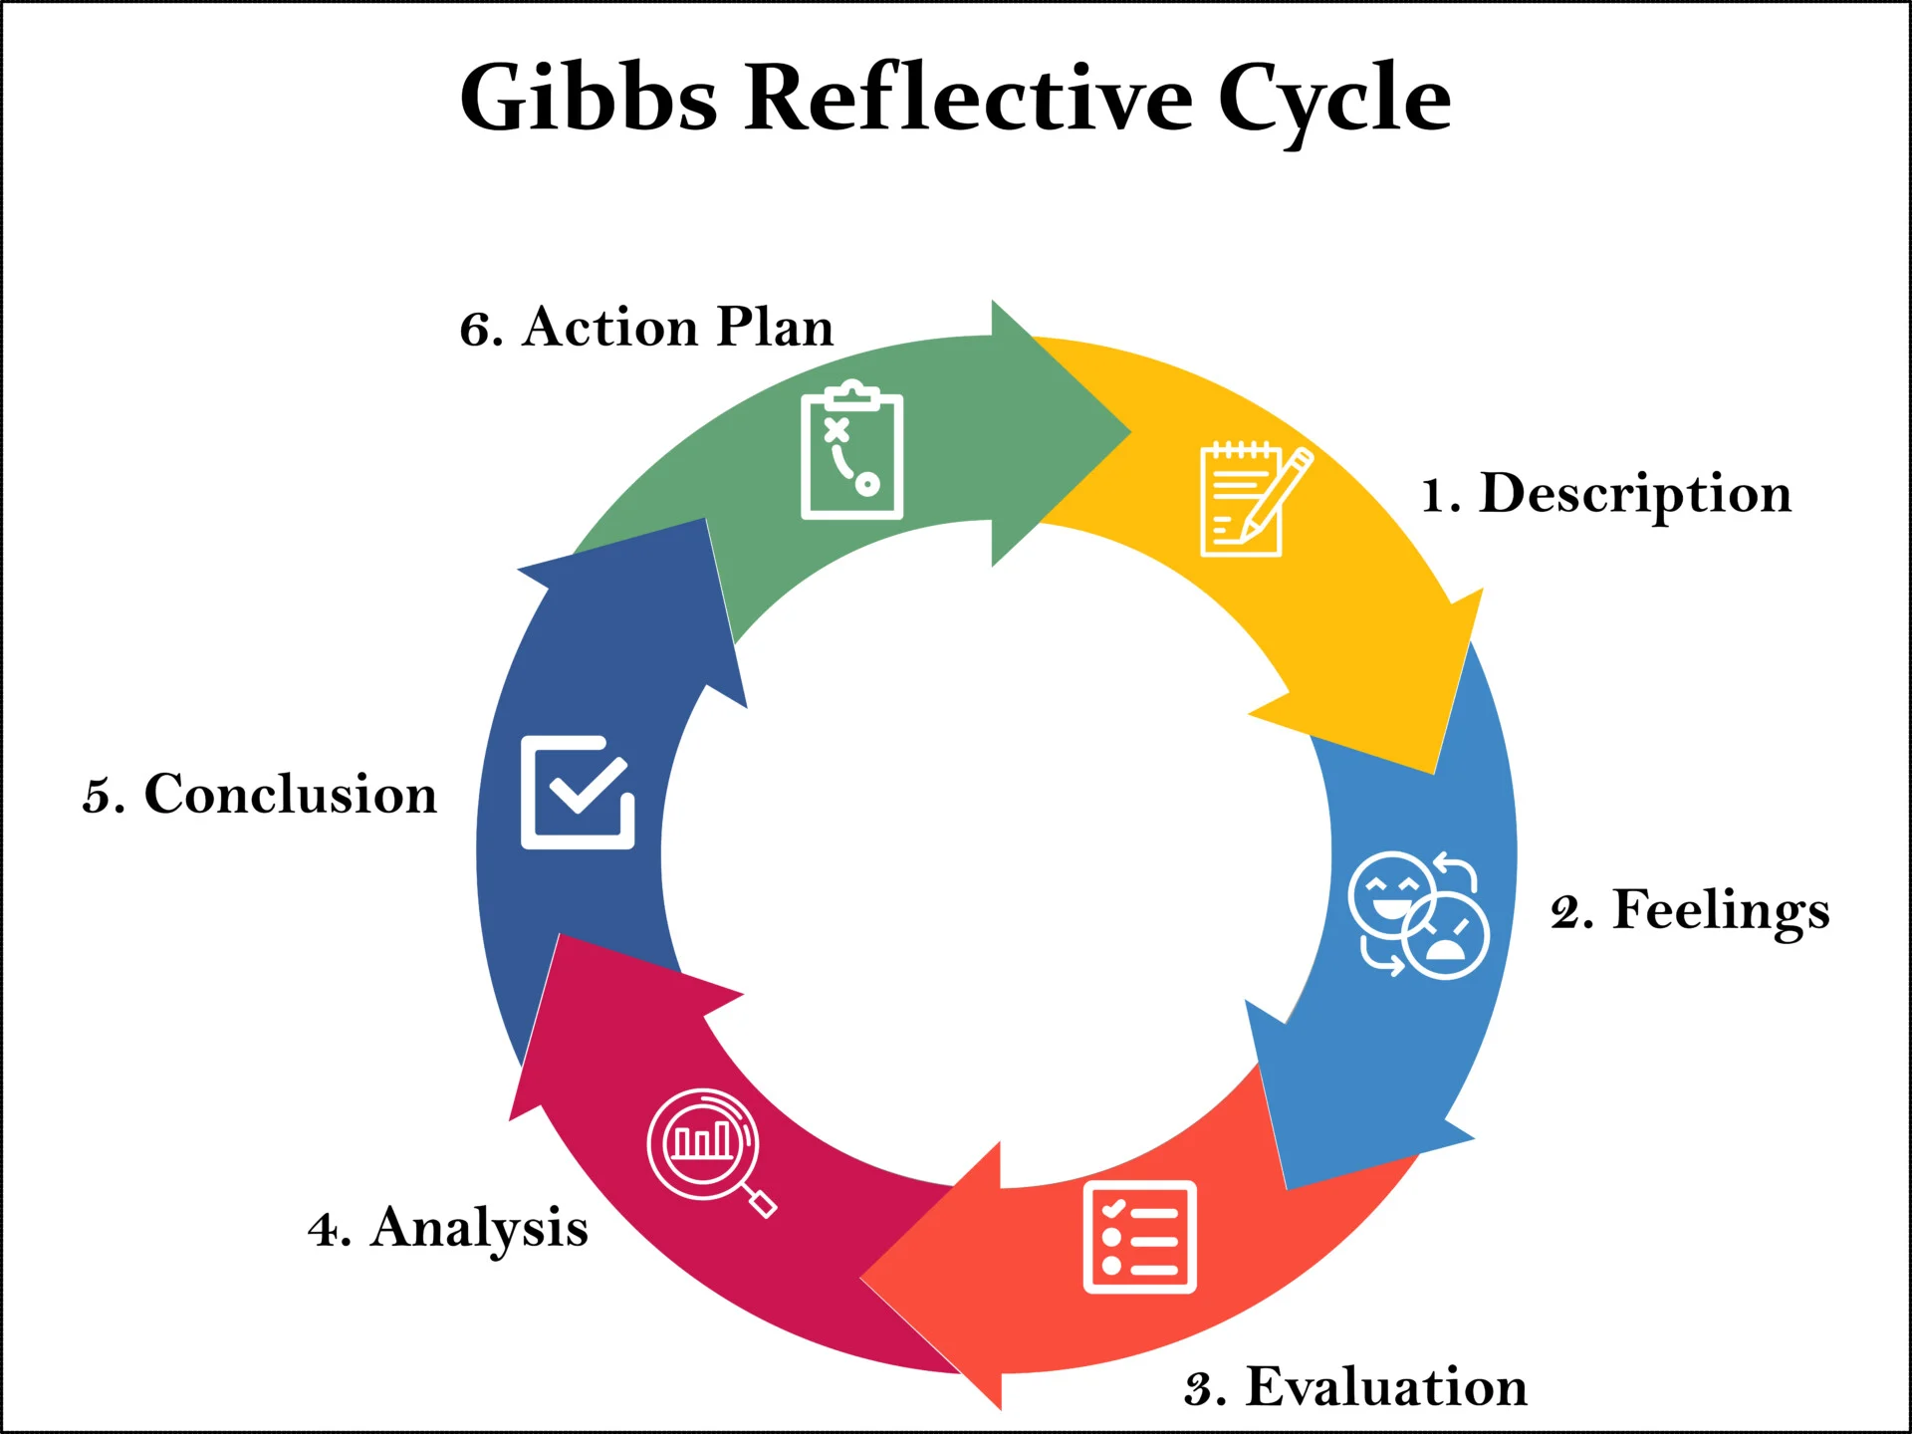

Figure 10: Gibbs Reflective Model
(Source: McLeod, 2025)
Description
In my effort to put together this international marketing report on KFC in the United States and the United Kingdom, I did a lot of research and analysis to learn how international brands alter their strategies in various markets. I analysed different frameworks like PESTEL, STP, and marketing mix 7Ps in order to analyse the differences between the environment, culture and strategy. It involved collecting verifiable information through journals, reports, and other sources in the industry, to have confidence and accuracy within my analysis. I also cross-examined economic, social, and technological to learn about the effect of market conditions on business decisions. Colomer et al. (2020) state that reflective learning enhances in-depth cognition, and encourages learning through facilitating critical thinking about the experiences and knowledge. This academic method aids in arranging intricate information in an efficient manner and becoming more astute in the analysis and critique of ideas.
Feelings
At first, the research was strenuous as two developed markets had to be analysed, and loads of data had to be gathered and compared thoroughly. Of particular concern to me were the issues of locating credible materials and having the correct usage of theoretical frameworks. Reflection aids the learner to acquire self-reflexivity and enhance their capacity to handle complex academic assignments (Aladini et al. 2025). I grew increasingly comfortable in understanding market differences, and relating theory to business strategy. The study of economic and social indicators helped me to be more motivated and develop my skills in scholarly research and critical thinking and feel confident in undertaking assignments.
Evaluation
The preparation of this report proved to be quite challenging and rewarding because it allowed me to enhance my research and analytical skills and exploit the credible sources as well as marketing models to full advantage. I managed to contrast critically the United States and the United Kingdom markets and how KFC can suit its strategies accordingly. A clear organised presentation of ideas was aided by the systematic use of PESTEL and STP frameworks. Reflective practice allows building a career by discovering the areas of strengths and weakness, whereas evaluation assists people in reaching better performance in the future (Graf and Harris, 2016). But, accessibility to the current data and controlling word count at the expense of critical analysis was difficult.
Analysis
Reflection allows us to relate theoretical knowledge to practice, enhancing our skills to make sound decisions and resolve more complex issues (Aladini et al. 2025). This experience has taught me to have critical thinking and use of evidence-based assessment in international marketing because without theory, there is no data and practical knowledge on the ground. The comparative analysis of two developed markets also helped me to structure the observation of economic, cultural and technological factors related to the business. It also has improved my writing and researching skills in academic writing, especially in the use of original journal materials and industry reports. I learned that reflective learning promotes lifelong learning and understanding of the intricate subjects.
Conclusion
Finally, the reflective process allowed me to review my learning process and recognise potential improvement areas in research, analysis, and writing papers. I also learned a lot concerning international marketing strategies and the significance of relying on believable information and theories. The process also enhanced the confidence rate in me to carry out comparative analysis of the market and to use marketing models efficiently. I learned that good academic and professional development requires constant contemplation. In general, this assignment has increased my critical thinking, time management and research skills, which will help me to improve my further academic activities and develop as a professional in the sphere of international business and marketing.
Action Plan
Area of Development | Action I Will Take | Timeframe | Expected Outcome
Research skills | I will also be reading more journal articles and other industry reports that are peer-reviewed in order to advance my knowledge on the subject of international marketing. | Next 3 months | Stronger academic research and better use of credible sources.
Time management | To avoid the stress of having to finish tasks at the last minute, I will plan a routine study routine and do assignments earlier. | Next semester | Improved productivity and timely completion of assignments.
Academic writing | I will work on structured thinking and Harvard referencing by university sites and comments. | Ongoing | Clear, critical, and well-referenced academic work.
Critical reflection | I will frequently use Gibbs reflective models and thus analyse my learning and performance. | Ongoing | Continuous academic and professional development.

Table 1: Action Plan for Self-improvement
(Source: Self-developed)

References
Abdelmeguid, A., Tsironis, G., Afy-Shararah, M., Tsagarakis, K.P. and Salonitis, K. (2024). Insights into Sustainability and Circular Economy Trends in Luxury Fashion: a LinkedIn Topic Modelling Study. Cleaner and Responsible Consumption, [online] 15(1), p.100228.doi: https://doi.org/10.1016/j.clrc.2024.100228
Aladini, A., Osman Abdul Wahab, M., Ismail, S.M. and Hashemifardnia, A. (2025). Ripples of reflection: how iterative reflective practices shape cognitive flexibility, emotional resilience, and problem-solving skills. Reflective Practice, pp.1-19. https://doi.org/10.1080/14623943.2025.2596423
Aziz, M. (2021). Research on KFC Consumer Satisfaction in UK and India. [online] ResearchGate. doi: https://doi.org/10.13140/RG.2.2.13936.33288
Bajj (2025). KFC Marketing Strategy: Recipe for Quality and Creativity. [online] Available at: https://startuptalky.com/kfc-marketing-strategy/ (Accessed on 20th march 2026).
Business Waste Ltd (2025). Packaging Waste Facts and Statistics. [online] Business Waste. Available at: https://www.businesswaste.co.uk/waste-facts/packaging-waste-facts-and-statistics/. (Accessed on 20th March 2026).
Chen, C.W. (2024). Utilizing a hybrid approach to identify the importance of factors that influence consumer decision-making behavior in purchasing sustainable products. Sustainability, 16(11), p.4432. https://doi.org/10.3390/su16114432
Colomer, J., Serra, T., Cañabate, D. and Bubnys, R. (2020). Reflective learning in higher education: Active methodologies for transformative practices. Sustainability, 12(9), p.3827. https://doi.org/10.3390/su12093827
Cui, Y. and Ting, Z. (2009). American Fast Food in Chinese Market: A Cross-Cultural Perspective ----The Case of KFC and McDonald’s. [online] Available at: https://www.diva-portal.org/smash/get/diva2:286121/FULLTEXT01.KFC (Accessed on 21st march 2026).
Food Standards Agency (2023). Food System Strategic Assessment: Trends and issues impacted by the Exit from the EU (Brexit) and regulatory change. [online] Food Standards Agency. Available at: https://www.food.gov.uk/research/food-system-strategic-assessment-trends-and-issues-impacted-by-the-exit-from-the-eu-brexit-and-regulatory-change. (Accessed on 20th March 2026).
Food Standards Agency (2025). Making Food Better Tracker Survey 2024. FSA research and evidence. [online] Available at: https://science.food.gov.uk/article/130815-making-food-better-tracker-survey-2024. (Accessed on 20th March 2026).
Fortune (2026). Yum Brands. [online] Fortune. Available at: https://fortune.com/company/yum-brands/ (Accessed on 20th March 2026).
Franchise Company (2020). The Franchise Market In The UK - The Franchise Company. [online] Available at: https://www.franchisecompany.co.uk/franchising-guides/the-franchise-market-in-the-uk/ (Accessed on 21st march 2026).
Francis-Devine, B. (2026). High cost of living: Impact on households. [online] House of Commons Library. Available at: https://commonslibrary.parliament.uk/research-briefings/CBP-10100/. (Accessed on 20th March 2026).
Geert Hofstede (2025). Country Comparison Bar Charts - Geert Hofstede. [online] Geert Hofstede. Available at: https://geerthofstede.com/country-comparison-bar-charts/. (Accessed on 20th March 2026).
Global.KFC (2024). KFC - Press Releases. [online] KFC. Available at: https://global.kfc.com/press-releases/kfcs-celebrates-global-growth-with-major-milestone-restaurant-openings (Accessed on 20th march 2026).
Graf, A.J. and Harris, B.R. (2016). Reflective assessment: opportunities and challenges. Reference Services Review, 44(1), pp.38-47. https://doi.org/10.1108/RSR-06-2015-0027
Growjo (2025). KFC UK and Ireland Revenue and Competitors. [online] Available at: https://growjo.com/company/KFC_UK_and_Ireland (Accessed on 20th march 2026).
Harari, D. (2026). The impact of food inflation on the cost of living. [online] House of Commons Library. Available at: https://commonslibrary.parliament.uk/research-briefings/cdp-2026-0004/. (Accessed on 20th March 2026).
Jolly, J. (2023). Starbucks to open 100 new UK coffee shops as tax bill on British sales falls. [online] the Guardian. Available at: http://theguardian.com/business/2023/mar/06/starbucks-open-new-uk-coffee-shops-tax-cafe-chain (Accessed on 21st march 2026)
Jordan, D. (2025). KFC to create 7,000 jobs in UK and Irish growth plan. BBC News. [online] 27 May. Available at: https://www.bbc.com/news/articles/cy75exp5p6mo (Accessed on 22nd march 2026).
KFC (2026). THE ECONOMIC AND COMMUNITY IMPACT OF KFC IN THE UK & IRELAND. Available at: https://brand-uk.assets.kfc.co.uk/drupal/production/2025-05/KFC-60th-Anniversary-Report-LR.pdf (Accessed on 20th march 2026)
Market.us (2026). Restaurant Digitalization Market Size, Share | CAGR 16.3%. [online] Market.us. Available at: https://market.us/report/restaurant-digitalization-market/. (Accessed on 20th March 2026).
Martin, J. (2026). KFC, Nando’s, and others ditch chicken welfare pledge as demand soars. [online] 20 Feb. Available at: https://www.bbc.com/news/articles/cm2r6jqm042o (Accessed on 20th march 2026).
Maze, J. (2025). KFC and Pizza Hut continue to struggle in the U.S. [online] Restaurant Business. Available at: https://restaurantbusinessonline.com/financing/kfc-pizza-hut-continue-struggle-us (Accessed on 20th march 2026).
McLeod, S. (2025). Gibbs Reflective Cycle. [online] Simply Psychology. Available at: https://www.simplypsychology.org/gibbs-reflective-cycle.html [Accessed 24 March 2026].
Murphy, J. (2019). Secret to KFC’s incredible rise. [online] News.Com.Au. Available at: https://www.news.com.au/finance/business/retail/kfcs-incredible-ascension/news-story/4424c673a17ffe1f09ec245c8e96df78 (Accessed on 20th march 2026).
Murtaza, N. (2026). Critical Analysis on Sell-Side Digital Practices Adopted by KFC For the Online Customer Experience. [online] doi: https://doi.org/10.22541/au.176790815.55729772/v1. (Accessed on 20th March 2026).
Mylonakis, J. and MichalisEvripiotis (2016). TOWARDS AN ASSESSMENT OF GLOBALIZATION AND LOCALIZATION OF WESTERN EAST-FOOD CHAINS IN CHINA: THE CASE OF KFC. European Journal of Business and Innovation Research, [online] 4(3), pp.17–28. Available at: https://www.researchgate.net/publication/360703356_TOWARDS_AN_ASSESSMENT_OF_GLOBALIZATION_AND_LOCALIZATION_OF_WESTERN_EAST-FOOD_CHAINS_IN_CHINA_THE_CASE_OF_KFC (Accessed on 20th march 2026).
Notshe, M. (2026). The United States. [online] Playroll. Available at: https://www.playroll.com/minimum-wage/the-united-states. (Accessed on 20th March 2026).
Novoa, S. (2025). KFC FCK Campaign: A Masterclass in Crisis Management and Brand Authenticity. [online] Science of Retail. Available at: https://scienceofretail.com/kfc-fck-campaign-crisis-management-case-study/ (Accessed on 21st march 2026).
Ocampo, F.A., McIntyre, B.G., Massey, D. and Saunders, R. (2025). Nursing student reflections on a research internship: A reflective discussion following the Gibbs' reflective cycle. Nurse education today, 145, p.106481. https://doi.org/10.1016/j.nedt.2024.106481
Pew Research Center (2025). Americans on Healthy Food and Eating. [online] Available at: https://www.pewresearch.org/science/2025/05/07/americans-on-healthy-food-and-eating/ (Accessed on 20th march 2026).
Reuters Staff (2025). KFC to invest $2 billion in UK and Ireland over five years. Reuters. [online] 27 May. Available at: https://www.reuters.com/business/world-at-work/kfc-invest-2-bln-uk-ireland-over-5-years-create-7000-jobs-2025-05-27/ (Accessed on 20th March 2026).
Severson, K. (2023). Hungry (but Not for Human Contact), Americans Head for the Drive-Through. The New York Times. [online] 7 Nov. Available at: https://www.nytimes.com/2023/11/07/dining/drive-through.html (Accessed on 22nd march 2026).
Shah, N.N., Fryar, C.D., Ahluwalia, N. and Akinbami, L.J. (2025). Fast Food Intake Among Adults in the United States, August 2021–August 2023. https://stacks.cdc.gov/view/cdc/174606/cdc_174606_DS1.pdf
Shekhar, S. (2026). KFC-parent Yum Brands tops same-store sales estimates as diners seek value meals. Reuters. [online] 4 Feb. Available at: https://www.reuters.com/business/kfc-parent-yum-brands-tops-same-store-sales-estimates-diners-seek-value-meals-2026-02-04/ (Accessed on 20th march 2026).
Sievert, K., Botha, T., Wood, B., Baker, P., Scapin, T. and Sacks, G. (2025). Global market trends and financial performance of the corporate fast-food industry and their potential contributions to diets high in meat and ultra-processed foods. Globalization and Health, 21(1), pp.60–60. doi: https://doi.org/10.1186/s12992-025-01158-9
Sikder, J. (2024). Digitalization of Food Industry Franchise-Motives and Challenges of a Successful Adoption. [online] Available at: https://www.theseus.fi/handle/10024/873859
Statista (2025). Topic: Online food delivery in the UK. [online] Statista. Available at: https://www.statista.com/topics/11325/online-food-delivery-in-the-uk/ (Accessed on 20th March 2026).
Statista Research Department (2025a). Topic: Yum! Brands. [online] Statista. Available at: https://www.statista.com/topics/2391/yum-brands/ (Accessed on 20th March 2026).
Statista Research Department (2025b). Topic: Online Food Delivery Services in the U.S. [online] Statista. Available at: https://www.statista.com/topics/3294/online-food-delivery-services-in-the-us/ (Accessed on 20th March 2026).
Statista Research Department (2025c). Topic: Health and Wellness Food Trends in the UK. [online] Statista. Available at: https://www.statista.com/topics/6843/health-and-wellness-food-trends-in-the-uk/ (Accessed on 20th March 2026).
Stewart, M.M., Moazzem, M.S., Proctor, J.N., Kerr, W.L., Bui, M.J. and Adhikari, K., 2026. Consumer Insights into “Clean Label” High-Fat, Low-Carbohydrate Protein Bars. Foods, [online] 15(3), p.551. doi: https://doi.org/10.3390/foods15030551
Sweney, M. (2025). KFC plans to invest £1.5bn in UK and Ireland, creating thousands of jobs. [online] The Guardian. Available at: https://www.theguardian.com/business/2025/may/27/kfc-plans-to-invest-15bn-in-uk-and-ireland-creating-thousands-of-jobs (Accessed on 20th march 2026).
The Food Foundation (2025). THE STATE OF THE NATION’S FOOD INDUSTRY 2025. [online] Available at: https://foodfoundation.org.uk/sites/default/files/2025-12/TFF_SofNFI_Report%202025.pdf (Accessed on 20th March 2026).
Wearden, G. (2024). UK borrowing costs hit three-month high amid ‘buyers’ strike’ fears; US inflation dips to 2.4% as jobless claims jump – as it happened. [online] The Guardian. Available at: https://www.theguardian.com/business/live/2024/oct/10/uk-property-market-strengthens-renters-squeeze-credit-conditions-nick-read-post-office-us-inflation-business-live-news (Accessed on 20th March 2026).
Zhang, Y. (2024). The Impact of Sustainable Development Strategies on the Valuation of KFC. Advances in Economics, Management and Political Sciences, [online] 99, pp.33-39. Available at: https://aemps.ewapub.com/article/view/15435

