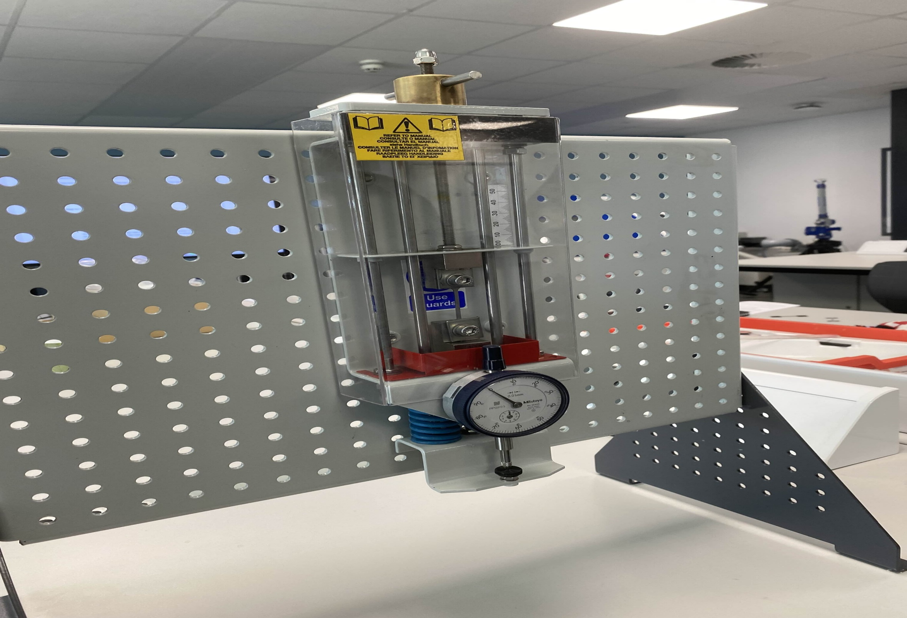

Tensile Testing

Report

8 December 2024

Engineering Science (ACHA4002)
Ethan Davies (2405602)
Word Count: 1506


Contents
1.0 Introduction 4
2.0 Experimental Procedure 5
3.0 Results (Raw Data) 8
3.1 Steel Tensile Test Results 8
3.2 Aluminium Tensile Test Results 8
3.3 Aluminium Alloy Tensile Test Results 10
3.4 PVC (Plastic) Tensile Test Results 11
4.0 Analysis 12
4.1 Steel Tensile Test Analysis 12
4.2 Aluminium Tensile Test Analysis 14
4.3 Aluminium Alloy Tensile Test Analysis 15
4.5 PVC (Plastic) Tensile Test Analysis 16
6 Conclusion 17
7 Evaluation 18
8 Further work 19
9 References 19

Table 1: Steel Results (Raw Data) 8
Table 2: Aluminium Results 9
Table 3: Aluminium Alloy Results 10
Table 4: PVC Results 11

Figure 1: Tensile testing device 5
Figure 2: Students Preforming Tensile Testing 6
Figure 3: Test Materials 7
Figure 4: Material Information Steel 8
Figure 5:Material Information Aluminium 9
Figure 6: Graphs Depicting Stress, Extension, and Elastic region of steel 13
Figure 7: Graphs Depicting Stress, Extension, and Elastic region of Aluminium 15
Figure 8: Graphs Depicting Stress, Extension, and Elastic region of Aluminium alloy 16
Figure 9: Graphs Depicting Stress, Extension, and Elastic region of PVC 16

1.0 Introduction
This report will document the process and the results of a Tensile Strength Test performed by students at the University of Wales Trinity St David. The experiment involves testing four different materials: mild steel, aluminium, duralumin (an aluminium alloy) and PVC plastic. A hand-operated Tensile testing apparatus will be used to apply tensile stress to each specimen until the material fails. Due to the apparatus being manually adjusted, some degree of error when recording measurements is anticipated. Nevertheless, students will be minimizing possible inaccuracies to the best of their ability.

A tensile test is fundamental when determining how a material will behave under a stretching force, allowing engineers to understand materials suitability for structures or mechanical/manufacturing applications (Callister & Rethwisch, 2018). The test purely gives raw data but using this data the students can then calculate the further information they need.

A typical test involves placing a material specimen into a testing machine then pulling the material at a constant rate while measuring the applied force and elongation of the material. As the students are manually pulling the specimen they will not be able to measure the force applied. They will calculate this after gathering their data.

The report will cover the experimental procedure, how the experiment should be carried out and the students’ results and analysis of those results. They will be comparing their results to others who have carried out similar tests with the chosen materials, and how the test could be improved if the students had unlimited time and resources to carry out the experiment.

2.0 Experimental Procedure
Materials are chosen and measured with verniers for their thickness, width and gauge length to obtain the cross-sectional area. This is then recorded along with its original length to use for referencing. The specimen material is then fitted into the tensile tester tightly, the dial indicator is then zeroed, and a safety guard is placed over the specimen material.
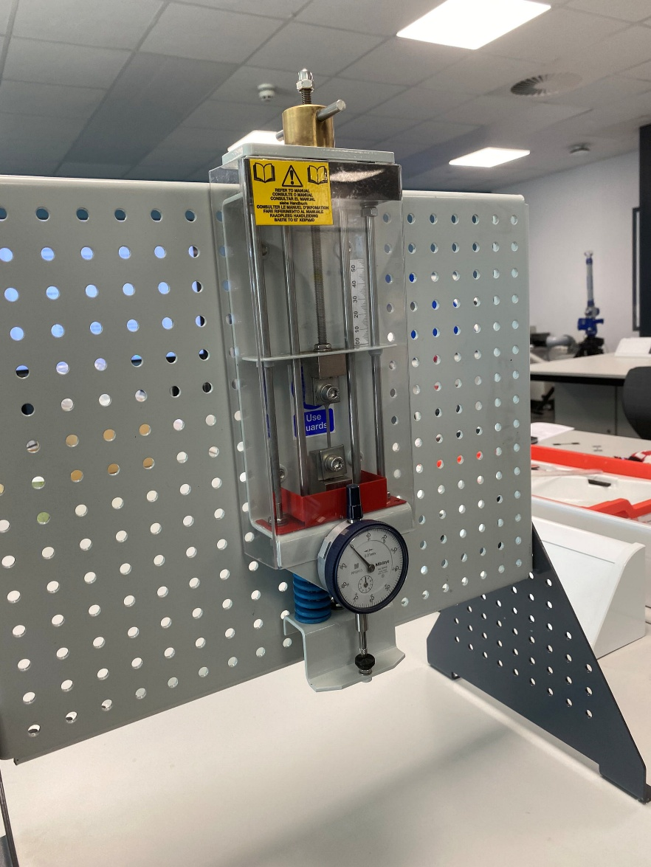
Figure 1: Tensile testing device
The load nut (as seen at the top of the apparatus) turns clockwise at a small but constant rate of 0.2mm each turn until reaching 5mm. This is when the turns increase to 1mm each, then another 10mm each until the specimen material breaks in two. At each turn, the personnel experimenting should record the value on the dial Indicator.

Now that the specimen material is broken, the elongation can be measured by pushing the two broken ends of the specimen together and then recorded. All the above can be repeated for each specimen material. Now that all specimens have been tested and the results have been recorded the personnel can now convert their readings into force values and find the extension at each point of the test. These forces can be converted into stress and nominal strain.

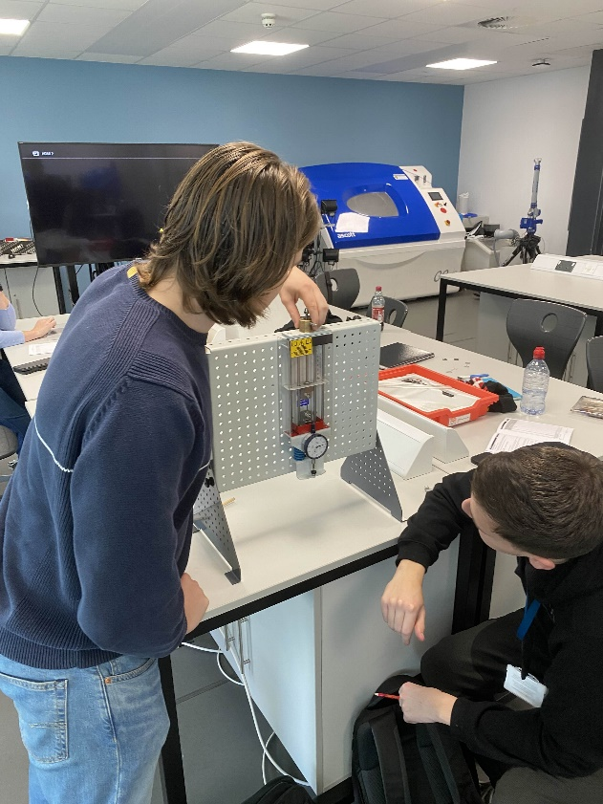
Figure 2: Students Preforming Tensile Testing
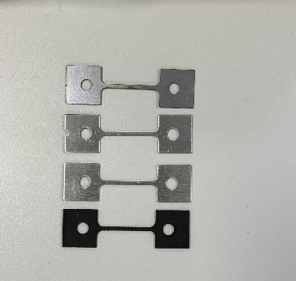
Figure 3: Test Materials

3.0 Results (Raw Data)

3.1 Steel Tensile Test Results

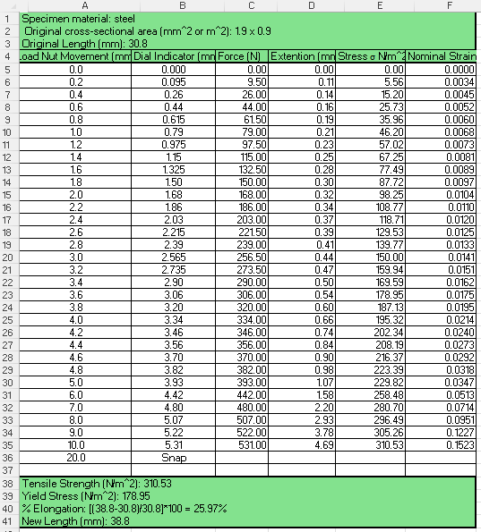
Figure 4: Material Information Steel
Table 1: Steel Results (Raw Data)

3.2 Aluminium Tensile Test Results

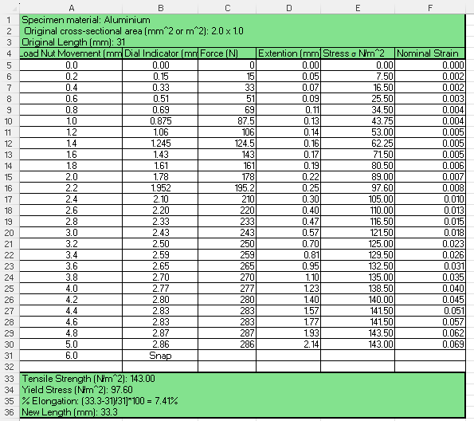
Figure 5: Material Information Aluminium

Table 2: Aluminium Results (Raw Data)

3.3 Aluminium Alloy Tensile Test Results

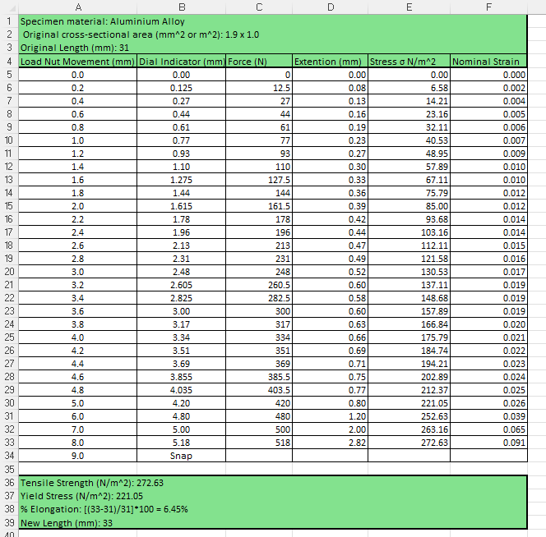
Figure 6: Material Information Aluminium Alloy

Table 3: Aluminium Alloy Results

3.4 PVC (Plastic) Tensile Test Results
When conducting a tensile test of PVC, it has a significantly higher ductility when compared to the other specimen. The PVC undergoes considerable elongation, with pronounced deformation, before the material eventually fails. This behavior results in variable reading from the dial indicator even when continuous strain is applied. This means it is a necessity for swift and precise data collection during the test, ensuring accuracy and consistency of data. This can lead to a higher chance of inaccurate data that does not reflet the materials true instantaneous response to an applied force.
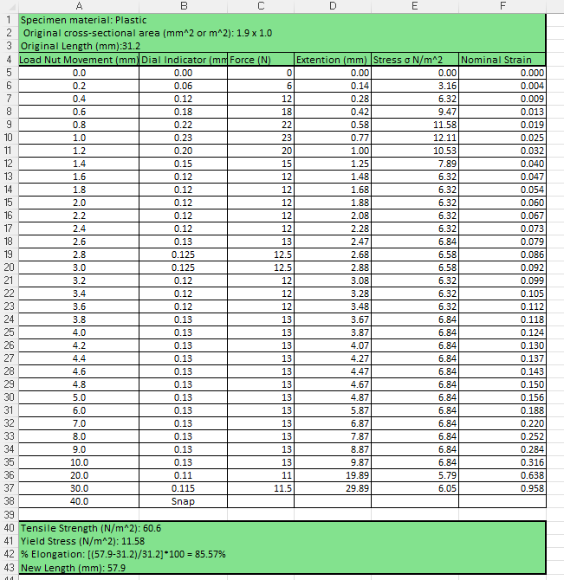
Figure 7: Material Information Plastic
Table 4: PVC Results (Raw Data)

4.0 Analysis

4.1 Steel Tensile Test Analysis
Table 5: Steel Analysis of Raw Data
The chart shows that steel has a rather linear increase until its yield point where it diverts drastically away from the linear pattern. It also has an abnormality at the start of its data. This is due to an error when setting up the first measurement point, this did not affect the rest of the data.
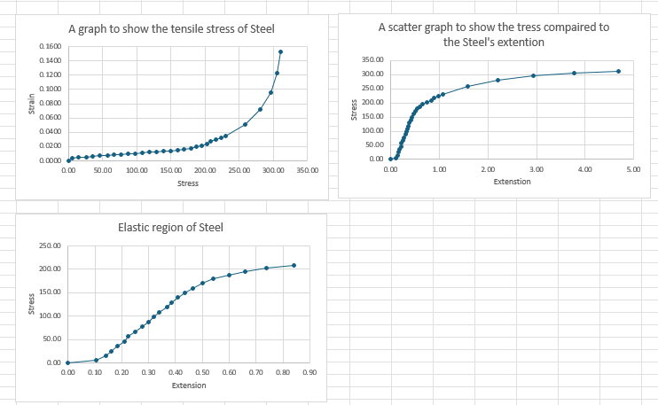
Figure 8: Graphs Depicting Stress, Extension, and Elastic region of steel

4.2 Aluminium Tensile Test Analysis
Table 6: Aluminium Analysis of Raw Data
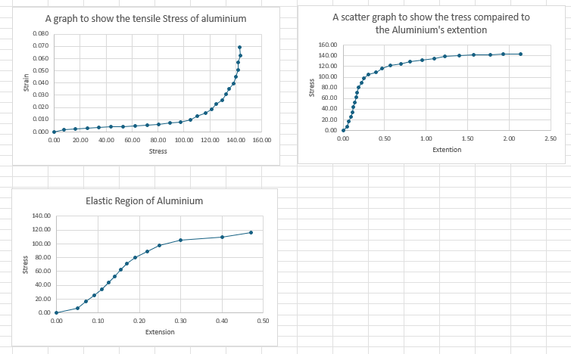
Figure 9: Graphs Depicting Stress, Extension, and Elastic region of Aluminium

4.3 Aluminium Alloy Tensile Test Analysis
Table 7: Aluminium Alloy analysis of Raw Data
The aluminum alloy tensile test is surprisingly different from its counterpart, aluminum. The aluminum alloy has a far higher yield point and an even higher tensile strength than the aluminum This is to be expected as the aluminum alloy is duralumin, which is a high-specification alloy, whereas the aluminum is a basic aluminum alloy not even pure aluminum. It also has an abnormality in its data as it has a diversion in the chart. The aluminum has a large increase in its extension but then it returns to its normal linear increase.
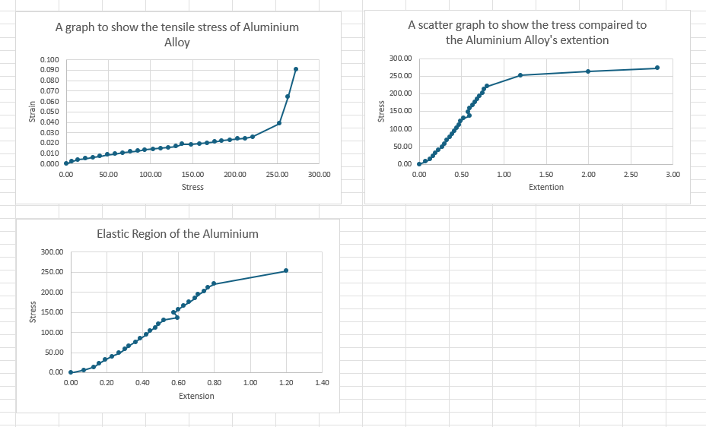
Figure 10: Graphs Depicting Stress, Extension, and Elastic region of Aluminium alloy

4.5 PVC (Plastic) Tensile Test Analysis
Table 8: Plastic Analysis of Raw Data
The data is interesting as it has a linear increase until its yield point and at that point it drops drastically and then sits around the same point until the plastic breaks. It does show that plastic can only deform so much before it can no longer be stretched.
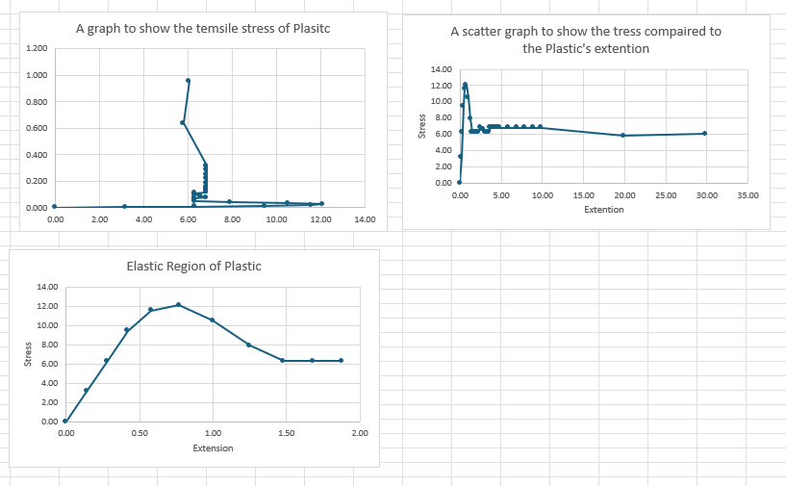
Figure 11: Graphs Depicting Stress, Extension, and Elastic region of PVC

6 Conclusion
I believe that the test for mild steel is valid when comparing it to another who has done the test but on a tensile testing machine that is not hand-operated removing a lot of human error. The test results are similar to those of the test conducted at UWTSD (University of Wales Trinity St David). The test referred to was performed by the Sokoine University of Agriculture in 2018. On page 7 they document their results and looking at the True Stress section of the table it has similar values to the test carried out by students at UWTSD.

Furthermore, comparing the test done on the plastic at UWTSD it has a similar measurement for Tensile Strength to the Shimadzu Corporation, specializing in analytical and measuring instruments. The graphs they have on their website for tensile testing of plastic have a similar graph to the one the students at UWTSD created.

7 Evaluation
To ensure that there are as few errors as possible the students would have to very slowly and constantly turn the testing tool so the material is not undergoing any shock that could create errors in the dial indicator. They would also be sure to properly set the dial indicator making sure it is zeroed as accurately as possible. The dial indicator having manual zeroing means that the zero point can be incorrect by a few slight points of a millimeter, this can affect the data.

8 Further work
If the students at UWTSD were given unlimited time and resources, this experiment could be improved massively. The use of a hand-turned tensile strength testing tool could be replaced with a machine that could give a gradual and even application of force to the specimen materials ensuring more accurate data points. Moreover, repeated tests of the materials could also be beneficial as it means the students could reinforce their data and their analysis as they would have more than one set of data for each material.

9 References
- SlideShare. (2018). TENSILE TEST REPORT. [online] Available at: https://www.slideshare.net/slideshow/tensile-test-report-89414455/89414455. [Accessed; 7th November 2024]
- www.shimadzu.com. (n.d.). Tensile Tests of Various Plastic Materials (1). [online] Available at: https://www.shimadzu.com/an/industries/chemicals/film/tensile-tests-of-various-plast/index.html. [Accessed: 7th November 2024
- Callister, W.D., & Rethwisch, D.G (2018) Materials Science and Engineering: An Introduction (10th ed.). Wiley.

‌

