Author: Milen Enchev
Student Number: 1908493
Module: Leadership and management, theory and practice
Module Code: LCBB6003
Tutor: Taye Osadiya
Leadership and Management, Theory and Practice. Assignment 1.

Reflection on the Role Team Leader
At LDC Care&Co
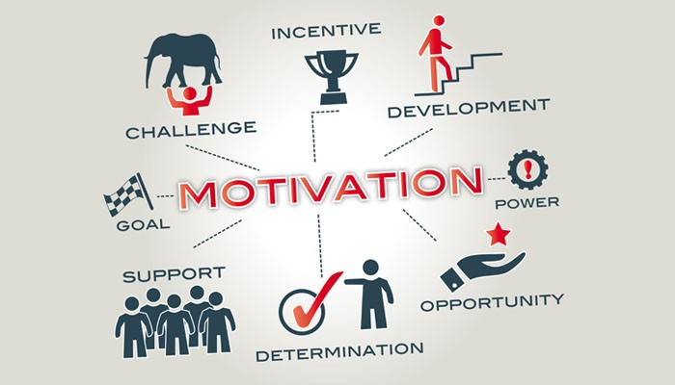

Contents
1. Introduction 2
2. Chosen Company: LDC Care & Co 2
3. Review of leadership theories and styles. 2
Trait Theory of leadership. 2
Transformational vs Transactional Leadership Theories. 3
Michigan University Studies on Leadership. 3
Ohio State University studies on Leadership 4
Autocratic leadership 4
Democratic Leadership. 4
Laissez-Faire Leadership. 5
4. Reflection on the Role Team Leader at LDC Care&Co. 5
5. Conclusion 6
6. References 6
Appendix. Leadership development plan based on my experience as a Team Leader in LDC Care & Co. 7

Introduction
The social-influence process where the leaders seek out the voluntary participation of the employees in order to achieve the goals of the organisation is called Leadership. An individual who delegates, influence and motivates others to act so that they meet their final targets and objectives, is called leader. These days businesses require leaders who are effective & efficient and recognize the complications of the quickly changing global environment. Employees will exhibit high effectiveness in their performance, if the task they have received from their leader is highly structured and the relationship Leader-Employees is stable (R & Nanjundeswaraswamy, 2014).
This report aims to discuss and analyze several leadership approaches and highlight the strengths and weaknesses. The assignment will also investigate where they are applicable. A reflection of the role team leader at LDC Care & Co will be concluded, it will be investigated what leadership approach has been applied, what went wrong and what could have been done differently.

Chosen Company: LDC Care & Co
LDC Care & Co is supported living & residential care company that provides care and support for people with mental disabilities (learning disabilities, autism, down syndrome, Prader Willi syndrome and others. The organizations support its service users with household chores, personal care, administering medications, emotional support, etc (Ldccare.co.uk, 2021).

Review of leadership theories and styles.

Trait Theory of leadership.
This theory follows the steps of the Great Man theory in believing that leaders are born with traits that make them better suited to leadership roles than others who do not own those characteristics. As such, the theory identifies some particular qualities such as intelligence, accountability, sense of responsibility, and creativity, decisiveness, human relations skill, ambition, dependability, initiative, emotional stability, among others, that lets an individual do extremely well at leadership (Khan, et al., 2016).
One key problem in the theory is that it does not suggest a conclusive list of leadership traits. Nevertheless, the theory's credibility stems from the fact that existing research backs up the significance of personality traits in leadership (Adams, 2018). Also, the theory helps the individual to pay attention to their strengths and weaknesses and work on them. Possessing the leadership traits does not make a person a good leader. The person should be able to realize that they possess the traits, pay attention to them, develop them, use them as strengths and leverage and eliminate the weaknesses.

Transformational vs Transactional Leadership Theories.
Transactional leadership - focuses on exchanges between leaders and followers. To boost efficiency, leaders would provide performance incentives. For instance, Politicians promises better life to the citizens and rely on their votes in return; Teachers give good grades when students have submitted well-written reports; Managers reward their subordinates when they fulfil the goals set for them. (King, 1990).
Transformational approach aims to engage followers to boost their level of motivation and integrity, not only foster a leader- follower relationship. A transformational leader is aware of the needs of their followers and works to help them achieve their maximum potential. Both approaches are not mutually exclusive and have been shown to be positively associated in studies. (Arenas, 2019).
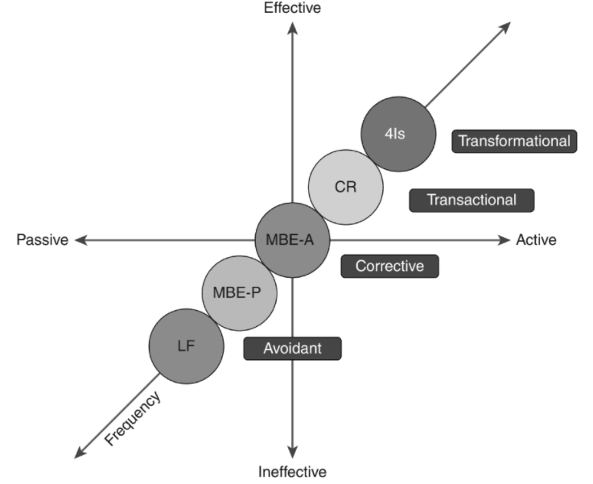
Full range Leadership. Image Courtesy: (Arenas, 2019)

Michigan University Studies on Leadership.
The studies have come up with two comprehensive leadership styles: an employee orientation, which accentuate on human relations, and a production orientation, emphasizing on task-oriented activities. The study discovered that employee orientation with general supervision generated more satisfactory results than production orientation with direct supervision (Northouse, 2010).
The research identify that an employee orientation combined with general (not close or direct) supervision delivered better results. Employee orientation concentrates on the human aspect of employment, stating that employees have needs that employer should recognize and care for. Also, employees would be more productive and engaged with their tasks when there is less direct pressure and control targeted towards them.

Ohio State University studies on Leadership.
Ohio University’s researchers have come up with two key leadership style behaviours: initiating structure and Consideration. Initiating structure behaviours are predominantly task-oriented behaviours, involving acts such as organizing work, giving structure to the work context, identifying role responsibilities, and setting up work activities. Consideration behaviours are basically relationship behaviours and consist of building comradeship, respect, trust and liking between leaders and followers. The two behaviours identified represent the core if the style approach and are essential to what leaders do Leaders provide structure and nurture their subordinates. The Ohio State studies viewed these two behaviours as distinct and independent, as two different continuums. For instance, a leader can be high in initiating structure and high or low in task behaviour. Correspondingly, leader can be low in setting structure and low or high in consideration behaviour. The extent to which a leader displays one behaviour is unrelated to the extent to which they display the other.
In some situations, high consideration has been found to be more effective, but in others high initiating structure is most effective. Some studies have indicated that being high on both behaviours is the best form for leadership (Crow, et al., 1996).
Autocratic leadership.
Autocratic leadership is being applied when one leader or another member of the company makes decisions on behalf of organisation, very little input from the employees is allowed. This type of leadership is particularly more suited for smaller businesses with a smaller number of employees. Only organisations where the nature of the work necessitates quick decision-making and dealing with uncertainty will benefit from this leadership style. However, some characteristics may play negative role for the organization. Declining receiving feedback and input from the employee could lead the leader into taking wrong or inappropriate decision for the company and it could make the employee frustrated. Also, no reward or recognition given to the subordinates could lead to bad morale at the workplace. Some experts suggest that this type of leadership style, which mimics that of a dictator, can be damaging rather than rewarding in the long term. (Giltinane, 2013).
In cases where a company is constantly changing or facing a crisis, autocratic leadership will be helpful. Because of its streamlined organisational structure and capacity to make quick decisions, it will be able to react to situations more quickly than other leadership styles.

Democratic Leadership.
Democratic leadership encourages team members to get involved in the decision-making process by sharing their views and opinions. A democratic leader promotes open dialog and assist employees in setting goals, provides evaluation of their performance and motivation to stimulates them to grow (Iqbal, 2011).
Democratic Leadership boosts job satisfaction by engaging team members/employees in what’s going on in the organisation, and also assists developing people’s skills. Employees and team members believe they have power over their own fate, such as the promotion they deserve, and are thus driven to work hard not only for monetary gain. Because participation takes time, this leadership style may cause things to happen more slowly but usually the end result is better. This leadership style would best fit for organisations where teamwork is crucial, and quality is more significant than speed to market productivity. Slow decision-making and the inability of employees to establish a consensus could be drawbacks.

Laissez-Faire Leadership.
Leaders that practise laissez-faire have a trusting and reliant attitude toward their personnel. They avoid micromanaging or becoming overly involved, and they don't offer excessive instruction or direction. Leaders would allow their staff to apply their creativity, resources, knowledge and experience to assist them achieve their goals (Goetbals, et al., 2004).

Disadvantages – Laissez Faire | Advantages - Laissez Faire
Duplicated work | Accountability
Overwhelmed Employees | Ideal environment for creatives
Lack of structure | High motivation rate among employees
Uncertain decision-making process

It’s been argued that this leadership style is very suitable for industries or organizations where creativity and flexibility are vital, and employees do not require constant supervision. For instance, Film or Musical industries - a preferred leadership style because it encourages employees to demonstrate their creativity and talents in their work. Another appropriate example could be the areas of scientific experiments and technological innovation (Bhatti, et al., 2012).

Reflection on the Role Team Leader at LDC Care&Co.
One year after I was hired as a support worker, I was offered the position Team Leader. It took me 3 months to finish my Team Leader training, and then I was designated to manage one of the houses with two service users. I was managing a team of 5 people. My old duties and responsibilities to look after the well-being of the service users remained.
My new role required the following duties: creating rota, approving annual leave requests, completing paperwork (such as risk assessments, mental capacity assessments, medication forms, etc), ordering medications, doctor appointments, being spoke person for service user’s needs and wants, managing the team and distributing tasks among my subordinates (Coventry.gov.uk, 2020).
When I started the new role, I did not fully realise the necessity of being a good leader. The training I received did not emphasize on leadership skills, it did emphasize on the technicality of the role. I was open to new ideas and feedbacks from my subordinates, also I would involve them in the decision-making process. Unfortunately, I had a lot of issues, and I met a lot of resilience from 4 of the subordinates. They would refuse to do shifts, citing reasons like inconvenience or personal issues preventing them from doing them. They would also neglect and ignore on purpose some of the tasks, I have given them. It appeared to be obvious that their behaviour was based on personal level, likes/dislikes, etc. Then I scheduled a team meeting to identify the problem. Everything was going well afterwards, but only for a week. Every month the team leaders would nominate staff members for staff member of the month, the winner gets £100. So, I told my subordinates that if they do their job properly, I will nominate 2 of them. I did it because I wanted to motivate them and to show them that I support them, however they weren’t impressed with my offer. Then I decided to open a new page in my leadership journey and started giving them direct commands and tasks with appropriate deadlines and stopped receiving feedback and input from them. I would threat them with supervision if they were late for work. However, I kept my promise to nominate them for staff member of the month if their performance is outstanding. My strict approach seemed to work as the job would get done and the service users were happy. However, I felt unfulfilled and like I failed to engage in positive work relationships with the subordinates, I could see that they are miserable and unmotivated. I asked for support from the managers, but they said that as long as the job is done nothing else matter. Then I decided to give up the role and to go back to my old one.
Reflecting on this case, it could be argued that at the beginning I have applied fragments of Employee Orientation leadership style by Michigan University and Democratic leadership style. I have also applied Transactional Leadership Theory by promising the employees to nominate them for employee of the month, ultimately bribing them with the prize. My approach was not bad, but I have missed very important piece of the puzzle – building trust and mutual respect, with the employees, or as Ohio university calls it Consideration Leadership style. Then my other major miscalculation would be switching from Democratic leadership to Autocratic, which would essentially make subordinates feel uncertain with even more limited possibility to trust me. I would consider as my main mistake not asking my designated manager for support sooner. What is more, the company have fault as well, as the training they provided did not include Leadership section.

Conclusion
There are various Leadership theories and models, each of them consisting distinct characteristics and applicability. Before deciding on certain leadership style, organisations or organisations departments should assess the needs of the organization, the needs of the subordinates and what type of supervision they require – direct or indirect. According to the findings in this essay sometimes is even recommendable to mix up to leadership styles to maintain a stable level of leadership. The reflection confirms the fact that when leading a team, a balanced mixture of knowledge, personal qualities and professionalism is needed, not only cheerful outlook and good intentions.

References
Adams, D., 2018. Mastering Theories of Educational Leadership and Management. Kuala Lumpur: University of Malaya Press.
Arenas, . F. J., 2019. A Casebook of Transformational and Transactional Leadership. 1 ed. Abingdon, Oxon: Routledge. Taylor & Francis Group.
Bhatti, N. et al., 2012. The Impact of Autocratic and Democratic Leadership Style on Job Satisfaction. International Business Research, 5(2), pp. 192-201.
Coventry.gov.uk, 2020. Team Leader - Care & Support. [Online]
Available at: https://careers.coventry.gov.uk/jobs/job/Team-Leader-Care-Support/1242#:~:text=As%20a%20Team%20Leader%20you,care%20professionals%20and%20other%20stakeholders.&text=Proven%20track%20record%20in%20managing%20resources.
[Accessed 7 April 2022].
Crow, G. M., Matthews, L. J. & McCleary, L. E., 1996. Leadership: A Relevant and Realistic Role for Principals. Larchmont, NY: Eye on Education.
Giltinane, C. L., 2013. Leadership Styles and Theories. Nursing Standard, 27(41), pp. 35-39.
Goetbals, G. R., Sorenson, G. J. & Burns, J. M., 2004. Encyclopedia of Leadership. 1 ed. Thousand Oaks: SAGE Publications.
Iqbal, T., 2011. The Impact of Leadership Styles on Organizational Effectiveness. Analytical Study of Selected Organizations in IT Sector in Karachi. Norderstedt: GRIN Verlag.
Khan, Z. A., Nawaz, A. & Khan, I., 2016. Leadership Theories and Styles: A Literature Review. Journal of Resources Development and Management, 16(1), pp. 1742-7150.
King, A. S., 1990. Evolution of Leadership Theory. Vikalpa: The Journal for Decision Makers, 15(2), p. 43–56.
Ldccare.co.uk, 2021. Who We Are. [Online]
Available at: https://www.ldccare.co.uk
[Accessed 7 April 2022].
Northouse, P. G., 2010. Leadership. Theory and Practice. 5 ed. United States: SAGE Publications, Inc..
R, S. D. & Nanjundeswaraswamy, T. S., 2014. Leadership styles. Advances In Management, 7(2), pp. 57-62.

Appendix. Leadership development plan based on my experience as a Team Leader in LDC Care & Co.
What are my Leadership development Objectives? | What leadership activities do I need to undertake to achieve my objectives? | Where will I develop my leadership to achieve my leadership objectives? | Target date for achieving my objectives
Gaining general knowledge concerning how to lead and manage people | At the start of my short Team Leader career I thought, that being kind and respectful with you subordinates is enough. I would require proper training from the manager regarding Leading and Managing people. | At the workplace | N/A
To improve my  communication and acknowledge diversity and culture. | I need to learn how to solve problems and conflicts in professional manner. I should ask my manager and fellow team leaders for support. Also, I should adapt my culture to the British culture. I might have insulted unintentionally someone with the way I speak or my mannerisms due to coming from completely different culture. | At the workplace.  Research in my free time. | N/A
To be able to respond and react adequately unprofessional behaviour from subordinates | Request tools and methods how to deal with intentional disobedience at the workplace. | At the workplace.  Research in my free time. | N/A
Assessing my Leadership skills & traits and determine strengths and weaknesses | Evaluating my Leadership skills set after completing the training and shadowing my manager.  Setting improvement goals | At the workplace.  Research in my free time. | N/A
To make smart decisions in fast paced environment | Shadowing my manager when making important decisions & asking for guidelines from them. | At the workplace.  Research in my free time. | N/A

