LCLM4002_BIRM Digital Skills Task 3
Website Evaluation

Student Number | 2439396 | Student Name |  | Guillermo H Minan Pinto
Website Chosen | https://www.highfieldedgbaston.co.uk
Insert hyperlink to website. | highfieldedgbaston
Evaluation
Respond to each question
Section 1 – Usability

(75 words maximum for each answer)
Question 1a - How quickly and easily does the website load?

Answer:

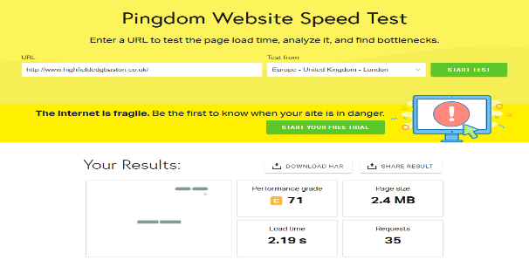
To check the speed and ease of access, I used the Pingdom website speed test. As a result, I obtained a performance grade of 71, a page size of 2.4 MB, a load time of 2.19 seconds, and 3 requests.

Question 1b - Does the website contain many sub-pages? How does a prospective customer navigate these?

Answer:
Yes, the website contains several subpages that you can access from the top, and it also allows you to return to the main menu.
Question 1c - Can a customer make a booking via the webpage?
Answer:
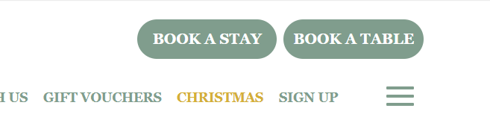
At the top, there are two options: one for staying and another for reserving a table. By clicking on "stay," you can choose the dates and the number of guests. Similarly, if you click on "table reservation," you can select the dates, time, and the number of people for the reservation.
Question 1d - What improvements could be made to the usability of the website?

Answer:
The restaurant's name should be positioned more prominently, featuring a larger, attention-grabbing logo. Furthermore, the address and phone number should be removed from the header of the advertisement. Overall, the current design appears plain and unappealing at first glance. Repeating the option to stay and reserve a table twice on the same page seems unnecessary; this space could be better utilised o emphasise the restaurant's name.
Section 2 – Pleasure – Customer Experience
(75 words maximum for each answer)
Question 2a –
How pleasant does the webpage look? Are there any differences in appearance on a mobile phone versus a computer?
The computer and the phone look the same, they provide the same quality of service.
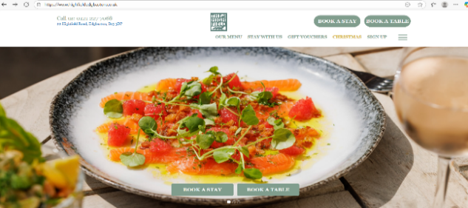
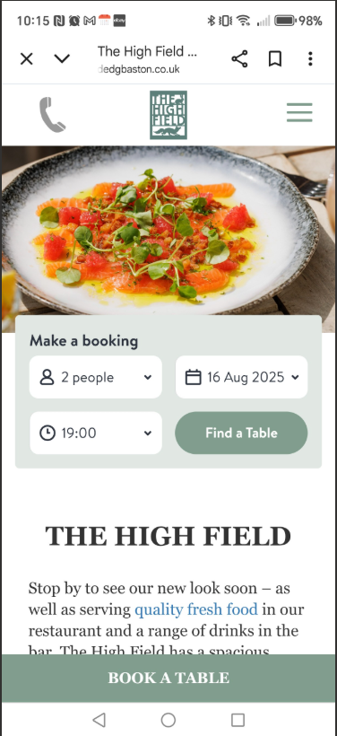

Question 2b - How does the website use imagery, video and colour?

The images they use primarily focus on the local area, particularly the restaurant itself. They showcase the interior of the venue, highlighting the business logo alongside the menu. However, when I checked the website, I noticed it does not feature any videos about the restaurant or its menu. In my opinion, the use of pastel colours creates a sense of authenticity and calmness. Their strategy appears to be aimed at providing a warm, home-like atmosphere.
Question 2c – Has the website made use of an online chat tool on the website? How effective is this in enquiring about the product or service?

Answer: No, the website doesn’t have an online chat tool. I reviewed the website and noticed that there is no option for online chat. However, I can make reservations, which are confirmed online. The only available option for inquiries is a phone number to call the restaurant directly. I believe that calling the restaurant improves the service experience, making it more personalised and accurate.

Question 2d – How effective are the social media links on the website?

Answer:
The page features two social networks: Facebook and Instagram. Accessing both platforms is quick, and they provide ample information, including comments from visitors, photos, and videos showcasing their experiences.

Section 3 – Perceived Value

(75 words maximum for each answer)
Question 3a - How are the services offered by the company made clear to customers?

Yes, the services are detailed at the Top of the website. We can select what we need to know and quickly access the information.
Question 3b - How are customer reviews made available? Are these up to date?

Answer:

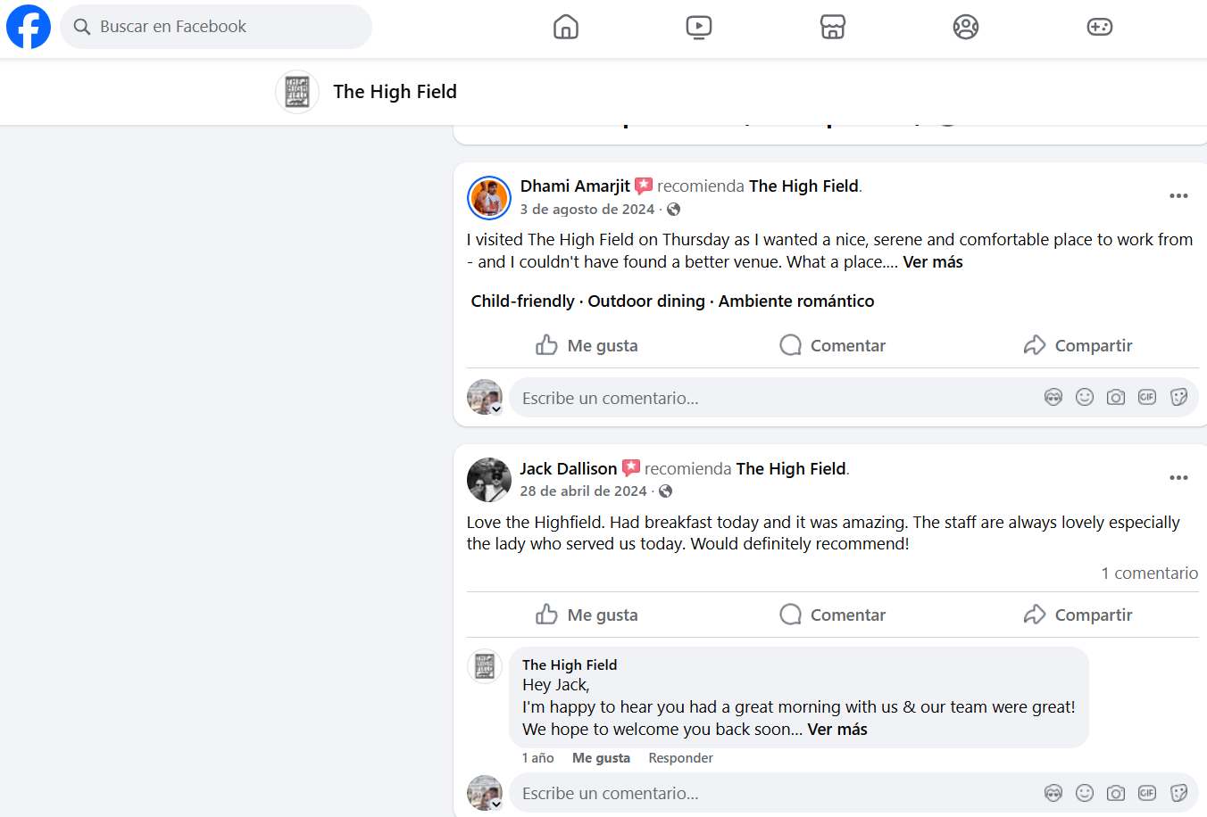
Customers can see and leave reviews on Facebook by visiting the link. They can also provide feedback on the website of the service. In addition, they have updated
The reviews.
Question 3c – How is the service presented as high quality? For what reasons would you use the company’s service or recommend it to a friend or family member?

Answer: The site offers two services: restaurant, pub and accommodation. Upon reviewing the prices, they appear to be of medium standard. The rates are affordable and reasonable compared to higher-end options. I would recommend this place to family and friends for any event, due to its competitive pricing and the good quality of service provided.

Question 3d - Are prices made clear to customers? If yes, do the prices reflect the quality of service shown? If no, why do you think the company has chosen not to include prices?
Answer: Yes, the list of all services offered is clear and well-marked for customers. As previously mentioned, they are reasonable and accessible for any budget.

Section 4 – Searchability

Question 4a - What three words would you type into Google to find this type of service? |  |  | 1.gastro
 |  |  | 2.Pub
 |  |  | 3. Birmingham
Question 4b - When you type these words into google, does the company’s website appear in the top ten websites?

Answer:
When I put the word gastro, pub, birminham in the google browser, the page comes up in second position.
When I put the word Birmingham pub gastro in the google browser, the page comes up in first position.
When I put the word pub Birmingham gastro the page comes up in third position.
Section 5 – Reflection and conclusion

(120 words maximum for each answer)
Question 5a - Do you feel that websites still have relevance in modern UK business? Explain your answer.
Answer:
In my opinion, this page serves as a business platform, showcasing information about the services and products it offers, specifically food and accommodation. Additionally, it provides availability for various social events. The navigation is straightforward, the content is engaging, and the design is user-friendly on both phones and computers.
Question 5b - If you were to make one recommendation about how to improve the website of your chosen company, what would it be? Why have you suggested this improvement?

Answer:
I recommend enhancing the main page's logo and information layout. For instance, the name of the place should be more prominent, and the colors could be more vibrant.

Reference List
Pingdom Website Speed Test available at: https://tools.pingdom.com/#6623a21608400000 (accessed on 08 August 2025).

HighfieldEdgbaston available at: https://www.facebook.com/TheHighFieldEdgbaston/ (accessed on 13 August 2025)

