International Hotel Management (Essay)

Student name: Andrea Bardoczi
Student Number: 2209718
Lecturer: Gayathri Nadeeshani
Introduction
The current essay aims to analyse the difference of marketing mix strategies between Marriott International, and Holiday Inn. Marriott is a very popular international hospitality brand and the company has a total of 30 hospitality brands under its umbrella (marriott, 2021). On the other hand, Holiday Inn is one of the most popular hospitality brands and the company provides services in 30 international markets (ihgplc, 2021). Marriott International's market revenue margin is $17 billion (marriott, 2021). Holiday Inn’s market capitalization is $6.5 billion (ihgplc, 2021). One of the reasons for selecting these two companies for this study is that the marketing strategies of the companies are very different from each other.
Through this essay, the marketing strategies of these two companies will be discussed in detail. At the same time, the current market position of the two companies will be discussed in detail. The strategy followed by these two companies in terms of sustainability marketing approach will be highlighted in this essay. Marketing strategy and business operating system related information of these two companies in pandemic situations will be analysed in this essay.

Main discussion
Marriott is a popular US hospitality brand and the company has been operating in the market for a long time (since 1927, 95 years) (marriott, 2021). The company was initially established as a five star hotel service and restaurant but currently the company is expanding its business towards tourism as well. As noted by Hazira et al., (2021), marketing plan is very important for hospitality brands as customer expectations are very important here. However, as mentioned by Redjeki et al., (2021), Providing practical customer satisfaction is important for the hospitality industry because most of the hospitality industry's revenue margins depend on loan customers. Therefore, in terms of marketing strategy, the marketing team of Marriott International develops a marketing strategy that depends on attracting loyal customers (marriott, 2021).
Holiday Inn is a US based popular hospitality company and this company is also operating in the market for a long time (since 1952, 70 years) (ihgplc, 2021). The company's marketing strategy is currently heavily dependent on the tourism industry, and because of this, the marketing team members of this company are focusing more on attracting new customers than loyal customers (ihgplc, 2021)s. As stated by Silva (2021), attracting new customers always provides hospitality companies with the greatest advantage in keeping ahead in the competitive market. However, as opined by Canhoto and Wei (2021), if more emphasis is placed on attracting new customers, the servicing policy of the company has to be changed again and again which increases the risk factor of the company.
By Market Position Marriott International has a very advantageous position in the market because the company has been able to expand its hospitality services in almost all international markets (marriott, 2021). The company has around 30 subsidiary brands and with all these brands, the company is providing differentiated hospitality services in the tourism industry (marriott, 2021). At present the company has 8000 properties, and with all these properties, the company is able to provide its hospitality services at 8400 locations (marriott, 2021). As noted by Clow and Baack (2013), it is very important to have the support of human resources in the promotional strategy because if there is support from human resource, it is convenient to implement marketing strategy as well as to provide services according to marketing. That's why around 120000 employees are associated with the company in the domestic market as well as the international market (marriott, 2021).
In terms of market position, Holiday Inn's business environment is somewhat weaker than Marriott's (ihgplc, 2021). The company has business operations in Asia Pacific, Europe, America and to a lesser extent African countries (ihgplc, 2021). Moreover, as the company is only investing in the hotel sector, the company's target market in the tourism industry is very limited (ihgplc, 2021). As mentioned by Chaffey and Ellis- Chadwick (2019), in the case of tourism and hospitality business, the revenue margin sources are very limited and the chances of increasing the profit margin are less. This is why there was no increase in Holiday Inn's revenue margin in the last financial year, even though the company did not incur any losses (ihgplc, 2021).
In terms of marketing strategy, the marketing members of Marriott International and Holiday Inn follow the 4P marketing mix strategy, such as price, place, promotion, and product or services. However, the difference between the two companies can be noticed when it comes to target marketing. For example, as mentioned in the annual report, in order to maintain customer loyalty, Marriott International's marketing executives target older customers more (marriott, 2021). As noted by Ghauri (2014), targeting older customers in terms of marketing loyalty maintenance reduces the company's chance of customer churn, rather, the possibility of attracting new customers increases a lot. In addition to tourism marketing, Marriott International's marketing members also work in operating business events (marriott, 2021).
The marketing approach followed by the Holiday Inn manager is more focused on targeting new markets and customers (ihgplc, 2021). In order to attract new customers, the company is providing hotel services in good tourist spots, and for this reason the company is investing heavily in the real estate industry. As opined by Housden (2008), investing in real estate in the hospitality business helps a lot in expanding the business. In terms of marketing approach, some special services are being provided by the company to strengthen the market position of the company, such as food services, meetings, and lodging conventions (ihgplc, 2021). Due to all these marketing strategies the company has directly strengthened its position in the competitive market (ihgplc, 2021).
In sustainable marketing, the company's marketing team is following three factors the most, such as planet, price, and people (marriott, 2021). In order to promote a sustainable marketing approach, the company is focusing more on reducing electricity consumption (marriott, 2021). The company is focusing more on investing in solar system manufacturing units to produce electricity (marriott, 2021). As opined by Kotler and Kartajaya (2017), a sustainable promotional strategy in marketing approach makes customer loyalty much easier because after seeing sustainable marketing, customers easily think that the company has a great sense of duty in social development. At the same time, following a sustainable approach, the company is giving more importance to its service charges and customer demand. Following a sustainable approach is helping the company to increase its number of employees (marriott, 2021).
Following a sustainable marketing approach, Holiday Inn’s marketing team follows special campaigns, such as the VERDE Educational campaign (ihgplc, 2021). Through this educational campaign the company follows the sustainable approach and also the company asks other sectors to follow the sustainable approach (ihgplc, 2021). As noted by Ryan (2012), in addition to following a sustainable approach, asking other organisations to follow a sustainable approach also benefits the parent company. For example, The US and UK hospitality industries are increasingly targeting solar electricity and sustainable water consumption in terms of sustainable approaches, and that's why Holiday Inn's marketing managers don't have much problem in following a sustainable marketing approach (ihgplc, 2021). Following the sustainable approach as well as promoting the brand value of Holiday Inn in the market is improving a lot, and this is affecting the company's customer base and revenue margins (ihgplc, 2021).
The hospitality industry has faced the most problems due to the pandemic situation because of the pandemic situation due to the lock-down situation by the governments of several countries, the services of the hospitality industry were somehow closed. The pandemic situation had a negative impact on Marriott International's revenue margin and the company's sales margin was depressed (marriott, 2021). However, the company began to focus less on the tourism industry as the company's revenue margins in the market became more diversified, and in this case the management of the company is currently focusing more on conducting multiple international business events (marriott, 2021).
On the other hand, as Holiday Inn's revenue margin is limited only in tourism and hotel services, the company's income has gone down (ihgplc, 2021). As the company's income sources are very limited, it is very challenging for the company to generate revenue from the market. In order to get out of this situation, the company has started promoting budget hospitality services more (ihgplc, 2021). Apart from providing budget hospitality services, the company has also launched a new event management facility. Several international business events are being targeted by the company through event management which has greatly widened the company's revenue margin (ihgplc, 2021).

Conclusion
After discussing the above entire essay, it can be concluded that Marriott International develops a marketing strategy that depends on attracting loyal customers. Holiday Inn’s marketing strategy is currently heavily dependent on the tourism industry. It is also known that Marriott International has around 30 subsidiary brands and with all these brands, the company is providing differentiated hospitality services in the tourism industry. It is noticed that in sustainable marketing, these companies’ marketing team is following three factors the most, such as planet, price, and people.
Marketing presentation

Introduction
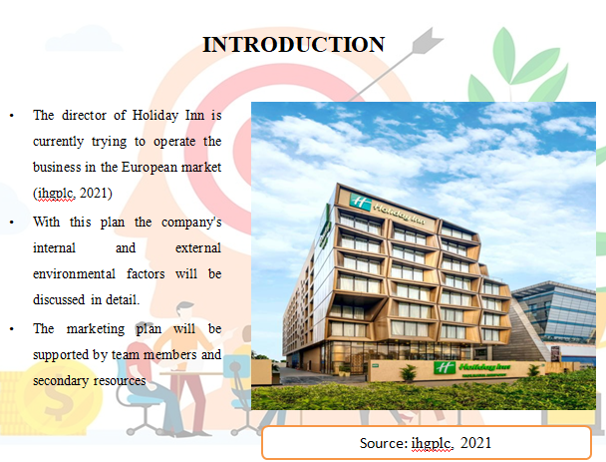
- The director of Holiday Inn is currently trying to operate the business in the European market (ihgplc, 2021)
- With this plan the company's internal and external environmental factors will be discussed in detail.
- The marketing plan will be supported by team members and secondary resources
The current presentation aims to analyse the marketing plan and strategies of Holiday Inn’s to expand hospitality business to the European market. Apart from developing the business in the UK and US markets, the company is currently operating in the Asia Pacific area. Currently the company is targeting the other European markets (many areas of Britain’s) to increase the target market and customer base. During this presentation the company's marketing mix strategy, internal environment analysis and external environment analysis will be discussed in detail.

The marketing mix
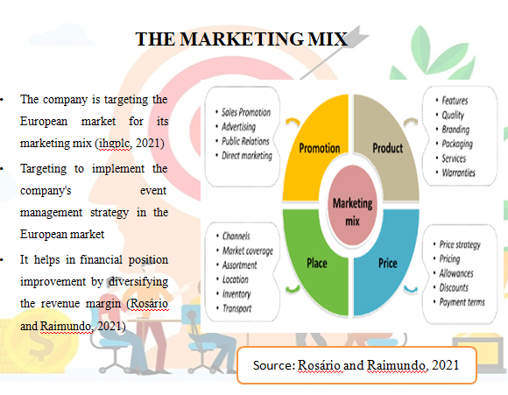
- The company is targeting the European market for its marketing mix (ihgplc, 2021)
- Targeting to implement the company's event management strategy in the European market
- It helps in financial position improvement by diversifying the revenue margin (Rosário and Raimundo, 2021)
In terms of product or service development, Holiday Inn's marketing team is looking to develop hospitality services related to event management. Developing event management in the UK market can be very profitable. Due to the fact that the UK market has a lot of big business events due to which the revenue margin for the company can improve a lot. As noted by Dieguez et al., (2021), providing hospitality services makes it much easier for companies to diversify their revenue margins.
Marketing Mix In terms of target marketing, the company will target various business or financial companies. In the case of event management, if you target the company, the target market is very limited, but targeting financial companies has a much higher revenue potential for event management companies (Fonseca and Carnicelli, 2021). For this reason, the company's managers are communicating directly with event managers of various companies in the field of marketing. Targeting the company's online and offline marketing makes this marketing approach much richer.

Micro marketing environment (SWOT analysis)
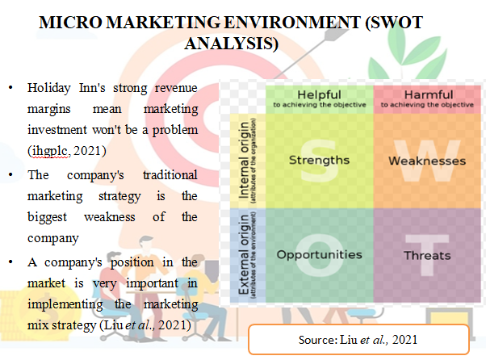
- Holiday Inn's strong revenue margins mean marketing investment won't be a problem (ihgplc, 2021)
- The company's traditional marketing strategy is the biggest weakness of the company
- A company's position in the market is very important in implementing the marketing mix strategy (Liu et al., 2021)
The company's revenue margin in the global market has exceeded $6.5 billion, and that's why it's not too much of a problem to invest in a new business operating in the UK market these days. As stated by Jones (2022), implementing a marketing mix strategy makes the company more likely to increase costs, therefore, having a strong financial position is a positive for any company in implementing its marketing strategy well.
However, due to the company's traditional marketing system, there will be many problems for the company to provide event management services. Human resource support is very important in event management marketing (Thaha et al., 2021). The fact that Holiday Inn's marketing managers do not have much human resources is problematic for the company. However, since the revenue margin is high, it will not be much of a problem for the company to develop human resources. However, the threat for the company to compete with its competitors (such as Marriott International) in the UK market may increase.

Macro marketing environment (PESTLE analysis)
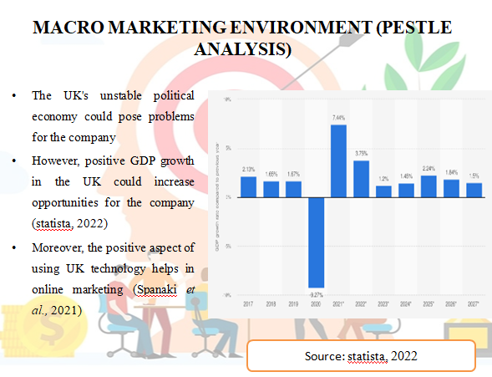
- The UK's unstable political economy could pose problems for the company
- However, positive GDP growth in the UK could increase opportunities for the company (statista, 2022)
- Moreover, the positive aspect of using UK technology helps in online marketing (Spanaki et al., 2021)
The political group in the UK is currently in a very unstable position due to which it may be problematic to expand business into this market. However, due to the positive GDP growth (3.25%, 2.71 Lakh Crore) in the UK, the opportunity to improve the hospitality business in this market is increasing. Socially, many UK companies organise their business meetings in luxury hotels, and in this field more importance is being given to organising domestic business events as well as international business events.
Due to the advanced technical infrastructure of the UK, the company will not have too many problems in operating the business. Due to advanced technical infrastructure the company will not have much problem in following online marketing, and at the same time, it is more convenient to communicate with domestic and international clients through various online marketing methods. Moreover, expanding into the UK legal and environmental law business market is becoming increasingly advantageous.
The UK's Employment Rights Act 1996 will make it much easier for companies to advance their human resources. Also the UK Environment Protection Act 2020 will help the company to promote a sustainable approach.

Creating customer value and engagement
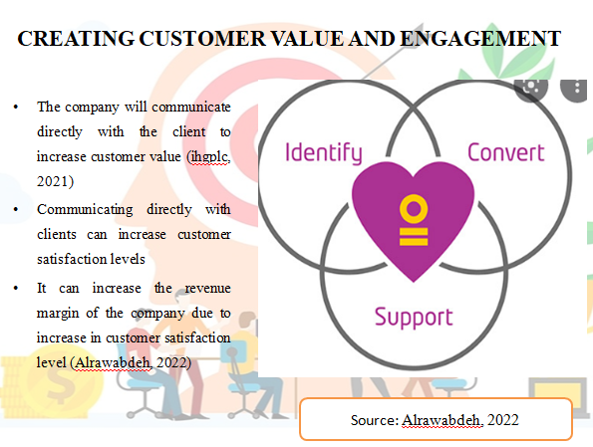
- The company will communicate directly with the client to increase customer value (ihgplc, 2021)
- Communicating directly with clients can increase customer satisfaction levels
- It can increase the revenue margin of the company due to increase in customer satisfaction level (Alrawabdeh, 2022)
In order to maintain customer value, the company's marketing team wants to analyse the demand trends of European market clients. At the same time, certain team members from the company are trying to communicate with other clean companies.
As a result, more companies will show interest in using Holiday Inn for office meetings or other events in the future. This can greatly increase the company's revenue margin and popularity in the corporate world which will help in the company's revenue margin improvement. Moreover, due to the diversification of income sources, it will be more convenient for the company to increase its revenue margin.
In order to improve visitor engagement, the company will arrange special halls or rooms where business meetings can be held well. Moreover, Holiday Inn's marketing team wants to target both online and offline channels for this marketing because selecting two marketing sources will help the company to reduce the communication gap with customers or clients.

Effective use of digital marketing
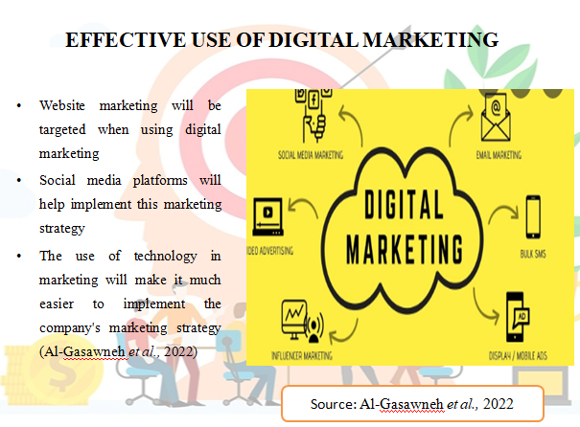
- Website marketing will be targeted when using digital marketing
- Social media platforms will help implement this marketing strategy
- The use of technology in marketing will make it much easier to implement the company's marketing strategy (Al-Gasawneh et al., 2022)
Website development and social media marketing will be given more importance in making the digital marketing strategy effective. In terms of website development, Holiday Inn's official website will be greatly advanced, so that other companies can better understand the activities of this company in the field of event management services. At the same time, social media will be used in advertising as it will be convenient to target a large number of users and professional areas. The marketing team is increasingly targeting development for website development and marketing, and in this field it is planned to employ those employees whose technical skills are more advanced.
The company also wants to stay ahead in server development while implementing the marketing strategy well. This server development process will be more effective by improving the advanced technology infrastructure as well as maintaining cyber security. As a result, it will be much easier for the company to advance their marketing plan in the future, and at the same time it will be more convenient for the company to face competitive advantage.

Work breakdown structure
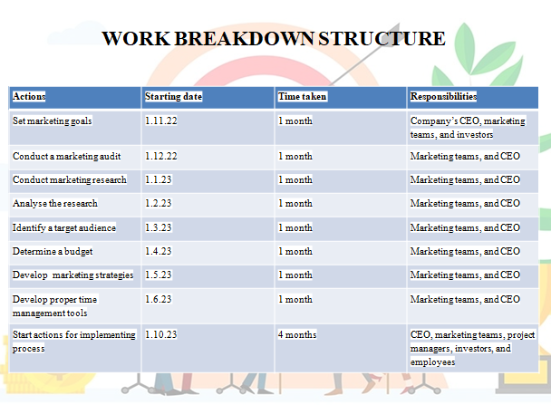
Actions | Starting date | Time taken | Responsibilities
Set marketing goals | 1.11.22 | 1 month | Company’s CEO, marketing teams, and investors
Conduct a marketing audit | 1.12.22 | 1 month | Marketing teams, and CEO
Conduct marketing research | 1.1.23 | 1 month | Marketing teams, and CEO
Analyse the research | 1.2.23 | 1 month | Marketing teams, and CEO
Identify a target audience | 1.3.23 | 1 month | Marketing teams, and CEO
Determine a budget | 1.4.23 | 1 month | Marketing teams, and CEO
Develop marketing strategies | 1.5.23 | 1 month | Marketing teams, and CEO
Develop proper time management tools | 1.6.23 | 1 month | Marketing teams, and CEO
Start actions for implementing process | 1.10.23 | 4 months | CEO, marketing teams, project managers, investors, and employees

It may take up to a year for Holiday Inn's marketing managers to implement this marketing plan, and the skills of the company's CEO, marketing team, and employees are especially important in developing and implementing this marketing plan.

Gantt chart
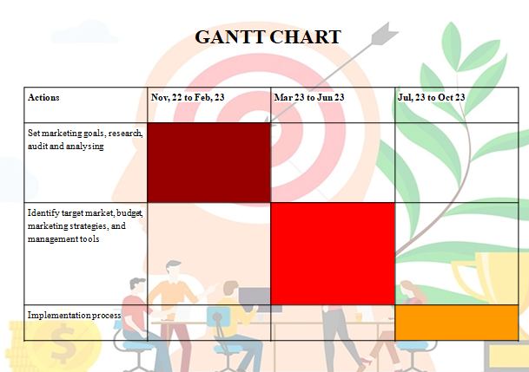
Actions | Nov, 22 to Feb, 23 | Mar 23 to Jun 23 | Jul, 23 to Oct 23
Set marketing goals, research, audit and analysing
Identify target market, budget, marketing strategies, and management tools
Implementation process

Conclusion
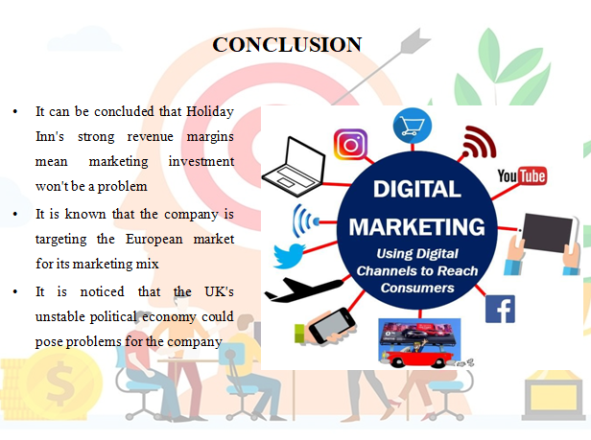
- It can be concluded that Holiday Inn's strong revenue margins mean marketing investment won't be a problem
- It is known that the company is targeting the European market for its marketing mix
- It is noticed that the UK's unstable political economy could pose problems for the company
After discussing the above entire presentation, it can be concluded that the company's revenue margin in the global market has exceeded $6.5 billion, and that's why it's not too much of a problem to invest in a new business operating in the UK market these days.
Reference list
Al-Gasawneh, J. A., AlZubi, K. N., Anuar, M. M., Padlee, S. F., ul-Haque, A., and Saputra, J. (2022). Marketing Performance Sustainability in the Jordanian Hospitality Industry: The Roles of Customer Relationship Management and Service Quality. Sustainability, 14(2), 803.
Alrawabdeh, W. (2022). Seasonal balancing of revenue and demand in hotel industry: The case of Dubai City. Journal of Revenue and Pricing Management, 21(1), 36-49.
Canhoto, A. I., and Wei, L. (2021). Stakeholders of the world, unite!: hospitality in the time of COVID-19. International Journal of Hospitality Management, 95, 102922.
Chaffey, D and Ellis- Chadwick, F. (2019) Digital Marketing. 7th ed, Pearsons, London.
Clow, K and Baack, D (2013), Integrated Advertising, Promotion and Marketing Communications. 6th ed, Pearson, London
Dieguez, T., Ly, N. T., Ferreira, L. P., and Silva, F. J. G. D. (2021, June). Digital customer network strategy influences on Hotel Business. In International Conference Innovation in Engineering (pp. 420-431). Springer, Cham.
Fonseca, A. P., and Carnicelli, S. (2021). Corporate social responsibility and sustainability in a hospitality family business. Sustainability, 13(13), 7091.
Ghauri, P N (2014) International Marketing, 4th Ed, McGraw Hill, London
Hazira, M. N., Alagas, E. N., Amin, M., Zamzuri, N. H., and Zairul, M. M. (2021). The best practice of marketing strategies for the Malaysian business event industry from experts' perspective. Journal of Hospitality and Tourism Insights.
Housden M (2008), Marketing Research and Information, Butterworth Heinemann, Oxford.
ihgplc (2021). Annual report. Available at https://www.ihgplc.com/en/investors/annual-report Accessed on 17.10.2022
Jones, P. (2022). A review of the UK’s tourism recovery plans post COVID-19. Athens Journal of Tourism, 9(1), 9-18.
Kotler,P and Kartajaya, H. Marketing 4.0 Moving from Traditional to Digital (2017) Wiley. New York.
Liu, C. H., Jiang, J. F., and Gan, B. (2021). The antecedent and consequence behaviour of sustainable tourism: integrating the concepts of marketing strategy and destination image. Asia Pacific Journal of Tourism Research, 26(8), 829-848.
marriott (2021). ANNUAL REPORT. Available at https://marriott.gcs-web.com/static-files/b82978a6-9d28-4e38-9855-fc4ae2cebe11 Accessed on 17.10.2022
Redjeki, F., Narimawati, U., and Priadana, S. (2021). Marketing Strategies Used by Hospitality Businesses in Times of Crisis of the COVID-19 Pandemic: Case Study. ENDLESS: International Journal of Future Studies, 4(1), 121-131.
Rosário, A., and Raimundo, R. (2021). Consumer Marketing Strategy and E-Commerce in the Last Decade: A Literature Review. Journal of Theoretical and Applied Electronic Commerce Research, 16(7), 3003-3024.
Ryan, D. (2012) Understanding Digital marketing: Marketing Strategies for Engaging The Digital Generation. Kogan Page, London.
Silva, P. M. (2021). Examination in B2B trade show: the effects of competitive intelligence and the information management system on the exhibitor's marketing strategy. Journal of Marketing Analytics, 9(3), 228-241.
Spanaki, M. Z., Papatheodorou, A., and Pappas, N. (2021). Tourism in the post COVID-19 era: evidence from hotels in the North East of England. Worldwide Hospitality and Tourism Themes, 13(3), 357-368.
statista (2022). United Kingdom: Real gross domestic product (GDP) growth rate from 2017 to 2027. Available at https://www.statista.com/statistics/263613/gross-domestic-product-gdp-growth-rate-in-the-united-kingdom/ Accessed on 17.10.2022
Thaha, A. R., Maulina, E., Muftiadi, R. A., and Alexandri, M. B. (2021). Digital marketing and SMEs: a systematic mapping study. Library Philosophy and Practice (e-journal), 5113.

