Programme: Master of Business Administration (MBA)
Module: Financial Management
Module Code: LCMB7002
Assignment: Financial Performance and Management - Tesla Inc.
Student Name: Ishan Dineshbhai Rana
Student ID:2507137
Lecturers’ Name: Shengfeng Mei, and Patrick Yeboah
Submission Date: 24th April 2026 by 2PM
Word Count: 4906
Table of Contents
1. Introduction 5
1.1 Overview of Tesla Inc. 5
1.2 Industry Context (EV Market) 5
2. Financial Health Check 6
2.1 Overview of Tesla’s Financial Performance (Last 5 Years) 6
2.2 Ratio Analysis 6
a) Profitability Ratios 6
b) Liquidity Ratios 7
c) Efficiency Ratios 7
d) Gearing Ratios 7
e) Investment Ratios 8
f) Cash Flow Ratios 8
2.3 Key Findings 8
a) Identify Trends 8
b) Identify Strengths 9
c) Identify Threats 9
2.4 Summary 9
3. Working Capital Management Analysis 10
3.1 Cash Operating Cycle 10
3.2 Evaluation of Tesla’s Liquidity 10
a) Strengths 10
b) Weaknesses 10
3.3 Recommendations 11
a) Improve Inventory Management 11
b) Credit Policy Improvements 11
c) Supplier Financing Strategies 11
3.4 Financing Options 11
a) Short-term vs Long-Term Financing 11
b) Pros and Cons for Tesla 12
3.5 Summary 12
4. Strategic Financial Restructuring Plan 13
4.1 Current Financial Issues 13
4.2 Proposed Strategies 13
4.3 Impact Analysis 13
4.4 Global & Ethical Considerations 14
4.5 Mitigation and Financial Control Measures related to Risk. 14
4.6 Summary 15
5. Investment Appraisal & Capital Budgeting 15
5.1 Project Evaluation (A, B, C) 15
a) Payback Period (PBP) 15
b) Accounting Rate of Return (ARR) 16
c) Net Present Value (NPV) 16
d) Profitability Index (PI) 16
e) Internal Rate of Return (IRR) 17
5.2 Project Comparison 17
a) Financial Comparison of Results 17
b) Risk Analysis 17
5.3 Recommendation of Best Project 18
5.4 Capital Rationing Decision 18
5.6 Summary 19
6. Conclusion 19
6.1 Summary of Key Findings 19
6.2 Final Strategic Recommendations 19
6.3 CFO Perspective 20
7. References 21
8. Appendices 26
Appendix 1: "Profitability Ratio" 26
Appendix 2: "Liquidity ratio" 26
Appendix 3: "Efficiency ratio" 27
Appendix 4: "Gearing Ratio" 28
Appendix 5: "Investment ratio" 29
Appendix 6: "Cash Flow Ratios" 29
Appendix 7: "Cash Operating Cycle" 30
Appendix 8: Project A 31
Appendix 9: Project B 32
Appendix 10: Project C 33
9. AI Acknowledgement 36

1. Introduction

1.1 Overview of Tesla Inc.
Tesla Inc. is a dominant American electric vehicle and clean energy firm established in 2003 and located in Austin, Texas. In 2024, Tesla recorded its highest revenues of more than $97,690 million and had sold more than 1.8 million vehicles all over the world (Tesla, 2024). The company is dedicated to innovation, sustainability and technological development, creating electric vehicles, battery storage, and solar products, yet still emphasizes creating fewer carbon emissions in the world and saving more energy.

1.2 Industry Context (EV Market)
The electric vehicle (EV) market has been growing at a very fast pace, with sales reaching over 14 million vehicles in 2023, making up almost 18% of the overall automobile sales on the international market. Governments are supporting the adoption of EVs by providing subsidies and emission rules, increasing the competition between manufacturers (Quinton, 2024). Technological innovation and improvements in battery efficiency, with rising consumer demand in sustainable transportation solutions in developed and emerging markets drives the industry.
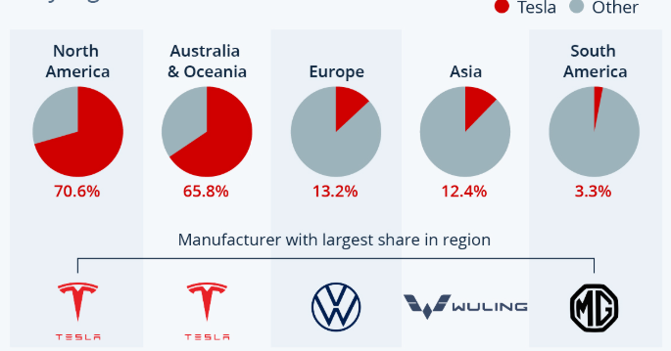
Figure 1: Tesla’s Market Share in 2021 By Region
(Source: Statista, 2026)

2. Financial Health Check

2.1 Overview of Tesla’s Financial Performance (Last 5 Years)
Tesla Inc. demonstrated significant financial growth between 2020 and 2024, supported by expansion in production and global demand. Total assets increased from $52,148m in 2020 to $122,070m in 2024, reflecting strong investment in infrastructure and operations. Revenue grew from $31,536m in 2020 to $97,690m in 2024, while net income rose from $862m to $7,153m, indicating improved profitability despite fluctuations (Tesla, 2020; Tesla, 2024). Shareholders’ equity also strengthened from $22,225m in 2020 to $72,913m in 2024, showing enhanced financial stability. But in 2022-2023, it turns out to be the most profitable, after which it will decrease in 2024, indicating the pressure on the margin. The total liabilities also rose to $48,390m as compared to $28,418m, but at a slower ratio compared to equity-enhancing leverage (Tesla, 2024). Tesla retained a high growth pace, recent drops in profit margins and cash flow productivity reflect some emerging problems in operations and competitiveness in the dynamic electric vehicle market.

2.2 Ratio Analysis

a) Profitability Ratios
The profitability ratios are used to measure how a firm can produce earnings in comparison to the revenue, assets, or equity as a measure of both efficiency in operations and financial performance. These ratios help stakeholders to analyze the effectiveness of the management and the long-term sustainability (Nasution and Yusleny, 2023). Increased profitability implies increased control of costs and value generation. Tesla’s profitability improved significantly from 2020 to 2022, with ROE rising from 3.88% to 28.16% and net profit margin from 2.73% to 15.45%. Nevertheless, the 2024 performance was lower ROE at 9.81% and margin at 7.32% and it signifies inefficiency and high cost or competitive pressure. [See Appendix 1]

b) Liquidity Ratios
Liquidity ratios identify the financial stability of a given company or its level of exposure to risks, by identifying its ability to meet its short-term liabilities by utilizing its current assets. The ratios help the stakeholders to consider the efficiency and solvency of the working capital (Blessing and Sakouvogui, 2023). There is a high rate of liquidity which increases the confidence of the creditors and offers continuity of operation. There are mixed 5-year liquidity position trends. The current ratio has increased to 2.02 (2024) as compared to 1.38 (2021), which shows better short-term solvency. The acid test ratio increased to 1.61 (2024) compared to 1.05 (2022), indicating an improved quick asset coverage. But the cash ratio decreased 1.36 (2020) to 0.56 (2024) indicating that there is less cash available immediately, although the overall liquidity has improved. [See Appendix 2]

c) Efficiency Ratios
The efficiencies ratios measure the efficiency of the company in its utilization of its assets to generate revenue; operations performance is emphasized. These ratios include inventory ratio and turnover ratio, indicating that the company effectively uses its assets and can drive a cash flow (Majka, 2024). The ratio of receivables turnover decreased to 22.11 (2024) as compared to 28.14 (2021) and 27.60 (2022), which showed a slower collection efficiency. There was a decline in the asset turnover ratio (0.99 in 2022) to 0.80 in 2024 indicating less utilisation of the assets. In the same manner, the fixed asset turnover ratio decreased to 2.73 (2024) as compared to 3.46 (2022) indicating that the efficiency of using fixed assets to generate revenues is being weakened as time goes by. [See Appendix 3]

d) Gearing Ratios
Gearing ratios are the measurements of the degree of debt in the capital structure of a firm and are a metric of financial risk and leverage. High gearing risk will increase the financial risk but potentially increase returns (Oranefo and Egbunike, 2023). These ratios are practical in determination of long-term solvency and financial ability of the firm to pay off the debts. The 2024 debt-to-equity ratio of 0.66 showed that Tesla stopped depending on debt and has become more financially stable compared to the 1.28 debt-to-equity ratio of 2020. The times interest earned ratio went up to a greatly bigger level, 25.69 out of 1.54, which means significantly greater capacity to meet interest payments and decreased financial risk. [See Appendix 4]

e) Investment Ratios
Investment ratio relates to returns to shareholders of a company and the perception of the performance by the market. Dividend payout and P/E ratio metrics are used to make investment decisions and represent future growth prospects and profitability (Suroso, 2022). The performance of the investment is mixed and has numerical changes. The dividend payout ratio remained low at 0.02 in 2024, 0.01 in 2023–2022, 0.02 in 2021, and higher at 0.08 in 2020. The price earnings ratio was very high ranging between 2822.68 in the year 2020 and 181.09 in 2024. The return on assets rose from 0.02 in 2020 to 0.15 in 2022, then declined to 0.06 in 2024. [See Appendix 5]

f) Cash Flow Ratios
The cash flow ratios are taken to evaluate the ability of a business to utilize cash on account of operation to cover the short-term liabilities and long-term debts. These ratios provide an insight into the liquidity, solvency, and financial flexibility (Barnabas and Oloyede, 2024). High cash flow is an indication of sustainability and reduced financial risk. Tesla has increased its operating cash flow ratio, operating gross cash flow increased favourably to 0.42 in 2020 and 0.52 in 2024 respectively. Nonetheless, it was lower than 1 with an implication of limited coverage of current liabilities. Cash flow to debt ratio rose to 0.31 as compared to 0.21 indicating a better yet average long-term debt payment ability. [See Appendix 6]

2.3 Key Findings

a) Identify Trends
Tesla presents a high growth pattern in 2020-2024 in terms of revenues, assets, and equity, which means expansion and access into a new market. The profitability grew significantly until 2022-2023 and dropped in 2024. The liquidity and leverage became better, and the efficiency ratios were at a constant level, which indicates a steady operational performance even under the current financial strains (Tesla, 2024).

b) Identify Strengths
The strengths of Tesla are its high revenue growth, growth in total assets, and growth in shareholders' equity, which reflect financial stability and its ability to grow. A better debt-to-equity relationship means that the risk of finances is lower (Huang, 2023). The good receivables management and robust operating cash flows underscore the good operations, whereas long-term profitability provides strong support to its competitiveness in the EV market.

c) Identify Threats
Tesla is threatened by the reduction in profitability in 2024, which means that the margin will become strained, and the cost of operations is increasing. Competitors are becoming more active in the EV market globally, which threatens the market share (Li, 2025). The short-term financial flexibility might be affected by a lower liquidity trend and moderate coverage of cash flow, whereas economic unpredictability and price decreases might also influence financial performance.

2.4 Summary
The financial forecast of Tesla Inc. indicates a high growth in 2020-2024 due to the increase in revenue, assets, and equity. The profitability rose to a high level until 2022-2023 but dropped in 2024, which points to margin pressure. The liquidity and gearing positions have improved, and it shows the enhanced solvency and minimized financial risk. Nonetheless, efficiency ratios deteriorated, indicating inefficiency in asset utilisation and decreased receivables collection. The performance of investment was still unstable, whereas the cash flow ratios showed the average coverage ability. All in all, Tesla is a company with strong growth and financial health, yet with new issues of dwindling profitability, inefficiencies in its operations, and growing rivalry in the international electric vehicle segment.

3. Working Capital Management Analysis

3.1 Cash Operating Cycle
The cash operating cycle entails measuring the amount of time a company uses to make investments in its inventory and receivables and convert them to cash after the payables. It indicates efficiency and management of the working capital (Asman et al., 2022). A smaller cycle means that there is greater control over the cash flow and efficiency. Cash operating cycle of Tesla varied between -0.74 days in 2020 and 14.80 days in 2024. Negative cycles experienced in 2020 and 2021 show effective management of the cash; cash receivable was received prior to payments (Tesla, 2024). Nonetheless, the rise to 14.80 days in 2024 indicates slower cash conversion, which is an indicator of lower working capital efficiency and high liquidity pressure. [See Appendix 7]

3.2 Evaluation of Tesla’s Liquidity

a) Strengths
The liquidity position of Tesla is good because the ratio of current decreased in 2021, reaching 1.38, and increased in 2024, reaching 2.02, showing an increase in the short-term debtor capacity. The acid-test ratio also grew to 1.61, indicating adequate liquid assets without having to use inventory (Tesla, 2024). Moreover, positive operating cash flows help sustain financial stability in the short-term and effective management of working capital.

b) Weaknesses
Tesla has improved, but the pressure on the liquidity of Tesla is reflected in the fluctuations of the cash operating cycle, which has risen to 14.80 days in 2024. This signifies a reduced rate of cash conversion (Tesla, 2024). Moreover, the use of inventory to provide liquidity in the previous years and average cash flow ratios less than 1 indicate that they may be unable to sufficiently meet liabilities on an operating cash basis.

3.3 Recommendations

a) Improve Inventory Management
Tesla needs to improve their inventory control through the adoption of just-in-time (JIT) systems and advanced demand forecasting technologies in order to minimize the holding costs and enhance the efficiency of turnover. The reduction of excess stock and optimization of the production schedule will minimize inventory days, increase cash flow, and operational efficiency, which will allow the resources to be utilized more effectively and better working capital management (Ramadani et al., 2024).

b) Credit Policy Improvements
Tesla can reinforce its credit policy by imposing more rigorous credit evaluation and cutting down the collection times of its receivables. Early payment discounts and better customer credit monitoring systems will increase cash inflows (Deng, 2024). Efficient receivables management will shorten the receivable days, enhance liquidity, and convert sales into cash more quickly, which will result in financial stability.

c) Supplier Financing Strategies
Tesla should be having a longer payment term with the suppliers in such a way that it does not compromise with its suppliers. The solutions to sustain cash during preserving the stability of the supply chain can be the implementation of supplier financing or trade credit (Ren et al., 2025). This approach increases liquidity by pushing cash expenditures out, increasing the cash operating cycle and gaining more flexibility in meeting short-term financial commitments.

3.4 Financing Options

a) Short-term vs Long-Term Financing
Short-term financing is the sum of money that is borrowed in periods less than a year, like trade credit and short-term loans, and is mainly used in relation to work capital requirements. Long-term financing refers to the financing obtained over a period of more than one year, such as equity and long-term debt, and that applies to expansion and capital investment (Ding, 2025). This decision will require cost, risk and financial flexibility.

b) Pros and Cons for Tesla
Short-term financing provides Tesla with flexibility and decreases initial costs but increases the refinancing and liquidity risk. Alternatively, long-term funding is more stable and allows large-scale investments, but with a possible increase in cost and obligation in the long-term (Cao, 2025). Tesla must compromise between both in order to optimise its capital structure, assume risk, and facilitate long-term growth and efficiency.

3.5 Summary
The working capital management in Tesla Inc. indicates how the company has changed in terms of cash flows and liquidity in the past years. The cash operating cycle showed an increase in negative in 2020-21 to 14.80 days in 2024, which means that there is less cash conversion and increasing pressure on working capital efficiency. Nevertheless, Tesla is still very liquid, and the ratio of current ratio now stands at 2.02 and the acid-test ratio at 1.61 which points to sufficient short-term solvency. The positive operating cash flows also contribute to financial stability. Nonetheless, there are weaknesses in changing cash cycles and cash flow ratios of less than one, which indicates a restriction in meeting liabilities solely through operations. To mitigate such problems, Tesla should be advised to improve the inventory management by using just-in-time, and the demand forecasting to minimize the holding costs and turnover. Enhancing credit policy and shortening receivables collection time would speed up cash inflows and enhance liquidity. Moreover, short-term cash strains might be alleviated through adopting supplier financing strategies and negotiating long-term payment terms. In terms of financing, short-term financing offers flexibility and risk of liquidity, but long-term financing offers stability but can be quite expensive. The combination of financing will play a crucial role in balancing the capital structure to ensure risk management and sustainable growth.

4. Strategic Financial Restructuring Plan

4.1 Current Financial Issues
Tesla has been experiencing several financial challenges pertaining to its capital structure, pressure on its costs, and risk points of expansion. Although its debt-to-equity ratio decreased from 1.28 in 2020 to 0.66 in 2024, overall liabilities have grown to reach $48,390m, which indicates still enjoying external funding. Increased production and raw material prices, especially lithium and battery materials, have caused a reduction in the profit margin in 2024. Moreover, profitability has also been further squeezed down by aggressive pricing to retain market share (Olesia and Zhou, 2023). Diversification through global markets into new gigafactories will expose the company to operational and financial risks such as high capital investment and unpredictable returns. These aspects demonstrate the necessity of the successful restructuring of finance to retain stable growth and competitive ability.

4.2 Proposed Strategies
Tesla can take several financial steps towards improving its financial situation. There is also the use of equity financing to raise funds without any additional financial risk and additional expansion and a healthy balance sheet. Financial pressures can be reduced by restructuring the debt, such as refinancing old debts at lower rate or even extending the maturity of the debt, which would promote a more stable cash flow. Also, Tesla can streamline the portfolio by selling poorly performing assets and redistributing investments in high-growth business opportunities like energy storage and driverless technology. The growth plans must be centred on cost-effective manufacturing and geographic diversification to reduce the risks to a minimum (Paakko, 2024). These strategies will assist Tesla to increase financial flexibility, lower leverage risks, and sustain the creation of long-term value at the same time as enhance operational efficiency.

4.3 Impact Analysis
It is argued that the suggested restructuring plans will have a positive influence on the overall financial performance of Tesla. The equity financing will enhance the equity of the shareholders, as well as decrease leverage, and the financial risk will be decreased. The interest coverage and cash flow stability will be improved with debt restructuring, and Tesla will be more capable of fulfilling its financial obligations. Efficiency in operations and profitability will also be enhanced by strategic positioning of assets and focus, leading to long-term shareholder value (Purnawan, 2024). Relying too much on equity financing, however, can dilute the existing shareholders' ownership. Better financial freedom will enable Tesla to adapt to the market and competition changes effectively. The net effect of these strategies will be a balanced capital structure, risk management, and an improved ability of the company to maintain growth in an extremely competitive industry.

4.4 Global & Ethical Considerations
Tesla is making filings in an international setting where it will be exposed to fluctuations on currency, inflation and variation in taxation systems. There is a currency risk due to global operations, which affects revenue and cost structure. The cost of production is raised, especially raw materials by inflation, which impacts profitability (Nwosu et al., 2025). The financial planning and net returns of Tesla are affected by taxation policies in various countries. Besides, environmental, social, and governance (ESG) issues are vital since the business model of Tesla is interconnected with sustainability and clean energy. Initiatives like ethical sourcing of materials, including lithium and cobalt, and responsible labour practices are critical in ensuring corporate reputation (Deberdt and Le Billon, 2022). Adherence to international law and corporate social responsibility increases the trust of stakeholders as well as long-term sustainability. The response to these factors will help Tesla to direct their financial strategies towards ethical standards and expectations of the market around the world.

4.5 Mitigation and Financial Control Measures related to Risk.
Tesla Inc. needs to embrace sound risk mitigation and financial management strategies to enhance financial restructuring. Advanced financial forecasting and scenario analysis can be used to predict market turmoil, price changes, and market unpredictability. The introduction of a stringent system of cost control, such as budgeting discipline and variance analysis, will be used to observe operational efficiency and minimize wasteful spending (Purnawan, 2024). The Tesla Company needs to diversify its supply chain also to reduce its reliance on a few sources of key raw materials like lithium and cobalt thus limiting the risk of disruption of supplies. Also, the foreign exchange and commodity price risks can be hedged to achieve more predictable financial results. The enhancement of internal controls, the transparency, and performance monitoring systems will enhance the decision making and accountability. Real-time financial tracking and strategic planning can be further improved by investing in digital financial systems and data analytics (Deberdt and Le Billon, 2022). All these measures contribute to the enhancement of financial resilience, mitigation of exposure to external shocks and sustainable long-term growth and operational efficiency and investor confidence.

4.6 Summary
The strategic financial restructuring plan of Tesla Inc. focuses on the major problems; increasing expenses, risks associated with expansion, and challenges of capital structure. Strategies, such as equity financing, debt restructuring and asset optimisation, are proposed to enhance financial stability and flexibility. The strategy is likely to boost profitability, lessen financial risk, and promote long-term growth. Also, global and ethical concerns, as well as, risk management aspects, make it comply with sustainability and regulatory standards. On the whole, the restructuring strategy puts Tesla in a position to be competitive and financially stable in the dynamic global market.

5. Investment Appraisal & Capital Budgeting

5.1 Project Evaluation (A, B, C)

a) Payback Period (PBP)
A payback period is used to determine the number of years it takes to cover the investment using the inflows of cash of a project. It analyzes the risk of liquidity and the rate of recovery of investments. The shorter the payback period, the better because it minimizes uncertainty and better manages cash flow, but it does not consider the time value of money (Sinaga et al., 2023). Projects B, C, and A did not pay back: none of the projects recaptured the original investment amount of 50 million pounds in five years. This implies increased liquidity risk and a reduced rate of cash recovery. The projects all fall short of the payback criterion despite the difference in their cash inflows, thus being not so attractive in terms of cash in the short term. [Referred to Appendix 8, 9 and 10]

b) Accounting Rate of Return (ARR)
Accounting rate of return is used to evaluate the mean annual accounting profit of a given investment as a percentage of the original investment. It considers profitability based on accounting information other than cash flows. Higher ARR is a signal of greater ROI, although it does not consider the time value of money and the time of cash flows (Huang and Tanaka, 2022). Project C has an ARR of 6%, then 2% of Project B and 1.6% of Project A. This means that Project C will have a high accounting profitability. The outcomes reveal that Project C is more appealing in terms of average returns, and Projects A and B have relatively lower profits. [Referred to Appendix 8, 9 and 10]

c) Net Present Value (NPV)
Net present value computes the value of the difference between the present value of inflows of cash and the initial investment, taking into consideration the time value of money. When the NPV is positive, it shows that it creates value and the project is acceptable. It is a popular investment appraisal technique to maximise shareholder wealth (Shou, 2022). Project C would have the best NPV of £1.98 million, then Project B with the £8.30 million and Project A with the £8.68 million (considering a negative value). Project C shows a smaller loss and is quite favourable despite all the NPVs being negative. This implies that not all of the projects are valuable at the 10% discount rate. [Referred to Appendix 8, 9 and 10]

d) Profitability Index (PI)
Profitability index is used to quantify or measure the value generated concerning investment per unit of investment, dividing the present value of inflows by the initial investment. A PI above one indicates a good project. It has found application in the capital rationing process where scarce resources are to be resourcefully allocated (Al-Ali and Al-Shabeeb, 2024). The profitability index of Project A and Project B is both 1.17, whilst that of Project C is 1.04. Projects A and B have high returns per unit of investment, though they all exceed one, which shows their acceptability. Nevertheless, the variation is minimal, implying a similar efficiency in projects in constrained investment conditions. [Referred to Appendix 8, 9 and 10]

e) Internal Rate of Return (IRR)
The internal rate of return refers to the discount rate at which the net present value of a project is equal to zero. It applies to the anticipated rate of return on the project (Pranoto et al., 2025). It is an important decision-making tool because projects whose IRR exceeds the required rate of return are accepted. Project C has the largest IRR of 8.59%, then Project B with an IRR of 3.26%, and lastly Project A with an IRR of 2.72%. None of the projects is financially viable since all the IRRs fall short of the target discount rate of 10%. Nonetheless, Project C is the most desirable choice since it has a relatively higher yield. [Referred to Appendix 8, 9 and 10]

5.2 Project Comparison

a) Financial Comparison of Results
The financial comparison of Projects A, B, and C demonstrates different performance under the investment appraisal techniques. Project C shows the best returns in terms of profitability with an ARR of 6% and an IRR of 8.59%. But Project A and Project B yield higher NPVs of £8.68 million and £8.30 million respectively, rather than 1.98 million in Project C, which is a strong indication of value creation. Also, the profitability index value of Project A and Project B (1.17) is greater than that of Project C (1.04), indicating a more optimal use of the investment. Projects A and B are better in their overall contribution to finances, though neither of the projects is at the 10% required rate of return.

b) Risk Analysis
The project C comes with a greater risk given inconsistent and varying cash inflows and growing uncertainty in returns. Project B provides predictable and constant cash flows, thereby minimizing the risk to finance, increasing predictability. Project A involves average risk and inflows that are variable inflows. There is a trade-off between financial and operational risk given the failing profitability and competitive advantage of Tesla, and it is wise to opt for stable cash flows on the project (Huang, 2023).

5.3 Recommendation of Best Project
Project C can be selected as the most suitable investment even though all projects have IRRs which are lower than the required discount rate of 10%. Project C has also shown high ARR (6%), IRR (8.59%), which implies that it is more profitable than the other two projects (Project A and B). It has also shown a low negative NPV (£1.98m), which implies that the value loss is not as immense. Financial performance-wise, Tesla has experienced a decreasing profitability and a rising cost pressure in 2024, and it is critical to choose a project with higher return prospects (De Almeida, 2024). The increased returns of project C would better suit the interests of Tesla, which would need to increase its margin and efficiency. Non-financially, the increment of Project C variable-cash inflows could increase growth opportunities and innovation potential, customer loyalty and competitive positioning. Despite the presence of the additional risk, Tesla has a very robust liquidity position and a better capital structure, which can absorb the risk, and thus, Project C is the most strategic among the options.

5.4 Capital Rationing Decision
Tesla can invest in a restriction of two projects under capital rationing, with the limitation of £100m since each project will be an investment of £50m. The choice must be determined based on the maximum total Net Present Value (NPV) and returns in general. Project A and Project B give an NPV of £8.68M and £8.30M, respectively, and Project C gives £1.98M. Hence, Project A and Project B give the best combination of NPV of £16.98m, which is a lot more superior compared to any other combination.
Project C has the highest ARR and IRR, but with a lower NPV, it has poor value creation in comparison with Projects A and B. In the financial aspect, Tesla ought to work on initiatives that will yield maximum shareholder wealth, thus NPV is the best criterion. Also, Projects A and B offer smoother and more predictable cash flow, minimizing financial risk and benefiting liquidity management. The strategically selected Projects A and B are associated with the fact that Tesla needs stabilized returns amidst increasing competition and price pressures. The combination minimises risk whilst maximising value and thus is the most effective means by which to deploy limited amounts of capital in a capital rationing environment.

5.6 Summary
Projects A, B and C are compared based on the main techniques of PBP, ARR, NPV, PI and IRR when the investment appraisal analysis of Tesla Inc. is provided. All the projects have 10% returns that are not satisfactory, and each has constraints in both payback and value creation. Project C has the best ARR and IRR, which means that it is more profitable but involves a greater risk. Nevertheless, the combined NPV of Projects A and B is more beneficial and stable in cash flows. In capital rationing, Projects A and B should be chosen, which still maximises shareholder value, and minimises financial risk and more predictable returns.

6. Conclusion

6.1 Summary of Key Findings
In the analysis, Tesla has experienced high growth in revenue, assets, and equity and this is a sign that Tesla has grown and dominated the market within the past five years. In 2024, profitability declined, which is an indication of cost and competition issues. The liquidity was boosted overall, and the working capital efficiency decreased slightly. The findings of the investment appraisal show that the profitability of Project C is relatively higher and thus pass the 10% required of the undertaking as compared to both Projects A and B which have higher value creation as indicated by NPV.

6.2 Final Strategic Recommendations
Tesla needs to concentrate on enhancing profitability and performance through cost containment and effective price discipline. An increase in liquidity will be achieved through the improvement of working capital management, especially the inventory and cash conversion cycle (Sogomi et al., 2024). Investment-wise, Project C can be preferred because it gives better returns, whereas Projects A and B should be an option due to their better NPVs under capital rationing. Tesla must consider a moderate approach to financing, which involves equity and low-cost debt, in order to finance the expansion and reduce the financial risk. Also, the financial metric is to be considered by the investment decisions, along with the strategic appeal for future development. The focus on innovation, cost-efficiency, and global diversification will help Tesla to be competitive and attain sustainable financial results in the fast-changing electric vehicle market.

6.3 CFO Perspective
As a Chief Financial Officer, it is crucial to have a good balance between growth and financial stability. Tesla needs to focus more on investments that are most likely to give high value to the shareholders and face financial risks effectively. This is dependent on strategic capital deployment, a better approach to liquidity management, and a keen assessment of investment prospects (Li, 2024). CFO must aim at improving profitability and retaining a consistent capital structure, as well as ensuring long-term sustainability with strong financial planning and strategic decision-making.

7. References
Al-Ali, A.H.H. and Al-Shabeeb, S.K.I., 2024. Relationship between profitability indicators and maximization market value added and intrinsic for the industrial companies. Global Business & Finance Review (GBFR), 29(2), pp.71-84. https://www.econstor.eu/bitstream/10419/305960/1/id596.pdf
Asman, F.N., Fernandez, D., Jamaludin, N.A., Omar Zaki, H. and Ghazali, A.W., 2022. Cash conversion cycle and firm’s performance. International Journal of Academic Research in Business and Social Sciences, 12(11), pp.2682-2692. https://www.academia.edu/download/106769993/cash-conversion-cycle-and-firms-performance.pdf
Barnabas, B. and Oloyede, J., 2024. Cash flow optimization: Strategies for enhancing short-term liquidity. Available at SSRN 5004465. https://papers.ssrn.com/sol3/Delivery.cfm?abstractid=5004465
Blessing, H. and Sakouvogui, G., 2023. Impact of liquidity and solvency ratios on financial performance: a comprehensive analysis. Indonesia Auditing Research Journal, 12(3), pp.102-115. http://journals.iarn.or.id/index.php/ARJ/article/download/208/141
Cao, X., 2025, August. A Comparative Analysis of Financial Performance of Tesla and BYD Based on Financial Statements Ratios. In 2025 5th International Conference on Enterprise Management and Economic Development (ICEMED 2025) (pp. 544-559). Atlantis Press. https://www.atlantis-press.com/article/126014981.pdf
De Almeida, J.B.T., 2024. Unraveling the Tesla phenomenon: A comprehensive analysis of stock valuation and discrepancy between price and value factors (Master's thesis, ISCTE-Instituto Universitario de Lisboa (Portugal)). https://search.proquest.com/openview/d14f2c634ea17c5724049e371b9bf5b1/1?pq-origsite=gscholar&cbl=2026366&diss=y
Deberdt, R. and Le Billon, P., 2022. The green transition in context—cobalt responsible sourcing for battery manufacturing. Society & Natural Resources, 35(7), pp.784-803. https://www.tandfonline.com/doi/abs/10.1080/08941920.2022.2049410
Deng, Y., 2024. Future Development Analysis Based on the Price Reduction Trend of Tesla. Advances in Economics, Management and Political Sciences, 112(1), pp.156-162. https://sure.sunderland.ac.uk/id/eprint/18412/1/pdf.pdf
Ding, R., 2025, July. Value Investing in the EV Industry: A Case Study of Tesla. In 2025 International Conference on Financial Risk and Investment Management (ICFRIM 2025) (pp. 929-937). Atlantis Press. https://www.atlantis-press.com/article/126013059.pdf
Huang, W., 2023. Understanding Tesla’s Financial Strength: Analysis of Financial Reports and DuPont Analysis. Highlights in Business, Economics and Management, 6, pp.250-261. https://pdfs.semanticscholar.org/13d2/10f4a9e7d5c3806b1f364c066b5617a3823c.pdf
Huang, Z. and Tanaka, F., 2022. MSPM: A modularized and scalable multi-agent reinforcement learning-based system for financial portfolio management. Plos one, 17(2), p.e0263689. https://journals.plos.org/plosone/article/file?id=10.1371/journal.pone.0263689&type=printable
Li, Y., 2025, February. Financial Analysis of the Company Tesla. In International Workshop on Navigating the Digital Business Frontier for Sustainable Financial Innovation (ICDEBA 2024) (pp. 566-575). Atlantis Press. https://www.atlantis-press.com/article/126008536.pdf
Li, Y., 2025, November. Analysis of Company’s Financial Situation: Taking Tesla Company as an Example. In 2025 International Conference on Financial Innovation and Marketing Management (FIMM 2025) (pp. 845-852). Atlantis Press. https://www.atlantis-press.com/article/126017147.pdf
Majka, M., 2024. Understanding Efficiency Ratios. https://www.researchgate.net/profile/Marcin-Majka-2/publication/381402363_Understanding_Efficiency_Ratios/links/666b64b9de777205a32c2aa5/Understanding-Efficiency-Ratios.pdf
Nasution, Y.A. and Yusleny, Y., 2023, February. Financial Performance Measurement Using Profitability Ratios And Liquidity Ratios. In Proceeding Medan International Conference on Economic and Business (Vol. 1, pp. 1730-1741). https://proceeding.umsu.ac.id/index.php/Miceb/article/download/282/303
Nwosu, O., Mairafi, S.L., Musa, A.A. and Kolo, I., 2025. Effect of Inflation and Exchange Rates on Financial Performance of Selected Quoted Manufacturing Companies in Nigeria. Journal of Business Development and Management Research. https://africanscholarpub.com/ajbdmr/article/download/573/577
Olesia, D. and Zhou, J., 2023. Financial risks in mergers and acquisitions (M&A): a case study of SolarCity’s acquisition by Tesla. Front. Bus. Econ. Manage, 11(3), pp.99-110. https://pdfs.semanticscholar.org/1cfd/04e51b1da883ff13930e4e44ad206ccd3840.pdf
Oranefo, P.C. and Egbunike, C.F., 2023. Gearing ratio and operating cash flow performance of quoted manufacturing firms in Nigeria. International Journal of Financial, Accounting, and Management, 4(4), pp.395-410. https://www.neliti.com/publications/620973/gearing-ratio-and-operating-cash-flow-performance-of-quoted-manufacturing-firms
Paakko, O., 2024. Supply chain complexities in developing electric autonomous vehicles: a comparative analysis of Tesla and Waymo. https://lutpub.lut.fi/bitstream/handle/10024/168870/bachelorsthesis_paakko_otto.pdf?sequence=1
Pranoto, A., Hermawan, H. and Albart, N., 2025. A Systematic Literature Review: Business Feasibility Analysis Using Net Present Value (NPV) and Internal Rate of Return (IRR) Methods in the Automotive Industry. Jurnal Indonesia Sosial Sains, 6(1), pp.171-184. https://elibrary.ru/item.asp?id=81154433
Purnawan, B.G., 2024. Accelerating the Future Tesla Market Strategy and Growth Opportunities. https://www.academia.edu/download/124198295/Accelerating_the_Future_Tesla_Market_Strategy_and_Growth_Opportunities.pdf
Quinton, C., 2024. The Impact of Government Subsidies on EV Manufacturers. https://digitalcommons.liberty.edu/cgi/viewcontent.cgi?article=2469&context=honors
Ramadani, R.A., Hati, B.K. and Setiawan, Z., 2024. Warehousing and inventory management analysis: case study Tesla. INC. Jurnal media akademik (JMA), 2(9). https://jurnal.mediaakademik.com/index.php/jma/article/download/773/718
Ren, P., Shi, B., Xue, Q. and Zang, W., 2025. Enterprise Supplier Management and Sustainable Development: A Case Study of Tesla Supplier Management. Journal of Education, Humanities and Social Sciences, 61, pp.129-133. http://drpehss.com/index.php/ojs/article/download/22/21
Shou, T., 2022, July. A literature review on the net present value (NPV) valuation method. In 2022 2nd International Conference on Enterprise Management and Economic Development (ICEMED 2022) (pp. 826-830). Atlantis Press. https://www.atlantis-press.com/article/125975449.pdf
Sinaga, A.S., Sari, M.M., Hutasuhut, A.A., Zahara, S.T., Amanda, A., Fitri, A. and Caesario, M.A., 2023. Comparison of capital budgeting methods: NPV, IRR, PAYBACK PERIOD. World Journal of Advanced Research and Reviews, 19(2), pp.1078-1081. https://pdfs.semanticscholar.org/35f5/923a958b071288b38d4e960e8268477ec19a.pdf
Sogomi, F.C., Patrick, M.K. and Kamau, C.G., 2024. Exploring the relationship between working capital management, liquidity, and financial performance within the context of Kenyan SME’s. African Journal of Commercial Studies, 4(2), pp.113-120. https://www.a-fl-insight.com/vol-15/80.pdf
Suroso, S., 2022. Can Financial Ratios Improve Stock Returns in Manufacturing Companies?. Atestasi: Jurnal Ilmiah Akuntansi, 5(1), pp.137-151. https://jurnal.feb-umi.id/index.php/ATESTASI/article/download/32/13
Tesla. 2020. Annual report of Tesla, Inc. of 2020. Available at: https://www.annualreports.com/HostedData/AnnualReportArchive/t/NASDAQ_TSLA_2020.pdf [Accessed 24th March 2026]
Tesla. 2022. Annual report of Tesla, Inc. of 2022. Available at: https://www.annualreports.com/HostedData/AnnualReportArchive/t/NASDAQ_TSLA_2022.pdf [Accessed 24th March 2026]
Tesla. 2023. Annual report of Tesla, Inc. of 2023. Available at: https://www.annualreports.com/HostedData/AnnualReportArchive/t/NASDAQ_TSLA_2023.pdf [Accessed 24th March 2026]
Tesla. 2024. Annual report of Tesla, Inc. of 2024. Available at: https://www.annualreports.com/HostedData/AnnualReports/PDF/NASDAQ_TSLA_2024.pdf [Accessed 24th March 2026]
Yahoo. 2026. Tesla Market Price per Share (TSLA). Available at: https://finance.yahoo.com/quote/TSLA/history/?utm_source=chatgpt.com&guccounter=1&guce_referrer=aHR0cHM6Ly9jaGF0Z3B0LmNvbS8&guce_referrer_sig=AQAAAGa6aklRP6RWlBYu4RlU4EAeLu6MTnAZjVfRkoo3P8Et3cEWz83e56fi5c7VBCpDPMqXWiM8XzU1-y_GPBOsJsQ_fb8YZxCwsFouyi3QK6-yVbVi0Cme7HgcE5C1ViXEuziosUVkun7nvZFGKKOcW14_OwhOUybPOpJsITojVaYT&period1=1616594957&period2=1774361309 [Accessed 24th March 2026]

8. Appendices

Appendix 1: "Profitability Ratio"
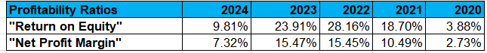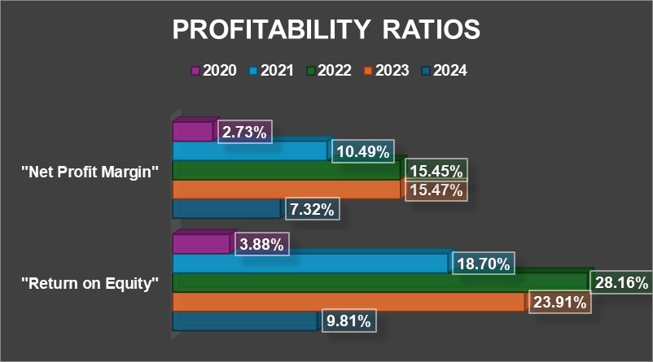
(Source: MS-Excel)

Appendix 2: "Liquidity ratio"
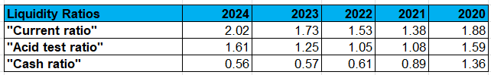
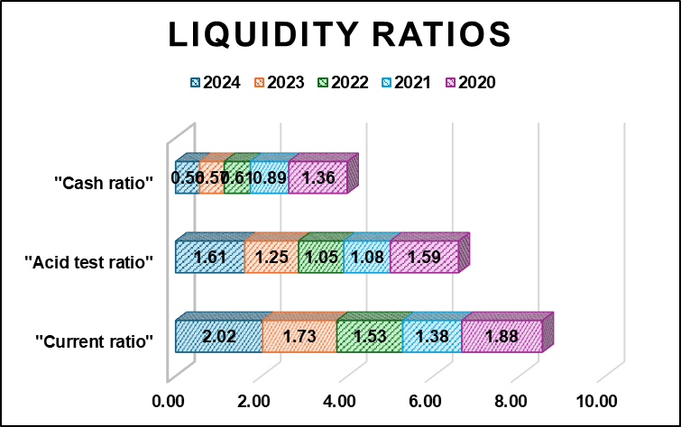
(Source: MS-Excel)

Appendix 3: "Efficiency ratio"
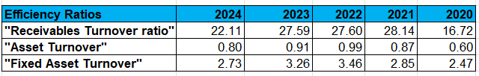
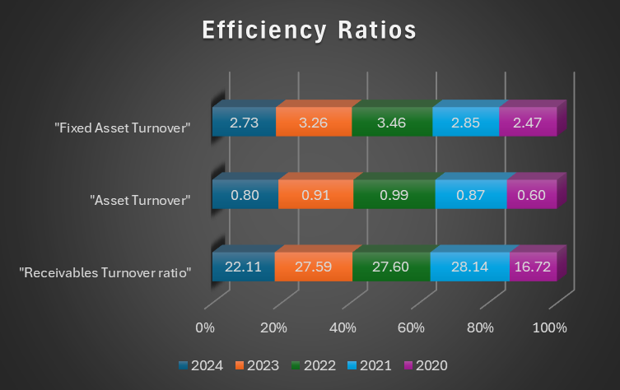
(Source: MS-Excel)

Appendix 4: "Gearing Ratio"
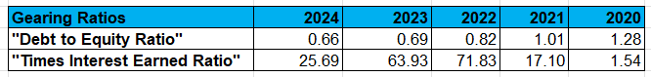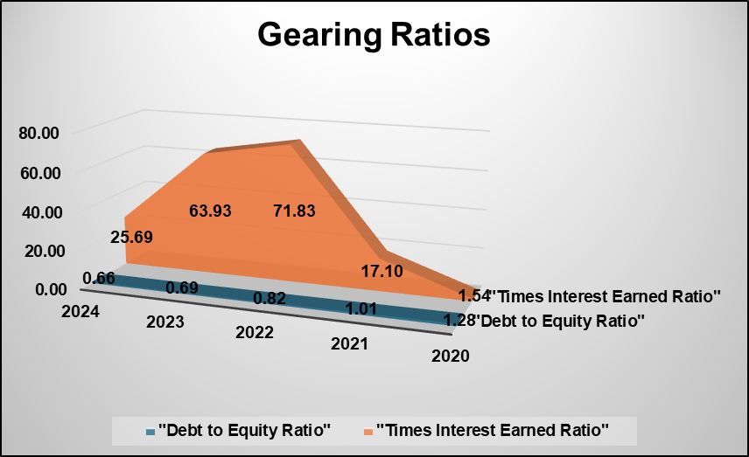
(Source: MS-Excel)

Appendix 5: "Investment ratio"
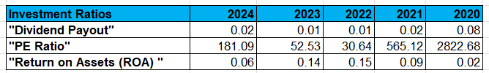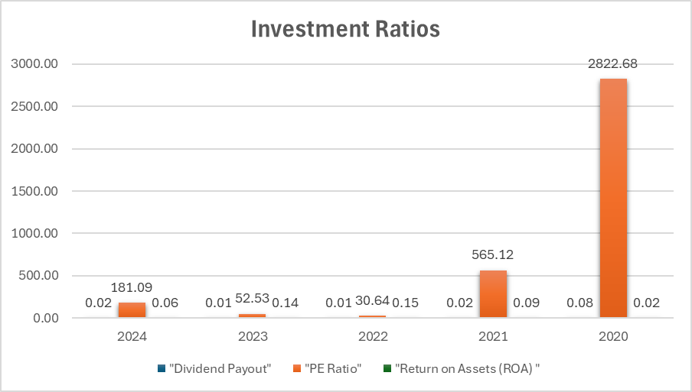
(Source: MS-Excel)

Appendix 6: "Cash Flow Ratios"
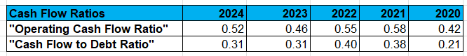
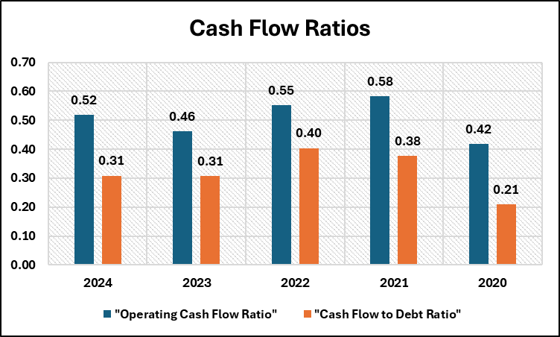
(Source: MS-Excel)

Appendix 7: "Cash Operating Cycle"
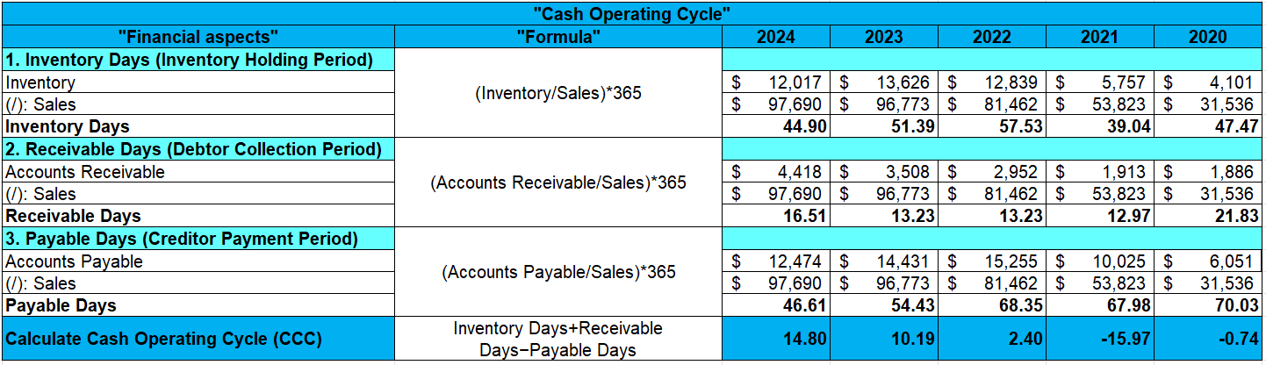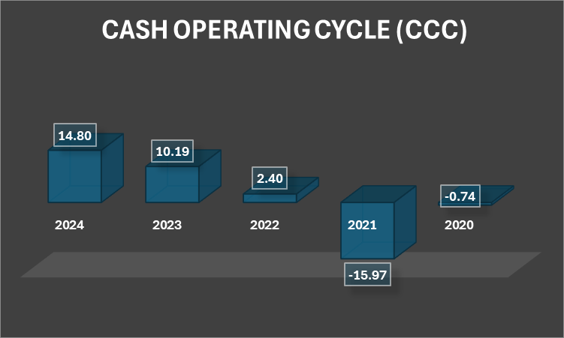
(Source: MS-Excel)

Appendix 8: Project A
"Year" | "Cash Flow" | "Discounting Factor @10%" | "Present Value"
0 | -£ 50.00 | 1.000 | -£ 50.00
1 | £ 10.00 | 0.909 | £ 9.09
2 | £ 12.00 | 0.826 | £ 9.92
3 | £ 14.00 | 0.751 | £ 10.52
4 | £ 10.00 | 0.683 | £ 6.83
5 | £ 8.00 | 0.621 | £ 4.97
"Net Present Value (NPV) of Project A" |  |  | -£ 8.68
"Profitability Index (PI) of Project A" |  |  | 1.17
"Year" | "Cash Flow" | "Discounting Factor @10%" | "Present Value" | Cumulative
0 | -£ 50.00 | 1.000 | -£ 50.00 | -£ 50.00
1 | £ 10.00 | 0.909 | £ 9.09 | -£ 40.91
2 | £ 12.00 | 0.826 | £ 9.92 | -£ 30.99
3 | £ 14.00 | 0.751 | £ 10.52 | -£ 20.47
4 | £ 10.00 | 0.683 | £ 6.83 | -£ 13.64
5 | £ 8.00 | 0.621 | £ 4.97 | -£ 8.68
"Payback Period (PBP) of Project A" |  |  |  | Not Recovered
Year | Cashflow | "Discounting Factor @10%" | Present value
0 | -£ 50.00 | 1.000 | -£ 50.00
1 | £ 10.00 | 0.909 | £ 9.09
2 | £ 12.00 | 0.826 | £ 9.92
3 | £ 14.00 | 0.751 | £ 10.52
4 | £ 10.00 | 0.683 | £ 6.83
5 | £ 8.00 | 0.621 | £ 4.97
"Internal Rate of Return (IRR) of Project A" |  |  | 2.72%
"Year" | "Cash Flow" | "Depreciation" | "Present Value"
0 | -£ 50.00 | 0.00 | -£ 50.00
1 | £ 10.00 | 10.00 | £ -
2 | £ 12.00 | 10.00 | £ 2.00
3 | £ 14.00 | 10.00 | £ 4.00
4 | £ 10.00 | 10.00 | £ -
5 | £ 8.00 | 10.00 | -£ 2.00
"Accounting Rate of Return (ARR) of Project A" |  |  | 1.60%
(Source: MS-Excel)

Appendix 9: Project B
"Year" | "Cash Flow" | "Discounting Factor @10%" | "Present Value"
0 | -£ 50.00 | 1.000 | -£ 50.00
1 | £ 11.00 | 0.909 | £ 10.00
2 | £ 11.00 | 0.826 | £ 9.09
3 | £ 11.00 | 0.751 | £ 8.26
4 | £ 11.00 | 0.683 | £ 7.51
5 | £ 11.00 | 0.621 | £ 6.83
"Net Present Value (NPV) of Project B" |  |  | -£ 8.30
"Profitability Index (PI) of Project B" |  |  | 1.17
"Year" | "Cash Flow" | "Discounting Factor @10%" | "Present Value" | Cumulative
0 | -£ 50.00 | 1.000 | -£ 50.00 | -£ 50.00
1 | £ 11.00 | 0.909 | £ 10.00 | -£ 40.00
2 | £ 11.00 | 0.826 | £ 9.09 | -£ 30.91
3 | £ 11.00 | 0.751 | £ 8.26 | -£ 22.64
4 | £ 11.00 | 0.683 | £ 7.51 | -£ 15.13
5 | £ 11.00 | 0.621 | £ 6.83 | -£ 8.30
"Payback Period (PBP) of Project B" |  |  |  | Not Recovered
Year | Cashflow | "Discounting Factor @10%" | Present value
0 | -£ 50.00 | 1.000 | -£ 50.00
1 | £ 11.00 | 0.909 | £ 10.00
2 | £ 11.00 | 0.826 | £ 9.09
3 | £ 11.00 | 0.751 | £ 8.26
4 | £ 11.00 | 0.683 | £ 7.51
5 | £ 11.00 | 0.621 | £ 6.83
"Internal Rate of Return (IRR) of Project B" |  |  | 3.26%
"Year" | "Cash Flow" | "Depreciation" | "Present Value"
0 | -£ 50.00 | 0.00 | -£ 50.00
1 | £ 11.00 | 10.00 | £ 1.00
2 | £ 11.00 | 10.00 | £ 1.00
3 | £ 11.00 | 10.00 | £ 1.00
4 | £ 11.00 | 10.00 | £ 1.00
5 | £ 11.00 | 10.00 | £ 1.00
"Accounting Rate of Return (ARR) of Project B" |  |  | 2.00%
(Source: MS-Excel)

Appendix 10: Project C
"Year" | "Cash Flow" | "Discounting Factor @10%" | "Present Value"
0 | -£ 50.00 | 1.000 | -£ 50.00
1 | £ 5.00 | 0.909 | £ 4.55
2 | £ 10.00 | 0.826 | £ 8.26
3 | £ 20.00 | 0.751 | £ 15.03
4 | £ 25.00 | 0.683 | £ 17.08
5 | £ 5.00 | 0.621 | £ 3.10
"Net Present Value (NPV) of Project C" |  |  | -£ 1.98
"Profitability Index (PI) of Project C" |  |  | 1.04
"Year" | "Cash Flow" | "Discounting Factor @10%" | "Present Value" | Cumulative
0 | -£ 50.00 | 1.000 | -£ 50.00 | -£ 50.00
1 | £ 5.00 | 0.909 | £ 4.55 | -£ 45.45
2 | £ 10.00 | 0.826 | £ 8.26 | -£ 37.19
3 | £ 20.00 | 0.751 | £ 15.03 | -£ 22.16
4 | £ 25.00 | 0.683 | £ 17.08 | -£ 5.09
5 | £ 5.00 | 0.621 | £ 3.10 | -£ 1.98
"Payback Period (PBP) of Project C" |  |  |  | Not Recovered
Year | Cashflow | "Discounting Factor @10%" | Present value
0 | -£ 50.00 | 1.000 | -£ 50.00
1 | £ 5.00 | 0.909 | £ 4.55
2 | £ 10.00 | 0.826 | £ 8.26
3 | £ 20.00 | 0.751 | £ 15.03
4 | £ 25.00 | 0.683 | £ 17.08
5 | £ 5.00 | 0.621 | £ 3.10
"Internal Rate of Return (IRR) of Project C" |  |  | 8.59%
"Year" | "Cash Flow" | "Depreciation" | "Present Value"
0 | -£ 50.00 | 0.00 | -£ 50.00
1 | £ 5.00 | 10.00 | -£ 5.00
2 | £ 10.00 | 10.00 | £ -
3 | £ 20.00 | 10.00 | £ 10.00
4 | £ 25.00 | 10.00 | £ 15.00
5 | £ 5.00 | 10.00 | -£ 5.00
"Accounting Rate of Return (ARR) of Project C" |  |  | 6.00%
(Source: MS-Excel)

9. AI Acknowledgement
I can affirm that I used AI tools merely to help with structuring and organising the report to meet the academic requirements.

