

Student name: Daniel Ifeanyichukwu Odunze
Student ID: 2010426

Module name: Introduction to Physiology
Module code: BMHP5003_LON
Lecturer name: Laila Surani.

Assessment: 2, Report.

Date: 26/04/22

Topic: Type 2 Diabetes.

1. Introduction
Diabetes is a chronic illness that starts with a high amount of glucose in the blood of the human body. It is also referred to as a metabolic disease since it affects the metabolism of the body. There are two forms of diabetes that may be observed: type 1 diabetes (also known as insulin dependent diabetes mellitus) and type 2 diabetes (also known as insulin resistant diabetes mellitus). Type 1 diabetes is more common than type 2 diabetes. In the globe, roughly 422 million people are afflicted with diabetes, according to the most current statistics from the World Health Organization.
While at the same time, diabetes claims the lives of more than 1.5 million people worldwide each year (Who, 2021).
The global burden of chronic diabetes is expanding at an alarming rate, and this is true everywhere. On the other hand, various public and governmental measures, including those at the international level, are being employed in the fight against the development of diabetes Mellitus and its complications. That group of policies is primarily concerned with reducing the incidence of complications connected with type 2 diabetes over the long run, as well as reducing health inequities related with the incidence of type 2 diabetes over the long term. This study will cover the anatomy and physiology of the human body, as well as the daily behaviours and routines that might lead to type 2 diabetic complications. This study will also explore health and social care practises, as well as government policies, in more detail.

2. Anatomy and Physiology of the Pancreas.

Anatomy is the study of the inside and outside structures of the body and how they fit together, while Physiology is the study of how those structures work. (Blanchard, 2005).

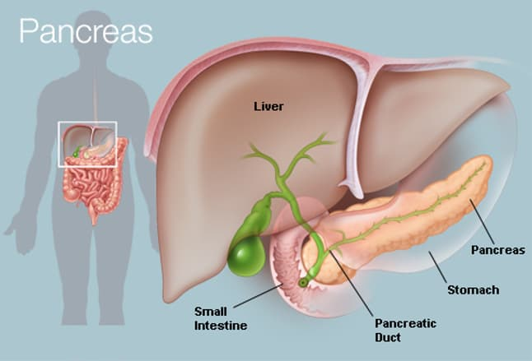
2014 WebMD, LLC.

The pancreas is approximately 6 inches in size and is situated in the middle of the body, across the rear of the abdomen, behind the stomach. It is responsible for digestion. It generates enzymes that aid in the digestion of meals. Looking in your abdomen, you'll notice that the pancreas' top is located on the right side and that it is attached to the duodenum (the first section of the small intestine) via a little tube known as the pancreatic duct. The pancreas, which is situated in the belly, is responsible for the production of insulin. The tip of the pancreas is a small section of the organ that runs from the right side of the body to the left side of the belly. It is responsible for digestion. (Hoffman, 2009).
Type 2 diabetes occurs when the body develops a resistance to insulin, resulting in a spike in blood sugar. The pancreas progressively loses its capacity to make and release insulin in a timely manner, necessitating the use of synthetic insulin to compensate. (Biga et al., 2021).
The discharge of insulin (produced by beta cells) and glucagon (produced by alpha cells) by the pancreas' endocrine cells happens within the pancreatic cells and is referred to as endocrine function. Glucagon and insulin are two hormones that regulate the rate at which glucose is metabolised in the body.
Type 2 diabetes is a chronic condition in which there is an abnormally high level of glucose in the blood. Type 2 diabetes is the most prevalent type of diabetes. Type 1 diabetes is the least frequent.
Insulin is a hormone that is generated in the pancreas by beta cells, which are specific cells that create insulin. Insulin is required for the transport of glucose into cells. Glucose is stored within the cells and later used for energy production.
If you have type 2 diabetes, your fat, muscle, and liver cells do not respond to insulin in the way that they should. Insulin resistance is the term used to describe this condition. As a result, blood sugar does not reach these cells, where it might be used as energy storage.
When sugar is unable to enter cells, a high quantity of glucose accumulates in the bloodstream. This is referred to as hyperglycaemia. As a result, the body will be unable to utilise the glucose as an energy source. Type 2 diabetes manifests as because of this.
Type 2 diabetes is typically diagnosed after a long period of time. When patients are diagnosed with the condition, most of them are overweight or obese. Weight gain fat makes it more difficult for your body to utilise insulin in the proper manner.
Type 2 diabetes can occur in persons who are neither overweight nor obese, as well as in those who are. This occurs more frequently in older persons.
Type 2 diabetes is influenced by a person's family history and genetics. Low physical activity, a bad diet, and extra body weight around the waist all raise your chances of contracting the condition. (Medline Plus, 2022).

3. Health and Lifestyle routine measures that increases chances of developing type 2 diabetes:

It may be challenging to maintain your blood sugar levels within the range suggested by your doctor at times. This is because a variety of events can cause your blood glucose levels to vary, often in an unexpected manner. Healthy diet is essential for living a healthy lifestyle, regardless of whether you have type 2 diabetes.
In addition to an elevated risk of type 2 diabetes, smoking cigarettes is associated with an increased risk of a variety of other health problems, including heart disease and cancer, and many others. If you spend substantial amounts of time sitting down, you are said to be living a "sedentary" lifestyle. Type 2 diabetes is associated with prolonged durations of sitting, which is associated with higher risk of getting the disease.
It has been shown that excessive use of alcoholic drinks is associated with a higher risk of acquiring type 2 diabetes. The current guidelines state that on a routine basis, no more than 14 units per week should be taken, and that these units should be taken over a period of 3 to 4 days.
Sleep deprivation, as well as sleeping for an extensive length of time, has been associated to an increased risk of cardiovascular disease. We can sleep for longer periods of time and with more efficiency if we consider a range of things.
When you drink a lot of alcoholic drinks on one or two days a week, you raise your chances of acquiring other health concerns, such as some types of cancer. In accordance with the data currently available, moderate alcohol use appears to be associated with a lower risk of developing type 2 diabetes. (Diabetes Uk, n.d.)
Individuals who do not engage in physical activity and who are overweight or obese are more likely than others to develop type 2 diabetes, (NIDDK, 2019).
Physical inactivity is a problem: Physical activity offers a variety of benefits, one of which is that it can help you avoid type 2 diabetes if you are genetically prone to it.
A diet high in fat and poor in fibres which may be contained in cereals, vegetables, and fruits significantly increases the likelihood of getting type 2 diabetes.
Unhealthy weight gain and obesity can be aggravated or hastened by a lack of physical exercise as well as bad food preparation selections. Being overweight is related with an increased chance of having type 2 diabetes, which might raise the risk of acquiring a range of other health concerns. (M, 2009).
Excessive use of alcoholic beverages can increase the risk of getting pancreatitis, which is a painful and sometimes fatal inflammation of the pancreas. The acinar cells of the pancreas are thought to be damaged by oxidants and other damaging by-products of alcohol metabolism. When enzymes that are normally produced into the digestive tract and activate when they reach the small intestine become active, the pancreas can become active, and consequently, the pancreas begins to "digest" itself. Pancreatic tissue that has been wounded causes inflammation, which further impairs the pancreas' ability to perform its normal functions. (Samokhvalov, Rehm, and Roerecke, 2015).
Type 2 diabetes is related with active smoking, which is a risk factor. (Willi et al., 2007).

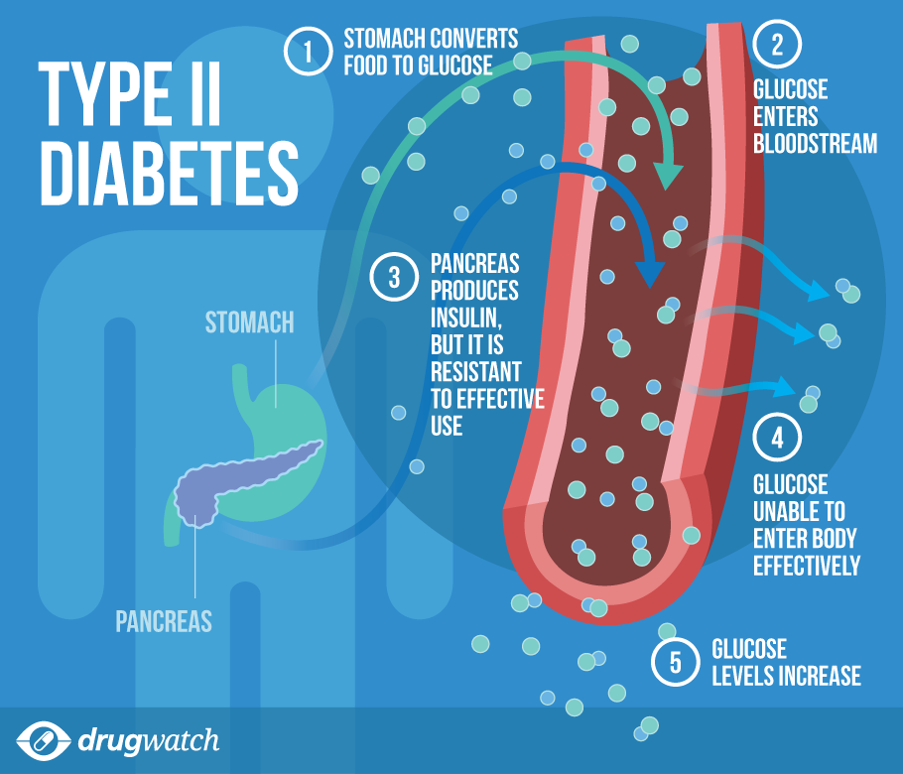
Drug watch google pictures.

4. Health and Social Care practice:

There have been a few laws and regulations put in place to tackle type 2 diabetes in the United Kingdom.
The NHS Diabetes Prevention Programme (NHS DPP) is a collaborative initiative by Public Health England, NHS England, and Diabetes UK. When the Scheme was originally established in 2015, it was intended to provide scientific proof behavioural interventions to a significant number of people who had been classified as being at substantial risk of developing Type 2 diabetes.
The long-term aims of the NHS Diabetes Prevention Programme are to: Reduce the incidence of Type 2 diabetes, Reduce the incidence of side effects associated with Type 2 diabetes – such as heart disease, stroke, kidney disease, eye disease, and foot problems associated with diabetes – and to reduce disparities associated with the cases of Diabetes in the United Kingdom. Public Health England published a report in 2018 stating that
As a result of public input, the government has responded by regulating the promotion of foods that are rich in fat, sugar, and salt, as well as their availability and price. (Gov.UK, 2021).
To reduce the number of amputations, the National Health Service (NHS) diabetes treatment and care programme has set a goal of providing patients with access to professional multidisciplinary footcare teams to reduce the number of amputations.
To achieve improved quality of diabetic patients' treatment, it is necessary to increase their admission to diabetes inpatient specialised nursing teams in hospitals.
The reduction of variation in the achievement of three NICE recommended treatment targets (HbA1c (blood sugar), cholesterol, and blood pressure), and one treatment target (HbA1c) for children, and the expansion of structured education including digital options to better support patient self-management are top priorities in adults.
According to the National Health Service Low Calorie Diet Programme, a high priority of pilot studies is being carried out to study at scale approaches that have been proved to put type 2 diabetes into recovery in people who have just recently been diagnosed with the condition. Patients with obesity who also have diabetes, hypertension, or both can benefit from the NHS Digital Weight Management Programme, which assists patients in managing their weight and improving their overall health. (NHS England, 2017).

5. Recommendations

Considering the complications of type 2 diabetes, the following recommendations would be appropriate.
Diabetes is a life-threatening condition. Following your diabetes treatment plan necessitates a commitment.
Find out everything you can concerning diabetes. Create a balanced diet and physical exercise schedule that you can stick to every day. Stay at a healthy weight by exercising regularly.
Maintain a close eye on your blood sugar levels and adhere to the recommendations of your health care professional for controlling your blood sugar level. You should take your prescriptions according to the instructions provided by your health-care provider. When you want assistance, ask your diabetes care team for assistance. If you smoke, try to limit your intake. Cigarette smoking raises the chance of developing type 2 diabetes as well as the risk of developing different diabetic complications. Maintain proper control of your blood pressure and cholesterol. In conjunction to your annual physical and regular eye examinations, arrange two to four diabetes checks a year to keep your diabetes under control. Maintain your immunisation records since diabetes raises your chance of contracting certain disorders. Vaccines given on a regular basis can help avoid them.
Take good care of your teeth since diabetes might make you more susceptible to gum disease. Take good care of your feet. If you want to consume alcoholic beverages, do so in moderation.
According on how much you consume and whether you eat at the same time, alcohol can result in either high or low blood sugar levels. You should drink only in proportion if you want to do so. For women, this means no more than one glass per day and no more than two drinks per day for males. (Mayo Clinic, 2018).

6. Conclusion

To summarise, diabetes is a hazardous condition that typically results in elevated blood sugar levels. As a result of the disease, the human body gets unable of creating enough insulin in the bloodstream, which can then be utilised by the body
Additionally, the role of many agencies in avoiding diabetes and placing the situation of diabetes into respite is covered in the themes, as well as specific instances of organisations that are actively working to further the cause of diabetes.

References.
Reference list
- Biga, L.M., Dawson, S., Harwell, A., Hopkins, R., Kaufmann, J., LeMaster, M., Matern, P., Morrison-Graham, K., Quick, D. and Runyeon, J. (2012). 17.9 The Pancreas. [online] open.oregonstate.education. Available at: https://open.oregonstate.education/aandp/chapter/17-9-the-pancreas/ [Accessed 22 Apr. 2022].
- Blanchard, S. (2005). 3 - ANATOMY AND PHYSIOLOGY. [online] ScienceDirect. Available at: https://www.sciencedirect.com/science/article/pii/B9780122386626500057 [Accessed 22 Apr. 2022].
- Diabetes Uk (n.d.). Diabetes risk factors. [online] Diabetes UK. Available at: https://www.diabetes.org.uk/preventing-type-2-diabetes/diabetes-risk-factors?gclid=Cj0KCQjwgYSTBhDKARIsAB8KuktZk8OyhqV8yHm_hb9rEMrlS7PT3wvQEc5w2yTwGsvB62wuE_C4jCQaAsrMEALw_wcB [Accessed 22 Apr. 2022].
- Gov.UK (2021). Restricting promotions of products high in fat, sugar and salt by location and by price: government response to public consultation. [online] GOV.UK. Available at: https://www.gov.uk/government/consultations/restricting-promotions-of-food-and-drink-that-is-high-in-fat-sugar-and-salt/outcome/restricting-promotions-of-products-high-in-fat-sugar-and-salt-by-location-and-by-price-government-response-to-public-consultation [Accessed 22 Apr. 2022].
- Hoffman, M. (2009). Picture of the Pancreas. [online] WebMD. Available at: https://www.webmd.com/digestive-disorders/picture-of-the-pancreas [Accessed 22 Apr. 2022].
- M, L. (2009). Type 2 Diabetes Causes. [online] EndocrineWeb. Available at: https://www.endocrineweb.com/conditions/type-2-diabetes/type-2-diabetes-causes [Accessed 22 Apr. 2022].
- Mayo Clinic (2018). Diabetes care: 10 ways to avoid complications. [online] Mayo Clinic. Available at: https://www.mayoclinic.org/diseases-conditions/diabetes/in-depth/diabetes-management/art-20045803 [Accessed 22 Apr. 2022].
- Medline Plus (2022). Type 2 diabetes: MedlinePlus Medical Encyclopedia. [online] medlineplus.gov. Available at: https://medlineplus.gov/ency/article/000313.htm#:~:text=When%20you%20have%20type%202 [Accessed 22 Apr. 2022].
- NHS England (2017). NHS England» Diabetes treatment and care programme. [online] England.nhs.uk. Available at: https://www.england.nhs.uk/diabetes/treatment-care/ [Accessed 22 Apr. 2022].
- NIDDK (2019). Symptoms & Causes of Diabetes | NIDDK. [online] National Institute of Diabetes and Digestive and Kidney Diseases. Available at: https://www.niddk.nih.gov/health-information/diabetes/overview/symptoms-causes [Accessed 22 Apr. 2022].
- Public Health England (2018). Health matters: preventing Type 2 Diabetes. [online] GOV.UK. Available at: https://www.gov.uk/government/publications/health-matters-preventing-type-2-diabetes/health-matters-preventing-type-2-diabetes [Accessed 22 Apr. 2022].
- Rad, A. (2022). Definition and Overview of the organs. [online] Kenhub.com. Available at: https://www.kenhub.com/en/library/education/the-human-anatomy [Accessed 22 Apr. 2022].
- Samokhvalov, A.V., Rehm, J. and Roerecke, M. (2015). Alcohol Consumption as a Risk Factor for Acute and Chronic Pancreatitis: A Systematic Review and a Series of Meta-analyses. EBioMedicine, [online] 2(12), pp.1996–2002. Available at: https://www.ncbi.nlm.nih.gov/pmc/articles/PMC4703772/ [Accessed 22 Apr. 2022].
- Willi, C., Bodenmann, P., Ghali, W.A., Faris, P.D. and Cornuz, J. (2007). Active Smoking and the Risk of Type 2 Diabetes. JAMA, [online] 298(22), p.2654. Available at: https://pubmed.ncbi.nlm.nih.gov/18073361/ [Accessed 22 Apr. 2022].
- World Health Organization (2020). Diabetes. [online] World Health Organization. Available at: https://www.who.int/health-topics/diabetes#tab=tab_1 [Accessed 22 Apr. 2022].

