



To what extent does community policing shape public perceptions of the police in the uk

(BMPL6015A)

Seren Thomas
(2305811)

Word Count: 8800
Abstract

This research investigates the extent to which community policing shapes public perceptions of the police in the UK. The research focuses on trust, confidence and legitimacy, and examines how community policing is implemented and experienced by the public. This research found that community policing can improve public perceptions; however, this is not consistent across all communities. This is due to limited visibility of neighbourhood officers, inconsistent engagement, and wider resource pressures affecting policing. The research found that public confidence in the police is moderate, rather than entirely negative, and is influenced by personal experiences, media coverage and high-profile incidents. Despite this, the research found that the public are still willing to cooperate with the police, particularly when reporting serious crime. This suggests a gap between confidence and cooperation. Primary research was used to gather public perceptions through a questionnaire. The research found that the public have a good understanding of community policing and believe it improves trust between the police and the public. However, many participants reported little or no direct contact with neighbourhood officers and low levels of visibility in their local area. Overall, community policing can positively shape public perceptions, but only when it is consistently delivered, visible, and supported by sufficient resources.

Acknowledgments

I would like to express my sincere gratitude to the University of Wales Trinity Saint David for providing me with the opportunity to undertake my studies over the past three years of my degree. The knowledge, support and experiences gained throughout my time at the university have played a significant role in both my academic and personal development.

I would also like to thank South Wales Police for allowing me to serve as a Special Constable over the past year and a half. The invaluable experience and insight I have gained during this time greatly influenced my understanding of policing and inspired my interest in undertaking this research topic. My experiences within policing helped shape both my perspective and motivation for carrying out this study.

A special thank you goes to my dissertation supervisor, Laura Knight, for her continuous guidance, support, knowledge and valuable experience throughout this process. Her encouragement and commitment ensured that I remained focused and on track at every stage of the dissertation. I am particularly grateful for the time and effort she dedicated to supporting students through her sessions and structured timetable, which helped me meet deadlines and avoid falling behind, even when only a small number of students attended.

Finally, I would like to thank my father, Wayne Edwards, for his constant encouragement and support throughout my studies. Thank you for always pushing me to achieve my best, for taking pride in my accomplishments, and for motivating me to continue working even during difficult periods. Your guidance, reassurance and willingness to listen whenever I needed advice have meant a great deal to me throughout this journey.

Declaration
This work has not previously been accepted in substance for any degree and is not being concurrently submitted in candidature for any degree.
STATEMENT 1
This dissertation is being submitted in partial fulfilment of the requirements for the degree of BA/BSc.
STATEMENT 2
This dissertation is the result of my own independent work/investigation, except where otherwise stated.
Other sources are acknowledged in the Reference Section.
STATEMENT 3
I hereby give consent for my dissertation, if accepted, to be available for photocopying and for interlibrary loan, and for the title and summary to be made available to outside organisations.
STATEMENT 4
I hereby give consent for my dissertation, if accepted, to be available on the university’s IT system to those who have consent to use the system.

Student’s Name: Seren Mai Thomas

Signed: SThomas

Date: 05/05/2026
Table of Contents
Chapter 1: Introduction 6
1.1 Background 6
1.2 Research Focus 6
1.3 Objectives 7
1.4 Method and Timescales 8
1.5 Value of Research 9
Chapter 2: Literature Review 10
2.1 Introduction 10
2.2 Public Perceptions of Policing 10
2.3 Community Policing and Public Engagement 12
2.4 Challenges, Controversies and Organisational Issues 14
2.5 Digital Policing and Trust 15
2.6 Officer Wellbeing, Demand Pressures and Resourcing 16
2.7 Policy Landscape and Current Reforms 17
2.8 Conclusion 18
Chapter 3: Research Methodology 20
3.1 Introduction 20
3.2 Research Philosophy 20
3.3 Research Approach 21
3.4 Research Strategy 21
3.5 Research Choice 23
3.6 Time Horizon 23
3.7 Data Collection 23
3.8 Data Analysis 25
3.9 Limitations 26
Chapter 4: Research Findings 28
4.1 Introduction 28
4.2 Participant Characteristics 28
4.3 Implementation of Community Policing and Public Engagement 30
4.4 Impact of Community Policing on Trust, Confidence and Legitimacy 35
4.5 Limitations and Challenges Affecting Community Policing 42
4.6 Summary 43
Chapter 5: Conclusion 45
5.1 Introduction 45
5.2 Research Objectives: Summary of Findings and Conclusions 45
5.3 Research Objective 1: Implementation of Community Policing 46
5.4 Research Objective 2: Impact on Trust, Confidence and Legitimacy 46
5.5 Research Objective 3: Limitations and Challenges 46
5.6 Recommendations 47
Reference List 48
AI Acknowledgement 59
Appendix 60

Chapter 1: Introduction

1.1 Background

Community policing refers to a policing approach centred on partnership, problem-solving and engagement between police and local communities, aimed at improving trust, confidence and legitimacy (Wood et al., 2022). The Baroness Casey Review (2023) and Angiolini Inquiry (2024) identified misconduct, vetting and cultural failings reducing public confidence following high-profile misconduct cases. Public confidence has fallen to 40% indicating reduced perceived legitimacy (YouGov, 2024), compared to 76% in 2015 (ONS, 2025), indicating a substantial decline in trust. Recent parliamentary research has similarly highlighted declining public trust and confidence as a major challenge facing contemporary policing in England and Wales (Evans and Low, 2024). Recent Welsh policy research has similarly emphasised that policing legitimacy and public confidence remain dependent on maintaining policing by consent within local communities (Hatherley, 2026). Almost half of women reported reduced confidence following the murder of Sarah Everard (End Violence Against Women, 2021). In response, The Neighbourhood Policing Guarantee (Starmer, 2025) has emphasised visibility, engagement and accountability. Despite this, there remains limited understanding of how community policing shapes public perceptions across the UK.

1.2 Research Focus

Building on the context outlined in the background, this study examines the extent to which community policing shapes public perceptions of the police in the UK, with particular focus on its impact on trust, confidence, and legitimacy.

Recent reviews including the Baroness Casey Review (2023), which found the Met Police repeatedly failed the communities it serves (Karia, 2023), and the Angiolini Inquiry (2024) identified misconduct and cultural failings that have damaged perceptions of police legitimacy. Public confidence in the police has reached a concerning low, with only 40% of people in England reporting trust in their local force (Rowland, 2025). The End Violence Against Women (2021) report also showed that almost half of women felt less trust in the police following the murder of Sarah Everard, underscoring a growing legitimacy crisis.

National reports such as His Majesty’s Inspectorate of Constabulary and Fire & Rescue Services (HMICFRS) State of Policing Assessment (2025) and Starmer’s Neighbourhood Policing Guarantee (2025) have renewed emphasis on visible, locally focused policing as a solution to rebuild trust. Similarly, local strategies like the South Wales Police, Crime and Justice Plan 2025-29 (Wools, 2025) and Neighbourhood Alert system (Neighbourhood Alert, 2025) demonstrate practical commitments to community engagement. However, the effectiveness of such initiatives depends heavily on consistent implementation and officer capacity, both of which are challenged by staffing pressures and resource constraints (Oscar Kilo, 2025). This study explores how community policing influences public trust and legitimacy.

1.3 Objectives

The overall aim of this study is to critically explore the role that community policing plays in shaping public perceptions of the police in the UK. To achieve this, the research will focus on three key objectives that collectively address both the implementation of community policing and its impact on public trust, confidence, and legitimacy.

Objective 1: To examine how community policing strategies are implemented within selected UK police forces and the extent to which they prioritise public engagement.
This objective will be achieved through secondary research in the literature review chapter of the study. Analysing academic research, government reports, and policy documents will help establish how different forces interpret and apply community policing principles in practice, identifying key consistencies and variations across the UK.
Objective 2: To explore the impact of community policing on public perceptions of trust, confidence and legitimacy in policing.
This objective will be addressed through both secondary research in the literature review and primary research using the questionnaire. Combining existing literature with first-hand data will allow for a comparison between public attitudes discussed in previous studies and those reflected in current responses gathered for this research.
Objective 3: To critically assess the limitations and challenges of community policing in influencing public perceptions, including barriers such as inconsistent practices, resource pressures or misaligned public expectations.
This objective will be addressed through both secondary research in the literature review and primary research using the questionnaire. Exploring these challenges through existing studies and participant responses will help identify whether community policing is achieving its intended goals or being hindered by broader structural and operational constraints.

1.4 Method and Timescales

Objective 1 will be addressed through a literature review, analysing academic research, government reports, and policy documents to examine how community policing strategies are implemented within selected UK police forces and the extent to which they prioritise public engagement. The literature review will also explore theoretical frameworks surrounding trust, confidence, and legitimacy in policing, providing the foundation for the research (Walliman, 2022).

Objectives 2 and 3 will be addressed through primary research using a questionnaire. The questionnaire will target the general public aged 18 and above, including colleagues and acquaintances working in policing roles, to collect data on perceptions of community policing and its effectiveness. It will include a mixture of quantitative questions, to identify trends and patterns in public opinion, and qualitative questions, to capture participants’ detailed thoughts and feelings (Braun and Clarke, 2021).

The questionnaire will be created using Microsoft Forms and distributed via social media and email, with a target of 100-150 responses to capture public and policing perspectives (Denzin et al., 2023).

The research project is planned over a timeframe of eight months, nearly two months will be dedicated to the literature review, followed by questionnaire design and piloting. Data collection and analysis will take place in months four to six, with the final two months reserved for synthesis of findings and writing up the dissertation.

1.5 Value of Research

Public trust in policing has declined, while the effectiveness of current engagement strategies remains unclear. While policies such as The Neighbourhood Policing Guarantee (Starmer, 2025) and local initiatives like South Wales Listens (South Wales Police, 2022) emphasise engagement and visibility, there is limited understanding of their impact on public trust and confidence.

Existing research often focuses on theory or operational outcomes, with limited focus on combined public perceptions and implementation challenges (Ruhl, 2024). By addressing this gap, the research will contribute to both academic and practical knowledge, providing a clearer picture of the factors that enhance or hinder public perceptions of legitimacy and confidence.

The findings will be of value to police forces, policymakers, and community stakeholders seeking to improve engagement strategies and strengthen public trust. Understanding the effectiveness and limitations of community policing can inform decision-making around resource allocation, officer deployment, and community engagement initiatives (Rowe, 2020). This study offers evidence-based insights into the evolving relationship between the police and the communities they serve, highlighting opportunities to improve legitimacy, accountability, and the overall effectiveness of policing in the UK.

Chapter 2: Literature Review

2.1 Introduction

Community policing has become a cornerstone of contemporary UK policing strategies, aiming to enhance public trust and confidence (Hanway and Hambly, 2023). This model emphasises proactive engagement, problem-solving, and close interaction with communities, moving away from purely reactive enforcement (Fay, 2024). Its prominence has grown alongside scrutiny of policing practices, particularly in the wake of high-profile incidents and public inquiries that have highlighted failures in police conduct and accountability (Casey, 2023). Dodd (2024) reports that only 40% of people in England express confidence in their local police force, reflecting persistent concerns about fairness, legitimacy, and effectiveness. Bradford et al (2025) similarly highlight that confidence in policing is not uniform across the UK, with significant disparities between demographic groups and communities.

The theoretical foundation of community policing rests on concepts of legitimacy, procedural justice, and policing by consent, which underpins UK policing as a model dependent on public approval and cooperation rather than coercion (Hough, 2020). By building trust and collaboration, communities are more likely to support and cooperate with police initiatives (Muir et al., 2022). However, translating policy into practice has proved complex, with numerous challenges relating to resources, organisational culture, and inconsistent implementation (Terpstra et al., 2019).

2.2 Public Perceptions of Policing

Public perceptions of policing in the UK are shaped by multiple factors, including direct interactions with officers, media coverage, and broader societal attitudes towards authority and fairness (Bradford et al., 2025). Trust is a central component of legitimacy, defined as the belief that police actions are morally appropriate and legally justified (Hough, 2020). Tyler (2006) argues that public willingness to cooperate with the police is strongly influenced by perceptions of fairness, legitimacy and procedural justice. However, surveys consistently indicate declining confidence, particularly following high-profile cases of misconduct, misogyny, and racism within the police service (Dodd, 2024). The Independent Office for Police Conduct (IOPC, 2025) highlights that public perceptions of police fairness are closely tied to perceptions of accountability and transparency, with many respondents indicating dissatisfaction with the handling of complaints and misconduct cases. Similar concerns regarding victim experiences and confidence in policing responses were also highlighted in the Victims Commissioner (2024) Annual Report.

Analyses by the Office for National Statistics (ONS, 2025), based on the Crime Survey for England and Wales (year ending March 2024), demonstrate that only 41% of respondents felt confident that the police would handle crime effectively in their area. Mann (2021) similarly identifies a trend in which more Britons report low confidence than confidence in the police to deal with local crime, highlighting a widening perception gap. These findings are echoed by the HMICFRS Annual Assessment (2025), which notes that public confidence varies considerably between forces and is influenced by local experiences, organisational culture, and historical incidents of misconduct. Comparative research conducted following the Covid-19 pandemic also identified noticeable shifts in public confidence and trust in policing across England and Wales (Durna and Karademir, 2025).

Community perceptions are also shaped by more subtle interactions and long-term exposure to policing practices. Fay (2024) notes that repeated positive engagement, even in minor neighbourhood interactions, can accumulate into greater trust over time, as consistent and fair encounters with officers help to reinforce perceptions of reliability, approachability, and procedural fairness. Conversely, repeated exposure to procedural inconsistency or perceived bias reinforces scepticism, particularly among younger people and ethnic minority groups (Bradford et al., 2025).
High-profile inquiries and reviews, such as the Baroness Casey Review (2023) and the Angiolini Inquiry (2024), have amplified public scrutiny by exposing structural and cultural issues within policing, including failures in vetting, misogyny, and inconsistent application of policy. Parliamentary discussions have similarly highlighted declining public trust and the need to improve police standards, accountability and legitimacy (Tudor, 2023). This scrutiny has also been shaped by international incidents of police misconduct, most notably the killing of George Floyd in the United States in 2020, which intensified global debate around policing practices, institutional racism, and legitimacy, including within UK policing discourse (Goldsmith and McLaughlin, 2022). Recent undercover reporting exposing misogynistic and discriminatory behaviour within policing has further intensified public scrutiny and concern regarding police culture (Polglase and Lee, 2025). Farrow (2023) further emphasises that perceived legitimacy is particularly sensitive to how the public believes police balance enforcement with fairness, with procedural justice acting as a key mediator of trust. Newburn (2022) argues that policing is inherently fallible due to the complex and contested social role that police organisations occupy within democratic societies, reflecting wider arguments regarding the political and social nature of policing institutions (Reiner, 2010). Meta-analytic evidence demonstrates that perceptions of procedural justice are strongly associated with willingness to cooperate with police and perceptions of legitimacy (Bolger and Walters, 2019).

2.3 Community Policing and Public Engagement

Community policing seeks to address these challenges by embedding officers within local communities, promoting visibility and proactive engagement, reflecting the principle of policing by consent that underpins UK policing and depends on public legitimacy, cooperation, and voluntary compliance (Innes et al., 2020). Neighbourhood policing teams, including Police Community Support Officers (PCSOs), are deployed to build relationships, respond to concerns, and tackle local issues before they escalate into serious crime (Dickson, 2021). Research evaluating neighbourhood policing implementation similarly found that consistent visibility and local engagement are associated with improved public reassurance and confidence (Colover and Quinton, 2018). Similarly, Dyfed-Powys Police (2024) introduced a new community policing strategy aimed at increasing neighbourhood officer visibility and strengthening local engagement. The College of Policing (2025a) also highlights the importance of dedicated neighbourhood policing career pathways in supporting long-term engagement and community-focused policing practice.

Research indicates that community engagement can enhance perceptions of legitimacy when officers are visible, and responsive (Muir et al., 2022). Higgins (2018) similarly argues that neighbourhood policing remains central to public confidence, although its effectiveness is increasingly challenged by resource pressures and competing operational demands. Fay (2024) argues that transparency, consistency, and participatory approaches foster public trust and a sense of ownership over local policing initiatives. Practical engagement strategies such as community meetings, digital consultation and collaborative problem-solving have also been identified as important mechanisms for strengthening police-community relationships (Martell, 2024). Experimental evidence has also suggested that PCSOs can positively influence perceptions of reassurance and visibility within neighbourhood policing contexts (Ariel et al., 2016). Such initiatives can mitigate negative perceptions stemming from high-profile incidents or broader societal mistrust.

Nevertheless, implementation remains inconsistent. Innes et al (2020) reports that neighbourhood policing is more effective in areas where officers are empowered to engage directly and have the necessary time and resources, whereas performance pressures and staffing shortages often lead to a reactive focus on crime response. Muir et al (2022) highlights that without sustained investment in community engagement, public perceptions are unlikely to improve, even if visibility increases. Current professional guidance similarly emphasises that effective neighbourhood policing depends on consistent implementation, local problem-solving and sustained community engagement (College of Policing, 2025c).

2.4 Challenges, Controversies and Organisational Issues

Despite the theoretical benefits, numerous challenges undermine community policing’s impact on public perception. Organisational culture, resource limitations, and structural inertia can impede effective engagement (Rowe, 2020). High-profile cases of misconduct, sexism, and racism, documented in reports such as the HMICFRS inspection (2022) and media investigations (Kotecha and Mowafi, 2025), erode public trust and complicate relationship-building efforts. Public perception is influenced by inconsistencies in officer behaviour, unclear accountability mechanisms, and perceived failures to address complaints effectively (Schulenberg et al., 2017).

Stop and search powers illustrate a complex intersection of policing practice, public perception, and community relations. Braakmann (2022) found that high intensity stop and search operations may have limited impact on crime reduction while simultaneously undermining trust, particularly in marginalised communities. Such findings are corroborated by Bradford et al (2025), suggest that procedural justice and transparency are more influential in shaping confidence than enforcement outcomes. Community policing initiatives can counteract these negative effects by emphasising dialogue, transparency, and participatory problem-solving (Innes et al., 2020). Community surveys have also identified antisocial behaviour, visibility and local safety as recurring public concerns linked to confidence in policing (Neighbourhood Watch, 2025).

Organisational pressures, such as demand for measurable crime reductions, often conflict with the relational and preventative objectives of community policing. This creates tension between policy and practice, affecting public perceptions when visibility or responsiveness declines. The Home Office (2026a) acknowledges that modern policing increasingly requires balancing local neighbourhood priorities with wider national operational demands, while debates surrounding police funding and staffing reforms continue to shape concerns regarding neighbourhood policing capacity (Nevett and Eardley, 2026). Terpstra et al (2019) argue that lack of recognition of relational work reinforces reactive policing.

Moreover, performance measurement and resource allocation present ongoing challenges. Recent government neighbourhood policing grant allocations highlight continued investment in localised policing priorities, but also reflect the emphasis placed on measurable outcomes within funding frameworks (Home Office, 2025a). Rowland (2025) notes that conventional metrics, such as crime reduction figures, may undervalue relational and preventative aspects of policing, which are central to community engagement. Recent investment in neighbourhood policing has been described by senior policing figures as potentially transformative for local policing delivery and visibility (McKenna and Healy, 2026). Terpstra et al (2019) similarly argue that institutional pressures to prioritise operational output over relational work can unintentionally degrade public perception, reinforcing the need for nuanced evaluation frameworks that recognise the qualitative benefits of community policing.

2.5 Digital Policing and Trust

Digital technologies provide both opportunities and challenges for community policing. Social media platforms and digital communication tools offer new avenues for engagement, transparency, and information dissemination (Bullock, 2018). Proactive digital engagement can increase visibility, facilitate rapid feedback, and provide mechanisms for reassurance, particularly in urban environments where direct interactions may be limited (Higgins and Halkon, 2023).

However, the adoption of digital tools is not without risks. Bullock (2018) cautions that online engagement can normalise hierarchical communication rather than promote genuine collaboration. There is also potential for unequal access and engagement, with some demographic groups excluded from digital participation, potentially exacerbating existing trust disparities (Higgins and Halkon, 2023). Thus, while digital policing can complement community engagement, it cannot substitute for sustained, face-to-face relational work that is critical for legitimacy and confidence (Muir et al., 2022).

In addition, digital channels can support transparency by providing communities with information about local policing decisions and outcomes. Bullock (2018) suggests that well-managed social media platforms allow police to communicate policies, explain enforcement actions, and respond to public concerns in real time.

2.6 Officer Wellbeing, Demand Pressures and Resourcing

Officer wellbeing and resourcing directly influence the capacity to implement community policing and shape public perceptions. Oscar Kilo (2025) highlights that police officers experience high levels of stress, fatigue, and exposure to traumatic incidents, which can affect their engagement with the public. HMICFRS (2025) notes that rising demand pressures, including calls for service and administrative duties, often constrain officers’ ability to maintain visibility and proactive engagement. Government workforce statistics also indicate continuing pressures relating to officer numbers and neighbourhood policing capacity (Home Office, 2026c). In practice, these pressures may shift policing from relational and preventative models towards reactive crime response, which can negatively influence public perceptions (Muir et al., 2022).

Research suggests that investing in officer wellbeing, training, and resourcing is critical for sustaining trust-building initiatives (Farrow, 2023). Community policing requires officers who are not only skilled in operational tasks but also in communication, cultural competence, and problem-solving (Dickson, 2021). Without adequate support, initiatives may be inconsistently applied, limiting their impact on public confidence and legitimacy (Rowe, 2020).

Oscar Kilo (2025) demonstrates that officers who receive mental health support and workload management training are better able to engage positively with residents, enhancing trust. Farrow (2023) notes that perceived professionalism and empathy in officer interactions correlate strongly with public confidence, indicating that officer wellbeing is not only an internal concern but a community-facing issue.

2.7 Policy Landscape and Current Reforms

The policy framework governing community policing in the UK emphasises visibility, engagement, and public accountability. Recent government announcements have also renewed emphasis on restoring neighbourhood policing through increased officer visibility and local engagement initiatives (Home Office, 2024). Key initiatives include the Neighbourhood Policing Guarantee (Starmer, 2025), Policing Vision 2030 released by the National Police Chiefs’ Council (NPCC, 2023), and guidance from the College of Policing (2025). These documents outline expectations for local engagement, officer accessibility, and collaborative problem-solving, while highlighting the importance of evaluating effectiveness. Political commitments to increase visible neighbourhood policing have also formed part of broader public safety reform agendas (Labour, 2026). South Wales Police’s Crime and Justice Plan 2025-29 (Wools, 2025) exemplifies the operationalisation of these strategies at a regional level, combining community feedback with targeted interventions. However, critics argue that increased policy emphasis on neighbourhood policing may prove difficult to operationalise consistently without sustained long-term investment and workforce stability.

Despite clear policy intentions, challenges remain. Recent national policing assessments continue to highlight that inconsistent implementation, organisational culture, and sustained resource pressures limit the effectiveness of community policing strategies in practice (HMICFRS, 2025b). Muir et al (2022) similarly emphasise that these factors can undermine policy objectives by weakening continuity and engagement at local level, resulting in variation in delivery across different areas and reducing the intended impact on public perceptions. Furthermore, public scrutiny and media coverage of misconduct continue to influence perceptions, highlighting the need for robust governance, transparent accountability mechanisms, and continuous evaluation of outcomes (Angiolini, 2024). Performance Tracker 2025 (Rowland, 2025) suggests that while progress is evident in some areas, national confidence levels remain uneven, reflecting the complex interplay between strategy, organisational practice, and public experience.

Policy reforms increasingly recognise the importance of embedding community policing principles in evaluation and accountability structures. The College of Policing (2025) stresses the need for evidence-based approaches that measure relational outcomes, such as community satisfaction and trust, alongside crime statistics. Similarly, Starmer’s (2025) Neighbourhood Policing Guarantee reflects a governmental commitment to visible and accessible officers, while regional plans, such as South Wales Police Crime and Justice Plan (Wools, 2025), operationalise these principles by integrating community feedback and prioritising local engagement.

2.8 Conclusion

The literature reviewed demonstrates that community policing has the potential to positively shape public perceptions of the police in the UK by promoting trust, confidence, and legitimacy. Sustained engagement, visibility, and transparency are key mediators of these outcomes (Innes et al., 2020). However, high-profile incidents of misconduct, alongside inconsistent application of policy and organisational pressures, can significantly undermine these gains by weakening public perceptions of legitimacy and trust, particularly among marginalised groups (HMICFRS, 2022).

The evidence suggests that community policing is most effective when implemented consistently, with adequate resourcing, strong leadership, and cultural reinforcement that values relational work alongside operational targets (Dickson, 2021). Digital technologies can support engagement, though they cannot replace face-to-face interactions critical for trust-building (Higgins and Halkon, 2023). Officer wellbeing, training, and sufficient resources are also essential to enable sustainable engagement practices (HMICFRS, 2025b). Policy reforms and guidance, including the Neighbourhood Policing Guarantee and Policing Vision 2030, provide a strategic framework, yet their effectiveness is contingent on local delivery and ongoing evaluation (NPCC, 2023).

Gaps in existing literature indicate a need for empirical research examining the direct impact of community policing on perceptions across diverse communities, particularly in relation to ethnicity, socioeconomic status, and prior experiences of policing (Bradford et al., 2025). Moreover, understanding how organisational culture, resource pressures, and digital engagement interact is essential for developing strategies that strengthen legitimacy and public trust.

Chapter 3: Research Methodology

3.1 Introduction

This chapter outlines the methodology adopted within this research, which aims to critically explore the extent to which community policing shapes public perceptions of the police in the UK. A clear and appropriate methodological approach is essential in ensuring that the research methods selected are capable of addressing the research aim and objectives in a systematic and credible manner (Greetham, 2019). Despite extensive academic and policy literature on community policing, there remains a gap in understanding how these approaches are experienced and interpreted by members of the public in practice, particularly in relation to how day-to-day engagement influences perceptions of trust, confidence, and legitimacy.

This chapter therefore explains the research strategy underpinning the study, followed by an outline of how the data was collected and analysed. The final section critically reflects on the limitations and potential challenges associated with the chosen methods, alongside steps taken to enhance the reliability of the research.

While alternative approaches such as longitudinal surveys or interview-based designs could have offered deeper insight into changes in perceptions over time, the chosen methodology represents the most appropriate balance between depth, feasibility and analytical rigour for the aims of this study (Adu and Miles, 2024).

3.2 Research Philosophy

This study adopts an interpretivist research philosophy. Interpretivism assumes that social reality is socially constructed and shaped by individual experiences and interpretations rather than being objectively measurable. This approach is appropriate for this study as public perceptions of community policing, trust, confidence and legitimacy are subjective and influenced by personal experiences, interactions, and local contexts. Therefore, understanding these perceptions requires exploring meanings and interpretations rather than purely objective measurement (Saunders et al., 2023).

3.3 Research Approach

This study adopts an inductive research approach, moving from specific observations in the collected data towards broader patterns and themes (Makri and Neely, 2021). Rather than testing pre-existing hypotheses, the research seeks to explore how public perceptions of community policing are constructed and understood. This is appropriate given the exploratory nature of the study and its aim to identify patterns in trust, confidence, legitimacy and perceptions of police visibility.

3.4 Research Strategy

This study adopts a mixed-methods research strategy, combining quantitative and qualitative approaches to develop a comprehensive understanding of public perceptions of community policing. Mixed-methods research involves the collection and integration of numerical and textual data to provide broader understanding of the research problem (Creswell and Clark, 2025). Mixed-methods research is particularly valuable in social science research where combining numerical and experiential data can provide a more comprehensive understanding of social issues (Baran and Jones, 2020). In this study, a mixed-methods strategy is implemented through the use of an online questionnaire containing both open and closed-ended questions.

The methodological choices underpinning this study align with Saunders’ Research Onion model, progressing from an overarching mixed-methods strategy to specific methods of data collection and analysis.

 (Saunders et al., 2023).

This approach is appropriate given the time constraints associated with an undergraduate dissertation and the study’s focus on capturing contemporary public perceptions of community policing rather than changes over time (Walliman, 2021). The strategy allows for the identification of prevailing attitudes towards community policing, trust and confidence in the police, as well as the perceived effectiveness of neighbourhood policing practices.

The choice of a mixed-methods strategy is justified by the nature of the research topic. Public perceptions of policing, particularly in relation to trust and legitimacy, cannot be fully understood through quantitative data alone, as such perceptions are influenced by personal experience, local context and interpretation (Flick, 2023). Quantitative methods enable the identification of patterns across a sample, such as levels of confidence or willingness to report crime, while qualitative methods explain these attitudes.

By integrating qualitative responses with quantitative findings, the study benefits from triangulation, which enhances the validity and credibility of the research (Hitchcock and Onwuegbuzie, 2022). Mixed-methods approaches are widely recognised as particularly suitable for research examining public attitudes and experiences within policing contexts (Wood et al., 2022), making this strategy well aligned with the aims of my study.

However, it is recognised that qualitative data obtained through open-ended questionnaire responses lacks the depth that could have been achieved through interviews; nonetheless, this limitation is offset by the ability to capture a broader range of perspectives within the available timeframe.

3.5 Research Choice

A mixed-methods approach was selected as it enables both numerical measurement of public attitudes (e.g. trust, confidence and visibility) and exploration of the reasoning behind these perceptions. This is particularly appropriate for research on community policing, where attitudes are shaped by both measurable experiences and subjective interpretation.

3.6 Time Horizon

This study adopts a cross-sectional time horizon, with data collected at a single point in time. This approach is appropriate for capturing contemporary public perceptions of community policing and provides a snapshot of trust, confidence and engagement within the current policing context.

3.7 Data Collection

Primary data was collected through an online questionnaire distributed to members of the public aged 18 and over. Primary data collection allows the research to be tailored specifically to the aims of the study and ensures that findings reflect current perceptions of community policing (Biggam, 2026). Participants are primarily drawn from communities within South Wales, although responses from other UK force areas are also included to provide broader contextual insight.

The study employs non-probability convenience sampling, whereby participants are recruited based on accessibility and willingness to take part. This sampling method is commonly used in exploratory social research and is considered appropriate for undergraduate-level studies examining attitudes and perceptions (Walliman, 2021). Online questionnaires are advantageous in social research as they enable cost-effective distribution and efficient data collection across large participant groups (Cleave, 2023). This approach is particularly suitable for research into community policing, as it captures perceptions from individuals embedded within local communities where neighbourhood policing practices are most visible and experienced. While this approach limits the extent to which findings can be generalised to the wider population, it enables the collection of a sufficient volume of data within practical constraints.

The questionnaire will be created and hosted using Microsoft Forms. It will be distributed via social media platforms, email sharing and word of mouth. Data collection will take place over a period of approximately one month, with the aim of obtaining a minimum of 100 responses. It is anticipated that the majority of respondents, estimated at around 90 per cent, will be based in Wales due to the researcher’s personal and social networks.

A range of question types will be used, including rating-scale questions, ranking questions, closed questions and open-ended questions. This combination supported the mixed-methods strategy by generating both quantitative and qualitative data (Creswell and Clark, 2025). The questionnaire is structured to align with the research objectives, with questions exploring confidence in local policing, willingness to report crime, visibility of neighbourhood officers, contact with neighbourhood policing teams, and perceptions of trust and engagement.

Ethical considerations were central to the data collection process. Participation is voluntary, and respondents will be informed at the outset that they must be aged 18 or over. An information statement explains the purpose of the research, how the data will be used, and the approximate completion time. No identifying information is automatically collected, ensuring anonymity. Participants are informed of their right to withdraw from the study at any time prior to submitting their responses by closing the questionnaire. These measures reflect ethical best practice in social research and support honest participation (Bottomley et al., 2020).

3.8 Data Analysis

Data analysis followed both quantitative and qualitative procedures in line with the mixed-methods design. Once data collection is complete, Microsoft Forms will be used to collate responses and automatically generate graphs and charts. These visual outputs will be used to present quantitative findings in the following chapter, allowing trends in public perceptions of community policing to be clearly illustrated.

Quantitative data generated through closed-ended questions and rating-scale items are analysed using descriptive statistical techniques. Responses are exported into spreadsheet software for organisation and analysis. Frequencies and percentages are used to summarise participant responses, while measures of central tendency, such as averages, are used where appropriate to identify overall trends. Descriptive quantitative analysis allows researchers to identify patterns, trends and frequencies within participant responses in a systematic manner (O’Leary, 2023).

Descriptive statistics are suitable for this study as the research does not aim to establish causal relationships or test hypotheses, but rather to explore patterns in public perceptions of community policing, confidence and trust in the police (Walliman, 2021). Quantitative findings are presented using tables and charts to enhance clarity and accessibility. This approach enables comparison between key variables, such as perceived police visibility and levels of trust, supporting a clearer assessment of how community policing practices relate to public confidence by integrating such data with the themes from the qualitative responses.

Qualitative data obtained from open-ended questionnaire responses are analysed using thematic analysis, following the approach outlined by Braun and Clarke (2021). This method provides a systematic framework for identifying patterns and themes within qualitative data while remaining flexible enough to capture nuanced perspectives. The process involved coding responses into broader themes such as visibility, communication, resource constraints and perceived effectiveness of community policing (Grad Coach, 2022). Recent methodological guidance further highlights thematic analysis as an effective approach for systematically developing themes and conceptual understanding from qualitative data (Naeem et al., 2023).

Thematic analysis is appropriate for this study as it allows participants to articulate their experiences and perceptions in their own words, adding depth and context to the quantitative findings (Flick, 2023). Integrating qualitative themes with quantitative trends strengthens the analysis by enabling triangulation, thereby enhancing the credibility of the research outcomes (Hitchcock and Onwuegbuzie, 2022). This reflects evidence-based policing approaches, which emphasise the importance of using empirical research to inform policing strategies and decision-making (Spooner et al., 2022).

3.9 Limitations

The chosen methodological approach presents several limitations which should be acknowledged. The use of convenience sampling limits the generalisability of the findings, as the sample may not be representative of the wider UK population. Participants who choose to engage with the questionnaire may hold particularly strong views about policing, which may introduce response bias (Clark et al., 2021). Delbosc (2023) argues that all social research contains some degree of researcher and participant bias, reinforcing the importance of transparency and reflexivity throughout the research process. Additionally, reliance on self-reported data means that responses may be influenced by recent experiences, media coverage or personal perceptions rather than long-term attitudes.

A key limitation of this study is the researcher’s limited social reach outside Wales, which is likely to result in a geographically concentrated sample. While this regional concentration limits national generalisability, it also provides more context-specific insight into community policing within Wales, which is valuable given ongoing debates around neighbourhood policing visibility and resource allocation. To mitigate this, participants are encouraged to share the questionnaire with friends and family where possible in order to widen its reach. Additionally, online questionnaires may exclude individuals with limited access to digital platforms.

To mitigate these limitations, the questionnaire was designed using clear and neutral language to reduce misinterpretation and minimise leading responses. The inclusion of open-ended questions allows participants to clarify and expand upon their answers, reducing the risk of oversimplification. Distribution across multiple platforms helped to maximise reach, and a target of at least 100 responses was set to enhance the robustness of the quantitative data.

Despite these limitations, the research remains reliable due to the consistent structure of the questionnaire, the anonymity afforded to participants, and the use of established analytical methods. Findings are interpreted in relation to existing academic literature on community policing and public trust, strengthening the credibility of the conclusions drawn (Denzin et al., 2023).

Chapter 4: Research Findings

4.1 Introduction

This chapter presents the findings from the questionnaire conducted as part of this study examining the extent to which community policing shapes public perceptions of the police in the United Kingdom. The questionnaire generated 117 responses from individuals aged 18 and above and included both closed and open-ended questions designed to capture quantitative and qualitative perspectives on neighbourhood policing.

The chapter is organised according to the three research objectives outlined earlier in the dissertation. First, the findings examine how community policing strategies are implemented within local communities, focusing on engagement, visibility and operational priorities. The second section explores the impact of community policing on public perceptions of trust, confidence and legitimacy. Finally, the chapter considers the perceived limitations and challenges that may affect the effectiveness of community policing. Throughout the analysis, empirical findings are interpreted alongside the literature discussed in Chapter Two in order to compare participants’ experiences with existing research on policing and public trust.

4.2 Participant Characteristics

Understanding the characteristics of participants provides important context when interpreting survey results (Swaen, 2016). Respondents were first asked to indicate their age group.

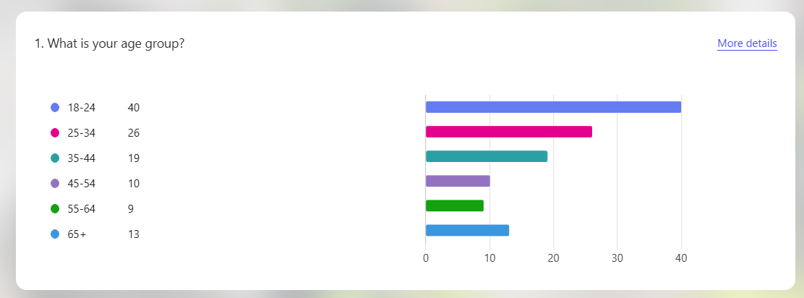

The results demonstrate a broad distribution of participants across several age categories. The largest proportion of respondents were aged between 18 and 24 (40 respondents), followed by those aged 25-34 (26 respondents) and 35-44 (19 respondents). Smaller numbers were aged 45-54 (10 respondents), 55-64 (9 respondents) and over 65 (13 respondents). Younger adults represented a substantial proportion of the sample. However, the inclusion of respondents across multiple age groups provides a range of perspectives on community policing.

Respondents were also asked which police force area they currently reside in.

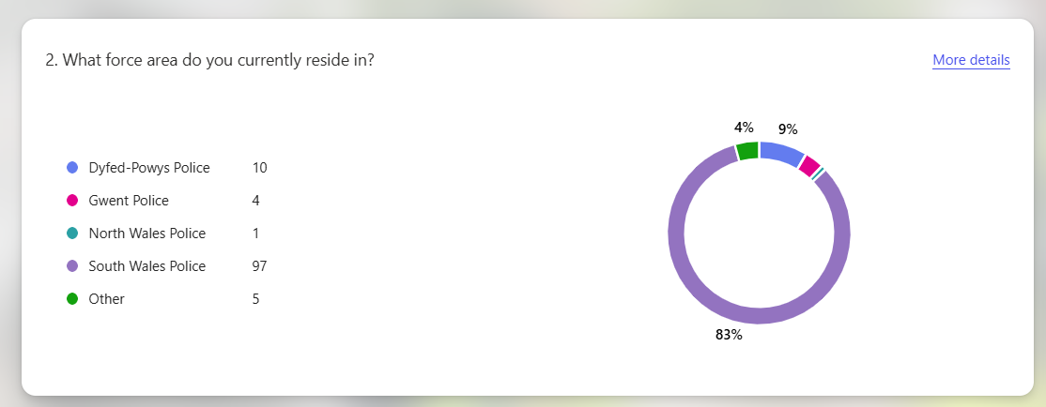

The findings show that the majority of respondents live within the South Wales Police force area (97 respondents), representing 83% of the sample. Smaller numbers reported residing within Dyfed-Powys Police (10 respondents), Gwent Police (4 respondents), North Wales Police (1 respondent) and other areas (5 respondents). This distribution reflects the networks through which the questionnaire was circulated and means the findings are particularly relevant to the South Wales policing context.

4.3 Implementation of Community Policing and Public Engagement

The first research objective examined how community policing strategies are implemented within local areas and the extent to which they prioritise public engagement. One indicator of engagement is the level of direct contact between the public and neighbourhood policing teams.

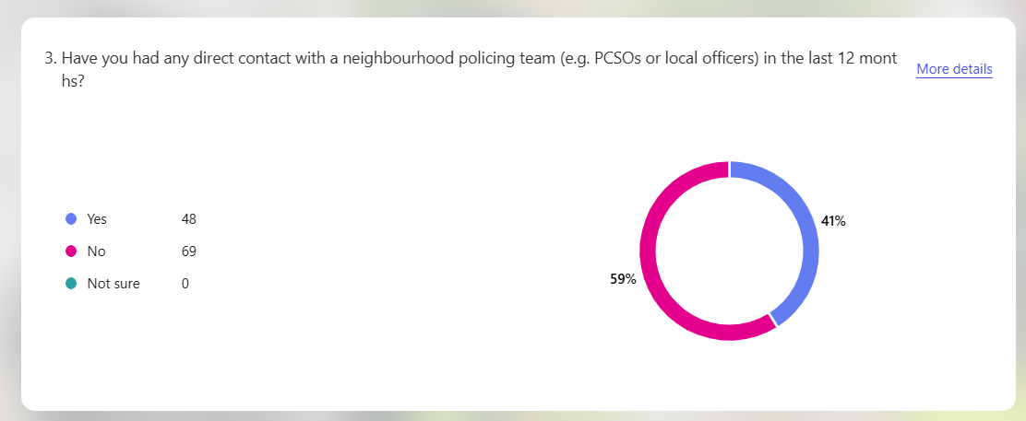

Participants were asked whether they had experienced direct contact with a neighbourhood policing team, such as Police Community Support Officers (PCSOs), within the previous twelve months. The results indicate that a majority of respondents (69 individuals, or 59%) had not experienced any direct contact during this period. In contrast, 48 respondents (41%) reported that they had interacted with a neighbourhood policing team. These findings suggest that many members of the public do not regularly experience direct interaction with neighbourhood officers (Home Office, 2025b).

Respondents who reported contact with neighbourhood officers were asked to rate their experience on a scale of one to five.

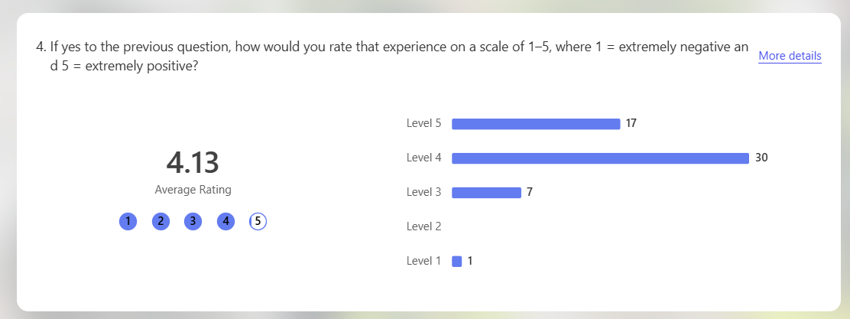

The findings demonstrate that interactions with neighbourhood officers were generally positive. The average score was 4.13 out of five, with most respondents selecting ratings of four or five. Only one respondent rated their experience as one. These findings suggest positive perceptions of engagement with neighbourhood officers.

Police visibility was further explored by asking respondents when they had last seen a police officer or PCSO on foot patrol in their local area.

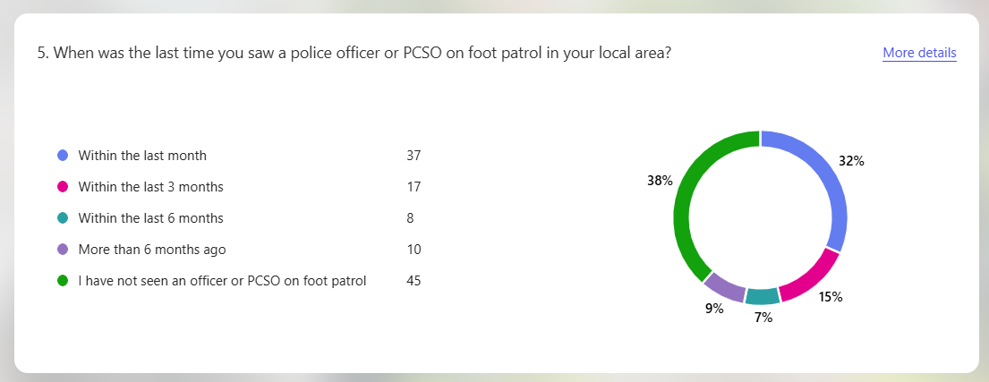

The results reveal varying levels of police visibility. 37 respondents (32%) reported seeing a police officer or PCSO within the previous month. However, a substantial proportion of respondents reported limited visibility, with 45 respondents (38%) stating that they had never seen a police officer or PCSO on foot patrol in their area. Smaller numbers reported seeing officers within the previous three months (17 respondents), six months (8 respondents) or more than six months ago (10 respondents). These findings suggest that police visibility varies significantly between communities, reflecting wider concerns in the literature that neighbourhood policing presence is inconsistent across England and Wales, with resource pressures and competing operational demands limiting proactive visibility in some areas (HMICFRS, 2022). This inconsistency may undermine procedural justice by limiting opportunities for regular positive police-public interactions.

Participants were also asked about the importance of PCSOs within neighbourhood policing.

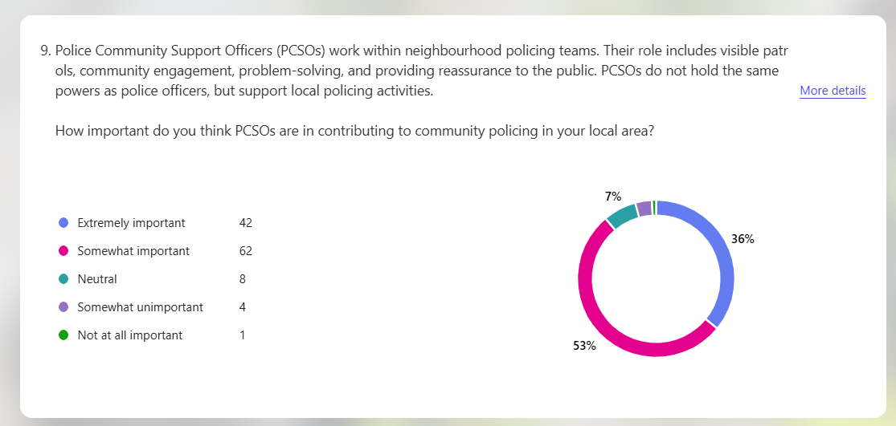

The results indicate strong support for the role of PCSOs. A total of 104 respondents considered PCSOs either extremely important or somewhat important within neighbourhood policing, while a small number viewed the role as unimportant. This highlights the value placed on visible community-focused policing roles that facilitate engagement and communication between police and communities. This aligns with research emphasising the importance of PCSOs in community engagement and reassurance, particularly through their role in maintaining local presence and fostering relationships with communities (Smith, 2026).

Further insight into public expectations of neighbourhood policing was gained by asking respondents what they believed were the main priorities of their local neighbourhood policing teams.

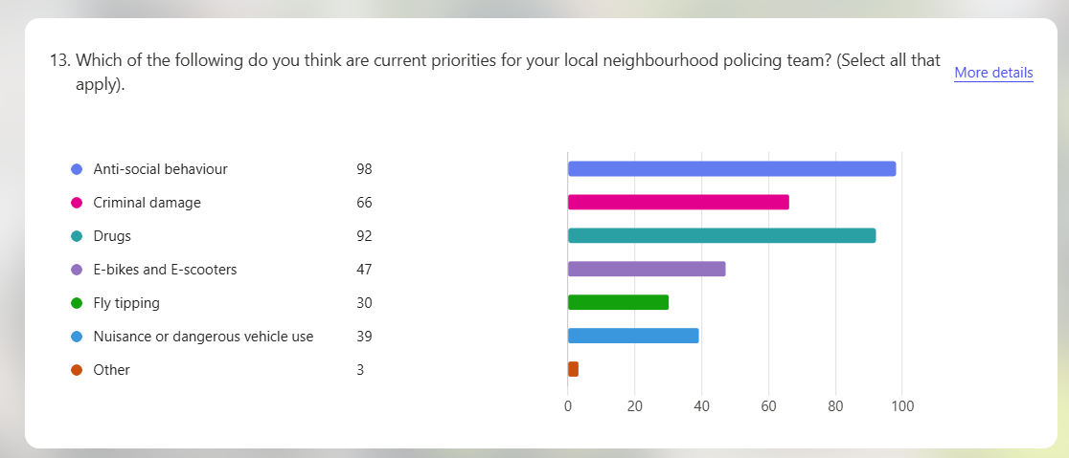

The findings suggest that the public associates neighbourhood policing primarily with addressing community-level issues that directly affect local quality of life. Antisocial behaviour was selected by 98 respondents, drugs by 92 respondents and criminal damage by 66 respondents. Issues such as burglaries, fly-tipping and nuisance behaviour were also mentioned but less frequently. This suggests community policing is associated with addressing visible local problems.

These findings reflect wider research on neighbourhood policing in the UK. In their analysis of community policing developments, Innes et al (2020) argue that neighbourhood policing was designed to enhance visibility, engagement and local problem-solving. However, they also highlight that the model has experienced variations in implementation due to resource pressures and competing operational priorities. Similarly, increasing demand on police services can reduce the time officers have available for proactive community engagement, limiting opportunities for visibility, relationship-building, and preventative policing within communities (Muir et al., 2022). These pressures may help explain why many respondents reported limited direct contact with neighbourhood officers despite recognising the importance of community policing roles. Policy initiatives aimed at increasing neighbourhood policing capacity have therefore emphasised the need to improve visibility and community engagement (Home Office, 2026b).

These findings suggest that community policing strategies are intended to prioritise engagement and visibility within communities, but implementation may vary depending on local resources and operational demands.

4.4 Impact of Community Policing on Trust, Confidence and Legitimacy

The second objective examined how community policing influences public perceptions of trust, confidence and legitimacy in policing.

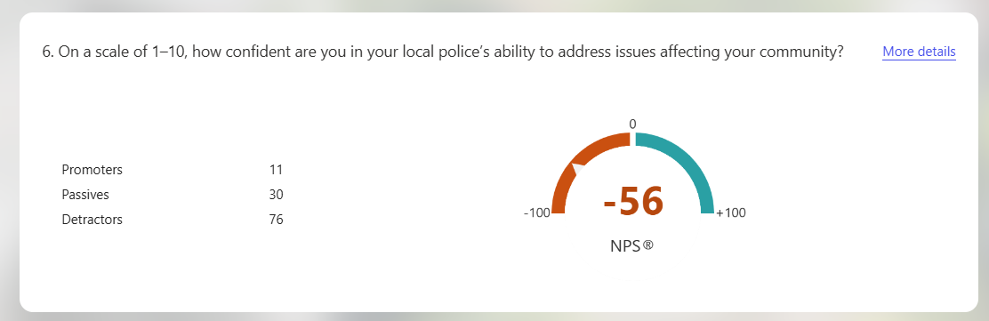

Respondents were asked to rate their confidence in their local police’s ability to address community issues on a scale of one to ten. The results indicate moderate levels of confidence overall, with the Net Promoter Score producing a negative score of -56. This indicates that lower confidence ratings outnumbered higher ones.

Despite this, respondents generally indicated that they would cooperate with the police when necessary.

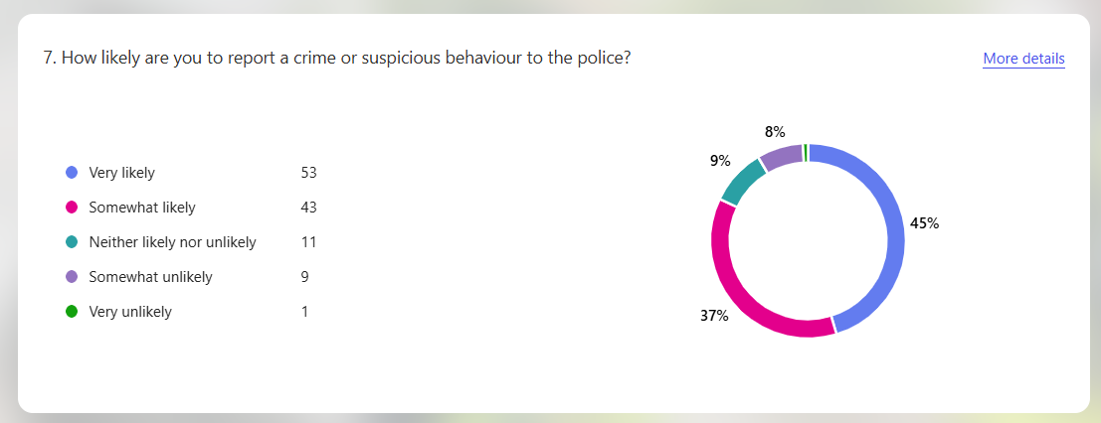

The majority of respondents stated that they would be willing to report crime or suspicious behaviour. 53 respondents reported that they would be very likely to report crime, while 43 indicated they would be somewhat likely to do so. Only a small number of respondents stated that they would be unlikely to report crime. These results suggest that although confidence levels may be moderate, public willingness to cooperate with the police remains relatively strong.

Qualitative responses provided further context for these findings, with participants explaining the reasons behind their likelihood of reporting crime.

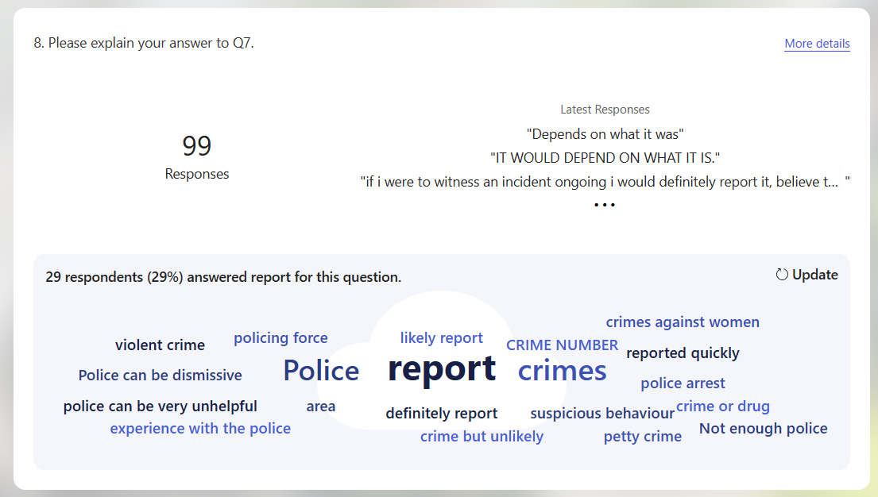

The qualitative responses reveal a noticeable trend that many respondents stated their decision would depend on the nature and seriousness of the incident. Several responses included phrases such as “depends on what it was”, suggesting that participants differentiate between more serious offences, such as violent crime or crimes against vulnerable individuals, and lower-level issues such as petty crime or minor antisocial behaviour. Some respondents stated they would report incidents involving immediate harm, while minor offences were less likely to be reported unless persistent or personally impactful. This reflects wider literature on reporting thresholds, which shows that willingness to contact the police is shaped by perceived seriousness and personal relevance of incidents (ONS, 2025).

A smaller number of responses referenced previous experiences with the police, with some participants expressing concerns that the police can be dismissive or unhelpful, which may reduce the likelihood of reporting certain incidents. This suggests cooperation depends on offence seriousness and confidence in police action. This reflects wider research which indicates that public cooperation with policing is often shaped by perceived police effectiveness and responsiveness (Bradford, 2026).
Participants were also asked to rank the methods they would most likely use to report crime or concerns to the police.

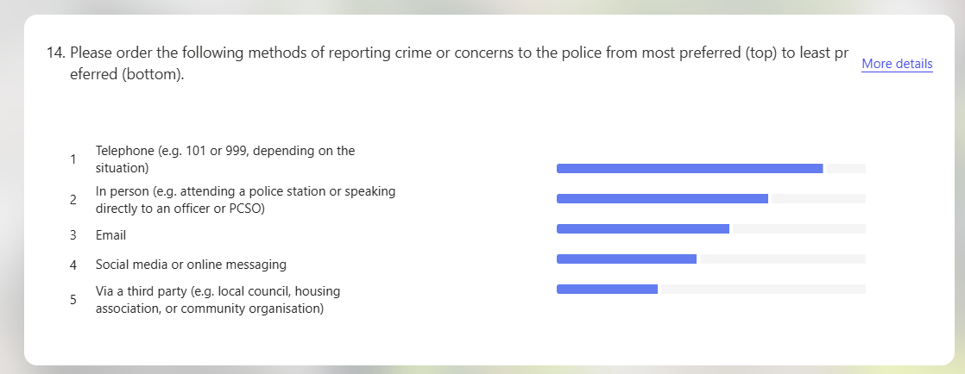

The results demonstrate that traditional reporting methods remain the most preferred. Telephone contact, such as calling 101 or 999 depending on the situation, was ranked as the most common reporting method, followed by speaking directly to officers in person. Digital communication methods, including email or social media messaging, were ranked lower. This suggests that despite increasing digitalisation within policing, many members of the public still prefer direct or traditional forms of contact with police services, which is particularly notable given the proportion of younger adults in the sample. This suggests trust remains associated with face-to-face interaction, even among digitally engaged age groups.

Respondents were also asked whether they believed that police understand the needs of their community.

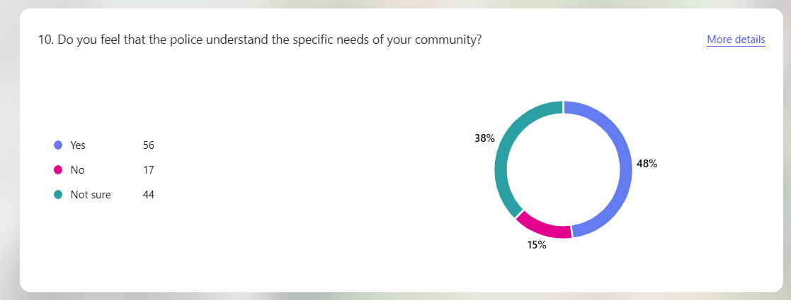

The results show that 56 respondents believed that police understand the needs of their community, while 44 respondents were unsure and 17 respondents believed that police do not understand community needs. This suggests that while some respondents perceive policing to be responsive to community concerns, there remains uncertainty regarding how effectively police understand local issues.

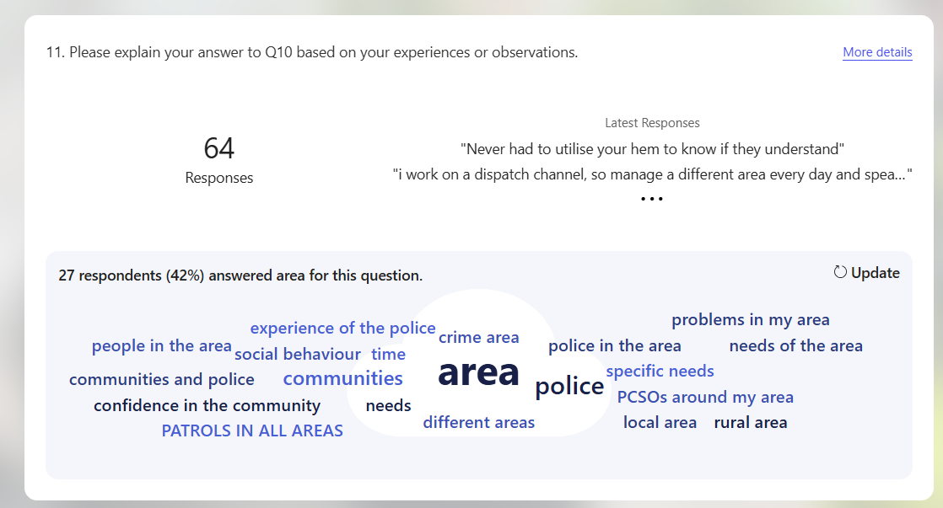

Participants were also asked to expand on their views regarding whether police understand the needs of their community. The qualitative responses highlighted recurring concerns relating to antisocial behaviour, local crime and police visibility. Analysis of the responses also showed that 27 participants (approximately 42%) referenced issues relating to their local “area”, suggesting concerns about the level of police presence within their communities. Several respondents indicated that police visibility influenced whether they believed officers understood local issues. For example, one respondent stated that officers “are visible in the area and deal with issues such as antisocial behaviour.” In contrast, others suggested that limited patrols affected their perceptions, with one participant stating they “hardly ever see officers on patrol anymore.” This suggests perceptions of police understanding are linked to visibility and engagement. This aligns with research indicating that regular interaction between police and communities can improve perceptions of responsiveness and legitimacy in policing (Bradford et al., 2025), particularly among respondents who reported limited police visibility or were unsure about police presence in their communities.

Participants were also asked whether community policing improves trust between the police and the public.

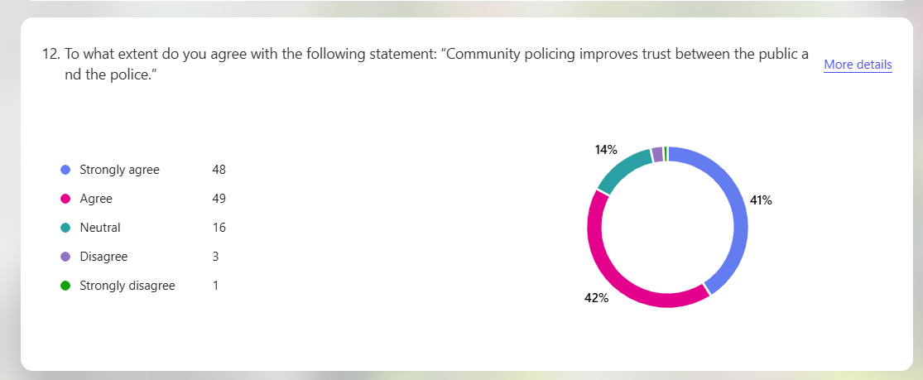

The findings demonstrate strong support for this view. A total of 97 respondents either agreed or strongly agreed that community policing improves trust between the police and the public, while only 4 respondents disagreed. This suggests that many participants perceive community policing as contributing positively to police-community relationships.

Respondents were also asked to rank factors they believed were most important for building public trust in the police.

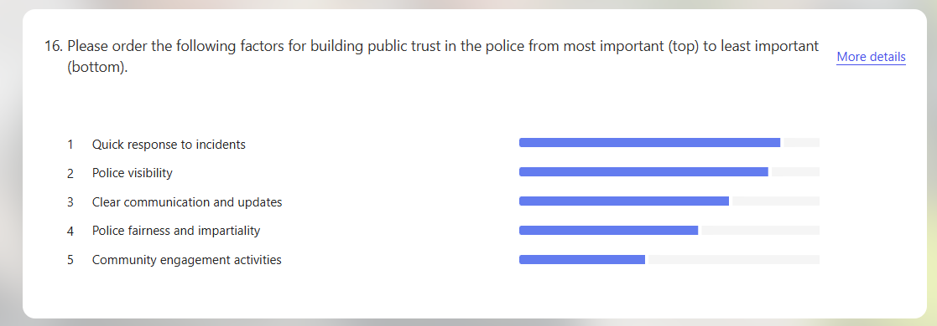

The results show that quick responses to incidents, police visibility and clear communication were ranked as the most important factors influencing trust. Community engagement activities were also considered important but ranked slightly lower. These findings highlight the importance of both operational effectiveness and communication in shaping public perceptions of policing, which aligns with evidence suggesting that visible policing, responsiveness and engagement are key factors influencing public confidence (College of Policing, 2025b).

These findings are consistent with wider research on public confidence in policing, with surveys suggesting that only around 40% of people in England express confidence in their local police force (Dodd, 2024). National survey data continues to indicate variation in public confidence and experiences of crime across England and Wales (ONS, 2026). Similarly, the Independent Office for Police Conduct reports that perceptions of fairness, transparency and accountability significantly influence public trust (IOPC, 2025). Academic research further suggests that procedural justice and legitimacy play a central role in shaping public confidence in policing (Bradford et al., 2025). The results of this study therefore suggest that community policing may strengthen public trust when it enables meaningful engagement between police and communities.

4.5 Limitations and Challenges Affecting Community Policing

The final objective examined the perceived limitations and challenges affecting community policing.

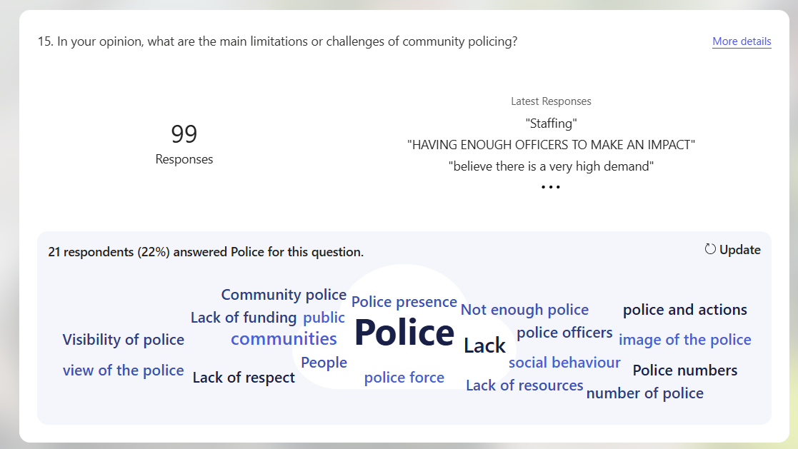

Participants were asked to identify what they believed were the main challenges facing community policing. The qualitative responses revealed several recurring themes. A prominent trend within the responses related to concerns about police resources. Many respondents referred to staffing shortages and increasing workloads, suggesting that neighbourhood policing may be affected by wider operational pressures. For example, one participant stated that “there are not enough officers to cover everything”, while another suggested that officers are often “too busy responding to other incidents to spend time in the community”. These responses indicate a perception that reactive demands on policing may limit opportunities for proactive engagement with local communities.

Concerns about police visibility were also frequently mentioned. Several respondents stated that they rarely encounter neighbourhood officers in their local areas, with one participant commenting that they “hardly ever see police on patrol anymore”. Others suggested that community policing may be difficult to deliver effectively if officers do not have sufficient time to engage with residents and address local concerns. This suggests that expectations of community policing may not always align with operational realities.

These perceptions reflect wider structural challenges within policing. The State of Policing assessment highlights that increasing demand pressures are placing significant strain on police resources and reducing opportunities for proactive engagement with communities (HMICFRS, 2025b). Similarly, research from the Police Foundation emphasises that modern policing requires balancing reactive operational responsibilities with preventative community policing strategies (Muir et al., 2022). Without sufficient resources and organisational support, neighbourhood policing initiatives may struggle to achieve their intended impact.

4.6 Summary

This chapter analysed questionnaire findings against the research objectives. The results indicate that while community policing is widely recognised as an important approach for building trust and strengthening relationships between police and communities, direct engagement between neighbourhood officers and members of the public appears to be relatively limited (Hough, 2020). Many respondents reported infrequent contact with neighbourhood policing teams and inconsistent police visibility within their communities.
Despite these challenges, participants generally expressed strong support for the principles of community policing and recognised its potential to improve trust between the police and the public. The findings also highlight the importance of police visibility, responsiveness and communication in shaping public perceptions of policing.

However, respondents also identified several challenges affecting the implementation of community policing, including resource pressures and increasing operational demand. These findings suggest that although community policing remains central to policing strategies in the UK, its effectiveness in shaping public perceptions depends on consistent implementation and sufficient resources for community engagement.

Chapter 5: Conclusion

5.1 Introduction

This chapter concludes the study by addressing the overall aim: to critically explore the extent to which community policing shapes public perceptions of the police in the UK. Drawing together the literature review and findings, it demonstrates how the research objectives have been met and considers implications for policy and future research.

Objective 1: To examine how community policing strategies are implemented within selected UK police forces and the extent to which they prioritise public engagement.
Objective 2: To explore the impact of community policing on public perceptions of trust, confidence and legitimacy in policing.
Objective 3: To critically assess the limitations and challenges of community policing in influencing public perceptions, including barriers such as inconsistent practices, resource pressures or misaligned public expectations.

5.2 Research Objectives: Summary of Findings and Conclusions

The findings show that community policing has an inconsistent influence on public trust and legitimacy. Respondents valued visible policing but reported limited direct contact with neighbourhood officers. This supports Hough (2020), who links engagement to legitimacy, while Hatherley (2026) reinforces the continued importance of policing by consent and public trust within UK policing. Innes et al (2020) similarly highlight inconsistent implementation.

A further contribution of this study is the “confidence-cooperation gap”, where respondents expressed moderate confidence but remained willing to report crime. This suggests cooperation is shaped by situational need as well as trust (Bradford et al., 2025).

5.3 Research Objective 1: Implementation of Community Policing

The findings indicate that community policing is implemented inconsistently, particularly in relation to visibility and engagement. Most respondents reported little or no recent contact with neighbourhood officers, with 59% stating they had not experienced any direct contact within the previous twelve months, suggesting limited exposure to proactive policing. This reflects HMICFRS (2025), which identifies resource pressures as limiting consistent engagement and highlights a gap between policy and practice.

However, survey responses indicated that when engagement with police does occur, it is generally viewed positively by respondents. This supports Fay (2024), who argues that meaningful interaction builds trust over time.

5.4 Research Objective 2: Impact on Trust, Confidence and Legitimacy

The findings show moderate confidence in policing overall (reflected in an average confidence score of 4.1/10), but strong agreement that community policing improves trust. Visibility, communication and responsiveness were key drivers of positive perception. These results support procedural justice theory, which links fairness and respectful treatment to legitimacy (Tyler, 2006). Respondents frequently associated police understanding of community needs with visibility, reinforcing Bradford et al (2025).

Participants indicated that willingness to report crime depends on offence seriousness and prior experience, showing that legitimacy is context-dependent. This reflects national trends of uneven confidence across England and Wales (ONS, 2025).

5.5 Research Objective 3: Limitations and Challenges

The findings highlight key challenges including resource constraints, increased demand and reduced visibility. Respondents frequently perceived officers as focused on reactive duties, limiting proactive engagement, with this theme appearing in approximately 27% of qualitative responses. This supports Rowe (2020) and HMICFRS (2025), highlighting tensions between reactive policing and preventative approaches.

A limitation is the geographical concentration of responses in South Wales, which restricts generalisability. Future research could broaden the sample across multiple force areas and include interviews with both the public and neighbourhood officers.

5.6 Recommendations

This research has several implications. Neighbourhood policing visibility should be strengthened by protecting time for proactive engagement. Policing strategies should prioritise communication, fairness and responsiveness to build trust. This aligns with the College of Policing (2025), which emphasises evidence-based approaches to improving public confidence.

A blended engagement approach should be adopted, combining face-to-face and digital communication (Higgins and Halkon, 2023). Future research should examine how perceptions vary across key demographic groups, particularly age and ethnicity, and explore whether sustained engagement improves trust and confidence over time.

This study reinforces legitimacy theory and highlights the conditional nature of trust. In conclusion, community policing remains central to shaping public perceptions of policing in the UK, but its effectiveness is limited by inconsistent implementation and operational pressures. Strengthening engagement is essential to improving trust, confidence and legitimacy within policing (Jackson and Bradford, 2010). As Sir Robert Peel stated, “the police are the public and the public are the police”, reinforcing the importance of maintaining strong, visible and meaningful relationships between policing and communities (Home Office, 2012).

Reference List

- Adu, P. and Miles, A. (2024) Dissertation research methods : a step-by-step guide to writing up your research in the social sciences. London: Routledge. Available at: https://doi.org/10.4324/9781003268154.
- Angiolini, E. (2024) The Angiolini Inquiry: Part 1 Report. Available at: https://assets.publishing.service.gov.uk/media/65e05420cf7eb1b0e5f57eff/E02740018_Angiolini_Inquiry_HC_530_Accessible.pdf (Accessed: 27 November 2025).
- Ariel, B., Weinborn, C. and Sherman, L. (2016) ‘”Soft” policing at hot spots—do police community support officers work? A randomized controlled trial’, Journal of Experimental Criminology, 12(3), pp. 277-317. Available at: https://doi.org/10.1007/s11292-016-9260-4.
- Baran, M. and Jones, J. (2020) Applied social science approaches to mixed methods research. Pennsylvania: IGI Global. Available at: https://doi.org/10.4018/978-1-7998-1025-4.
- Biggam, J. (2026) Succeeding with your Master’s dissertation : a step-by-step handbook. 6th edn. Maidenhead: Open University Press. Available at: https://ezproxy.uwtsd.ac.uk/login?url=https://www.vlebooks.com/product/openreader?id=TrinityStD&accId=8886856&isbn=9780335253661&uid=^u.
- Bolger, P. and Walters, G. (2019) ‘The relationship between police procedural justice, police legitimacy, and people’s willingness to cooperate with law enforcement: A meta-analysis’, Journal of Criminal Justice, 60, pp. 93-99. Available at: https://doi.org/10.1016/j.jcrimjus.2019.01.001.
- Bottomley, J., Pryjmachuk, S. and Wright, M. (2020) Academic writing and referencing for your policing degree. London: Routledge. Available at: https://doi.org/10.4324/9781041054054.
- Braakmann, N. (2022) ‘Does stop and search reduce crime? Evidence from street‐level data and a surge in operations following a high‐profile crime’, Journal of the Royal Statistical Society. Series A, Statistics in society, 185(3), pp. 1370-1397. Available at: https://doi.org/10.1111/rssa.12839.
- Bradford, B. (2026) ‘Research on public trust and police legitimacy: where next, and why?’, Evidence Base. Available at: https://doi.org/10.1080/30679125.2025.2608830.
- Bradford, B., Weirich, C., Rowlands, D. and Crawford, A. (2025) ‘Public confidence in the police: using opinion survey data to explore the current ‘moment’ in British policing’, Policing & Society, 35(7), pp. 883-900. Available at: https://doi.org/10.1080/10439463.2025.2508198.
- Braun, V. and Clarke, V. (2021) Thematic Analysis: A Practical Guide. London: SAGE Publications. Available at: https://us.sagepub.com/en-us/nam/thematic-analysis/book248481.
- Bullock, K. (2018) ‘The Police Use of Social Media: Transformation or Normalisation?’, Social Policy and Society, 17(2), pp. 245-258. Available at: https://doi.org/10.1017/S1474746417000112.
- Casey, L. (2023) The Baroness Casey Review: Final Report. Available at: https://www.met.police.uk/SysSiteAssets/media/downloads/met/about-us/baroness-casey-review/update-march-2023/baroness-casey-review-march-2023a.pdf (Accessed: 24 November 2025).
- Clark, T., Foster, L., Sloan, L. and Bryman, A. (2021) Bryman’s Social Research Methods. 6th edn. Oxford: Oxford University Press. Available at: https://global.oup.com/ukhe/product/brymans-social-research-methods-9780198796053?cc=gb&lang=en&.
- Cleave, P. (2023) Advantages of Questionnaires in Online Research. Available at: https://www.smartsurvey.co.uk/blog/advantages-of-questionnaires-in-online-research (Accessed: 28 February 2026).
- College of Policing (2025a) Evaluation of the neighbourhood policing programme career pathway. Available at: https://library.college.police.uk/docs/CoP/Evaluation-Neighbourhood-policing-programme-career-pathway-2025.pdf (Accessed: 27 November 2025).
- College of Policing (2025b) Improving public confidence in the police: An evidence-based guide. Available at: https://assets.college.police.uk/s3fs-public/2025-01/Improving-public-confidence-in-the-police-guide.pdf?VersionId=XpjDwAk0rd7AjDXNdBY75ImCNWDJJ_7k (Accessed: 1 December 2025).
- College of Policing (2025c) What works: implementing neighbourhood policing. Available at: https://www.college.police.uk/guidance/improving-public-confidence-police/what-works-implementing-neighbourhood-policing (Accessed: 28 November 2025).
- Colover, S. and Quinton, P. (2018) Neighbourhood policing: impact and implementation. Available at: https://assets.college.police.uk/s3fs-public/2021-02/np_rea_summary.pdf (Accessed: 27 November 2025).
- Creswell, J. and Clark, V. (2025) Designing and Conducting Mixed Methods Research. 4th edn. California: SAGE Publishing. Available at: https://us.sagepub.com/en-us/nam/designing-and-conducting-mixed-methods-research/book269004.
- Delbosc, A. (2023) 'There is no such thing as unbiased research - is there anything we can do about that?', Transport Reviews, 43(2), pp. 155-158. Available at: https://doi.org/10.1080/01441647.2022.2146939.
- Denzin, N., Lincoln, Y., Giardina, M. and Cannella, G. (2023) The SAGE Handbook of Qualitative Research. 6th edn. California: SAGE Publications. Available at: https://us.sagepub.com/en-us/nam/the-sage-handbook-of-qualitative-research/book275161.
- Dickson, G. (2021) ‘Bridging the Gap? Police Volunteering and Community Policing in Scotland’, Policing: A Journal of Policy and Practice, 15(4), pp. 2070-2082. Available at: https://doi.org/10.1093/police/paz070.
- Dodd, V. (2024) ‘Only 40% of people in England trust their police force, research reveals’, The Guardian. Available at: https://www.theguardian.com/uk-news/2024/apr/18/only-40-of-people-in-england-trust-their-police-force-research-reveals (Accessed: 20 October 2025).
- Durna, T. and Karademir, K. (2025) A comparison of public trust and confidence in the police in England and Wales before and after the covid. Available at: https://ukdataservice.ac.uk/app/uploads/durna2025-03-05.pdf (Accessed: 24 November 2025).
- Dyfed-Powys Police (2024) New Community Policing Strategy will increase visibility of neighbourhood policing officers. Available at: https://www.dyfed-powys.police.uk/news/dyfed-powys/news/2024/october-2024/new-community-policing-strategy-will-increase-visibility-of-neighbourhood-policing-officers (Accessed: 21 October 2025).
- End Violence Against Women (2021) Almost half of women have less trust in police following Sarah Everard murder. Available at: https://www.endviolenceagainstwomen.org.uk/almost-half-of-women-have-less-trust-in-police-following-sarah-everard-murder/ (Accessed: 20 October 2025).
- Evans, R. and Low, N. (2024) Public trust and confidence in the police. Available at: https://post.parliament.uk/public-trust-and-confidence-in-the-police/ (Accessed: 20 October 2025).
- Farrow, K. (2023) Legitimacy & Confidence in Policing. Available at: https://www.cumberlandlodge.ac.uk/wp-content/uploads/2023/12/Legitimacy-and-Confidence-in-Policing-SCREEN.pdf (Accessed: 27 November 2025).
- Fay, T. (2024) Community Policing: How To Build Public Trust With Police Community Engagement. Available at: https://newsroom.delib.net/community-policing-with-consent-police-engagement/ (Accessed: 24 November 2025).
- Flick, U. (2023) An Introduction to Qualitative Research. 7th edn. London: SAGE Publications. Available at: https://us.sagepub.com/en-us/nam/an-introduction-to-qualitative-research/book278983.
- Goldsmith, A. and McLaughlin, E. (2022) ‘Policing’s New Vulnerability Re-Envisioning Local Accountability in an Era of Global Outrage’, British Journal of Criminology, 62(3), pp. 716-733. Available at: https://doi.org/10.1093/bjc/azab073.
- Grad Coach (2022) Qualitative Coding Tutorial: How To Code Qualitative Data For Analysis (4 Steps + Examples). Available at: https://www.youtube.com/watch?v=8MHkVtE_sVw (Accessed: 5 March 2026).
- Greetham, B. (2019) How to write your undergraduate dissertation. 3rd edn. London: Red Globe Press. Available at: https://research-ebsco-com.uwtsd.idm.oclc.org/c/onvpsy/search/details/5qgj7d2h2n?db=nlebk.
- Hanway, P. and Hambly, O. (2023) Public perceptions of policing: A review of research and literature. Available at: https://www.gov.uk/government/publications/public-perceptions-of-policing-a-review-of-research-and-literature/public-perceptions-of-policing-a-review-of-research-and-literature (Accessed: 24 November 2025).
- Hatherley, S. (2026) Trust, legitimacy and confidence in policing in Wales: why consent still matters. Available at: https://research.senedd.wales/research-articles/trust-legitimacy-and-confidence-in-policing-in-wales-why-consent-still-matters/ (Accessed: 2 May 2026).
- Higgins, A. (2018) The future of neighbourhood policing. Available at: https://www.police-foundation.org.uk/wp-content/uploads/2010/10/TPFJ6112-Neighbourhood-Policing-Report-WEB_2.pdf (Accessed: 21 October 2025).
- Higgins, A. and Halkon, R. (2023) Contact and confidence in a digital age: Improving police-public relations with technology. Available at: https://www.police-foundation.org.uk/wp-content/uploads/2010/10/contact-and-confidence.pdf (Accessed: 30 November 2025).
- His Majesty’s Inspectorate of Constabulary and Fire & Rescue Services [HMICFRS] (2022) An inspection of vetting, misconduct, and misogyny in the police service. Available at: https://hmicfrs.justiceinspectorates.gov.uk/publication-html/an-inspection-of-vetting-misconduct-and-misogyny-in-the-police-service/ (Accessed: 27 November 2025).
- His Majesty’s Inspectorate of Constabulary and Fire & Rescue Services [HMICFRS] (2025a) PEEL Assessments 2023-25. Available at: https://hmicfrs.justiceinspectorates.gov.uk/peel-reports-year/2023-25/ (Accessed: 30 November 2025).
- His Majesty’s Inspectorate of Constabulary and Fire & Rescue Services [HMICFRS] (2025b) State of Policing: The Annual Assessment of Policing in England and Wales 2024-25. Available at: https://hmicfrs.justiceinspectorates.gov.uk/publication-html/state-of-policing-the-annual-assessment-of-policing-in-england-and-wales-2024-25/ (Accessed: 25 November 2025).
- Hitchcock, J. and Onwuegbuzie, A. (2022) The Routledge Handbook for Advancing Integration in Mixed Methods Research. London: Routledge. Available at: https://ezproxy.uwtsd.ac.uk/login?url=https://www.vlebooks.com/product/openreader?id=TrinityStD&accId=8886856&isbn=9780429780141&uid=^u.
- Home Office (2012) Definition of policing by consent. Available at: https://www.gov.uk/government/publications/policing-by-consent/definition-of-policing-by-consent (Accessed: 22 April 2026).
- Home Office (2024) Government kick-starts plan to restore neighbourhood policing. Available at: https://www.gov.uk/government/news/government-kick-starts-plan-to-restore-neighbourhood-policing (Accessed: 22 April 2026).
- Home Office (2025a) Neighbourhood policing grant allocations. Available at: https://www.gov.uk/government/publications/neighbourhood-policing-grant-allocations-and-projections-2025-to-2026/neighbourhood-policing-grant-allocations (Accessed: 21 October 2025).
- Home Office (2025b) Provisional revision to neighbourhood policing data, at 31 March 2024. Available at: https://www.gov.uk/government/publications/provisional-revision-to-neighbourhood-policing-data-at-31-march-2024/provisional-revision-to-neighbourhood-policing-data-at-31-march-2024 (Accessed: 28 February 2026).
- Home Office (2026a) From Local to National: A New Model for Policing. Available at: https://assets.publishing.service.gov.uk/media/69779267276692606c013862/260125_White_Paper.pdf (Accessed: 2 May 2026).
- Home Office (2026b) Growth under the Neighbourhood Policing Programme, as at 28 February 2026: management information. Available at: https://www.gov.uk/government/statistics/neighbourhood-policing-programme-as-at-28-february-2026/growth-under-the-neighbourhood-policing-programme-as-at-28-february-2026-management-information (Accessed: 28 February 2026).
- Home Office (2026c) Police workforce, England and Wales: 30 September 2025. Available at: https://www.gov.uk/government/statistics/police-workforce-england-and-wales-30-september-2025/police-workforce-england-and-wales-30-september-2025 (Accessed: 2 May 2026).
- Hough, M. (2020) Good Policing: Trust, Legitimacy and Authority. Bristol: Policy Press. Available at: https://doi.org/10.46692/9781447355083.
- Independent Office for Police Conduct [IOPC] (2025) IOPC Public Perceptions Tracker Summary Report, Financial Year 2024/25. Available at: https://www.policeconduct.gov.uk/publications/public-perceptions-tracker-summary-report-202425 (Accessed: 25 November 2025).
- Innes, M., Roberts, C., Lowe, T. and Innes, H. (2020) Neighbourhood policing : The Rise and Fall of a Policing Model. Oxford: Oxford University Press. Available at: https://doi.org/10.1093/oso/9780198783213.001.0001.
- Jackson, J. and Bradford, B. (2010) ‘What is Trust and Confidence in the Police?’, Policing: A Journal of Policy and Practice, 4(3), pp. 241-248. Available at: https://doi.org/10.1093/police/paq020.
- Karia, S. (2023) ‘Scathing Casey report finds Met Police repeatedly fails the communities it serves’, ITV News. Available at: https://www.itv.com/news/2023-03-20/damning-casey-report-finds-met-police-repeatedly-fails-the-communities-it-serves (Accessed: 20 October 2025).
- Kotecha, S. and Mowafi, M. (2025) ‘300 people tell BBC of police misogyny and racism’, BBC News. Available at: https://www.bbc.co.uk/news/articles/ceq0jx7ljn9o (Accessed: 28 November 2025).
- Labour (2026) Taking back our streets. Available at: https://labour.org.uk/delivering/taking-back-our-streets/ (Accessed: 3 May 2026).
- Makri, C. and Neely, A. (2021) ‘Grounded Theory: A Guide for Exploratory Studies in Management Research’, International Journal of Qualitative Methods, 20, pp. 160940692110136-. Available at: https://doi.org/10.1177/16094069211013654.
- Mann, B. (2021) More Britons now unconfident than confident in the police to deal with crime locally. Available at: https://yougov.co.uk/politics/articles/38574-more-britons-now-unconfident-confident-police-deal (Accessed: 25 November 2025).
- Martell, N. (2024) 8 Ways to approach police community engagement. Available at: https://www.delib.net/newsroom/how-approach-police-community-engagement (Accessed: 28 November 2025).
- McKenna, D. and Healy, Z. (2026) ‘Extra funding 'a game changer', police chief says’, BBC News. Available at: https://www.bbc.co.uk/news/articles/c2k9y488gppo (Accessed: 4 May 2026).
- Muir, R., Higgins, A., Halkon, R. and Walcott, S. (2022) A new mode of protection. Available at: https://police-foundation.org.uk/policingreview2022/wp-content/uploads/srpew_final_report.pdf (Accessed: 24 November 2025).
- Naeem, M., Ozuem, W., Howell, K. and Ranfagni, S. (2023) ‘A Step-by-Step Process of Thematic Analysis to Develop a Conceptual Model in Qualitative Research’, International Journal of Qualitative Methods. Available at: https://doi.org/10.1177/16094069231205789.
- National Police Chiefs’ Council [NPCC] (2023) Policing Vision 2030. Available at: https://www.npcc.police.uk/SysSiteAssets/media/downloads/publications/policing-vision/policing-vision-2030.pdf (Accessed: 30 November 2025).
- Neighbourhood Alert (2025) National Member Survey 2025. Available at: https://www.neighbourhoodalert.co.uk/Content/Pages/National-Survey (Accessed: 21 October 2025).
- Neighbourhood Watch (2025) 2025 Crime and Community Survey. Available at: https://www.ourwatch.org.uk/sites/default/files/documents/2025-12/Crime%20and%20Community%20Survey%202025.pdf (Accessed: 28 November 2025).
- Nevett, J. and Eardley, N. (2026) ‘Home Office to scrap Boris Johnson's police staffing grant’, BBC News. Available at: https://www.bbc.co.uk/news/articles/c301zj60dnno (Accessed: 4 May 2026).
- Newburn, T. (2022) ‘The inevitable fallibility of policing’, Policing & Society, 32(3), pp. 434-450. Available at: https://doi.org/10.1080/10439463.2022.2037557.
- Office for National Statistics [ONS] (2025) Perception and experience of police and criminal justice system, England and Wales: year ending March 2025. Available at: https://www.ons.gov.uk/peoplepopulationandcommunity/crimeandjustice/articles/perceptionandexperienceofpoliceandcriminaljusticesystemenglandandwales/yearendingmarch2025 (Accessed: 25 November 2025).
- Office for National Statistics [ONS] (2026) Crime in England and Wales: year ending December 2025. Available at: https://www.ons.gov.uk/peoplepopulationandcommunity/crimeandjustice/bulletins/crimeinenglandandwales/yearendingdecember2025 (Accessed: 28 February 2026).
- O’Leary, Z. (2023) The Essential Guide to Doing Your Research Project: Steps in Quantitative Analysis. Available at: https://study.sagepub.com/oleary3e/student-resources/analysing-data/steps-in-quantitative-analysis (Accessed: 28 February 2026).
- Oscar Kilo (2025) National Police Wellbeing Survey 2025. Available at: https://www.oscarkilo.org.uk/media/9009/download?inline (Accessed: 30 November 2025).
- Polglase, A. and Lee, J. (2025) ‘Unmasked: Secret BBC filming exposes hidden culture of misogyny and racism inside Met Police’, BBC News. Available at: https://www.bbc.co.uk/news/articles/cvgq06d44jyo (Accessed: 27 November 2025).
- Reiner, R. (2010) The politics of the police. 4th edn. Oxford: Oxford University Press. Available at: https://doi.org/10.1093/police/par008.
- Rowe, M. (2020) Policing the Police: Challenges of Democracy and Accountability. Bristol: Policy Press. Available at: https://doi.org/10.51952/9781447347088.
- Rowland, C. (2025) Performance Tracker 2025: Police, Institute for Government. Available at: https://www.instituteforgovernment.org.uk/publication/performance-tracker-2025/criminal-justice/police (Accessed: 21 October 2025).
- Ruhl, C. (2024) Broken Windows Theory. Available at: https://www.simplypsychology.org/broken-windows-theory.html (Accessed: 25 October 2025).
- Saunders, M., Lewis, P. and Thornhill, A. (2023) Research methods for business students. 9th edn. England: Pearson Education Limited. Available at: https://www.researchgate.net/publication/240218229_Research_Methods_for_Business_Students.
- Schulenberg, J., Chenier, A., Buffone, S. and Wojciechowski, C. (2017) ‘An application of procedural justice to stakeholder perspectives: examining police legitimacy and public trust in police complaints systems’, Policing & Society, 27(7), pp. 779-796. Available at: https://doi.org/10.1080/10439463.2015.1102252.
- Smith, L. (2026) Police Community Support Officers in Wales: evidence review. Available at: https://www.gov.wales/sites/default/files/statistics-and-research/2026-02/police-community-support-officers-in-wales-evidence-review-045848.pdf (Accessed: 3 May 2026).
- South Wales Police (2022) About Us. Available at: https://www.southwaleslistens.co.uk/Content/Pages/About-Us (Accessed: 21 October 2025).
- Spooner, E., Hughes, C. and Jones, P. (2022) Police Research and Evidence-based Policing. London: Routledge. Available at: https://doi.org/10.4324/9781041056430.
- Starmer, K. (2025) New measures to put neighbourhood bobbies back on beat. Available at: https://www.gov.uk/government/news/new-measures-to-put-neighbourhood-bobbies-back-on-beat (Accessed: 20 October 2025).
- Swaen, B. (2016) How to Write a Results Section | Tips & Examples. Available at: https://www.scribbr.co.uk/thesis-dissertation/results-section/ (Accessed: 28 February 2026).
- Terpstra, J., Fyfe, R. and Salet, R. (2019) ‘The Abstract Police: A conceptual exploration of unintended changes of police organisations’, The Police Journal, 92(4), pp. 339-359. Available at: https://doi.org/10.1177/0032258X18817999.
- Tudor, S. (2023) Police standards and culture: Restoring public trust. Available at: https://lordslibrary.parliament.uk/police-standards-and-culture-restoring-public-trust/ (Accessed: 27 November 2025).
- Tyler, T. (2006) Why people obey the law. 2nd edn. Princeton: Princeton University Press.
- Victims Commissioner (2024) 2023/24 Annual Report. Available at: https://cdn.websitebuilder.service.justice.gov.uk/uploads/sites/6/2024/10/2023-24-Annual-Report-Victims-Commissioner-accessible.pdf (Accessed: 25 November 2025).
- Walliman, N. (2021) Research methods: the basics. 3rd edn. London: Routledge. Available at: https://doi.org/10.4324/9781003141693.
- Wood, D., Bradshaw, S., Dickens, T., McLeod, J., Simpson, F. and Weaver, G. (2022) Blackstone’s handbook for policing students. 17th edn. Oxford: Oxford University Press.
- Wools, E. (2025) South Wales Police, Crime and Justice Plan 2025-29. Available at: https://www.southwalescommissioner.org.uk/wp-content/uploads/2025/03/C24-0163_PCC_Police-Crime-and-Justice-Plan-2025_Single-Pages.pdf (Accessed: 21 October 2025).
- YouGov (2024) How much confidence Brits have in police to deal with crime. Available at: https://yougov.com/en-gb/trackers/how-much-confidence-brits-have-in-police-to-deal-with-crime (Accessed: 20 October 2025).

AI Acknowledgement
I confirm that I have not used any AI tools in the research and creation of this assignment. I confirm that I have not presented any AI generated materials as my own work. I confirm I have copies of my drafts, notes, and other resources I used, which I may be asked to provide in evidence.

Appendix
Questionnaire screenshots


