Tittle: Professional Career Development
Module Code:BMSW4005
Name: Eunice Obeng
Student number:1808206
Lecturer: Olu Adegbite
Date: 31st January, 2020.

Content
A. Discursive report
1. Introduction …………………………………………………………………………………3
2. Reports on self awareness tool in career choice and development, with particular reference to Wallsall advertisement for care manager ………………………………………………….3
a. Self awareness ………………………………………………………………………3,4,5,6
b. Personality Assessment …………………………………………………………………6,7
c. Psychometric Test ………………………………………………………………………7,8
3. Conclusion ………………………………………………………………………………8
4. Reference ………………………………………………………………………………9
5. Appendix ……………………………………………………………………………10,11

B. Reflective report
- Introduction ……………………………………………………………………12
- Recruitment ……………………………………………………………………12
- Selection ………………………………………………………………………12,13
- Selection Method…………………………………………………………………13
- Interviews ……………………………………………………………………….13
- The role of the preparative steps before inyterviews on performance ………….14,15
- Feelings …………………………………………………………………………15
- Conclusion ………………………………………………………………………16
- References ……………………………………………………………………….17
- Appendices…………………………………………………………………………18
  - Job description ………………………………………………………….19
  - Cover letter………………………………………………………………20
  - Curricullum Vitae ………………………………………………………21,22
  - Mock interview Grading …………………………………………………23

A
Discursive report

introduction
In this assignment, am going to produced discursive report based on the results obtained from utilization of the self awareness test learn in class. The importance of the insights gained from the test conducted to my career ambition or progression.
Am going to talk about self awareness, the importance of it, the skills gained, Am also going to talk about personality assessment, strength and weaknesses which will help in solving problems. I will also reference on psychometric test, the importance, what I gain from it, where I need to improve and how Johari window helping me to improve, importance of it and the characteristics

REPORTS ON SELF-AWARENESS TOOL IN CAREER CHOICE AND DEVELOPMENT, WITH PARTICULAR REFERENCE TO WALSHAL ADVERTISMENT FOR CARE HOME MANAGER.

Self-Awareness
Self-awareness skills refers to one’s ability to be aware of or to recognize his emotion, behaviours, beliefs, motivations and other characteristics such as strengths and weakness such that it enables him or her identifies and understand him or herself as a separate entity. Having self-awareness skills not only enables you to understand your own personality but also helps you apprehend other people; their perceptions about you and your response to their actions. It helps you to change your own thoughts and interpretations in an effort to alter some unwarranted emotions. Developing self-awareness skills is important for learning about yourself and discovering your true capabilities which is vital for a successful career selection and development. self-awareness skills improves emotional intelligence, the self-analysis that you conduct will help you to be aware of your own values which if touched by any event or action will generate certain emotional responses when you have a better understanding of the problem and You can take more effective action to address it. Knowing your strengths, enables you to utilize them more effectively and in appropriate situations whereas knowing your weakness helps you figure out when you need to draw on the strengths of others.
Also acknowledging our weaknesses prevents us from reacting inappropriately at any point in time and from making disastrous decisions.
Self-awareness is a central concept in career development. It has been defined as a relatively complete and accurate perception of individual’s own qualities and the characteristics of their environment. Self-awareness refers to the realistic and accurate perception of one’s interest, values skills, limitations and lifestyle preferences. Self-awareness requires individuals to take the time to develop insights into themselves and assess what is meaningful to them in their lives. Self-awareness is one of the important tools for a successful career decision making. Different theories have been used to refer to self-awareness; such are self concept, self image, vocational identity and self observation generalization.
All major career development models have attempted to explain how individuals obtain and utilize self-knowledge to make career choices and shape their career development. A fundamental assumption that has guided most of the theories of career development is that self knowledge is essential for making career progress and developing satisfying career. Most of the models of career management subscribe to the notion that career success and satisfaction will most likely be achieved by individuals who develop insights into themselves and their work environments. Self-awareness also plays a critical role in self-management models, simple put; self-management has been described as a process of influencing oneself. It encompasses self, assessment, personality traits and a skill. It has been argued to be critical in regulating individual performance and achieving managerial excellence. A thorough awareness of one’s interest, values, talents and lifestyle preference enables individual to set appropriate career goals, develop appropriate career strategies and regulate their behaviour successfully.
Career development process on other hand is a lifelong process involving psychological, educational, economic, sociological and physical factors as well as chances factors that interact to influence the career for an individual. Cultural influences have not been adequately considered in theories of career development; however, research suggests that there are important factors among cultural groups in areas such as work values and career decision- making attitudes (Leon, 1995).
Career decision making is generally regarded as a process that contain identifying alternatives , gathering information , weighing the options, selecting ones choice and implementing the chosen alternative whilst this basic process seems fairly straight forward, it has been noted that individuals differ considerably in how they negotiate the decisional process. Career decision-making styles thus have been advanced to describe the variety of ways in which individual approach respond to and behave in career decision situations.
Individual career management is the process by which a person can make reasoned, appropriate decisions about his or her work life as well as the relationship between the work and non work domains. This process of career management takes place over the course of a person’s life time and is based on the idea that individuals constantly seek jobs and works environments that match their personalities, talents and lifestyle preferences. People are more fulfilled and more productive when their work and life experiences are compatible with their own desires and aspirations. Research supports the notion that people are more satisfied with their career choices and jobs when their work experience are consistent with personal qualities such as needs, values and preferences. Performance in a career is enhanced when the job requires the application of skills and abilities that the individual possesses.
Self-awareness can be broadly defined as the extent to which people are consciously aware of their internal states and their interactions or relationships with others. Self-awareness is operationalised in different ways depending on the situational and dispositional self-awareness.
(Silvia &Duval 2001) defined situational self-awareness as an automatic process by which we compare our current actions to our internalized standards, making changes where necessary to reduce inconsistency.
Dispositional self-awareness also known as self-consciousness or self-attentiveness is the trait like tendency for an individual to focus on and reflect on their own psychological processes and inner experiences as well as their relationship to others. (S. Williams & Allinson 2015) their work on self-awareness highlighted on the interrelationship between the cultivation of self- awareness and self-development.
Emotional self-awareness helps you to control situation fear, frustration, anger, etc. What is its importance in my job at Wallsal Care home? Self-awareness means knowing your values, personality, needs, habits, emotions, strengths, weaknesses, etc. It allows you to motivate yourself and manage your stress better. It helps you with your intuitive decision making and helps you in leadership position, seeing and recognizing one’s self in a mirror. Self-awareness goes beyond accumulating knowledge about ourselves; it is also about paying attention to our inner state with a beginner’s mind and an open heart. According to Daniel Coleman, “self-awareness is the key cornerstone to emotional intelligence”. The ability to monitor our emotions and thoughts from moment to moment is key to understanding ourselves better, being at peace with who we are and proactively managing our thoughts, emotions and behavior. Self-aware people turn to have a positive outlook.
An investigation by Sutton (2016) also explained the component parts of self-awareness and their benefits, the study found that the self-reflection, insight and mindfulness aspects of self-awareness can lead to benefits such as becoming a more accepting person while rumination and mindfulness aspects can lead to emotional burdens. Using self- awareness interview question and the use of reflective questionnaire will bring into fore how emotional stability a prospective hiree is. Asking empathy interviews questions about how they interact with other employees both fellow team members and leaders will give a sense of how they view those relationships
Personality Assessment
According to Jessup and Jessup 1975. That which makes one person different from another and includes all the psychological characteristics of an individual, personality is used to describe the non-cognitive and non-intellectual characteristics of an individual. It refers more to the emotional make-up of a person and is reflected in the style of his/her behaviour rather than the quality of his or her performance.
Robbins (2001) describes personality as “the sum total of ways in which an individual reacts and interacts with others. The effects of using personality assessment tool in selection process has been criticized by Bandura (1977) in his argument that if personality does not explain behaviour, it may not be a useful tool in effective selection but it helps in highlighting one’s self awareness, so that one’s psychological characteristics can be properly analyzed during the selection processes. Lewis (1985) has described this method as a selection procedure using -0865multiple methods. It is a programme of tests work simulation situation, exercise and interviews which are designed to measure and assess a wide range of different abilities, skills behavioural characteristics and potential required for effective performance in the job.
Some steps in establishment of assessment centre
- Identifying the skills and behaviours required of the post.
- Relating specific exercise and tasks to the first step.
- Testing the exercise on an appropriate sample of individuals to ascertain that they do measure what they say they measure and feeding this information back into the process.
- Training assessors from within the organization to observe and rate candidates effectively or providing professionally trained staff to carry out the task.
- Giving feedback to the candidates. Although setting up of an assessment centre that is relevant to the organization entails enormous costs, requires time and expertise. It provides the organization with the capacity to view and assess candidates from a number of differing perspectives using wide variety of methods. It also provides opportunity to exhibit their skills and talents to the assessors and also to get to know the organization well. This places the candidates in a position to take a well-informed decision if offered the job. It provides more holistic approach to assessment. This method would have helped in identifying many personalities as kind, passionate and result oriented, who is very eager to meet deadlines and mix it with extreme customer care.

Psychometric tests
Psychometric tests are logical way used to rate each and everyone intelligence level abilities and behaviour style.
After doing the psychometric test, the results shows that I preferred “conventional” the most, followed by “enterprising”.
Logistics Analyst - For logistics Analyst I score 84%, that means I will be good in the managerial side in my career. Assisting company managers in decision making processes and direct programmes design to provide sub contractors, managers and customers with logistic technology.
Actuarial Consultant – For Actuarial Consultant I score 84%, that means I will be good at managing and providing guidance on financial impact of risks. I can work in field related to healthcare, pension, investment, banking and the rest.
Accountant - For Accountant I score 90%, Accountant review and analyse financial statements, budgets, financial reports and business plans in order to check for the irregularities resulting from error or fraud, and provide their clients with financial advice in matters such as financial forecasting and risk analysis. They may audit financial data , resolve insolvency cases, prepare tax returns, and provide other tax-related advice in reference to the current legislation.
For the following managerial Role I score:
Archive Manager – 73
Telecommunications Manager – 70
ICT Project Manager – 70
Regulatory Affair Manager – 67
Risk Manager - 84

Conclusion
My calm natural disposition coupled with my passion to always serve humanity and brings the needed smile on the face of the sick and most vulnerable really informed my decision to develop a career in care home management where I can bring smile on the face of the sick and vulnerable individuals in our society. Nursing profession has always been my hearts beat and hope to build a strong career to be able to affect the life of the sick and vulnerable in my society.
Looking at the score, I got for the psychometric test, am 100 percent sure I will be able to manage the nursing home very well to the company expectation.

REFERENCES
- Armstrong M. 1999 managing people vol.4. Kogan page, London.
- Belbin M.1993. Team rotes at work. butter Worth-Heinemann, UK
- Beardwell P & Holsen L (ends) 1997. Human Resource Management: A Contemporary Perspective. Englewood Cliffs, Prentice Hall, NJ.
- Cole G.A. 1991. Personnel Management: theory and practice (2nd Ed.). DP Publication, London.
- W.B Jnr. & Davis K. 1993. Human Resource and Personnel Management. Mcgraw Hill, New York.
- Whitehill A.M. 1992. Japanese Management.
- Jessup, G & Jessup, H. 1975. Selection and assessment at work. Methnen, London.
- Bandura, A. (1977). Social Learning theory; Englewood Cliffs, Prentice Hall, NJ.
- Silvia & Duval 2001.
- S. Williams & Allison, 2015
- Ashford, S. J. (1989).”Self-assessments in organizations. A literature Review and Integrating Model, Research in organizational behaviour 11:133-174
- Ashford, S. & Tsui, A.S (1991). Self-regulation for Managerial Effectiveness. Academy of management journal 2:251-280
- Blustein, D.L. (1994). Who Am I? The question of self identity in career development. pp139-154
- Callanan, G.A. & Greenhouse, J.H. (1999). Personal and Career Development.
- Church, A.H. (1997). Managing Self-awareness in High Performing Individuals in Organisations.
- Singh, R. (2001). The Effectiveness of Different Career Model, PHD dissertation, Leboir College of Business Drexel University, Philadelphia .

Appendix 1
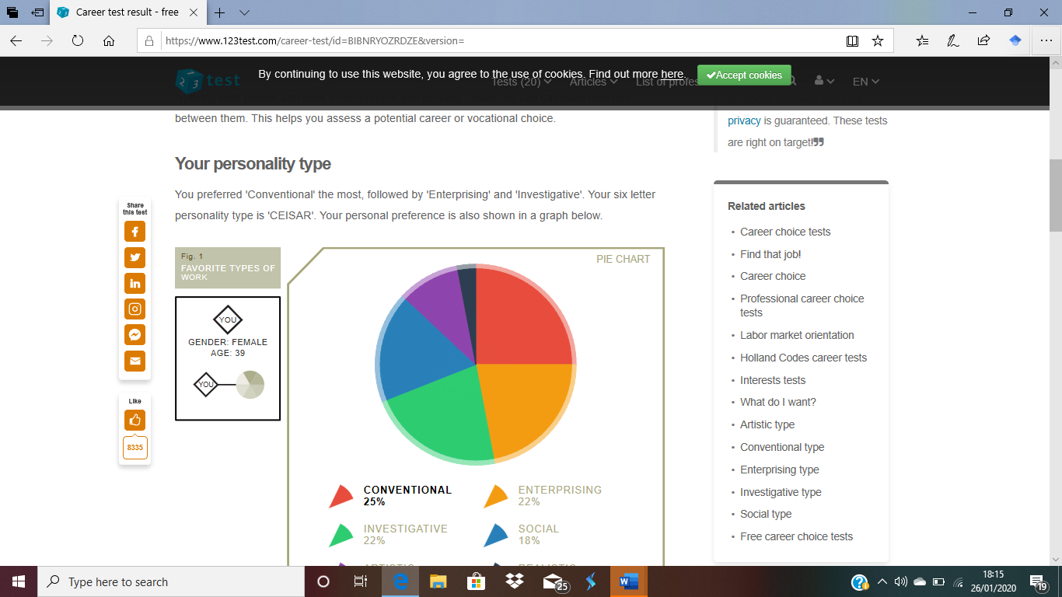

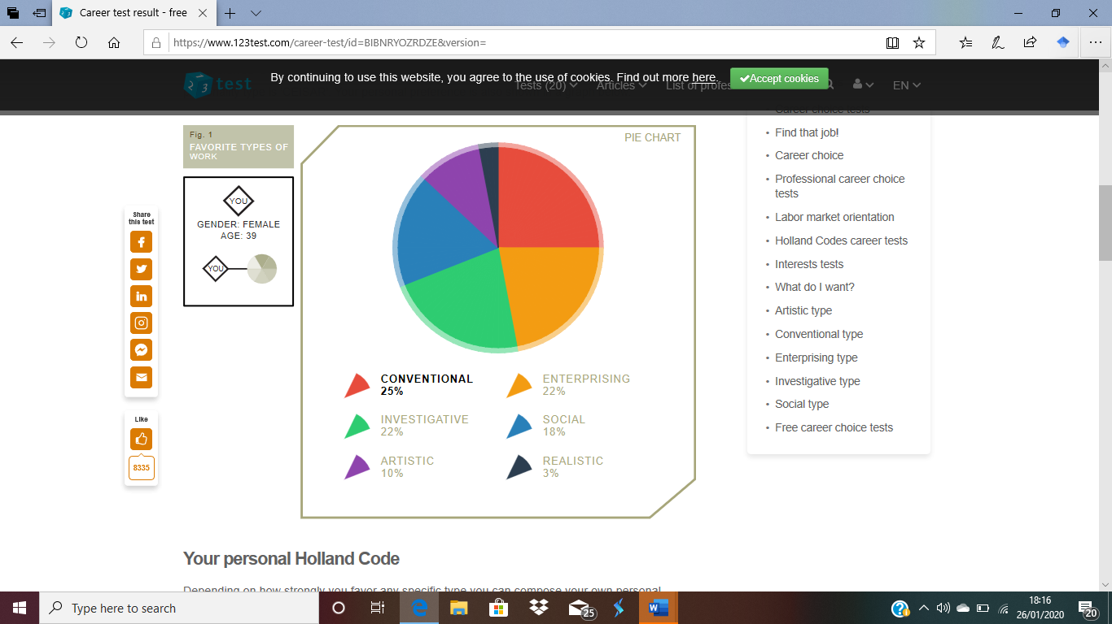
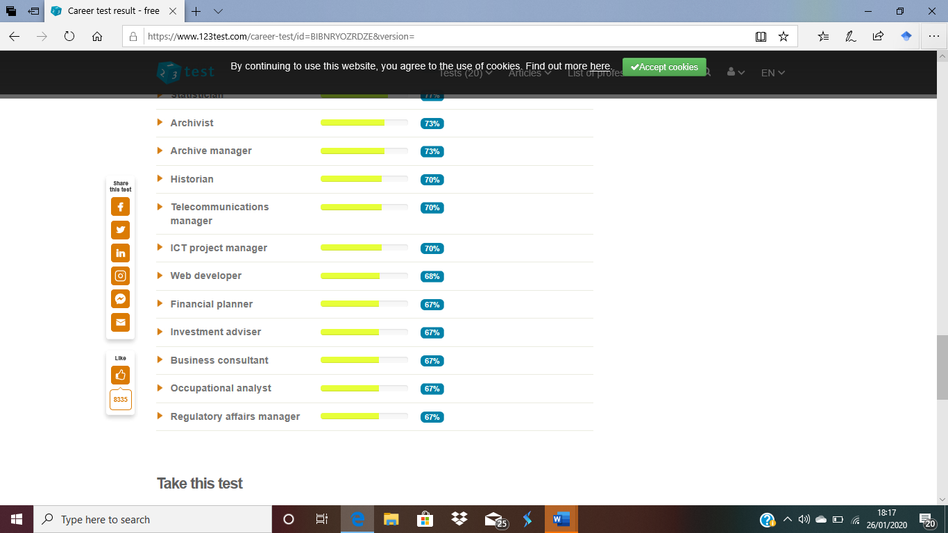

B. Reflective Report
Introduction
In this assignment, am going to produce a reflective report that focuses on the in-class recruitment activity. Recruitment, The role of preparation steps before interviews on performance, interviews, selection and the selection methods. I will also include diagrams under the Appendices for illustration.

Recruitment
Recruitment is that set of activities an organization uses to attract job candidates who have the abilities and attitudes needed to help the organization achieve its objectives. (Glueck 1978) (Dowling and Schuler 1990) defined recruitment as searching for and obtaining potential job candidates in sufficient numbers and quality so that the organization can select the most appropriate people to fill its job needs.
Recruiting is related directly to a number of other personnel activities. Employment planning determines the number of employees needed and all subsequent personnel activities such as selection, orientation, development and compensation cannot be effective unless good employees have been recruited.
The diagram below explains the various stages of recruitment processes;
Job applicants
Provides
Recruiting
Employment planning

For selection

The recruiting process begins with an attempt to find employees with the abilities and attitudes desired by the organization and to match them with the tasks to be performed. How difficult the recruiting job is depends on a number of factors. External influences such as government and union restrictions, the dictates of the labour markets, the employers’ requirements and candidates’ preference.

Selection
Selection is the process by which an enterprise chooses from a list of applicants the person or persons who best meets the selection criteria for the position available considering current environmental conditions, the nature the labour market, union requirement, government regulations, etc.

Selection Methods
An organization’s success depends on whether that organization employs the right people. Choosing the right person for the job is therefore critical to its success whist there is a vast array of selection methods available to an organization from psychometric exercises to graphology, the following are some of the examples of selection tools used by the organization.
- Interviews
- Bio data
- Personality assessment
- Work simulations
Interviews
Interviewing is by far the most popular method. It is popular because of its ease and conveniences to conduct, but it require discipline and skills to do well. The three common forms of interviews are one-to-one, sequential and paired. The interview could be structured or unstructured. All interviews should be well planned. Argyle (1972) expresses this well;“there are certain subtleties about being good candidates, it is necessary to draw attention to your qualities whilst remaining modest and submissive”. The interviewer should limit his or her talking to approximately 20% of the time then allowing the interviewee to talk for 80% of the interview. Cote (1988) summarized key skills to effective interviewing as follows
- Ability to prepare adequately.
- Ability to listen.
- Ability to ask relevant question.
- Ability
- Ability to summarize and make notes of the candidates’ performance.
- Ability to control the interview with tact, diplomacy and firmness.
A number of methods can be used by Wallsall Care Home Institution in its recruitment process but it decided to adopt advertisement on its website to inform prospective applicants about its recruitment. There are three elements involved in recruiting; the organization, the applicant and the interviewing valuable who known as the recruiter in some institutions. The recruiter is the filter and matcher, who is actually seen be the applicants and is perceived, observed and studied as a representative of the organization. The students William F. Glueck (1979) studied tended to prefer recruiters aged between 35 and 55years old during their recruiting interview, characteristics in the recruiter the students wanted were friendliness, knowledge, personal interest in the applicants and truthfulness.
The effectiveness of selection methods will depend upon a number of factors which Muchinsky (1986) refers to as the evaluative standards. This usual standards or measures against which methods are selected as follow;
Fairness, cost, user friendliness, acceptability, validity and reliability and applicability.
The role of preparatory steps before interviews on performance
Agyle (1972) said, there are certain subtleties about being good candidates, it is better and necessary to draw attention to your qualities whilst remaining modest and submissive, and all these can be possible due to your level of preparation. before walking into an interview, it is important to have an understanding of the role for which you are being interviewed.
- Why is the position being filled, being it organizational growth or employee replacement?
- What are the key positions behaviour and competencies being looking for?
- What type of person might fit best into the vacancy?
- Have a great knowledge of your target company and its products or services, and know exactly how to convey that you are the perfect fit for the job. Spend a few hours learning everything you can about the company, read current news and releases from the company. Get a sense who the company is and how to embody a similar personality during your interview, get a list of the people you are meeting with from the company then learn more about them. Including what type of behaviours that might intrigue them or turn them off.
Know the type of interview format ahead from either the recruiter or the Human Resource to enable you prepare adequately. And once you know, investing time to become familiar with this style can make a huge difference. Know your strength and weaknesses, consider why you are interested in taking up that function and identify a couple of key factors that make it a great fit for you and know it aligns with what motivates you.
In relation to my application for employment as a nursing home manager at Wallsall, I need to be aware and acquaint myself the key responsibilities that goes with the employment ,management of staff, the nature of specific deliverables that are the key performance areas that, the Care home managers are expected to know their reward systems, staff training and development. My research on the website of the agency will help me acquaint myself with all the necessary information, prior to the interview.

Feelings
I prepare well for my interview which made me feel really confident, I look for a job that I was comfortable that was in my field where I have worked for years, I checked for the requirements that the employer needed. I did some research about the company, their salary range, what they do, their goals and values. I then made my cover note and a suitable Curriculum vitae to suit it, and also wrote my cover note in addition.
My curriculum vitae was not properly structured because the time that I was printing I don’t actually know what happened, Some of the bulleting points I put later shifted making my Curricullum vitae looking messy and not neat as I typed it, but I tried my possible best to do some correction but to my surprise it did not work out as I was in a hurry because time was not on my side.
I made sure to gather all the necessary documents required of me in order to get the job which includes: my curriculum vitae, cover note, certificates, passport , drivers licences and the rest neatly in a file. I also made sure I dress appropriately to suit the job search I was looking for by wearing a black and white suit to match the job am looking for
I made sure to arrive about thirty minute earlier in order to get settled for my interview till I was call in for the interview. I smiled, shake hands and I was asked to take a seat, I made sure I made good eye contact, listening to the questions carefully and provided the needed answer that was required . After the interviewer finished asking his questions he then asked if I have any question to ask so I asked him a question that I had concerning the job.

Conclusion
Over all, I thought I did very well and fantastic at the interview , because I was able to answer all my questions very well. I never felt terrified nor nervous at all because I knew I prepared really well towards my interview.
I have learned a lot throughout this term by doing this module by gaining confidence and competence as effective employee and also gotten the readiness for employability. I have also understand the skills and knowledge needed for working effectively. I have also learn good practice relating to respect, effective communication, and also employment regislation, and also not forgetting health and safety regulations and good conduct procedures.
I could not express my disappointment at the moment, mostly remembering all the time spend doing my curriculum vitae, putting things together and typing and after that it ended up my C.V been messy, but I explained it to my Tutor why it happened that manner in our next class. I felt very sad about my Curriculum vitae when I perfectly knew that it was not properly arranged or messy which cold let me loose some marks but I had no choice than to present it like that because of time. I was upset about this situation but it reminded me that I need to develop my IT skills in using better digital device in order for me to be able to manage better my computer. The lesson that I learned about this is that, I needed to be more organized and also work on my IT skills better.
According to Laura J.R(2016), organizational skills are not only knowing how to put together an excel spread sheet, how to make and follow a to-do list, having a clean desk etc…., but they help you to eliminate problems and promote positive habits.

REFERENCES
- Armstrong M. 1999 managing people vol.4. Kogan page, London.
- Belbin M.1993. Team rotes at work. butter Worth-Heinemann, UK
- Beardwell P &Holsen L (ends) 1997. Human Resource Management: A Contemporary Perspective. Englewood Cliffs, Prentice Hall, NJ.
- Cole G.A. 1991. Personnel Management: theory and practice (2nd Ed.). DP Publication, London.
- W.B Jnr. & Davis K. 1993. Human Resource and Personnel Management. Mcgraw Hill, New York.
- Whitehill A.M. 1992. Japanese Management.
- Jessup, G & Jessup, H. 1975. Selection and assessment at work. Methnen, London.
- Bandura, A. (1977). Social Learning theory; Englewood Cliffs, Prentice Hall, NJ.
- Silvia & Duval 2001.
- S. Williams & Allison, 2015
- Sutton 2016
- https://www.shrm.org (interview guide)
- Anderson N. (1990). Repertory good techniques in employee selection, personnel Review,19
- Argyle, M. (1972). The Psychology of Interpersonal behavior. Harmondsworth: Penguin
- Laura J.R(2016) What is organizations and why is it important? Available at
- ;www.youthemployment.org.uk/young-prof-article/onisation-skills-overview/(accessed:24/04/19

Appendix 1

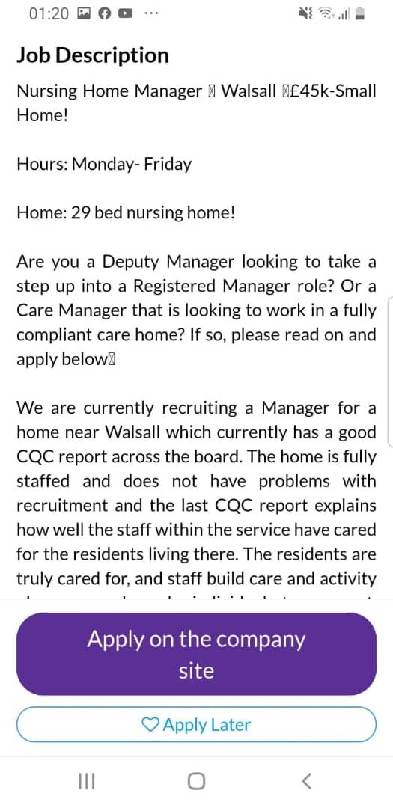

Appendix 2
The South Quay Building
189 Marsh Wall
London E14 9SH
December 12, 2019

Re: care manager ( Ref JM – J33644/CS) Advertised on Jobmedic.co.uk
Dear ms Claire,
Concerning the recent advert for a care manager caught my attention, and as I appear to be the perfect match for your requirement , I am enthusiastically for this position. As a professional with a rich and varied background in the healthcare industry , I am more than qualified to make an immediate and positive contribution to your company. Am with 10 years of experience working in the health sector, both nursing homes, hospital and residential homes, I do have the skills, healthcare knowledge and record of patient- care excellence that you are seeking for as a care manager.
Please consider my credentials:
Outstanding communication skills with colleagues. Patients and families
The ability to support and collaborate with members of the interdisciplinary medical teams
I look forward to hear from you soon.

Yours Sincerely ,
Eunice Obeng

Appendix 3
CURRICULUM VITAE

PERSONAL DETAILS

Name: EUNICE OBENG

Address: 10 Clisold Street
Birmingham
West Midlands
B18 7HH
Telephone: 07503888564

Email: maa_u78@yahoo.ie

PROFILE.

I AM HARD WORKING, A GOOD TIME KEEPER AND I CAN WORK ON MY OWN OR AS PART OF A
TEAM.I CAN WORK UNDER ANY CONDITIONS AND AM WILLING TO LEARN AS WELL.I AM RELIABLE
AND ENTHUSIASTIC PERSON.I HAVE A GOOD COMMUNICATION SKILLS AND I CAN BE A TEAM MEMBER
WITH THE ABILITY TO COMMUNICATE BOTH IN WRITTEN OR VERBALLY WITH VARIETY OF PEOPLE.I TAKES MY WORK AND DUTIES SERIOUSLY AS TO ACHIEVE FIRST CLASS SERVICE TO MY CLIENTS.AM MOTIVATED,ADAPTABLE AND RESPONSIBLE PERSON WITH YEAR’S OF EXPERIENCE WORKING IN THE
HEALTH SECTOR EITHER AS A SUPPORT WORKER OR HEALTH CARE ASSISTANT.HAVING WORKED
WITH RECRUITMENT AGENCIES WHERE I HAD THE CHANCE TO HAVE EXPERIENCE WORKING WITH
VARIOUS GROUP’S OF SERVICE USER’S WITH DIFFERENT NEED’S.AM ENERGETIC AND TRUSTWORTHY PERSON WHO ENJOY’S A CHALLENGE AND ACHIEVING GOALS.

EDUCATION

SEPT.2010 COLLINS TOWN PARK COMM.COLLEGE, DUBLIN.

Course: Pre Nursing [FETAC LEVEL 5]
Course Content
● Human Growth | Health & Safety | Care Provision & Practice
Anatomy | Nursing | Computing
Work Experience | Communications

MAY 2004 UNITED CARE TRAINING LTD DUBLIN
Certificate (NVQ level 2 in health and social care).

1996 – 1998 TECHNOLOGY SECONDARY SCHOOL, GHANA.
‘A’ LEVELS PASSED.

1985– 1995 OXFORD INTERNATIONAL PRI.SCHOOL, GHANA.
‘O’ LEVELS PASSED

WORK EXPERIENCE;

April 11 – Present Care Assistant
Mayfield Nursing Home. Chapelizod, Dublin 20.

Duties: Bathing & dressing of Client.
Served meals & assisted feeding of clients.
Caring for elderly people with physical disabilities.
Attending to service user’s appointments and reviews. Promoting well being of client.
Taking Service User’s out for daily activities.

Jan 10 - April 11 Recreational Assistant
St. Mary’s hospital. Phonics Park, Chapelizod, Dublin 20

Duties Assisted in all aspects of client’s activities program’s which include holiday and travelling.
Assisting Service user’s in physiotherapy sessions. Assisting in Art and craft activities.

Oct. ’02 – 04 Classroom Assistant, Children Aged 6-7 years
Presentation Primary School
Sexton Street, Limerick
Duties
- Responsible for helping children with different tasks both individually and in small groups.
- Organizing Art & Craft activities.
- Implementing projects on the National Curriculum.
- Supervising and facilitating children working on the computers.
● | Gaining experience in the area of special needs
● | Responsible for helping the children individually and in small groups
● | Involved in organizing indoor and outdoor activities
● | Arranging a variety of play based Art & Craft activities.
● | Encouraging and helping the children during mealtimes.
●  Involved in a parent toddler group | Supervising the children’s personal hygiene routine.
- Preparing snacks and hot meals for the older children
- Organizing age appropriate play based activities

FURTHER TRAINING.

HEALTH AND SAFETY
FIRST AID
FOOD HYGIENE
POVA ABUSE AND NEGLECT
MEDICATION
INFECTION CONTROL
PRINCIPLES OF CARE
MANUAL HANDLING
FIRE SAFETY

HOBBIES & INTEREST
Cooking
Watching movies
Reading novels
Socializing and shopping.

REFERENCE

1.Temp labour healthcare. 2. Camillus Cooke
47 Frederick street. Mayfield Nursing Home
Jewellery quarters, Chapelizod, Dublin 20
Birmingham B1 3HN. Tel: 016264684
Tel: 01216223838

3. Mrs. Anne O’Loughlin 4.Averill Whelan
West Dublin Disability Services, Collins town Park Com. College
Ballyowen Community Centre, Clondalkin, Dublin 22
Ballyowen Lane, Tel: 014572300
Lucan, County Dublin
Tel 01621108

Appendix 4



