

BA(Hons) Business Management

Student Name: Samuela Sousa
Student Number: 2030400
Course Name: Project management A2
Lecturer Name: Molly Jack
Session: October 2022 Term

Project management
evaluation of the Cross-rail project (Elizabeth Line)
Table of Contents

Introduction
Discussion
The total budget of the project
WBS
Project duration
Gantt Chart
Quality stakeholders
Stakeholder priority graph
Project risk management
Risk graph
Initial project plan
Causes behind the overruns and delay of the project
Conclusion
Recommendations
References

Introduction

The project Cross-rail, or the “Elizabeth Line”, expanded more than 100 km from Heathrow in the West direction to Abbey Wood Shenfield in the East direction through the tunnels. The “Elizabeth Line” has started to deliver around London and South East by improving the attachments of transport and cutting the times of journey. “Elizabeth Line” was established through Cross-rail Limited, which stops at a total of 41 stations that are accessible. The total probable budget of this project is 25 billion pounds. The project was mostly delayed through some critical issues of health and safety testing and signaling systems. The last-decided and final time of this “Elizabeth Line” was at the end of May month in 2022. Basically, Cross-rail is a project of railway construction mainly in central London. This project of Cross-rail aims to provide a higher-frequency rail hybrid commuter and also a system of rapid transit in the West direction of the capital. The total budget of this project, WBS, refers to the Work Breakdown Structure; actual project duration will be discussed in the essay on project management. A Gantt chart of the evaluation of these project names of some quality stakeholders will also be included here. Impacts of the quality stakeholders in this entire project and their contributions to this project, major risk factors, initial project plan and some causes behind the overruns and delay of the project will be analyzed. A cogent summary of this entire project and some relevant recommendations will also be provided in this essay on Cross-rail project management.

Discussion

The total budget of the project
The project of Cross-rail was anticipated to serve over 200 million passengers in a single year and also aims to increase the more than 10% capacity of having trained (Milillo et al., 2018). The construction of the Elizabeth Line was one of the biggest construction projects in the entire infrastructure of Europe. The railway of London had been renamed through the name of “Queen Elizabeth”. This Cross-rail project of the Elizabeth Line was devoted in the year of 2010 (Sweet, 2019). The total budget at that time was 15 billion pounds. This project took a total of 12 years, from the year of 2010 to the year of 2022 (Sweet, 2019). The revised funding or allocated budget of this Cross-rail project was 14.8 billion pounds which was decided and agreed upon in the month of October 2010 (Heberling et al., 2019). The container of funding or allocated budget was positively increased from 14.8 billion pounds to more than 17 billion pounds. Based on the total budget, the actual and overall cost of the Cross-rail project was nearly 20 billion pounds (Milillo et al., 2018). The Government played a significant role and spent more than 15 million pounds up to the month of January 2022. The Department of Transport (DfT), the Transport for London, the Government and the Mayor of London jointly sponsored the Cross-rail project of the Elizabeth Line (Sweet, 2019). This project was originally planned or announced to open in the year 2018, but the pandemic situation of the spreading Corina Virus effectively spoiled it, and the opening was delayed through this reason for three years.

WBS
WBS, or Work-breakdown structure in systems engineering and project management, is a project breakdown which is deliverable-oriented (Burghate, 2018). WBS organizes the project work of an entire team into some manageable sections. The main purpose of the WBS is to generate a plan according to the team members.
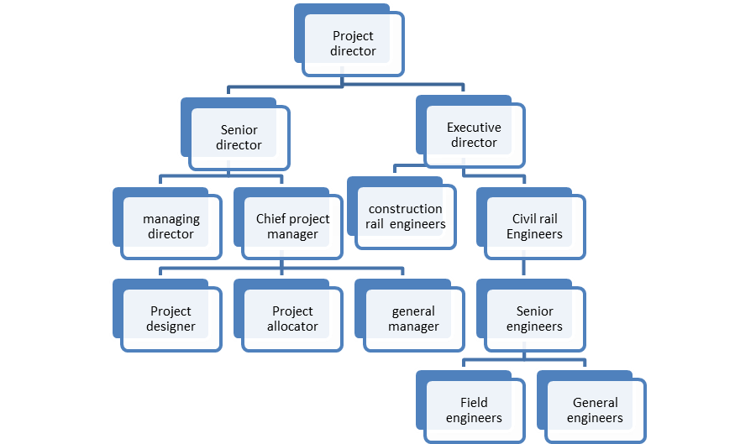
Figure 1: WBS of Cross-rail project
(Source: Self-developed)

The primary position was the project director of the Cross-rail project. The executive director and senior director were under the project director. The managing director and chief project manager were under the senior director. Construction rail engineers and civil rail engineers were the main two positions under the Executive director (Burghate, 2018). General manager, project allocator and project designer were the main posts of chief project manager. Field engineers and general engineers were under the post of senior engineer. All team members worked significantly and sustainably for the Cross-rail Project.

Project duration
The opening time of the Cross-rail project of the Elizabeth Line was in the month of May 2022. This project work was started in 2010, and it took a total of 12 years and started its transportation service in the year 2022 (Sergeeva and Winch, 2021). It has made more than 40 million journeys since the time of opening the Cross-rail project of the Elizabeth Line (Newlove-Eriksson, 2020). Nearly 22 million journeys were gone out at the middle part between Paddington city to Abbey Wood. The transformation journey of the Elizabeth Line had already started to transform various journeys across London city and South East through improving the attachments of transportation and cutting the times of journey (Newlove-Eriksson, 2020). The railway service of the Elizabeth Line provided some additional capacities, such as new and innovative stations, work-through trains and transforming accessibilities.
On the date of 23rd August in the year 2022, the TfL, which refers to Transport for London, declared or announced that the transporting services of the Elizabeth Line would start Sunday transportation services as well (Cooper and Wright, 2022). The starting date of this railway service of the Elizabeth Line remained linked for reliability development and successful commissioning. The entire timetable of this Elizabeth Line included over 24 trains at peak in one hour between Paddington and Whitechapel and more than 15 trains at off-peak in one hour (Sergeeva and Winch, 2021). The viral spreading of Corona Virus and the critical situation of the Covid pandemic were responsible for the delay of this project, and for that reason, the entire project of the Elizabeth Line had been delayed for three years.

Gantt chart
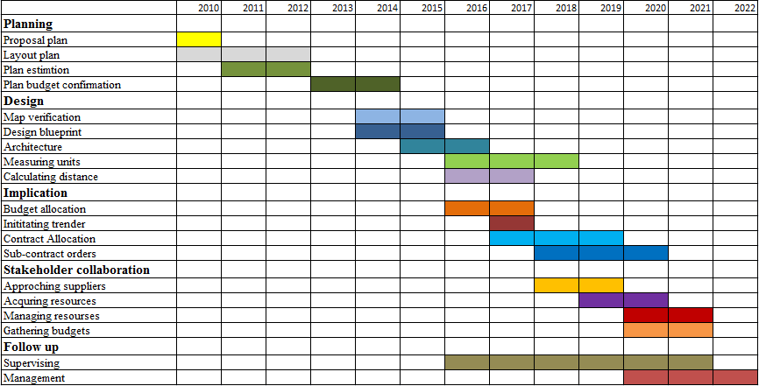
Table 1: Gantt chart of the Cross-rail project plan
(Source: Self developed)

Quality stakeholders
Simmon Bennett, who is the former stakeholder engagement of the Cross-rail project, was aggressively involved in the project of the Elizabeth Line from the starting time in 2010. Simmon had an approach to stakeholder relationship management in a Webinar that is available on the YouTube Platform (Cooper and Wright, 2022). There was a large range of stakeholders who have been involved in this project since 2010. Each stakeholder fell a significant impact on this project through their valuable support and contributions. These stakeholders are future passengers, local authorities, local politicians, national politicians, Department for London, HM treasury, London businesses, impacted communities, railway bodies, Government, statutory bodies and everyone else. Bentley, which is the information academy of Cross-rail, effectively helped in this project to ensure the best practices of digital technologies through developing, sharing and capturing the entire management of the supply chain of Cross-rail (Gakis, Salak and St. John, 2022). The railway construction company, Cross-rail Limited, is responsible for the construction and delivery of the entire project. The Mayor of London and the Department of Transport were the prime stakeholders or sponsors. There was a huge presence of some external stakeholders such as political representatives, competitors, customers, business partners, NGOs, suppliers and many more. The Government of London paid the major currency, which is more than 15 million pounds, and this contribution was helpful for the additional development of this entire project (Muruganandan et al., 2022). Apart from the pandemic years from 2019 to 2021, the Government of London contributed an equivalent tax surplus to the entire project of Cross-rail every year.

Stakeholders
Name of Stakeholders | Impact of Stakeholders
Future passengers | Very high
HM Treasury | high
Department for Transport | high
Local authorities | Moderate
London businesses | High
National politicians | High
Local politicians | Low
Statutory bodies | Moderate
Railway bodies | High
Government of London | Very high
Everyone else | Low
Table 2: Stakeholder Matrix
(Source: self-developed)
Stakeholders played some helpful and effective roles in the entire Cross-rail project of the Elizabeth Line and its further development. The contribution of future passengers of the Elizabeth Line had a very high impact on this project. London businesses, national politicians, railway bodies and the Government of London had a high impact here (Muruganandan et al., 2022). DfT and HM Treasury, local authorities, statutory bodies and everyone else related to this project and their contribution and support fell a moderate impact on the stakeholder matrix. Impacted communities and local politicians fell a low and very low impact accordingly to this entire project.

Project Risk management
Cross-rail is the main company of railway construction which is majorly responsible for constructing and delivering the “Elizabeth Line”. Delay in the improvement from some responsible authorities, incomplete equipment installation, lack of government initiatives, high-cost pressure, low professionalism, worker health and safety issues and the deadlines of critical times were the major risk factors of this project.
- Delay in the improvement: There were some delays in the project improvement, and the authorities are mainly responsible for these delays. Monitoring and reporting the progress of a project can reduce the risk of delays (Medeossi and Nash, 2020). The government authorities posted some restrictions across the funding budget, which is responsible for the delay of project improvement.
- Incomplete equipment installation: There was an incomplete installation of resources and other materials essential for this project of Cross-rail. A faster technological solution is needed for this risk factor of incomplete equipment installation.
- Lack of Government initiatives: In this project of the “Elizabeth Line”, there was an absence of government initiatives. Major railways are operated and managed through the Regional Government, and for that reason, the absence of government initiatives was risky for this Cros-railway project.
- Deadlines of critical times: Meeting the deadlines is a green flag for every project. There were various deadlines which were occurred through the pandemic situation, incomplete installation, the pressure of high cost and other negative issues.
- High-cost pressure: Increment in the actual budget was the most affected risk factor in this project (O'Malley, 2019). The step of budget enhancement increases the pressure of high-cost for initiating the Elizabeth Line.
- Low professionalism of the expert engineers: Low professionalism was seen in the expert engineers who were related to this entire project (Gil and Fu, 2022). Completely dissatisfactory performance was not expected from those engineers.
- Worker health and safety issues: Tkáčik, BAM Nuttall, and Ferrovial Agroman are the name of those workers who died during this project because of the risk elements in this project (O'Malley, 2019). For that reason, the issue of worker health and safety was the significant risk factor of this project.

Risk priority graph
Risk factors | Very high | High | Moderate | Low
Delay in the improvement
Incomplete equipment installation
Lack of Government initiatives
Deadlines of critical times
High-cost pressure
Low professionalism
Worker safety issues
Table 3: priority graph
(Source: Self)
Delays in the project improvement fell a very high impact on the Cross-rail project of the Elizabeth Line. The risk factor of incomplete equipment installation also felt a high impact on this. Faster technical solutions were needed to reduce this risk (Gil and Fu, 2022). The lack of government initiatives and the deadlines of critical times felt moderate and high impact accordingly in this project. The risk of high-cost pressure, including the enhancement in the actual budget, felt a very high impact here. Apart from this, low professionalism from the expert engineers and the risk of worker health and safety issues had a very high impact on this entire project.

Initial project plan
The project of the Cross-rail of the Elizabeth Line had originally started most probably 12 years ago means, in the year 2010. This railway project is considered one of the biggest projects in entire Europe. It is also one of the hugest investments of the single infrastructure of the United Kingdom. The Elizabeth Line is one of the most significant changes to the transport network of London. The Cross-rail project achieved a huge milestone in the month of May 2015 (Pollalis and Lappas, 2019). The biggest challenge or obstacle for the Cross-rail project was to convert the new tunnels of the railway into a totally functioning railway and also connect those railways with the lines of national rail to the East direction and West directions (Pollalis and Lappas, 2019).
The routeway of the central section features various types of key systems across the whole tunnelled section of the route of the Elizabeth Line. The beginning of the trail running marked a key point in the transition of the Elizabeth Line to a functional railway. According to the plan, there were more than 10 thousand people who were employed within more than 40 working sites in London and throughout the South East of the United Kingdom (Pollalis and Lappas, 2019). As per the initial project plan, the Elizabeth Line is going to begin its transportation services in the year of 2018. But the viral spreading of Corona Virus had stopped this approach, and the project of the Elizabeth Line started its journey in the month of May 2022.

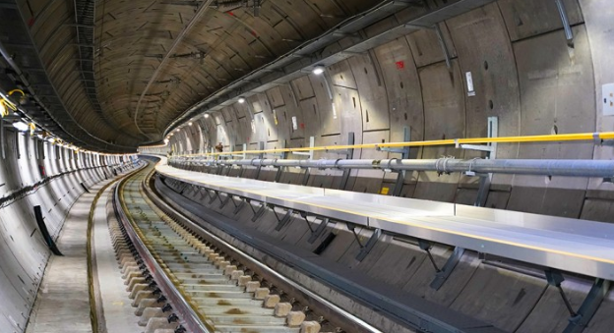
Figure: The Cross-rail project of the Elizabeth Line
(Source: https://www.crossrail.co.uk/project/routeway/)

Causes behind the overruns and delay of the project
Various risk factors such as delays in the improvement from some responsible authorities, incomplete equipment installation, high-cost pressure, low professionalism, worker health and safety issues and the deadlines of critical times are the main causes behind delays and overruns of the project (Medeossi and Nash, 2020). Appropriate and effective management can reduce this type of overruns and delays of the Cros-rail project of the Elizabeth Line.
- The theory of management as planning: The theory of management as planning is one of the best theories for construction. This theory divides the processes of project management into execution, controlling, closing processes and initiating. Proper planning can help to describe the main point of view, which is going to be so much impactful for the entire project and project development also (Hopmere, Crawford and Harré, 2020). Making a transparent map of this railway’s transportation is effective for all. The steps of initiating the entire project and planning for various strategical steps and also the final closing of various processes under this project can decrease the causes behind the overruns and delays of the Cross-rail project of the Elizabeth Line (Kumar, 2020). Planning processes have two streams or departments, such as controlling processes and executing processes (Hopmere, Crawford and Harré, 2020). These two processes are co-related with each other through performance data and information along with corrections (Kumar, 2020). Various changes are included in a project plan. Based on this theory of management as planning, the authorities and the entire team of this project can reduce the high risks of falling down.

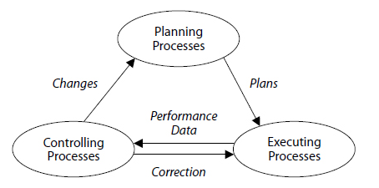
Figure: The teary of project management as planning
(Source: https://www.pmi.org/learning/library/underlying-theory-project-management-obsolete-8971)

Conclusion
From the entire analysis, it can be concluded that the low professionalism, deadlines of critical times and the high-cost pressure are the main reasons behind the overruns and delays of the project. This large project construction has to focus on strategic planning and needs to be focused on the time duration of the project. The overflow of the actual budget was the main reason for project delaying and high-cost pressure. This project must have some effective and impactful recommendations for further development of this project. Through achieving the step-by-step management system and manageable and systematic flow of budget, the risk issues of this Cross-rail project of the Elizabeth Line can be controlled.

Recommendations
- Through identifying, monitoring and understanding the actual goals and objectives of the project, some recommendations can be provided.
- It can be recommended that the maintenance of a report of project progress is mandatory that can be used for presenting to the officials successively (Shields et al., 2018).
- A comparison of the prices of equipment should always be proposed at the project’s initial stage with the help of guessing or forecasting (Wilde, 2019).
- It can also be recommended that the significance of the equipment and alignment with all elements of the system of the tunnel must always be prioritized (Wilde, 2019).
- A properly scheduled meeting with the supporters and the team members should be conducted to manage the budget costs.
- The projection team should generate some alternative processes of management to increase the responsibilities of engineers and other workers (Shields et al., 2018).
- A tracker of the project budget should be generated to get each information related to the Cross-rail project of The Elizabeth Line.

References
Burghate, M., 2018. Work breakdown structure: Simplifying project management. International Journal of Commerce and Management, 3(2), pp.453-461.
Cooper, Z. and Wright, K., 2022. A People Centred Design: Human Factors Integration of the Crossrail Route Control Centre. In Crossrail Project: Infrastructure Design and Construction (pp. 221-233). ICE Publishing.
Gakis, A., Salak, P. and St. John, A., 2022. Crossrail Farringdon Station SCL Tunnels: delivering value through innovation and best practice. In Crossrail Project: Infrastructure Design and Construction (pp. 263-276). ICE Publishing.
Gil, N. and Fu, Y., 2022. Megaproject Performance, Value Creation, and Value Distribution: An Organizational Governance Perspective. Academy of Management Discoveries, 8(2), pp.224-251.
Heberling, J.M., McDonough MacKenzie, C., Fridley, J.D., Kalisz, S. and Primack, R.B., 2019. Phenological mismatch with trees reduces wildflower carbon budgets. Ecology Letters, 22(4), pp.616-623.
Hopmere, M., Crawford, L. and Harré, M.S., 2020. Proactively Monitoring Large Project Portfolios. Project Management Journal, 51(6), pp.656-669.
Kumar, S., 2020. Relevance of Buddhist Philosophy in Modern Management Theory. Psychology and Education, 58(2), pp.2104-2111.
Loo, B.P., Bryson, J.R., Song, M. and Harris, C., 2018. Risking multi-billion decisions on underground railways: Land value capture, differential rent and financialization in London and Hong Kong. Tunnelling and Underground Space Technology, 81, pp.403-412.
Medeossi, G. and Nash, A., 2020. Reducing Delays on High-Density Railway Lines: London–Shenfield Case Study. Transportation Research Record, 2674(7), pp.193-205.
Milillo, P., Giardina, G., DeJong, M.J., Perissin, D. and Milillo, G., 2018. Multi-temporal InSAR structural damage assessment: The London crossrail case study. Remote Sensing, 10(2), p.287.
Muruganandan, K., Davies, A., Denicol, J. and Whyte, J., 2022. The dynamics of systems integration: Balancing stability and change on London's Crossrail project. International Journal of Project Management, 40(6), pp.608-623.
Newlove-Eriksson, L., 2020. Accountability and patchwork governance in urban rail interchanges: junctions of London Crossrail and Stockholm City Line compared. Public Works Management & Policy, 25(2), pp.105-131.
O'Malley, J., 2019. Big Project, Big Delay?. Engineering & Technology, 14(9), pp.70-73.
Pollalis, S.N. and Lappas, D., 2019. Crossrail-Elizabeth Line London, UK.
Sergeeva, N. and Winch, G.M., 2021. Project narratives that potentially perform and change the future. Project management journal, 52(3), pp.264-277.
Shields, C.A., Rutz, J.J., Leung, L.Y., Ralph, F.M., Wehner, M., Kawzenuk, B., Lora, J.M., McClenny, E., Osborne, T., Payne, A.E. and Ullrich, P., 2018. Atmospheric river tracking method intercomparison project (ARTMIP): project goals and experimental design. Geoscientific Model Development, 11(6), pp.2455-2474.
Sweet, R., 2019. Damned if they did: A defence of Crossrail. Construction Research and Innovation, 10(2), pp.32-38.
Wilde, D., 2019. Connaught Tunnel, UK: condition and repairs. Proceedings of the Institution of Civil Engineers-Engineering History and Heritage, 172(2), pp.46-56.

