Developing Workplace Critical Thinking
BMSW5101
Diana Decheva
Student ID:2129230
Part 1 – Individual Business Report
Part 2 – Reflective Journal

Table of Contents
Part 1 – Report 3
Introduction 3
Introduction of the company 3
Theoretical discussion 3
Answer to the question 6
Critical evaluation of the theory 10
Recommendations 11
Conclusion 11
Part 2 – Reflective journal 12
Introduction 12
Choice of model 12
Reflection of the learning experience 13
Week 1 13
Week 2 13
Week 3 13
Week 4 14
Week 5 14
Week 6 15
Week 7 15
Week 8 16
Week 9 16
Conclusion 16
References 18

Part 1 – Report

Introduction
This report considers the role of leadership and management in the workplace by considering the case of Tesco. Research findings demonstrate the application of human relations management in the workplace and its role for coping with the effects of the pandemic in a flexible manner.

Introduction of the company
The organisation of interest is Tesco. This is the market leader in the UK’s grocery retail sector, as suggested by the 27% market share and 355,000 employees (Bedford, 2023; Tesco, 2023a). Tesco is also considerably large in terms of market capitalisation - £18.7 billion – as well as annual revenue of £65.8 billion (Reuters, 2023). In the UK alone, the company operates with approximately 2,800 physical stores and online sales channels (Tesco, 2023a).
The considerable size of Tesco, its leadership market position and exposure to customers require effective management, so that the complex company can sustain its competitiveness in a changing environment. The report continues with a discussion of the management theories and practices of Tesco in a post-pandemic environment.

Theoretical discussion
Two models are discussed in the report. First, the competing values model by Cameron and Quinn (2011) is introduced to better understand the organisational culture and values of Tesco. The theory suggests the existence of four main types of organisational culture – adhocracy, clan, hierarchy and market-oriented – depending on the internal or external orientation of an organisation and core values (Cameron and Quinn, 2011). As shown below, each organisational culture has specific priorities based on its orientation and specifics (Cameron and Quinn, 2011).

Figure 1 – Major types of organisational culture
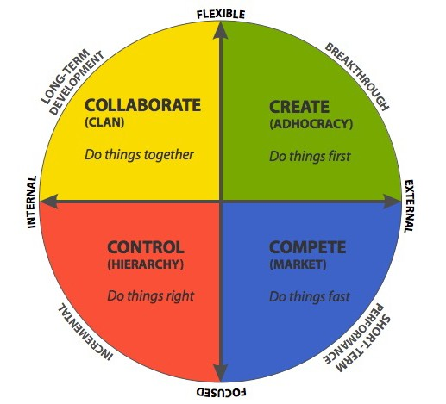
Source: Cameron and Quinn (2011)
Tesco has a competitive culture which is supported by several pieces of evidence. First of all, this is the market leader with 27% market share, indicating the ability of Tesco to respond in a fast manner (do things fast) to a variety of external changes (Bedford, 2023). Second, the organisational values, as reported by the company’s website, focus primarily on delivering continuous improvements to customers, as well as excellent customer service (Tesco, 2023b). Thus, the company’s purpose is driven by the changing requirements and needs of customers. Respectively, the actions of Tesco must be focused on meeting customers’ preferences in the best possible way. This is evidence of a competitive, market-oriented organisational culture which is altered according to external changes.
Given the discussion of organisational culture and values of Tesco with the support of the competing values model, the discussion proceeds with the second model under consideration – human relations management. As shown below, management theories have evolved over time and the branch of human relations management is still applicable in the contemporary environment (MA, 2014). There are different contributors to human relations management, such as Mayo, Maslow and McGregor, but the current report considers only the theoretical contributions of Maslow and his Hierarchy of Needs model (MA, 2014).

Figure 2 – Chronological overview of management theories
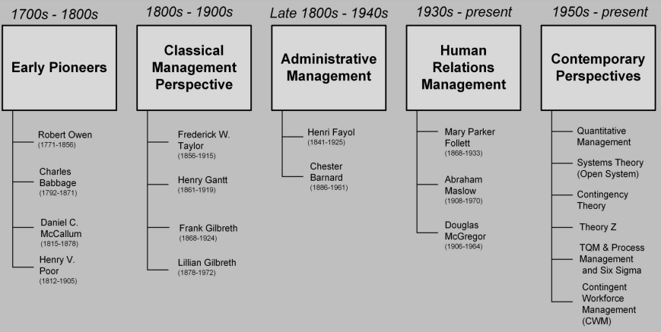
Source: MA (2014)
The model emphasises the satisfaction of five distinct groups of human needs which are organised as a pyramid based on their importance and sequence of addressing (Maslow, 1943). Since employees are also humans, the Hierarchy of Needs is applicable in work-related context, as shown below (Mintz, 2017). Respectively, managers and leaders must consistently and orderly address physiological, safety, belonging, esteem and self-actualisation needs to achieve the best levels of employee satisfaction, motivation and retention (Badubi et al., 2017).
Physiological needs focus on necessities, such as food, water, time for rest and others (Maslow, 1943). Safety needs in work-related context refer to good pay level, security of employment, effective organisational policies, safe working conditions and others (Mintz, 2017). Belonging needs focus on developing a coherent work environment, strong teamwork, common vision, as well as support by leaders if necessary (Hook and Jenkins, 2019). Esteem needs are met by delivering individual and group-based rewards which recognise the efforts and contribution of every employee (Mintz, 2017). Theoretically, self-actualisation needs are suggested to deliver the maximum level of motivation (Maslow, 1943). These needs in work-related context refer to professional growth, training and development, promotional opportunities, effective job design changes, challenges and others (Hook and Jenkins, 2019).

Figure 3 – Hierarchy of Needs model
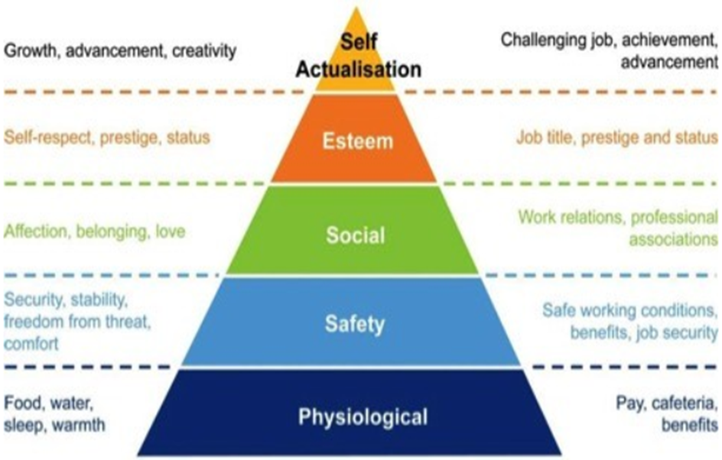
Source: Mintz (2017)
Taken together, both theories are of essential importance in understanding the managerial priorities and decisions of Tesco amid a changing external environment.

Answer to the question
The article by Cerruti and Godoski (2020) discusses some of the contemporary changes in the workplace environment caused by the pandemic. The main trends recognise the importance of enhanced flexibility, safety at work, maintenance of social connection with co-workers amid remote working conditions, as well as physical and mental health perseverance (Cerruti and Godoski, 2020). While some of the above-mentioned changes have been gradually evolving over time, the pandemic caused a sense of urgency and immediate change by organisations (Cerruti and Godoski, 2020). Therefore, it is important to analyse the response of Tesco given the prevailing organisational values, beliefs and attitudes and the major requirements for change caused by the external event – the pandemic.
According to Rollinson (2019), organisational culture has a key role in explaining the actual behaviour of all organisational members. Culture is based on beliefs and values which in turn shape specific attitudes and behavioural norms – key factors explaining the behaviour of employees and decision-makers at an organisation (Rollinson, 2019). Therefore, the organisational culture of Tesco can explain the response of the company to the above-mentioned key workplace changes caused by the pandemic.
As discussed, Tesco has a market-oriented competitive culture according to the competing values model by Cameron and Quinn (2011). Therefore, the company is suggested to be quite fast in responding to external changes and implementing the necessary workplace modifications based on the pandemic requirements.
This proposition is supported by several pieces of evidence from Tesco. First, Tesco initiated flexible working schemes to protect its employees from the virus and meet the overall needs of more flexible working (Tesco, 2023c). Office employees typically spend 40%-60% of their working time outside of the office; thereby, being engaged in remote working mode (Tesco, 2023c). Moreover, store employees, who cannot work remotely, enjoy a set of opportunities for a more flexible working process, such as lifestyle break, part-time working, shorter working weeks and others (Tesco, 2023c). The above-mentioned job modifications are extensive and quickly introduced after the outbreak of the pandemic; thereby, showing the appropriateness of Tesco’s organisational culture for delivering fast changes in the workplace.
Second, Tesco has also strengthened its health and wellbeing policies and practices. The company provides not only health checks to its employees, but also face-to-face consultations with mental health professionals, supporting team activities and others (Tesco, 2023d). Moreover, Tesco provided at the early stages of the pandemic free 12-month access to digital wellness tools, such as Headspace and SilverCloud, to support mental wellbeing of 300,000 workforce members (SilverCloud, 2020). The digital tools have been effective for stress and anxiety management (SilverCloud, 2020).
Third, profound safety changes also took place. During the most severe episodes of the pandemic, Tesco also implemented a strict safety protocol focused on ensuring mask protection, enhanced cleaning/hygiene standards, avoidance of unnecessary contacts among employees, precautionary measures and others (Tesco, 2021). The risk management processes included an appropriate risk assessment, identification of affected stakeholder groups, as well as specific measures for control and management (Tesco, 2021). The comprehensive and detailed policies in the field clearly demonstrate the ability of Tesco to effectively respond to pandemic related health challenges by sustaining its business operations.
The above-mentioned three key changes show the fast response of Tesco to adapt workforce changes in alignment with the propositions from the article by Cerruti and Godoski (2020). It can be suggested that the market-oriented organisational culture contributed to the fast adaptation to external changes. Based on the human relations theory, organisational culture has a key role in establishing unity of an organisation and maintaining elevated employee morale. These key goals are achieved by emphasising training and development programs, fostering open communication, and encouraging participative decision-making (Linnenluecke and Griffiths, 2010). Considering this, there is a theoretically suggested connection between human relations model and organisational culture. Hence, it is also necessary to analyse the workplace transformation process through the prism of Maslow’s model, as the latter is a key theory in the field of human relations management.
- Physiological needs: The mental wellbeing of employees became the centre of attention for Tesco. The combination of flexible work, remote work for office employees, as well as the variety of measures intended to support mental wellbeing could be considered as effective measures to meet the basic physiological needs of employees (Tesco, 2023c, d).
- Safety needs: Tesco avoided layoffs during the pandemic; instead, it hired an additional 16,000 full-time employees (Butler, 2020). Thus, the disrupted economic processes did not affect the work safety of employees. Moreover, Tesco implemented a strict protocol for health and safety at work, as discussed (Tesco, 2021). The measure maximised the efforts to reduce the spread of the virus in the workplace. In addition, employees received free-of-charge support to digital tools for self-help by Tesco (SilverCloud, 2020).
- Belonging needs: The organisational culture emphasised on safety and belonging during the pandemic, as suggested by the following key principle of Tesco: "Nothing is more important than the safety of our customers and colleagues” (Tesco, 2021; p. 1). This guidance supported the development of a coherent environment where all organisational members – managers, store and office employees, etc. – act together for the achievement of the best performance and health protection during the pandemic. The creation of a team-based response is performance has also been supported by the leading values of Tesco promoting trust and mutual respect, teamwork, shared decision making and experience (Tesco, 2023b). Moreover, the sense of belonging was strengthened by keeping good communication at all levels of the organisation. Active communication in face-to-face and team-based formats was maintained based on online platforms for communication during the pandemic (CareersHelp, 2021).
- Esteem needs: Tesco demonstrated flexibility in terms of rewards, as well. The company provided additional 10% bonuses to all full-time employees in 2020 – a collective reward policy designed to recognise the commitment of workforce members during the pandemic (Pratt, 2020). Moreover, Tesco extended the discount to 20% when employees purchase products from Tesco’s stores (Pratt, 2020). This financial reward is also a way of recognising employee contribution. It is also worth noting that Tesco maintained the existing reward and recognition policies regardless of the pandemic disruptions, as shown below (CareersHelp, 2021). Hence, the above-mentioned rewards are additions to the already existing reward policy (Pratt, 2020).
Figure 4 – Existing key rewards at Tesco
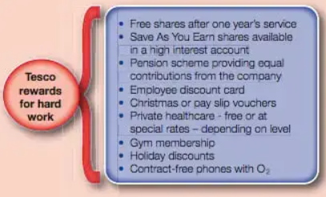
Source: CareersHelp (2021)
- Self-actualisation needs: Tesco has not interrupted its extensive training and development efforts regardless of the pandemic. Instead, some considerable improvements were completed during the pandemic period. The My Tesco application was introduced during the pandemic. The application facilitates collaboration among employees by allowing them to enhance one's skill set and acquire additional hours of availability. More than 40% of Tesco's employees use the application on a weekly basis (Tesco, 2023e). In addition, Tesco has been quite focused on young professionals, as over 50,000 were aided in enhancing their employability skills in 2022 (Tesco, 2023e). The initiative aims to enhance professional skills and initiate future professional trajectories, in conjunction with the Prince's Trust and Institute of Grocery Distribution.
Taken together, the above-mentioned pieces of evidence demonstrate extensive efforts by Tesco to meet all levels of human needs according to the Hierarchy of Needs theory. Thus, the company has effectively applied the human relations model in managing its workforce and workplace during the pandemic by effectively responding to the urgent and considerable need for change.

Critical evaluation of the theory
The Hierarchy of Needs model belongs to the group of content models of employee motivation (Ramlall, 2004). This means that the model provides clear determinants to be followed by managers and there is little room for ambiguity regarding the most effective human resource management policies – a key advantage over the group of process models of employee motivation (Ramlall, 2004).
Nevertheless, the model may be subject to different interpretations depending on the prevailing values, beliefs and attitudes in an organisation. In this relation, the work by Hofstede (2001) is quite important. Based on a large-scale survey among IBM employees, Hofstede (2001) identified six cultural dimensions which are unique for every country – risk tolerance, indulgence, level of masculinity, power distance, time orientation, as well as collectivism/individualism. It is important to mention that the predominant cultural specifics of a given nation are often translated in the organisations operating in the specific country (Hofstede, 2001). This is quite relevant for critically analysing the Maslow’s model, as well. For example, if a nation has a low tolerance to risk, risk-averse values can be quite common; thereby, shaping attitudes and behaviours focused on stability, predictability, avoidance of uncertainty and others (Hofstede, 2011). Thus, security needs could be quite important according to Maslow’s model. And the vice versa – risk-seeking national culture may promote organisational values, attitudes and behaviours which make security needs less relevant for employees (Hofstede, 2011).
Another example from the Hofstede’s model stems from the preferences for rewards. If a nation is more individualistic, esteem needs may be of disproportionally high priority for employees (Hofstede, 2011). This puts pressure to prioritise esteem needs when devising human resource management policies. These examples indicate that the predominant national culture may lead to an unequal treatment of the five human needs by prioritising some or ignoring others.
Another critical remark refers to the ability of organisations to systematically address all human needs from the model. Employees in each organisation may have different cultural backgrounds and preferences – a situation of importance for international companies. As a result, employees can be quite diverse and require different focus along the pyramid of human needs. This poses a challenge to implement the Maslow’s model, as there is need for a customised approach and focus on the specific needs of every employee. Hence, the theory of Hierarchy of Needs is just a general model which is more valid for coherent organisations with strong and mutually accepted values.

Recommendations
The critical discussion of the theory and the case of Tesco leads to several key recommendations for improved performance and resilience in the future.
First, Tesco must constantly monitor the external environment and changes related to the macroeconomic situation, the industry of operations, customers and key stakeholders. Awareness regarding the external changes is highly necessary to promote quick modifications of the workplace in alignment with the existing market-oriented organisational culture.
Second, the critical analysis of the Maslow’s model also shows the challenges of operating with a culturally diverse workforce. To promote effective human resource management policies and practices, Tesco must establish a high level of organisational coherence and mutual understanding – a challenging task requiring consensus around several key organisational values, norms and behavioural codes. If commonly accepted by all employees regardless of their cultural and ethical background, these features of the organisational culture can help Tesco in making relevant changes and progress in the future.
Third, Tesco is also advised to implement extensive and objectives measures of performance. This is suggested with the idea of measuring the effectiveness of promoted change and the possible areas for improvement. The company must also strengthen its communicational process and active involvement of employees, as the latter can be a key source for relevant changes in terms of organisational culture and response to different situations. Moreover, the inclusion of employees can improve the quality of decision-making process and the level of employee motivation (Uzohue et al., 2016). Thus, preferences for democratic (consultative) leadership are also appropriate in a changing environment.

Conclusion
To sum up, research findings demonstrate the key role of organisational culture in guiding the response to different situations and episodes of crisis. Tesco’s example is quite indicative for the value of market-oriented culture and the wide range of policies which address all levels of the Maslow’s model. Regardless of the stated imperfections of the human relations theory, it appears to be a relevant managerial framework of value for Tesco in the future. A greater integration of employees and their inclusion in many internal processes, including decision-making, can be a key to a more resilient performance in the future.

Part 2 – Reflective journal

Introduction
This is a reflective report based on my performance in the following module: Developing workplace critical thinking. The reflective learning journal covers the learning sessions from week 1 to week 9 by exploring personal experiences and insights regarding the studied materials and exercises.

Choice of model
The process of reflection is suggested to be cyclical in nature and enriched by new experiences over time (Atkinson and Murrel, 1988). Reflective is important to identify key experiences and critically analyse the performance and directions for future development in the future (Wain, 2017). Thus, reflection supports continuous improvement – a key factor for success as a professional.
It is also important to note that the reflection process is systematic (Wain, 2017). There are different models guiding the reflection process, such as the popular frameworks developed by Kolb and Gibbs (Atkinson and Murrel, 1988; Gibbs, 1988). The current reflective report applies the latter, as shown below.
Figure 1 – Gibbs reflective cycle
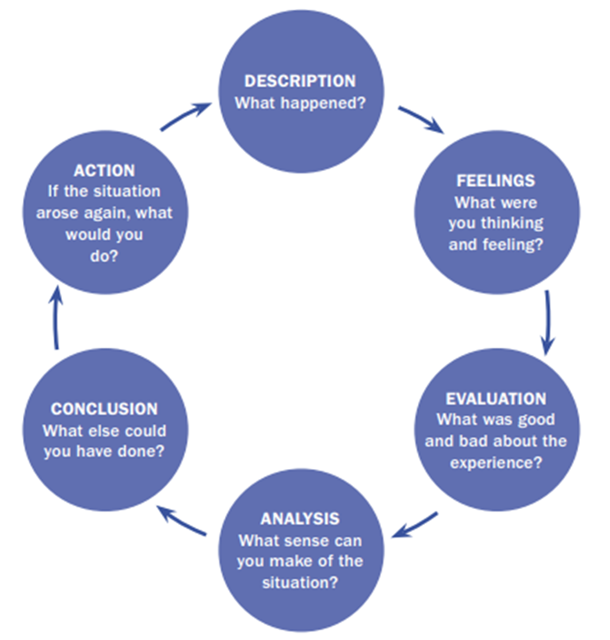
Source: Wain (2017)
The reflection process consists of six distinct stages, as suggested by the Gibbs’s model, which are systematically employed in the current analysis, as well (Wain, 2017). This approach ensures that all important aspects of the learning experience are reflected in an objective manner; thereby, being able to identify relevant directions for future learning and progress.

Reflection of the learning experience
The reflection process considers the specific learning experience in each of the nine weeks.

Week 1
Week 1 was introductory. The module content was discussed, as well as general aspects of the contemporary workplace changes and management theories. Special attention was placed on reasoning and the logic of thinking by investigating both – inductive and deductive reasoning. I felt motivated to understand the basics of the module. The starting content was quite relevant, as it paved the way for the process of critical thinking, especially in terms of applied reasoning. I consider the first week as a good starting point, as set the foundation for the rest of the module and stimulated my motivation in the subject. Therefore, it can be concluded that the experience was quite important for identifying the main directions of the module and the expectations for the future themes, included in the studied material.

Week 2
The following week (week 2) included a brief recap of the content from the first one, as well as an investigation of key definitions and terms. Special attention was placed on clarifying the concepts of values, beliefs and attitudes – key pillars of organisational culture. I felt excited to start learning the core content of the module. I also found the information quite important for proceeding with the rest of the module content. Thus, the studied material in week 2 could be considered as the foundation due to its high importance in the fields of critical thinking and organisational culture. Based on the experience in week 2, I gained extra motivation and a conceptual understanding regarding the key terms and directions of the module. Moreover, it was possible to expand my ability to apply critical thinking and recognise the significance of values, beliefs and attitudes as determinants of organisational performance.

Week 3
After a recap of the content from week 2, week 3 focused on explaining the importance of critical thinking. More importantly, management theories were introduced with an emphasis on human relations approach. The new learning content was quite important for understanding contemporary management policies and practices; however, I could not understand the actual application of the human relations management approach. I was initially confused. Then, the discussion of two case studies – JIT and Scanlon Plan – helped me better understand the application of management theories in practice. It was important, as it expanded the discussion beyond the theory and included important practical insights. As a result, I am better aware of the role and importance of applying management theories. I am also more confident regarding the main goals and aspects of the human relations model. I also applied the model in the first part of the assignment when investigating the case of Tesco. This can be seen in the critical analysis of Tesco’s performance and the role of human relations model for achieving a better performance, despite the challenges imposed by the pandemic. Considering this experience, I can conclude that my understanding and confidence are high enough to use the human relations model in practical tasks.

Week 4
Week 4 expanded the studying of management theories by focusing on one of the first models – scientific management theory. The analysis of scientific management was important to realise the initial efforts of practitioners to apply management principles in practice based on a specific model of actions. Week 4 also included an analysis of the skills, which are necessary for critical thinking and decision-making, especially given the challenging business environment. The content in week 4 was quite extensive in terms of volume. There were many new things in relation to management theories and discussion points. I had difficulties in memorising and understanding all new content. The provided case study regarding critical thinking helped me in addressing some learning gaps and applying the new concepts with more confidence. I consider the learning experience in week 4 as quite important given the relevant theories and practical examples. As a result of the learning experience, I am better able to understand the differences between scientific management and human relations models. I also have a roadmap showing to me all key skills necessary to perform critical thinking and decision-making. Therefore, the gained knowledge is suggested to be of high important for future practice as professional and decision maker.

Week 5
Week 5 covered some conceptual tools to enhance critical thinking, especially 6 Bono’s thinking hats. The content of the learning also focused on bureaucratic management. It was presented and critically discussed. I felt motivated to expend my knowledge regarding the theories of management. Moreover, the 6 Bono’s thinking hats was quite interesting to me, as it was possible to get a specific framework for critical thinking. Considering this, the content in week 5 is highly evaluated due to its practical application as a future professional. Therefore, I see this week as a particularly important for the module. It expanded the theoretical understanding of management theories and contributed to practicing critical thinking. I can conclude that the learning content is quite engaging after the experience in week 5. After several weeks of being a part of the developing workplace critical thinking module, I can see the general concept of the module and better appreciate its importance in the future professional development. This in turn further improves my level of motivation with the module.

Week 6
Week 6 was also quite important, as it included relevant concepts. More specifically, week 6 prioritised the understanding of the key skills required for decision making. The critical thinking poles were utilised, as well. Another theory in the field of management was discussed – contingency management theory. Given the accumulated knowledge and experience, I felt quite confident with the new learning content. I could easily understand the skills and the theoretical knowledge behind the contingency theory in management. This was possible because of my past experience and developed routine when studying of all previous management theories. I also consider the learning content as essential for practicing critical thinking and applying management theories. This is quite important given the growing importance of decision making and the current popularity of contingency theory. The analysis of the experience in week 6 must also recognise the practical nature of the educational process. There was an exercise requiring an application of theory in practice. I consider this is a new level of studying, as it requires a deeper understanding of the learning content and an ability to apply knowledge, rather than just memorising it – a higher level of progression according to the Bloom’s Taxonomy methodology (Bloom, 1956). Thus, it can be concluded that week 6 activities strongly contributed to the actual progress in the study field.

Week 7
The learning experience in week 7 expanded the knowledge related to management theories. It was focused on systems theory – another popular management framework in modern business organisations. Moreover, there was a summary of the critical thinking concept during week 7. I felt confident and motivated to learn about another management theory. I consider the experience as quite positive and valuable, as it expanded the scope of management theories covered by the module. Based on this, I can conclude that I have a wide range of theories to apply in my future practice. Week 7 also included a practical exercise requiring application of theory. I admired the practical exercise due to its relevance for understanding the implications of systems theory. Moreover, it was the second practical exercise of management theories after the one which had taken place in week 6. Already having two practical exercises was quite good for developing my practical capabilities to apply management theories and practice critical thinking. Therefore, the learning experience in week 7 was of help in upgrading my theoretical and practical skills.

Week 8
Week 8 was quite different than the previous ones in terms of content. It included new concepts, such as innovation and creativity, by focusing on their management. Moreover, the role of the business environment was explored as a factor behind workplace changes. At the beginning, I could not understand the link between the above-mentioned themes and the previously studied concepts. The uncertainty created some stress and anxiety. Nevertheless, at the end of the week, I was able to understand the meaning of the concepts and their profound role for workplace management. More importantly, it was possible to appreciate the role of critical thinking in changing environment and the dynamic world in general. Thus, the content of the module was quite relevant in setting a relevant background – the context of workplace changes in 21st century. Based on my experience in week 8, I could better appreciate the impact of external changes in delivering opportunities and threats to business organisations – a concept closely linked to the propositions of the PEST model (Johnson et al., 2017). I also better understood the value of flexibility and critical thinking in decision making process.

Week 9
Week 9 explores the role of values, beliefs, attitudes and behaviour. The connection between these concepts was analysed. More specifically, values were investigated due to their considerable role for shaping organisational culture and sustainable performance of businesses. I consider the learning in week 9 as quite relevant, as I better understood how organisations operate. I also recognised the role of values for achieving sustainable development. Although separate in a different topic, values, beliefs, attitudes and behaviour are quite connected with the other important topics studied in the previous weeks. Thus, the learning content in week 9 could be assessed based on a considerable contextual thinking and knowledge acquired from the previous weeks. Taken together, the study of the four elements of organisational culture contributed to the better understanding of management in general.

Conclusion
To sum up, the reflective report explored the learning experience in all nine weeks. The discussion was based on the reflective stages of the Gibbs’s model; thereby, being able to recognise important reflective information in a consistent manner. Since the Gibbs’s model suggests the identification of potential future actions, it is also relevant to identify some relevant activities based on the reflection from all nine weeks. The module expanded my theoretical understanding and practical application in the field of management. Nevertheless, it is important to further expand my knowledge; hence, I plan to read a book about systems management. I also intend to complete extra cases and exercises in management. Finding a coach can also be considered as a good practice for expanding my knowledge and experience by cooperating with an experienced professional in the field. In the foreseeable future, it can also be valuable to attend an internship in an organisation, so that my practical experience is expanded based on my professional interaction with the organisational culture, as well as specific work-related issues requiring critical thinking and decision making.

References
Atkinson, G. and Murrell, P. (1988) Kolb's experiential learning theory: A meta-model for career exploration, Journal of Counselling & Development, Vol. 66(8), pp. 374–377.
Badubi, R. (2017) Theories of Motivation and Their Application in Organisations: a Risk Analysis, International Journal of Innovation and Economic Development, Vol. 3(3), pp. 44-51.
Bedford, E. (2023) Grocery Market Share in Great Britain 2017-2023, [online] Available: https://www.statista.com/statistics/280208/grocery-market-share-in-the-united-kingdom-uk/ [Accessed: 7 August 2023]
Bloom, B. (1956) Taxonomy of educational objectives: Cognitive and affective domains. New York: David McKay
Butler, S. (2016) Tesco gives permanent jobs to 16,000 staff taken on in Covid crisis, [online] Available: https://www.theguardian.com/business/2020/aug/24/tesco-gives-permanent-jobs-to-16000-staff-taken-on-in-covid-crisis [Accessed: 9 August 2023]
Cameron, K. and Quinn, R. (2011) Diagnosing and Changing Organizational Culture. 3rd edition, San Francisco: Jossey Bass
CareersHelp (2021) Motivational theory in practice at Tesco, [online] Available: https://careershelp.co.uk/motivational-theory-in-practice-at-tesco-2/ [Accessed: 9 August 2023]
Cerruti, K and Godoski, L. (2020) Five Post-COVID Behaviors(sic) and Attitudes that will Reshape the Workplace, in Work design Magazine, [online] Available: https://www.workdesign.com/2020/06/five-post-covid-behaviors-and-attitudes-that-will-reshape-the-workplace/ [Accessed: 8 August 2023]
Gibbs G (1988) Learning by Doing: A guide to teaching and learning methods. Further Education Unit. Oxford Polytechnic: Oxford
Hofstede, G. (2001) Culture's consequences: Comparing values, behaviors, institutions, and organizations across nations. Thousand Oaks, California: Sage Publications
Hofstede, G. (2011) Dimensionalising Cultures: The Hofstede Model in Context, Online Readings in Psychology and Culture, DOI: 10.9707/2307-0919.1014
Hook, C. and Jenkins, A. (2019) Introducing Human Resource Management. 8th edition, Pearson: UK
Johnson, G., Whittington, R., Scholes, K., Angwin, D. and Regner, P. (2017) Exploring Strategy. 11th edition, Pearson
Linnenluecke, M. and Griffiths, A. (2010) Corporate Sustainability and Organisational Culture, Journal of World Business, Vol. 45(1), pp. 357-366.
Management and the Arts (MA) (2014) Chapter 3: Management History and Practice, [online] Available: https://managementandthearts.com/5e/wp-content/uploads/2014/09/MgtArts5e-Ch3-Slides.pdf [Accessed: 8 August 2023]
Maslow, A. (1943) A Theory of Human Motivation, Psychological Review, Vol. 50(4), pp. 430-437.
Mintz, S. (2017) Meeting Millennials’ Needs in the Workplace, [online] Available: http://www.workplaceethicsadvice.com/2017/04/meeting-millennials-needs-in-the-workplace.html [Accessed: 8 August 2023]
Pratt, L. (2020) Tesco rewards staff with 10% bonus payment, [online] Available: https://employeebenefits.co.uk/tesco-bonus-payment/ [Accessed: 9 August 2020]
Ramlall, S. (2004) A review of employee motivation theories and their implications for employee retention within organizations, Journal of American Academy of Business, Cambridge, Vol. 5(1), pp. 52-63.
Reuters (2023) Tesco PLC, [online] Available: https://www.reuters.com/markets/companies/TSCO.L/ [Accessed: 7 August 2023]
Rollinson, D. (2019) Organisational Behaviour and Analysis: An Integrated Approach. 7th edition, London: Pearson
SilverCloud (2020) Covid-19: Tesco provides staff with free access to digital wellness tools, [online] Available: https://www.silvercloudhealth.com/uk/press_releases/tesco-free-access-to-digital-wellness-tools [Accessed: 8 August 2023]
Tesco (2021) Covid-19 Risk Assessment: Tesco Maintenance working in Stores, [online] Available: https://www.tescoplc.com/media/756858/risk-assessment-c19-tm-in-retail-last-updated-080121.pdf [Accessed: 9 August 2023]
Tesco (2023a) Annual Report, [online] Available: https://www.tescoplc.com/media/u1wlq2qf/tesco-plc-annual-report-2023.pdf [Accessed: 7 August 2023]
Tesco (2023b) Core Purpose and Values, [online] Available: https://www.tescoplc.com/about/how-we-do-business/core-purpose-and-values/ [Accessed: 8 August 2023]
Tesco (2023c) Flexible Working at Tesco, [online] Available: https://www.tescoplc.com/sustainability/documents/policies/flexible-working-at-tesco/ [Accessed: 9 August 2023]
Tesco (2023d) Health, safety and wellbeing, [online] Available: https://www.tescoplc.com/sustainability/colleagues/health-safety-wellbeing/ [Accessed: 9 August 2023]
Tesco (2023e) Job creation, skills and reward, [online] Available: https://www.tescoplc.com/media/1zibq13k/job-creation-skills-and-reward-factsheet-2023.pdf [Accessed: 10 August 2023]
Uzohue, C., Yaya, J. and Akintayo, O. (2016) A Review of Leadership Theories, Principles, Styles and Their Relevance to Management of Health Science Libraries in Nigeria, Journal of Educational Leadership and Policy, Vol. 1(1), pp. 17-26.
Wain, A. (2017) Learning Through Reflection, British Journal of Midwifery, Vol. 25(10), pp. 662-669.

