How does this material culture illustrate the position this person had in ancient Egyptian society?

Cambridge University’s archaeology department defines material culture as “the medium through which we act, understand ourselves and relate to each other. They habituate our reflexes, make meanings concrete and intervene as agents in our lives.” As stated by this definition, material culture can tell you a lot about a person, such as their background, occupation, status etc. This can be used particularly with the excavation of Theban Tomb 99, which is located in the Necropolis of Sheikh Abd el-Qurna on the West Bank at Thebes in Egypt (Thebes is located within the city of Luxor). This tomb was built for Senneferi, who was an Ancient Egyptian official and treasurer who served the 18th Dynasty under the rule of Thutmose II, Hatshepsut, and Thutmose III.
Although, material culture is an extremely important method for Archaeologists and Historians to infer information from items left behind from the past, there is a lot of issues regarding the accuracy of information available. For example, in the case of TT99, Nigel Strudwick and his team working on the archaeological dig, managed to discover a history of the usage of the tomb from 1420 BC – 1992 AD when their dig began. They observed that from c.1050 BC to early AD it was used for many other burials outside of the 18th Dynasty, and then beyond that it was used from 6th Century – the Medieval Islamic period as possible habitation, leaving behind many different types of jewellery, pottery, and other artefacts. One main issue they may have faced from material culture left behind in the tomb is, successfully working out what time period it was from, so that it may not become muddled with their observation of who this tomb may of belonged to.

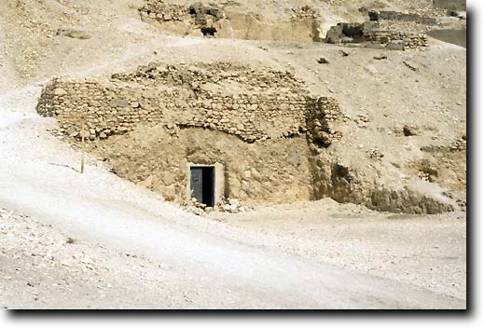
There is a lot to infer from the material culture of the outside façade and entrance of the tomb (as seen in figure 1). As you can see from the photograph taken in 1992, this is a tomb that is giving the illusion that it wants to stay hidden. It appears to be built into the side of a rock and does not present as the stereotypical tomb of Egyptians to be buried in a giant pyramid. There is a lot that could be inferred from this. You could perhaps make an assumption that this is a very insignificant tomb, due to its lack of prowess, or alternatively as I would assume, it could be a façade to perhaps confuse potential grave robbers from stealing anything of value.
Figure 1 – The Courtyard, Entrance and Façade of TT99 from the south in 1992.

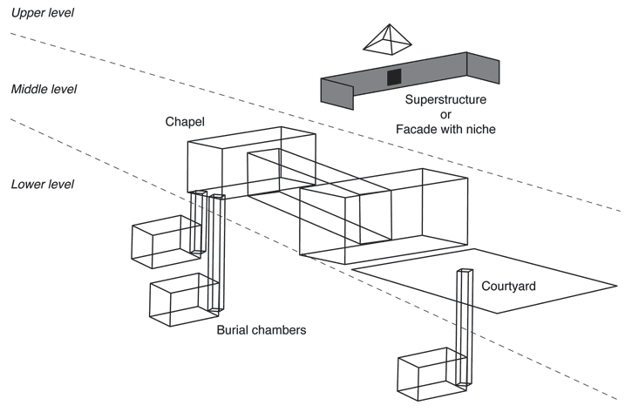
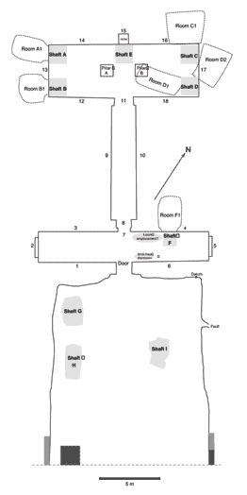
Looking at the layout (as seen in figure 3), you can see that it features a courtyard with 3 shafts, a front room with 1 possible shaft and 2 loom-related emplacements, a passage, and a rear room or shrine with 5 shafts. If you cross reference figure 3 with figure 1, you can clearly see the area of the courtyard marked out by some slightly raised walls outside the entrance to the tomb. The courtyard, particularly with it and the entrance to the tomb facing south, could potentially be linked to the Sun god Ra, as it perhaps may enable the dead from the tomb to have direct communication with him, through the tomb gaining the maximum amount of sunlight throughout the day. The courtyard also provides a purpose of being used as an area for rituals, and later was used in this case for more burial shafts.
Figure 2 - Schematic diagram of TT99
Figure 3 - Floorplan of TT99
As you can see in figure 2, shafts were built to create mini ‘tombs’ within the main structure of TT99 to fit in many burials within one location, acting as a mausoleum. However, based off the plotted history provided by Nigel Strudwick, many other burials unrelated to the initial 18th Dynasty burials have been discovered here. “In 1050 BC, some people of the 21st Dynasty cut at least one shaft within the tomb. Later on, in 850 BC at least one 22nd Dynasty family reuses TT99, with 3-4 generations of family being mentioned. In 705 BC and 680 BC, Priest Wedjahor and his son Priest Horenpe was buried, cutting a new shaft. Also, in 680-600 BC and in the Ptolemaic and Roman eras, there may have been some further burials.”
The tomb being used for multiple burials can illustrate a lot about Senneferi position within Egyptian society. Based on the fact that he was built such a large tomb, could perhaps indicate that he was a well-respected and valued servant of the ruling 18th Dynasty. Most people were likely buried in graves similar to the ones most people are buried in today, so the fact that he was buried in such a large tomb could indicate a high status. Another element which highlights Senneferi status within Ancient Egypt is the location of the tomb in the wider area of Thebes. From a quick google maps search of TT99, you can see that it is buried within an area called the Tombs of the Nobles, but it is also not too far away from the Valley of the Queens and the Ramesseum, which was built 200 years later by Ramesses II. Due to the tomb proximity to these important tombs, it could indicate that he was an extremely well-respected figure and was given the honour of this to aid him securing a better afterlife, maintain social status post death, and receive continued protection from the Pharaohs who were considered to be demi-gods. However, this can be contested as later on the tomb was reused by other dynasties from about 1050 BC – to early AD, as this may be interpreted that Senneferi was not that important to be remembered in history. I would argue that the later additions to the tomb, had many practical reasons. Because Ancient Egypt economy was most likely to be at the mercy of the River Nile, and harvests, it may have become too costly to keep on building tombs for different families all the time, so by placing some important figures in already a well decorated and respected tomb of another figure, it could help possibly cut costs, while giving their loved ones and respected figures a good send off without the need for budgeting and possibly and inadequate tomb. Another purpose could be that it may throw potential grave robbers off from raiding pre-existing tomb, as the likely presumption would be that there is nothing of value to raid. This also links to the fact that many of the burials tombs were placed in shafts underground (as seen in figure 2). Because of the high value goods that were placed inside graves, such as food, furniture, tools, and other decorative offerings, that were used to help aid the deceased journey into the afterlife, they became as previously stated prime targets for grave robbers to earn some quick cash. As a result, these shafts could have been built for the burials to act as a maze and hopefully stop anyone from trying to steal from the deceased and hamper their efforts of going to the afterlife. These grave robbers are proven to have been a massive problem for Egyptian burials in Thebe as during Nigel Strudwick excavation of the courtyard and doorway, it was discovered that the “rock surface around the doorway is recessed, suggesting that a structure may have been placed against the door… most of the area beneath the floor level was not solid and was made of stone and mud brick indicating it is not modern or done by Senneferi.. perhaps this was done by the 25th Dynasty reusers of the Tomb.”

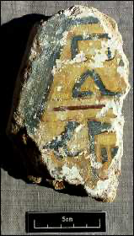
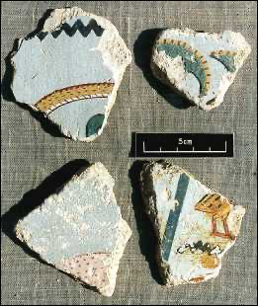
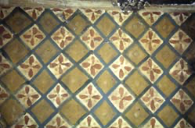
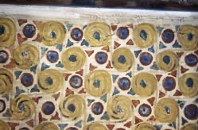
On the superstructure of the tomb (see figure 2 for reference), there was some fragments of wall paintings found. It is presumed they came from a tomb roughly the same age as TT99, but the place of origin cannot be identified (see figures 4 and 5). Similarly, inside the tomb, the ceilings are painted into intricate designs and details (as seen in figures 6 and 7).These wall paintings, presumably on the substructure of TT99, and the ceiling designs can illustrate a lot about Senneferi position in Ancient Egyptian society. I’d argue that the more detail there is in a tomb, the more significant and well respected a person was. It also indicates high status from the cost it may have taken to commission these paintings, as only the wealthy could afford to do so, while the rest of Ancient Egyptian society was buried in a standard grave. Particularly on figure 4, I would presume that the text is most likely to be hieroglyphics, explaining who was buried here, or perhaps their official title or role within society. This is most likely only done on tombs of people who made significant contributions to Egyptian society, such as Senneferi who acted as a treasurer and perhaps an advisor to three 18th Dynasty Pharaohs, as inscribed headstones for all probably didn’t become the standard until the at least the next millennia, so only the wealthy could afford to have their names written so that all in history will forever remember their name and legacy.
Figure 4 - Painted yellow fragment with text
Figure 5 - Painted grey-blue fragment, in the style of the Thutmoside period
Figure 7 - Ceiling of TT99, with a diamond shaped pattern with crosses or flowers
Figure 6 - Ceiling of TT99, with a sun-like pattern
The ceilings shown in figures 6 and 7, also show of Senneferi status through wealth, but also provide a vital role in the afterlife. In figure 6, the ceiling is painted with a gold, red and blue into the pattern of a sun. This could be deemed to represent the journey of the dead the afterlife and the rebirth of the dead into Ancient Egyptian paradise. Similarly, a diamond shape design, with some detailing which looks like flowers, could also represent a rebirth and rejuvenation too, aiding the soul’s ability to live again.
As you can also see, gold has been heavily used throughout the decoration of the tomb. Gold does not tarnish or corrode, so is used heavily as a symbol of eternity and immortality. It could be deemed as a god like material for these qualities, so is heavily used to encourage the dead to be able to travel and join the world of the gods in the afterlife. Alongside this, the ability to be able to afford such a lavish tomb, is a key indicator of an elite or royal status. It reflects on the deceased, and in this case Senneferi’s, piety, power and success on earth which was believed to continue into the world of the dead.

Material culture illustrates the position this person had in ancient Egyptian society. In the case of TT99, material culture provided here heavily implies the status and wealth of Senneferi. The location of the tomb is in the Tombs of the Nobles as well as being in close proximity to the Valley of the Queens and some tombs of Kings, which demonstrates Senneferi proximity to royalty in life, through his role as a Treasurer as well as in death as a respected advisor. The tomb also appears to be designed to be well hidden, perhaps in an attempt to protect treasures there he or his family may want to take into the afterlife to aid his ascension into Ancient Egyptian paradise and give as offerings to the Gods. This is also demonstrated through the heavy use of gold within the tomb which represented the Gods and immortality of the soul.

Table of Figures:
Figure 1 – The Courtyard, Entrance and Façade of TT99 from the south in 1992. 1
Figure 2 - Schematic diagram of TT99 1
Figure 3 - Floorplan of TT99 1
Figure 4 - Painted yellow fragment with text 2
Figure 5 - Painted grey-blue fragment, in the style of the Thutmoside period 2
Figure 7 - Ceiling of TT99, with a diamond shaped pattern with crosses or flowers 3
Figure 6 - Ceiling of TT99, with a sun-like pattern 3

Bibliography:
University of Cambridge – Department of Archaeology, Material Culture (n.d)
https://www.arch.cam.ac.uk/research/research-themes/material-culture [accessed 26/03/2026]

Strudwick, Nigel, A brief history of TT99 (c. 1997-2018)
https://tt99.fitz.ms/history.html [accessed 26/03/2026]

Strudwick, Nigel, The architecture of TT99 (c. 1992)
https://tt99.fitz.ms/architecture.html# [accessed 26/03/2026]
Strudwick, N. 2016. The Tomb of Pharaoh’s Chancellor Senneferi at Thebes (TT99). Oxford: Oxbow.

University of Cambridge – Department of Archaeology, Material Culture (n.d) https://www.arch.cam.ac.uk/research/research-themes/material-culture [accessed 26/03/2026]
Strudwick, Nigel, A brief history of TT99 (c. 1997-2018) https://tt99.fitz.ms/history.html [accessed 26/03/2026]
Strudwick, Nigel, The architecture of TT99 (c. 1992) https://tt99.fitz.ms/architecture.html# [accessed 26/03/2026]
Strudwick, Nigel, The elements of TT99 (c. 1997-2018) https://tt99.fitz.ms/architecture/plan.html [accessed 26/03/2026]
Strudwick, Nigel, A brief history of TT99 (c. 1997-2018) https://tt99.fitz.ms/history.html [accessed 26/03/2026]
Strudwick, Nigel, A brief history of TT99 (c. 1997-2018) https://tt99.fitz.ms/architecture/door.html [accessed 27/03/2026]
Strudwick, Nigel, TT99: Façade and superstructure (c. 1997-2018) https://tt99.fitz.ms/architecture/super.html [accessed 27/03/2026]
Strudwick, Nigel, The Ceilings of TT99 (c. 1997-2018) https://tt99.fitz.ms/paintings/ceilings.html [accessed 27/03/2026]

