5C001 – Organisational performance and culture in practice

This assignment will critically explore the relationship between organisational strategy, culture and behaviour in relation to two opposing business structures within the case study of the residential home, Calamere House.

AC 1.1

Calamere House is a family-owned organisation operating within the residential care sector. Established in 1974, the company adopts a flat, non-hierarchical organisational structure. According to Taylor and Woodhams (2022), a flat non-hierarchical structure is popular among smaller firms, where employees report directly to a single manager. A reduction in managerial layers can positively impact the culture of an organisation by promoting employee involvement in the decision-making process, leading to increased efficiency and creativity (Lee, 2022). Although non-hierarchical structures are effective to some extent, Taylor and Woodhams (2022) state these models often face complications once organisations begin to expand and when performance drops. This could be a consequence of a deficiency of well-defined systems and processes which can lead to a lack of transparency impacting the goals of an organisation (Reitzig, 2022).

Considering the literature above, the adoption of a non-hierarchical structure under Kristen’s ownership was appropriate for Calamere House, for example, as there were only forty-two employees reporting directly to Kirsten, this makes it a smaller firm, resulting in a lower demand for a hierarchical structure (Reitzig, 2022). Maintaining the flat structure ensured continuity during the transition from her parents’ ownership and aligned with both of their consultative management styles. Reitzig (2022) supports this method as he explains that shifting from one structure to another without transitioning effectively is problematic and can affect the culture and behaviours of an organisation. Finally, it is clear from the case study that by utilising a values-based approach, this had a positive impact on staff well-being, communication and efficiency, where employees have been involved from the outset, enabling staff to possess a deeper understanding and passion for the organisation (Shaw, 2019).

Chaffinch Group follows a hierarchical bureaucratic structure. This is known as a tall organisational structure resulting in multiple hierarchical levels, constricted spans of control and set working expectations with an elevated level of supervisory oversight (Taylor and Woodhams, 2022). This approach can be seen as an advantage to ensure all employees are treated fairly and equally, where leaders follow policies and procedures by the rule of the law (Taylor and Woodhams, 2022).
Staff must follow posed rules and procedures aligned with their job description, resulting in clear direction and shared outcomes (Waite, 2021). However, Hayward (2019) argues that although most employee’s value clear direction from leaders, they also value self-sufficiency.

Due to the difficulties and stark differences experienced following the change in structure, a hierarchical management style is appropriate under Chaffinch Group’s ownership due to its large-scale business, defined roles, accountability and autocratic management style.

AC 1.2

The main priority when operating a care home in the United Kingdom (UK) is to promote the well-being of residential patients, ensuring their safety, dignity, and quality of life (Department of Health and Social Care, 2025b). Therefore, this must be at the forefront of Chaffinch Groups’ approach to strategy to ensure they are meeting their patient’s needs.

The concept of strategy is defined as a structured plan of action aimed at achieving specific structural goals, which is not just targeted at larger firms but also private ones like the initial structure of Calamere House (Taylor and Woodhams, 2022). Chaffinch Group’s strategy should be planned rather than emergent to ensure the business’s values, behaviours, and culture align with its goals and performance objectives (CIPD, 2025a). During the formulation stage, it is essential to focus on the three core areas of strategy: analysis, development, and implementation which will investigate all the impacting factors (Taylor and Woodhams).

The work of Tingsager and Smith (2022, cited in Taylor and Woodhams, 2022) states, strategic analysis involves developing a shared understanding of the organisation’s overall mission, strategy, contexts and flaws, which may involve input from external experts. Throughout this initial phase, it is crucial to critically discuss and analyse the wider context of the organisation. This stage typically involves executives of the company; however, Chaffinch Group must consider that under Kristen’s ownership and autocratic management style, most staff were involved in the decision-making process, therefore, it may have been beneficial for Chaffinch Group to involve all staff and customer perceptions through meetings or surveys of initial enquiry (CIPD, 2025b).

The next stage is strategy development, where Chaffinch Group’s executive team, along with other key departments, including Human Resources (HR) will examine different strategies in relation to their current position and consultative management style (Taylor and Woodhams, 2022). By utilising analysis tools like SWOT and PESTLE, this will support Chaffinch Group to evaluate internal and external settings, through clear interaction and partnership, facilitating identification of current strengths, weaknesses, opportunities, and threats to support strategic decisions (Taylor and Woodhams, 2022). Although these tools will encourage collaboration between employees, CIPD (2025e) state that SWOT analysis can be time-consuming and may lack structure due to key elements being missed. Therefore, this can result in compromised data, potentially affecting decisions and therefore directly impacting patient care.

Finally, strategy implementation is described as vigorous and complex, where leaders are expected to turn strategic plans into practical actions to ensure the company reaches organisational goals (Tawse and Tabesh, 2020) Once the strategy is establish it will be used as a framework which will guide the development of a comprehensive business plan, outlining how the strategy will be applied (Taylor and Woodhams, 2022). This strategy must always remain flexible to ensure feedback is integrated into the process (Tomlinson, 2023). To do this Chaffinch Group must communicate these objectives clearly to all staff regarding why they are implementing change (CIPD, 2022). Increased communication and sincerity around the core purposes and drivers of an organisation will be vital to manage change effectively (CIPD, 2022).

To conclude, if Chaffinch Group had implemented a rational approach to strategy formulation, with clear goals and objectives, this approach may have resulted in more favourable and effective outcomes.

AC 1.3
The acronym PESTLE stands for “Economic, Sociological, Technological, Legal and Environmental”, which are all key external factors which influence an organisation (CIPD, p.1, 2025c). In relation to strategic business planning, analysis of an external environment using PESTLE can provide data around the direction of the business, focusing on its growth, targets, risks and validity (CIPD, 2025c). Lucarz (2022) states this will enable employers to determine which force is impacting their organisation and how they might decide to adapt to this factor. Comparable to SWOT, PESTLE analysis offers a broad overview but lacks the depth and flexibility needed to manage uncertainty in dynamic environments (Taylor and Woodhams, 2022).

A major concern for Chaffinch Group is the negative impact society is having on the residential sector. To begin, the UK’s population is ageing rapidly, with the number of people over the age of eighty-five are projected to double by 2043, as a result, this will increase the demand for residential care services (Department of Health and Social Care, 2025a). This will increase pressure on staff, which is already a signification concern today. According to a government survey, 53.9% of residential care sectors conveyed challenges with staff retention, highlighting the ongoing challenge of maintaining a stable workforce in the sector (Department of Health and Social Care, 2025a). Chaffinch group have already lost several members of staff due to their approach to organisational change, therefore, the challenge of not only retaining their current staff but recruiting more staff with the relevant skills is of concern to ensure all patients receive high-quality and safe care.

Since the change of ownership, Chaffinch Group have integrated more legal policies and formal procedures in comparison to Kirsten’s ownership. Legal factors play a positive role in shaping Chaffinch Group’s delivery of service, safety, as well as the operations of care home companies across the sector (Department of Health and Social Care, 2025a). Complying with the Health and Safety at Work Act 1974 ensures Chaffinch Group will create a safe setting, conduct risk valuations, and implement appropriate training, which directly affects staff wellbeing, retention, and operational efficiency (Department of Health and Social Care, 2022). Not only, does this legal requirement protect patients, but safeguards staff by providing clear guidance on how to act and respond appropriately in the workplace (Department of Health and Social Care, 2022).

If Kirsten implemented legal regulations involving structure and staffing, having clear procedures and policies may have positively impacted the growth of Calamere House. For example, under Regulation 18 of the Health and Social Care Act (2008), having systems in place for supervision, delegation and performance management force support to managers to maintain their opposed structures whilst improving efficiency and accountability and consistency as a business grows.

AC 1.4

Chaffinch Group’s decision to invest in technology marks a significant transformation from Kirsten’s ownership of Calmere House. This strategic move will undoubtedly improve processes and elevate both service delivery and employee engagement (CIPD, 2025f). When implementing the use of Artificial Intelligence (AI) and other technologies it is important to understand both the organisations needs as well as the impact it will have on employees and patients (CIPD, 2025f). According to Escalera (2025) 59% of employees say the use of technology enhance their daily productivity and 49% now use digital resources to support their organisation and workload.

The use of a digital care management systems could benefit Chaffinch Group as this enables staff to access patient records instantly, it provides real-time updates, enables accurate reporting reflecting latest observations, assessments and interventions (Department of Health and Social Care, 2022). For patients this can result in improved care due to continuity across shifts, which can also result in detecting issues early contributing to a safer and more proactive care (Munson, 2025).

Although the use of digital systems can support streamlining and enhance communication, there are numerous negatives, for example, many care homes suffer from poor infrastructure impacting their internet and phone connection, especially in rural areas, therefore it is not suitable for all organisations (Garner et al., 2024). Additionally, the article highlights the substantial costs associated with implementing digital systems, including software licenses, hardware upgrades, and staff training. Therefore, although this system could benefit Chaffinch Group it is essential for them the be aware of the downfalls.

Another way Chaffinch Group could utilise technology is by implementing AI powered monitoring, where sophisticated systems are installed into care homes which monitors sound and motion data, meaning the residents may need assistance or medical attention, therefore immediately notifying staff (Munson, 2025). This source continues to discuss, that a pilot of the AI monitoring systems showed the number of night falls had halved, therefore having a 20% drop in hospital admissions. The study also observed a 75% reduction in the amount of unnecessary overnight monitoring by staff, resulting in saving around £13,000 per staff member annually (NHS Southwest London Integrated Care Board, 2023). However, over-reliance on AI may inadvertently decrease face-to-face interactions between staff and residents, leading to feelings of loneliness or neglect (The National Care Forum, 2024).

AC 2.1

Since Chaffinch Group took over ownership of Calmere House, the care home has faced increasing staff turnover, sickness absence, and a decline in morale due to a change from Kirsten’s consultative leadership to Chaffinch Group’s strict autocratic management style. It is clear the employees feel undervalued and overworked. Patients are unhappy due to the loss of personalised care and the increase of agency workers.

To understand these issues, the use of theories and models can be helpful to understand organisational and human behaviour. Schein’s model of organisational culture (1988) is based on three layers: artifacts, values and underlying assumptions (Barends and Rousseau, 2022).

Figure 1: Schein’s Model of Organisational Culture (Author, 2025).

Without any gradual transition period Calamere House shifted from a culture that was built on a people-focused ethos where leaders and employees shared the same values, built strong relationships through trust and open communication and where staff were familiar with their routines and leadership styles. To Chaffinch Groups corporate approach involving implementation of a hierarchical structure, increased policies and procedures, with a strict focus on efficiency and profitability.
This rapid cultural change led to staff resistance, low morale and loss of trust.

Donelly et al. (2020) highlights that human behaviour can have a large impact on the culture of an organisation and whether targets are achieved. He states, employees often resist to change due to mistrust, impacting motivation; therefore, it is crucial for leaders to build relationships to understand their staff and build trust through open trusting communication.

Handy’s (1976) model of organisational culture involves four main types of organisational culture: “power culture, task culture, person culture and role culture” (Personnel Today, p.1, 2023). This model assists to examine and explain the cultural shift at Calamere House, for example, under Kirsten’s ownership the residential home reflected a person and task culture, with a high level of teamwork, autonomy and engagement. Whereas Chaffinch Group lacked to incorporate either of the cultures, instead introduced role and power cultures. This shift negatively impacted human behaviour at Calamere House resulting in employees feeling demotivated and undervalued. The case study proves that when certain areas of an organisation like leadership style, culture and employee motivation are misaligned this can impact both well-being and service quality.

Although Schein and Handy’s models supports to identify the differences across individual cultural layers, both have similar limitations due to the simplicity of the models, making it challenging to measure (Barends and Rousseau, 2022).

AC 2.1

The change in ownership of Calamere House by Chaffinch Group led to significant changes in selection practices and employee voice, as a result, this negatively impacted the organisational culture and behaviour due to lack of structure, employee voice and personalisation.

To begin, under Kirsten’s ownership and consultative management style employees were involved in the decision making of the selection process. According to Young (2024) giving employees autonomy and the opportunity to make decisions positively impacts well-being, performance, and organisational behaviour. The report continues to discuss, when leaders trust their employees, this increases motivation, passion and satisfaction. However, according to Acas (2023), having too many unqualified opinions during the selection process can risk bias and inconsistency which may result in delays and discrimination.

Chaffinch Group neglected to embrace this approach to recruitment. Following the loss of employees at Calamere House, Chaffinch Group increasingly relied on agency staff, where only their qualifications and experience were checked by the agency. Although checking for formal qualifications and experience is important, and something Kirsten lacked, Chaffinch Group did not undertake any further assessment of their suitability.

According to CIPD (2024d), to ensure procedural fairness and equity, all selection processes should involve two main methods, shortlisting and assessment. Evidence shows “how fair candidates perceive the selection process to be, influences their subsequent behaviour” (Lucy et al., 2023, p.5). Therefore, Chaffinch Group should recognise that their current selection process is negatively influencing their organisational culture and employee behaviour due to the lack of formal structure and employee voice.

Under Kirsten’s leadership of the selection process, employee voice was actively encouraged, contributing to high levels of engagement. Whereas Chaffinch Group’s approach lacked such methods. A study by Adrinato et al. (2024) proved by utilising employee voice this fosters motivation, responsibility and long term-commitment. Consequently, had Chaffinch Group embraced these aspects, staff retention may have been alleviated combined with improved patient satisfaction.

AC 2.3

Change management is a structured approach that provides support to transfer an organisation from one state to another desired state. To effectively manage the transition from a small, owner-managed residential care home under Kirsten’s ownership to Chaffinch Group’s larger organisation, the leaders could begin by looking into recognised models of effective change management, like Kotter’s eight step model and Lewin’s three step model. Quantitative research by Roman et al. (2024) revealed strong connections between the two models. Despite each models implementing unique approaches, the study highlighted that they share the same foundational principles of change.

Kotter’s eight step model of change provides a strong foundation for leaders who are beginning to plan a change management initiative (Taylor and Woodhams (2022). Taylor (2022) continues to explain, Kotter’s model highlights the importance of communicating to the wider workforce to encourage staff to embrace change, however, to achieve this it is crucial to establish a clear vision regarding how and why this will be implemented in practice. If Chaffinch Group embedded these principles before transitioning to a bureaucratic hierarchical structure, the organisation may have observed reduced resistance to change, in which employees may have demonstrated increased motivation and engagement.
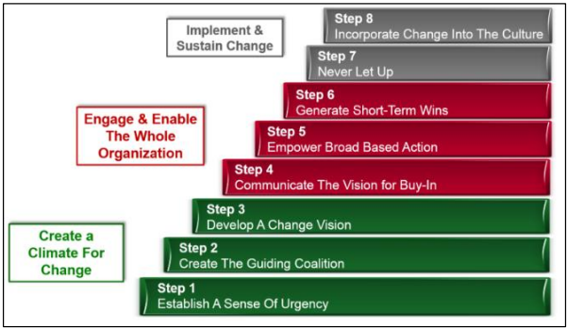
Figure 2: Kotter’s 8-step Change Model (Laig and Abocejo, 2021, p.36).

While Kotter’s model provides a progressive structure for change, CIPD (2024a) claims the model lacks evidence on whether Kotter’s model works in practice. Additionally, if Chaffinch group were to use it, it is advised to use in conjunction with other tools. For example, to better manage change whilst utilising Kotter’s model Chaffinch Group could use tools like questionnaires and structured checklists focusing on each specific step of transition (CIPD, 2024b).

Additionally, the use of Lewin’s three stage model of change could also support Chaffinch Group’s transition by guiding staff through a three-stage process; unfreeze, change and refreeze.
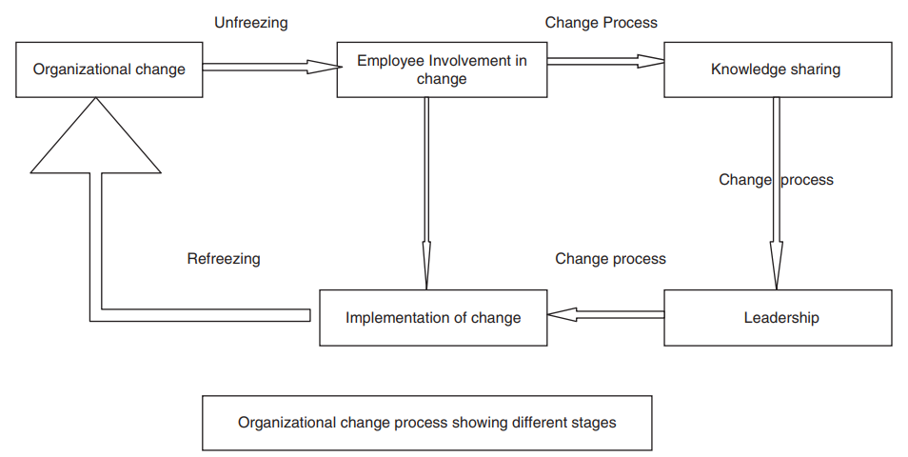

Figure 3: Model of organisational change, Kurt Lewin’s three step model (Hussain et al., 2016, p.126).

During the initial unfreeze stage, organisational leaders must prepare employees for change by challenging existing assumptions, raising awareness to the benefits of change and addressing concerns about the transition to a larger organisation (CIPD, 2024a). Following the change stage will involve Chaffinch Group introducing new policies, frameworks, structures and procedures, for example, the digital care and AI systems. Employees will be provided with structured support through training to facilitate their adaption to their new roles and expectations of the evolving organisation (Raza, 2024). Finally, the refreeze process involves embedding and sustaining the permanent change (CIPD, 2024a). To ensure Chaffinch group manage this phase effectively they could implement aspects of employee voice through performance reviews to gain feedback and to encourage leaders to reward their employees and celebrate success (Raza, 2024).

AC 2.4

Following the organisational transformation of Calamere House, employees experienced significant change that affected and disrupted roles, practices, values and relationships. The experience of change can be understood through the Kubler-Ross Change Curve which can be partitioned into five psychological stages: 1) Denial, 2) Anger, 3) Bargaining, 4) Depression 5) Acceptance, which analyses human behaviour during a crisis (Lindblad, 2022).
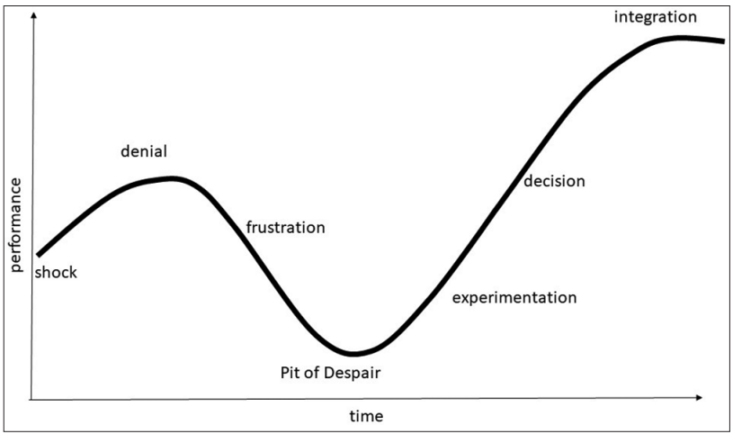

Figure 4: Kubler-Ross Change Curve (Malone, 2018, p. 37).

Initially, employees demonstrated behaviours like shock and denial, characterised by uncertainty and resistance following the disclosure of Kirsten’s decision to sell Calamere House to Chaffinch Group. According to Chavan and Bhattacharya (2022) this stage is generally temporary, however, research proves it may take time for employees to process such unexpected and devastating news. The source continues to describe employee’s behaviour as defensive during this time of doubt.

The following stage of Kubler’s Change Curve highlights that employees may feel frustration at the prospect of change which usually develops after a shock (Malone, 2018). It is clear from analysing the case study that the change to a hierarchical bureaucratic structure under Chaffinch Group’s ownership produced a high level of frustration and anger. Chaffinch group introduced rigid policies and procedures, which replaced Kirsten’s previous informal, values driven practices. These organisational changes depersonalised the environment and ethos of Calamere House, therefore, negatively impacting employees’ engagement, passion and professional fulfilment.

Overtime employee morale deteriorates, aligning with the lowest stage of Kübler’s Change Curve, specifically the phase of depression. According to CIPD (2024a) this can be the most difficult period. During this stage it is evident that employees at Calamere House felt hopeless, unsupported and demotivated, such pressure drove staff to leave.

Although some employees attempted to experiment through persisting with organisational change, the continued loss of former colleagues had a detrimental impact on absence, workload and extended working hours. Leaders at Chaffinch Group could have used this opportunity of experimentation following the loss of several colleagues, to request feedback allowing present staff to express their concerns to determine the cause of high employee turnover and increased sickness absence (CIPD, 2022). Malone (2018) agrees, she states this period should involve rewards to celebrate the experimental behaviour.

To conclude, it remains unclear whether employees decided to leave following the experiment stage or to integrate the change, but what is evident is that the change in ownership was neither positive nor effectively managed.

AC 2.5
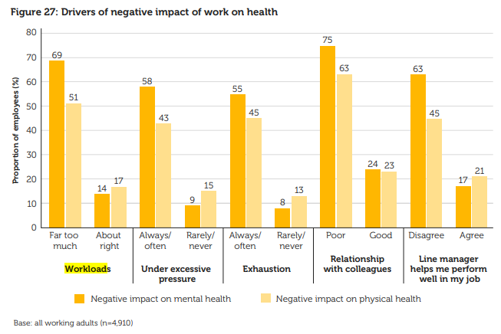
Employee well-being at Calamere House can be influenced by a range of factors, but two significant factors are workload and workplace relationships. Young and Tong (2025) state, excessive workloads and poor working relationships with colleagues correlate with poor mental and physical health. The graph below proves 69% of workers report that excessive workload is having a negative impact on their mental health and 75% report that poor relationships with colleagues is also having a detrimental impact (Young and Tong, 2025).

Figure 5: Drivers of negative impact of work on health (Young and Tong, 2025,
p. 31)

Increased levels of workload play a central role in shaping how employees feel about their jobs and their ability to perform effectively (Sayin et al. 2021). High workload can lead to burnout, which is a physiological reaction to chronic work stress, therefore, it is important for organisations to address these problems to decrease stress levels and promote employee wellbeing. As well as employee well-being, literature surrounding the health care sector shows that increased employee workload can increase violent behaviour of residential patients when they subsequently feel neglected and not effectively cared for (Sayin et al. 2021).

Secondly, relationships with colleagues play a pivotal role in shaping employee wellbeing at work. “The level of success we achieve at work is in direct proportion to the quality of our relationships” (Klaasen, n.d, p. 1). Nevertheless, having inadequate working relationships can have the opposite effect. According to Acas (2025), two in five people in the UK experience conflict at work, where conflict was most common amongst managers and colleagues. The graph below proves the significant consequences of unresolved workplace relationship issues, demonstrating why it is essential for Chaffinch Group to address these concerns (Acas, 2021b).
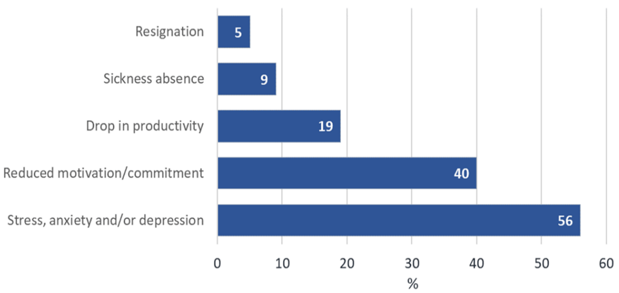

Figure 6: Reported Impacts of Conflict (Acas, 2021b, p.1)

As Calamere House are not generating the anticipated income, it is important to address these conflicts, as statistics prove workplace conflict costs UK employers £28.5 billion pounds annually. Financial consequences that can arise from poor workplace relationships and unresolved conflict (Acas, 2021b). For Chaffinch Group, the impact of excessive workload and poor relationships can impact not employees alone, but patient care and customer satisfaction (Hasin et al, 2023).

AC 3.1

At Calamere House, employee retention is critical to sustaining high levels of customer service, organisational performance and wellbeing. The employee lifecycle involves six chronological stages: “attraction, recruitment, onboarding, development, retention and separation” (Burke, p.1, 2019).

Figure 7: A typical lifecycle model (Smith and Mitchel, 2022, cited in Taylor and Woodhams, 2022).

CIPD (2025g) state the importance of understanding potential push and pull factors which may be affecting retention at Calamere House and how support from the people manager, recruitment advisor and employment relations case advisor is essential.

Pull factors at Calamere House | Push factors at Calamere House
- Supportive leadership  - Career development opportunities  - Recognition  - Focus on well-being  - Flexible working options  - Use of employee voice | - Poor management  - Lack of recognition  - Excessive workload  - Negative working relationships  - High staff turnover  - Lack of communication  - Loss of culture

Figure 7: Potential push and pull factors at Calamere House (Author, 2025).

In reference to case study, Kath’s autocratic management style is particularly direct and lacks compassion. To support the retention stage Kath must build strong workplace relationships through clear communication, empathy and recognition of progress and achievements, resulting in creating a safe environment where employees feel valued and heard (British Council, 2023). This approach offers an inclusive and supportive climate which enhances trust and passion, where employees are more likely to remain motivated and committed to their organisation (CIPD, 2024d).

The recruitment advisor supports retention at Calamere House by hiring candidates who align with their organisational values (Young and Tong, 2025). Although Muller-Heyndyk’s (2019) source is over six years old, the author emphasises the importance of a ‘cultural fit’, meaning how well a person’s values, beliefs and behaviours align with an organisations culture. Therefore, if Chaffinch Group had recruited individuals whose behaviours and values align, this may minimise challenges and result in low turnover of employees at Calamere House.

Finally, the Employment Relations Case Advisor can support staff with targeted interventions to significantly reduce the likelihood of employees taking time off work due to a stress related illness (CIPD, 2025f). Taking proactive measures through the implementation of reasonable adjustments, offering flexible working patterns and changes to individual workloads, will ensure staff at Calamere House are heard, understood and supported successfully (Hasin et al, 2023). Additionally, to minimise staff turnover and to create an employee retention strategy, it is crucial to investigate and collect data through exit interviews and surveys (CIPD, 2025g).

AC 3.2

For Chaffinch Group to achieve full occupancy within six months, people practices must be vertically aligned with Chaffinch Group’s business strategy. Vertical integration in the context of people practices and Calamere House signifies that recruitment, rewards, employee relations and learning and development (L&D) must be directly aligned to Chaffinch Groups vertical strategic goal of filling 100% resident rooms (Tingsager and Smith, 2022, cited in Taylor and Woodhams, 2022).

In relation to resourcing, people practices can help Chaffinch Group ensure they achieve their goal by recruiting qualified and skilled employees as this ensures employees are competent and will be able to deliver a safe and compassionate care (Rustiawan et al. 2023). Additionally, (CIPD, 2025j). emphasises that workforce planning is an effective mechanism to detect potential business challenges and workforce implications, in doing so, ensuring the desired workforce have the skills to achieve organisation goals.

Additionally, having an effective reward system at Calamere House, like recognition schemes, and performance bonuses, linked to delivering high quality service may motivate staff to contribute to Chaffinch Groups’ organisational goal of filling 100% of resident rooms within 6 months (CIPD, 2025i).

Strong employee relations at Calamere House are vital to achieving 100% occupancy. Effective people practices can strengthen relations by fostering open communication and inclusive policies which enhance wellbeing and engagement (Young and Tong, 2025). Additionally, embedding values such as respect, integrity and compassion strengthens not only workplace relations but residents and their families too (NHS Employers, 2024). Within the case study, it is evident that resident’s autonomy has been diminished; previously they had the chance to decorate their rooms. Restoring this authority would re-engage and retain residents.

The purpose of utilising L&D at Calamere House is to focus on developing skills and abilities within the workplace (Government Skills, 2025). The People team will utilise training, mentoring and professional development opportunities to fill skill gaps and to encourage a learning culture where employees remain motivated to deliver high-quality care that attracts and retains residents (Gore, 2024). “Proactively investing in skill development ensures your workforce is future-ready and capable of driving innovation and growth” (Gore, p.1, 2024).

AC 3.3

High levels of turnover can negatively affect many aspects of an organisation, most notably employee engagement and overall workforce stability (CIPD, 2025g). To address the rising turnover at Calamere House, Kath must adopt a structured approach that draws upon consultation, stakeholder mapping and employee voice.

According to Smith and Mitchell (2022, cited in Taylor and Woodhams, 2022) stakeholder mapping will enable Kath to identify and prioritise groups with the greatest influence regarding why employee turnover at Calamere House has increased. The source continues to highlight that by recognising staff as high interest stakeholders, this enables consultation interventions to be directed to those whose engagement is most critical to the service quality and retention.

Direct consultation involves informal discussions or formal meetings with employees, whereas indirect consultation occurs through structured groups like consultative committees, working parties or recognised trade unions (Acas, 2021a). In relation to Calamere House, Kath will be following the direct approach to consultation.

To initiate consultation with employees, Kath could adopt a quantitative approach by implementing staff surveys as a method of collecting data based upon the issue regarding retention and turnover of staff. The survey may involve questions regarding staff morale, engagement, organisational support and workplace concerns. Surveys are effective data collection tools for capturing perspectives and experiences across an organisation (CIPD, 2025k).

However, Kath must also acknowledge the limitations associated with this method. HR Zone (n.d) states, surveys can risk low response rates, desirable answers and may result in a lack of depth when analysing responses. Young and Tong (2025) reported that employee surveys are sometimes perceived as a ‘tick box exercise’ offered as a substitute instead of more meaningful and honest face to face meetings. In such cases, qualitative employee voice systems are underutilised, resulting in leaders receiving limited insights from employees. Finally, surveys risk saturation, due to being overused and therefore producing repetitive responses, limited insights, disengagement and failure to capture real employee perspectives (HR Zone, n.d).

However, CIPD (2025k) highlights the importance of using a variety of methods as they all have different strengths and weaknesses, therefore, alongside surveys, Kath could also use employee interviews as a tool to gather qualitative data alongside surveys. Qualitative research methods are seen to have improved outcomes as they provide depth and offer higher levels of understanding regarding employee experiences (CIPD, 2025k).

Interviews provide structured opportunities to learn, listen, encourage dialogue, and build trust to involve employees in the organisational decision making (Acas, 2021a). However, interviews during staff consultation can be extremely time consuming, increase a chance of bias and may result in employees being dishonest to satisfy workplace leaders (Barraza, 2023).

In conclusion, consultation requires open-mindedness, where Kath and other leaders at Calamere House must collectively consider employee voice to support the next steps of decision-making (Acas, 2021a).

References:

Acas (2021a) Consulting employees and representatives. What consultation is. Available at: https://www.acas.org.uk/consulting-employees (Accessed: 29 November 2025).

Acas (2021b) Estimating the costs of workplace conflict. Available at: https://www.acas.org.uk/research-and-commentary/estimating-the-costs-of-workplace-conflict/report#5 (Accessed: 22 November 2025).

Acas (2024) Recruitment How employers should recruit. Available at: https://www.acas.org.uk/recruitment (Accessed: 10 November 2025).

Acas (2025) Conflict at work: why it happens and how people try to resolve it. Available at: https://www.acas.org.uk/conflict-at-work-why-it-happens-and-how-people-try-to-resolve-it (Accessed: 22 November 2025).

Adrianto, A, Ben-Ner, A, Sockin, J and Urtasun, A. (2024) ‘Sharing Is Caring: Employee Stock Ownership Plans and Employee Well-Being in U.S Manufacturing’. IZA – Institute of Labor Economics. Available at: https://www.jstor.org/stable/resrep68999
Barends, E. and Rousseau, D. (2022) Organisational culture and performance: an evidence review. Scientific summary. London: Chartered Institute of Personnel and Development. Available at: https://www.cipd.org/globalassets/media/knowledge/knowledge-hub/evidence-reviews/2023-pdfs/organisational-culture-and-performance-scientific-summary.pdf (Accessed: 6 November 2025).
Barraza, C. (2023.) 14 Advantages and disadvantages of interviews. Available at: https://barrazacarlos.com/advantages-and-disadvantages-of-interviews/ (Accessed: 29 November 2025)
Burke, M. (2019). ‘Six stages to success with the Employee Lifecycle’. 6 Q, Available at: https://6q.io/blog/six-stages-to-success-with-the-employee-lifecycle/ (Accessed: 23 November 2025)

Chavan, S. and Bhattacharya, S. (2022). ‘Study of employees' behaviour during organizational change: effects of business theatre on Kübler-Ross model’. Cardiometry, (22), pp.237–243. Doi: https://10.18137/cardiometry.2022.22.237243

CIPD (2022) Effective Cross-functional Collaboration in a Changing World of Work. Available at: https://www.cipd.org/uk/knowledge/reports/cross-functional-collaboration/ (Accessed: 20 October 2025)

CIPD (2024a) Change management: A guide for people professionals. Available at: https://www.cipd.org/en/knowledge/guides/change-management/#models-for-change (Accessed 15 November 2025).

CIPD (2024b) Change management tools. Available at https://www.cipd.org/uk/knowledge/tools/change-management/ (Accessed 15 November 2025).

CIPD (2024c) Health and wellbeing at work 2025 report. Available at: https://youtu.be/U7wG23Hr7fU (Accessed: 20 November 2025).

CIPD (2024d) Inclusive recruitment: Guide for people professionals. Available at: https://www.cipd.org/uk/knowledge/guides/inclusive-employers/ (Accessed: 10 November 2025).

CIPD (2024e) Workplace conflict puts strain on job quality for estimated eight million UK workers. Available at: https://www.cipd.org/en/about/press-releases/workplace-conflict-puts-strain-on-job-quality/ (Accessed: 22 November 2025)

CIPD (2025a) Change management. Available at: https://www.cipd.org/uk/knowledge/factsheets/change-management-factsheet/#needtochange(Accessed: 20 October 2025).

CIPD (2025b) Organisation development. Available at: https://www.cipd.org/uk/knowledge/factsheets/organisational-development-factsheet/#Organisationdevelopment (Accessed: 20 October 2025).

CIPD (2025c) PESTLE analysis. Available at: https://www.cipd.org/uk/knowledge/factsheets/pestle-analysis-factsheet/ (Accessed: 23 October 2025).

CIPD (2025d) Strategic human resource management. Available at: https://www.cipd.co.uk/knowledge/strategy/hr/strategic-hrm-factsheet (Accessed: 20 October 2025).

CIPD (2025e) SWOT analysis. Available at: https://www.cipd.org/uk/knowledge/factsheets/swot-analysis-factsheet/ (Accessed: 20 October 2025).

CIPD. (2025f). Technology, AI and the future of work. Available at: https://www.cipd.org/uk/knowledge/factsheets/emerging-future-work-factsheet/ (Accessed 28 October 2025).

CIPD (2025g) Employee turnover and retention. Available at: https://www.cipd.org/uk/knowledge/factsheets/turnover-retention-factsheet/ (Accessed: 24 November 2025).

CIPD (2025i) Analysis: Activating your employer brand to recruit and retain in a challenging climate. Available at: https://www.cipd.org/uk/views-and-insights/thought-leadership/insight/activating-employer-brand/ (Accessed: 25 November 2025).

CIPD (2025j) Strategic workforce planning: Guide for people professionals. Available at: https://www.cipd.org/uk/knowledge/guides/strategic-workforce-planning/ (Accessed: 25 November 2025).

CIPD (2025k) Employee engagement and motivation. Available at: https://www.cipd.org/uk/knowledge/factsheets/engagement-factsheet/#assessing-and-measuring-employee-engagement (Accessed: 28 November 2025).

Roman, C.T, Manolica, A and Bulat, C.I, (2024) ‘Qualitative Analysis of Change Management Models’, ‘Ovidius’ University Annals. Economic Sciences Series, XXIV(1), pp. 502–508. Available at: https://stec.univ-ovidius.ro/html/anale/RO/2024i1/Section%204/17.pdf

Department of Health and Social Care (2025a) Adult social care workforce skills survey: September 2025 report. Available at: https://www.gov.uk/government/statistics/adult-social-care-workforce-skills-survey-september-2025/adult-social-care-workforce-skills-survey-september-2025-report (Accessed: 23 October 2025).

Department of Health and Social Care (2025b) Care and support statutory guidance. Available at: https://www.gov.uk/government/publications/care-act-statutory-guidance/care-and-support-statutory-guidance#safeguarding-1 (Accessed: 25 October 2025).

Department of Health and Social Care (2022) A plan for digital health and social care. Available at: https://www.gov.uk/government/publications/a-plan-for-digital-health-and-social-care/a-plan-for-digital-health-and-social-care (Accessed 28 Oct. 2025).

Donnelly, L.F., Frush, K., Shook, J., Schein, P.A. and Schein, E.H., (2020). ‘The Importance of Both the Technical and Social Domains in Creating a Culture That Accelerates Improvement in Healthcare’, Scientific Research Publishing, 12, pp 1575-1582. Available at: https://www.scirp.org/pdf/health_2020121812105837.pdf

Gladka, O., Fedorova, V. and Dohadailo, Y., (2022). Development of conceptual bases of the employee life cycle within an organization. Business: Theory and Practice, 23(1), pp.39-52. Available at: https://doi.org/10.3846/btp.2022.13510

Escalera, J. (2025). ‘Zoom fatigue, AI FOMO and tech overload: How HR can help employees’, HR Zone, 26 March. Available at: https://hrzone.com/zoom-fatigue-ai-fomo-and-tech-overload-how-hr-can-help-employees/ (Accessed 28 Oct. 2025).

GOV.UK (2025) Supplementary information: Small and Medium-sized Enterprises definition (HTML)
Available at: https://www.gov.uk/government/publications/procurement-act-2023-short-guides/supplementary-information-small-and-medium-sized-enterprises-definition-html (Accessed: 14 October 2025).

Government Skills (2025) A rapid review of reviews on the nature of the relationship between learning and development and employee engagement, wellbeing, attraction and retention. Norwich Business School, University of East Anglia. Available at: https://www.gov.uk/government/publications/learning-and-development-employee-engagement-and-wellbeing/a-rapid-review-of-reviews-on-the-nature-of-the-relationship-between-learning-and-development-and-employee-engagement-wellbeing-attraction-and-retent (Accessed: 25 November 2025)

Hasin, H., Hussain, W. S., Nordin, E., Jamil, A., and Johari, Y. C. (2023). ‘The Impact of Workload, Management Factors, and Job Insecurity on Employee Well-Being: A Review of Recent Research’, International Journal of Academic Research in Business and Social Sciences, 13(4), 1002 – 1011. Available at: http://dx.doi.org/10.6007/IJARBSS/v13-i4/16703

Hayward, S. (2019) ‘Management hierarchies: are they still necessary in the workplace?’ HR Zone, 18 March. Available at: https://hrzone.com/management-hierarchies-are-they-still-necessary-in-the-workplace/ (Accessed: 20 October 2025).

Hussain, S.T., Lei, S., Akram, T., Haider, M.J., Hussain, S.H. and Al, M. (2016) ‘Kurt Lewin’s change model: A critical review of the role of leadership and employee involvement in organizational change, Journal of Innovation and knowledge, 3 (2018), pp.123-127. Available at: https://doi.org/10.1016/j.jik.2016.07.002

Klaasen, D. (n.d) ‘Do you have Inspired Working Relationships?’ HRZone. Available at: https://hrzone.com/blog/do-you-have-inspired-working-relationships/ (Accessed: 22 November 2025).

Laig R.B.D and Ferdinand T.A (2021) ‘Change Management Process in a Mining Company: Kotter’s 8- Step Change Model’, Journal of Management, Economics, and Industrial Organization, 5(3), 31-50. http://doi.org/10.31039/jomeino.2021.5.3.3

Lee, S. (2022) ‘The myth of the flat start‐up: Reconsidering the organisational structure of start‐ups’, Strategic management journal, 43(1), pp. 58–92. Available at: https://doi.org/10.1002/smj.3333.

Lindblad, L. (2022) A Map for Tackling the Change Curve in a Complex Organisation. Unpublished Batchelors Thesis. Laurea University of Applied Sciences. Available at: https://www.theseus.fi/bitstream/handle/10024/781033/Lindblad_Lilli.pdf?sequence=2 (Accessed: 17 November 2025).

Log my Care (2025) Benefits of a digital care management system. Available at: https://www.logmycare.co.uk/blog/benefits-of-a-digital-care-management-system#what-are-the-benefits-of-a-digital-care-management-platform-0 (Accessed 28 Oct. 2025).

Lucarz, P. (2022) ‘Five simple steps to workforce planning success’. People Management, 28 February. Available at: https://www.peoplemanagement.co.uk/article/1751678/five-simple-steps-workforce-planning-success (Accessed: 25 October 2025).

Lucy, D., Mason, B., Sinclair, A., Bosley, A. and Gifford, J. (2023) Fair selection: An evidence review – Practice summary and recommendations. London: Chartered Institute of Personnel and Development. Available at: https://www.cipd.org/globalassets/media/knowledge/knowledge-hub/evidence-reviews/2023-pdfs/fair-selection-evidence-practice-summary_tcm18-114569.pdf (Accessed 6 Nov. 2025).

Malone, E.D. (2018) ‘The Kubler-Ross change curve and the flipped classroom: Moving students past the pit of despair’, Education in the Health Professions, 1(2), pp.36-40. Available at: https://doi.org/10.4103/EHP.EHP_26_18

Muller-Heyndyk, R. (2019) ‘Employees who ‘fit in’ more productive’. HR Magazine, 4 June. Available at: https://www.hrmagazine.co.uk/content/news/employees-who-fit-in-more-productive (Accessed: 24 November 2025).

Munson, S. (2025) Care home technology: How will AI affect care homes? Available at: https://www.carehome.co.uk/advice/tech-ai-care-homes (Accessed: 29 October 2025).

The National Care Forum (2024) The pros and perils of AI use in care. Available at: https://www.nationalcareforum.org.uk/partners-news/the-pros-and-perils-of-ai-use-in-care/ (Accessed: 29 October 2025).

Personnel Today (2023) ‘What are the models of organisational culture?’, Personnel Today, 19 January. Available at: https://www.personneltoday.com/hr/what-are-the-organisational-culture-models/ (Accessed 6 November 2025).

Raza (2024) ‘Lewin’s 3 Stage Model of Change Explained’ BMC, 20 December. Available at: https://www.bmc.com/blogs/lewin-three-stage-model-change/ (Accessed: 16 November 2025).

Reitzig, M. (2022) ‘How to get better at flatter designs: considerations for shaping and leading organizations with less hierarchy’, Journal of Organisation Design, 11(1), pp. 5–10. Available at: https://doi.org/10.1007/s41469-022-00109-7.

Rustiawan, I., Gadzali, S.S., Suharyat, Y., Iswadi, U. and Ausat, A.M.A., (2023). The strategic role of human resource management in achieving organisational goals. Innovative: Journal Of Social Science Research, 3(2), pp.632-642. Available at: https://doi.org/10.33395/jmp.v12i1.12508

Shaw, J (2019) ‘How businesses can bounce back after a challenging period’. Personnel Today, 19 January. Available at: https://www.peoplemanagement.co.uk/article/1741745/how-businesses-can-bounce-back-after-challenging-period (Accessed: 20 October 2025).

Sayin, F. K., Denton, M., Brookman, C., Davies, S. and Zeytinoglu, I. U. (2021). Workload, workplace violence and harassment, and well-being of personal support workers in home and community care. Relations industrielles / Industrial Relations, 76(2), 312–335. https://doi.org/10.7202/1078509ar
Tawse, A. and Tabesh, P. (2020) 'Strategy implementation: A review and an introductory framework', European Management Journal, 39(1), pp. 22–33. Available at: https://doi.org/10.1016/j.emj.2020.09.005
Taylor, S. and Woodhams, C. (2022) Studying Human Resource Management: A Guide to the study, context and practice of HR. 3rd ed. London: Kogan Page
Tomlinson, G. (2023) 'How to create an HR business plan that delivers', HR Magazine, 04 July. Available at: https://www.hrmagazine.co.uk/content/comment/how-to-create-an-hr-business-plan-that-delivers (Accessed: 22nd October 2025).
Waite, K., Beevers, K., Small, N., Tomlinson, K. and Hussain, S. (2021) People practice: A Complete Guide. 1st edn. London: Kogan Page.

Young, J. (2024) CIPD Good Work Index 2024: Summary report and practical guidance. London: Chartered Institute of Personnel and Development. Available at: https://www.cipd.org/globalassets/media/knowledge/knowledge-hub/reports/2024-pdfs/8625-good-work-index-2024-summary-report-web.pdf (Accessed 6 November 2025)

Young, J. and Tong, D (2025) Good Work Index 2025. London: Chartered Institute of Personnel and Development. Available at: https://www.cipd.org/globalassets/media/knowledge/knowledge-hub/reports/2025-pdfs/8868-good-work-index-2025-report-web1.pdf (Accessed: 24 November 2025).

