Title page



Name Zachury Shane Jassi
Student number 2017021
Module code BMSW 4004
Lectures name Eric
Assignment title reflective portfolio

Contents
Introduction 3
Audit of my skills and competencies 4
Swot analysis 4
Swot analysis table 4
Personal development plan 5
Personal development plan table 5
Analysis of skills required to be an effective manager in the motor vehicle industry 6
Communication skills 6
leaderships skills 7
Assessment of the concepts learnt throughout this module using Gibbs reflective cycle 8
Recruitment and selection mock interview 8
In class learning 9
Appendices 10
Reference page 11

Introduction

this aim of this reflective report is to audit my own skills and competencies using analysis tools such as a swot analysis and personal development plan. It will also highlight skills needed for a manager in the Motor vehicle industry looking at the definition of each skill, why such skills are import for a manager in the Motor vehicle industry and how a person could obtain these skills. The report will then assess the concepts I have learnt throughout this module using the Gibbs reflective cycle. I will apply the Gibbs reflective cycle to a few experiences in this module, mock interview, in class learning swot analysis and personal development plan.

Audit of my skills and competencies

In this section of my reflective report, I will be highlighting my strengths and competencies using analysis tools such as swot analysis and personal development plan to help audit my skills demonstrating my strengths and weaknesses.

Swot analysis

a swot analysis is a highly used analysis and strategy tool nearly anyone can use a swot analysis from students to business owners the acronym swot consists of 4 words/sections.
- Strengths
- Weaknesses
- Opportunities
- Threats
People have been using swot analysis for years with it being nearly the most popular analysis tool being used currently. It is very simple for anyone to do a swot analysis with it being a simple diagram usually in the form of a table that consists of no math’s. as mentioned before a swot analysis can be used by many for example businesses, individuals, teams, and in education. We use swot analysis for purposes such as brainstorming, decision making and personal development helping you identify strengths weaknesses opportunities and threats (SWOT Analysis, 2021)

Swot analysis table

Strengths | Weaknesses | Opportunities | Threats
Good communication  Patient  Focused  IT skills | Impatient  Easily distracted  Lack of education | Further education  Apprenticeships  Training schemes  Expanding economy | Covid 19  Low employment  0-hour contracts

Personal development plan

A personal development plan is a development tool used to assess, reflect, and document your progression. It is also used to help an individual understand the steps to be taken to further their development (assessment conditions, 2021)
A personal development plan is an efficient way of assessing the skills you already have and what you plan to do to develop the skills you need.

Personal development plan table

Career objective | Steps to be taken | resources | Responsibilities | Time frame
Obtain a level 5 qualification | Apply for the course | Internet. laptop | To be dedicated to completing work | Jan 2021  Jan 2022
Find part time security work | Obtain security badge | Training course | Obtain a DBS check | 3 months
Improve writing skills | Read more and practice | Books and internet | Make time for study | 2 weeks

After reviewing my swot analysis and personal development plan I believe I am at an advantage in the job market because I could be easily molded and trained by an employer. I also feel that I am taking the correct steps to achieve my career goals.

Analysis of skills required to be an effective manager in the motor vehicle industry

The industry I have chosen is the motor vehicle maintenance and repair industry. The British motor industry dates as far back to the year 1885. The motor industry has great importance on the British economy producing around £20.2 billion a year. Creating around 168,000 jobs and exporting around 12.8% of good to the United Kingdom (UK Automotive and the UK Economy - SMMT, 2021)
The British motor industry is made up of many different departments a few of these departments for example are maintenance and repair, vehicle sales and production. To be a manager in the motor vehicle maintenance and repair industry is a very difficult role because not only do you need to have industry knowledge it would be mandatory to also have good customer service skills and most importantly good heath and safety skills as well as other skills like good communication, teamworking skills, the ability to perform under pressure, leaderships skills and good organisation.

Communication skills

Communication skills are very important skills that everyone should have for either their professional or personal life. communication can be defined as transferring information to help achieve better understanding. there are many ways in which we communicate for example verbally, using body language or gestures and listening being a few. (Communication, 2021)
Communication skills are vital for a manager in the motor vehicle industry and contributes towards good health and safety. Communication skills allow people to identify problems more easily and be able to take clear instructions to solve problems. Good communication allows managers to deliver information more quickly and more accurately. it is important that a manager in any professional role be a good communicator. understanding questions and needs of colleges and being well understood by persons he or she is managing is vital in managing a good team and being able to express their self’s effective and professionally all leading to better professional relationships in the workplace
Acquiring good communication skills can be achieved in many ways. Some team building exercises can help you further develop your communication skills. Simply listening more can help you become an effective communicator. Also, managing your emotions better and practicing public speaking are more great ways to improve your communication skills

leaderships skills

it is essential for a manager in any industry to have excellent leadership skills. The term leadership skills is made up of many different skills and strengths for example strategic thinking, good communication, people management, good planning and delivery. A leader can be defined as a person or persons to help guide and organize an individual or a group of people with a shared goal
excellent leadership skills are very important skills and strengths a manager in the motor vehicle industry must have. It’s essential that a manager can take charge and lead a team in all scenarios weather that be heavy workloads or meeting deadlines, a manager must be able to mentor and motivate the team thus boosting moral and allowing the team to perform in the best way possible. Being able to effectively evaluate, problem solve and, make decisions are some more good example of good leadership skills. which a manager in the motor vehicle industry would be required to perform to a high level on a day-to-day basis with the industry being so fast paced and demanding
there are various ways in which a person may obtain leadership skills. Simply just being dependable and offering your support to those who may need it is a good way to practice leadership skills. leadership skills can also be obtained through training courses, and team working exercises. (indeed.com,2021)

problem solving skills

It is essential for a manager in any industry to have excellent problem-solving skills problem-solving skills are being able to effectively analyse and understand a problem. Being able to think about different ways of solving the problem, brainstorm, and strategies a plan to help find a solution to the problem. Taking into consideration which solution would be most efficient and effective. (deepon, 2021)
For a manager in the motor vehicle industry good problem-solving skills are highly required with the motor vehicle industry being so fast paced and problematic its essential that a manager be able to solve any problem thrown their way being able to think and really understand problems and issues that affect themselves and their team members. Having the ability to understands different ways of solving a problem and the affect each solution might have on the team is also very important as well as structuring a plan or knowing the correct steps needed to be taken to solve the issue (indeed,2021)
There are many ways in which one could gain good problem-solving skills. attending problem solving training events is a great way to start off. Simply reading about problem solving technics and observing how others problem solve are more great ways of which a person could strengthen and gain good problem-solving skills.

Assessment of the concepts learnt throughout this module using Gibbs reflective cycle

Recruitment and selection mock interview

Description: as part of one of our assignments we were challenged to find a job in our chosen career choice we were then asked to put together a word document containing the job description, our cv and a personalised cover letter. Then on the following week in class we would take part in a mock interview for the job we choose using the job application we had produced. as a class we choose to undertake our mock interviews at home via Microsoft teams. Our lecturer eric would be the person interviewing us.
Feelings: to begin with I was feeling very nervous as it had been a while since I had applied for a job or undertaken a face-to-face interview. I was worried my personalised cover letter would not be good enough also I feel this was a very good part of the module as it allowed me to be throw out of comfort zone and I could really put some of the interview techniques previously learned into play.
Evaluation: I felt the mock interviews worked well overall and I was able to pick up loads more new skills throughout the whole experience. I would have preferred the mock interview to have been in class rather than online as I feel this way it would have been less nerve racking. I feel my interview didn’t go as well as I had hoped. Regardless of all the preparation and notes I had made when in the interview my mind went blank. But after completing the interview and getting feedback from my lecturer I had done well scoring 89 points out of 100 and would be offed the job
Analysis: I gained many new skills like interview techniques. public speaking and many more throughout the mock interview experience. Skills that can be taken away and applied to everyday life. I feel its very important to have these sorts of skills as these skills would be used in loads of different types of situations not only just interviews. being great transferable skills
Conclusion: I feel as if I could have improved up on my interview preparations maybe I could have made more notes or practiced my answers more this module has taught me how to present myself in an interview or professional settings and it has also taught me how to answer questions in a professional manner which I feel will impact and help me in my future goals and aspirations. This module also taught me the valuable lesson of doing research which could put you at an advantage

In class learning

Description: with covid restrictions easing it was an option to study the final module of the course I’m undertaking in class instead of online learning. This meant attending the university campus twice a week for lessons
Feelings: In the run up to the start of term I was feeling nervous and scared as we had just come out of a national lockdown, and I hadn’t been in a classroom setting for a while. However, I was also excited to be in class and excited that I would receive all the help I needed throughout the module. Traveling to and from class was another big issue for me because of coronavirus and staying safe. But I soon began to feel more relaxed after making the journey a few times and meeting my lecturer and classmates
Evaluation: The In-campus learning was very relaxed and helpful I found work and tasks I had been set to be easier to grasp than if I was learning from home simply being able to have discussions about work with lectures and classmates gave a better understanding of topics we were covering at the time. Also, the lectures were very supportive and helpful
Analysis: on reflection of the final term. In class learning was very beneficial for me I was able to work alongside classmates and lectures to really understand the work we were doing and gain skills that I could use for the future in the development of my professional career and personal life.
Conclusion: I gained more academic confidence due to in class learning gained some new friends and developed relationships with my lectures I was able to understand assignments better and be able to discuss and question parts I didn’t understand

Self-awareness methods

Description: As part of our assignments, we used self-awareness tools such as personal development plan and swot analysis to audit our skills and competences
Feelings: I found that using personal development plan and swot analysis was very helpful for my career development and self-awareness. It allowed me to understand and recognise my goals and tasks ahead and the steps I need to take to accomplish them at the time I felt excited to set some goals and work out how I would achieve my goals
Evaluation: using personal development plan and swot analysis as part of my assignment worked very well for me. It has also helped me to set clear goals and understand the steps I need to take to achieve them
Analysis: on reflation I realised how important it is to use swot analysis and personal development plan as part of your career development.
Conclusion: as a result of this module, I have gained confidence in my personal development and have a clear understanding on the relevant steps I need to take to achieve my goals.

Appendices

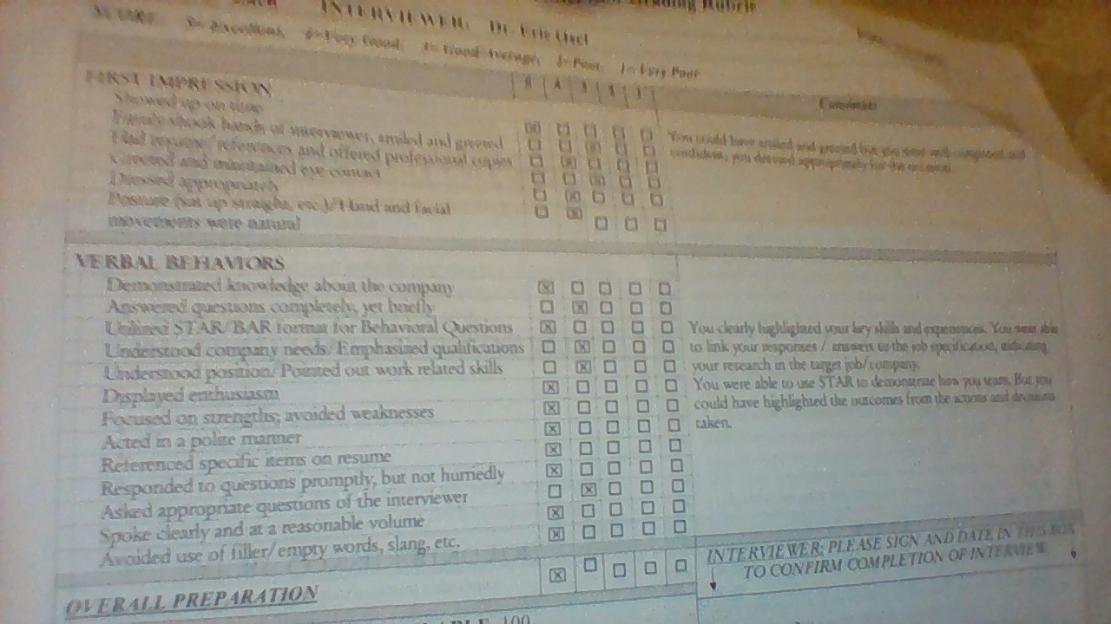

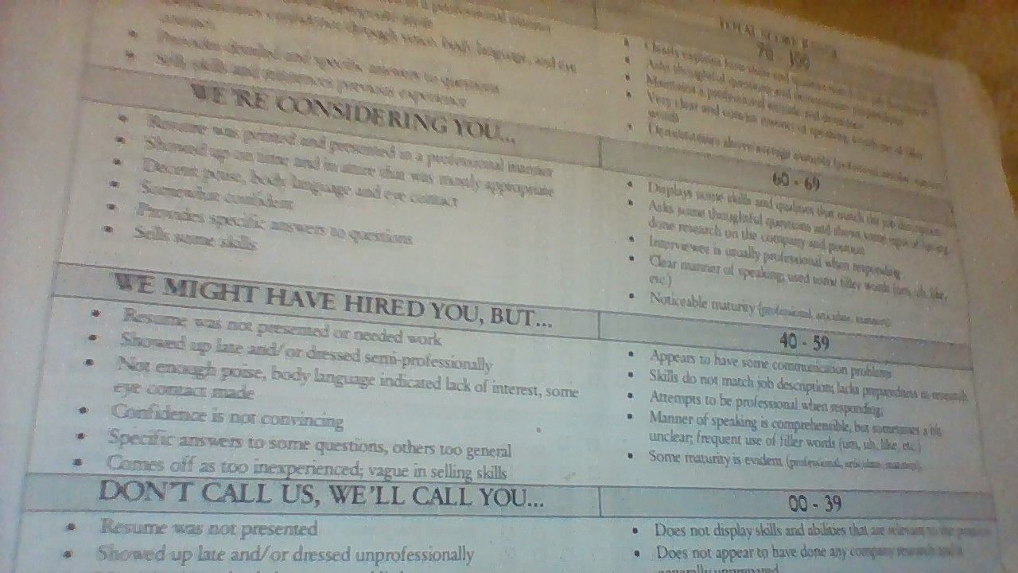

Reference page

Corporate Finance Institute. 2021. Communication. [online] Available at: <https://corporatefinanceinstitute.com/resources/careers/soft-skills/communication/> [Accessed 29 November 2021].

deepon, b., 2021. 6 Management Skills Every Manager Should Have. [online] Nurture an Engaged and Satisfied Workforce | Vantage Circle HR Blog. Available at: <https://blog.vantagecircle.com/management-skills-manager-should-have/#:~:text=6%20Management%20Skills%20Every%20Manager%20Should%20Have%201,and%20encourage%20work%20relationship.%20...%206%20Emotional%20Intelligence> [Accessed 9 December 2021].

Google Books. 2021. SWOT Analysis. [online] Available at: <https://books.google.co.uk/books?hl=en&lr=&id=Yrp3DQAAQBAJ&oi=fnd&pg=PA1&dq=what+is+a+swot+analysis&ots=ODmh4sv3YC&sig=nhYonui6hY-K6EpC3DnUBYc55YA#v=onepage&q=what%20is%20a%20swot%20analysis&f=false> [Accessed 24 November 2021].

Indeed.com. 2021. [online] Available at: <https://www.indeed.com/career-advice/resumes-cover-letters/leadership-skills> [Accessed 2 December 2021].

Indeed.com. 2021. [online] Available at: <https://www.indeed.com/career-advice/resumes-cover-letters/problem-solving-skills#:~:text=Problem-solving%20skills%20examples%201%20Research.%20Researching%20is%20an,Solving%20problems%20in%20a%20timely%20manner%20is%20essential.> [Accessed 10 December 2021].

Taylor & Francis. 2021. The use of a personal development plan and the undertaking of learning activities, expertise-growth, flexibility and performance: the role of supporting assessment conditions. [online] Available at: <https://www.tandfonline.com/doi/abs/10.1080/13678868.2011.620782> [Accessed 25 November 2021].

SMMT. 2021. UK Automotive and the UK Economy - SMMT. [online] Available at: <https://www.smmt.co.uk/industry-topics/economy/uk-automotive-and-the-uk-economy/> [Accessed 29 November 2021].

Sarsby, A., 2016. SWOT analysis. Lulu. com

