UNIVERSITY OF WALES TRINITY SAINT DAVID

Effective Teamwork and Communication
Module code: BMSW4002

Lecturer: Lloyd Beharry
Student Name: Mariana Ungureanu (2129381)

Table of contents:

1.Introduction
The three models of communication
2. The Shannon- Weaver model
3.Schramm’s model
4. Berlo’s Model of communication
The communication skills (verbal, non-verbal and listening skills)
5. Verbal communication
6. non-verbal communication
7.Listening skills
8.The advantages and disadvantages of communication technology
9.Poor communication
10.Conclusion
11.References

Introduction
A process in which certain information is sent or received by one person and another is termed communication. It is a process that could happen between two individuals or groups of individuals. It could be taken place in the face-to-face way based on the use of different devices of communication. A sender who is needed in communication is a person who starts the process of communication because a certain amount of information or message is shared and transferred by him to another person who is referred to as the receiver of that information. The message is then decoded or interpreted by the receiver after receiving the message.

The three models of communication

1.The Shannon-Weaver model
Five key parts have been identified based on this model based on which the communication process occurs. These included the sender of the message, the encoder of the message, the channel used, the decoder of the message, and the receiver of the message. The importance of decoding and encoding messages is one area that is focused on by this model. Noise may occur during the decoding, sending, and encoding, based on which a message could be disrupted or clouded. On a radio broadcast, it is static in the most traditional sense, and it could have even resulted in misspelling an email or mishearing a conversation. In the process of communication, the role of noise has been introduced by this model (Xu and Zhang, 2021).
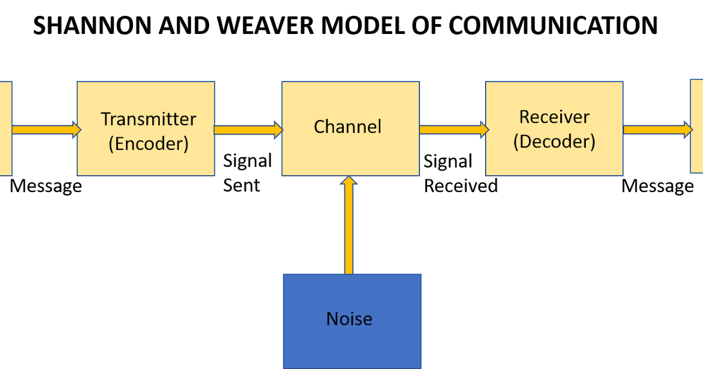

The message is then decoded by the receiver before getting a proper understanding and interpretation of this message. Noise could be present in the channel, and capacity is not retained by the receiver of decoding, due to which issues are created in the communication process (Miazga and Królikowska, 2020). For example, in the case of Maria and Pedro, Maria was the sender and encoder of the message which was to buy chicken, the channel was phone call and decoder was Pedro who misunderstood chicken to kitchen due to the noise at the building site. This led to miscommunication.

2.Schramm’s model

Communication has been regarded by Schramm’s model as one kind of process that occurs between a decoder and an encoder. One important thing that is accounted for by this model is how the message is interpreted by the people. It has been argued based on this model that knowledge, experience, and background of people are some important factors based on which the interpretation process could be affected. It is also believed by Schramm that a medium is used in transforming the message. In terms of sending feedback, an ability is developed by the decoder, and this feedback will be sent regarding the message so that it can be indicated that the receiver has received the message (Shoener et al., 2019).
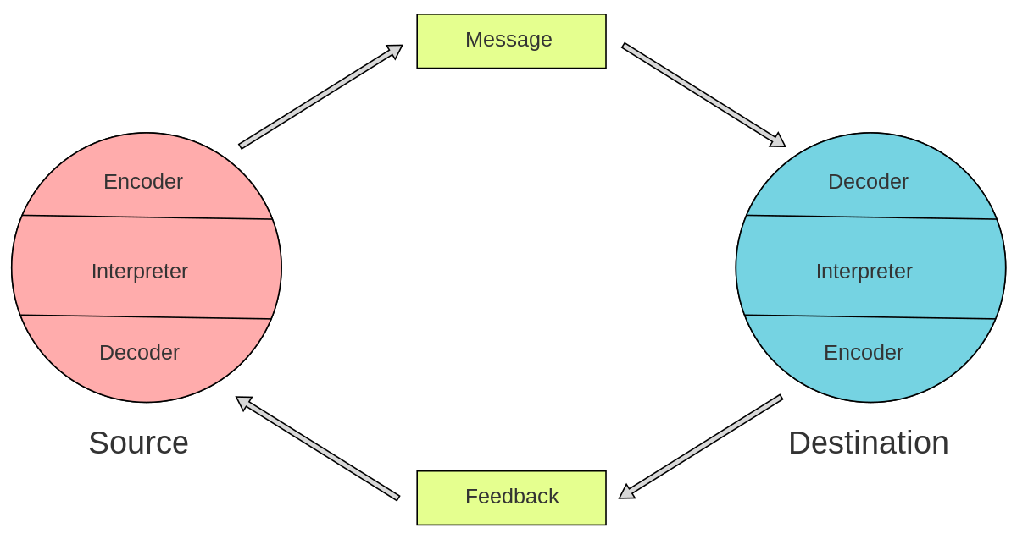
From the case of Maria and Pedro the communication was incomplete based on this model as there was no feedback from Pedro. Maria encoded the massage to get chicken when coming back home which was decoded by Pedro as I will see you in Kitchen which was a misinterpretation. For the communication to be complete Pedro should have asked Maria is she said Chicken or Kitchen.

3. Berlo’s Model of communication

According to Berlo’s theory, for communication to be effective, the sender and the receiver must be on an equal level. As a result, the source and the receiver should both be compatible. Based on the case of the professor and village people, they were unable to understand the message of the professor as he was communicating in a different language and due to lack of knowledge villagers were unable to understand it.

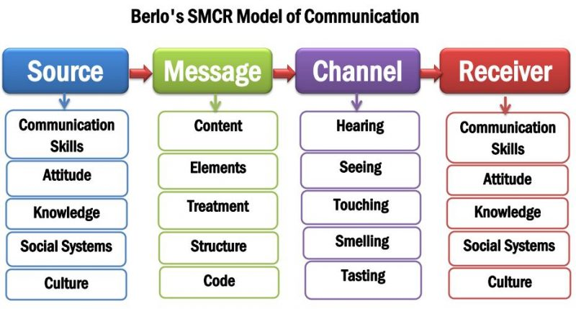

S -Sender
A person or individual who originates the message or the source is known as the sender. The message is sent by the sender to another person who is the receiver. The following are key factors that are linked with the sender and receiver.
A factor based on which process of communication could be affected is communication skills. In the case of good ski of communication, the message will be delivered by the sender in an effective way. Communication will not be considered effective when the message cannot be grasped by the receiver.
A certain level of effect is also created on the message because of the attitude of the receiver and sender. The attitude of an individual towards self, the environment, and the receiver will create some changes in the effect and meaning of the message (Catalano et al., 2019).
M-Message
A substance that is going to be shared and sent by one person is termed a message and it is taken between the sender and the receiver. The message could be in different forms such as video, text, audio, voice, or other media (Otoniel et al., 2019). The message was encoded in a different language which villagers were not able to understand.
C-Channel
In sending a message the medium that is used is termed a channel. Technical machines are involved in terms of mass communication or other forms and processes of communication. Some of the key machines that are used in this process include the internet and telephones. The five senses of human beings are used in general communication, and it is one key channel of communication (Schramm et al., 2019). In the case study of professor and the village people channel was heard as professor was speaking that his house was on fire.
R- Receiver

The communication skills (verbal, non-verbal and listening)

Verbal Communication
Any type of communication that will be based on the use of language so that meaning can be conveyed is defined as verbal communication. Oral communication may be included in this form of communication, such as speaking a thing or message by one individual over presentation, debates, interviews, face-to-face discussions, and telephones. Written communication may be included in it, such as emails and letters
In the case of Max, the multitasker, there is an oral communication being carried out between Max and his clients. Max can properly communicate the strategies he uses to attract the customers.

Non-Verbal Communication
Pauses, tone, facial expressions, and body language in speech are used in non-verbal communication as one kind of medium which is used in communication. Multiple channels of communication are used in this form of communication such as tone of voice, facial expressions, and entire body. In the case of A Day with a chief there are many non-verbal ques that are given by the Chief that helped Mark to feel comfortable. The nodding during the conversations is a sign that Chief is understanding the points being mentioned by Mark. Another non-verbal que is the gruff voice used at the end indicating that chief did not like Mark suggestion.

Listening skills
Active listening is an important element for making communication successful. It is the tendency of individuals of listening to the words and messages that have been sent by individuals based on giving proper attention to the meaning of the words. The central idea being communicated should need to be first determined by the individual to decipher messages.
In terms of learning some new skills, effective listening is considered one important and significant skill. In the case of Max, the multitasker, the main issue was he was not actively listening to Tamara’s instructions when she changed the dates of the event which lead to miscommunication and confusion on the date of the event.

The advantages and disadvantages of communication technology

Individuals have been allowed based on the technology of communicating with each other over larger distances. It could be considered as one kind of universal language based on which people could be allowed to communicate with other people in any country in the world. The process of communication and interaction has become easier based on the advancement of technology (Aceto, Persico and Pescapé, 2019).
The level of efficiency has been increased, and the speed of sending and receiving messages has been improved based on the rapid development of communication-based technology,
In the workplace environment, technology is one key aspect that is commonly used. People have become able to communicate and sharing their ideas and knowledge by using some technological tools that have helped in increasing the overall performance of the employees and the companies.
The level of effectiveness of the communication process has been increased by technology. Communication has become easier and quicker with such tools (Sadeghi, 2019).
A higher level of security in the communication process has been ensured with the use of an advanced form of technology. The risk of being spied on/listening to the process of communication between two confidential parties could be eliminated based on the use of technology.
Due to advancements in ICTs over the year a valuable level of improvement has been made in communication. In the facilitation of communication, various kinds of benefits have been raised with ICTs and in this regard, different businesses have realized the importance of the use of advanced and technological tools of communication. The use of ICTS has become an important part of the communication process of businesses (Golosova and Romanovs, 2018).

Poor Communication
As we are all using different types of communication, I would like to point out some aspects of my daily communication issues I came across at work. My work takes place in one of the busiest train stations in London. I work in King Cross train station.
On a typical busy day more than 10.000 people are using train transport. Due to noise from the trains, people, devices/speakers, trolleys most of the communication is missing. E.g. one of my supervisors has told us to leave work after we have finished cleaning the train. Our understanding was to go home. So, this is a small example of missing communication.

Conclusion
In both the personal and professional lives of people, it is concluded that the role of successful communication has been recognized as very important. Better people and situations could be understood based on effective communication by individuals in their personal life. In professional life, effective communication helps in getting the better job position.

References
Aceto, G., Persico, V. and Pescapé, A., 2019. A survey on information and communication technologies for industry 4.0: State-of-the-art, taxonomies, perspectives, and challenges. IEEE Communications Surveys & Tutorials, 21(4), pp.3467-3501.
Catalano, L., Commins, P., Schramm, S., Karothu, D.P., Rezgui, R., Hadef, K. and Naumov, P., 2019. A filled organic crystal as a hybrid large-bandwidth optical waveguide. Chemical Communications, 55(34), pp.4921-4924.
Golosova, J. and Romanovs, A., 2018, November. The advantages and disadvantages of blockchain technology. In 2018 IEEE 6th workshop on advances in information, electronic and electrical engineering (AIEEE) (pp. 1-6). IEEE.
Hirsch, J., Adam Noah, J., Zhang, X., Dravida, S. and Ono, Y., 2018. A cross-brain neural mechanism for human-to-human verbal communication. Social cognitive and affective neuroscience, 13(9), pp.907-920.
Miazga, M. and Królikowska, J., 2020. Assessment of Security of Water Supply for Benissa Municipality, Spain Employing the Shannon-Weaver Model. Rocznik Ochrona Środowiska, 22.
Otoniel, E., Franzon, B., Carvalho, G.A., Malheiro, M., Schramm, S. and Weber, F., 2019. Strongly magnetized white dwarfs and their instability due to nuclear processes. The Astrophysical Journal, 879(1), p.46.
Paranduk, R. and Karisi, Y., 2020. The effectiveness of non-verbal communication in teaching and learning english: a systematic review. Journal of English Culture, Language, Literature and Education, 8(2), pp.140-154.
Sadeghi, M., 2019. A shift from classroom to distance learning: Advantages and limitations. International Journal of Research in English Education, 4(1), pp.80-88.
Schramm, S., Karothu, D.P., Lui, N.M., Commins, P., Ahmed, E., Catalano, L., Li, L., Weston, J., Moriwaki, T., Solntsev, K.M. and Naumov, P., 2019. Thermochemiluminescent peroxide crystals. Nature communications, 10(1), pp.1-8.
Shoener, B.D., Schramm, S.M., Béline, F., Bernard, O., Martínez, C., Plósz, B.G., Snowling, S., Steyer, J.P., Valverde-Pérez, B., Wágner, D. and Guest, J.S., 2019. Microalgae and cyanobacteria modeling in water resource recovery facilities: A critical review. Water research X, 2, p.100024.
Uldbjerg, C.S., Schramm, S., Kaducu, F.O., Ovuga, E. and Sodemann, M., 2020. Perceived barriers to utilization of antenatal care services in northern Uganda: a qualitative study. Sexual & Reproductive Healthcare, 23, p.100464.
Vogel, D., Meyer, M. and Harendza, S., 2018. Verbal and non-verbal communication skills including empathy during history taking of undergraduate medical students. BMC medical education, 18(1), pp.1-7.
Vogel, D., Meyer, M. and Harendza, S., 2018. Verbal and non-verbal communication skills including empathy during history taking of undergraduate medical students. BMC medical education, 18(1), pp.1-7.
Xu, H. and Zhang, L., 2021, July. Urban Interactive Installation Art as Pseudo-Environment Based on the Frame of the Shannon–Weaver Model. In International Conference on Human-Computer Interaction (pp. 318-336). Springer, Cham.

