Changemakers
ADAA5001
Holly Morris-Price
2104336
Exhibition Evaluation

The run-up to the exhibition’s opening night went alright, however for most of it there was quite a lot of miscommunication between seconds years in both Photography and Fine Art but after having meetings to figure out the rough spots everything went much smoother.
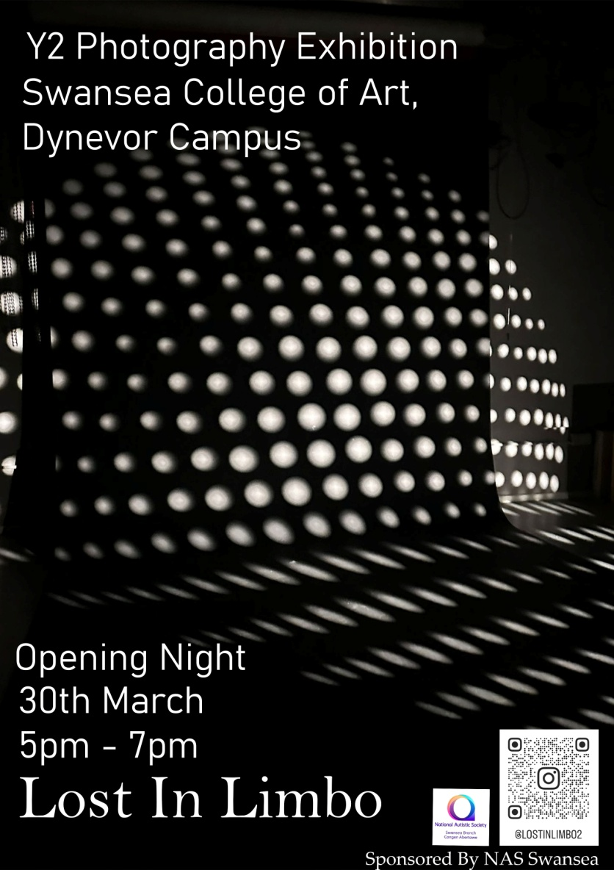
Some issues that were ran into were promotion wise, we didn’t know if we were going to promote the second year show with fine art or separately, and after discussing with the class we ended up promoting our half separately from fine art since many of us felt the title didn’t quite include everyone, so as a class we then created our own poster and Social media for promotion. We named it ‘Lost in Limbo’ as everyone had work that was about identity in a way or under the umbrella of an inside feeling.

On the social media page we posted sneak peeks of work throughout the final week which was also prep week as a way to make people more interested. Posters were also put up around the university and within gallery spaces etc to further promote.
Poster >>>>>>>>>>>>>>>>

As part of the opening night we decided to not only have a catalogue of peoples work (those who wanted their work inside it) but we also as a group decided to offer postcards, drinks, and also we decided to provide Welcome drinks which were sponsored by NAS Swansea.
photography corridor walls to make sure every ones work had a flat surface to go onto. When putting up my own work it was a 2 person job

My piece was named
Absent Paths, Absent Mind
And the idea behind the work was for it to show how chaotically lonely someone’s mind can be. I was heavily inspired by the photographer Alan Schaller and also by Chinese Photographer Fan Ho. My produced piece is definitely more inspired by Alan Schaller with his metropolis collection due to the deep blacks in each image, and i wanted to get those same deep blacks in my own work so I would have nice sharp lines between the blacks and whites in the image.
I knew I wanted to have a single image scaled up, however the impact i wanted for the image was something I wanted to essentially ‘personalise’ to each person who saw it. So while for myself it conveys how my own mind feels absent while following my own paths, for someone else it could convey something totally different. This is something I thought about while doing the final images for the exhibition. And in the end I feel my image worked well and conveyed the message to each person nicely, my lines were sharp and the blacks were deep and stood out nicely against the white wall.
During the preparation week I helped sand & fill walls so that work had a flat surface to go onto and so that everything was neat and tidy surrounding it, and i also helped take tables to the foyer so we could set the welcome drinks up and also have maps of the exhibition for people to take with them.

