Manifesto task 1
- Sustainable design must progress
- Sustainable design need to co-exist with nature
- Us as a society need to protect our planet and our future with sustainable design
- Design needs to pure and clean
- Sustainable ideas could benefit our physical and mental health.
- We need to produce good sustainable design that could benefit our civilisation

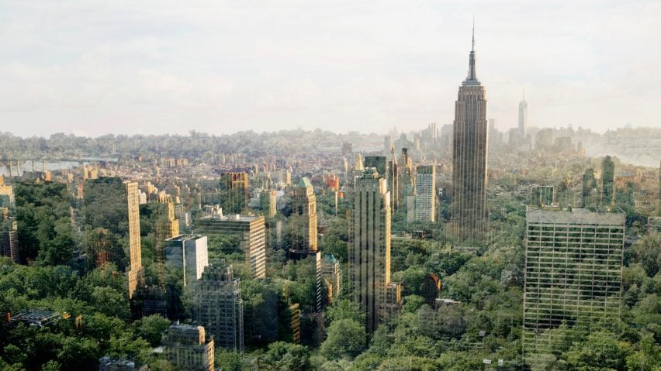
- We need to come up with a better alternative compared to the unhealthy ways our civilisation as progressed in the past.
Origin of image: https://static.dezeen.com/uploads/2021/11/es-devlin-dezeen-15-manifesto_dezeen_2364_col_8-852x479.jpg

- We need to produce good sustainable design that could benefit our civilisation. “We realised that what we design decides our destiny”. (Delvin, 2021) This quote relates to my point, signifying that our choices for design greatly benefits our future. This quote proves that there is a necessity for sustainable design because if otherwise that could impact our civilization negatively. This quote feels like a warning which pushes designers to focus on a more sustainable products or sustainable ideas that could shape our future into clean and healthy environment to live in. Personally, I believe that sustainability is the hope for our future and our designs. Our planet has suffered significantly due to our civilisation abusing destructive ways of mass production, to produce our everyday products.

- Sustainable ideas could benefit our physical and mental health. By promoting sustainable solutions, we can encourage society to move away from unethical methods of production for a greener and cleaner process. "Sustainable solutions could affect wider society, organisations, and material-human relationships, leading to increased environmentally damaging consumption for reasons beyond economic utility" (Van Der Loo, Pigosso, pg.6). this highlights the potential risks eco-friendly method which may unintentionally lead to overconsumption and greed in a society therefore the societal change between traditional and sustainable methods can be challenging. However, embracing this change would be significantly practical and a better solution for a healthier future.

"Since I and many around me started driving electric cars, more charging stations and parking spaces became available. This enables me to run my errands by car rather than with public transportation”. (Van Der Loo, pg.6.). This quote shows the behaviour of someone having the realisation of the sustainable results, and the convenience that modern day sustainable products grant. Therefore, the speaker shows satisfaction on how the sustainable products effect the modern infrastructure of his area, this also introduces a different lifestyle for this person. This is a perfect example of how sustainability can drastically change someone’s lifestyle from a small detail in their life, this does show an improvement that sustainability does have an effect, mentally on people lives making them satisfied and comfortable due to sustainability being convenient and solving everyday struggle for their lifestyles.

- Sustainable design needs to co-exist with nature. This can benefit many factors for our environment and health for our foreseeable future. I picture a future where nature is integrated into all aspects of sustainable design, I believe that it is required in order for us to manifest an inspirational outlook of how sustainable design should look.
“The built environment plays a key role in the pursuit of sustainability, notably in enhancing resource and energy efficiency, in conjunction with minimising negative impacts on the environment and on human health”. (W. Zhong, T. Schroeder, J. Bekkering, 2023, pg.2).

Bibliography
- Es-Delvin - swapping cars for trees: https://designmanifestos.org/es-devlin-swap-cars-for-trees/#:~:text=It's%201%20November%202036%20and,has%20become%20a%20forested%20park.
- Explaining the rebound effects of sustainable design: a Behavioural perspective, 2024, Van Der Loo, I.G.H, Pigosso, D.C.A. https://librarysearch.uwtsd.ac.uk/permalink/44WHELF_UWTSD/igoone/cdi_proquest_journals_3055414924
- Case study/article- Designing with nature: Advancing three dimensional green spaces in architecture through frameworks for biophilic design and sustainability Weijie Zhong, Torsten Schroeder, Juliette Bekkering: https://www.sciencedirect.com/science/article/pii/S2095263523000201

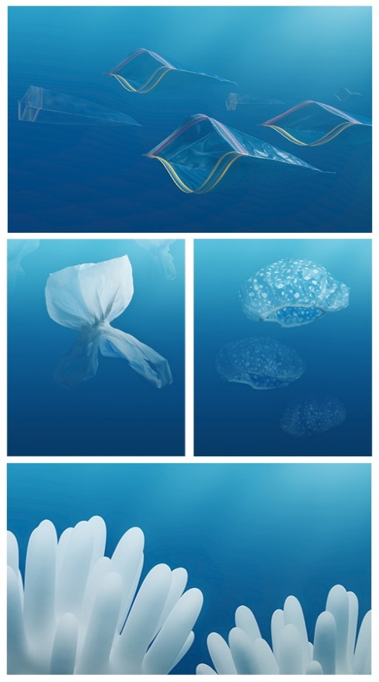
Task 2- Semiotics
Denotation-
Connotation-

