Module Code: EMPL4012
Student name: Nahid Sultana
Student ID:1605705
Tutor:Mushfiqur Rahman

Researching and Analysing Data

Table of Contents
Introduction 3
Articulating Question 3
Gathering Information 3
Interrogating the data 5
Findings 8
Conclusion 9
Appendices 9
References 10

Figure 1: Shopping Pattern of people (Source: pwc.com)……………………………………………..4
Figure 2: Relationship between age and online shopping (source: author) 5
Figure 3: Distribution of Ratings (Source: author) 8

Introduction
One of the most prominent skills of a person in building his career is the analytical skill. A person should have the ability to reach any conclusion by researching and analysing data properly (Trilling and Fadel, 2009). To research and analyse properly, he should know about the sources and methods of collecting and analysing data. The report will show both primary and secondary data about the online and high street shopping. Then it will show how to reach any conclusion by analysing these data with some analytical and statistical tools.

Articulating Question
Article 4 (City must wake up to digital growth, says tech investor) from the topic ‘Online and the high street shopping’ is chosen as the topic to run research and analysing data. The article tells that people are attracting to the online shopping and companies from the USA like Amazon.com and Google are grabbing the market share of offline business firms (Carroll, 2017). The article also reveals that the city, as well as the companies, should respond positively to the digital growth and should expand their business in online. The research will review both on the online shopping and high street shopping in the UK and conclusion will be drawn based by analysing the collected data. The main question on which the research will be conducted is:
Are people getting more interest in online shopping relative to high street shopping?
This will help to conclude whether the business firms of the UK should focus on online selling or not.

Gathering Information
There are mainly two sources available to collect information and they are a primary source and secondary source (Cook and International Business Machines Corporation, 2014). The primary information is the authentic information that is collected from the respondents directly in the time of research through hypothesis testing, observation, questionnaire, interviewing, audio-visual etc. (Hox and Boeije, 2005). The secondary information is the previously collected information by others that is collected from journals, newspapers, articles, books, research papers etc. (Hox and Boeije, 2005). In this report, both sources will be used to gather information.
According to many researchers, the demand for online shopping is growing very fast worldwide. Due to the advancement of the technology, the online shopping has become easier to the shoppers than the high street shopping (Shahzad, 2015). According to PWC global (2017), 56% do shopping in Amazon.com among the 24,000 active shoppers from 29 countries, 39% say that social network is the main reason behind their online shopping and 47% have wearable tech devices. The research has also shown that the online shopping with the mobile is increasing day by day through the in-store shopping is increasing in recent years (Shahzad, 2015).
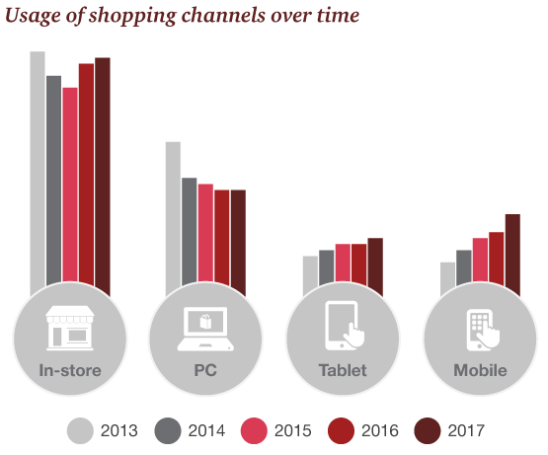
Figure 1: Shopping Pattern of people (Source: pwc.com)

Now it’s time to show the condition in the UK from the same research. 36% of the respondents have started searching products in Amazon.com, 38% purchase products online via mobile phone and 22% thinks mobile sites are difficult to use (PwC, 2017). Another research shows that 24million people did online shopping and spent around £5bn for Christmas last year (Theguardian.com, 2017). Seven out of ten internet users do shopping in online and the average spending was £500 per year in the previous year (Theguardian.com, 2017). Another article shows that the online sales touched the record of monthly online sales of £10.1 billion and the 2.9% reduction in the high street visiting by the shoppers in November last year (Butler, 2017). The people who use the internet are losing interest in high street shopping. In recent years, the percentage of online shopping after midnight has increased by more than 30% (Wood, 2017).
To gather the primary information, we have used a questionnaire with 14 related questions and surveyed over 200 shoppers from the age range of 15-50. The questionnaire is given in the appendix part. The survey is conducted to know the current trends of shopping among the shoppers.

Interrogating the data
164 people among the respondents say they like online shopping over high street shopping. Among them 17% age 35+ years, 54% age in between 15-25years and 29% age in 25-35 year. From the result, it can be said that there is a relation between the age and online shopping. Young people like online shopping more than the middle-aged people. It can be showed in a graph.

Figure 2: Relationship between age and online shopping (source: author)

The figure shows that there is a negative correlation between the age and percentage of people who like online shopping.
The other 36 (18%) people who don’t like online shopping age above 30 years. They don’t like because most of them don’t think the process is safe. The hackers may use the system to know their personal information (Miyazaki and Fernandez, 2011). Other thinks most of the products from online don’t comply with the quality. They like to shop by physically checking the products. Some of them said that the online sellers charge more price than the high street sellers. Some of them don’t like the system because they think the system is complex.
Among the people who like online shopping, most of them tell that they like online shopping because it saves their time by providing the home delivery and they can order and get their products at any time for their comfort. Some of them said that it is easy to search for a wide range of products within a very short time through the online.
The spending in online shopping on a yearly basis for the respondents are given below:
Number of People | Spending in Online Shopping (£)
37 | 1000
5 | 2000
42 | 500
18 | 800
29 | 1500
20 | 1200
13 | 1800
Total | 8800

The yearly mean/average spending per person is 8800/7 = £1257.143. It’s a huge amount of money. By the help of Microsoft Excel, it is found that the variance of the income is 251020.4 and the standard deviation is 501.0194 which mean there less deviation in the spending. The calculations on the spreadsheet has been given in Appendix B
Among the 164, 43% of them buy foods and beverage, 36% buy fashion and clothing products, 34% buy electronic products. 20% buy home and kitchen appliances and 7% buy books and other materials. 78% buy more than one kinds of products from the online shop.
82% of the respondents said that they think online shopping is advantageous because they can see and place an order at any time. People are now very busy in their works. Online saves their time and they can have their product at their desired time. According to our research, 33% of the respondent place order before midnight, 39% place order after midnight, 15% place orders in the morning and other place orders both in daytime and night. So the people are more active in online shopping from midnight to morning (Wood, 2017).
From the survey, we have found that main media to do online shopping is smartphones. 51% respondents told that they do shopping with their smartphone. 37% use both laptop and smartphone and 12% use tab.
The social media marketing strategy by the company inspires them more as around 60% of them said that they know about the products from the social media. 23% are inspired by the friends and colleagues and other people are inspired by the online advertisements.
43% of them buy foods and beverage, 36% buy fashion and clothing products, 14% buy electronic products. 20% buy home and kitchen appliances and 7% buy books and other materials. 78% buy more than one category of products from the internet.
Among the people who don’t do online shopping, 70% said that high street shopping is more advantageous as they can buy their products by judging them physically and they feel more secure and sound in doing high street shopping. Others said that high street shopping costs them less than the online sellers.
The ratings of the respondents have shown with a graph below:

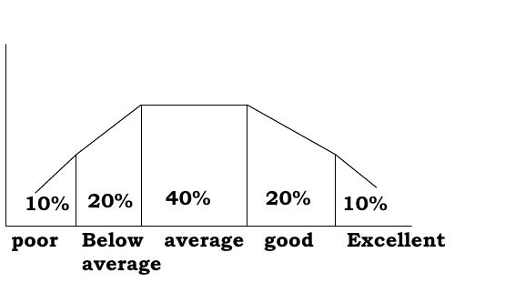
Figure 3: Distribution of Ratings (Source: author)
The graph is showing that more people are satisfied with online shopping and will continue online shopping.

Findings
By analysing the secondary and primary data, it is clear that the number of online shoppers is increasing day by day. Young people are more interest in online shopping (Shahzad, 2015). Lack of time and growing business of people in their works force people to shop from online (Park and Kim, 2013). The technological advancement also inspires the people to shop online (Park and Kim, 2013). Online sellers give them the opportunity to shop 24×7 hours daily. So people can shop anytime if they want. The high street shop has more cost than the online shoppers like rent of outlet, salaries, and wages of employees, tax, utility, and maintenance cost of the showrooms. So they are facing problem in competing with the online competitors. People buy mainly foods and drinks, clothing and fashion products, electronic products and home and kitchen appliances (Shahzad, 2015). The online runs mainly a B2C business. The number of buyers from Amazon.com is growing day by day. Black Friday, single’s day, offer day etc. strategies by the online companies like amazon.com, Alibaba.com, Zappors.com are attracting the people more (Park and Kim, 2013). The average spending of people is increasing day by day (Shahzad, 2015). The demand for online products is growing day by day and the trend line of online shopping is going upward year to year. Foreign companies are entering the market of the UK to grab the opportunity. But some people are feeling less secure as the hackers are targeting this online shopping and digitalization to know others personal information (Miyazaki and Fernandez, 2011).

Conclusion
From the research, it is found that the online market is growing day by day as people are getting more interest in the online shopping. Though the high street sales by the offline firms are increasing in the recent years, the online sales of the online firms are increasing at a very high rate. The foreign competitors are grabbing the market share of the domestic company and the companies are losing value day by day. It makes other foreign competitors enter the market. So, the domestic companies should turn or expand their business for selling their products in online through internet. The firms should also pursue digital marketing strategy and should adjust them to the digital growth. The firms also have to ensure the safety and security of customers by developing strong and secured operating system.

References
Butler, S. (2017). Online and upward: UK internet shopping hits record high. [online] the Guardian. Available at: https://www.theguardian.com/business/2013/dec/17/online-internet-shopping-high-street-record [Accessed 1 Dec. 2017].
Carroll, L. (2017). City must wake up to digital growth, says tech investor. [online] the Guardian. Available at: https://www.theguardian.com/business/2013/mar/01/city-wake-up-digital-investor [Accessed 1 Dec. 2017].
Cook, J.M., and International Business Machines Corporation, 2014. Collecting data from data sources. U.S. Patent 8,738,565.
Hox, J.J. and Boeije, H.R., 2005. Data collection, primary versus secondary.
Miyazaki, A.D. and Fernandez, A., 2011. Consumer perceptions of privacy and security risks for online shopping. Journal of Consumer affairs, 35(1), pp.27-44.
Park, C.H. and Kim, Y.G., 2013. Identifying key factors affecting consumer purchase behavior in an online shopping context. International Journal of Retail & Distribution Management, 31(1), pp.16-29.
PwC. (2017). 2017 Total Retail survey. [online] Available at: https://www.pwc.com/gx/en/industries/retail-consumer/total-retail.html [Accessed 1 Dec. 2017].
Shahzad, H., 2015. Online Shopping Behavior.
Theguardian.com. (2017). Cite a Website - Cite This For Me. [online] Available at: https://www.theguardian.com/lettheconversationflow/story/0,,1665607,00.html [Accessed 1 Dec. 2017].
Trilling, B. and Fadel, C., 2009. 21st century skills: Learning for life in our times. John Wiley & Sons.
Wood, Z. (2017). Online shopping sees 30% rise between midnight and 6am, study says. [online] the Guardian. Available at: https://www.theguardian.com/money/2014/oct/10/internet-online-shopping-30-per-cent-rise-midnight-6am-john-lewis [Accessed 1 Dec. 2017].

Appendices
Appendix A- Questionnaire
- What is your age?
- Do you do online shopping?
- Do you like shopping online?
- If yes, why?
- If no, why?
- How much you spend on online shopping yearly?
- £500. b) £800. c) £1000. d) £1200. e) £1500. f) £1800. g) £2000. h) £2000+
- What do you buy from the online shop?
- Do you think online shopping is more advantageous than high street shopping?
- If no, then why in-store shopping is advantageous?
- If yes, then why online shopping is advantageous
- In what way you order from online?
- Which inspire you to shop online?
- When do you place an order in online?
- Rate online shopping on a scale of 1 to 5, where 5 is excellent and 1 is poor.
Appendix B

