Engine Workshop Technical Report
Workshop session 16/11/18 Engine workshop
This report will discuss the process used to disassemble a ford 1.4 Zetec engine from a complete engine to a rotating assembly and valvetrain in preparation for crankshaft removal and taking measurements for engine wear evaluation. The health and safety rules and legal legislation that will cover the workshop session will be investigated and then will suggest how they control what PPE (personal protective equipment) and other preventative safety measures must be taken when in a workshop environment. Finally, a conclusion on what has been found during disassembly will be made regarding the condition of the engine and what this would mean for undertaking further repair in a real environment.
Legislation
Most injuries in the workplace involve heavy lifting causing excessive strain or slips and trips on spilt fluids and parts or tools that have been left on the floor or trailing across the room. These are called movement injuries. A non-movement injury would be an electrical, heat or injury caused by machinery or tooling such as a cutting disc breaking up and cutting the user as debris flies from the grinder.
Long term health issues must also be considered, this would include dermatitis from handling substance with bare skin, asthma from airborne particles and strain injuries causing premature arthritis, neck and back problems.
The Engines that are being disassembled have previously been disassembled and to enable longevity as a teaching tool most bolts and other fixings have not been tightened to full manufacturer specification. This also reduces chance of straining muscles trying to undo a seized bolt. Also, the engines have been cleaned and carry only trace amounts of oil and other substances that may cause irritation to the skin, despite that, gloves are available for those who would prefer to protect their skin from any lingering substance.
The engine is mounted into an engine stand meaning it does not need to be manhandled into positions that the worker can access different components. Therefore, the risk of crushing hands and feet are greatly reduced, Despite this it is workshop policy to always wear steel toe capped boots when in the workshop area due to regular movement of heavy objects between workshops.
Method
The only tools required in this section were a 3/8 drive ratchet with a selection of metric sockets ranging from 8 to 19mm and extensions of varied lengths to allow reach behind manifolds and into the spark plug valley.
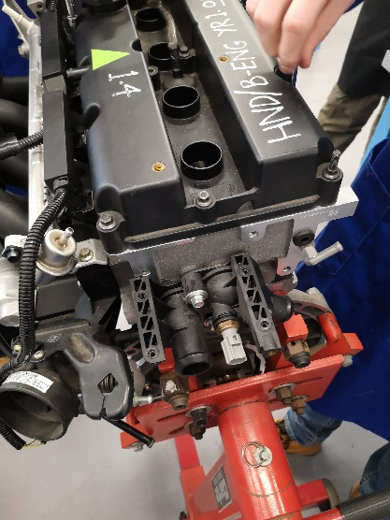
To begin, electrical wiring was unclipped from the engine, this included spark plug HT leads and loom for the injection and engine monitoring systems.
Next, the engine crank case breather and oil separator were removed, this was done with caution as oil may have been trapped in the baffle system. It was found that no vacuum or breather hosing was fitted to the engine at the time of disassembly and would have caused poor running if this was the case when the engine was fitted to a vehicle or test bed.
The thermostat housing and thermostat were removed. They were found to only have 2 of the 4 bolts fitted it may not have held water pressure during vehicle running.
The coil pack was removed allowing access to the rear coolant inlet on the engine which also houses the coolant temperature sensor.
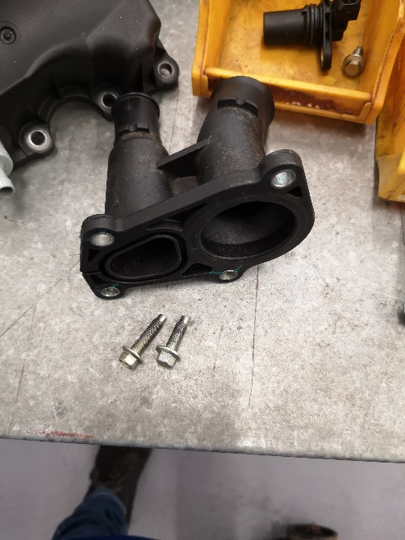
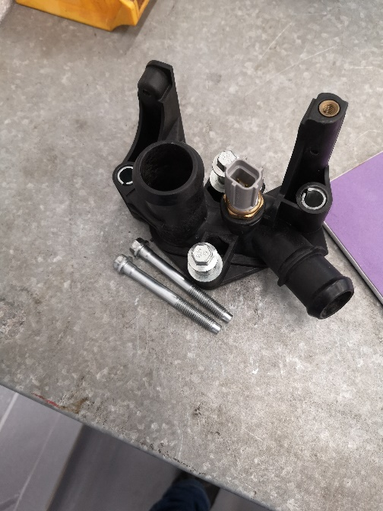
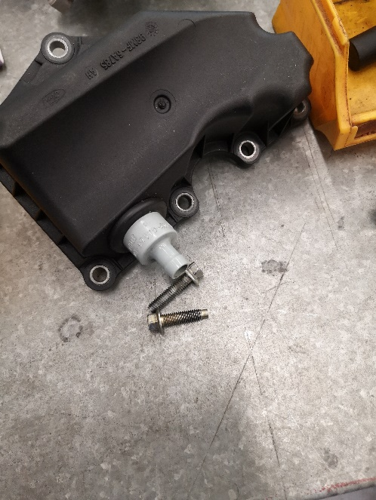
Then the inlet and exhaust manifolds were removed, challenge was encountered removing the injector rail from the manifold due to tight bolt access, a lever was used to allow larger space and they were removed. The inlet manifold also houses the throttle body and oil breather inlets so these camo off at the same time.
Next were the valve covers which were simply unbolted. These were found to be also missing a number of bolts.

Finally the engine was rotated on the stand to allow removal of the sump with a number of 10mm bolts.

Conclusion
With the engine having been disassembled before, the risks of excessive strain and oil/water spillage were almost eliminated. Therefore, there was very little risk while taking the engine apart.
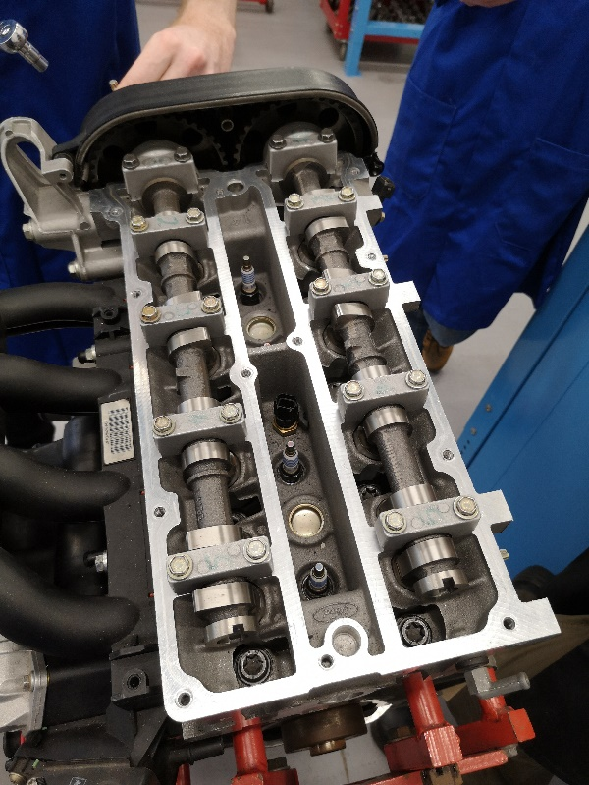
No excessive wear or damage was found around the crankshaft or camshaft with covers removed and further disassembly and evaluation will be required to find the cause of failure in this engine.
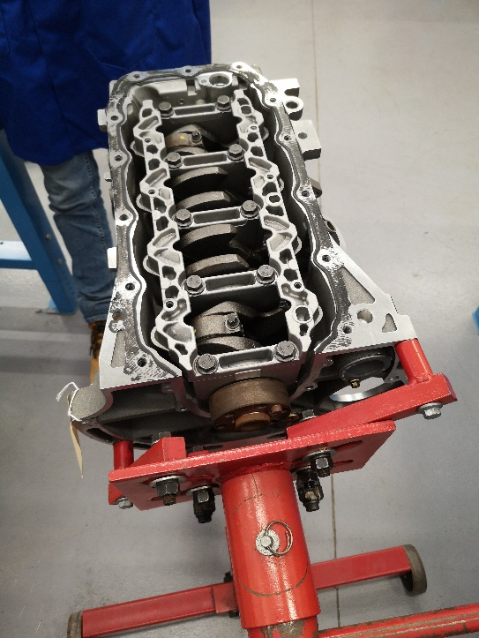
The condition of all parts removed in the session were excellent however several missing bolts may have caused leaks or more catastrophic failure if the engine were to be run in the future. From this session I have learnt that in order to remove all parts from an engine, it is not always required to take all parts off separately. Sometimes, like in the case of the throttle body, it can be easier to leave it attached to another part and this reduces time taken to disassemble the engine and risk of losing bolts. Despite this, If troubleshooting faults it may be necessary to inspect all parts separately so this may not always be possible.

References
Health and safety in engineering workshops HSG129, Second Revision, 1999. http://www.hse.gov.uk/pubns/priced/hsg129.pdf

