

Financial Management for the Hotel Industry (BMIH5007)
Assignment 1 - Business Report -
Comparison of two Hospitality Organisations
Student Name: Bogdan-Adrian Gisca
Student ID: 2118571
Lecturer: Tristan Hawkins

Executive Summary
In the hospitality industry, the report compares Mandarin Oriental Hotel Group with Premier Inn. Mandarin Oriental excels in luxury, providing tailored experiences and cultural immersion, while Premier Inn prioritises dependability and cost-effectiveness. Prioritising both ensures positive customer feedback and high-quality services. Mandarin Oriental caters to wealthy travellers, while Premier Inn targets budget-conscious guests. Despite having different approaches, both brands in the competitive hospitality industry display successful strategies that are in line with their respective market segments.
Introduction
The hospitality sector epitomises a blend of various offerings and exceptional customer service, embodying the essence of unparalleled guest experiences. Mandarin Oriental Hotel Group and Premier Inn are two prominent players in this expansive landscape, each with a unique niche to carve out. The Mandarin Oriental Hotel Group epitomises sophistication and luxury and is renowned for its elegance and grandeur. Tending to the discriminating elite, the group curates an experience rooted in refined hospitality through a global presence spanning iconic locations.
On the other hand, Premier Inn has made a name for itself as an advocate of reasonably priced luxury, offering high-quality lodging at reasonable costs. Widely acknowledged for its uniform standards of service and widely available accessibility in all regions, Premier Inn caters to a wider demographic seeking comfort without sacrificing quality. This report delves deeply into an examination and comparison of these two industry titans in the hospitality industry, dissecting the nuances of their business models, marketing strategies, financial positions, and dedication to customer-centric and sustainable practices. Knowing where they stand out in the industry provides an important context for understanding the diverse landscape of hospitality.

Company profiles
Mandarin Oriental Hotel Group
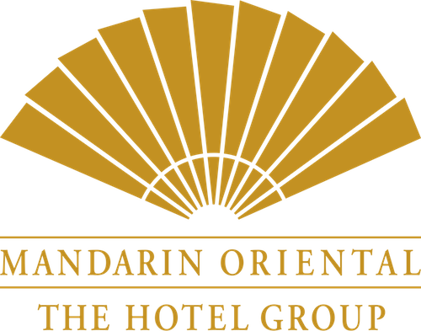
Source- (mandarinoriental, 2023)
Global Presence and History
Since its founding in Hong Kong in 1963, the Mandarin Oriental Hotel Group has undergone an unmatched transformation, cementing its position as a renowned worldwide symbol of luxury hospitality. The brand's prestige stems from its collection of unique properties situated in major global cities like New York, London, and Tokyo, showcasing its presence in important markets across the globe. Mandarin Oriental's international recognition is evident due to its extensive presence across 33 hotels and seven residences across 23 countries, demonstrating its unwavering commitment to a global standard of excellence (mandarinoriental, 2023).
Brand positioning and target market
The group's strategic strength lies in its focused approach to a discriminating clientele seeking bespoke luxury experiences. Travellers seeking sophistication and exclusivity in their accommodations are drawn to Mandarin Oriental's brand positioning, which revolves around the concepts of personalised service and refined elegance. Setting an unmatched standard for personalised, exceptional service, this deliberate focus on customising each guest's experience to perfection accentuates the brand's uniqueness within the luxury hospitality sector (Foroudi, 2020).
Unique Features
Mandarin Oriental stands out for its unwavering dedication to providing exceptional customer service, which manifests in its legacy service standards that seamlessly blend contemporary aesthetics with a genuine representation of regional culture. This combination creates a marriage that appeals to the connoisseur of elegance and customs. Notably, the group's world-class dining experiences and holistic wellness spas serve as examples of its commitment to offering an all-encompassing, opulent experience. Mandarin Oriental's success stems from its ability to create a setting that combines luxury and cultural authenticity, turning it into a distinctive feature that epitomises the quintessential Mandarin Oriental experience (mandarinoriental, 2023).
Premier Inn
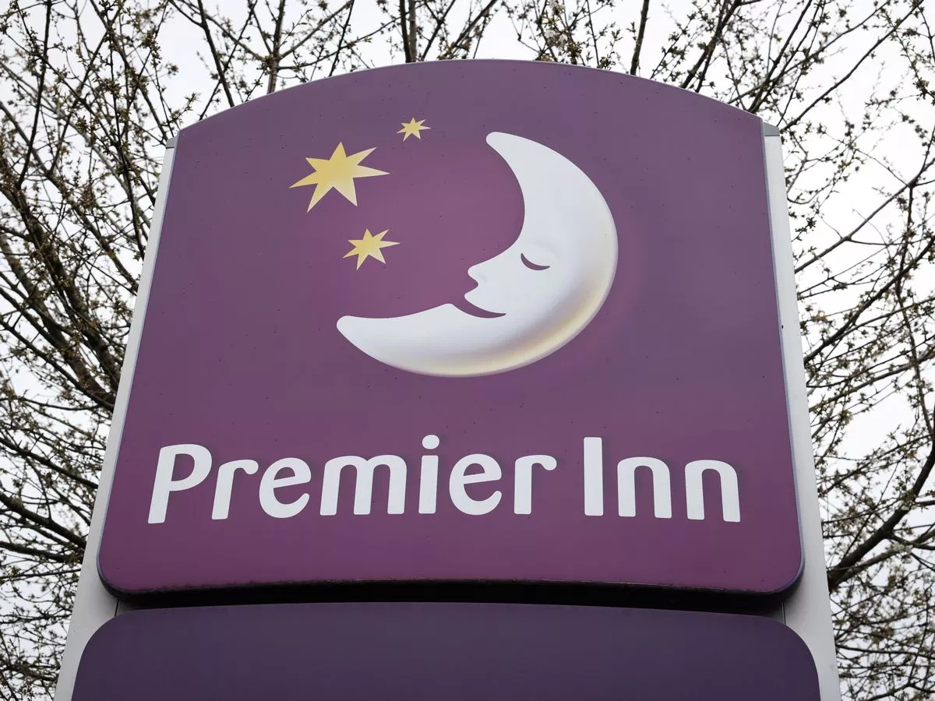
Source- (Premierinn, 2023)
Global Presence and History
Having been founded in the UK in 1987, Premier Inn has quickly become a well-known chain of budget hotels, guiding its growth into a prominent position in the hospitality industry. With its rapid expansion into popular regions like the UK, Germany, and the Middle East, it now boasts a staggered network of over 900 hotels and a repertoire of more than 80,000 rooms. Premier Inn's unwavering focus is on providing high-quality lodging at competitive rates, solidifying its reputation as a reliable brand in the budget hotel industry (Premierinn, 2023).
Brand positioning and the target market:
Premier Inn prides itself on being the first choice for budget-conscious travellers and families looking for reasonably priced yet comfortable accommodations. Its brand strategy is focused on consistency, promoting a standard and inviting customer feedback. Customers find resonance in this strategic emphasis on upholding consistent service standards, which guarantees a hassle-free environment while keeping costs reasonable. The cornerstone of Premier Inn's brand ethos is its unwavering commitment to providing value without sacrificing quality (Foroudi, 2020).
Unique Features
Special Features: The cornerstone of Premier Inn's success rests in its distinctive selling propositions, which are painstakingly curated to provide guests with a consistent and dependable experience throughout all properties. The chain's dedication to offering tastefully decorated, cosy rooms that are tailored to guarantee a restful night's sleep is complemented through hearty breakfast selections and value-added services that cater to the various needs of its patrons. Premier Inn has carved out a niche for itself in the budget hotel market with its unwavering dedication to providing affordability without sacrificing quality (Premierinn, 2023).
Financial Performances
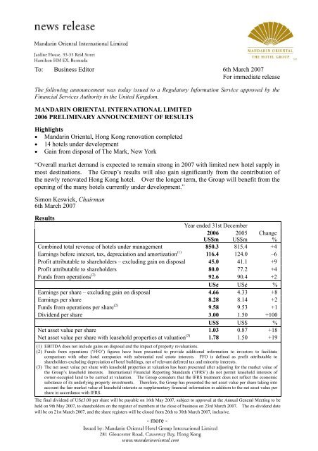
Source- (mandarinoriental, 2023)
The financial performance of Mandarin Oriental Hotel Group is indicative of a strong revenue stream and noteworthy profitability metrics. The group's consistent upward trends in revenue growth can be attributed to its strong practice of upscaling hospitality. Mandarin Oriental has maintained healthy profit margins despite a discriminating customer base seeking opulent experiences, thanks to its premium positioning and exceptional service offerings. Market analysis reveals its niche dominance that is supported by its consistent market share growth in the luxury market. Despite having a smaller footprint than other industry titans in the hospitality sector, its quality-over-quantity strategy has cemented its standing as a key player in the upscaling hospitality space (Alnawas, 2019).
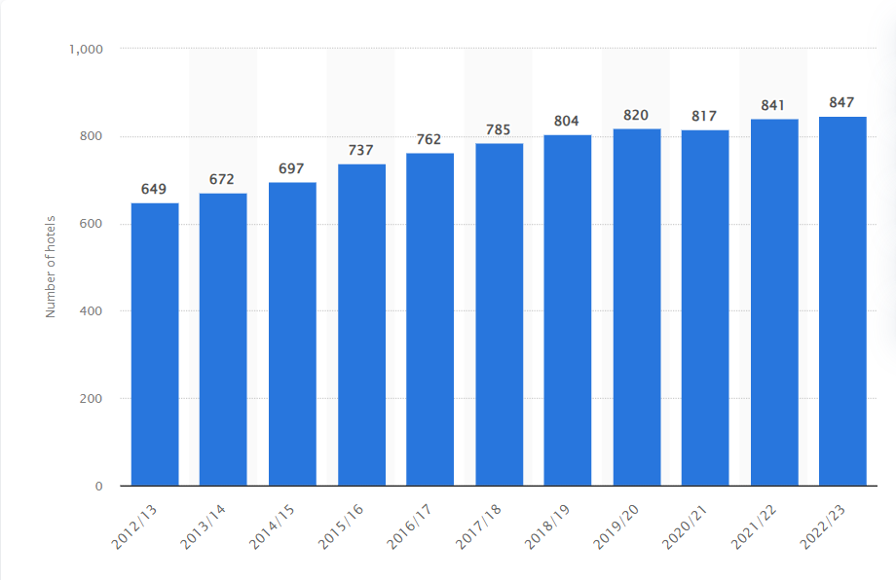
Source- (Premierinn, 2023)
Conversely, the financial performance of Premier Inn is dependent on its substantial network of budget hotels and its high revenue generation. The brand's profitability metrics demonstrate its competitive pricing strategy while maintaining operational sustainability. Premier Inn's market position is firmly rooted in its substantial market share, which is driven by consistent growth patterns and a growing selection of affordable lodging options. It has established a solid presence in the budget hotel sector thanks to its capacity to provide dependable quality at reasonable prices, making it a formidable competitor in this market (Anagnostopoulou, 2019).

Operational Strategies
Mandarin Oriental Hotel Group
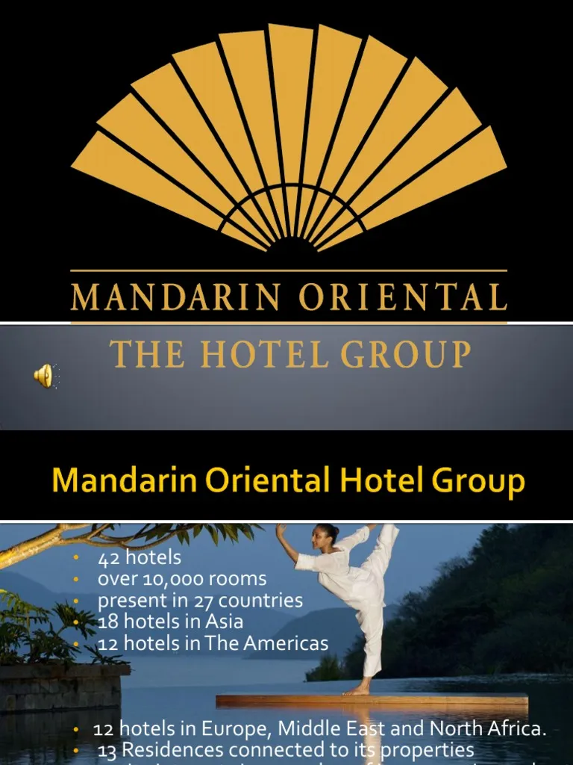
Source- (mandarinoriental, 2023)
Services Offerings
Perfect service standards with a focus on personalised attention and bespoke luxury experiences.
Services ranging from holistic wellness centres to fine dining experiences and activities centred on cultural immersion catered to individual preferences (mandarinoriental, 2023).
International Presence and Growth Techniques
Global reach throughout important cosmopolitan centres, strategic growth focuses on key cities that appeal to luxury travellers. The target market alignment highlights the affluent individuals who are looking for exclusive experiences, luxury, and sophistication (Rutherford, 2021).
Chronology Sustainability, Innovation, and Integration
Creative application of technology to improve customer experiences without sacrificing personalised care. Investments in environmentally friendly initiatives and sustainable practices that preserve luxury standards (Mandić, 2021).
Premiere Inn

Source- (Rutherford, 2021)
Service Offerings and Quality
Focus on consistent, dependable quality throughout all properties, guaranteeing a cosy and inviting stay experience. Standard amenities and service offerings are designed to provide value without sacrificing guest comfort (Premierinn, 2023).
International Presence and Growth Techniques
Extend the network throughout several countries while concentrating on high-traffic areas and strategic locations for travellers on a budget. The target market is geared towards families, business travellers, and vacationers looking for reasonably priced yet cosy lodging (Rutherford, 2021).
Chronology Sustainability, Innovation, and Integration
Innovation aimed at maintaining budget-friendly offerings while boosting service delivery efficiency. Initiatives to support sustainability, like responsible resource management within operational frameworks and energy-efficient practises (Mandić, 2021).
Both businesses base their operational strategies on specific market segments; Mandarin Oriental prioritises luxury and personalised service, while Premier Inn concentrates on value, consistency, and affordability. Their service offerings, growth strategies, and technological and sustainable approaches complement their respective target markets, enabling each to thrive in specific niche segments of the hospitality sector (Njoroge, 2019).
Corporate Social Responsibility and Sustainability
Mandarin Oriental Hotel Group
Environmental Initiatives
Reduction of carbon footprint, waste management across properties, and energy-efficient practices that demonstrate a commitment to sustainability. Application of environmentally friendly technologies and methods, such as the use of renewable energy sources and water conservation measures (Camilleri, 2022).
CSR and Community Engagement Programmes
Participates in a variety of community-focused initiatives, lending support to nearby communities through partnerships and charitable endeavours. CSR initiatives that emphasise social welfare, cultural preservation, and education strengthen the organisation's commitment to social responsibility (Úbeda-García, 2021).
Premiеr Inn
Environmental Initiatives
Prioritises sustainability through the adoption of waste reduction strategies, energy-efficient operations, and conscientious waste management techniques. Implies environmentally friendly initiatives to lessen its impact on the environment, such as resource conservation and sustainable sourcing methods (Farmaki, 2019).
CSR and Community Engagement Programmes
Participates in outreach initiatives within the communities surrounding its hotel locations, lending support to regional causes and initiatives.
CSR initiatives that support community outreach, education, and charitable giving are consistent with the brand's commitment to social responsibility (Úbeda-García, 2021).
Premier Inn and Mandarin Oriental Hotel Group both exhibit a dedication to environmental sustainability and community involvement. While Mandarin Oriental focuses on luxury-oriented sustainable practices and comprehensive corporate social responsibility initiatives, Premier Inn showcases its dedication to environmental sustainability and community outreach while appealing to travellers on a budget. Every one of them synchronises their initiatives with their brand ethos, benefiting their respective communities and the environment (Moneva, 2020).
Marketing and Branding
Mandarin Oriental Hotel Group
Brand Image and Reputation
Revered for its prestigious brand image, which is linked to elegance, sophistication, and superior customer service. Maintains its esteemed status by leveraging its exclusivity and personalised experiences to uphold its stellar reputation among high-end travellers (Foroudi, 2019).
Marketing Plans and Initiatives
Focuses on carefully crafted marketing campaigns that target affluent demographics via digital platforms, high-end events, and luxury lifestyle publications. Focuses on experiential marketing, leveraging social media, and partnerships with high-end brands to bolster its perception of exclusivity and elegance (Hultman, 2021).
Premiеr Inn
Brand Image and Reputation
Renowned for its value-oriented lodging, dependability, and consistency, it fosters a reputation for high-quality stays at reasonable prices. Positioned as a reliable option for cost-conscious travellers looking for cosy and reliable housing (Latif, 2020).
Marketing Plans and Initiatives
Advertisements from airlines focus on value and dependability, appealing to families, business travellers, and vacationers looking for affordable yet high-quality accommodations. Prioritises digital marketing, loyalty plans, and partnerships while reiterating its brand message with a focus on consistency and affordability (Hultman, 2021).
Premier Inn and Mandarin Oriental Hotel Group both create brand images specifically for their target markets. Mandarin Oriental places more emphasis on exclusivity and luxury than Premier Inn does. The latter tailors its marketing strategies to appeal to its target audience and this is comprised of customers who are looking for unique experiences that fall within their budget range (Mercade Mele, 2019).
Customer Experience
Mandarin Oriental Hotel Group
The Mandarin Oriental, which is widely associated with luxury, has consistently received positive feedback and high ratings from customers based on their reviews. Customers frequently praise the personalised service, meticulous attention to detail, and elegant blending of modern luxury and cultural authenticity. Positive testimonials from satisfied customers attest to the brand's dedication to offering exceptional experiences, which has helped to build its stellar reputation (Nuseir, 2022).
Mandarin Oriental continues to place a high value on service quality, paying close attention to the needs and preferences of its clients. High levels of customer satisfaction are safeguarded through the brand's commitment to creating memorable moments, from bespoke concierge services to culinary excellence. Offering exclusive benefits, the group's loyalty programmes entice customers to return and enjoy unparalleled extravagance and personalised service time (Alnawas, 2019).
Premiеr Inn
Prémiеr Inn, famous for its value and dependability, consistently receives positive reviews from consumers and high marks for the quality of its services. Customers frequently extol the brand for its dedication to providing a relaxed and reliable stay experience, enhancing Premier Inn's reputation for offering high-quality lodging at reasonable prices (Chittiprolu, 2021).
The Premier Inn's service quality evaluation focuses on creating a welcoming and hassle-free environment. The brand's emphasis on well-designed rooms, hearty breakfast options, and standard amenities all help to raise customer satisfaction levels. Although not as lavish as its luxury counterparts, Premier Inn's loyalty programmes cater to frugal travellers through offering incentives and discounts for repeat stays (Moliner, 2019).
Conclusion
Mandarin Oriental Hotel Group and Premier Inn represent unique, yet effective strategies in the hospitality sector. The Mandarin Oriental thrives on luxury and provides tailored experiences rooted in cultural authenticity, while the Premier Inn surpasses in dependability and cost. Prioritising service quality is evident in both companies' positive customer feedback and loyalty programmes, which are customised for their respective clientele. While Mandarin Oriental caters to wealthy travellers seeking extravagance, Premier Inn offers budget-conscious guests comfortable accommodations without sacrificing comfort. Their differing market segments can be effectively targeted, as demonstrated by their commitment to customer satisfaction, brand positioning, and operational strategies. Ultimately, these industry titans of hospitality show that maintaining a competitive edge in the hospitality landscape requires matching services to specific consumer needs.
References
- Alnawas, I. and Hemsley-Brown, J., (2019). Examining the key dimensions of customer experience quality in the hotel industry. Journal of Hospitality Marketing & Management, 28(7), pp.833-861.
- Alnawas, I. and Hemsley-Brown, J., (2019). Market orientation and hotel performance: investigating the role of high-order marketing capabilities. International Journal of Contemporary Hospitality Management, 31(4), pp.1885-1905.
- Anagnostopoulou, S.C., Buhalis, D., Kountouri, I.L., Manousakis, E.G. and Tsekrekos, A.E., (2019). The impact of online reputation on hotel profitability. International Journal of Contemporary Hospitality Management, 32(1), pp.20-39.
- Camilleri, M.A., (2022). Strategic attributions of corporate social responsibility and environmental management: The business case for doing well by doing good!. Sustainable Development, 30(3), pp.409-422.
- Chittiprolu, V., Samala, N. and Bellamkonda, R.S., (2021). Heritage hotels and customer experience: a text mining analysis of online reviews. International Journal of Culture, Tourism and Hospitality Research, 15(2), pp.131-156.
- Farmaki, A., (2019). Corporate social responsibility in hotels: a stakeholder approach. International Journal of Contemporary Hospitality Management, 31(6), pp.2297-2320.
- Foroudi, P., (2019). Influence of brand signature, brand awareness, brand attitude, brand reputation on hotel industry’s brand performance. International journal of hospitality management, 76, pp.271-285.
- Foroudi, P., (2020). Corporate brand strategy: drivers and outcomes of hotel industry’s brand orientation. International Journal of Hospitality Management, 88, p.102519.
- Hultman, M., Papadopoulou, C., Oghazi, P. and Opoku, R., (2021). Branding the hotel industry: The effect of step-up versus step-down brand extensions. Journal of business research, 124, pp.560-570.
- Latif, K.F., Pérez, A. and Sahibzada, U.F., (2020). Corporate social responsibility (CSR) and customer loyalty in the hotel industry: A cross-country study. International Journal of Hospitality Management, 89, p.102565.
- mandarinoriental, (2023). Our Company. [Online] Available at: https://www.mandarinoriental.com/en/our-company [Accessed 19 11 2023].
- Mandić, A. and Petrić, L., (2021). The impacts of location and attributes of protected natural areas on hotel prices: Implications for sustainable tourism development. Environment, development and sustainability, 23, pp.833-863.
- Mercade Mele, P., Molina Gomez, J. and Garay, L., (2019). To green or not to green: The influence of green marketing on consumer behaviour in the hotel industry. Sustainability, 11(17), p.4623.
- Moliner, M.Á., Monferrer, D., Estrada, M. and Rodríguez, R.M., (2019). Environmental sustainability and the hospitality customer experience: A study in tourist accommodation. Sustainability, 11(19), p.5279.
- Moneva, J.M., Bonilla-Priego, M.J. and Ortas, E., (2020). Corporate social responsibility and organisational performance in the tourism sector. Journal of Sustainable Tourism, 28(6), pp.853-872.
- Njoroge, M., Anderson, W. and Mbura, O., (2019). Innovation strategy and economic sustainability in the hospitality industry. The Bottom Line, 32(4), pp.253-268.
- Nuseir, M.T., (2022). Assessing the impact of brand equity and demographic characteristics on brand loyalty: The mediating role played by customer experience in United Arab Emirates’ Hotel Industry. Journal of Hospitality & Tourism Research, 46(5), pp.905-922.
- Premierinn, (2023). About us. [Online] Available at: https://www.premierinn.com/gb/en/why.html [Accessed 19 11 2023].
- Rutherford, D.G., (2021). Hotel management and operations.
- Úbeda-García, M., Claver-Cortés, E., Marco-Lajara, B. and Zaragoza-Sáez, P., (2021). Corporate social responsibility and firm performance in the hotel industry. The mediating role of green human resource management and environmental outcomes. Journal of Business Research, 123, pp.57-69.

