

Demographic Factors and the Choice of Insurance Policies among People in the UK aged 18-45

Subject Code: LCMB7020
Lecturer: Dr Hoang Dang Nguyen
Course: MBA General Management
Term: 3

Student Name: Dhruv Kalpeshkumar Shukla
Student Number: 2210110

Acknowledgement
I would like to express my sincere appreciation to my advisor on the dissertation, Dr. Hoan Dang Nguyen, for his consistent mentorship, invaluable counsel, and ongoing assistance during the course of the research endeavour. The mentor's guidance and support were crucial factors in influencing the calibre and comprehensiveness of this dissertation.
I wish to extend my heartfelt gratitude to the remaining professors who have devoted their time and knowledge to evaluate this dissertation and offer constructive criticism. Their insightful remarks have significantly enhanced the scholarly calibre of the work.
I would also like to extend my sincere appreciation to my companions for their words of encouragement, valuable insights, and nurturing atmosphere. Your companionship has served as an inspiration.
I would also like to express my sincere appreciation to the survey participants whose involvement laid the groundwork for the empirical support of this dissertation. The participants' candid feedback and eagerness to share their perspectives have significantly influenced the outcomes of this study.
I also express my sincere gratitude to my parents for their steadfast encouragement, understanding, and support. The faith you have placed in my capabilities has served as an impetus, and for that I am extremely appreciative of the efforts you have exerted to support my academic progress.
Lastly, I would like to extend my sincere appreciation to all individuals who have contributed in any capacity, regardless of their size, to the successful culmination of this dissertation. The completion of this academic undertaking has been facilitated by your combined endeavours.

E-Declaration Form

Master’s Degrees by Examination and Dissertation
Declaration Form.
1. This work has not previously been accepted in substance for any degree and is not being concurrently submitted in candidature for any degree.
Signed: Dhruv Kalpeshkumar Shukla
Date: 08/02/2024

2. This dissertation is being submitted in partial fulfilment of the requirements for the degree of Master in Business Administration.
Signed: Dhruv Kalpeshkumar Shukla
Date: 08/02/2024

3. This dissertation is the result of my own independent work/investigation, except where otherwise stated.
Other sources are acknowledged by footnotes giving explicit references.
A bibliography is appended.
Signed candidate: Dhruv Kalpeshkumar Shukla
Date: 08/02/2024

4. I hereby give consent for my dissertation, if accepted, to be available for photocopying, inter- library loan, and for deposit in the University’s digital repository
Signed (candidate): Dhruv Kalpeshkumar Shukla
Date: 08/02/2024
Supervisor’s Declaration.
I am satisfied that this work is the result of the student’s own efforts.
Signed: Hoang Dang Nguyen
Date: 10/02/2024

Abstract
This dissertation investigates the correlation among demographic factors, perceived health, financial literacy, and insurance decision-making in the United Kingdom. The implications of the investigation's findings for the financial education and insurance sectors are significant. The findings of this research offer insurance providers a foundation for formulating customised and client-centric policies that accommodate the distinct needs of individuals at various stages of existence. Correlations between insurance selection and the following six hypotheses are examined in the dissertation: age, gender, socioeconomic status, perceived health status, lifestyle, and financial literacy. Age-related preferences highlight the critical need for insurance providers to tailor their products and services to correspond with distinct phases of life. Despite the presence of certain similarities in gender patterns, additional analysis is required to consider the complexity of individual viewpoints.
While socioeconomic status has been recognised as a determinant, the lack of agreement among participants emphasises the need for further research. Health perceptions underscore the intricate interplay of factors that influence insurance selections, thereby emphasising the importance of customised coverage. A significant correlation can be observed between insurance preferences and both financial literacy and lifestyle choices, highlighting the complex nature of decision-making. This study provides a comprehensive understanding of the factors that influence insurance decision-making, thus imparting invaluable insights to policymakers and industry stakeholders.

Table of Contents
Acknowledgement 1
E-Declaration Form 2
Abstract 3
Chapter 1: Introduction 6
1.1 Background and Context 6
1.2 Research Questions 6
1.3 Research Objectives 6
1.4 Significance of the Study 7
1.5 Scope 7
1.6 Limitations 8
1.7 Structure of the Dissertation 8
Chapter 2: Literature Review 9
2.1 Key Terms 9
2.2 Correlation between Demographic Factors and Insurance Choices 13
2.2.1 Correlation between Age and Insurance Choices 14
2.2.2 Correlation between Gender and Insurance Choices 14
2.3 Correlation between Socioeconomic Status and Insurance Choices 15
2.4 Correlation between Perceived Health Requirements and Insurance Choices 16
2.5 Correlation between Lifestyle and Insurance Choices 18
2.6 Correlation between Financial Literacy and Insurance Choices 20
2.7 Research Gap 21
2.8 Conclusion 22
Chapter 3: Methodology 24
3.1 Research Onion 24
3.1.1 The Research Philosophy 25
3.1.2 The Research Approach 26
3.1.3 Research Strategies 27
3.1.4 Time Horizon 28
3.1.5 Data Collection Techniques 28
3.1.6 Data Analysis Techniques 30
3.1.7 Hypothesis 31
3.2 Ethical Considerations 32
Chapter 4: Data Analysis 33
4.1 Statistical Analysis 33
4.1.1 Age 34
4.1.2 Gender 34
4.1.3 Socioeconomic Status (SES) 35
4.2 Hypothesis Testing 36
4.2.1 Hypothesis 1 36
4.2.2 Hypothesis 2 39
4.2.3 Hypothesis 3 43
4.2.4 Hypothesis 4 47
4.2.5 Hypothesis 5 50
4.2.6 Hypothesis 6 55
Chapter 5: Findings and Observations 61
Chapter 6: Recommendations 66
Chapter 7: Conclusion 68
7.1 Summary of Results 68
7.2 Limitations of the Research 69
7.3 Conclusion 70
References 71
Appendices 82
Survey Questions 82
Ethics Form 92

Chapter 1: Introduction

1.1 Background and Context
The insurance industry is of the utmost importance in a world that is becoming more uncertain and complex, as it ensures the financial security and risk management of individuals and their assets. By examining the intricate interplay between demographic variables, digitalization, health insurance inclinations, and financial literacy, this research endeavours to enhance comprehension of the decision-making mechanisms demonstrated by individuals aged 18 to 45 in the United Kingdom.
This demographic is comprised of individuals from diverse economic backgrounds and life experiences. Young adults just commencing their professional careers, those pursuing higher education, and those in their late 30s and early 40s contemplating starting families, developing long-term financial strategies, or purchasing comprehensive insurance comprise this demographic. Distinct financial considerations, individual risk perceptions, and specific insurance requirements are inherent to each stage of life (Becker and Zweifel, 2008).

1.2 Research Questions
- How does demographic variables, including age, gender, and socioeconomic status correlate to insurance preferences within the 18-45 age group in the UK?
- How the influence of perceived health correlate to the selection of insurance policies among individuals between the ages of 18 and 45 in the United Kingdom?
- How does lifestyle correlate to the selection of insurance policies among individuals between the ages of 18 and 45 in the United Kingdom?
- What is the influence of financial literacy on the selection of insurance policies among individuals between the ages of 18 and 45 in the United Kingdom?

1.3 Research Objectives
- To analyse the impact of demographic variables, including age, gender, and socioeconomic status on insurance preferences within the 18-45 age group in the UK.
- To identify the influence of perceived health on the selection of insurance policies among individuals between the ages of 18 and 45 in the United Kingdom.
- To evaluate the influence of lifestyle on the selection of insurance policies among individuals between the ages of 18 and 45 in the United Kingdom.
- To assess the influence of financial literacy on the selection of insurance policies among individuals between the ages of 18 and 45 in the United Kingdom.

1.4 Significance of the Study
To commence, the insurance industry stands to benefit significantly from the findings of this research. Understanding the interrelationships among financial literacy, health insurance preferences, demographic variables, and digitalization as they pertain to insurance decisions can be of immense benefit to insurance providers. These observations may serve as a foundation for the development of customer-centric and customised insurance policies, thereby bolstering the insurance sector's ability to accommodate the diverse needs of individuals. Moreover, our inquiry may shed light on potential areas for progress in digital insurance services, thus promoting the creation of more efficient and customer-focused solutions.

1.5 Scope
A comprehensive analysis of the various determinants that influence the insurance choices of individuals aged 18 to 45 in the United Kingdom is conducted in this study. The scope of the study is broad, encompassing a diverse range of demographic variables. The variables consist of socioeconomic status, age, and gender. Intentionally, their combined impact on decisions concerning insurance preferences is to be analysed. Furthermore, the research broadens its focus to investigate the implications of financial literacy, lifestyle and perceived health on the process of making insurance decisions. This comprehensive inquiry encompasses the use of online resources, the implications of mobile applications for the insurance sector, and the operation of comparison websites.

1.6 Limitations
A common challenge that arises in research that relies on surveys is the potential for self-reporting bias. The provision of inaccurate information or respondent bias towards social desirability could potentially undermine the dependability and validity of the research findings. In order to address this apprehension, rigorous protocols will be established for the research to ensure the protection of participants' privacy and encourage anonimous and forthright responses.

1.7 Structure of the Dissertation
- Chapter 2: Provides an in-depth analysis of the current state of knowledge regarding the impact of digitalization and demographic variables on insurance selection. It examines the impact of existing literature on age, gender, socioeconomic status, education, and family structure on insurance preferences.
- Chapter 3: The research design, data collection methodologies, and data analysis techniques utilised in the study are described in detail in this chapter. The document defines the process of designing, implementing, and overseeing surveys. In addition to detailing the sampling strategy, ethical considerations, and research onion, this chapter also offers valuable information into the methodology employed in the research.
- Chapter 4: In this chapter, the outcomes of the data analysis are presented. The chapter provides an overview of noteworthy discoveries pertaining to age, gender, socioeconomic standing, perceived health and financial literacy.
- Chapter 5: An extensive analysis of the research findings is presented in this chapter, which also addresses the research questions and objectives. The implications of the findings for insurance providers, policymakers, and financial educators are interpreted.
- Chapter 6: Recommendations based on the data analysis will be provided in this chapter.
- Chapter 7: The concluding section, this section synthesises the most important findings and their significance derived from the research.

Chapter 2: Literature Review
This chapter delves into prior research findings on how age, gender, education, family, and other characteristics influence people's insurance decisions. Understanding these concepts is critical for businesses, governments, and researchers because it allows us to better understand why consumers select different types of insurance. We begin by looking at how age affects insurance choices, demonstrating how a person's stage of life might influence the type of insurance they choose. Then we'll look at gender, as well as how cultural norms and risk preferences influence insurance decisions. The chapter also looks into how people's insurance decisions are influenced by their education, family structure, and financial circumstances.
Furthermore, we will learn how education influences how well people understand insurance options, as well as how family circumstances, such as marriage or having children, might influence the type of insurance someone picks. We will also look at essential frameworks such as the Life-Cycle Hypothesis Model, which explains how people's insurance preferences vary as they age. Then we will look at how gender determines how much risk someone is willing to take and, as a result, how much insurance they purchase. The chapter also examines how economic issues such as wages and job security can impact insurance decisions. Finally, we will examine how economic ups and downs affect insurance decisions, as well as how new technologies, particularly social media, influence how individuals think about and choose insurance.

2.1 Key Terms
In this section, we will look at the important or key terms in our research. The key terms to be examined in this section are: demographic factors such as age and gender, insurance choices, socioeconomic status, perceived health, lifestyle, financial literacy, and risk aversion.
Demographic Factors
The factors related to a population's age, gender, and location of residence are called demographic factors (Walsh and Mitchell, 2005). These details serve multiple purposes and aid in our understanding of the composition of a community. For instance, planning for elder services or schools is aided by knowing the ages of the residents in a town. Understanding people's occupations and income levels helps one to understand the status of the economy. Information on factors like marital status, household size, and occupation type is also included in demographics (Hollerbach, England and Farkas, 1986).
Age
Age is a key demographic variable in the context of my dissertation, since it represents the total number of years that a person has lived. A variety of techniques will be used in this study framework to measure age in an efficient manner. The first method uses chronological age, which is derived by deducting the respondents' birth year from the present year. Furthermore, age will be categorised into discrete groups or categories, such as 18–25, 26–35, and 36–45, to identify patterns and trends within life phases. We will examine understanding generational cohorts, including Millennials and Generation X, to find commonalities and factors influencing insurance decisions.
Gender
Gender refers to societal and cultural expectations, identities, roles, actions, and characteristics judged appropriate for males and females (Bertrand, Kamenica and Pan, 2015). In contrast to biological sex, which is determined by physical and physiological characteristics such as chromosomes and reproductive organs, gender is a complex and all-encompassing concept that includes societal conventions and expectations regarding femininity and masculinity (Muehlenhard and Peterson, 2011). For the purpose of this study, we will consider men and women as separate genders and how the differences between them affect their insurance choices. In order to measure gender in this study, respondents are categorised as male, female, or non-binary, taking into account the wide range of gender identities. It is critical to understand how a person's gender may affect their risk perceptions, financial objectives, and lifestyle choices—all of which can affect which insurance coverage they prefer.
Insurance Choices
People select insurance plans to safeguard themselves against many possible financial hazards. There are numerous varieties of insurance, and each one meets needs, are called insurance choices. Health insurance, for instance, assists with the cost of prescription drugs and medical visits. Auto insurance protects vehicles against theft, damage, and accidents (Pitacco, 2014; Lemaire, 1987). Renters insurance will protect your rental property from harm; homeowners’ insurance will do the same if you own it (Kilroy, 2022). People get life insurance to ensure that their loved ones would have access to funds in the case of their death. This study examines how factors like age, gender, socioeconomic status, risk tolerance, climate change and recessions affect insurance choice. All these factors will be defined and explored in the coming sections. Examining a number of important factors, including coverage preferences, risk perception, financial objectives, and lifestyle considerations, is part of the measurement of insurance choices. Age and gender are two examples of factors that can influence how people feel about insurance.
Socioeconomic Status
Socioeconomic status (SES) refers to an individual's or a family's position within a society's economic and social stratification (Reynolds and Ross, 1998). It provides a complete assessment of an individual's or family's social status in comparison to others by taking into account a range of factors such as income, education, occupation, and fortune (Conger and Donnellan, 2007). For this study, the socioeconomic status is identified by, factors such as income level, family system and wealth. Assessing a range of factors, including income, level of education, and professional prominence, is necessary to determine one's socioeconomic standing. When taken as a whole, these metrics paint a complete picture of a person's financial situation, level of education, and social position.
Perceived Health
A person's subjective evaluation of their own state of health, including their physical and mental well-being as well as their general healthiness, is known as perceived health (McDowell, 2010). Determining the motives and considerations that influence insurance decisions within the designated age range requires an understanding of the intersections between demographic factors and perceived health (Adebayo et al., 2015). When measuring perceived health, personal evaluations of an individual's health status are taken into account. This subjective assessment can cover a wide range of health conditions, from excellent to bad. A more in-depth investigation of how people evaluate their own health requirements and the extent of coverage they might seek is made possible by examining perceived health in the context of insurance decisions.
Lifestyle
A person's lifestyle is made up of a variety of habits, behaviours, and preferences that together influence how they live, affecting their priorities, risk perceptions, and general state of health (Thirlaway and Upton, 2009). Deciphering the complex reasons underlying insurance decisions made by individuals in the designated age range requires an understanding of the interaction between lifestyle behaviours and demographic variables (Feinstein, 1993). When measuring one's lifestyle, one must consider a number of factors, including stress management, recreational activities, smoking habits, food, and exercise (Walsh, 2011). A comprehensive investigation of how individual choices and habits may impact the kinds of insurance coverage people prioritise is made possible by considering lifestyle analysis in the context of insurance decisions.
Financial Literacy
The term "financial literacy" describes a person's aptitude, knowledge, and comprehension of handling their finances, including budgeting, saving, investing, and understanding financial goods like insurance policies (Lusardi and Mitchell, 2014). Comprehending the significance of financial literacy in combination with demographic variables is essential to deciphering the intricacies that influence insurance selections within the designated age bracket. Evaluating financial literacy entails determining how well people understand financial ideas, how capable they are of making educated financial decisions, and how knowledgeable they are about different financial products, such as insurance (Braunstein and Welch, 2002). Examining how people's financial literacy affects their preferences, coverage selections, and general involvement with the insurance market is made possible by analysing financial literacy in the context of insurance choices.

Risk Aversion
The willingness of people to tolerate risk in their decision-making processes is referred to as risk aversion (Holt and Laury, 2002). Gender has a considerable influence on the formation of risk attitudes and, as a result, insurance selections, according to this idea. Gender has been proven in research to be an important factor in measuring risk aversion. Men and women frequently have different viewpoints on financial dangers, which influences their insurance choices (Powell and Ansic, 1997). Women, on average, are more risk-averse than men, according to Maxfield et al. (2010). As a result, women tend to be more conservative in their financial decisions, including insurance selection.

2.2 Correlation between Demographic Factors and Insurance Choices
This section looks deeper into the relationship between demographic factors and insurance choices. Individual insurance decisions are heavily influenced by demographic parameters such as age, gender, and socioeconomic background. Understanding the variations in these demographic features is significant for businesses, legislators, and academics alike, as it provides crucial insights into people's preferences and considerations when selecting insurance policies tailored to their unique needs. In the first section, we analyse the significance of demographic factors, demonstrating how statistics like age, gender, and residence help us understand community composition and aid in strategic planning for various services. Following that, we go into the complicated world of insurance options, studying the various insurance alternatives available to individuals seeking financial protection against potential hazards.
The next subsections delve into the precise relationships between demographic variables and insurance decisions. We begin by looking into the complex relationship between age and insurance decisions, revealing how life stages, financial circumstances, and risk assessments combine to determine people's preferences. Moving forward, we will investigate the impact of gender on insurance decisions, taking into account the subtleties of societal expectations and healthcare-seeking habits. As we progress through these aspects, it becomes evident that demographic factors weave a complex tapestry that has a significant impact on insurance preferences and decisions. In the following sections, we will explore in detail how demographic factors like age, gender, etc, are related to insurance choices of people.

2.2.1 Correlation between Age and Insurance Choices
The connection between an individual's age and life stage, as well as the accompanying financial considerations and risk assessments, is complex. Several major studies have emphasised the relationship between age and insurance selection. Cantiello et al. (2015) conducted a comprehensive study that demonstrated the significant influence of age on insurance decisions, especially among the younger generation. This study emphasised the tendency of young people to select insurance policies with inadequate coverage levels. Individuals in this position are typically driven by financial incentives because they believe they are largely immune to hazards or unpleasant events. This trend is reflective of a broader trend in which younger individuals may prioritise cost-effectiveness over total coverage due to their unique life circumstances. On the contrary, as people age and progress through life phases, their insurance preferences regularly shift. Becker and Zweifel (2008) discovered an age-related shift towards broader insurance coverage. This transition is typically caused by significant life events such as marriage, parenthood, and greater financial responsibilities. People are more likely to obtain comprehensive insurance coverage during critical times because they prioritise safeguarding their income and security.

2.2.2 Correlation between Gender and Insurance Choices
Significant research literature, as indicated by Lim et al. (2019), shows that gender has a correlation with health insurance preferences. Females, on average, demonstrate well-known patterns of healthcare-seeking behaviour, characterised by a more thorough approach to resolving health concerns and a preference for preventative healthcare interventions. Proactive healthcare management frequently indicates a desire for complete health insurance coverage. This is due to the unique healthcare needs associated with gender, such as gynaecological care, pregnancy-related medical costs, and a longer lifespan, all of which required a broader range of health insurance.
Nonetheless, it is crucial to recognise that the impact of gender on insurance decisions does not exist in a vacuum. Feinstein (1993) connects the relationship between gender and insurance preferences to various demographic parameters, including socioeconomic status and educational attainment. Individuals from higher socioeconomic sections have a stronger preference for complete health insurance packages, regardless of gender or age. This interaction shows that, while gender is important, it frequently interacts with other demographic characteristics. This demonstrates the complex interplay of education, gender, and socioeconomic status in influencing insurance decisions. Furthermore, gender gaps exist in other insurance sectors besides health insurance, such as auto and life insurance. Nosita et al. (2020) did a study that illustrates the tremendous impact that gender has on risk perception and risk tolerance, which in turn influences motor insurance coverage decisions. Disparities in driving habits, accident frequency, and vehicle classifications, for example, based on gender, may result in differing estimates of the need for comprehensive vs basic auto insurance.

2.3 Correlation between Socioeconomic Status and Insurance Choices
According to existing research, people in higher socioeconomic strata desire more comprehensive insurance coverage (Preker et al., 2007). This tendency is due to their increased financial ability to pay higher premiums as well as their increased proclivity to prioritise risk avoidance. This is demonstrated by the fact that persons with more financial resources are more likely to choose insurance policies with broad coverage. When confronted with unforeseen circumstances regarding their well-being, assets, or legal requirements, the underlying rationale for this liking is a desire to protect their financial resources and maintain their quality of life.
Individuals from lower socioeconomic levels, on the other hand, may prefer more affordable insurance alternatives due to financial constraints. They may feel compelled to select insurance policies with less comprehensive coverage in exchange for reduced costs. This phenomenon is especially noticeable in the context of health insurance choices, when those with lower incomes may choose basic coverage with fewer benefits. Their choice is influenced by the perceived economic burden of insurance in comparison to their present financial circumstances (Ross, Bradley, and Busch, 2006). Because of the financial constraints associated with a lower socioeconomic class, insurance pricing and comprehensiveness may be trade-offs. Furthermore, the consequences of socioeconomic status extend beyond insurance coverage and rates. It intersects with access to information and educational attainment, both of which can influence financial literacy and, by extension, insurance decisions. A better socioeconomic status is usually associated with greater access to financial literacy and educational resources, both of which allow people to make more informed insurance decisions.

2.4 Correlation between Perceived Health Requirements and Insurance Choices
The complex relationships between health and insurance have long been a topic of scholarly investigation, particularly in attempt to decipher the intricate mechanisms through which perceived health needs impact the design, cost, and availability of insurance policies. Adverse selection and moral hazard are two theoretical frameworks that have significantly influenced the discourse and form the basis of much of this research. The notion of adverse selection, which Rothschild and Stiglitz (1976) first proposed, states that people who perceive a greater likelihood of experiencing negative health outcomes are more inclined to proactively pursue insurance coverage. Conversely, this conduct engenders an intrinsic precariousness within the reservoir of risks within the insurance system. Expanding on this notion, Arrow (2001) proposed the theory of moral hazard, which posits that individuals' conduct may be influenced by their insurance coverage, potentially resulting in more hazardous health decisions. The foundational principles established here serve as a solid basis for comprehending the intricate interconnections that exist between perceived health and insurance policy design.
The contribution of Cutler and Zeckhauser (2004) to our comprehension of the manner in which perceived health considerations influence the pricing of insurance policies is substantial. The study sheds light on a crucial element—individuals who possess a heightened perception of health hazards are more likely to demonstrate a propensity to pay increased premiums for insurance protection. This occurrence exemplifies the insurers' obligation to provide compensation for the heightened probability of claims from individuals who perceive themselves to have a greater health risk. This highlights the complex economic calculations that determine the pricing structures of insurance policies, in which the market dynamics are significantly impacted by the perceived health of individuals.
Another significant paradigm shift occurs when behavioural economics is incorporated into the discussion. The notion of "nudging," as initially proposed by Thaler and Sunstein (2012), posits that the manner in which insurance policies are constructed may have a subtle impact on the decision-making processes of individuals. When this is implemented in the insurance industry, it suggests that structuring policies strategically to address and acknowledge the perceived health concerns of individuals may have a positive influence on their decision-making. The incorporation of behavioural economics into the field of insurance research offers a novel outlook, acknowledging that the choices of individuals are not exclusively based on rational considerations, but can be impacted by nuanced contextual signals and framing. This methodology provides opportunities to develop policies that are more in line with the psychological intricacies of health perception, which may result in greater acceptability and utilisation of insurance coverage.
The research conducted by Finkelstein and McGarry (2006) makes a substantial contribution to the wider comprehension of how perceived health influences the development of policies. The significance of integrating risk assessment mechanisms that align with individuals' subjective perceptions of health is underscored in their research. Customising insurance policies to account for these subjective perceptions requires more than a standard approach. Conversely, it accommodates the varied perspectives and valuations of health among individuals, resulting in insurance offerings that are potentially more alluring and personalised. By adopting a personalised approach, businesses not only recognise the wide range of perspectives that individuals have regarding their health, but they also emphasise the possibility of enhancing customer satisfaction, loyalty, and market competitiveness.
In summary, the amalgamation of these research articles provides a comprehensive understanding of the influence that perceived health needs have on insurance policies. For insurers, policymakers, and researchers navigating the intricate intersection of health and insurance, these insights are invaluable. The inclusion of various viewpoints in the presentation enhances the overall comprehension of the complex dynamics involved, laying the groundwork for subsequent investigations and strategic deliberations in the field of health insurance.

2.5 Correlation between Lifestyle and Insurance Choices
Extensive scholarly investigation has been devoted to the complex correlation between lifestyle decisions and insurance policies. This investigation has illuminated the various ways in which personal habits, behaviours, and selections intersect with the domains of policy formulation, pricing, and availability. The primary objective of this extensive literature review is to conduct a thorough examination of prior studies, elucidating the intricate dynamics that define the influence of lifestyle choices on insurance policies. A fundamental element of this discourse pertains to the theoretical frameworks that form the basis of the correlation between insurance and lifestyle. Numerous studies in this field are built upon the foundational concepts of risk pooling and risk segmentation, which were first proposed by Chiappori and Salanié (2000) and Pauly (1974), respectively. These frameworks shed light on the processes by which individuals who lead comparable lifestyles may possess comparable risk profiles, thereby impacting the manner in which insurers devise policies and establish pricing strategies. A comprehensive understanding of the theoretical foundations is essential for comprehending the wider context in which insurance policy dynamics are influenced by lifestyle decisions.
The correlation between lifestyle choices and health also emerges as a critical aspect of the influence on insurance policies. Considerable research, including the investigation carried out by Van Baal et al. (2008), underscores the explicit association between specific lifestyle variables and health results. An individual's health profile is substantially influenced by lifestyle decisions, which encompass smoking patterns, dietary selections, and levels of physical activity. Aware of the correlation between lifestyle choices and health, insurers frequently integrate these variables into pricing models and policy structures. The insurance industry's ubiquitous risk-based pricing strategies may result in more advantageous insurance terms for individuals who lead healthier lifestyles. An area of investigation that is unique among scholarly works examines the possible ramifications of lifestyle modification programmes on insurance policies. In their study, Cohen-Mansfield and Parpura-Gill (2006) examine the potential impact of interventions that promote lifestyle modifications—such as fitness initiatives and wellness programs—on risk reduction and, consequently, insurance dynamics. The objective of these programmes is to encourage policyholders to adopt healthier behaviours, which may reduce the insurers' overall risk exposure. Insurers might discover prospects to extend more advantageous terms as individuals proactively undertake lifestyle modifications, attesting to the beneficial effects of these interventions on sustained health results.
In this environment, the significance of technology also cannot be overstated. Health-tracking applications and wearable devices have become ubiquitous monitoring and promotion tools. Realising the potential of real-time health data, insurers have begun to integrate these technologies into their policies. By integrating wearable devices, insurers are able to collect objective data regarding the lifestyles of policyholders, which in turn facilitates more precise risk assessments (Farrell et al., 2019). The transition towards policy structures that rely on data is consistent with the principles of precision underwriting and signifies a changing paradigm in the insurance industry, in which policy considerations incorporate lifestyle choices that are quantified. When considering the influence of lifestyle choices on insurance policies, social determinants of health, which comprise a multitude of environmental and socioeconomic elements, are also significant. Marmot and Wilkinson (2003) underscore the impact of social determinants on health outcomes in their research. In order to account for the interdependence of health, socioeconomic status, and lifestyle, insurers may find it necessary to implement more comprehensive strategies when developing policies. By comprehending and incorporating these wider determinants, one can enhance the insurance landscape by making it more comprehensive and equitable.
In summary, the body of literature concerning the influence of lifestyle choices on insurance policies illuminates a multifaceted interaction among social determinants of health, theoretical frameworks, health considerations, lifestyle modification initiatives, and technological progress. The correlation between lifestyle choices and insurance policies transcends mere risk mitigation; it profoundly influences the design, pricing, and accessibility of insurance products.

2.6 Correlation between Financial Literacy and Insurance Choices
Due to its implications for individual financial well-being and the insurance industry's stability as a whole, the influence of financial literacy on insurance policies has received considerable scholarly attention. A comprehensive definition of financial literacy encompasses the capacity to comprehend and implement a range of financial competencies, such as budgeting, saving, and investing. Financial literacy is of paramount importance in the insurance industry as it significantly impacts the decision-making processes of individuals concerning coverage options, insurance products, and risk management strategies. An essential element in the correlation between insurance policies and financial literacy is the degree to which individuals are informed about insurance products and the benefits that accompany them. The relationship between financial literacy and the ability to comprehend insurance terms and policy features has been the subject of numerous studies. An investigation carried out by Lusardi and Mitchell (2014) revealed that individuals possessing greater degrees of financial literacy exhibited a higher propensity to comprehend insurance policies with precision and to render well-informed judgements regarding coverage. This highlights the significance of financial literacy in improving the capacity of consumers to navigate the intricate realm of insurance products.
Additionally, scholars have shown considerable interest in examining the impact of financial literacy on the intention to purchase insurance. Caratelli and Ricci (2011) conducted a study to investigate the correlation between financial literacy and the propensity to acquire various forms of insurance. According to the results, those who possessed a greater level of financial literacy demonstrated a greater propensity to acquire insurance policies that corresponded to their particular requirements and risk profiles. This implies that enhancing financial literacy has the potential to enable individuals to make more informed decisions regarding their insurance needs, thereby facilitating more effective risk management.
Moreover, studies has also examined the effect of financial literacy on the ability of insurance policyholders to file claims in a timely and well-informed manner. A study was undertaken Hadi & Abdullah (2023) to examine the relationship between financial literacy and the effectiveness of the claim procedure. The findings of the study indicated that participants who possessed a greater level of financial literacy were more adept at navigating the claims procedure, which led to expedited claims resolution and an overall enhanced experience. This underscores the pragmatic ramifications of financial literacy in guaranteeing that policyholders can efficiently exploit their insurance coverage in times of necessity.
Furthermore, beyond the ramifications at the individual level, financial literacy exerts an impact on the more extensive dynamics of the insurance market. The investigation conducted by Weedige et al. (2019) examined the impact of financial literacy on the outcomes of the insurance market. According to the research findings, an insurance market that is more efficient and competitive could benefit from a populace that is better informed about finances. This would enable policyholders to respond to market demands with innovative and customised products. Notwithstanding these favourable correlations, it is imperative to acknowledge the obstacles and deficiencies in financial literacy that endure across diverse demographic cohorts. In a study conducted by Fernandes, Lynch, and Netemeyer (2014), disparities in financial literacy levels according to age, income, and education were highlighted. In order to guarantee that all segments of the population have equal access to the advantages of financial literacy as it pertains to insurance policies, it is vital to rectify these disparities.
In summary, the body of literature concerning the influence of financial literacy on insurance policies highlights the complex and diverse aspects of this correlation. Financial literacy is an increasingly vital element in the effective operation of the insurance sector, as it sanctions individuals' understanding of insurance terminology and shapes market dynamics. These findings offer valuable insights for policymakers and educators who aim to improve financial literacy levels. The potential benefits of these improvements extend to both individuals and the insurance market as a whole. Nevertheless, continuous endeavours are required to rectify inequities in financial literacy and foster a society that is more comprehensive and enlightened.

2.7 Research Gap
The insurance industry, as a vital element within the financial sphere, has a substantial impact on the financial security and risk reduction of individuals. Therefore, it is imperative to comprehend the intricate factors that impact individuals when they are deliberating on insurance decisions. Prior inquiries have yielded significant insights into the factors associated with the process of insurance selection (Adepoju, Mask and McLeod, 2019; Vargas, Del Mar Camacho Miñano and Pascual‐Ezama, 2015). Nevertheless, a significant knowledge deficit persists regarding the comprehensive analysis of the ways in which demographic variables, perceived health, and financial literacy impact individuals' insurance decision-making processes. Additionally, numerous studies have independently performed analyses regarding the influence of demographic variables on insurance choices. Isolated investigations into the effects of age, gender, socioeconomic status, education, and family composition have produced substantial insights. However, an area that has been relatively overlooked is an examination of the combined impact of these variables on the selection of insurance.
Extensive research has also been conducted on the factors that influence health insurance preferences, such as gender, financial literacy, and perceived health (Costouros, 2017: Bauhoff, Carman and Wuppermann, 2013: Shane, Dan and Trivedi, 2012 ). Nevertheless, a substantial research void persists concerning the investigation of the correlation between financial literacy and demographic variables that influence health insurance preferences. Furthermore, the significance of financial literacy in facilitating informed financial decision-making (Stolper and Walter, 2017; Braunstein and Welch, 2002), including that concerning insurance, is universally acknowledged. A robust body of research has consistently demonstrated a positive association between financial literacy and the application of judicious decision-making across various financial domains. Conversely, research examining the correlation between demographic variables and financial literacy in relation to insurance selection is scarce.

2.8 Conclusion
In this literature review, we have effectively uncovered the correlation that exists among age, gender, education, familial standing, and several other characteristics that impact the insurance preferences of this distinctive demographic. The significance of demographic factors, such as age, gender, and socioeconomic factors, has been underscored, as they serve as the foundational framework for understanding the composition of a community and enabling informed strategic choices. Regarding insurance preferences, age has been identified as a significant factor with a nuanced effect; in this regard, life stages, financial circumstance, and risk assessments converge. Gender, an aspect that surpasses biological distinctions, has been characterised as a complex interplay of risk perceptions, societal conventions, and personal lifestyle choices—all of which impact the selection of insurance coverage.
We also learned that the insurance alternatives that individuals choose—property, life, health, and auto—have been likened to barriers they construct to protect themselves against a range of financial dangers. Considered to include wealth, income, and family composition, socioeconomic status has been recognised as a substantial determinant. A greater propensity for comprehensive coverage is observed among individuals occupying lower socioeconomic strata, while the former are compelled to strike a balance between affordability and coverage. Also, the impact of perceived health, defined as an individual's subjective evaluation of their physical and mental well-being, on the determination of insurance policy choices has been unveiled. The recognition of the importance of lifestyle decisions, encompassing habits, inclinations, and conduct, in influencing attitudes towards risk, priorities, and well-being, and consequently insurance preferences, has been established.
In short, this literature review serves as a navigational instrument, imparting understanding of the intricate landscape that British citizens aged 18 to 45 traverse when it comes to insurance decision-making. The complex interplay among age, gender, education, familial status, socioeconomic status, perceived health, lifestyle, financial literacy, and risk aversion offers invaluable insights to policymakers, researchers, and businesses. As we advance through the subsequent chapters, fortified with a more thorough understanding of these components, we are poised to unveil deeper strata and pragmatic methodologies for traversing the realm of insurance selections among this dynamic demographic.

Chapter 3: Methodology
This chapter describes how we carried out our research. To organise and carry out our study, we employ a structure known as the research onion. It is like peeling an onion, with each layer revealing a different component of our research methodology. First, we review our philosophy course, in which we look at two schools of thought: positivism and interpretivism. Positivism is interested in facts and numbers, whereas interpretivism is interested in the intricacies of people's lives. As our research is quantitative in nature, we picked the positivism method.
Following that, we talk about our research strategy, or how we go about researching issues. We use a deductive method, which means we start with certain concepts and hypotheses, specifically how demographics influence insurance choices. Our research strategy is founded on quantitative methodologies, such as structured questionnaires, which enable us to collect specific data. We also talk about the time horizon, which is how we collect data at one moment in time to get a picture of insurance decisions. Moreover, we will explain how we obtained participant consent and kept their data confidential.

3.1 Research Onion
The researchers Saunders, Lewis, and Thornhill (2009) developed the research onion as a multi-layered framework to aid in research planning and implementation. The structure of the system can be compared to that of an onion, with each layer representing a different stage or component of the research process. The research onion will serve as a comprehensive structure for this investigation's full research strategy. At the heart of the research onion are the philosophical concepts that establish the researcher's technique for the investigation. These fundamental assumptions shape the research technique and data collection strategies, which in turn shape the overall research design. The successive layers of the onion expand on this base, delving into increasingly more specific components of the research process as the onion develops in size. As one goes through the strata of the research onion, elements about the research technique, data gathering techniques, and data analysis methodologies are encountered. Each layer is an important part of the study technique, and their systematic evolution is not by chance.
The research onion will be a significant component in influencing the research technique for this investigation. This can help you choose the optimal research methodology, whether quantitative, qualitative, or a hybrid approach. It will also assist in the selection of data collection methods, such as qualitative inquiries and surveys. Furthermore, the research onion will aid with data analysis procedures, ensuring their suitability in respect to the study objectives.
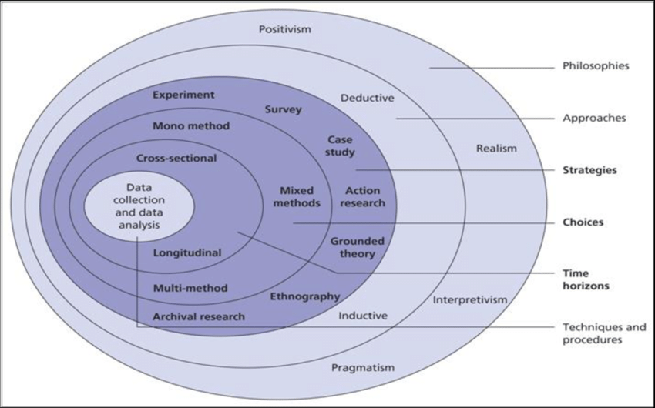Source: Saunders, Lewis and Thornhill (2009)

3.1.1 The Research Philosophy
The research philosophy, which lies at the heart of the research onion, has a significant influence on the overall course of the research effort. This section delves into the two major research philosophies, interpretivism and positivism, that serve as the foundation for the technique used in this study (Ma and Ma, 2022). Positivism, as a philosophical research framework, is based on the idea that the same techniques that have proven efficient in the scientific sciences can also be utilised to comprehend the intricacies of the social domain. Positivism prioritises objectivity, quantification, and the purposeful use of scientific findings at its foundation. The goal is to discover generalizable patterns and linkages in social processes. Deductive processes are preferred by positivist researchers who use painstakingly controlled and regulated data collection methodologies to rigorously examine hypotheses
For this research, we will use the positivistic approach. The use of a highly quantitative research approach demonstrates adherence to positivist ideas such as objectivity, quantification, and empirical rigour. By consciously combining positivist ideas into the research philosophy, we try to improve overall understanding of the selected research issue by capitalising on the various benefits of both philosophies while keeping consistent with the study's broader objectives.

3.1.2 The Research Approach
The second layer of the research onion, the research approach, provides the plan of the investigation. For our research, we will adopt a deductive research strategy. Deductive research is a method that begins with the formulation of a hypothesis or theory, which is then evaluated and refined through empirical observations and data analysis (Casula, Rangarajan and Shields, 2020). This method is systematic and logical, with researchers starting with a broad hypothesis and then reducing it down to specific discoveries that can be reviewed. This deductive reasoning approach is aligned with quantitative research, which collects and examines numerical data to draw conclusions. Deductive reasoning is well-suited to quantitative research methods due to its methodical nature. Quantitative studies employ a systematic and structured approach to data collection and analysis, which typically involves surveys, experiments, and statistics (Rahi, 2017). The deductive approach provides a clear framework for designing experiments and statistical tests to either support or refute the assumptions.
One distinctive feature of deductive research is its reliance on hypothesis testing. In quantitative research, hypotheses are developed based on existing ideas or prior knowledge and then rigorously verified with numerical data. The deductive approach facilitates the development of a logical and testable link between theory and empirical evidence. Furthermore, the deductive reasoning process contributes to the impartiality and generalizability that quantitative research demands. The organised approach promotes objectivity by providing a clear and logical framework for the research process. Furthermore, the methodical nature of deductive reasoning allows researchers to draw broad conclusions that may be applied to a larger population, boosting the generalizability of findings.
Quantitative research typically necessitates extensive statistical analysis, which the deductive approach enhances (Nardi, 2005). The structured and methodical nature of deductive reasoning enables the application of statistical tests to determine the significance of correlations between variables, which improves the quantitative research procedure.

3.1.3 Research Strategies
The research strategies layer is meant to specify the processes and tactics that will be used specifically for this investigation. This professional framework investigates three common research methodologies employed in scientific investigation: mixed methods research, quantitative research, and qualitative research (Bryman, 2017). Nonetheless, it is critical to stress that quantitative research is the primary focus of this investigation. The rigorous technique to gathering and interpreting numerical data that distinguishes quantitative research serves as the foundation for the chosen research plan. By utilising a variety of data collection tactics such as structured questionnaires, experiments, and surveys, this methodology enables for the quantification and subsequent statistical analysis of information. This technique is ideal for scientific research that seeks to find precise and quantitative patterns, linkages, and correlations among variables.
Structured surveys, an important component of quantitative research methodology, are designed to collect numerical data on critical criteria such as demographics, insurance choices, and other relevant variables (Rea and Parker, 1992). These surveys' data collection is driven by strict design criteria, ensuring that it corresponds to the study hypotheses. Sophisticated statistical processes are utilised to evaluate the quantitative data that has been collected. This enables the investigation of hypotheses as well as the identification of important relationships within the data. By adhering to rigorous statistical analysis, this dedication assures that the results of quantitative research are not only correct, but also based in strong statistical principles. Quantitative research methods prioritise objectivity and generalizability, guaranteeing that any conclusions reached about the research topic are built on verifiable facts. Within the quantitative model, this research strategy uses exclusively quantitative methodologies to conduct a full and detailed study of the defined research queries. By adhering to the concepts of accuracy and evidence-based conclusions, the entire technique adopted in this study improves its overall rigour and validity.

3.1.4 Time Horizon
The time horizon is another crucial component in research since it decides how long the investigation will endure. This investigation employs a cross-sectional temporal period. A cross-sectional time horizon is the collecting of data at a specific point in time or during a specific time period (Rindfleisch et al., 2008). It gives a quick rundown of the research variables and their correlations. Because it is consistent with our research objectives, a cross-sectional time frame is appropriate for this study. As a result, data will be collected throughout time via questionnaires, offering a snapshot of the participants' insurance decisions and the reasons that influenced them at the time.
Using a cross-sectional time perspective, the study issues can be explored in a targeted and efficient manner, with a special emphasis on the current state of insurance decision-making. The use of a cross-sectional time horizon is consistent with the study's objectives and questions, which do not necessitate the use of a longitudinal or historical technique. The study's purpose is to shed light on the current state of insurance selections within the designated demographic and to determine the current context in which these selections are influenced by demographic variables. As a result, the cross-sectional time horizon is the most effective tool for attaining these objectives on time and on budget.

3.1.5 Data Collection Techniques
To ensure a thorough grasp of the subject area, this investigation will employ a quantitative data collection methodology. The gathering of numerical data serves as the foundation for the gathering of quantitative data. Structured questionnaires are the primary method of quantitative data collection in this study. Surveys can collect data from a wide and diverse sample of participants in an efficient and effective manner. For this project, structured questionnaires will be used to obtain numerical data on demographic demographics, insurance choices, and other pertinent variables. The surveys will include closed-ended questions with pre-determined response alternatives, allowing participants' responses to be quantified. These surveys will be distributed using several channels, including in-person interactions and internet platforms, to provide widespread accessibility to the intended audience.
Through the application of the widely accepted and utilised method of random sampling (Singh and Mangat, 1996), this research ensures the production of an unbiased sample that accurately represents the entire population. Due to its inherent capacity to mitigate biases in participant selection, random sampling proves to be an exceptional approach in accomplishing our research goals. The primary aim of this study is to investigate the characteristics, attitudes, and behaviours of individuals across the United Kingdom, with the guarantee that no specific demographic or geographical group is inadvertently disadvantaged or favoured. Assuring that all eligible candidates are afforded an unbiased and fair chance to be included in the sample, random sampling establishes the foundation for an inquiry that accurately reflects the intrinsic diversity of the population.
The research methodology involves distributing a questionnaire to a representative sample of thirty to forty individuals from each of the constituent nations of the United Kingdom, namely Scotland, England, Northern Ireland, and Wales. The implementation of random sampling ensures a systematic reduction in the likelihood of sample skewness, thus providing a fair and impartial process for participant selection. Through the implementation of this approach, we generate a sample that exhibits a greater degree of similarity to the entire population, thus augmenting the credibility and practicality of our findings.
By utilising random sampling, one hopes to produce samples that possess not only statistical integrity but also external validity. Through offering an equal opportunity to all potential participants within the designated age bracket, our study aims to produce findings that can be more accurately generalised to the wider population of individuals aged 18-45 in the United Kingdom. The survey will be created with the help of Microsoft forms. This online survey will be then be distributed to our target population through emails and social media channels. The survey will be having questions that enquire about the respondent’s choice of insurance, how certain factors like gender and wealth influence it and how their choices change during their lives.
To illustrate the point, consider a hypothetical study examining the academic performance of children in a school. Through the implementation of random sampling, the researchers would ensure that every student, regardless of their academic standing, has an equitable opportunity of being chosen to participate in the study. This comparison underscores the reliability and practicality that random sampling provides in the participant selection process, thus facilitating the formulation of more accurate and impartial conclusions concerning academic performance.
In brief, the deliberate selection of random samples for inclusion in our research methodology is a strategic choice motivated by the imperative to obtain a sample that is both unbiased and representative. This section has provided a comprehensive understanding of the rationale and application of random sampling, laying the groundwork for a rigorous investigation into the diverse perspectives of individuals aged 18 to 45 across the United Kingdom.

3.1.6 Data Analysis Techniques
To acquire a complete understanding of the research issues, this study applies a quantitative method within the data analysis layer of the research onion. Quantitative data from structured surveys will be thoroughly examined to uncover patterns and establish correlations between variables. Bar charts and pie charts will be created using Microsoft Forms' data visualisation features to improve the clarity of data display. Using these visual representations, one can more clearly convey the distribution and interrelationships of numerous variables.
To fully understand the survey data, we will also employ statistical analysis (mean, median, mode) and variability (standard deviation, range) (Marshall and Jonker, 2010). For example, while examining participants' income levels, we will calculate the mean income to represent the central value and the standard deviation to demonstrate the dispersion or variability around the mean. Similarly, we will use hypothesis tests and confidence intervals to draw broader inferences or make predictions about the entire population based on the observed sample (Asadoorian and Kantarelis, 2005).

3.1.7 Hypothesis
For our research, we will implement the following hypothesis:
- H1: Age is correlated to the selection of insurance policies among individuals between the ages of 18 and 45 in the United Kingdom.
- H2: Gender is correlated to the selection of insurance policies among individuals between the ages of 18 and 45 in the United Kingdom.
- H3: Socioeconomic status is correlated to the selection of insurance policies among individuals between the ages of 18 and 45 in the United Kingdom.
- H4: Perceived health requirement is correlated to the selection of insurance policies among individuals between the ages of 18 and 45 in the United Kingdom.
- H5: Lifestyle is correlated to the selection of insurance policies among individuals between the ages of 18 and 45 in the United Kingdom.
- H6: Financial literacy is correlated to the selection of insurance policies among individuals between the ages of 18 and 45 in the United Kingdom.
The age hypothesis states that individuals in the UK between the ages of 18 and 45 make most of their insurance policy selections depending on their age. It suggests that as people age, their goals and life stages change, resulting in a shift in how they perceive risk and their financial responsibilities.
Similarly, the gender hypothesis claims that gender has a major impact on the insurance policies selected by British people between the ages of 18 and 45. It is hypothesised that gender-related differences in risk perception, financial decision-making, or life priorities have an impact on people's preferences for various types of insurance coverage.
Furthermore, the socioeconomic status hypothesis postulates that an individual's financial circumstances significantly influence the insurance coverage they choose within the specified age range. Socioeconomic factors such as work, income, and education are thought to play a significant role in influencing the kind of insurance coverage that an individual chooses.
Perceived health hypothesis implies that although those who are worried about their health might prioritise comprehensive coverage for serious illnesses or future medical bills, those who feel well might choose for health benefits or preventative therapy. This idea states that there is a positive relationship between an individual's perceived degree of health and the types of insurance coverage they wish to have.
Parallel to this, the lifestyle hypothesis asserts that choices made by individuals in their everyday lives have a significant impact on the insurance plans they select within a certain age range. It is expected that varying lifestyles would subject individuals to varying levels of risk, which will influence the types of insurance coverage deemed essential. others with more adventurous lifestyles may favour plans that cover extreme sports or travel, whereas others with more sedentary lifestyles might emphasise health or life insurance. This group has a wide range of lifestyle preferences.
Lastly, the financial literacy hypothesis suggests that British residents between the ages of 18 and 45 make different insurance policy choices based on how financially literate they are. It is thought that having a higher level of financial literacy is necessary in order to comprehend the complexity of insurance products, effectively assess one's needs, and make informed decisions.

3.2 Ethical Considerations
In compliance with university regulatory requirements, an ethical form serves as the essential undertaking in the research attempt. The current document describes the research objectives, data collection techniques, participant rights safeguards, and data management and storage standards. The study supervisor signs the ethics form after completing a thorough critical review, reiterating the researcher's commitment to keeping the highest ethical standards throughout the project.
Furthermore, all potential participants must grant clear informed permission to promote voluntary and well-informed participation. The authorization form explains the research's objectives, data gathering techniques, potential benefits, and any associated hazards in detail. This guarantees that participants are enthusiastic about participating in the study and have a clear comprehension of the research methodology.

Chapter 4: Data Analysis
The survey has received 48 responses. The data analysis for this will be done in sections. First, we will look at statistical analysis of demographic factors, such as age and gender.

4.1 Statistical Analysis
The demographic factors and their respective values are provided in the below table:
Profile | Categories | Frequency | %
Age | 18-24 | 15 | 33.33%
 | 25-34 | 22 | 48.89%
 | 35-45 | 11 | 24.44%
Gender | Male | 19 | 38.78%
 | Female | 18 | 36.73%
 | Non-binary | 4 | 8.16%
 | Prefer not to say | 6 | 12.24%
Socioeconomic Status | Low income | 12 | 24.49%
 | Middle income | 22 | 44.90%
 | High income | 4 | 8.16%
 | Prefer not to say | 3 | 6.12%

Now let’s calculate the mean, median and standard deviations for each of these profiles.

4.1.1 Age
For age,
Mean (μ) ≈ 29.25
Median = 29.5
Standard Deviation (σ) ≈ 6.98

4.1.2 Gender
As the gender data is not numerical, we will calculate the mode. The mode in this case will be the gender with the greatest number of respondents.
Gender | Frequency
Male | 19
Female | 18
Non-binary | 4
Prefer not to say | 6

As we can see from the table, Male has the highest number of entries. Hence, the mode is male.

4.1.3 Socioeconomic Status (SES)
As the data for the socioeconomic status is income, which is numerical, we can calculate the mean, median and standard deviation for the data.
Socioeconomic Status | Frequency
Low income | 12
Middle income | 22
High income | 4
Prefer not to say | 3

The values for SES are:
Mean (μ) ≈ 1.95
Median: Middle income
Standard Deviation (σ) ≈ 0.73

The following table summarises the data analysis for demographic factors:
Category | Age | Mode | Mean | Median | Standard Deviation
Age | 29.5 | NA | 29.25 | 29.5 | 6.98
Gender | NA | Male | NA | NA | NA
Socioeconomic Status | NA | NA | 1.95 | Middle income | 0.73

4.2 Hypothesis Testing

4.2.1 Hypothesis 1
Age is correlated to the selection of insurance policies among individuals between the ages of 18 and 45 in the United Kingdom.

To test this hypothesis, we have devised 3 questions.
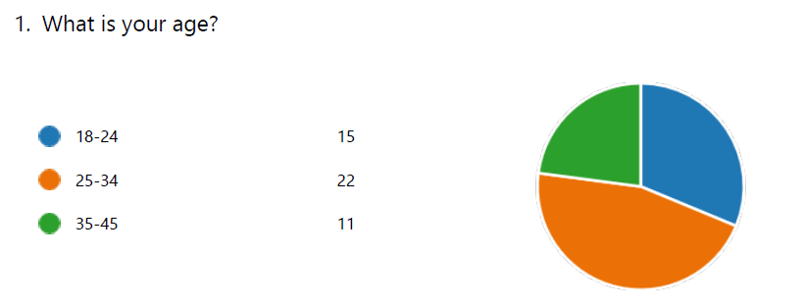
The survey gathered information from participants aged 18 to 45 residing in the United Kingdom, with the objective of examining the correlation between demographic variables and insurance policy selection. Three age categories were utilised to distribute the participants: 18-24, 25-34, and 35-45. Upon conducting an age distribution analysis, it was noted that a considerable proportion of the participants, consisting of 22 individuals, were between the ages of 25 and 34. Notable contributions were also made by those aged 18 to 24 with 15 participants. In contrast, the age cohort ranging from 35 to 45 years old was marginally underrepresented, comprising a mere 11 participants.
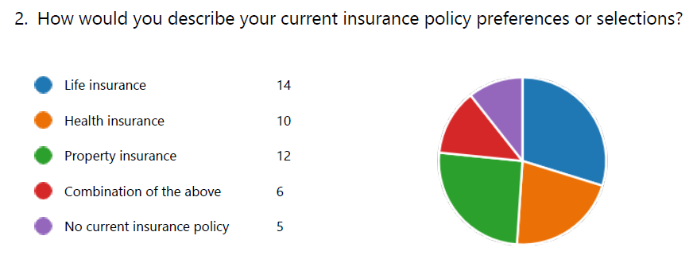
Life insurance was preferred by 22% of participants, or 14 people. This shows that participants recognise life insurance's long-term financial security and highlight the necessity of proactive financial preparation.
Health insurance was chosen by 16% of participants, indicating a growing awareness of the importance of physical and mental health. Ten people who took a proactive approach to health risks and healthcare costs showed this tendency.
Twelve people, or 19% of the total, preferred property insurance, highlighting the importance of protecting physical assets like homes and valuables. This alternative makes individuals feel accountable and ready for the capriciousness of events that may affect private belongings.
Six respondents, or 9%, preferred a mix of insurance types, suggesting an all-encompassing risk management approach. This subgroup recognises the complexity and diversity of financial stability issues and seeks to minimise them through diversified insurance coverage.
Five responders (7%), or 5%, did not have insurance. This little but substantial part raises questions about this decision's causes. It is required to perform more research to identify whether this subgroup lacks insurance coverage owing to financial constraints, a perceived lack of necessity, or other causes.
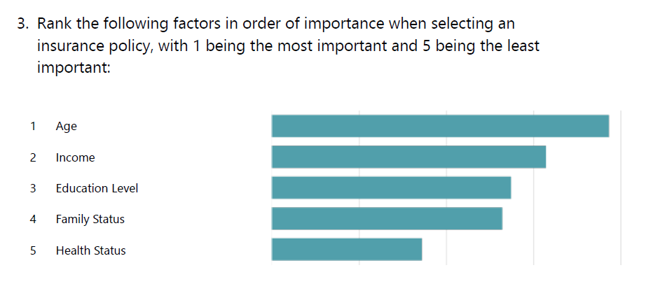
Age is the main factor in picking an insurance coverage. Young people prefer long-term coverage and planning programmes, for example. Age affects insurance coverage, showing a complex approach to life stages.
Income and decision-making are closely related. In addition to determining insurance premium affordability, income levels determine whether an individual can afford coverage expenses. The correlation between insurance coverage selection and income shows the need of financial stability in obtaining adequate insurance.
Education does affect an individual's decision-making abilities, but it's less important when choosing an insurance coverage. Education does influence decision-making, but it is less strongly linked to insurance coverage's specific needs and goals.
Family status is the fourth factor since family interactions affect insurance selections. Along with dependents and marital status, family-oriented factors might affect the type and quantity of coverage people choose.
Although crucial, health ranks fifth in importance. This feature is crucial for some types of insurance, but it's also important for many, especially health insurance. Health status is crucial, but it is often just one of several criteria that affect insurance policy choices.

Results
While health status remained of utmost importance, it was regarded as a fundamental factor intrinsic to numerous insurance categories, especially health insurance. The correlation between age and the choice of insurance policies is corroborated by a nuanced examination of trends in preferences related to age. This provides valuable insights into the intricate interaction of demographic variables in the process of making insurance decisions among the surveyed population.
In summary, the findings from the survey validate the proposed hypothesis by demonstrating a complex relationship between age and the choice of insurance policies among British citizens between the ages of 18 and 45. The inclusion of various age group preferences enhances the comprehension of the complex elements that impact insurance choices among this demographic, thereby underscoring the significance of customising insurance offerings to correspond with distinct life stages.

4.2.2 Hypothesis 2
Gender is correlated to the selection of insurance policies among individuals between the ages of 18 and 45 in the United Kingdom.
To test this hypothesis, we have devised 3 questions.
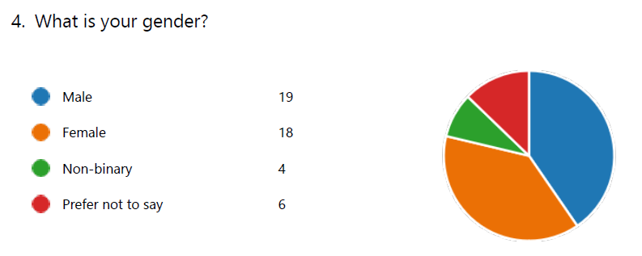
The survey data shows the gender makeup of UK participants aged 18–45. 19 men self-identified, a large percentage of the survey sample. This subgroup will shed light on the attitudes and preferences of guys in the population, revealing the factors that influence their insurance policy choices.
Additionally, 18 respondents identified as female, exhibiting equal representation to male respondents. This cohort's information will provide a complete understanding of women in the defined age bracket's insurance preferences. The investigation of gender-influenced insurance choices will be more complete if both men and women respond.
Four non-binary respondents completed the poll. Non-binary perspectives are needed to identify the variety of gender identities and understand how different experiences and variables affect insurance preferences. The population study is more broad and representative thanks to this group's responses.
Six respondents chose not to disclose their gender identify and safeguard their anonymity. Their contribution to understanding insurance policy selection trends is valuable even though they have not disclosed their gender identify. Observing privacy preferences emphasises the importance of ethical survey analysis.
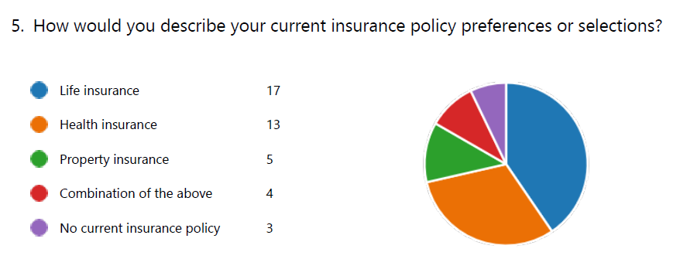
The survey data summarises UK respondents aged 18–45's insurance policy preferences. Life insurance was preferred by 16 respondents, demonstrating their importance of financial stability. The respondents' significant representation shows that they value comprehensive coverage beyond immediate needs and proactive financial planning.
Thirteen people preferred health insurance, indicating a higher awareness of health protection. This pattern emphasises a proactive approach to minimising health-related threats and medical cost-related economic constraints, prioritising complete health insurance.
Five respondents preferred property insurance to protect their homes and belongings. This group was underrepresented, but it shows that participants acknowledged the importance of preserving personal property and minimising property ownership hazards.
Four people preferred a mix of insurance types, suggesting a thorough risk management plan. This subgroup's preference for a diversified approach shows that they understand the complexity of financial stability concerns and are prepared to mitigate them with life, health, and possibly property insurance.
Three respondents lacked insurance. Despite its small size, more research is needed to understand this demographic's insurance decision-making, including financial constraints, a perceived lack of necessity, and other factors.
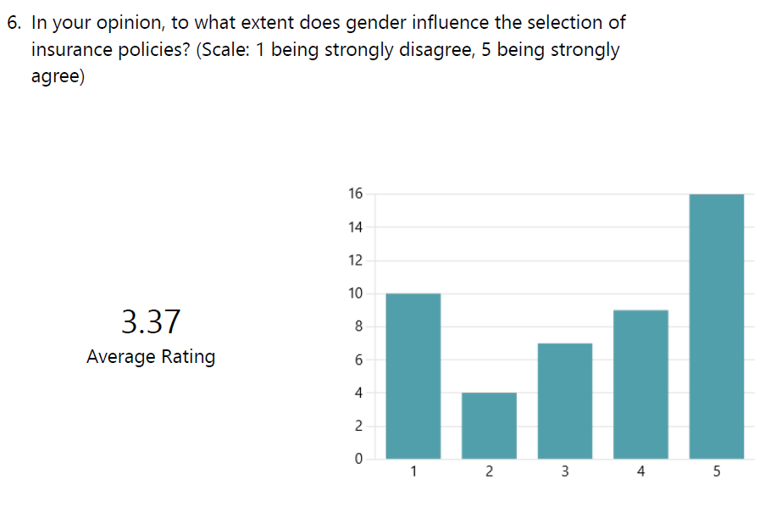
The influence was assessed using a five-point Likert scale, with one indicating "strongly disagree" and five representing "strongly agree." The responses reveal a range of viewpoints, with ten participants expressing significant disagreement (rated 1), implying that they consider gender to have little influence on insurance policy selection. Conversely, sixteen respondents expressed firm agreement (rated 5), suggesting that they hold the belief that gender plays a substantial role in shaping insurance preferences. The range of perspectives presented highlights the intricate nature of the correlation between gender and insurance selections among this particular group.
Nine respondents, representing the majority, awarded a rating of 4, which indicated a moderately strong agreement with the notion that gender does indeed influence insurance selections. Furthermore, seven participants offered a rating of three, signifying a comparatively impartial position regarding the impact of gender on preferences for insurance policies.
Upon computing the mean rating derived from every response, the compiled data presents a score of 3.37. The mean indicates that there is a moderate degree of consensus among participants regarding the fact that gender has a noticeable impact on the choice of insurance policies among individuals in this particular age bracket. On the contrary, the wide array of ratings underscores the importance of conducting nuanced analyses and conducting additional research in order to gain a more comprehensive understanding of the fundamental elements that influence these viewpoints.
Results
Upon conducting an examination of the survey data, valuable insights are gained regarding the hypothesis positing a correlation between gender and the choice of insurance policies among individuals aged 18 to 45 in the United Kingdom. The gender composition of the surveyed population comprises the following: nineteenth males, eighteen females, four non-binary individuals, and six respondents who declined to disclose their gender identity.
A closer examination of the preferences exhibited by male and female respondents with regard to particular categories of insurance policies reveals that they exhibit similarity in their choices. A total of seventeen respondents, regardless of gender, indicated a predilection for life insurance, underscoring a shared commitment to safeguarding and ensuring long-term financial stability. This implies that both sexes recognise the significance of coverage extending beyond imminent necessities, which signifies a progressive mindset towards financial strategizing that surpasses gender-based limitations.
In summary, although there are commonalities in the insurance preferences of male and female participants, the data do not provide conclusive support for the hypothesis that gender significantly influences the choice of insurance policies. The complexity of personal viewpoints and the wide array of ratings underscore the necessity for additional investigation and examination in order to gain a more comprehensive understanding of the fundamental elements that contribute to these attitudes among the designated age cohort in the United Kingdom.

4.2.3 Hypothesis 3
Socioeconomic status is correlated to the selection of insurance policies among individuals between the ages of 18 and 45 in the United Kingdom.
To test this hypothesis, we have created 2 questions.
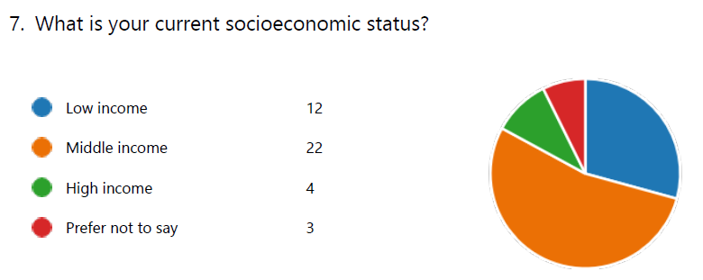
The survey results provide valuable information regarding the present socioeconomic standing of the participants, showcasing a wide range of financial experiences within this specific demographic. This study examined the viewpoints and decision-making procedures of twelve individuals who identified as having a low income, providing insight into the challenges faced by those with limited financial resources when selecting insurance policies. Gaining insight into the factors that influence this subgroup is crucial in order to conduct a thorough analysis of the insurance preferences of the larger population.
On the other hand, a considerable plurality of participants, amounting to 22 individuals, classified themselves as belonging to the middle income bracket. This enlarged representation provides a holistic understanding of the viewpoints and decisions made by individuals residing in the middle-income category. The insights obtained from this collective make a substantial contribution to the overall analysis by capturing the intricate elements that impact insurance choices among a larger proportion of the surveyed populace.
A subgroup of four respondents who disclosed a high income was both significant and discrete. The viewpoints of individuals possessing greater financial means offer significant contributions to our understanding of the preferences and deliberations of those who, in the process of choosing insurance policies, may enjoy greater flexibility and choice. Conducting an analysis of the responses obtained from this cohort contributes to a more comprehensive comprehension of the ways in which financial prosperity impacts insurance decisions among the designated age cohort.
A total of three respondents chose not to reveal their present socioeconomic status, underscoring the significance of honouring personal privacy preferences when filling out surveys. Although their precise socioeconomic standing is unknown, their collective contribution is still substantial in illuminating more extensive patterns in the preferences for insurance policies. By adopting this methodology, a comprehensive and ethical analysis of the surveyed populace is guaranteed, as the preferences of individuals concerning the divulgence of private data are recognised and honoured.
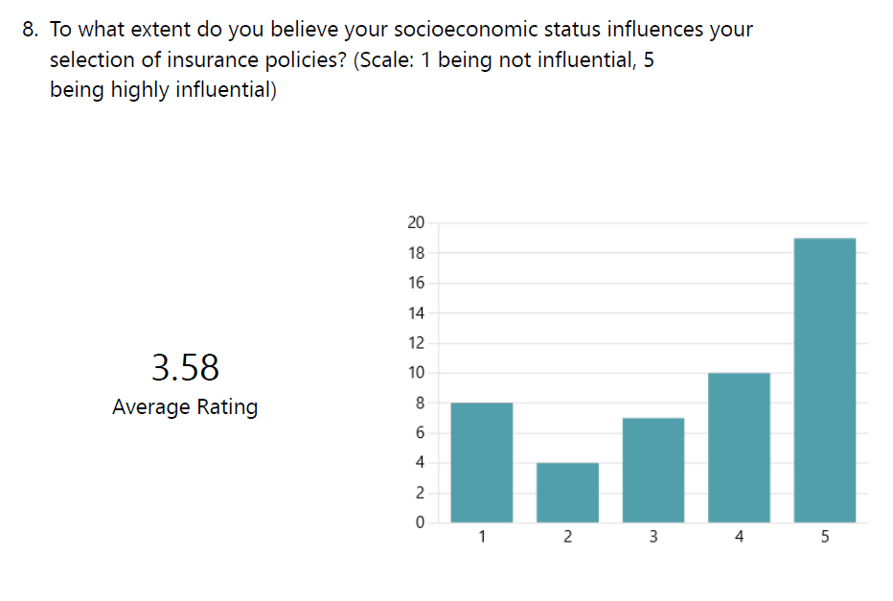
The participants were requested to assess the level of influence using a five-point scale, with five representing the most influential. The responses reveal a range of viewpoints, with 19 participants expressing firm agreement (rated 5), indicating that they consider socioeconomic status to have a substantial impact on insurance preferences. The significant proportion of the surveyed populace that recognises the influence of their financial situation on their insurance policy decisions is indicated by this figure.
Conversely, eight respondents express significant disagreement (rated 1), suggesting that socioeconomic status might be regarded as having a lesser impact on the insurance decisions of a subset of participants. The multitude of viewpoints highlights the intricate nature of the correlation between financial standing and insurance choices among this particular group.
A significant proportion of the participants' responses are situated in the intermediate range of the measure, as 10 individuals offered a rating of 4 and 7 participants provided a rating of 3. The aforementioned responses indicate a range of opinions from moderate to strong regarding the notion that socioeconomic status has a noticeable impact on the choice of insurance policies.
The mean rating obtained by summing all of the responses is 3.58. The calculated mean suggests that the majority of respondents concur that their socioeconomic status significantly impacts the insurance policies they select. The intricate diversity of viewpoints underscores the necessity for comprehensive examinations that reveal the fundamental elements that contribute to these perceptions and gain a deeper comprehension of the way in which financial status intersects with insurance preferences among this demographic in the United Kingdom.
Results
The survey data offers an exhaustive analysis of the hypothesis that there exists a correlation between the selection of insurance policies and socioeconomic status among individuals aged 18 to 45 in the United Kingdom. The sample population for this study comprises individuals who self-identify as having low income, moderate income, high income, or a subgroup that chooses not to disclose their financial status, thus constituting a socioeconomic status representation. In addition, the participants were requested to assess the degree to which socioeconomic status affected their insurance preferences, which unveiled a range of viewpoints. A consensus was reached among 19 respondents regarding the substantial impact of socioeconomic status on insurance preferences, as evidenced by their strong agreement.
The majority of participants situated themselves in the intermediate range of the measure, as ten individuals offered a rating of four and seven individuals provided a rating of three. The aforementioned responses indicate a range of opinions from moderate to strong regarding the notion that socioeconomic status has a noticeable impact on the choice of insurance policies. The intricate diversity of viewpoints underscores the necessity for comprehensive examinations that reveal the fundamental elements that contribute to these perceptions and gain a deeper comprehension of the way in which financial status intersects with insurance preferences among this demographic in the United Kingdom. The mean rating obtained by calculating the responses as a whole was 3.58. The calculated mean suggests that the majority of respondents concur that their socioeconomic status significantly impacts the insurance policies they select.

4.2.4 Hypothesis 4
Perceived health requirement is correlated to the selection of insurance policies among individuals between the ages of 18 and 45 in the United Kingdom.
To test this hypothesis, we have developed 2 questions.
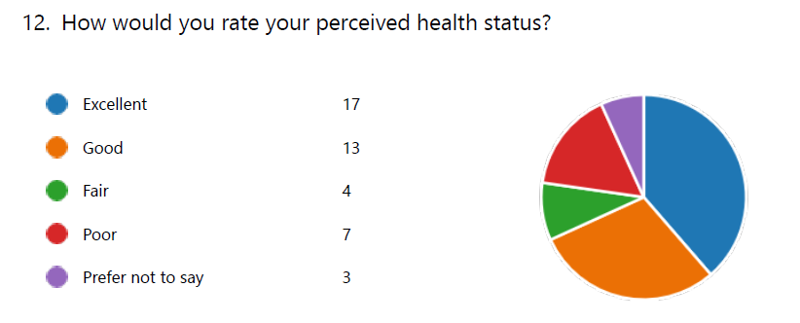
Significantly, seventeen participants expressed an outstanding rating for their health, signifying that a considerable proportion of the surveyed populace maintains a favourable self-evaluation of their general state of being. The insights provided by this group make a substantial contribution to the comprehension of the preferences and factors that influence the insurance policy decisions of individuals who perceive their health to be exceptional.
Concurrently, thirteen participants assessed their health status as favourable, constituting a considerable proportion of the surveyed population. The group's viewpoints offer significant insights into the decisions and deliberations of individuals who hold a positive perception of their health. These nuanced insights provide valuable information regarding the factors that may influence their insurance selections.
On the other hand, four participants indicated that their health was satisfactory, thereby offering a moderate self-evaluation. The viewpoints of this subgroup provide distinctive perspectives on the factors and considerations that individuals who have a more impartial attitude towards their health may prioritise when choosing insurance policies, potentially placing emphasis on coverage that specifically targets health-related issues.
A diminished self-perception of health was expressed by seven individuals in their "poor" ratings. It is imperative to comprehend the viewpoints of this collective in order to discern the distinct priorities and considerations of individuals who might encounter health issues or obstacles. The participants' answers enhance the collective comprehension of how individuals' desired insurance coverage may be influenced by their perceived health status in an effort to mitigate potential risks.
Additionally, three participants exercised their right to privacy by declining to reveal their perceived health status, thus indication their intention to withhold this personal information. Although the precise state of their health is not disclosed, their collective contribution is substantial in illuminating more extensive patterns in insurance policy preferences, safeguarding their privacy preferences, and guaranteeing an ethical methodology for survey analysis.
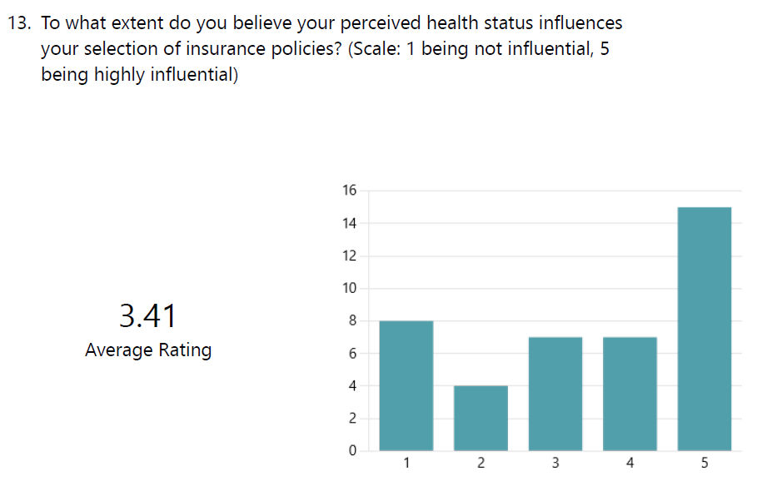
The responses reveal a wide array of viewpoints, with fifteen respondents expressing strong agreement (rated 5), indicating that they believe that perceived health status has a substantial impact on insurance preferences. This subgroup suggests that a significant proportion of the surveyed populace recognises the influence of their health condition on their insurance policy decisions, potentially underscoring the significance of health-specific coverage.
Conversely, eight participants expressed significant disagreement (rated 1). This suggests that a subset of the participants may consider perceived health status to have a lesser impact on their insurance choices. The multitude of viewpoints highlights the intricate nature of the correlation between the health status of this demographic and the choices they make regarding insurance.
The majority of participants' ratings fell within the intermediate range of the scale, as seven individuals contributed a rating of four and seven individuals contributed a rating of three. The aforementioned responses indicate a range of opinions from moderate to strong regarding the notion that perceived health status has a noticeable impact on insurance policy selection. This observation suggests that although heath status does play a role, it might not be the exclusive criterion for certain individuals when making insurance decisions.
The mean rating obtained by summing all of the responses is 3.41. The aforementioned mean signifies a moderate degree of consensus among respondents concerning the significant impact that their perceived health status has on their insurance policy selection. The diversity of viewpoints underscores the necessity for comprehensive examinations that reveal the fundamental elements that contribute to these perceptions and gain a deeper comprehension of the way in which health status and insurance preferences intersect among this age cohort in the United Kingdom.
Results
The survey data offers significant insights into the hypothesis that there exists a correlation between the selection of insurance policies and the perceived health status of individuals aged 18 to 45 in the United Kingdom. The responses obtained from the participants demonstrate a wide array of perspectives concerning their health. Specifically, seventeen individuals rated their health as excellent, while thirteen individuals described it as good. These results suggest that a considerable proportion of the surveyed population holds positive self-evaluations of their overall well-being. The insights of individuals who possess an exceptional perception of their own health significantly contribute to the comprehension of the preferences and factors that might impact their selection of insurance policies. In a similar vein, the perspectives of individuals who hold a positive perception of their health provide intricate details regarding the determinants that influence their insurance choices. This contributes to a holistic comprehension of how favourable health perceptions might influence the insurance preferences of this particular demographic.
In the rating responses, the variety of perspectives regarding the impact of perceived health status on insurance preferences is reflected. In contrast to the consensus among participants regarding the influence of perceived health status on insurance preferences, which was supported by 15 respondents who strongly concurred and 8 who strongly disagreed with this notion, the results indicate that participants held divergent views on the subject. A significant proportion of the participants surveyed occupied the intermediate position on the continuum, signifying a moderate to strong concurrence with the notion that perceived health status has a noticeable impact on insurance policy selection. The average rating of 3.41, which was calculated, provides additional evidence that participants recognise the impact of perceived health status on their insurance decisions, although their level of agreement varies.

4.2.5 Hypothesis 5
Lifestyle is correlated to the selection of insurance policies among individuals between the ages of 18 and 45 in the United Kingdom.

To test this hypothesis, we have developed 3 questions.
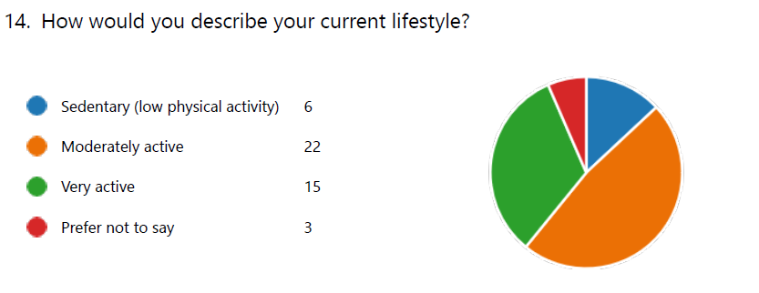
Sedentary lifestyles were reported by six individuals, implying diminished levels of physical activity. The perspectives of this subgroup provide significant contributions to our understanding of the preferences and considerations of individuals who may prioritise insurance policies on grounds other than physical activity, possibly placing greater emphasis on other facets of their health and overall well-being.
Conversely, a significant proportion of the participants, amounting to 22 individuals, characterised their present way of living as moderately strenuous. This noteworthy depiction provides intricate perspectives on the decisions and deliberations of people who engage in a moderate amount of physical activity on a daily basis. Gaining insight into the viewpoints of this cohort is critical in order to conduct a thorough analysis of the potential impact of lifestyle variables on the selection of insurance policies by the surveyed population.
A total of fifteen respondents indicated that they led extremely active lifestyles, which entailed strenuous physical activity. The group's viewpoints offer significant insights into the decisions and factors that influence individuals who lead more physically active lifestyles. The significance of insurance coverage that corresponds to the specific health requirements and factors that individuals with extremely active lifestyles muster may be particularly pronounced. Consequently, their perspectives are indispensable for comprehending the points where lifestyle and insurance preferences intersect.
The decision of three individuals to withhold information regarding their present way of life exemplifies their inclination towards privacy with regard to this facet of their personal data. Although the precise particulars of their daily lives are withheld, upholding their privacy preferences guarantees an ethical methodology towards survey analysis while simultaneously recognising their significant input into the wider patterns of insurance policy inclinations.
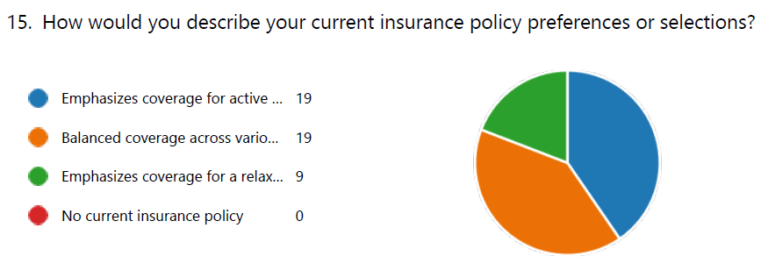
Significantly, the preference of nineteen individuals was for insurance policies that prioritise coverage specifically designed for individuals leading active lifestyles. The viewpoints expressed by this subgroup provide significant contributions to our understanding of the priorities and considerations of individuals who lead active and dynamic lives. The individual's preference for insurance coverage that corresponds to their particular health requirements and activities indicates a proactive stance in protecting against potential hazards linked to an active way of life.
Simultaneously, an equivalent proportion of participants, amounting to nineteen individuals in total, selected insurance policies that offer comprehensive coverage encompassing diverse facets of existence. The considerable amount of representation signifies a predilection for all-encompassing coverage that attends to a variety of requirements. The selections made by this cohort indicate a practical and comprehensive methodology towards making insurance decisions, in which members place importance on a comprehensive protection strategy that encompasses various aspects of their lives.
On the other hand, a preference for insurance policies that prioritise coverage for a laid-back lifestyle was expressed by nine individuals. The viewpoints of this subgroup provide valuable insights into the priorities and considerations of individuals who tend to favour media coverage that is more relaxed or focused on leisure activities. The inclinations of individuals provide insight into the potential impact of lifestyle decisions on the insurance coverage they pursue, placing particular emphasis on protection that is customised to their unique needs and speed of life.
It is noteworthy that none of the respondents indicated that they do not currently have an insurance policy in place. This finding implies that all participants have consciously chosen insurance coverage or communicated their preferences regarding it. The lack of uninsured individuals highlights the importance that surveyed demographics attribute to protecting themselves from potential dangers and uncertainties; this contributes to a more complete comprehension of the significance of insurance.
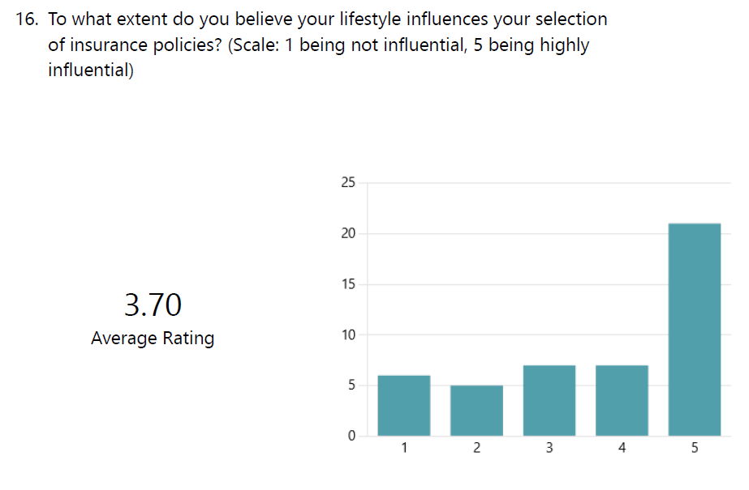
The responses reveal a spectrum of viewpoints; among the respondents, twenty-one expressed firm agreement (rated 5), indicating that they believe that lifestyle has a significant impact on insurance preferences. The fact that this majority represents the surveyed population suggests that a considerable segment of the populace is cognizant of the influence that their lifestyle decisions have on the insurance coverage they pursue; consequently, they may modify their selections to correspond with their particular activities and routines.
Conversely, six respondents expressed significant disagreement (rated 1). This suggests that a subset of the participants may consider lifestyle to have a lesser impact on the decisions they make regarding insurance. The multitude of perspectives highlights the intricate nature of the correlation between the way of life of this demographic and the choices they make regarding insurance.
The majority of participants positioned themselves in the upper echelon of the rating scale, as 21 individuals offered a rating of 5 and 7 individuals provided a rating of 4. The aforementioned responses indicate a range of opinions from moderate to strong regarding the notion that lifestyle has a substantial impact on the choice of insurance policies. This statement suggests that there is an understanding that certain risks and concerns that individuals wish to mitigate via insurance coverage are influenced by lifestyle choices.
The mean rating obtained by summing all of the responses is 3.70. The aforementioned mean indicates that the majority of respondents concur that their lifestyle significantly impacts their insurance policy selections. The complexity of these viewpoints underscores the necessity for comprehensive examinations that reveal the fundamental elements that contribute to these perceptions and gain a deeper comprehension of the way in which lifestyle influences insurance preferences among this demographic in the United Kingdom.
Results
The survey data offers deep understanding into the hypothesis that there is a correlation between lifestyle and insurance policy selection among British citizens aged 18 to 45. The lifestyles of the respondents comprise a wide range: six individuals self-identify as sedentary, 22 individuals characterise their way of life as moderately active, and 15 individuals assert that they lead an extremely active lifestyle. Furthermore, three respondents opted to withhold information regarding their present way of life, thereby underscoring the significance of confidentiality in survey materials. Sedentary individuals provide valuable insights regarding preferences and factors that extend beyond physical activity. The viewpoints of this subgroup enhance comprehension regarding the potential impact of lifestyle factors, excluding exercise, on the selection of insurance policies, so as to highlight alternative facets of their health and well-being.
Diverse viewpoints are evident in the rating responses regarding the impact of lifestyle on insurance preferences. The results of the survey revealed that although 21 respondents strongly concurred that lifestyle has a significant impact on insurance preferences, 6 respondents strongly disagreed. This suggests that participants held divergent views regarding the influence of lifestyle on insurance selections. The majority of participants exhibited ratings in the upper range of the scale, as 21 individuals contributed a rating of 5, and 7 participants contributed a rating of 4. The aforementioned responses indicate a range of opinions from moderate to strong regarding the notion that lifestyle has a substantial impact on the choice of insurance policies. This statement suggests an acknowledgment that certain risks and considerations are influenced by lifestyle choices, which individuals may wish to mitigate via insurance coverage.

4.2.6 Hypothesis 6
Financial literacy is correlated to the selection of insurance policies among individuals between the ages of 18 and 45 in the United Kingdom.
To test this hypothesis, we have developed 3 questions.
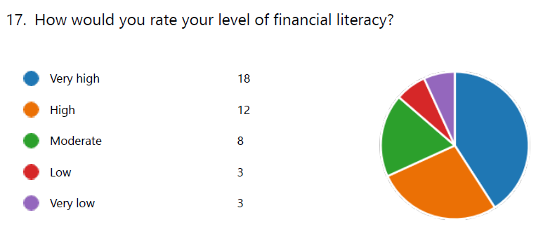
18 individuals provided a rating of "very high" for their financial literacy. This indicates that a considerable proportion of the surveyed populace possesses a solid comprehension and mastery of financial principles and procedures. The viewpoints expressed by this collective provide invaluable contributions to our understanding of the factors that influence the decisions and reasoning processes of individuals who adeptly and confidently navigate the financial terrain.
Concurrently, twelve participants assessed their level of financial literacy as high, signifying a comprehensive understanding of fundamental financial concepts and procedures. The opinions expressed by this collective offer significant insights regarding the decisions and factors that individuals who possess a certain level of financial confidence but still desire supplementary information before making specific choices do. This underscores their ongoing dedication to financial education.
Eight participants indicated that they possessed a moderate degree of financial literacy. The viewpoints of this subgroup provide a nuanced comprehension of the priorities and considerations of those who have a basic understanding of financial concepts but may pursue further education or advice when confronted with more intricate financial choices. An examination of the decisions made by this cohort illuminates the intricacies of financial decision-making within the framework of moderate financial literacy.
On the other hand, three of the participants expressed a low level of financial literacy, signifying a recognition of the necessity to enhance their comprehension of financial principles and procedures. It is imperative to comprehend the viewpoints of this cohort in order to discern possible obstacles and deficiencies in financial literacy among the surveyed population. This will provide valuable information regarding specific domains that could benefit from focused educational interventions.
In a similar vein, three additional participants disclosed possessing an exceptionally limited understanding of financial matters. The viewpoints of this subgroup enhance comprehension of the distinct obstacles and factors that individuals who may encounter substantial impediments to financial literacy must bear in mind. It is critical to investigate the decisions and inclinations of this demographic in order to develop financial education programmes that are both effective and inclusive, accommodating the varying degrees of literacy present in the surveyed populace.
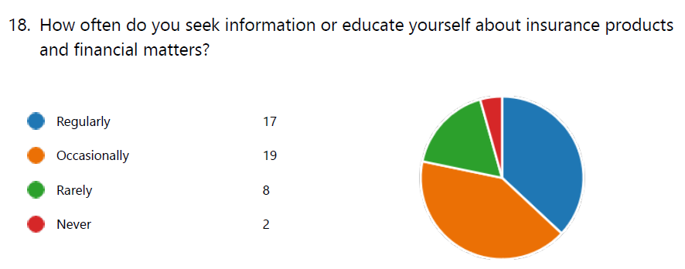
Seventeen individuals demonstrated a dedication to consistent inquiry and learning, signifying that they proactively pursue information. The proactive approach taken by this subgroup emphasises a diligent endeavour to remain informed, which demonstrates an understanding of the ever-changing insurance and financial environments and a commitment to making informed choices.
Simultaneously, a marginally larger cohort of nineteen individuals indicated that they engage in intermittent information-seeking or self-education regarding financial matters and insurance products. This considerable depiction implies a practical and flexible mindset, in which individuals acknowledge the significance of remaining well-informed but may modify their endeavours in accordance with particular requirements or situations. The perspectives provided by this group are invaluable in illuminating the delicate equilibrium that individuals must maintain when interacting with financial information.
On the contrary, eight participants indicated that they seldom engage in the pursuit of knowledge or pursue information pertaining to financial matters and insurance products. The viewpoints expressed by this collective offer valuable insights into the deliberations and priorities of individuals who may not have as much exposure to financial information. Gaining insight into the factors contributing to this sporadic participation can illuminate possible obstacles or challengers that may hinder the provision of consistent financial education to this subset of the surveyed populace.
Two respondents indicated that they never conduct research or acquire knowledge regarding financial matters and insurance products. Although constituting a lesser subgroup, it is vital to comprehend the viewpoints of this group in order to determine the causes of their total disinterest in financial education. This understanding can identify particular domains in which focused initiatives could be advantageous, thereby addressing possible obstacles to engagement in financial education endeavours.
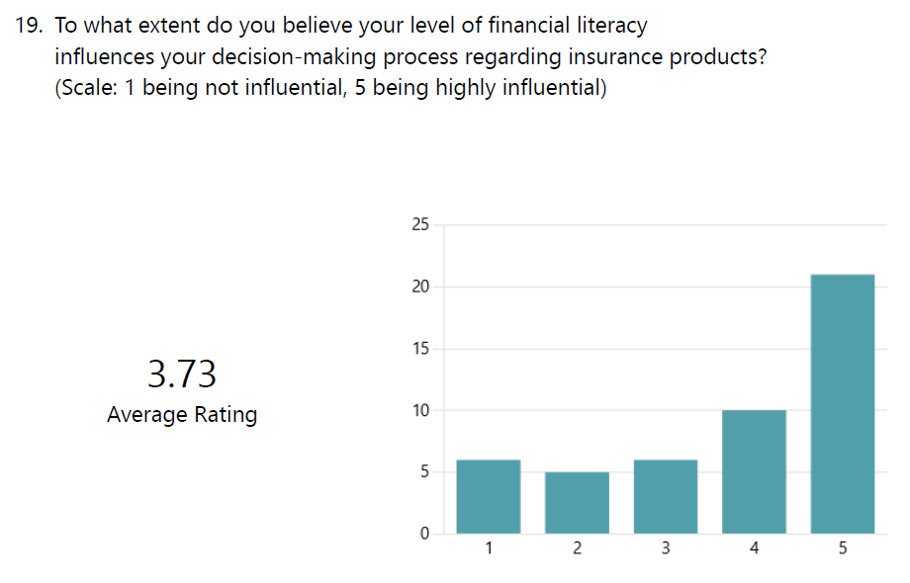
The responses reveal a spectrum of viewpoints; among the respondents, twenty-one expressed firm agreement (rated 5), indicating that they consider financial literacy to have a significant impact on their insurance product decision-making. The fact that a substantial proportion of the surveyed populace recognises the influence of their financial expertise on the decisions they undertake when choosing insurance coverage underscores the significance of financial literacy in facilitating well-informed choices.
Conversely, six respondents express significant disagreement (rated as 1), suggesting that financial literacy might be considered less influential in shaping the decision-making process of a subset of participants with regard to insurance products. The multitude of viewpoints highlights the intricate nature of the correlation between financial literacy and insurance choices among this particular group.
The majority of participants positioned themselves in the upper echelon of the rating scale, as 21 individuals offered a rating of 5 and 10 participants provided a rating of 4. The aforementioned responses indicate a range of opinions from moderate to strong in support of the notion that financial literacy significantly impacts the way in which individuals make decisions concerning insurance products. This could suggest an acknowledgment that a more comprehensive comprehension of financial principles aids in the formulation of more knowledgeable and strategic decisions regarding insurance coverage.
The mean rating obtained by summing all of the responses is 3.73. The aforementioned mean indicates that the majority of respondents concur that their level of financial literacy significantly impacts their approach to evaluating insurance products. The need for comprehensive analyses to identify the fundamental factors that contribute to these perceptions and to gain a deeper understanding of the relationship between financial literacy and insurance preferences among this age group in the UK is underscored by the nuanced range of opinions.
Results
The survey data offers deep understanding into the hypothesis that there exists a correlation between financial literacy and the choice of insurance policies among individuals in the United Kingdom who are between the ages of 18 and 45. The reported financial literacy levels of the respondents exhibit variation. Specifically, 18 individuals rated their financial literacy as extremely high, 12 as high, 8 as moderate, 3 as low, and 3 as very low. Furthermore, the respondents were queried regarding the regularity with which they pursue knowledge or conduct research on financial matters and insurance products. A substantial proportion of the surveyed populace consists of individuals who have attained an exceptionally high level of financial literacy, denoting their comprehensive grasp of fundamental financial principles. The viewpoints of these individuals provide vital insights into the deliberations and decision-making procedures of those who adeptly and confidently navigate the financial terrain; these perspectives may therefore impact the selection of insurance policies.
Distinct patterns emerge from the participants' responses with regard to the frequency at which they pursue information or education concerning insurance products and financial matters. A proactive approach to remaining informed is demonstrated by seventeen individuals who share a commitment to regular exploration and education. The endeavours of this subgroup demonstrate a diligent acknowledgment of the ever-changing insurance and financial environments, as well as a commitment to making informed choices.A marginally larger cohort of nineteen individuals indicates sporadic pursuits of knowledge or instruction, implying a practical and flexible mindset. This considerable representation suggests that while individuals acknowledge the significance of remaining informed, they may customise their endeavours in accordance with particular requirements or situations. On the other hand, eight of the respondents indicate infrequent interaction with financial information, which offers valuable insights into the priorities and considerations of those who may not engage with such data as often. Gaining insight into the factors contributing to this sporadic participation can illuminate possible obstacles or challengers that may hinder the provision of consistent financial education to this subset of the surveyed populace.

Chapter 5: Findings and Observations
Hypothesis 1: Age is Correlated to the Selection of Insurance Choices
The correlation between age and insurance policies among individuals aged 18 to 45 in the United Kingdom is confirmed by the survey results. Although health status is fundamental, it has become an essential factor to consider in numerous insurance categories, particularly health insurance. An in-depth examination of age-related preferences offers significant insights into the intricate dynamics between demographic variables and the process of making insurance decisions among the surveyed population. The variation in preferences observed among various age cohorts highlights the criticality of customising insurance provisions to correspond with distinct phases of life. The aforementioned exhaustive comprehension of the impact of age on insurance selections underscores the imperative for insurance providers to take into account the distinct requirements and preferences of individuals throughout various stages of their lives.
The findings of our survey also match with studies in our literature review. Cantiello et al. (2015) and Becker and Zweifel (2008) demonstrate a clear trend in the insurance preferences of various age cohorts through their exhaustive research. Cost-effectiveness is frequently favoured over exhaustive coverage by younger individuals, who are motivated by financial incentives and a perception of being impervious to risks. As people progress in age and experience significant life events such as marriage and parenthood, their insurance preferences tend to gravitate towards more comprehensive coverage.
Hypothesis 2: Gender is Correlated to the Selection of Insurance Choices
Although there are common patterns in the insurance preferences of male and female participants, the data do not provide conclusive support for the hypothesis that there is a significant correlation between gender and the choice of insurance policies. The choices of both genders, as evidenced by the eighteen female and nineteen male respondents, exhibited similarities, most notably a shared inclination towards life insurance, which signifies a mutual concern for enduring financial stability. The survey population's diversity is further underscored by the inclusion of non-binary respondents and individuals who opt not to disclose their gender identity. The complexity of personal viewpoints and the wide array of ratings underscore the necessity for additional investigation in order to comprehend the fundamental elements that contribute to these attitudes among the designated age cohort in the United Kingdom.
Although the correlation between gender and health insurance preferences is underscored in the literature review, however, based on the survey data, there is insufficient evidence to definitively establish a correlation between gender and the selection of insurance policies among the specified age group in the United Kingdom. Lim et al. (2019) conducted an extensive investigation that highlights gender-specific trends in healthcare-seeking behaviour and females' predilection for comprehensive health insurance coverage. Nevertheless, the findings of the survey unveil parallels in the insurance preferences of the male and female participants, specifically a common predilection for life insurance, which suggests a shared apprehension regarding long-term financial security.
Hypothesis 3: Socioeconomic Status is Correlated to the Selection of Insurance Choices
The survey responses offer a thorough analysis of the hypothesis positing a correlation between the choice of insurance policies and socioeconomic status. The nuanced picture is reflected in the socioeconomic diversity of the participants, which includes individuals of varying income levels (low, middle, and high) as well as those who opt not to disclose their financial status. The rating responses demonstrate a wide range of viewpoints, among which a considerable proportion recognises the influence of socioeconomic status on insurance preferences. Nonetheless, the discord among participants—certain individuals vehemently disagreeing—illustrates the nature of the correlation between one's financial situation and the choices made regarding insurance. The moderate consensus among all respondents indicates that although socioeconomic status does appear to be a determinant of these perceptions among this age group in the United Kingdom, further investigations are required to identify the underlying factors at play.
However, a strong correlation exists between socioeconomic status and insurance preferences, with those in higher socioeconomic strata desiring more comprehensive coverage, in our literature review. According to Preker et al. (2007), individuals who possess more substantial financial means are more likely to choose insurance policies that offer comprehensive coverage. This preference stems from their capacity to pay higher premiums and their inclination to prioritise risk mitigation. The survey responses provide a comprehensive examination of this hypothesis, showcasing a cohort of participants from disparate socioeconomic backgrounds who possess a range of income levels and opt not to reveal their financial circumstances.
Hypothesis 4: Perceived Health Status is Correlated to the Selection of Insurance Choices
The survey data offers significant insights regarding the hypothesis positing a correlation between the selection of insurance policies and the perception of one's health status. The multitude of health perceptions, which encompass excellent, good, average, and poor, is indicative of the intricate nature of the variables that impact insurance decisions. The insights of individuals in excellent or good health substantially contribute to the comprehension of the factors that influence their decision-making, underscoring the criticality of customised coverage predicated on health considerations. On the other hand, the perspectives of individuals who are in fair or poor health provide illumination regarding particular health-related issues that impact the coverage choices that individuals make. The wide range of rating responses (from strong agreement to strong disagreement) emphasises the diverse perspectives held by the participants concerning the influence of health status on insurance choices. The mean rating that was computed provides evidence that participants, albeit to varying degrees, recognise the impact of perceived health status on their insurance decisions.
Like our literature review, the survey data provides robust evidence in favour of the proposition that the insurance decisions of individuals are substantially impacted by their perceived health status. The theoretical frameworks of adverse selection and moral hazard, which have been explained in our literature review, with references to the research of Rothschild and Stiglitz (1976) and Arrow (2001), provide similalr observations. These frameworks emphasise how individuals who perceive higher health risks may proactively pursue insurance coverage, thereby introducing intricacies into the insurance system. The survey also aligns with the research conducted by Cutler and Zeckhauser (2004) on the manner in which individuals who hold more optimistic perceptions of health risks are more inclined to pay higher premiums.
Hypothesis 5: Lifestyle is Correlated to the Selection of Insurance Choices
The survey data offers extensive insights into the hypothesis positing a correlation between lifestyle choices and insurance policy selection. The diversity of lifestyles—sedentary, moderately active, and extremely active—along with preferences for lifestyle-specific coverage—illustrates the impact that personal decisions have on insurance selection. The lack of respondents lacking insurance policies highlights the importance that individuals attribute to protecting themselves from potential dangers, thus emphasising the significance of insurance within the demographic that was surveyed. The rating responses reveal a spectrum of viewpoints, although the vast majority of respondents strongly concur that lifestyle has a significant impact on insurance preferences. This acknowledgment implies that lifestyle choices are associated with particular hazards and factors that individuals seek to mitigate via insurance.
The survey results provide additional evidence for the connection between insurance policy selection and lifestyle decisions, building upon the theoretical frameworks of risk pooling and risk segmentation proposed by Chiappori and Salanié (2000) and Pauly (1974), respectively, which were discussed in the literature review. It highlights the possibility of risk profiles being similar among persons who have similar lifestyles, which could influence how insurance companies create policies and pricing tactics. In addition, it was similar to what Cohen-Mansfield and Parpura-Gill (2006) suggested, about lifestyle change programmes which might be used as treatments to reduce risk and positively impact insurance dynamics.

Hypothesis 6: Financial Literacy is Correlated to the Selection of Insurance Choices
The survey data offers extensive insights regarding the hypothesis positing a correlation between financial literacy and insurance policy selection. The diverse range of financial literacy skills exhibited by the participants, in addition to their perspectives on how they interact with financial information, underscore the complex and multifaceted aspect of financial decision-making. Individuals who possess an exceptionally high level of financial literacy offer invaluable perspectives on the deliberations and choices of those who confidently navigate the financial terrain. Individuals who demonstrate a proactive stance by engaging in consistent education and exploration highlight the awareness of the ever-changing insurance and financial environments. The rating responses exhibit a diversity of viewpoints, although the majority of respondents strongly concur that financial literacy has a significant impact on their insurance product decision-making. This implies an acknowledgment that a more comprehensive comprehension of financial principles aids in the formulation of more knowledgeable and strategic decisions regarding insurance coverage. The computed mean rating provides evidence that, on the whole, respondents hold the belief that their level of financial literacy significantly impacts their decision-making with respect to insurance products.
In our literature review we discussed the study conducted by Lusardi and Mitchell (2014), which emphasised the crucial importance of financial literacy. It highlighted that individuals who possess a greater level of financial knowledge are more likely to accurately understand insurance policies, make informed decisions, and effectively navigate the complexities of the insurance market. Our survey has also highlighted the differences in financial literacy that exist based on age, income, and education. It emphasises the need for actions to address these inequalities and guarantee that everyone has fair access to the benefits that come with financial literacy.

Chapter 6: Recommendations
From our data analysis, we have found 6 recommendations that can be implemented by insurance companies:
- Age-Related Tailoring: In light of the intricate relationship between age and insurance preferences, it is advisable for insurance providers to implement policies that are tailored to specific age groups. By acknowledging the fact that distinct life phases are accompanied by distinct priorities and requirements, insurance providers in the United Kingdom can tailor their offerings to appeal to the preferences of those between the ages of 18 and 45.
- Policy Development Incorporating Gender Considerations: Although there are common patterns in insurance preferences between the sexes, the results of the survey emphasise the importance of formulating policies that are inclusive of all genders. Insurance providers ought to recognise the wide range of gender identities and customise policies accordingly in order to cater to the distinct requirements of every individual, regardless of gender.
- Social Indebtedness: In light of the intricate correlation between socioeconomic standing and insurance choices, purveyors of insurance should demonstrate sensitivity towards individuals from various financial backgrounds. It is essential to develop a variety of policies that address the distinct requirements of individuals with low, moderate, and high incomes.
- Implementation of Health-Focused Customisation: In light of the robust association between individuals' perceptions of their health status and their insurance preferences, service providers ought to contemplate the provision of customisation options that prioritise health. By customising coverage to cater to the distinct health requirements and apprehensions of individuals categorised as having excellent, good, middling, or poor health, insurance products can be rendered more pertinent and appealing.
- Coverage Centred on Lifestyle: As a result of the considerable impact that lifestyle has on insurance preferences, service providers ought to design coverage options with a focus on lifestyle. Developing policies that accommodate sedentary, moderately active, and very active lifestyles, in addition to those that prioritise a relaxed or leisurely way of life, can accommodate the varied preferences of individuals.
- Financial Literacy Initiatives: The promotion of financial literacy initiatives should be a priority for insurance providers, considering the significant influence that financial literacy has on the process of making insurance decisions. Designing programmes that augment individuals' financial knowledge can be facilitated through collaboration with financial literacy organisations or educational institutions.

Chapter 7: Conclusion
This final chapter summarises the principal discoveries and understandings derived from the extensive survey undertaken among participants aged 18 to 45 in the United Kingdom with respect to their inclinations and selections in insurance policies. By investigating six distinct hypotheses, complex patterns in insurance decision-making have been uncovered, providing insight into the intricate interaction between demographic variables, lifestyle preferences, and financial literacy.

7.1 Summary of Results
The purchasing decisions of individuals between the ages of 18 and 45 in the United Kingdom are notably impacted by age, particularly in the context of health insurance. The necessity of customising insurance offerings to correspond with distinct life phases is emphasised by the varying preferences that exist among age groups. Conversely, although there are commonalities in the patterns observed among male and female participants, the available data does not provide definitive evidence to support the notion that gender significantly influences the choice of insurance policies. A collective preference for life insurance and other similar decisions indicate a shared concern for long-term financial security. The inclusion of non-binary respondents serves to underscore the inclusiveness and diversity of the population under study.
Additionally, a variety of perspectives support the hypothesis that socioeconomic status influences insurance selection. Although a considerable proportion of respondents recognise the influence of socioeconomic status on personal preferences, the divergence of opinion underscores the intricate nature of the correlation between financial standing and insurance choices. Similarly, insurance decisions are substantially impacted by perceived health status; when individuals rate their health as exceptional or good, it underscores the importance of customised coverage that takes into account health-related factors. The diverse range of responses highlights the intricate influence that health perceptions have on individuals' insurance preferences.
Lifestyle inclinations are a significant determinant in the insurance decisions made by individuals aged 18 to 45 who were surveyed. An assortment of behaviours, spanning from inactive to extremely vigorous, underscore the impact that personal decisions have on insurance selection. The lack of respondents who do not possess insurance policies underscores the importance that people attribute to protecting themselves from potential dangers. Furthermore, it is crucial to acknowledge that insurance decisions are significantly impacted by financial literacy, as individuals exhibit diverse degrees of financial expertise. Individuals who possess a strong grasp of financial concepts underscore the critical impact that possessing such knowledge has on making well-informed decisions regarding insurance coverage. Individuals who demonstrate a proactive stance by engaging in consistent education and exploration highlight the awareness of the ever-changing insurance and financial environments.

7.2 Limitations of the Research
The correlation between age and insurance policy selection underscores the significance of customising insurance offerings to correspond with distinct phases of life. Subsequent investigations may explore the ways in which age-related variables, such as significant life occurrences or evolving risk perceptions, impact the long-term insurance preferences of individuals. Upon analysing the impact of gender on insurance preferences, it becomes apparent that although there are commonalities in trends, gender does not definitively determine which options are selected. Subsequent investigations may delve into the ways in which gender-specific risk perceptions, societal expectations, and life experiences influence the observed similarities and distinctions in insurance preferences among males, females, and non-binary individuals.
The correlation between insurance selection and socioeconomic status implies a complex interaction, wherein perspectives on the influence of financial standing differ. Further research may be warranted to examine the unique influence that particular aspects of socioeconomic status, such as level of education or employment stability, have on the insurance choices made by individuals in this particular demographic. The correlation between insurance policies and perceived health status highlights the significance of customised coverage in light of health-related factors. Further investigation could be directed towards the precise health-related considerations that impact decision-making, thereby enhancing our comprehension of the ways in which individuals with varying health perceptions rank insurance coverage.
The results pertaining to the relationship between lifestyle and insurance preferences demonstrate a significant effect, particularly among individuals who lead an active or leisurely way of life. Further research may be warranted to investigate the impact of cultural changes on the demand for specific categories of coverage, technological integrations in insurance tailored to particular lifestyles, and emerging lifestyle trends. By establishing a correlation between insurance choices and financial literacy, subsequent investigations may centre on evaluating the efficacy of various financial literacy programmes. An examination of the responses of individuals with diverse degrees of financial literacy to various instructional methodologies can provide valuable insights for the enhancement of financial literacy programmes.

7.3 Conclusion
In conlusion, this dissertation offers an exhaustive examination of the determinants that impact the choice of insurance policies by individuals in the United Kingdom between the ages of 18 and 45. By investigating six hypotheses—lifestyle, financial literacy, age, gender, socioeconomic status, and perceived health status—vital information has been obtained that illuminates the complex dynamics of insurance decision-making among this demographic. The study validates the notion that age is a critical factor in influencing insurance preferences, underscoring the need for customised products and services that correspond to the various phases of an individual's life. Although there are commonalities in trends, there is no definitive correlation between gender and unique insurance preferences; this underscores the need to take individual preferences into account beyond the confines of gender. Divergent opinions exist regarding the extent of the relationship between socioeconomic status and insurance selection, indicating the need for additional research into particular aspects of financial standing.

References
Adebayo, E.F. et al. (2015) 'A systematic review of factors that affect uptake of community-based health insurance in low-income and middle-income countries,' BMC Health Services Research, 15(1). https://doi.org/10.1186/s12913-015-1179-3.
Adepoju, O.E., Mask, A. and McLeod, A. (2019) 'Factors associated with health insurance literacy,' Journal of Healthcare Management, 64(2), pp. 79–89. https://doi.org/10.1097/jhm-d-18-00021.
Albert, A. and Modigliani, F. (1963) 'THE LIFE CYCLE HYPOTHESIS OF SAVING: AGGREGATE IMPLICATIONS AND TESTS,' The American Economic Review, 53(1), pp. 55–84. https://www.sid.ir/en/journal/ViewPaper.aspx?ID=279735.
Altbach, P.G. (2004) 'Globalisation and the university: Myths and realities in an unequal world,' Tertiary Education and Management, 10(1), pp. 3–25. https://doi.org/10.1080/13583883.2004.9967114.
Arrow, K.J. (2001) 'Uncertainty and The Welfare Economics of Medical Care,' American Economic Association, 26(5), pp. 851–883. https://doi.org/10.1215/03616878-26-5-851.
Asadoorian, M.O. and Kantarelis, D. (2005) Essentials of inferential statistics. https://spiral.lynn.edu/facbooks/6/.
Bauhoff, S., Carman, K.G. and Wuppermann, A. (2013) Financial Literacy and Consumer Choice of Health Insurance: Evidence from Low-Income Populations in the United States, RAND Corporation eBooks. https://doi.org/10.7249/wr1013.
Becker, K. and Zweifel, P. (2008) 'Age and Choice in Health Insurance,' The Patient: Patient-Centered Outcomes Research, 1(1), pp. 27–40. https://doi.org/10.2165/01312067-200801010-00006.
Berge, T.J. and Jordà, Ò. (2011) 'Evaluating the Classification of Economic Activity into Recessions and Expansions,' American Economic Journal: Macroeconomics, 3(2), pp. 246–277. https://doi.org/10.1257/mac.3.2.246.
Bertrand, M., Kamenica, E. and Pan, J. (2015) 'Gender Identity and Relative Income within Households *,' The Quarterly Journal of Economics, 130(2), pp. 571–614. https://doi.org/10.1093/qje/qjv001.
Bhargavan, M. (2002) The effect of employer-provided health insurance on labor market participation.
Borghans, L. et al. (2009) 'Gender differences in risk aversion and ambiguity aversion,' Journal of the European Economic Association, 7(2–3), pp. 649–658. https://doi.org/10.1162/jeea.2009.7.2-3.649.
Bowden, J. and Marton, F. (2004) The University of Learning. Psychology Press.
Braunstein, S.F. and Welch, C. (2002) 'Financial Literacy: An Overview of practice, research, and policy,' Federal Reserve Bulletin, 88(11), p. 0. https://doi.org/10.17016/bulletin.2002.88-11.
Browne, M.J. and Kim, K. (1993) 'An International analysis of life insurance demand,' Journal of Risk and Insurance, 60(4), p. 616. https://doi.org/10.2307/253382.
Bryman, A. (2017) 'Quantitative and qualitative research: further reflections on their integration,' in Routledge eBooks, pp. 57–78. https://doi.org/10.4324/9781315248813-3.
Bundorf, M.K., Levin, J. and Mahoney, N. (2012) 'Pricing and welfare in health plan choice,' The American Economic Review, 102(7), pp. 3214–3248. https://doi.org/10.1257/aer.102.7.3214.
Burroughs, W.J. (2008) 'Climate change: a multidisciplinary approach,' Choice Reviews Online, 45(10), pp. 45–5591. https://doi.org/10.5860/choice.45-5591.
Cantiello, J. et al. (2015) 'The impact of demographic and perceptual variables on a young adult’s decision to be covered by private health insurance,' BMC Health Services Research, 15(1). https://doi.org/10.1186/s12913-015-0848-6.
Caratelli, M. and Ricci, O. (2011) 'The Relationship between Everyday Practices and Financial Literacy: An Empirical Analysis,' Social Science Research Network [Preprint]. https://doi.org/10.2139/ssrn.2016068.
Casula, M., Rangarajan, N. and Shields, P.M. (2020) 'The potential of working hypotheses for deductive exploratory research,' Quality & Quantity, 55(5), pp. 1703–1725. https://doi.org/10.1007/s11135-020-01072-9.
Chiappori, P. and Salanié, B. (2000) 'Testing for asymmetric information in insurance markets,' Journal of Political Economy, 108(1), pp. 56–78. https://doi.org/10.1086/262111.
Coale, A.J. and Levy, M.J. (1965) Aspects of the analysis of family structure. Princeton, N.J.: Princeton University Press.
Cohen, A. and Einav, L. (2007) 'Estimating Risk Preferences from Deductible Choice,' The American Economic Review, 97(3), pp. 745–788. https://doi.org/10.1257/aer.97.3.745.
Cohen‐Mansfield, J. and Parpura-Gill, A. (2006) 'Loneliness in older persons: a theoretical model and empirical findings,' International Psychogeriatrics, 19(02), p. 279. https://doi.org/10.1017/s1041610206004200.
Conger, R.D. and Donnellan, M.B. (2007) 'An interactionist perspective on the socioeconomic context of human development,' Annual Review of Psychology, 58(1), pp. 175–199. https://doi.org/10.1146/annurev.psych.58.110405.085551.
Costouros, T. (2017) 'Gender and ethical decision-making in the general insurance industry,' Journal of Behavioral Studies in Business [Preprint]. https://roam.macewan.ca/islandora/object/gm:1458.
Cribb, J. and Emmerson, C. (2016) What happens when employers are obliged to nudge? Automatic enrolment and pension saving in the UK. https://doi.org/10.1920/wp.ifs.2016.1619.
Cummins, J.D. and Doherty, N.A. (2006) 'The Economics of insurance Intermediaries,' Journal of Risk and Insurance, 73(3), pp. 359–396. https://doi.org/10.1111/j.1539-6975.2006.00180.x.
Cutler, D.M. and Zeckhauser, R. (2004) 'Extending the theory to meet the practice of insurance,' Brookings-Wharton Papers on Financial Services, 2004(1), pp. 1–53. https://doi.org/10.1353/pfs.2004.0002.
Dylko, I.B. and McCluskey, M. (2012) 'Media effects in an era of rapid technological transformation: a case of User-Generated Content and Political participation,' Communication Theory, 22(3), pp. 250–278. https://doi.org/10.1111/j.1468-2885.2012.01409.x.
Einav, L. and Finkelstein, A. (2011) 'Selection in Insurance Markets: Theory and Empirics in Pictures,' Journal of Economic Perspectives, 25(1), pp. 115–138. https://doi.org/10.1257/jep.25.1.115.
Farrell, M. et al. (2019) 'Wearables and the internet of things: considerations for the life and health insurance industry,' British Actuarial Journal, 24. https://doi.org/10.1017/s1357321719000072.
Feinstein, J.S. (1993) 'The Relationship between Socioeconomic Status and Health: A Review of the Literature,' The Milbank Quarterly, 71(2), p. 279. https://doi.org/10.2307/3350401.
Feinstein, J.S. (1993) 'The Relationship between Socioeconomic Status and Health: A Review of the Literature,' The Milbank Quarterly, 71(2), p. 279. https://doi.org/10.2307/3350401.
Fernandes, D., Lynch, J. and Netemeyer, R.G. (2014) 'Financial literacy, financial education, and downstream financial behaviors,' Management Science, 60(8), pp. 1861–1883. https://doi.org/10.1287/mnsc.2013.1849.
Finkelstein, A. and McGarry, K. (2006) 'Multiple Dimensions of Private Information: Evidence from the Long-Term Care Insurance Market,' The American Economic Review, 96(4), pp. 938–958. https://doi.org/10.1257/aer.96.4.938.
Frederiks, E.R., Stenner, K. and Hobman, E.V. (2015) 'Household energy use: Applying behavioural economics to understand consumer decision-making and behaviour,' Renewable & Sustainable Energy Reviews, 41, pp. 1385–1394. https://doi.org/10.1016/j.rser.2014.09.026.
Froot, K. (2009) On the Pricing of Intermediated Risks: Theory and Application to Catastrophe Reinsurance.
Grinin, L., Tausch, A. and Korotayev, A. (2016) Economic cycles, crises, and the global periphery, Springer eBooks. https://doi.org/10.1007/978-3-319-41262-7.
Hadi, H. H., & Abdullah, I. S. (2023). THE COMPLEMENTARY RELATIONSHIP BETWEEN FINANCIAL CULTURE AND FINANCIAL LITERACY-AN APPLIED STUDY IN INSURANCE COMPANIES OPERATING IN THE IRAQ STOCK EXCHANGE. World Bulletin of Management and Law, 20, 8-20
Harrington, S.E. and Niehaus, G.R. (1998) Risk management and insurance. http://ci.nii.ac.jp/ncid/BA68076970.
Hilker, C. (2000) INNOVATIONS IN THE INSURANCE MARKETING THROUGH SOCIAL MEDIA. https://www.ceeol.com/search/chapter-detail?id=480064.
Hollerbach, P.E., England, P. and Farkas, G. (1986) 'Households, Employment, and Gender: A Social, Economic, and Demographic View.,' Population and Development Review, 12(4), p. 812. https://doi.org/10.2307/1973441.
Holt, C.A. and Laury, S.K. (2002) 'Risk aversion and incentive effects,' The American Economic Review, 92(5), pp. 1644–1655. https://doi.org/10.1257/000282802762024700.
Kahneman, D. and Tversky, A. (1979) 'Prospect Theory: An Analysis of Decision under Risk,' Econometrica, 47(2), p. 263. https://doi.org/10.2307/1914185.
Kahneman, D., Knetsch, J.L. and Thaler, R.H. (1991) 'Anomalies: the endowment effect, loss aversion, and status quo bias,' Journal of Economic Perspectives, 5(1), pp. 193–206. https://doi.org/10.1257/jep.5.1.193.
Kaplan, A. and Haenlein, M. (2010) 'Users of the world, unite! The challenges and opportunities of Social Media,' Business Horizons, 53(1), pp. 59–68. https://doi.org/10.1016/j.bushor.2009.09.003.
Kennedy, B.L. (2018) 'Deduction, induction, and abduction,' in SAGE Publications Ltd eBooks, pp. 49–64. https://doi.org/10.4135/9781526416070.n4.
Kilroy, A. (2022) '8 Different types of insurance policies and coverage you need,' Forbes Advisor, 24 May. https://www.forbes.com/advisor/insurance/types-of-insurance-policies/ (Accessed: December 26, 2023).
Kumar, A., Nagar, S. and Anand, S. (2021) 'Climate change and existential threats,' in Elsevier eBooks, pp. 1–31. https://doi.org/10.1016/b978-0-12-822928-6.00005-8.
Kumar, R. et al. (2023) 'Digital Transformation of the Insurance Industry – A Case of the Indian Insurance Sector,' The Impact of Climate Change and Sustainability Standards on the Insurance Market, pp. 85–106. https://doi.org/10.1002/9781394167944.ch6.
Kunreuther, H. and Michel-Kerjan, E. (2009) 'The development of new catastrophe risk markets,' Annual Review of Resource Economics, 1(1), pp. 119–137. https://doi.org/10.1146/annurev.resource.050708.144302.
Kunreuther, H., Michel-Kerjan, E. and Ranger, N. (2012) 'Insuring future climate catastrophes,' Climatic Change, 118(2), pp. 339–354. https://doi.org/10.1007/s10584-012-0625-z.
Lemaire, J. (1987) 'Automobile Insurance: Actuarial models,' Journal of Risk and Insurance, 54(3), p. 633. https://doi.org/10.2307/253374.
Lim, M.T. et al. (2019) 'Age, sex and primary care setting differences in patients’ perception of community healthcare seeking behaviour towards health services,' PLOS ONE, 14(10), p. e0224260. https://doi.org/10.1371/journal.pone.0224260.
Lusardi, A. and Mitchell, O.S. (2007) 'Financial Literacy and Retirement Preparedness: Evidence and implications for Financial education,' Business Economics, 42(1), pp. 35–44. https://doi.org/10.2145/20070104.
Lusardi, A. and Mitchell, O.S. (2014) 'The Economic Importance of Financial Literacy: Theory and evidence,' Journal of Economic Literature, 52(1), pp. 5–44. https://doi.org/10.1257/jel.52.1.5.
Ma, J. and Ma, Y. (2022) 'The discussions of positivism and interpretivism,' Global Academic Journal of Humanities and Social Sciences, 4(1), pp. 10–14. https://doi.org/10.36348/gajhss.2022.v04i01.002.
Mandell, L. and Klein, L.S. (2009) 'The impact of financial literacy education on subsequent financial behavior.,' Journal of Financial Counseling and Planning, 20(1), pp. 15–24. http://6aa7f5c4a9901a3e1a1682793cd11f5a6b732d29.gripelements.com/pdf/lewis_mandell_linda_schmid_klein.pdf.
Marshall, G. and Jonker, L. (2010) 'An introduction to descriptive statistics: A review and practical guide,' Radiography, 16(4), pp. e1–e7. https://doi.org/10.1016/j.radi.2010.01.001.
Maxfield, S. et al. (2010) 'Gender and risk: women, risk taking and risk aversion,' Gender in Management: An International Journal, 25(7), pp. 586–604. https://doi.org/10.1108/17542411011081383.
McDowell, I. (2010) 'Measures of self-perceived well-being,' Journal of Psychosomatic Research, 69(1), pp. 69–79. https://doi.org/10.1016/j.jpsychores.2009.07.002.
Muehlenhard, C.L. and Peterson, Z.D. (2011) 'Distinguishing between sex and Gender: history, current conceptualizations, and implications,' Sex Roles, 64(11–12), pp. 791–803. https://doi.org/10.1007/s11199-011-9932-5.
Nardi, P.M. (2005) Doing Survey Research: A guide to Quantitative methods. http://ci.nii.ac.jp/ncid/BA73235042.
Nosita, F. et al. (2020) 'IMPACT OF DEMOGRAPHIC FACTORS ON RISK TOLERANCE,' Journal of Security and Sustainability Issues, 9(4). https://doi.org/10.9770/jssi.2020.9.4(18.
Pauly, M.V. (1974) 'Overinsurance and Public Provision of Insurance: The Roles of Moral Hazard and Adverse Selection,' The Quarterly Journal of Economics, 88(1), p. 44. https://doi.org/10.2307/1881793.
Piotr, Z. and Krzysztof, S. (2023) 'Unraveling economic choices : a historical perspective on the intersection of decision science and behavioral economics,' Orbis Idearum, 11(1), pp. 33–56. https://ruj.uj.edu.pl/xmlui/handle/item/317808.
Pitacco, E. (2014) Health Insurance: Basic Actuarial models. http://ci.nii.ac.jp/ncid/BB17707914.
Pk, S. and Yadav, D. (2021) 'Link between air pollution and global climate change,' in Elsevier eBooks, pp. 79–108. https://doi.org/10.1016/b978-0-12-822928-6.00009-5.
Politi, M.C. et al. (2013) 'Knowledge of health insurance terminology and details among the uninsured,' Medical Care Research and Review, 71(1), pp. 85–98. https://doi.org/10.1177/1077558713505327.
Powell, M. and Ansic, D. (1997) 'Gender differences in risk behaviour in financial decision-making: An experimental analysis,' Journal of Economic Psychology, 18(6), pp. 605–628. https://doi.org/10.1016/s0167-4870(97)00026-3.
Preker, A.S. et al. (2007) 'Rich-Poor Differences in Health Care Financing,' Health Financing for Poor People–Resource Mobilization and Risk Sharing [Preprint].
Rahi, S. (2017) 'Research Design and Methods: A systematic review of research paradigms, sampling issues and instruments development,' International Journal of Economics and Management Sciences, 06(02). https://doi.org/10.4172/2162-6359.1000403.
Rea, L. and Parker, R. (1992) Designing and Conducting Survey Research: A Comprehensive guide. http://cds.cern.ch/record/1748583.
Reynolds, J.R. and Ross, C.E. (1998) 'Social Stratification and Health: Education’s Benefit beyond Economic Status and Social Origins,' Social Problems, 45(2), pp. 221–247. https://doi.org/10.2307/3097245.
Rindfleisch, A. et al. (2008) 'Cross-Sectional versus Longitudinal Survey Research: Concepts, Findings, and Guidelines,' Journal of Marketing Research, 45(3), pp. 261–279. https://doi.org/10.1509/jmkr.45.3.261.
Robinson, K.J. (2019) A federal right to education: Fundamental Questions for Our Democracy. NYU Press.
Rosa, E.A. et al. (2015) 'The human (Anthropogenic) driving forces of global climate change,' in Oxford University Press eBooks, pp. 32–60. https://doi.org/10.1093/acprof:oso/9780199356102.003.0002.
Ross, J.S., Bradley, E.H. and Busch, S.H. (2006) 'Use of health care services by Lower-Income and Higher-Income uninsured adults,' JAMA, 295(17), p. 2027. https://doi.org/10.1001/jama.295.17.2027.
Rothschild, M. and Stiglitz, J.E. (1976) 'Equilibrium in Competitive Insurance Markets: An essay on the economics of Imperfect information,' The Quarterly Journal of Economics, 90(4), p. 629. https://doi.org/10.2307/1885326.
Saunders, M., Lewis, P. and Thornhill, A. (2009) Research Methods for Business Students (5th edn), Pearson Education eBooks. https://epubs.surrey.ac.uk/816026/.
Savaresi, A. (2016) 'The Paris Agreement: a new beginning?,' Journal of Energy & Natural Resources Law, 34(1), pp. 16–26. https://doi.org/10.1080/02646811.2016.1133983.
Schich, S. (2010) 'Insurance companies and the financial crisis,' OECD Journal: Financial Market Trends, 2009(2), pp. 123–151. https://doi.org/10.1787/fmt-2009-5ks5d4npxm36.
Shane, Dan, D. and Trivedi, P.K. (2012) 'What drives differences in health care demand? the role of health insurance and selection bias,' RePEc: Research Papers in Economics [Preprint]. https://econpapers.repec.org/RePEc:yor:hectdg:12/09.
Sheldon, P., Rauschnabel, P. and Honeycutt, J.M. (2019) The dark side of social media: Psychological, Managerial, and Societal Perspectives. Academic Press.
Shrestha, L.S. et al. (2019) 'Rise of Social Media Marketing: A Perspective on Health Insurance,' 2019 5th International Conference on Advanced Computing & Communication Systems (ICACCS) [Preprint]. https://doi.org/10.1109/icaccs.2019.8728510.
Singh, R. and Mangat, N.S. (1996) Elements of survey sampling, Kluwer texts in the mathematical sciences. https://doi.org/10.1007/978-94-017-1404-4.
Spagnoletti, P., Resca, A. and Lee, G. (2015) 'A Design Theory for Digital Platforms Supporting Online Communities: A multiple case study,' Journal of Information Technology, 30(4), pp. 364–380. https://doi.org/10.1057/jit.2014.37.
Stevens, L.M. (2015) 'Planning parenthood: Health care providers’ perspectives on pregnancy intention, readiness, and family planning,' Social Science & Medicine, 139, pp. 44–52. https://doi.org/10.1016/j.socscimed.2015.06.027.
Stolper, O.A. and Walter, A. (2017) 'Financial literacy, financial advice, and financial behavior,' Journal of Business Economics, 87(5), pp. 581–643. https://doi.org/10.1007/s11573-017-0853-9.
Sugerman, S. et al. (2000) 'Family planning clinic patients: their usual health care providers, insurance status, and implications for managed care,' Journal of Adolescent Health, 27(1), pp. 25–33. https://doi.org/10.1016/s1054-139x(99)00126-3.
Thaler, R.H. (2016) 'Behavioral Economics: past, present, and future,' The American Economic Review, 106(7), pp. 1577–1600. https://doi.org/10.1257/aer.106.7.1577.
Thaler, R.H. and Sunstein, C.R. (2012) Nudge: The Final Edition. Penguin UK.
Thirlaway, K. and Upton, D. (2009) The Psychology of lifestyle: Promoting Healthy Behaviour. Routledge.
Thistlethwaite, J. and Wood, M.O. (2018) 'Insurance and climate Change Risk Management: Rescaling to look beyond the horizon,' British Journal of Management, 29(2), pp. 279–298. https://doi.org/10.1111/1467-8551.12302.
Tomer, J.F. (2007) 'What is behavioral economics?,' Journal of Socio-economics, 36(3), pp. 463–479. https://doi.org/10.1016/j.socec.2006.12.007.
Tversky, A. and Kahneman, D. (1981) 'The framing of decisions and the psychology of choice,' Science, 211(4481), pp. 453–458. https://doi.org/10.1126/science.7455683.
Van Baal, P. et al. (2008) 'Lifetime medical costs of obesity: Prevention no cure for increasing health expenditure,' PLOS Medicine, 5(2), p. e29. https://doi.org/10.1371/journal.pmed.0050029.
Van Den Broek-Altenburg, E. and Atherly, A. (2019) 'Using Social Media to Identify Consumers’ Sentiments towards Attributes of Health Insurance during Enrollment Season,' Applied Sciences, 9(10), p. 2035. https://doi.org/10.3390/app9102035.
Van Doorslaer, E. et al. (2000) 'Equity in the delivery of health care in Europe and the US,' Journal of Health Economics, 19(5), pp. 553–583. https://doi.org/10.1016/s0167-6296(00)00050-3.
Vargas, M.J.S., Del Mar Camacho Miñano, M. and Pascual‐Ezama, D. (2015) 'Risk factors selection in automobile insurance policies: a way to improve the bottom line of insurance companies,' Revista Brasileira De Gestão De Negócios, pp. 1228–1245. https://doi.org/10.7819/rbgn.v17i57.1741.
Viscusi, W.K. (2008) 'How to value a life,' Journal of Economics and Finance, 32(4), pp. 311–323. https://doi.org/10.1007/s12197-008-9030-x.
Walsh, G. and Mitchell, V. (2005) 'Demographic characteristics of consumers who find it difficult to decide,' Marketing Intelligence & Planning, 23(3), pp. 281–295. https://doi.org/10.1108/02634500510597319.
Walsh, R. (2011) 'Lifestyle and mental health.,' American Psychologist, 66(7), pp. 579–592. https://doi.org/10.1037/a0021769.
Weedige, S.S. et al. (2019) 'Decision making in Personal Insurance: Impact of insurance Literacy,' Sustainability, 11(23), p. 6795. https://doi.org/10.3390/su11236795.
Wilkinson, R.G. and Marmot, M. (2003) Social determinants of health: The Solid Facts. World Health Organization.

Appendices

Survey Questions
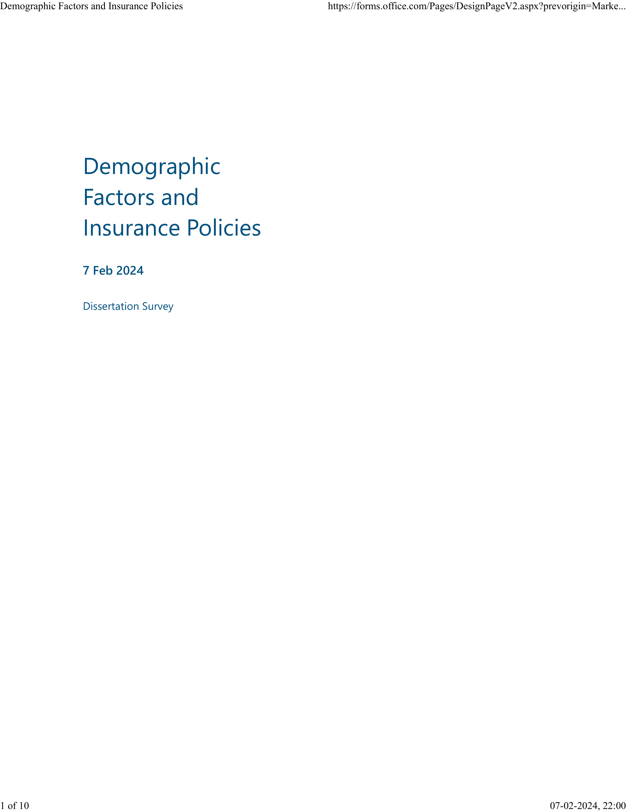
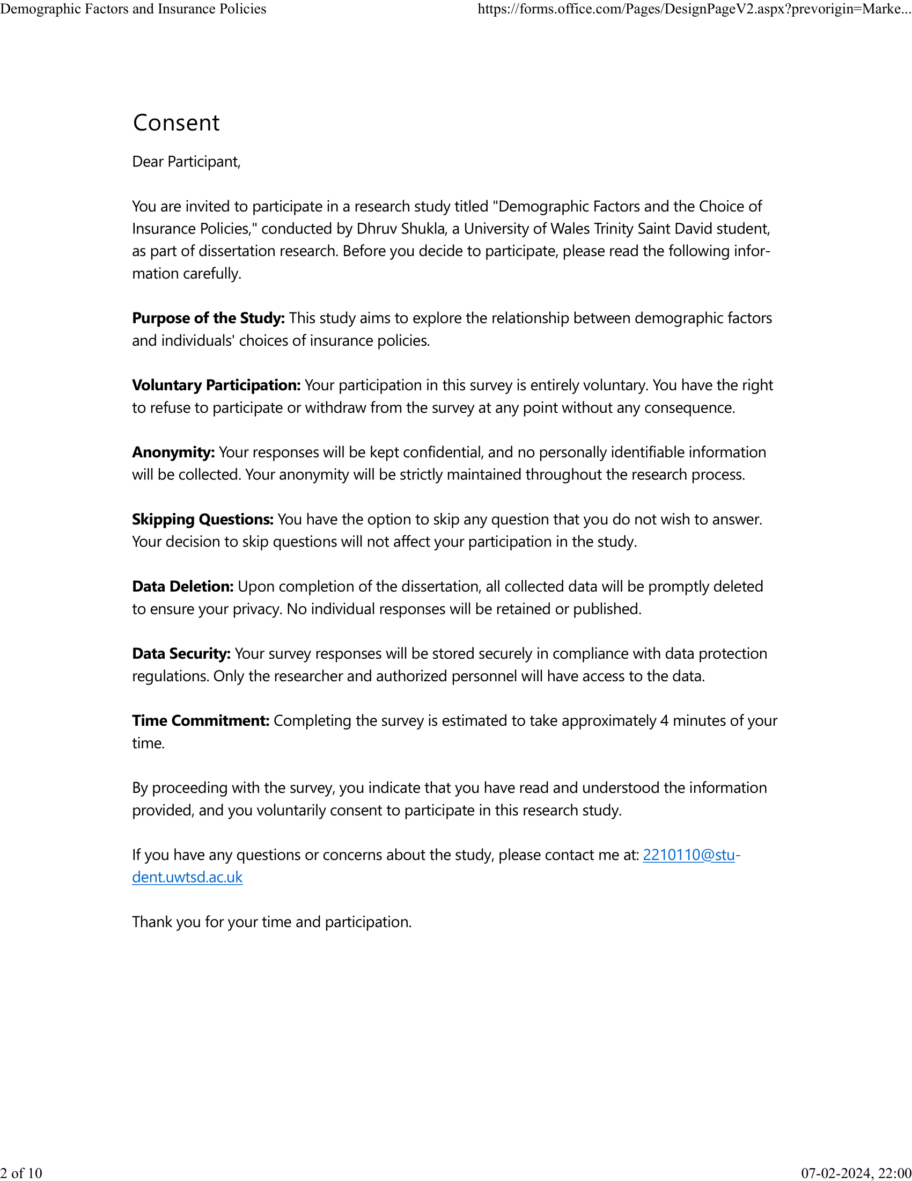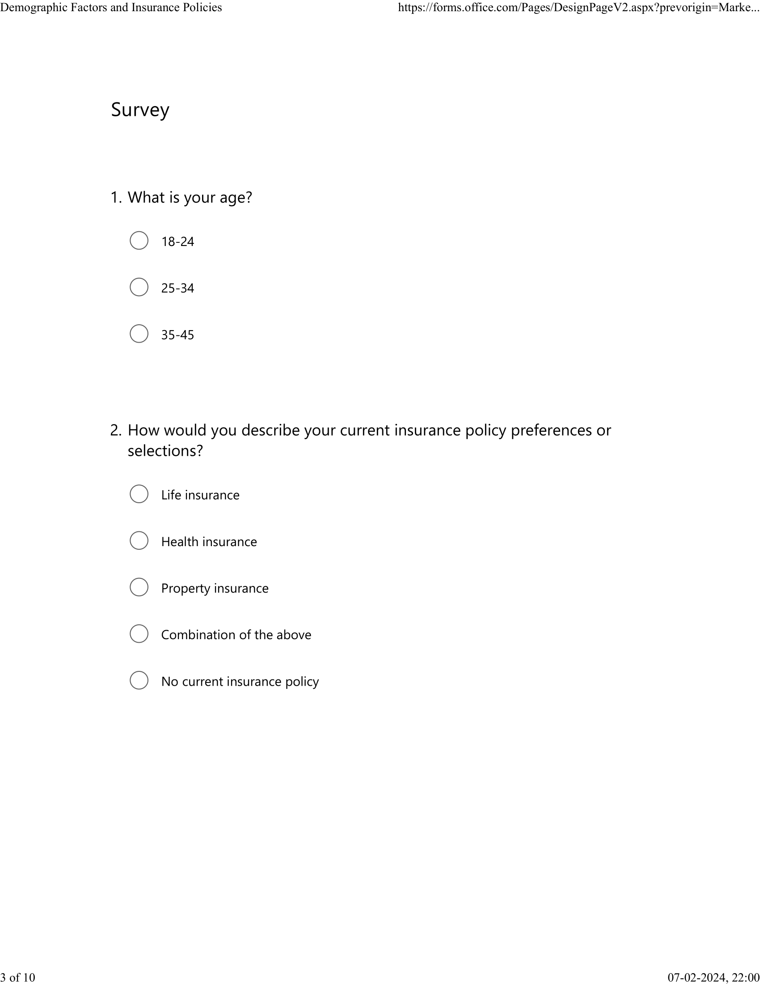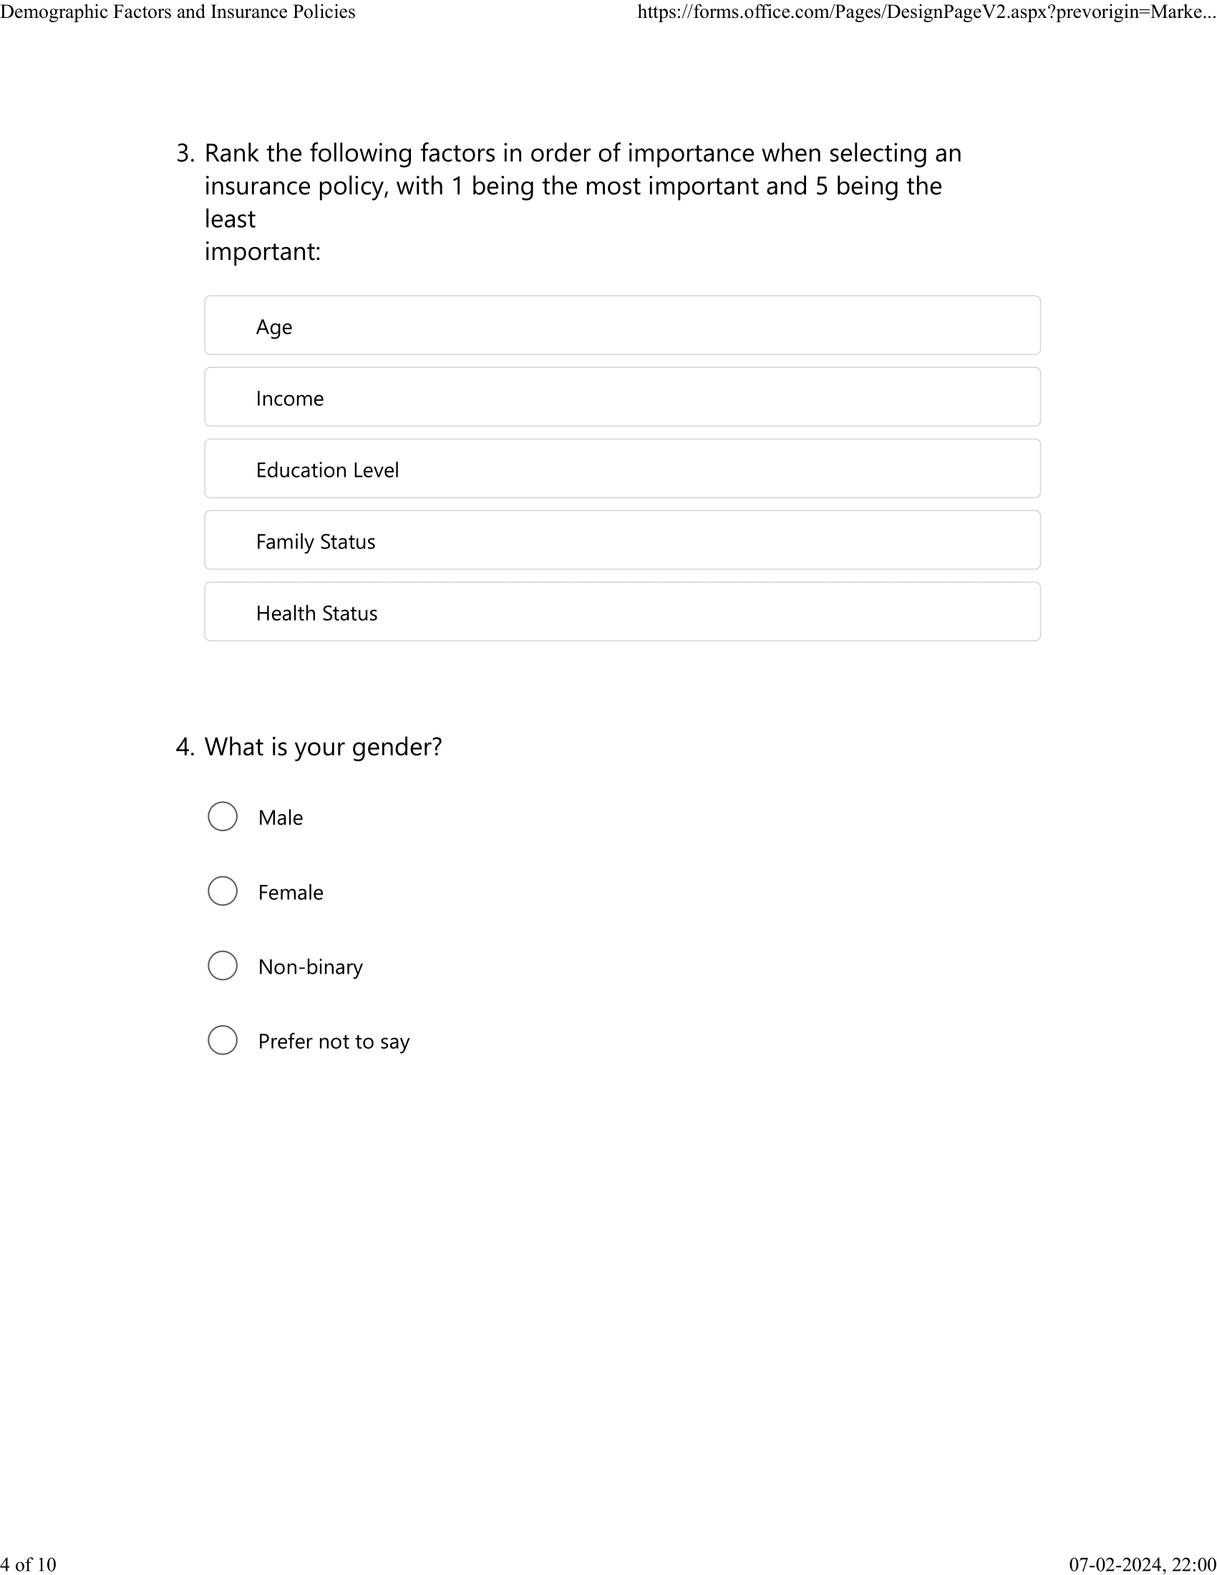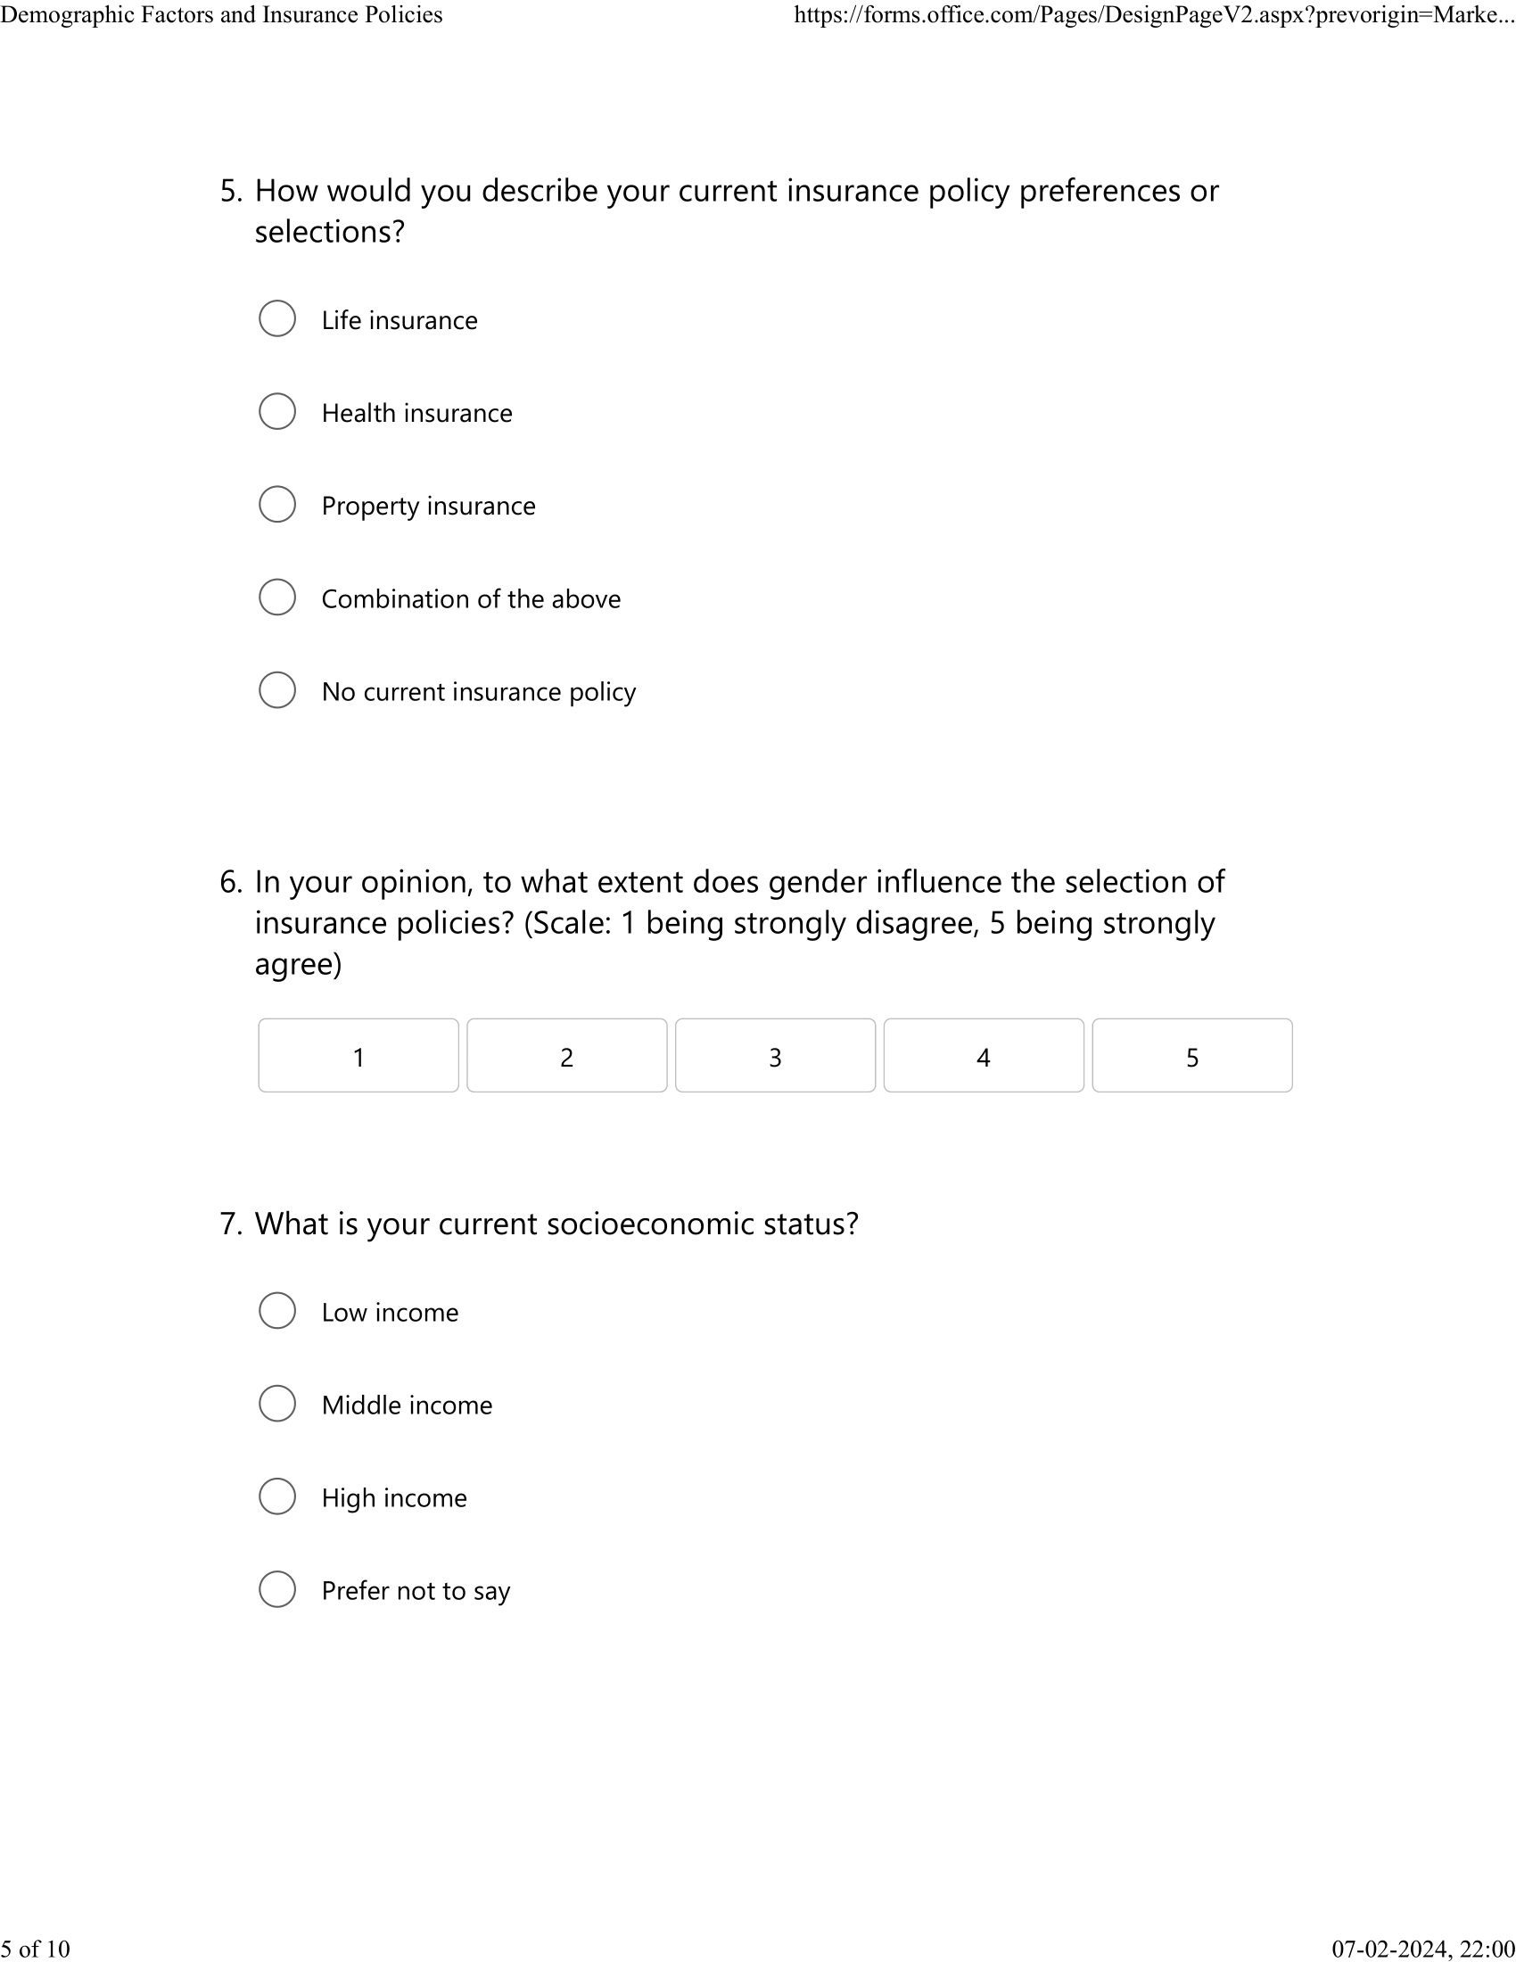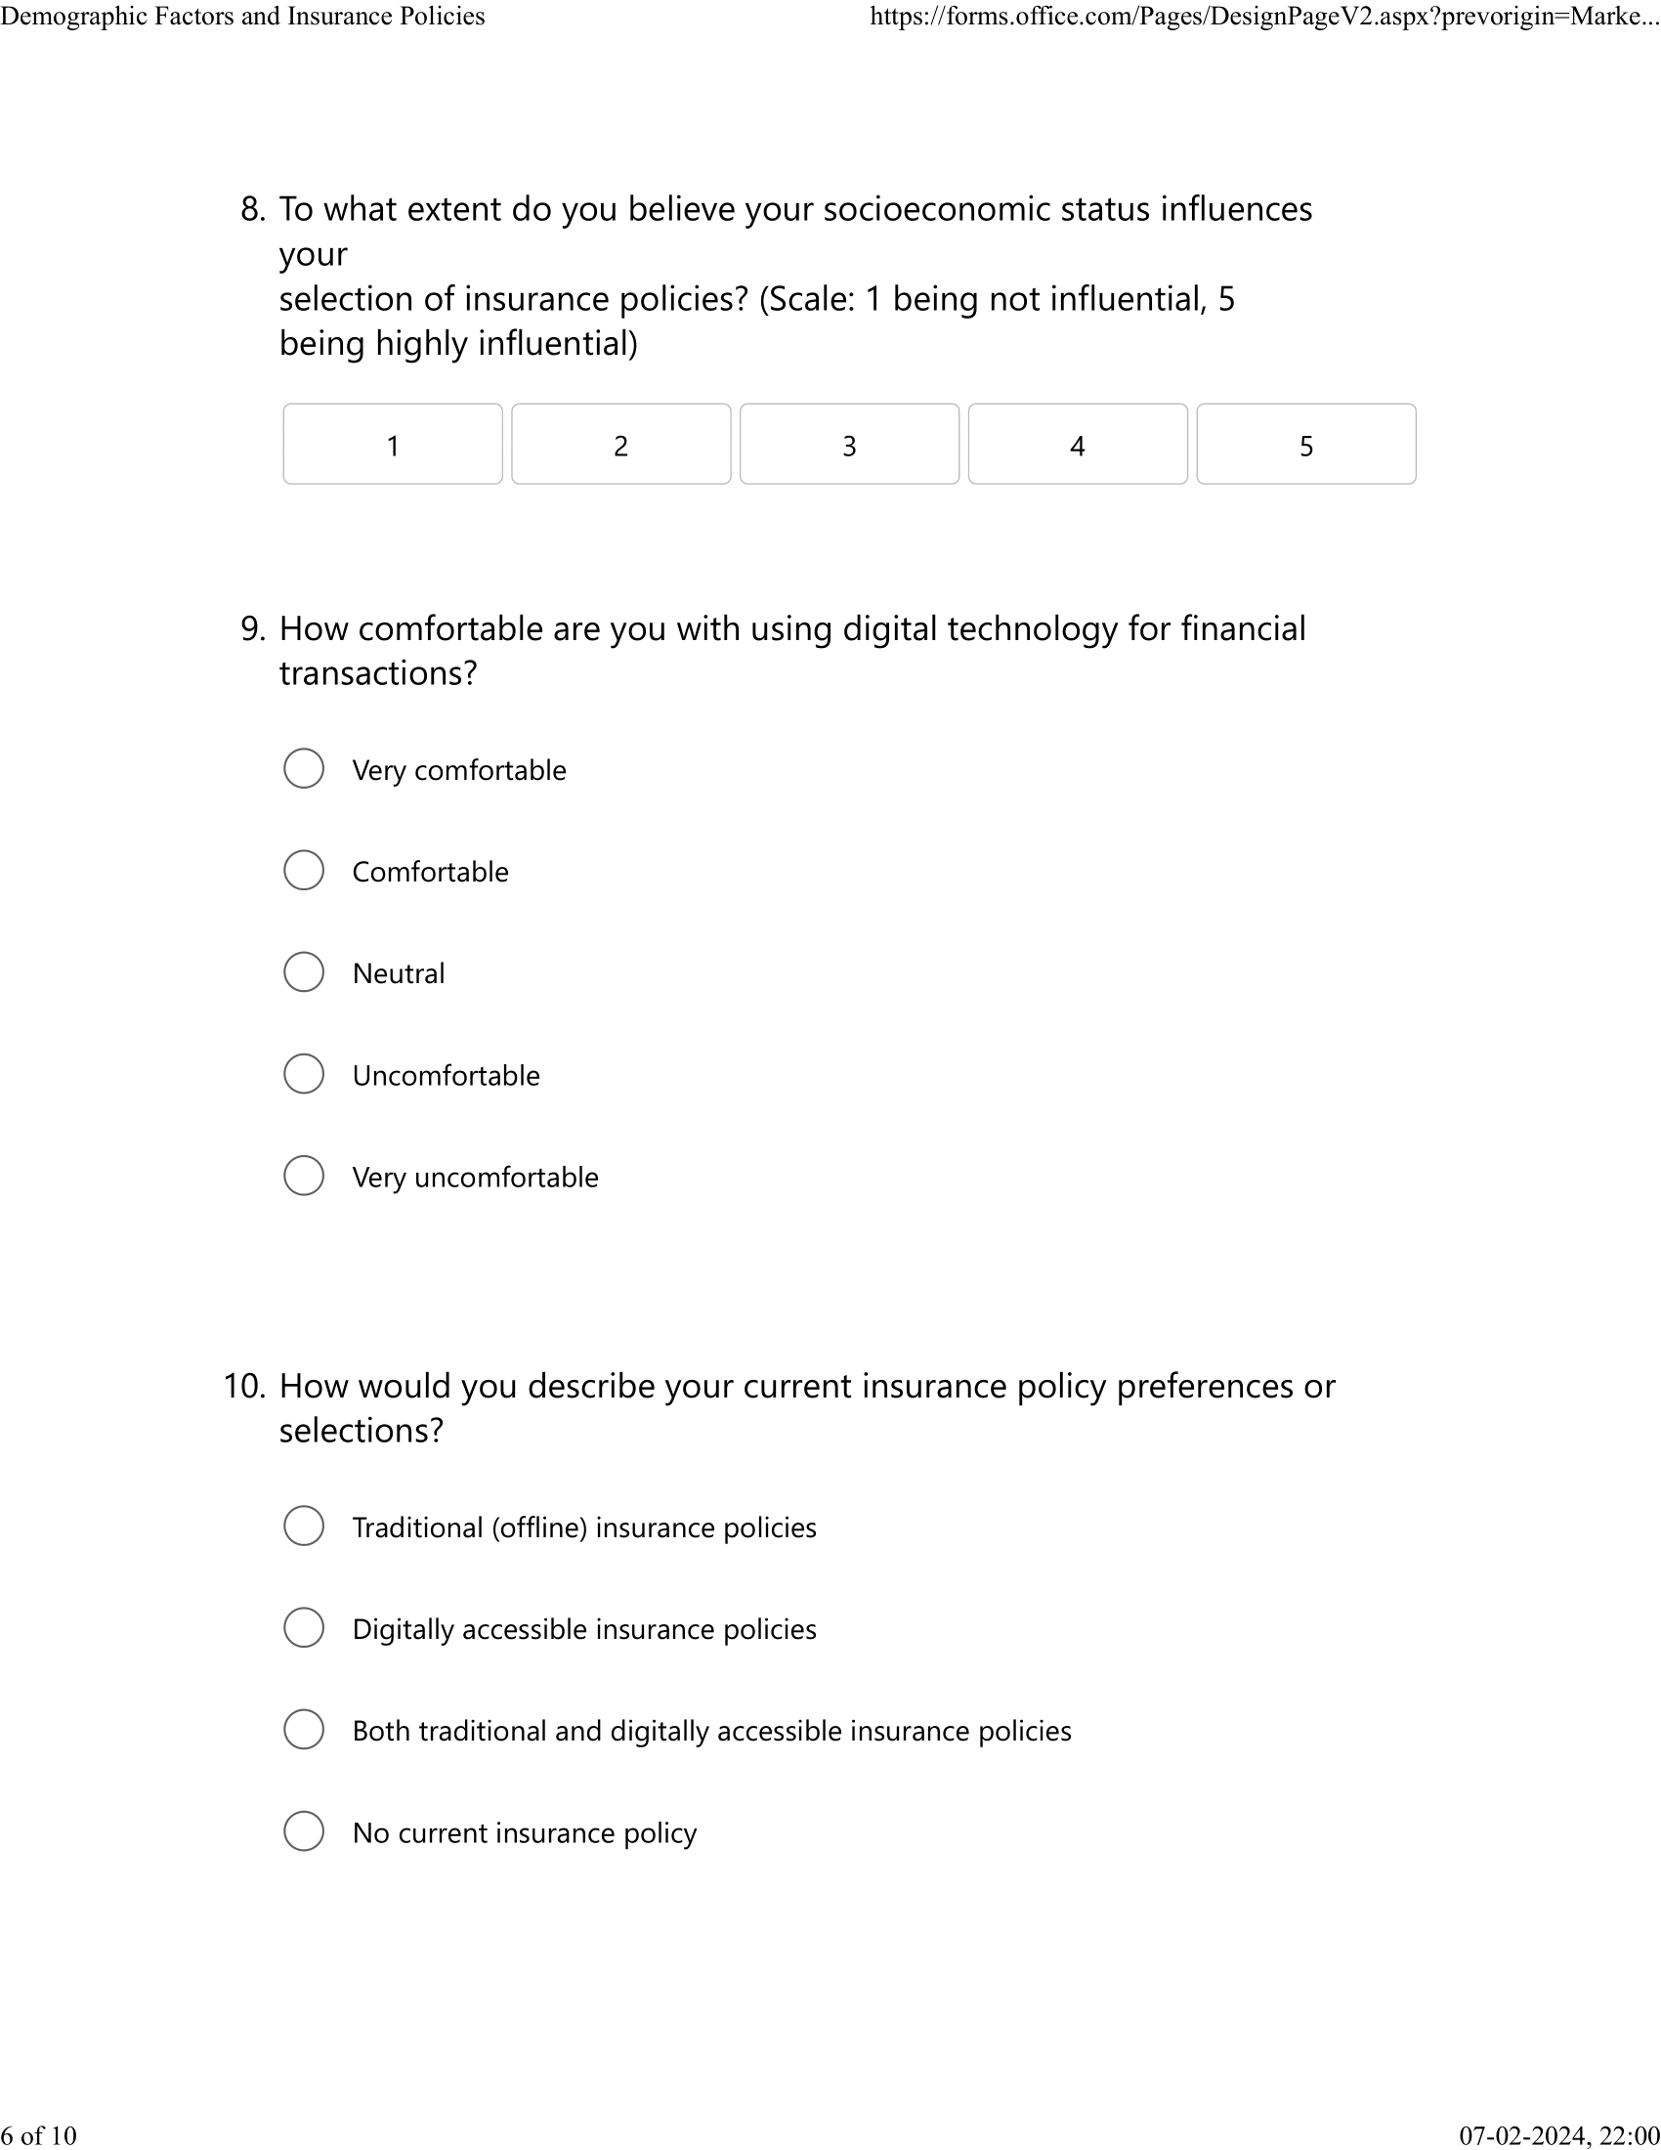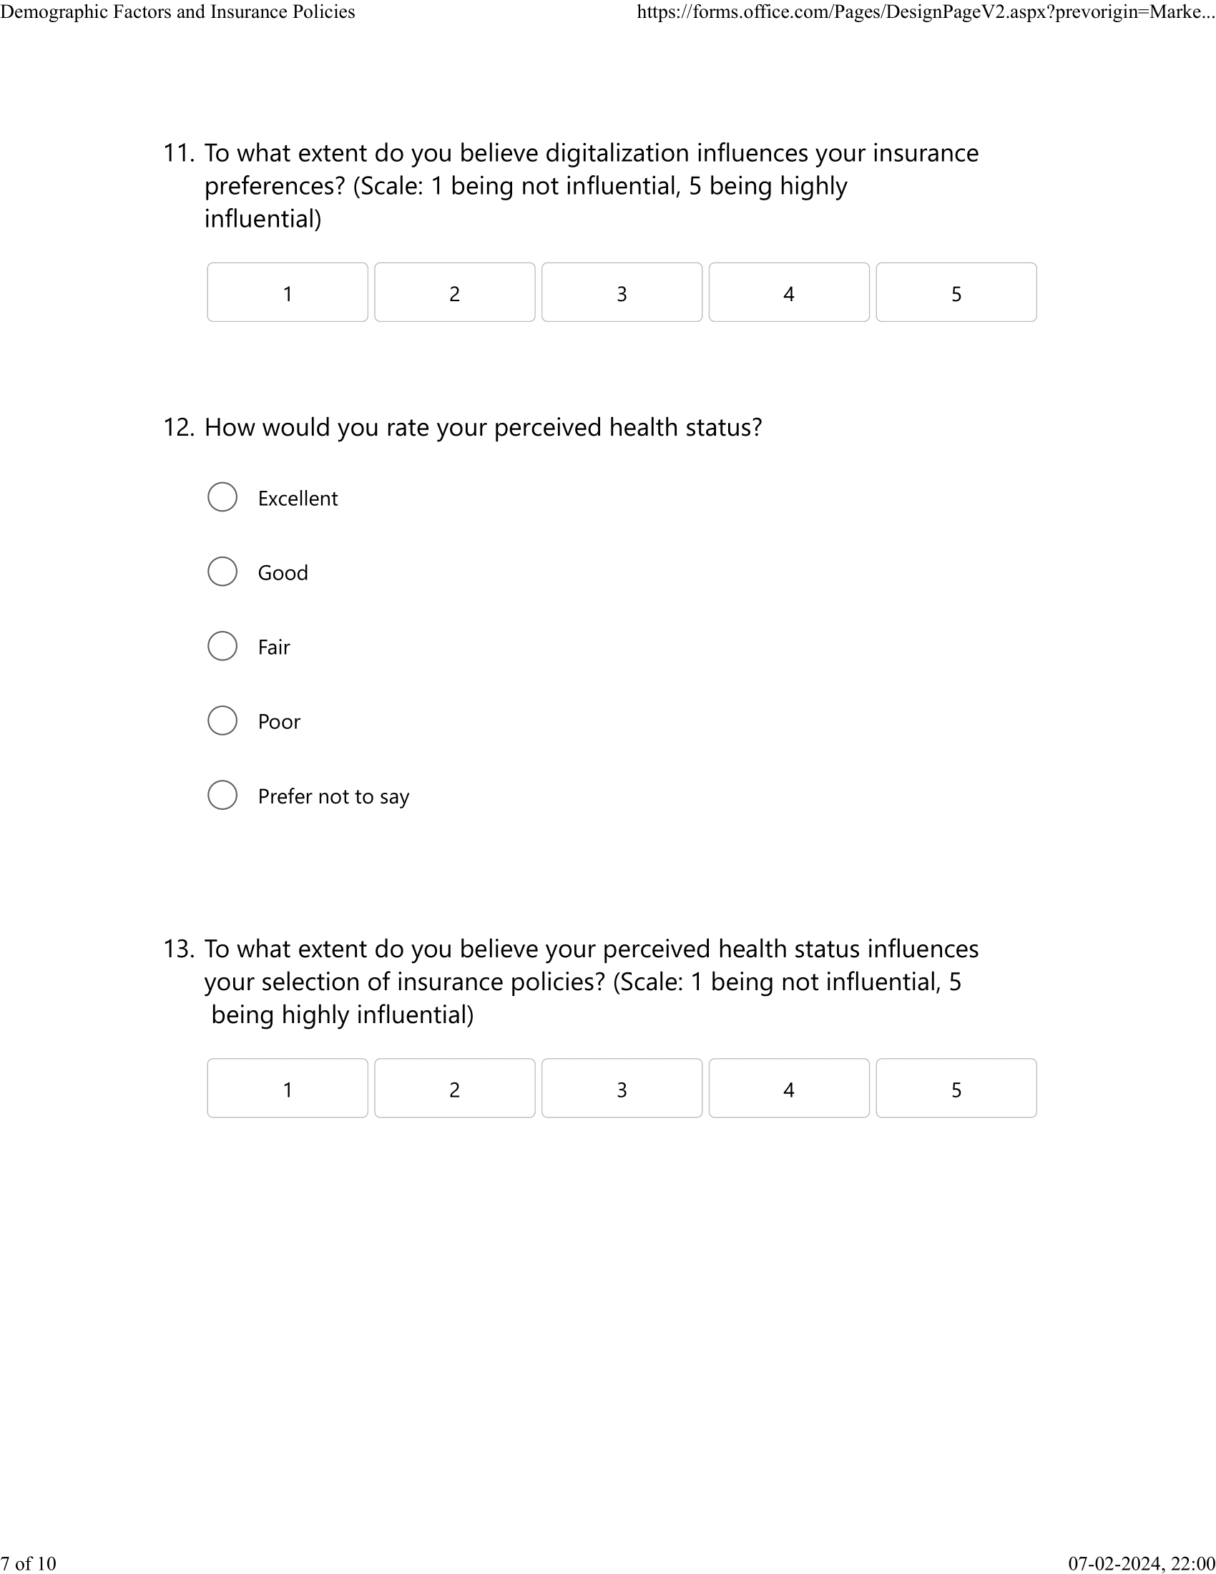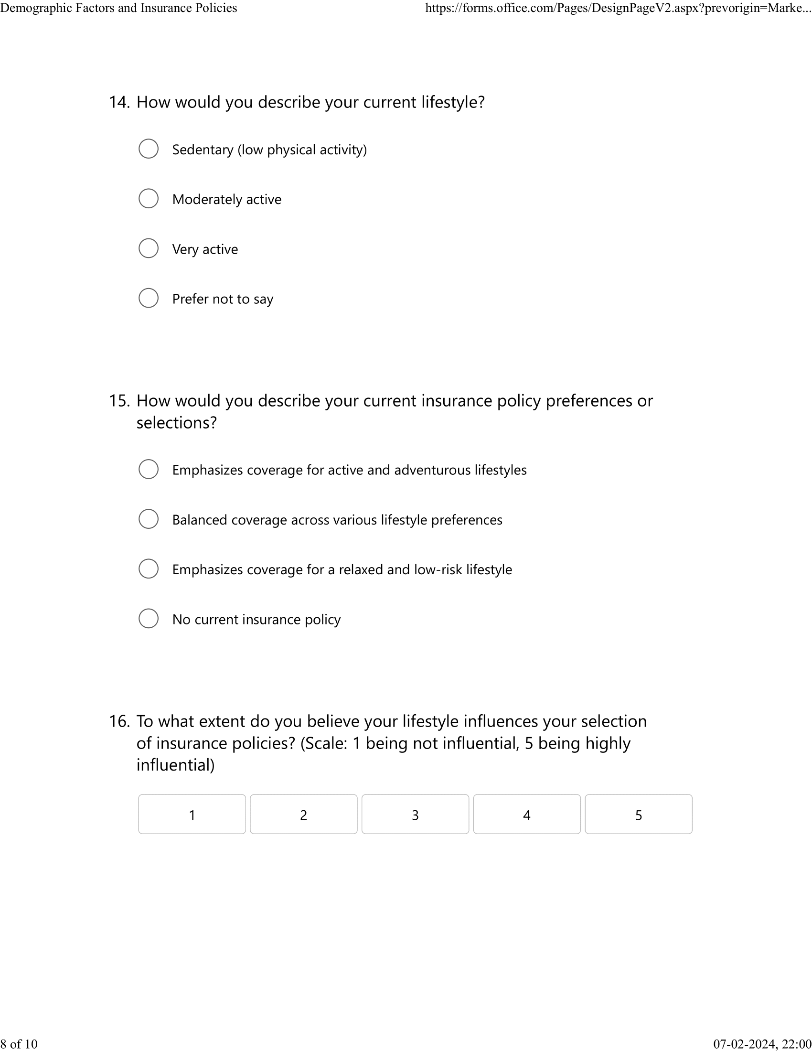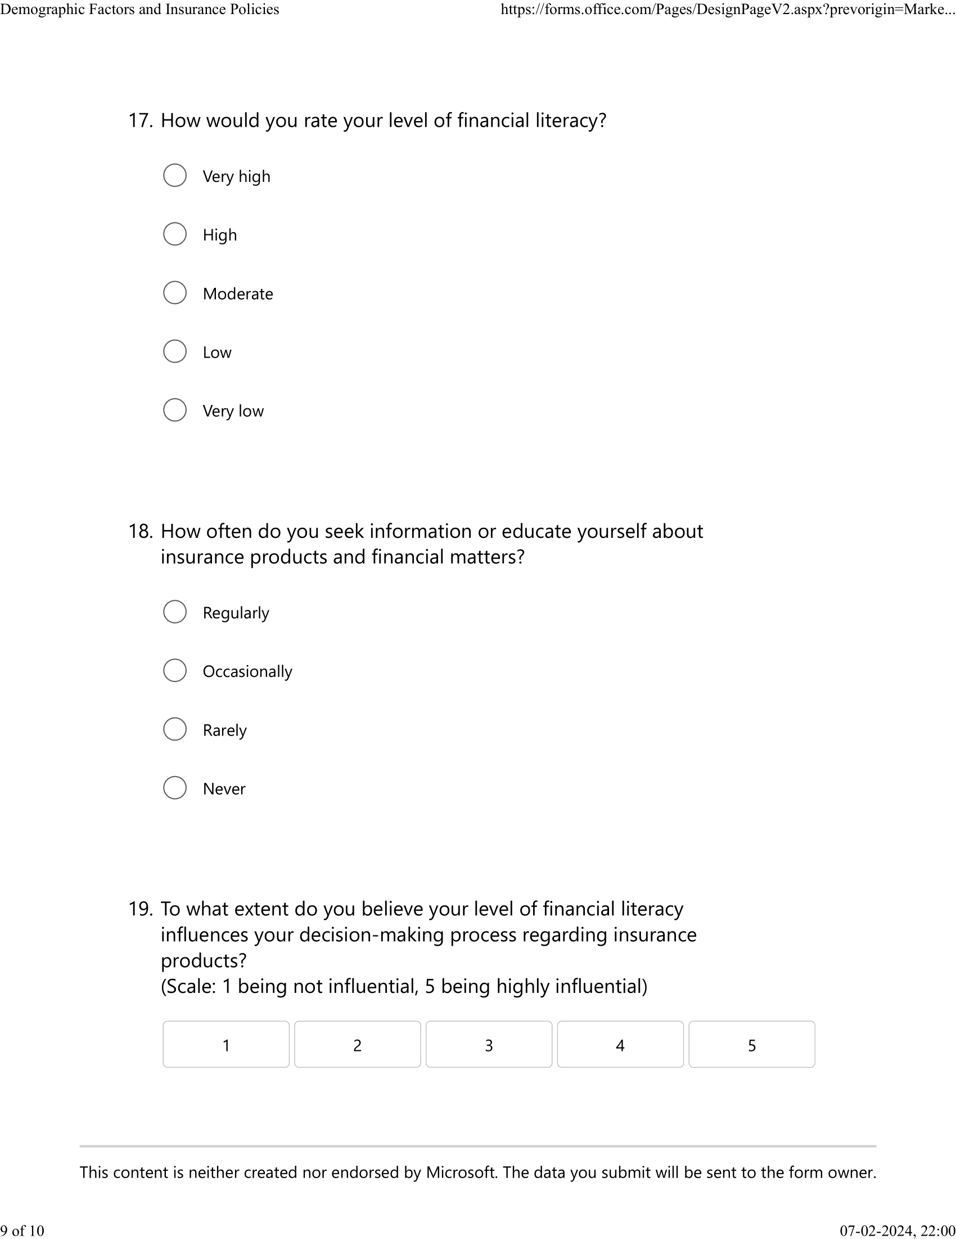

Ethics Form


