

LEVEL 6

MODULE CODE: ECAD6004

Enterprising and Creative Teaching and Learning

Assessment Type: Video Assignment
Assessment component: 2
Component weighting: 50%

Assignment Title:
Consider how you might be able to develop the creative or enterprising skills of learners through your own pedagogy.

1500643

SUBMISSION DETAILS: 14/03/18

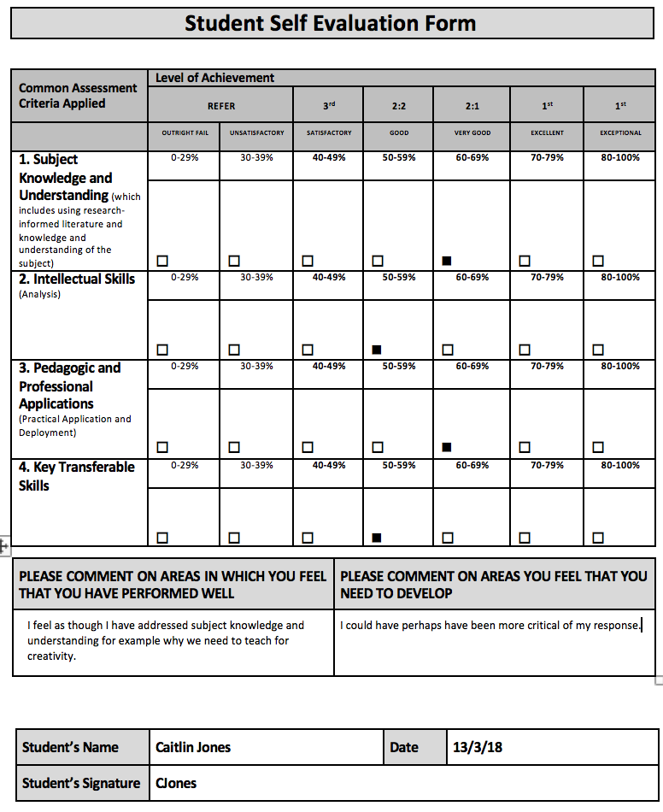

Video Link

https://youtu.be/cz-tX2CF6e0

Summary

Throughout my presentation I discuss ways in which I could develop children’s creative abilities through my own pedagogy. I chose to focus on the Foundation Phase as research shows that teaching for creativity should start in the early years of education as Cowley (2005) says that these years provide fertile ground for the development of creative attitudes. As creativity is such a broad topic, I decided to focus on one type of learning environment and one area for development. This was culture and attitude, inspired by Seelig’s (2012) Innovation Engine, where she describes how creativity happens through interplay between your external and internal world. Through wide and deep reading I understood the importance of creating a culture in the classroom that allows children to feel as though they experiment, put ideas forward and take risks in their learning.

Although it is children’s creativity that is discussed, research has shown the importance of the teacher and their responsibility to act as a facilitator, encouraging and supporting without hindering creativity. In practice, I hypothesise this may be a difficult balance to strike. The Welsh Government published the view that children bring creative attitudes with them to school, so this asks the question of why we see a decline in creativity throughout education, as shown in Kim’s (2011) study. Cohen (1988) and Hayes (2012) state that teachers should foster a creative attitude and Thorne (2007) and Grainger (2006) talk of the positive relationship teachers need with the children in their class in order to do this.

As researchers such as Weigerif suggest children should generate an abundance of ideas, I have suggested allowing children to walk to promote creative ideas, supported by Oppezzo’s (2014) research into the positive impact of walking on the generation of novel ideas. It is this novelty and also appropriateness that Amabile (2012) believes makes creativity. As well as the physical act of walking for idea generation, research suggests it may be beneficial to allow incubation time for children to ponder over their ideas.

The Foundation Phase framework (DES, 2015) recognises the importance of play to develop creativity and Bruce (2011) supports this. Therefore, I have spoken of encouraging more child-led play in my practice and guiding children if they become frustrated when they encounter a problem in their play. This led me to think about whether adults should intervene to guide their creativity or allow children to fail multiple times. After reading a range of research around the topic, I decided a combination of both may be successful in developing children’s attitudes to creativity. Fisher and Williams (2009) state that it is important for adults to intervene sensitively although Hayes (2012) states too much intervention can hinder the creative process and reduce self-sufficiency. Additionally, Ryan believes that creative play can actually build resilience, due to their occasional failures and subsequent development of alternative creative solutions.

Working with others is a competency in the Entrecomp framework, which suggests that it may be an important factor in developing creativity. Vygotsky wrote of constructivism, where learners worked more successfully and creatively as part of a group. A range of other research suggests group work can be beneficial in developing creativity, mainly through the discussion and dialogue. I have witnessed this multiple times during Professional Teaching Practice, where children use exploratory talk to bounce ideas off each other. However, Paulus and Nijstad (2003) warn of some children not feeling confident enough to offer their ideas. The Welsh Government hope that through the supportive culture created through the other strategies suggested, the fear of offering ideas may diminish in children. Again, this highlights the importance of the teacher’s role to actually establish this culture. Additionally, structure can be given to the groups for example through DeBono’s (1985) thinking hats or employing a cooperative learning approach which has been successfully implemented in Pembroke Dock Community School (PDCS, 2018).

To conclude, through a general teaching approach, I could develop learner’s creative abilities by creating a culture in the classroom that allows children to be creative and subsequently develop their attitudes to creativity. Once this climate is established, collaborative work could be introduced to allow learners to broaden their creative and critical thinking and develop these skills which research suggests are critical for the future.

Bibliography

Allpsychologycareers.com. (2018). Explore How Creativity is Measured. [online] Available at: http://www.allpsychologycareers.com/topics/measuring-creativity.html [Accessed 11 Mar. 2018].

Amabile, T. (1996) Creativity in Context, Boulder: Westview Press.

Amabile, T. (2012). Componential Theory of Creativity. Harvard Business School.

Amabile, T. (2013). The Consensual Assessment Technique. [Blog] Creative Huddle. Available at: https://www.creativehuddle.co.uk/the-consensual-assessment-technique [Accessed 4 Mar. 2018].
Bacigalupo, M., Kampylis, P., Punie, Y., Van den Brande, G. (2016). EntreComp: The Entrepreneurship Competence Framework. Luxembourg: Publication Office of the European Union.
Barnes, J. (2009). Cross-curricular learning 3-14. London: Paul Chapman.

Beard, C. and Wilson, J. (2006). 2nd ed. Experiential Learning. London: Kogan Page.

Bruce, T. (2011). 2nd ed. Cultivating Creativity. London: Hodder Education.

Cohen, L. (1988). Developing Children's Creativity, Thinking, and Interests. Strategies for the District, School, and Classroom. OSSC Bulletin, 31(7), p.71.

Costa, A., Kallick, B. (2008). Learning and Leading with Habits of Mind. Virginia: ASCD.

Cowley, S. (2005) Letting the Buggers Be Creative, London: Continuum.

Craft, A. (2000). Creativity Across the Primary Curriculum, Abingdon: Routledge.

Craft, A. (2002). Creativity and Early Years Education. London: Continuum.

Craft, A. and Jeffery, B. (2008). ‘Creativity and performativity in teaching and learning. British Journal of Educational Research. 34(5), 577-84.

Cremin, M. (2004). ‘The role of the imagination in classroom drama’. Canterbury: Canterbury Christ Church University.

DeBono, E. (1985). Six Thinking Hats: An Essential Approach to Business Management, New York: Little, Brown and Company.

Department for Children, Education, Lifelong Learning and Skills. (2008). Play/Active Learning. Cardiff: Welsh Assembly Government.

Department for Children, Education, Lifelong Learning and Skills. (2008). Learning and Teaching Pedagogy. Cardiff: Welsh Assembly Government.

Department for Education and Skills. (2015). Foundation Phase Framework. Cardiff: Welsh Government.

Donaldson, G. (2017). Successful Futures. Crown.

Duffy, B. (2000). Supporting Creativity in the Primary Classroom, Buckingham: Open University Press.

Enlergent, C. and Tarrant, K. (1995). Creating Collaborative Cultures for Educational Change. Remedial and Special Education, 16(6), pp.325-336.

Estyn. (2017). A curriculum that engages all pupils.. [online] Available at: https://www.estyn.gov.wales/effective-practice/curriculum-engages-all-pupils [Accessed 28 Feb. 2018].

Estyn. (2017). Creative strategies that encourage thinking and high attainment. [online] Available at: https://www.estyn.gov.wales/effective-practice/creative-strategies-encourage-thinking-and-high-attainment [Accessed 28 Feb. 2018].

Estyn. (2016). Improving Literacy Through Creative Learning. [online] Available at: https://www.estyn.gov.wales/effective-practice/improving-literacy-through-creative-learning [Accessed 28 Feb. 2018].

Ewing, R. and Saunders, J. (2016). Why pushing creativity out of classrooms will stop children succeeding in the 21st century. [online] the Guardian. Available at: https://www.theguardian.com/stage/2016/nov/17/why-pushing-creativity-out-of-classrooms-will-stop-children-succeeding-in-the-21st-century [Accessed 27 Feb. 2018].

Fisher, J. (2004). What is creativity? In R. Fisher and M. Williams. Unlocking Creativity. London: David Fulton.

Fisher, R. and Williams, M. (2009). Unlocking Creativity. Oxon: Routledge.

Freire, P. (1982). The Pedagogy of the Oppressed. Harmondsworth: Penguin.

Frenkel, K. (2012). Tina Seelig’s Insights on Creativity. [Blog] The Creativity Post. Available at: http://www.creativitypost.com/create/tina_seeligs_insights_on_creativity [Accessed 27 Feb. 2018].

Fumoto, H., Robson, S., Greenfield, S. & Hargreaves, D. (2012). Young Children’s Creative Thinking, London: SAGE Publications Ltd.

Furlong, J. (2015). Teaching Tomorrow's Teachers. Oxford: University of Oxford.

Gov.co.uk. (2014). Enterprise for All: the Relevance of Enterprise in Education. [online] Available at: https://www.gov.uk/government/uploads/system/uploads/attachment_data/file/338749/EnterpriseforAll-lowres-200614.pdf [Accessed 8 Dec. 2017].

Grainger, T. and Barnes, J. (2006) Creativity in the Primary Curriculum in J. Arthur, T. Grainger and D. Wray. (eds.) Learning to Teach in the Primary School London: Routledge.pp.209-225.

Grigg, R. (2015). Becoming an outstanding primary school teacher. New York: Longman.

Hayes, D. (2012). Foundations of primary teaching. 5th ed. Abingdon, Oxon: Routledge.

Hickey, G. and Robson, D. (2013). The Leonardo Effect. London: Routledge.

iNews. (2018). Schools should produce creative thinkers - not just exam robots. [online] Available at: https://inews.co.uk/news/schools-producing-creative-thinkers-not-just-exam-robots/ [Accessed 5 Mar. 2018].

Kim, K. (2011). The Creativity Crisis: The Decrease in Creative Thinking Scores on the Torrance Tests of Creative Thinking. Creativity Research Journal, 23(4).

Kinsella, V., Fautley, M. (2017). Creativity – Getting it right in a week, St Albans: Critical Publishing.

Learning and Teaching Scotland. (2006). The Reggio Emilia Approach to Early Years Educaiton. Glasgow: Learning and Teaching Scotland.

McCarthy, J. (2017). 10 Tools for Your Students’ Creativity Toolbox. [Blog] Edutopia. Available at: https://www.edutopia.org/article/10-tools-your-students-creativity-toolbox [Accessed 5 Mar. 2018].

N.A.C.C.C.E. (1999). All our futures: creativity, culture and education, London: DfEE.

OECD. (2008). Innovating to Learn, Learning to Innovate. OECD.

Oppezzo, M. and Schwartz, D. (2014). Give your ideas some legs: The positive effect of walking on creative thinking. Journal of Experimental Psychology: Learning, Memory, and Cognition, 40(4), pp.1142-1152.

Pappano, L. (2014). Creativity Becomes an Academic Discipline. [online] Nytimes.com. Available at: https://www.nytimes.com/2014/02/09/education/edlife/creativity-becomes-an-academic-discipline.html?_r=0 [Accessed 30 Oct. 2017].

Paulus, P. and Nijstad. B. (2003). Group Creativity: Innovation through Collaboration. New York: Oxford University Press.

Pembroke Dock Community School. (2018). Co-operative Learning at Pembroke Dock Community School. [video] Available at: https://pembrokedockcp.primarysite.media/media/co-operative-learning-at-pembroke-dock-community-s [Accessed 3 Mar. 2018].

Pembroke Dock Community School. (2018). Creative Schools | Pembroke Dock Community School. [online] Available at: http://www.pembrokedockcommunityschool.co.uk/creative-schools/ [Accessed 5 Mar. 2018].

Robinson, K. (2011). Out of our minds: learning to be creative. London: John Wiley.

Robinson, K. (2015). Creative Schools. London: Penguin Books.

Rumbold, A. (1990). The Report of the Committee of Inquiry into the Quality of the Educational Experience offered to 3 and 4 year olds. London: H.M.S.O.

Ryan, T. (1990). Thinker's Keys. Queensland.

Saracho, O. (2002). Young Children's Creativity and Pretend Play. Early Child Development and Care, 172(5), pp.431-438.

Seelig, T. (2012). A Crash Course in Creativity: Tina Seelig at TEDXStanford. [video] Available at: https://www.youtube.com/watch?v=gyM6rx69iqg [Accessed 3 Mar. 2018].

Seelig, T. (2012). InGenius: A Crash Course on Creativity. London: Hay House.

Seelig, T. (2014). Innovation Engine. London: Harper Collins.

Sternberg, R. (2006). The Nature of Creativity. Creativity Research Journal, 18(1), pp.87-98.

Thinking Schools International. (2011). What are some basic pathways to Thinking? Thinking Schools International. Available at: http://www.thinkingschoolsinternational.com/site/wp-content/uploads/2012/08/GTS-Excerpt-7.pdf [Accessed 4 Mar. 2018].

Thorne, K. (2007). Essential Creativity in the Classroom, Abingdon: Routledge.

Thornton, L. and Brunton, P. (2009). 2nd ed. Understanding the Reggio Approach. Oxon: Routledge.

Unicef UK. (2018). UN Convention on the Rights of the Child (UNCRC) - Unicef UK. [online] Available at: https://www.unicef.org.uk/what-we-do/un-convention-child-rights/ [Accessed 5 Mar. 2018].

Warnock, M. (1994). Imagination and Time. Oxford: Blackwell.

Weigerif, R. (2010). Mind Expanding. Berkshire: Open University Press.

Welsh Assembly Government. (2010). How to develop thinking and assessment for learning in the classroom. [online] Cardiff: Welsh Assembly Government. Available at: http://learning.gov.wales/docs/learningwales/publications/130429how-to-develop-thinking-en.pdf [Accessed 28 Feb. 2018].

Welsh Government. (2017). Education in Wales: Our National Mission. Action Plan 2017-21. Cardiff: Welsh Government.

Williams, F. (1982). Developing Children's Creativity at Home and in School. G/C/T, 5(4), pp.2-6.

Windschitl, M. (1999). The challenges of sustaining a constructivist classroom culture. Phi Delta Kappan, 80(10), pp. 751-755.

Ynystawe Primary School. (2017). Creativity. Carmarthen: UWTSD. 6th November.

Ynystaweprimary.co.uk. (2018). Home | Ynystawe Primary School. [online] Available at: http://www.ynystaweprimary.co.uk/ [Accessed 5 Mar. 2018].

