DISSERTATION PROPOSAL

LCBB6000

To understand what are the effects of a successful digital marketing campaign on luxury brand performance

TED BAKER’S

Student: Emiliya Georgieva 1815854
Module leader:Dr.Anupam Mazumdar
Supervisor:Dr.Tushara Balendran

Title: To understand what are the effects of a successful digital marketing campaign on luxury brand performance 3
Chapter 1: Introduction 4
Significance of the topic 4
Purpose of the research 4
Proposed aim, objectives and research questions 4
Chapter 2: Literature Review 4
Chapter 3: Research Methods and Methodology 5
Research philosophy 5
Research paradigm 5
Research approach 5
Research methodology 5
Research strategy 5
Sampling methods 5
Data collection methods/tools 5
Ways of interpreting data 5
(Gantt chart) 5
6
Ethical consideration of the research 6
Chapter 4: Conclusion 6

Title: To understand what are the effects of a successful digital marketing campaign on luxury brand performance

Chapter 1: Introduction

Significance of the topic
Digital marketing is mainly inclusive of all forms of marketing efforts that include use of the internet. In this organization under take advantage of digital channels such as websites, search engine, social media, email etc with the help of which organization can connect with prospective and current consumers (Cavender and Kincade, 2014). In today’s business world the use of internet is being significantly enhanced around the globe. This provide opportunity for organisations under take advantage of digital tools and techniques to attract larger base of customers. The present research is conducted on the effect of digital marketing campaign on luxury brand performance. This research identifies the concept of digital marketing campaign and the impact of successful digital marketing on the company performance. For this research Ted Baker a leading luxury brand of United Kingdom is being undertaken. The research also determines potential digital marketing campaign with the help of which company can enhance their growth.

Purpose of the research
The main purpose of present research is to identify the effects of successful digital marketing campaign on luxury brand performance. The present research is conducted on Ted Baker’s, which is operating its roles and responsibilities in the provinces of United Kingdom as a luxury brand. The main purpose of this research is to determine the impact of successful digital marketing campaign on company performance along with certain digital marketing campaigns that will help organization to long term growth and success.

Rationale of the research
The reason behind selecting area of digital marketing for luxury brands for this investigation is personal interest and inclination towards understanding digital marketing impact on the corporate industry specifically elite high income brands. In addition to this investigating the outcome of successful digital marketing campaign on performance of luxury brand can help determine the scope of digital marketing for luxury businesses. It can help uncover the role of digital marketing campaigns in supporting growth of luxury brands so that the usage of digital marketing by luxury brands becomes more specific and targeted. The area of this investigation is important because luxury firms can use the conclusion of this investigation to modify their digital marketing campaign and maximize its positive impact on the company. In addition to this it’s also useful for any future research in the field of digital marketing because it will provide evidence based results about the potential results of digital marketing campaigns in the current corporate world.

Proposed aim, objectives and research questions
Research Aim
To identify the impact of a successful digital marketing campaign on luxury brand performance. A study on Ted Baker, UK
Research Objectives
- To identify the concept of the digital marketing campaign.
- To determine the impact of a successful digital marketing campaign on Ted Baker’s performance in the UK.
- To evaluate the potential digital marketing campaigns that will help Ted Baker to maximise its growth.
Research Questions
- What is the concept of the digital marketing campaign?
- What is the impact of a successful digital marketing campaign on Ted Baker’s performance in the UK?
- What are the potential digital marketing campaigns that will help Ted Baker to maximise its growth?

Chapter 2: Literature Review
Literature review is defined as an overview of previously published work on a particular topic. With the help of this investigator can gain formality with the current knowledge in the chosen field. With the help of this researcher can also gain understanding of the research topic and can fulfil research aims and objectives in effective manner
Concept of the digital marketing campaign
According to the viewpoint of Dodson, (2016) digital marketing campaign is inclusive of execution of marketing strategy across different digital marketing channels. With the help of digital marketing campaign organization can influence attention of target market audience in effective manner. In simple terms digital marketing campaigns to update in online marketing efforts that allow organization to enhance growth, drive engagement, conversion, revenue and traffic. In today’s business world digital marketing campaign is a dynamic in sustainable marketing strategy which helps organization to enhance their marketing effort and influence attention of customers. With the help of digital marketing campaign organization can not only take advantage of social media marketing search engine optimization, pay-per- click, mobile marketing, affiliate marketing analytics and more. With the help taking advantage of these forms of marketing tools and techniques organization is having capacity to enhance their digital marketing growth. In addition to this it has been analysed with the help of taking advantage of digital marketing campaign organization can successfully issue more competitive edge in the market.
Impact of a successful digital marketing campaign on Ted Baker’s performance in the UK

According to the viewpoint of Chaffey and Ellis-Chadwick, (2019)digital marketing campaign in todays marketing world is one of the most effective tool which allow organizations to assure more growth and profitability. In context with Ted Baker which is a luxury brand in the United Kingdom, it has been analysed and with the help of implementing digital marketing campaign company can significantly enhance their growth revenue and can assure global reach. In addition to this with the help of this organization can also assure positive impact in terms of lower cost and effective targeting options with multiple strategies. This will help organization to assure open is offering personalised services to customers that helps in improving conversion rate. In addition to this it has been analyse that by taking advantage of digital marketing campaigns Ted bakers have significant impact on their performance, as it helps organization to satisfy customers on large scale which automatically enhances organization competitive ratio in profitability edge.
Potential digital marketing campaigns that will help Ted Baker to maximise its growth
According to the viewpoint of (Behera, Kamboj and Bala, 2020) in today’s business environment digital marketing is playing important in crucial role which help leading and small business organization to assure higher growth and profitability. In context with the present selected luxury brand Ted Baker’s it has been analysed but there are different types of digital marketing campaign that will help organization to maximise their growth this Ted Baker can take advantage of social media marketing, search engine optimization, email marketing and can conduct traditional and online digital marketing campaigns with the help of taking use of marketing campaigns on different social media platforms such as Facebook, Instagram etc can assure maximum attention of customers. This will significantly assure organization to enhance their overall growth and performance in the industry.
RACE digital marketing model
This marketing framework is used for implementing successful marketing campaigns because it offers structured way of planning marketing strategy of an organization. The four stages of this framework are reach, act, convert and engage. It is useful model for creating digital marketing strategy because it provides single approach which can be applied to different levels of a digital marketing. Each stage of the RACE framework supports an enterprise in setting up clear and realistic objectives, strategies, tactics and KPI’s needed for attaining its marketing objectives. The explanation of the model along with its critical analysis and application in case of luxury brand Ted Baker is provided below:
- Reach: This stage focuses on building awareness about the brand so that consumers recognize the brand and are aware about its products. In this Ted Baker can collaborate with famous online fashion portals such as digital Vogue and Harper’s Bazar to create awareness about its luxury products to create higher brand awareness among high income consumers.
- Act: In this stage the focus of businesses is on building suitable brand interaction with consumers on offline or online channels and generating leads. In this stage Ted Baker can offer consumers rewards for providing contact details and taking action such as subscribe to company website to influence their decision making positively.
- Convert: In this stage the actual action of converting potential consumer to existing consumer is accomplished. Ted Baker can personalize website recommendation for very consumer so that they are make decision in favour of purchasing from the company. Discounts and special gift codes can also be used by Ted Baker for the conversion stage..
- Engage: This stage s focused in building strong consumer relationship so that loyal consumer base is gained by the company. Ted Baker needs to build digital loyalty program in order to improve consumer engagement post sale of product.

The advantage of this model is that is that it improves consumer relationship management. It also helps increase sales of the company. It helps influence the consumer to take further action and purchase goods of the firm. It helps the brand attract target consumer segment by using suitable channels for increasing brand recognition.While the disadvantage of this model is that specific actions which can help the company improve consumer engagement and loyalty are not offered in the framework. It requires investment in building digital technological competency and financial resources. Along with this, it is complicated stage and different tactic needs to be sued to ensure suitable interaction is completed with different consumer segment. In addition to this, it does not provide immediate results in terms of sales and profits and increases expenditure of the company in publishing and promotion.

Chapter 3: Research Methods and Methodology
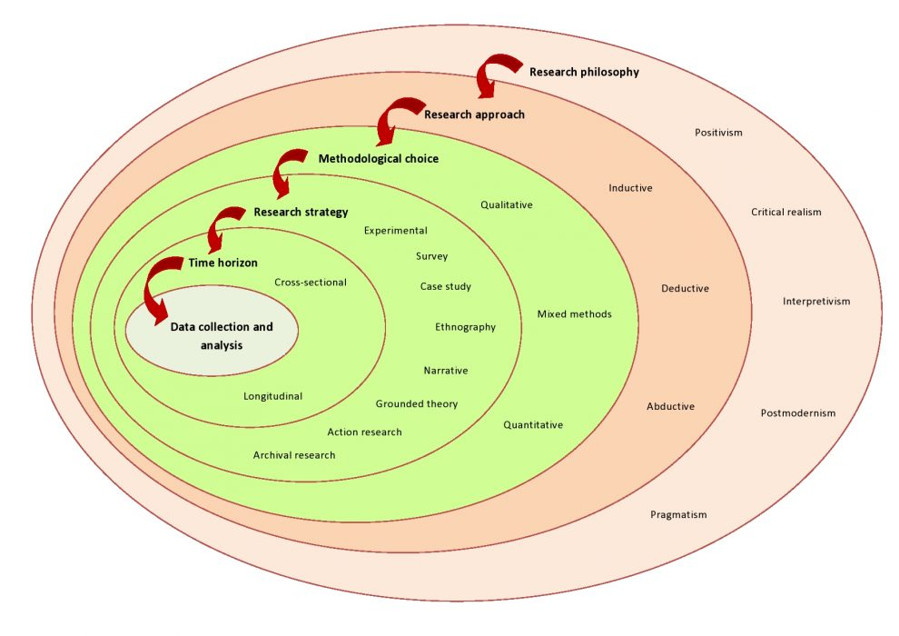
Figure 1: Research Onion
Source: https://www.aesanetwork.org/research-onion-a-systematic-approach-to-designing-research-methodology/

Research philosophy
Present research conducted on the concept of the impact of digital marketing campaigns on a luxury brand performance. For this researcher has taken use of positivism research philosophy (Dźwigoł and Dźwigoł-Barosz, 2018). The main reason is to take this approach in order to take advantage of factual knowledge and further accumulated any information via observation. In addition to this by taking advantage of this method researcher is aiming towards to support research in practical in scientific way.

Research paradigm
To accomplish present research objectives and aim researcher is implementing research project approach in which investigator is taking advantage of quantitative method. Along with this researcher is taking use of positivism pragmatism to accomplish research objectives in an effective way.

Research approach
Research approach is one of the most essential methods of research methodology that help investigator to accomplish research objectives in effective manner, as to accomplish present research objectives investigator is taking advantage of deductive research approach. The primary reason to take use of this method is to support investigation objective it also helps in coordinating with positivism research philosophy. With the help of this investigator is also looking towards to have better form of canning in testing of numeric facts and data.

Research methodology
Research methodology is a crucial aspect of every research framework it offers vital data information related to the selection and choice of research method. In order to fulfill present research aims and objectives investigator is under taking advantage of quantitative research approach in which survey methodology is being selected. By taking advantage of this method researcher is aiming towards to collect data and information from wider range of sources. With the help of this investigator can accumulate information in numerical and statistical manner and further present them with the help of tables and chart.

Research strategy
Research strategy is termed as a framework and design which help investigator to conduct research in appropriate manner. This is mainly dependent focus on selection of research strategy which is mainly inclusive of experiment, action research, empirical research, observation etc. Along with this it has been analysed that it provides investigator and opportunity to execute research in effective manner. In addition to this with the help of research strategy investigator can execute research in a systematic way which helps in accomplishing overall research in effective manner (Stokes and Wall, 2017). Furthermore, it has been evaluated that to fulfill present research investigator is taking advantage of survey research strategy. The main reason to take use of this method is to accumulate data from wide range of respondents and further analyse their viewpoint. With the help of this investigator can acquire data from sufficient sample size that further helps in assuring valid outcome.

Sampling methods
This is mainly termed as a statistical process in which researchers can take use of statistical method to accomplish research.
Sample size
To fulfill present research investigator is taking advantage of random sampling method in which they are taking use of 30 respondents. All these are employees of Ted bakers. In this investigator is taking use of the probability method. The main reason to take them as respondents that they are having appropriate and efficient knowledge associated to the topic in this investigator will acquire information from questionnaire.
Sample type
All the selected employees of Ted Baker are inclusive of employee level.

Data collection methods/tools
There are various forms of data collection analysis method for example primary and secondary. In order to execute present research investigator is taking use of both the primary secondary form of data collection method (Sakyi, Musona and Mweshi, 2020). With the help of this investigator is taking use of survey to acquire authentic in first hand data. While on the other hand in context with secondary data collection method researcher is taking use of past research work, books, articles etc. Furthermore in order to analyse primary data researcher is taking use of frequency tables and charts. While on the other hand in terms with secondary data collection method researcher is taking advantage of literature review. In primary data investigator is taking use of questionnaire in which total 12 close ended questions will be included. The survey is paper base in which the respondents needs to answer in first 12 days.

Ways of interpreting data
In order to interpret data that has been collected from primary and secondary sources investigator is going to interpret them with the help of charts and tables. While in context with secondary data to interpret collected data from secondary sources investigators undertaking use of literature review. To analyse quantitative data investigator is taking use of excel to increase bar and charts.

(Gantt chart)

Research Activities | Week 1 | Week 2 | Week 3 | Week 4 | Week 5 | Week 6 | Week 7 | Week 8 | Week 9 | Week 10
Introduction (background, rationale of the study, aims, research objectives, research questions.)
Literature Review
Research methodology
Creating questionnaire/ interview questions
Collection of Data
Analysis of Data
Discussion/Interpretation of data
Conclusion and Recommendation

Ethical consideration of the research
Present research is conducted on the impact of successful digital marketing campaign on the luxury brand performance. In order to execute this research investigator aim towards adhering to all ethical consideration in order to fulfill research objectives in effective manner. In this investigator has undertaken use of BERA code of ethics and properly complied with the provision of data protection adds this will help in enhancing viability of research.

Chapter 4: Conclusion
According to the above mentioned analysis it has been determined the digital marketing campaigns plays important role in today’s business environment that will help organization to take use of global reach, lower cost, personalization social currency and can significantly improve conversion rate. With the help of taking use of appropriate research method accomplishment of research m can be accomplished in an effective manner. Furthermore, according to the above discussion it has been stated that it is essential for organization to invest in digital marketing campaigns with the help of effective research to assure higher growth and profitability.

References
Books and Journals
Behera, R.K., Gunasekaran, A., Gupta, S., Kamboj, S. and Bala, P.K.( 2020). Personalized digital marketing recommender engine. Journal of Retailing and Consumer Services, 53, p.101799.
Cavender, R. and Kincade, D.H.(2014). Management of a luxury brand: Dimensions and sub-variables from a case study of LVMH. Journal of Fashion Marketing and Management.
Chaffey, D. and Ellis-Chadwick, F.( 2019). Digital marketing: strategy, implementation & practice. Pearson uk.
Dodson, I., (2016). The art of digital marketing: the definitive guide to creating strategic, targeted, and measurable online campaigns. John Wiley & Sons.
Dźwigoł, H. and Dźwigoł-Barosz, M., (2018). Scientific research methodology in management sciences. Financial and credit activity problems of theory and practice, 2(25), pp.424-437.
Sakyi, K.A., Musona, D. and Mweshi, G.K., (2020). Research Methods and Methodology.
Stokes, P. and Wall, T., (2017). Research methods. Bloomsbury Publishing.

