Project management: LCLM 5003

Student name: Junaid Hussain

Student number: 2329602

Lecturer name: Doreen Amundam

Part A: Poster
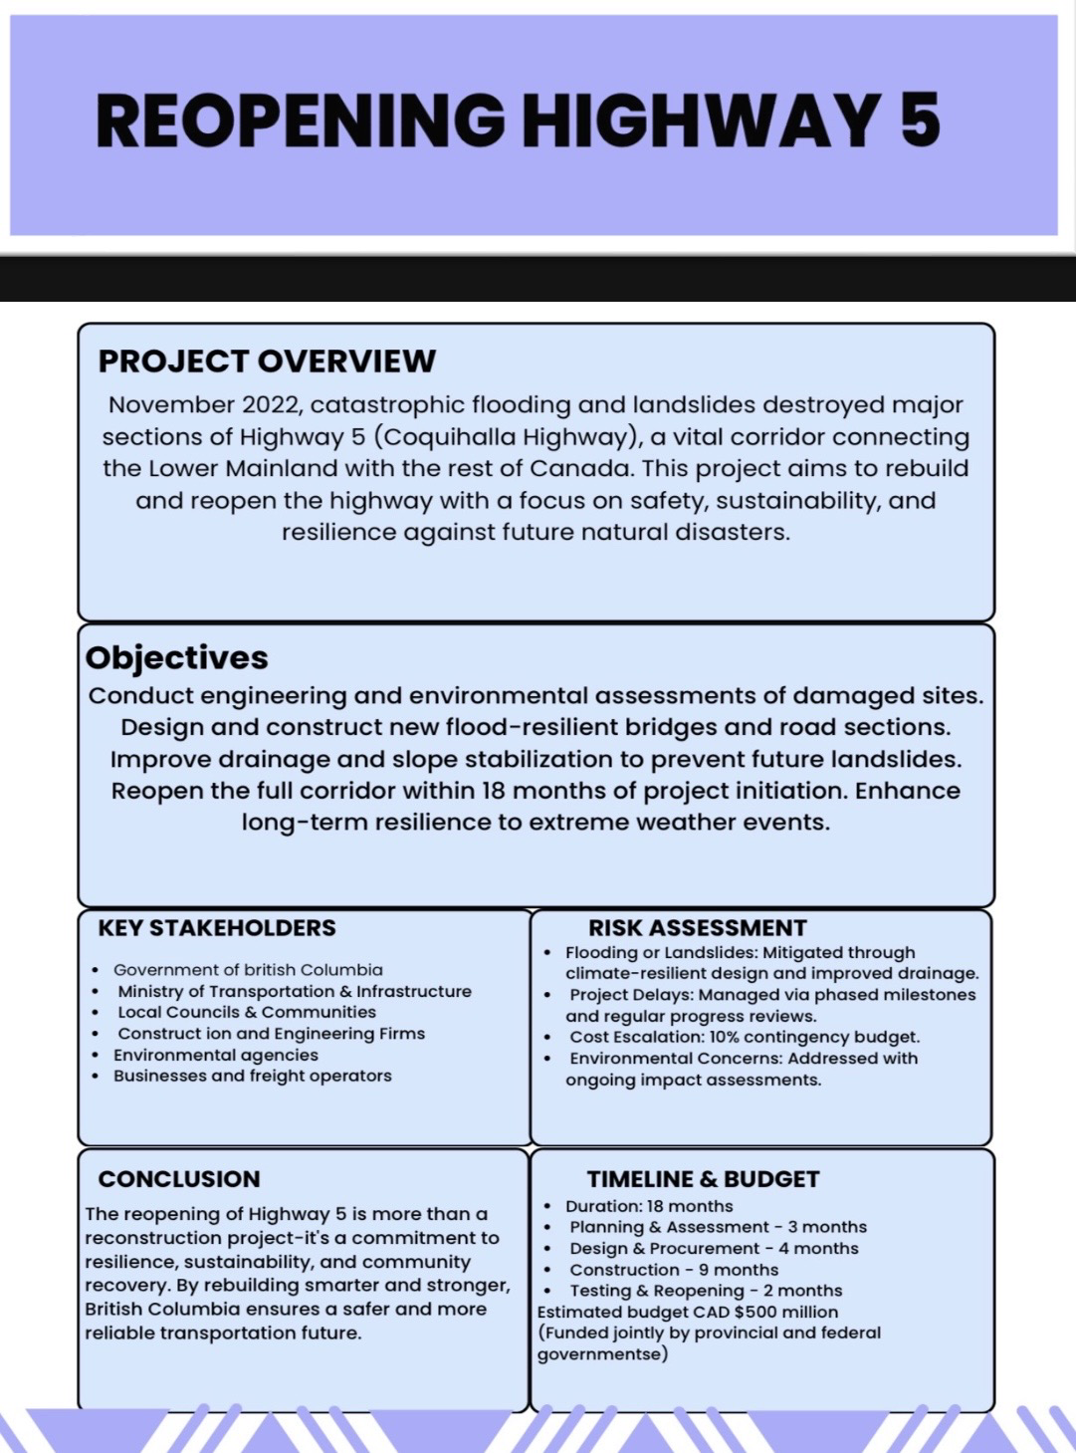

Part B: Reflection on Poster Feedback
Creating my poster about Reopening Highway 5 was a really useful experience. It helped me learn how to plan and present a project in a clear and simple way. My aim was to show how the government could rebuild the highway after the 2022 floods in British Columbia with a focus on safety, strong design, and preventing future problems like landslides.
One thing I think went well was the way I organised my poster. I broke the project into different sections like objectives, key risks, stakeholders, and budget. This made the information easy to read and follow. My peers said the layout was clear and professional. They also said I did a good job keeping the text short and straight to the point.
They said I should include more visuals like charts, icons or simple diagrams to make the poster more engaging. They also suggested using a risk matrix instead of just listing risks in bullet points. I agree this would have helped the audience understand the risks better, especially at a quick glance.
Another suggestion was to give more detail in the timeline. I had shown the project stages (planning, design, construction, reopening), but I didn’t break down the smaller tasks or show how they link together. In my final project, I will improve this by using a Gantt chart to show the timeframes clearly and include more milestones.
I also learned that I need to make better use of tools like the Work Breakdown Structure, Quad Chart and stakeholder analysis frameworks. These tools help show how work is organised and who is involved in each part. I will add these into my final project plan to make it more complete and professional.
Overall, the feedback helped me think about how to improve both the look and the content of my work. I learned that even when you have good ideas, it’s important to present them in a way that is easy to understand and visually appealing. I also saw how important it is to back up my plan with real sources and project management tools.
In my final version, I will make sure to include more visuals, use the right tools, and give more detail about tasks and timelines. This will show that I understand project management and can apply it properly. I feel more confident now about completing the rest of the assignment and using what I’ve learned from this poster to improve my full project plan.
These skills will also help me in future roles where I may need to manage or support projects in the workplace. Knowing how to break down tasks, manage risks, and present information clearly will be useful not just in academic settings but in real life job situations too. It has shown me how important it is to plan well and communicate ideas effectively.

Project Management Plan: Reopening of Highway 5

Introduction
In 2022, British Columbia experienced catastrophic flooding caused by an atmospheric river, leading to widespread landslides, infrastructure damage, and bridge collapses. Among the most critical impacts was the destruction of Highway 5, a vital transportation corridor connecting the lower mainland with the rest of Canada. The closure of this highway disrupted the movement of goods, services, and people, affecting economic activity and emergency response. This project management plan focuses on the reopening of Highway 5 to restore essential transportation and support community recovery.
A multi phase approach will be adopted (infrastructure and projects authority, 2024), considering immediate reconstruction, medium term safety improvements, and long term climate adaptation strategies. This project will not only rebuild the highway but will also embed resilience into its design to withstand future extreme weather events. The plan incorporates extensive stakeholder engagement, advanced risk mitigation, appropriate allocation of resources, and compliance with environmental regulations.

Project Description
The project entails the complete restoration and reopening of Highway 5, which was rendered inoperable due to the floods and landslides. This includes demolition of irreparable sections, construction of new bridges, reinforcement of road surfaces, drainage improvements, and environmental safeguards. The objective is to rebuild the highway to a resilient standard that can withstand future extreme weather events, ensuring safety and continuity of service.
The project is expected to span 12 months and will involve several contractors, government bodies, and local stakeholders. The end goal is to deliver a high quality, durable highway with enhanced capacity and safety features. This includes the application of modern pavement materials, reinforced substructures, and embedded monitoring systems to detect stress or damage in real time. Lessons learned from previous infrastructure projects (Royal town planning institute, 2018) and UK best practices, such as those recommended by the Institution of Civil Engineers (ICE) and the Infrastructure and Projects Authority (IPA), will guide planning and execution.

Scope
In Scope:
- Assessment and removal of damaged structures
- Bridge reconstruction
- Road and surface repairs
- Environmental mitigation and safety checks
- Traffic signage and safety barriers
- Stakeholder and community coordination
Out of Scope:
- Rebuilding unrelated infrastructure (e.g., schools, residential buildings)
- Broader disaster relief programs
- Healthcare or social services unrelated to road transport

Work Breakdown Structure (WBS)
Project Management
Planning
Documentation and Reporting
Site Preparation
Site Access and Clearance
Debris Removal
Demolition of Damaged Sections
Road and Bridge Reconstruction
Earthworks
Bridge Building
Road Surfacing
Environmental Compliance
Permits and Inspections
Quality Assurance and Testing
Handover and Project Close

Quad Chart

Category | Details
Project Goals | Restore Highway 5 to operational status, enhance resilience, re-istablish transport, minimize disruption
Stakeholders | Gov. of British Columbia, Ministry of Transportation, Contractors, Residents, Environmental Bodies
Risks | Weather delays, cost overruns, labour shortages, environmental compliance
Resources/Timeline | Budget: $100m CAD, Duration: 10–12 months, Resources, staff, equipment, consultants

Expanded Explanation of the Quad Chart
The Quad Chart provides a high level snapshot of the project’s four most important areas: goals, stakeholders, risks, and resources. Each quadrant plays a specific role in giving stakeholders, including project sponsors and senior decision makers, a concise summary of the project’s landscape.
Project Goals: These highlight the core purpose of the project, which in this case is to reopen Highway 5 with improvements in flood resilience and transport efficiency. By including resilience in the goals, the chart aligns with both short term recovery and long term strategic priorities.
Stakeholders: Listing key groups such as government departments, contractors, environmental bodies, and residents shows the range of interest that must be coordinated. This visual emphasis ensures stakeholder communication remains central throughout the project lifecycle.
Risks: Identifying top risks such as weather delays, cost overruns) gives a quick view of what could go wrong. The inclusion of this quadrant reinforces the need for continuous risk monitoring and mitigation planning.
Resources and Timeline: This quadrant provides a snapshot of budget and delivery window. Stakeholders can use this to track high level feasibility and ensure resources are proportionate to project complexity.

Gantt Chart

Phase | Timeframe | Activities
Planning & Permits | Month 1–2 | Initial planning, regulatory approvals
Site Prep & Demolition | Month 2–3 | Clearance, debris removal, demolition
Reconstruction | Month 3–8 | Bridge & road works, surfacing
Environmental Monitoring | Month 6–9 | Compliance checks
Quality & Testing | Month 9–10 | Inspections, materials testing
Handover | Month 10–12 | Final review, transfer to authorities

Expanded Explanation of the Gantt Chart
The Gantt Chart is a key project management tool used to visualize the project schedule. It breaks the project into distinct phases, each with a defined time period and set of activities. :Lock, 2020)This helps stakeholders understand the sequence of operations, dependencies, and overall project pacing.
Planning & Permits (Months 1–2) Early stage planning includes site inspections, environmental approvals, and stakeholder meetings. These foundational tasks ensure the project starts on solid legal and technical ground.
Site Preparation & Demolition (Months 2–3) This phase involves site clearance, safety setups, and controlled demolition of damaged structures. Delays here could affect downstream construction, making efficiency vital.
Construction (Months 3–8) The core engineering phase includes bridge reconstruction, road resurfacing, slope stabilisation, and installation of drainage. As the longest phase, it's closely monitored through progress reports.
Monitoring & Auditing (Months 6–9) Environmental, financial, and safety audits take place in parallel with late stage construction to ensure compliance.
Quality Assurance (Months 9–10) Testing of materials, bridge stress tests, and surface inspections are done to confirm readiness for public use.
Handover & Closure (Months 10–12) This final stage involves formal approval, transfer to authorities, and project documentation closeout.
These visual tools (Quad and Gantt charts) help communicate complexity clearly and allow for easier project governance, especially when engaging with non technical stakeholders.

Stakeholders Involvement

Stakeholder engagement is a critical aspect of project success, particularly in public infrastructure projects such as the reopening of Highway 5. (Maylor,2010) Effective engagement ensures that the needs, concerns, and expectations of all involved parties are acknowledged, addressed, and incorporated into the project planning and delivery process. This not only enhances project transparency and public trust but also minimises the risk of delays, disputes, or project failure due to miscommunication or opposition.
Key stakeholder groups involved in this project include:
Government Agencies and Transport Authorities: These include the Ministry of Transportation and Infrastructure (MoTI), the local municipal councils, and regulatory bodies. They are responsible for funding allocation, issuing permits, overseeing compliance with national and regional construction codes, and providing strategic direction. Their approval is essential at multiple project milestones including environmental assessments, design approvals, and final inspections.
Construction Firms and Contractors: These stakeholders are responsible for on the ground implementation of the project. Their duties include sourcing materials, hiring labour, ensuring site safety, and maintaining timelines and quality standards. Close collaboration between contractors and government authorities is essential to ensure standards are met and budgets are adhered to.
Local Residents and Business Owners: Residents and local business operators along the Highway 5 corridor are directly affected by construction activities. Their daily routines, access to services, and business operations may be disrupted. As such, regular community updates, public consultations, and feedback mechanisms (e.g. town halls, surveys) are necessary. Involving these stakeholders early helps mitigate resistance and generates local support.
Environmental and Conservation Groups: Environmental bodies and NGOs are essential in ensuring the project complies with ecological standards and causes minimal disruption to local ecosystems. These stakeholders play an advisory role during environmental impact assessments (EIA) and contribute to developing sustainable mitigation strategies such as wildlife corridors, water run off management, and reforestation plans.
Emergency Services: Fire brigades, ambulance services, and police forces require up to date access to the route during construction and post completion. Their involvement in planning helps ensure emergency response times are not compromised. Collaboration with these stakeholders supports the design of diversion routes and temporary access points during different project phases.
Media and Public Relations Teams: The media plays an indirect yet vital role in shaping public perception. A designated communications team should provide consistent updates via press releases, social media, and public websites. This keeps the wider community informed, manages expectations, and builds trust in the project team.
Academic and Engineering Institutions: Partnerships with universities or research bodies can provide access to innovative designs, climate modeling tools, and independent evaluations. These institutions may also help monitor long term project outcomes and provide case study material for future national infrastructure planning.
Stakeholder engagement will be guided by a detailed Communication Plan outlining frequency, format, and responsibilities for all interactions. The use of RACI (Responsible, Accountable, Consulted, Informed) charts will help define roles clearly. Digital dashboards, stakeholder mapping tools, and regular engagement logs will support transparency and effective coordination throughout the project lifecycle

Allocation of Resources
• Human Resources: Project manager, civil engineers, construction workers, environmental consultants
• Financial Resources: Estimated budget of $100 million CAD
• Material Resources: Concrete, steel, machinery (cranes, excavators, pavers)
• Time: Total project duration of approximately 12 months
Risk Analysis
Risk | Likelihood | Mitigation Strategy
Weather delays | High | Use flexible scheduling and weather forecasting
Cost overruns | Medium | Strict budget control and phased spending
Labour shortage | Low | Workforce planning and recruitment
Environmental violations | Medium | Early engagement with regulators

Recommendations for Future Practice
Based on this project management plan, the following recommendations are made for future disaster recovery and road infrastructure projects:
Preposition Framework Contracts: As recommended in the UK’s Infrastructure and Projects Authority guidance, having pre approved contractors and designs can drastically cut mobilisation time in emergencies.
Integrated Digital Systems: Adopting Building Information Modeling (BIM) and cloud based planning tools like MS Project can help synchronize tasks and flag risks across large, dispersed teams.
Early Community Engagement: Consult local communities before, during, and after construction to foster goodwill and uncover local insights that may reduce project delays.
Climate Adaptation Planning: Ensure all road designs include buffer zones, climate resistant materials, and future proofing for electrification and autonomous traffic systems.
Third-Party Auditing: Include an independent audit body to conduct quality and financial checks at each major phase. This builds public trust and improves governance, a standard approach in UK government funded programs.
Implementing these recommendations can help standardize a blueprint for resilient, sustainable, and transparent infrastructure recovery efforts in both UK and international contexts.

Conclusion
The reopening of Highway 5 is a critical infrastructure project that addresses the significant transportation and economic disruptions caused by the 2022 floods in British Columbia. Through strategic planning, effective stakeholder engagement, resource allocation, and risk mitigation, the project aims to restore connectivity and build future resilience. This plan demonstrates the application of key project management principles to ensure timely and successful delivery. Continuous learning, quality assurance, and adaptive planning will be essential. In future projects,(Institute for government, 2018) these lessons will serve as a benchmark for post disaster reconstruction not only in Canada but for infrastructure professionals globally.

References
Institute for Government. (2018) How to Transform Infrastructure Decision Making in the UK. https://www.instituteforgovernment.org.uk/sites/default/files/publications/IfG infrastructure decision making WEB.
Association for Project Management (APM) & All Party
Parliamentary Group for Project Delivery. (2025)
Improving National Infrastructure Project Delivery. APM.
https://www.apm.org.uk/media/c4zhvmno/250506-appg-
for project delivery inquiry into improving national infrastructure project delivery

Infrastructure & Projects Authority (IPA). (2025) Annual Report on Major Projects 2023-24. HM Government.
https://assets.publishing.service.gov.uk/media/678a4a9869b
9b76c761d0574/IPA_Annual_Report_2023-24

The Chartered Institute of Building (CIOB). (2022) Code of Practice for Project Management for the Built Environment (6th editionWiley/ Blackwell.

National Highways (2021) Lessons Learned Highway Sector Extreme Weather. HM Government.
https://assets.publishing.service.gov.uk/media/61927d24d3
bf7f055d72d4dd/lessons-learned-highway-sector-extreme-weather

UK Roads Leadership Group (2021) The Case for Investing in Highway Maintenance.
https://ukrlg.ciht.org.uk/media/15247/the-case-for
investing in highway maintenance

Royal Town Planning Institute. (2018) A Smarter Approach to Infrastructure Planning. https://www.rtpi.org.uk/media/1pyhzyhz/a smarter approach to infrastructure planning

Maylor, H. (2010). Project Management. Pearson Education UK.

Lock, D. (2020). Project Management.11th edition. Gower Publishing, UK.

