Why I think you need this module
By Dr Caroline Jawad 2019

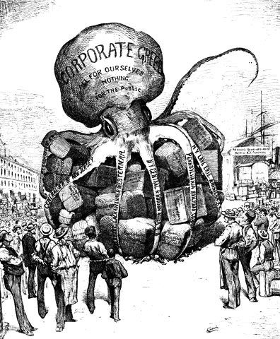

Figure 1 Cartoon depicting Populism (aka Pefferism) a reform movement of the 1890's against the special privileges of industrialism and the American banking system.

After many financial crises and organisational scandals and in an era of severe turbulence, rapid change and increasing complexity has emerged.

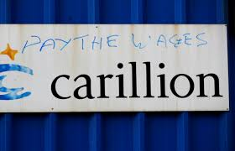

Figure 2 Carillion collapse - Does it confirm that for decades, companies, privatisation and extreme capitalism have failed in their basic business responsibilities and ends up threatening just about every strand of public life one way or another? Tens of thousands of jobs lost, the pension fund needs bailing out and dozens of infrastructure projects are thrown into question. This is just one of a number of corporate failures that lies at the door of government of all tribes. With just £29 million left in cash to service over £2 thousand million worth of debt, does the failure of this company demonstrate just how reckless and incompetent this model of never-ending growth, dividend payouts and exorbitant pay for senior staff gets? Is it all ending in foolish risk taking – at any cost?

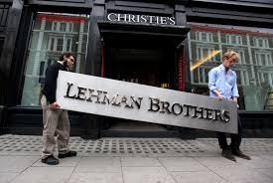

Figure 3 Lehman Brother investment bankcrashed into bankruptcy – the biggest corporate failure in history – and sent the world’s financial system reeling close to collapse, causing panic among policymakers on both sides of the Atlantic. The US government was forced into a $700bn (£540bn) bailout of the banking sector, while in the UK, Lloyds Bank rescued HBOS and the government was then forced to rescue Lloyds and the Royal Bank of Scotland.

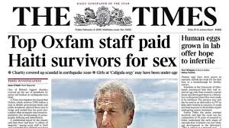

Figure 4 The Times in 2018 published a string of stories based on the contents of an internal report from 2011, that showed Oxfam had investigated senior staff — including its then Haiti country director — for alleged sexual exploitation and bullying. The allegations included Oxfam staff paying young Haitian women for sex during the humanitarian response to the 2010 earthquake. Would you agree that this is an abhorrent abuse of power by Oxfam officials?



Figure 5 Corruption at FIFA included bribery, wire fraud, racketeering, and money laundering and Blatter asked why, he, the Fifa president should bear all the charges, the responsibility and the blame. Why indeed.



Figure 6 The 'Me too' phrase, first coined by American social activist Tarana Burke in the mid-2000s, went viral in 2017 following a tweet by actor Alyssa Milano, who – in the wake of allegations against Harvey Weinstein – encouraged victims of sexual harassment or assault to share their stories in order to show the breadth of the problem. Employers claim it is unfair to put the onus of responsibiity on them to prevent sexual harassment and victimisation - do you agree?



Figure 7 In 2016, Samsung dealt with exploding Note 7 batteries. In 2017, it was imploding corporate ranks. Heir Lee Jae-yong at the head of the empire was caught in a sprawling political scandal that took down former South Korean President Park Guen-hye.

There is a dark cloud hanging over economic prosperity and global consumption habits, which I argue, fundamentally challenges the purpose of business. All too often the approach to business practices has been the one-dimensional classical economics, lacking in richness and depth. I suggest to you, that discipline of philosophy can facilitate ways forward.

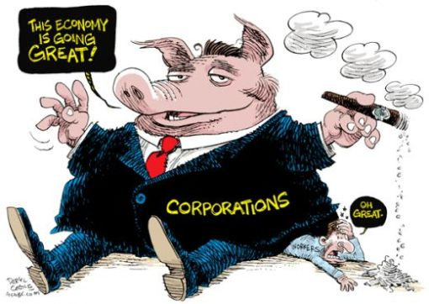

Figure 8 Who is in control - nation states or global corporations?

Arguably, the concept of ‘not business as usual’ in management is becoming old-fashioned, while the socio-economic challenges of globalisation mature. In many countries, labour market conditions are deteriorating and underemployment at an unprecedented level. Workers face a distinctively new normal, as the operational capacities of business leaders are fundamentally changing. In order to successfully navigate in an uncertain, volatile and increasingly complex business environment, a supplementary approach to rational problem-solving and optimal decision-making is required.

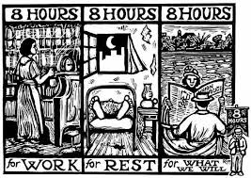

Figure 9 Historically, eight hours of work came about following a campaign by social reformer Robert Owen in 1810. At the time, factories were open 24 hours, and workers would often find themselves working 10-15 hour shifts.

The rising demand for both creative and concrete problem-solving as well as abstract and strategic thinking indicates the necessity to broaden the reflectivity-horizon of the narrow business perspective that future business leaders will determine their decisions within. Business tends to seek one rationalised conclusion at the expense of others. This closes opportunities, rather than opens them. Philosophy, on the other hand, can through critical reasoning continually question and rethink the assumed certainties and its basic premises. In this sense, business and philosophy might seem poles apart at first glance and their interdisciplinary potential has for long been largely unrecognised on traditional business schools, but you are about to challenge this.

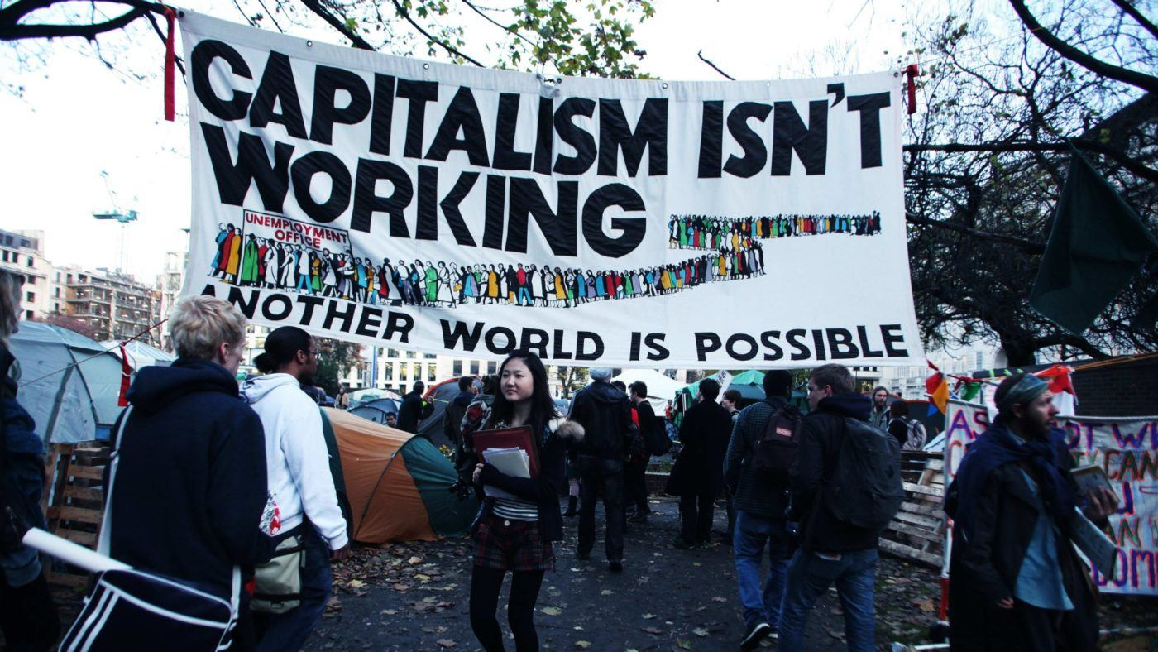

Figure 10 The argument that capitalism is not working because it requires inequality of wealth and the current level of rising wealth inequality is set to grow still further. Whose responsibility is this?

I urge you to consider how we must be willing to constantly challenge our traditional beliefs and perceptions in order to engage in the discussion of where we are heading, and where we want to head. The call to confront our habitual mindset is not grounded in the common anti-capitalistic bias, where business is evil and cannot be trusted, but in an assessment of the long-term socio-economic impact of short-term decision-making. I am not an anti‐capitalist. I should say that I am actually a great believer in the merits of capitalism myself. But I am certainly more in favour of democracy than the very raw capitalism that we are seeing at the moment changing Europe and also parts of America.

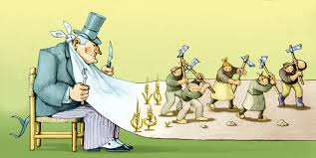

Figure 11 Capitalism the economic system in which capital goods are owned by private individuals or businesses. An alternative interpretation of capitalism is that we live in a corporate plutocracy and those holding all the wealth and therefore power have no intention of changing the status quo, even if it is not sustainable. Is that fair?

Philosophy pursues questions rather than answers them. In this sense, the responsibility of philosophy is not so much to answer our questions, but to question our given answers. The placement of the concepts of ethics, morality or justice under an investigative lens can help us move beyond the confinements of prevailing knowledge. This is the essence of the discipline of philosophy – it teaches not what to think, but how to think. It examines the enduring fundamental questions concerning human life, society, ethics and knowledge, just to name a few. Whereas, the business discipline represents a definite ordering of the world through the fabrication of concepts, methods and models as a way to reduce complexity, philosophy explores its conceptual framework and developments. Porter’s Five Forces and almost every other generic framework for problem-solving are heuristics: they can speed up the process of finding a solution, but it is at the expense of autonomous thinking. In this way, philosophy can help articulate the blind-spots of business by looking behind its assumed certainties and theoretical preconditions. By pondering the questions which are beyond the scope of business, philosophy can broaden the reflectivity-horizon of future business leaders to help them manage complexity and make sound decisions, not only in the purview of good business, but also in accordance with the needs of society.

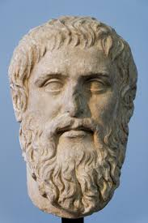

Figure 12 Plato believes that conflicting interests of different parts of society can be harmonised. The best, rational and righteous, political order, which he proposes, leads to a harmonious unity of society and allows each of its parts to flourish, but not at the expense of others. How do we achieve this?

This, however, does not point to a future of philosopher-leaders, as Plato encouraged. This is because the pragmatic judgement and technical expertise of business is still very much needed to direct the philosophical reflections towards practical decisions and concrete actions. In this regard, business models, concepts and strategies are certainly still a necessity. But in order to keep improving them, philosophy demands attention. This is the interdisciplinary potential of business and philosophy. So don’t worry, there will still be plenty of need for specialized business experts, which turns us back to the initial question: Is philosophy really a passport to a successful career in business? No, but it is definitely not irrelevant. Not for business. Not for career progress. Not for society.

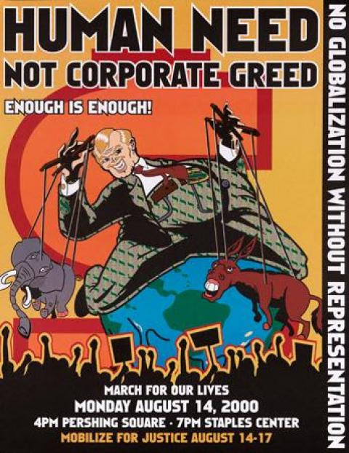

Figure 13 Greed is not always good. Corporate moral agency, also referred to as corporate moral responsibility, is considered by some to be a counter-balance for the entrepreneurial drive toward profitability. Others in positions of authority might prioritize profits and the competitive drive ahead of an adherence to a moral or ethical code beyond the letter of the law. Who is right? And why?

There is greed, materialism, lack of ideals, and selfishness in the world of business and, even worse, within myself. Why are we all so unethical? I have questions about the ethics of everything, and eventually, after many twists and turns in the world of business, I found a home in applied ethics which refers to the practical application of moral considerations. It is ethics with respect to real-world actions and their moral considerations in the areas of private and public life, the professions, health, technology, law and leadership.

