With reference to one site and its hinterland, discuss the significance of the site in terms of its importance to local narratives linking archaeology, heritage, environment and/or landscape.

Dan Yr Ogof Cave Complex – Heritage Management, Environmental Conservation Approaches

Grace Loveday – 1600336 – University of Wales Trinity St David

Acknowledgements:
- Dan Yr Ogof Show Caves for the production of their souvenir guides
- Sarah Symons for her interest in the site and a most captivating read
- Dan Yr Ogof’s conservatory panel and use of the Alan Coase Slide Gallery
- British Caving Association and the Cambrian Caving Council for their printed resources

Contents:
- Abstract
- Photographs & Mapping
- Introduction & Key Issues
- Evaluation of site features
- Methodology & Data
- Importance to Local Narratives
- Archaeology & Heritage
- Environment and Landscape Conservation
- References & Appendices

Abstract:
The Dan Yr Ogof cave complex is a collection of three caves, open to the public, and a mass of caverns and tunnels open to professional cavers only. The site has been open to the public since 1939, with the main Cathedral Cave being the point of interest for most explorers (discovered 1953). The cave was closed during the Second World War to be a government store. The cave complex we see today is categorised into three distinct phases, DYO I, DYO II, DYO III (Dan Yr Ogof). DYO I being the first exploration, undertaken by the local land owners, the Morgan Brothers, in 1912. DYO II was the furthering of this exploration, undertaken from 1964 when exploration resumed after the war years, finding in 1966/7 saw further passageways to allow for the site to reach the length we see today. DYO III and the excavations of Ogof Yr Esgyrn commenced in 1974 and continued through to 1985 when the site was commercialised. The report will cover the current environmental and conservation issues that the site faces today, and how the differing layers of exploration and excavation have affected the physical make-up of the site. The site’s conservation plan will be evaluated, and how the site is affected by those professionally caving and the policies and restrictions of which they abide. This report will bring to light issues surrounding human interaction and interference with the site, and whether the site is currently managed properly and in the best interests of the limestone caverns.

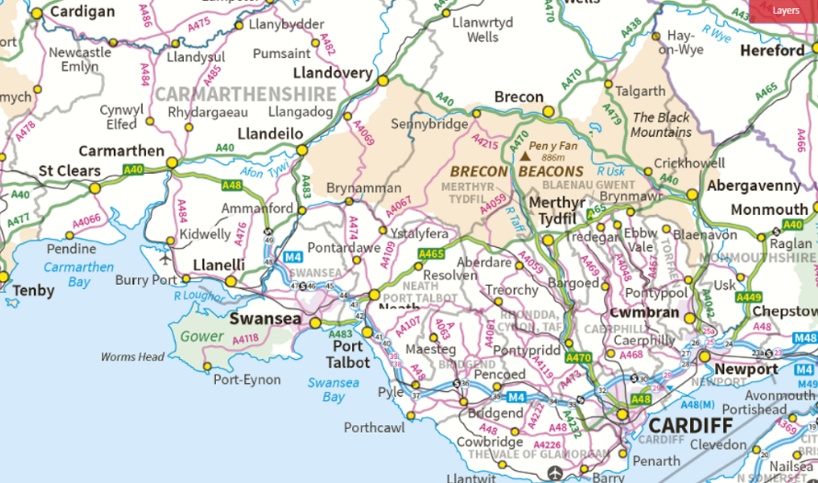
(OS Mapping)—≥ South Wales via Coflein

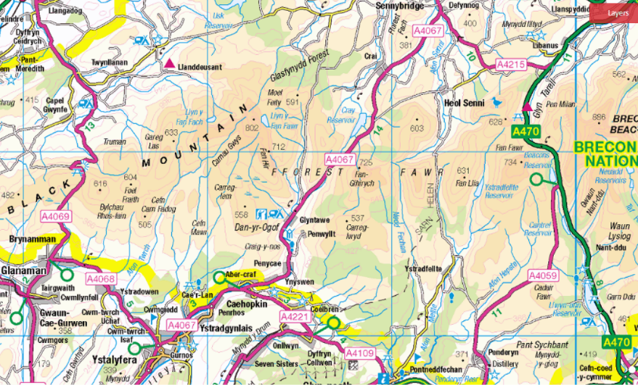
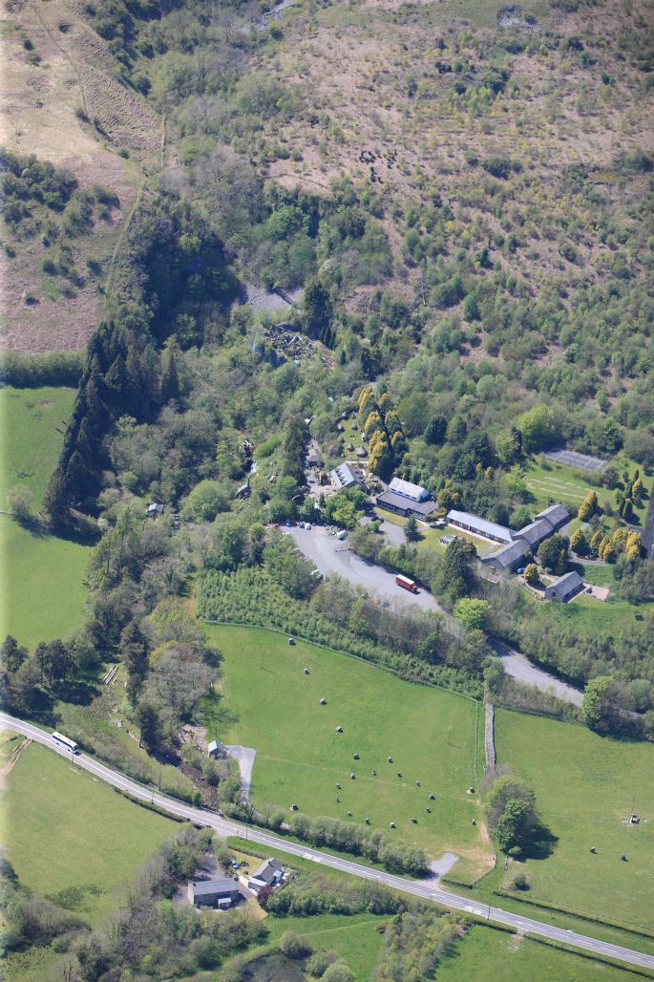

Description: RCAHMW colour oblique photograph of Dan yr Ogof showcaves. Taken by Toby Driver on 22/05/2012.
Catalogue Number: C916253
File Reference: AP_2012_1982.TIF

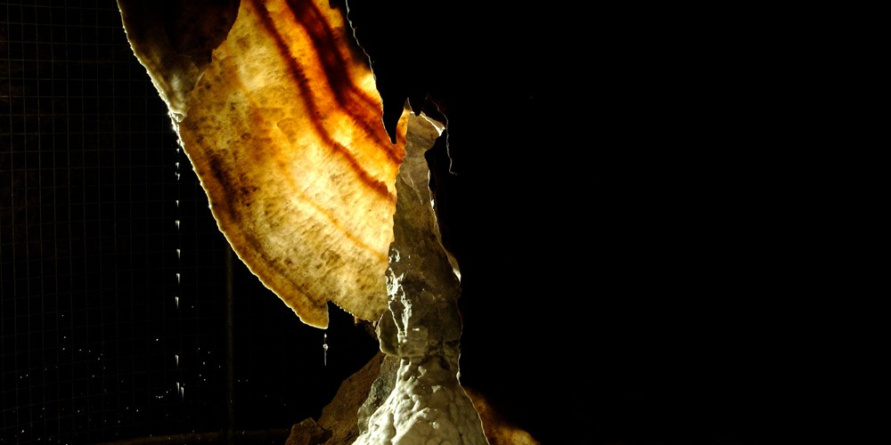
Figure 1: Flitch of Bacon, Courtesy of National Show Caves Website (see appendix)
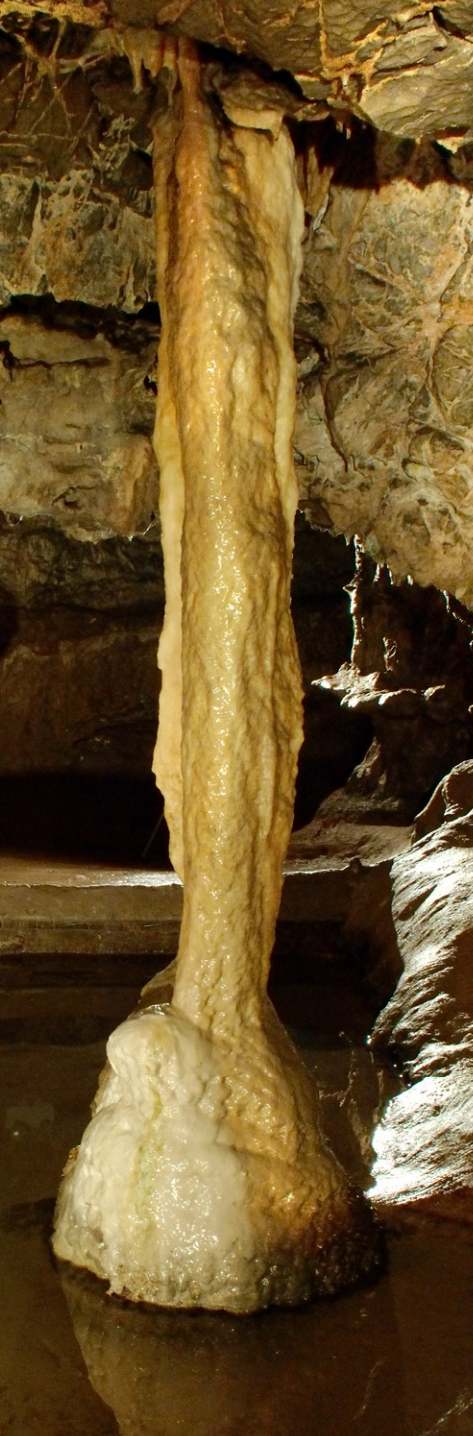
The National Show Caves Centre for Wales is a well established tourist site that is a Site of Specific Scientific Interest (SSSI) due to the nature of the formations inside the caves and the geomorphology of the surrounding areas. The site is formed of three different caves, Dan Yr Ogof, Ogof Yr Esgyrn and Cathedral Cave. Dan Yr Ogof is home to unique rock formations, including stalactites, stalagmites, and flowstones. The most notable of these formations are the Flowstones, ribbed with red and orange colours due to the lead compounds in the water that flows through them. These characteristics led to the largest formation being called the ‘Flitch of Bacon’ after preliminary explorations. Other noted developments include the ‘Alabaster Pillar’ which is a connection of two stalagmites and stalactites to form a strong singular pillar. This cave structure does not follow typical passageway formations that are usually associated with carboniferous limestone caves, instead the passages are seen to be falling at a steep gradient, an indication of surface weight, attributed to the ice age glacial movements.
Figure 2: Alabaster Pillar, Courtesy of National Show Caves Website (See Appendix)

Cathedral Cave is famed for its large cavern, cascading waterfalls, open spaces and underground lakes. The introduction of electric lighting revealed the tubular surfaces of the cave ceiling and discovered the ‘Organ Pipes’ a collection of tubular stalactites covering a large portion of the ceiling. These geological wonders are the larger two of the caves and are currently presented in a very visitor orientated way. Adding to the grandeur of the cathedral cave, the visitors are accompanied by a string of speakers playing classical music that use the acoustic space to echo throughout the cave system. The visitor’s journey is directed and shaped by pathways of audio guided information.
Ogof Yr Esgyrn, the Bone Cave, is situated at 45 metres above the Dan Yr Ogof cave platform, and has value in both archaeological and geomorphic senses, due to the unique discoveries and the process of which they were discovered. The archaeological excavations of the Bone Cave took place in three distinct periods, the 1923 excavations and the discoveries of the human remains, the second period starting in 1938 where a larger portion of bodies were excavated, along with Roman Britain era objects such as brooches, military adornments, and pottery sherds. Interestingly, the pottery sherds were hidden under a 75mm thick sheets of calcite forming over the cave floor, giving a valuable insight into the speed and growth of these calcite sheets. The final excavations were undertaken in 1978 to understand more about the Roman deposits and discovered a handful of coins minted across Gaul and Rome, and two 2nd century bodies, one male and one female.
Such excavations are important to highlight the prolonged human use of the cave, with visible evidence of human interaction dating back to late glacial periods and bronze age man.
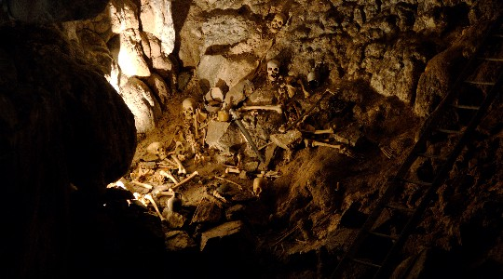
Figure 3: Ogof Yr Esgyrn and Bronze age skeletons
Local Narratives & their engagement with the Caves:
The narratives surrounding this site engage with the motives of the first explorers, the Morgan Brothers, and their personal background and possible motives for undertaking the dangerous expeditions time and time again. At this point we can only speculate, as there was little written about their discoveries, from a descriptive point of view we only have photographs. But as the brothers were from a background of mining and agricultural farming, we can suggest that their motive was potentially wealth driven, with the ideas that the valuable materials are found underground. Locally, the caves have been of interest and a tourist destination, after the discovery they were opened to the public in 1939 and they were a success.
With the beginnings of the Second World War in late 1939, the project was near abandoned for 30 years. During the war years, the site was used to house valuable objects from various museums and libraries across wales for safe keeping but due to legislature such as the Official Secrets Act information surrounding this use is inaccessible. The national importance of these caves should also be recognised, pioneering in research and understanding of limestone caves, although in comparison to others the caves are young, they have come to be so varied and large because of the pushing nature of the forceful streams that carved open the caverns and created the intense rock formations.
The caves are locally admired, par example, the author Sarah Symons, born in Ystradgylnais and with an interest in caving all her life being a driving force behind publishing her book. Other examples include the various caving clubs in the area that are behind furthering the explorations, such as Cambrian Caving Council, South Wales Caving Council and the British Caving Association. Without their ambition and curiosity, half of the tunnels and passageways would not have been mapped to the extent of which we know about today.
In this report, highlighting the key issues surrounding heritage management, in accordance to specific government bodies and their codes of conduct is integral to understanding and evaluating the conservation management plans. This site is protected through Natural Resources Wales due to its SSSI status and adheres to strict regulations surrounding the upkeep and expansion of the site. The site is also a scheduled nature reserve, holding various species of salamander, newt, and white cave trout.

Current Heritage Management Strategies:
The site currently uses mainly built measures to ensure the safety of the cave and the visitors, attempting in the most part to create an environment that is accessible but not harmful. Visitor journeys are directed by raised platforms, handrails drilled into the cave walls, caging around potentially hazardous rock, concrete flooring and artificial lighting running throughout the ‘accessible’ parts of the cave structures. Raised platforms and walkways that run along the two main caves are the safest way to make the visitor safe, but also ensuring that they do not do additional damage to parts of the cave that are off the path. The caves in their earlier years suffered some irreversible damage when a few stalagmites were broken and taken from the cave. Vandalism is an important part of any heritage site to consider, and especially here when the site is of such historic and scientific importance. Previous cases of vandalism prove that despite having extensive signage and monitoring, the caves are still vulnerable to human interaction. This is not only due to vandals, this damage is not limited to vandalism with intent, the act of littering or dropping chewing gum can have effects on the cave for hundreds of years, as they cannot degrade in the underground environment or any environment at all.
The walkway system to approach and climb up to the Bone Cave is a concrete pathway, leading up a cliff face that is caged with a canopy roof. The safety guidelines recommend that wearing a hard hat is essential to visitor safety when using the canopy, as the steepness and lowering of the passageway can be dangerous. This passage is the latest edition in visitor access and still has much work. Once at the peak of this mountain, the cave is accessed by a lowered doorway and the contents blocked off with a large metal screen to protect the valuable artefacts that still reside there. Again this cave has in the past fallen prey to vandalism because it was earlier not deemed as important to the site, before the majority of the discoveries had been made. There is no access to this cave in the evenings and low level lighting is implemented to protect the bone structures that still reside there. There is no supervision on this site and there is no regulated limit for those climbing to the peak. The visitor flow is stumped and struggles to stay constant, with mass movement contributing again to the depletion of the doorways and some of the walls.
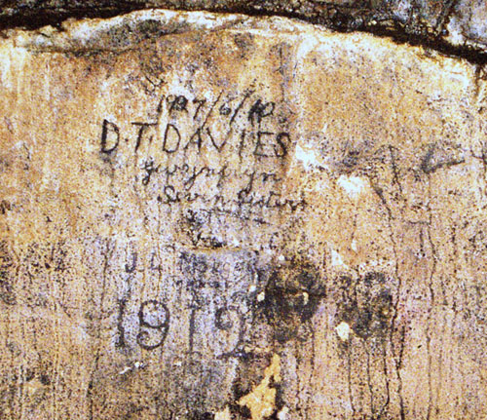
Handrails are one of the most prominent features of the cave complexes, being one of the oldest forms of safety put in place for ease of navigation during the time in the cave. Unfortunately to the detriment of the site, these are drilled into the cave walls and damage the foundations. These could be improved by adding free standing supports, for anybody who needs them, or advised to use them only when absolutely necessary to limit the weight put on them and in turn the weight crushing against the rock. In addition, the walkways and platforms cause a barrier to the natural growth of the cave’s environmental state, although the cave grows little in 10 years, evidence of human interaction can get trapped or stuck under the rock, as seen in the Bone Cave with pottery. The caging of potentially hazardous rock can be seen as damaging because the processes of decay, movement and growth are again then stunted, and even in the past 50 years, the alteration of this growth is possible to cause issue in the future for visitors and environmentalists. Artificial lighting runs throughout the cave system, along with a ventilation system to regulate airflow. Artificial lighting could be a potential problem, although it is at low risk to the site because it is limited to only the times the cave is in use. There have been no studies to suggest that lighting is harmful to the cave or the natural environment, flora or fauna that reside there.
Figure 4: Inscribed Graffiti, Above, South Wales Caving Co. Below, Morgan Brothers (see appendix)
Visitor interaction has physical effects of wear and tear, as the visitors are being pushed through the caves in a controlled way, the mass movement of people through small spaces, and a singular entrance point, it is evident that there has been alteration to the site. Specifically, where the visitor walkways create a loop where by two points meet up again. Here the erosion due to mass movement is most evident, because of the smoothing and rounding of the rock that make up the corners of the passage ways. This constant touch with oily hands has resulted, in only the short time the site has been open, in alterations in the rock face that would never have naturally occurred. But managing the visitor flow by staggering entrance times or creating a maximum limit per cave would curb the effects, so why is the centre not putting these precautionary procedures in place for the safeguarding of the site’s unaltered and natural future growth? Perhaps because the measures currently in place work, or that they have not yet been challenged. This site is seen to be favouring accessibility over conservation, creating more stable and safe environments for visitors and putting the physical damage of mass movement to one side as they fix larger issues and turning the site into a business-centric operation.
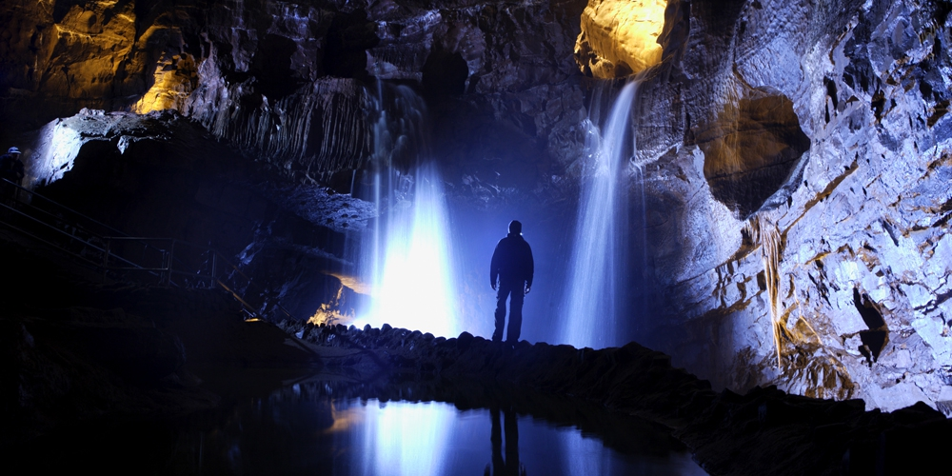
Figure 5: Cathedral Show Cave
The current conservation management plans outline these key things:
- Dan Yr Ogof’s specific heritage and scientific importance to the landscape of Wales.
These values are endangered by both carelessness and intentional vandalism.
The responsibility for protecting the cave must be shared by all those who visit them for whatever purpose.
- The cave is a Site of Special Scientific Interest and part of the nation’s heritage to be protected for present and future generations.
- Putting the conservation and protection of the cave at the forefront of all activity and liaising with the relevant governmental bodies to keep this true.
- Providing the guidelines by which the professional cavers abide, and ensuring that every visit is insignificant to the physical body of the cave.
- There are employed within the park, Conservation Wardens that partake in the caving crews with professionals in order to keep their exploits in check.

Although these rules and regulations surrounding the safe keeping of the site are in place, the written conservation policy given to the site is extremely vague, there are no reports annually or even per decade on the development of the site, no evaluative measures undertaken by the staff and barely any in house monitoring. Although Natural Resources Wales are a large and trustworthy organisation, they should not be the soul contributors to the understanding and monitoring of such a nationally important geographic monument. The improvements to the conservation policy the site currently holds would be to implement a more permanent measuring system for the continued upkeep of the caves, that would therefore highlight any irregularities or anomalies that could be dealt with before they became dangerous. An additional clause would include something with a more specific heritage waterways based conservation plan, with a particular focus on river channels, river erosion and growth levels, pollution levels to ensure that we can and are doing everything to keep this natural wonder in place for future generations. Long term river management would mean protection for climate change, predicting the outcomes of the earth warming and drying. Addressing these issues in relation to caves are important due to the fact the majority of the cave systems rely on water to keep the walls, roofs, ceilings and rock beds dry and safe. By putting in preventative and non-invasive measures the site can be properly looked after as climates change and needs change.

References and Appendices:

Coase A,C.(1975.) The structural geomorphology of the Dan yr Ogof Caves, Tawe Valley, South Wales.. http://search.ebscohost.com/login.aspx?direct=true&db=edsble&AN=edsble.674099&site=eds-live. [accessed 03-02-19]
Ford, D. Coase, A. (1989) Limestone Caves of Wales, (Dan Yr Ogof Essays) Cambridge University Press, Cambridge.
Symons, S. (2003) The Wonders Of Dan Yr Ogof, Dinas, Ceredigion.
Dan Yr Ogof, Showcaves Souvenir Guide (1990)
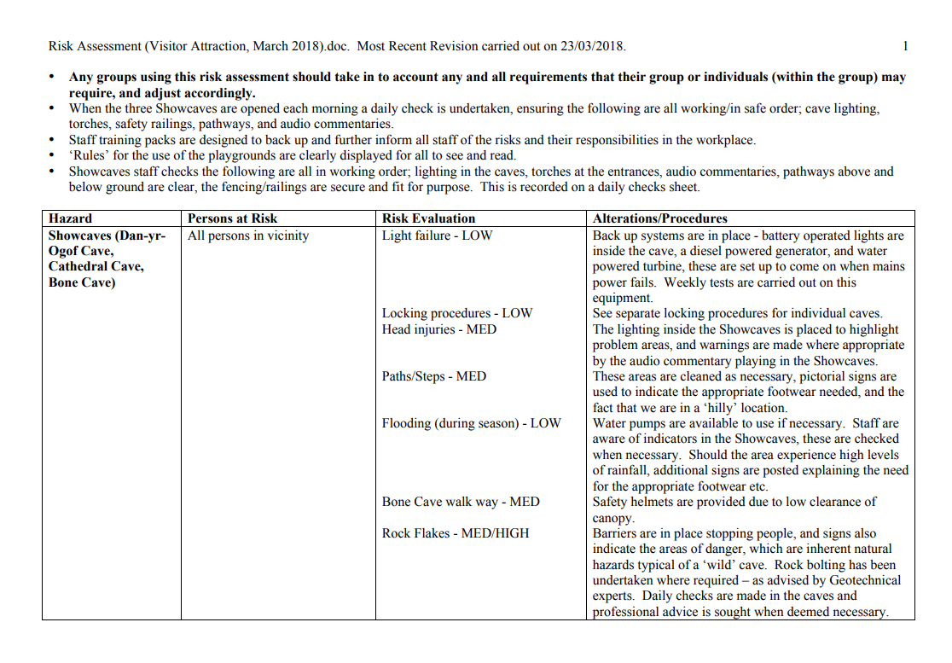
Figure 6:http://www.showcaves.co.uk/pdf/RiskAssessment.pdf Risk assessments carried out in order to fulfil safety rotas

Photographs used:
National Showcaves Wales – Dan Yr Ogof Press free imagery
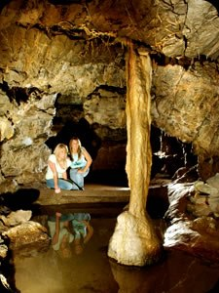
http://www.showcaves.co.uk/press_enquiries.html

South Wales Caving Council Imagery:
https://www.swcc.org.uk/aboutswcc/history/members/piwh_1/earlydyobeginningsofswcc_ofd.php

https://coflein.gov.uk/en/site/96556/details/ogof-yr-esgyrnbone-cave-dan-yr-ogof
Ford, D. Coase, A. (1989) Limestone Caves of Wales, (Dan Yr Ogof Essays) Cambridge University Press, Cambridge.
Symons, S. (2003) The Wonders Of Dan Yr Ogof, Dinas, Ceredigion.
Ford, Coase (1989)
Ford, Coase (1989)
Dan Yr Ogof, Showcaves Souvenir Guide (1990)

