Marketing plan for the brand
Six Senses
Dina Priedulena
Student ID Number: 2233688
Marketing Essentials BMIH4005
Chris Wilkin
Word Count: 1375

The company Six Senses was founded in 1995 and considers its mission to promote responsible practices at the highest level of hospitality.
Six Senses offers its services in Asia & the Pacific, Europe, and Middle East & Africa. In the company's range of services, in addition to overnight stays in hotels, resorts, or residences, there are also wellness &Spa services, various rituals, and opportunities for spiritual practice.
(Six Senses, 2023)
In this work, a brand analysis will be performed using six fundamental facets of marketing (SOSTAC) ( Chaffey and Smith, 2013, p. 4) as a basis.
SWOT (Micro analysis) (Fisher, Wisneski, Bakker, 2020) will be used to find the brand's strengths, weaknesses, opportunities, and threats.
The marketing plan will be based on the following key points.
Company’s strengths:
in 2019, Six Senses became part of IHG® (InterContinental Hotels Group), which is one of the world's leading hotel companies.
The article (PR Newswire, 2019) mentions awards that the Six Senses brand has received in various countries and categories, such as: "2018, 2017: Six Senses Hotels Resorts Spas – Travel & Leisure, US – World's Best Award, Top Hotel Brand" and "2018: Skift 2018 Innovators in Travel, Hospitality, and Aviation – Best Hotel Brand" and others.
Opportunities:
as part of IHG, Six Senses is slated to expand to 60 properties around the world within the next 10 years (PR Newswire, 2019) and the company has the opportunity to use such benefits as communication networks, platforms, advertising opportunities, rewards programs intended for customers, etc.
According to an article (Steinberg, 2022)and studying reviews on Tripadviser.com (Tripadvisor, 2021 - 2022) can be named the following weaknesses and threats:
exotic and hard-to-reach locations dictate a large investment of money and the risk of whether it will pay off,
and the difficulty of finding suitably qualified staff willing to work in such exotic places,
a large range of specific services that are offered leads to the fact that the quality of these services falls.
When examining the brand using Bowman's strategy clock (www.mindtools.com, 2023), it can be concluded that the company's position is in the middle between Differentiation and Focused Differentiation. The company's product has a high perceived value, and the price is also relatively high. The company offers luxury services, the real value of which is difficult to determine (rituals, spiritual practices, sunset watching, etc.), but they are perceived as something expensive and exclusive (Focused Differentiation).
External analysis (Pestle)( Dinçer and Yüksel, 2019) .
Political conditions in the UK (Brexit, strikes) affect the hospitality industry in various ways, as
example, problems with the workforce, and difficult delivery of necessary goods.
Due to what is happening in the world currently, the increasing inflation is affecting purchasing power and especially affecting the hospitality industry as it is not a necessity.
Six Senses has 3 hotels in Turkey, and it is unlikely that the earthquake and its consequences will not affect the tourism and hospitality industry.
Key points of current customer analysis:
Gender breakdown percentage of about equal, it can be concluded that the audience is largely made up of pairs (it may be concluded that offers are working well for couples).
The highest percentage of customers is 25-34 (35.53%) (aim to increase the next age group (35-44/ 20.79%).
The audience uses the most FB platform (48.40%) (important marketing channel).
Branded search is 70%, showing customers looking direct.
78.01 % use Mobile Web (telephone app should work smoothly).
(similarweb.com, 2023)
According to Bowman's strategy clock (www.mindtools.com, 2023)
brands’ position could be in the middle between Differentiation and Focused Differentiation.
High perceived value and the price is also relatively high (Differentiation).
The real value is difficult to determine (rituals, spiritual practices, sunset watching, etc.), but they are perceived as something expensive and exclusive (Focused Differentiation).
Six Senses is in one of the leading positions in both global and country rankings, losing only to Four Seasons, which allows us to conclude that the existing strategy works well enough.
Six Senses marketing channels:
The fairly high organic search index(65.07%) indicates that the brand and related information can be easily found on the Internet.
70% is branded search, which shows that people are looking for information related to this company directly.
The rather high direct search index (22.64%) indicates that direct company homepages, FB pages, etc. are being searched for.
In general, it can be concluded that the performance in this area is good enough.
(similarweb.com, 2023)
SMART Objectives
(Doran.1981)
Specific:
The aim is to introduce a new product: membership in a closed VIP club with a high membership fee that will only be accessible to club members.
Physically, the company's usual services will be offered, but in a closed environment. The offer will include an opportunity to feel special, exclusivity, and an opportunity to separate from common tourists.
Customers' interest in expensive and exclusive services, as well as the fact that customers are most interested in the services of the given brand directly (branded search), indicate that this type of service could be successful.
Since Six Senses currently has 21 properties in 17 countries, the plan is to allocate one property in each country for the needs of this project.
Select the 10 best customers from each existing property's customer base and offer membership in the closed club, which would make up 210 VIP customers in an ideal version, but in the expected reality they could be 60% (126 VIPs).
In the future, the opportunity to become a member of the club will be possible only with recommendations.
The plan is based on the following factors:
customers with high solvency will be selected from the customer base,
well-to-do people want to differentiate themselves from others,
a certain category of people wants things that are not so easily available, for example, they are ready to join waiting lists for exclusive cars or gadgets.
Measurable/ Timely:
it is planned to create the first customer base within a year and get at least part of them (30% - 50%) to use the new service.
Long-term plan: within five years, to make the given product an indisputable high value in the market and in the estimation of society.
Attainable:
physically, the company's usual services will be offered (this section will not cause additional expenses), losses can only be caused by the fact that the given properties will be inaccessible to the wider public, at the same time, if the project will be successful, they will be recovered within the next few years, which will be ensured by the high membership fee in addition to the standard service charge.
Strategic emphasis will be placed on the company's strengths:
the awards received by the company show high quality, which allows us to conclude that the products of the given company are quite high on the Perceptual map (Business Professor, 2021),
the benefits provided by the fact that Six Senses is part of IHG® (InterContinental Hotels Group) will be used.
Within the given project, in the first stage, the market segment will be formed by already existing customers, who will be selected from the existing database, age, gender, etc. are irrelevant in this context. The most important factor is how these customers have interacted with the company so far, and how valuable, and reliable customers they have been.
Within each property, research must be carried out, selecting from the customer database those customers who would be potentially interested/valuable for the new project.
If the project succeeds during the year, further club members will be added only after the recommendations of existing club members, reducing information distribution/advertising expenses.
Marketing mix (Marušić, 2019).
Tactics:
Key points of the new product:
exclusivity and uniqueness,
high price/high quality,
differentiation from products offered by competitors.
To understand what the membership price should be, it will be needed to calculate the capacity of each property, considering the potential number of VIP customers, and customers who will use the given offer.
Place:
in each of the 17 countries, research should be carried out to determine which property would be the most suitable for the given project. The fastest and most convenient way of transporting customers to locations must be provided.
Marketing Communication
Mix (Kotler. 2009, p.865).

Promotion:
The following of the six communication mix elements will be used in the context of the given product:
events and experiences (local entertaining informative events will be held for selected customers),
personal selling (work with potential customers in hotels, which will be done by the staff),
direct marketing (classic mail and an e-mail will be used).
Action:
since the offered product will be presented as exclusive, no channels available to the wider public (social networks, advertisements, etc.) will be used.
Communication will only be done personally with the potential customer.
If there will be an opportunity, then when the customer will be in of the company's properties.
Sending emails (to provide feedback).
By sending personalized letters by mail (to create the effect of importance).
RACE Planning Framework
(Sonica Rautela.2021).
ACT:
attracting existing customers to the new product using channels with feedback and direct (personal) communication.
Actions that require a response from the customer.
Convert /Engage :
work with the existing customer base to convince them of the new product.
Control:
how many of the potential customers were interested in/bought the new product?
based on data on the interest and users of the new product, calculate how profitable the project is,
in which regions/customer groups does the new product generate more interest?

References:

Chaffey, Smith, P. R., & Smith, P. R. (Paul R. (2013). Emarketing excellence : planning and optimizing your digital marketing (4th ed.). Routledge.

Doran. (1981). There’s a SMART Way to Write Management’s Goals and Objectives. Management Review (Saranac Lake, New York), 70, 35–36.–.

Dinçer, & Yüksel, S. (2019). The Importance of PESTEL Analysis for Environmental Scanning Process. In Handbook of Research on Decision-Making Techniques in Financial Marketing (pp. 336–357). IGI Global. https://doi.org/10.4018/978-1-7998-2559-3.ch016

www.mindtools.com, 2023. www.mindtools.com. [Online]
Available at: https://www.mindtools.com/a2rq300/bowmans-strategy-clock
[Accessed 6 March 2023]

Fisher, Bakker, R. M., & Wisneski, J. E. (2020). SWOT. In Strategy in 3D. Oxford University Press. https://doi.org/10.1093/oso/9780190081478.003.0011

Hospitality Net, 2023. hospitalitynet.org/brand. [Online]
Available at: https://www.hospitalitynet.org/brand/23000262/six-senses.html#:~:text=Six%20Senses%20Hotels%20Resorts%20Spas,the%20IHG%20Hotels%20%26%20Resorts%20family.
[Accessed 9 February 2023].

IHG® Welcomes Six Senses Hotels Resorts Spas to its Family of Brands: Six Senses becomes the newest addition to one of the world’s leading hotel companies. (2019). PR Newswire.
Jobber, & Ellis-Chadwick, F. (2020). Principles and practice of marketing (Ninth edition.). McGraw-Hill.

Kotler. (2009). Marketing management (1st ed.). Pearson/Prentice Hall.

Kotler. (2005). Ten Deadly Marketing Sins: Signs and Solutions [Review of Ten Deadly Marketing
Sins: Signs and Solutions]. Journal of Consumer Marketing, 22(1), 47–48. Emerald Group Publishing Limited. https://doi.org/10.1108/07363760510576563

Kotler. (2008). FAQs on marketing : answered by the guru of marketing. Marshall Cavendish.

Marušić. (2019). IMPORTANCE OF MARKETING MIX IN SUCCESSFUL POSITIONING OF PRODUCTS AND SERVICES ON THE MARKET. Ekonomska Misao i Praksa, 28(1), 431–446.

Michopoulou. (2019). “The future of global hospitality: What is going to really matter?” - Neil Jacobs, the CEO of Six Senses Hotel Resorts Spas. International Journal of Spa and Wellness, 2(3), 171–172. https://doi.org/10.1080/24721735.2020.1790236
Napierała, & Birdir, K. (2020). Competition in Hotel Industry: Theory, Evidence and Business Practice. European Journal of Tourism, Hospitality and Recreation, 10(3), 200–202. https://doi.org/10.2478/ejthr-2020-0017

Ravilious, K., 2023. theguardian.com. [Online]
Available at: https://www.theguardian.com/world/2023/feb/10/geological-impact-of-turkey-syria-earthquake-slowly-comes-into-focus
[Accessed 10 February 2023].

similarweb.com, 2023. similarweb.com. [Online]
Available at: https://pro.similarweb.com/#/digitalsuite/websiteanalysis/overview/website-performance/*/999/2022.11-2022.11?webSource=Total&key=sixsenses.com,banyantree.com,amanresorts.com,unusualhotelsoftheworld.com,fourseasons.com
[Accessed 11 February 2023].

Six Senses Vana marks launch of brand’s first dedicated wellness retreat. (2023). Business World (India).

Six Senses, 2023. https://www.sixsenses.com/en. [Online]
Available at: https://www.sixsenses.com/en
[Accessed 1 February 2023].

Sonica Rautela. (2021). Social Media for New Product Launch: A Study of Social Media Platforms Across the RACE Planning Framework. International Journal of Interactive Mobile Technologies, 15(5), 187–204. https://doi.org/10.3991/ijim.v15i05.18147

Smith, & Chaffey, D. (2005). eMarketing eXcellence : the heart of eBusiness (2nd ed.). Butterworth-Heinemann.

Taylor. (2022). Summer “airmageddon” to extend the staycation boom. Investors Chronicle, 11–.

Tripadvisor, 2021 - 2022. Tripadvisor.com. [Online]
Available at: https://www.tripadvisor.com/Hotel_Review-g667128-d23341248-Reviews-Six_Senses_Ibiza-Portinatx_Sant_Joan_de_Labritja_Ibiza_Balearic_Islands.html
[Accessed 01 February 2023].

Wilson. (2003). Gantt charts: A centenary appreciation. European Journal of Operational Research, 149(2), 430–437. https://doi.org/10.1016/S0377-2217(02)00769-5
Yates. (2019). NFU “staggered” farming left off jobs shortage list. Farmers Weekly, 171(12), 10–11.

Yates. (2019). NFU “staggered” farming left off jobs shortage list. Farmers Weekly, 171(12), 10–11.
Appendix 1 (presentation)

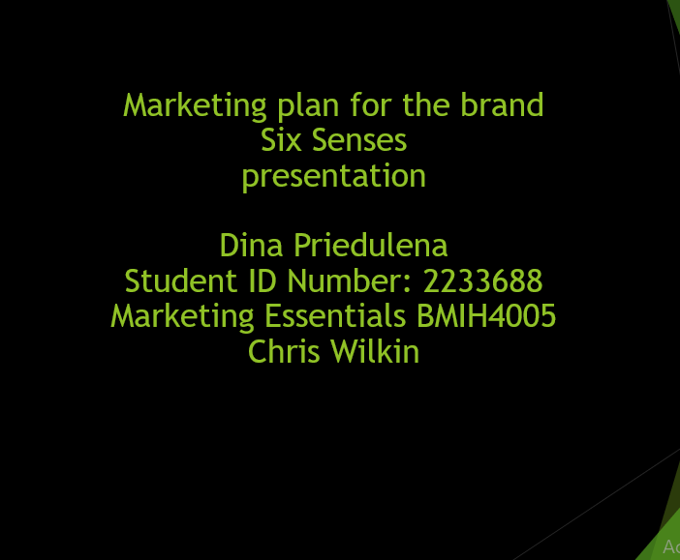

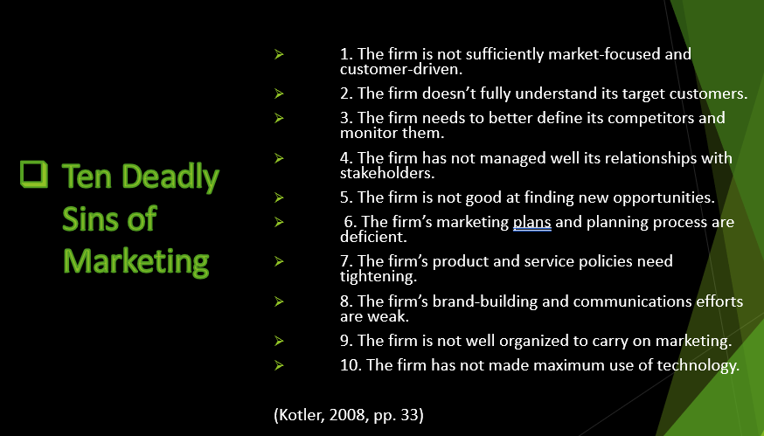
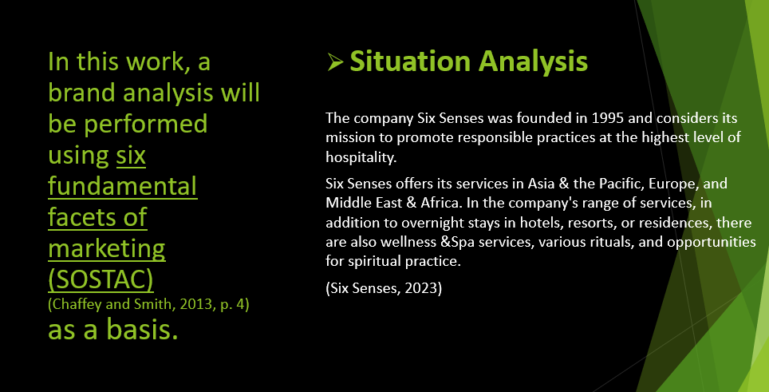

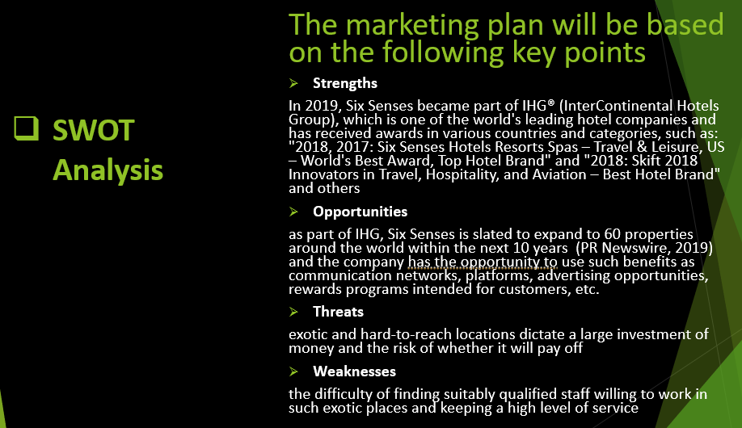
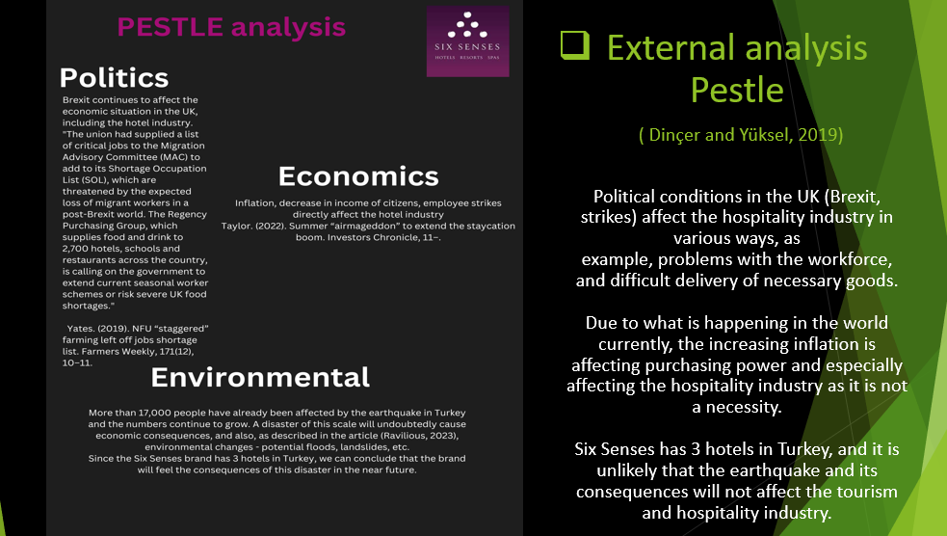
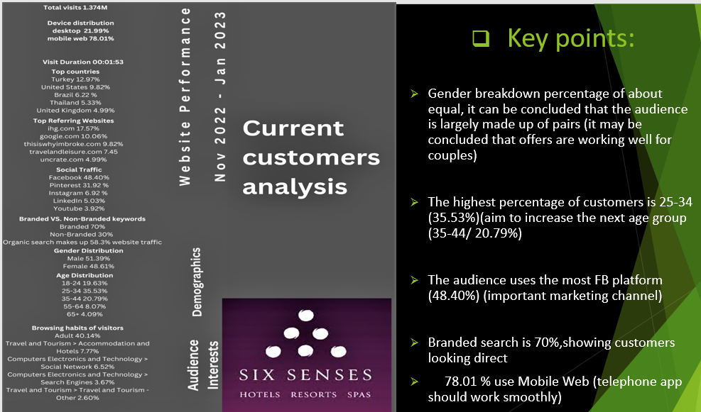
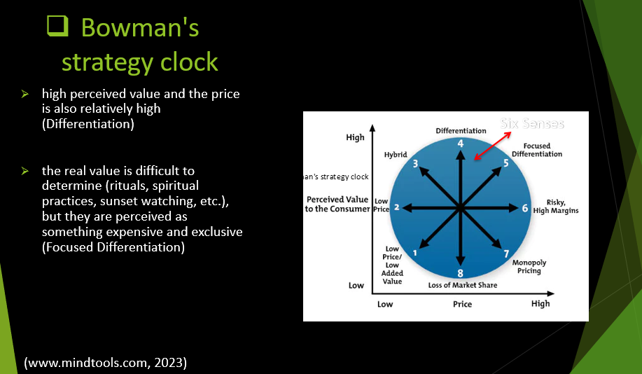

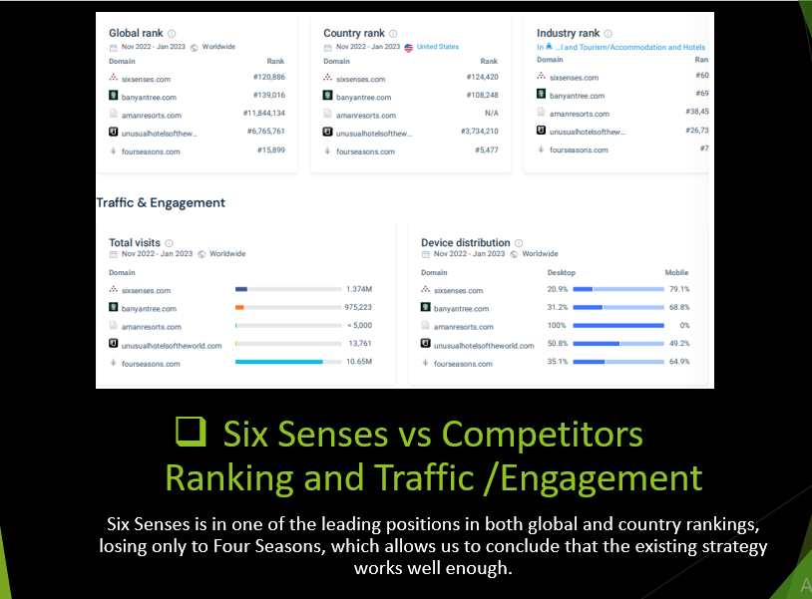
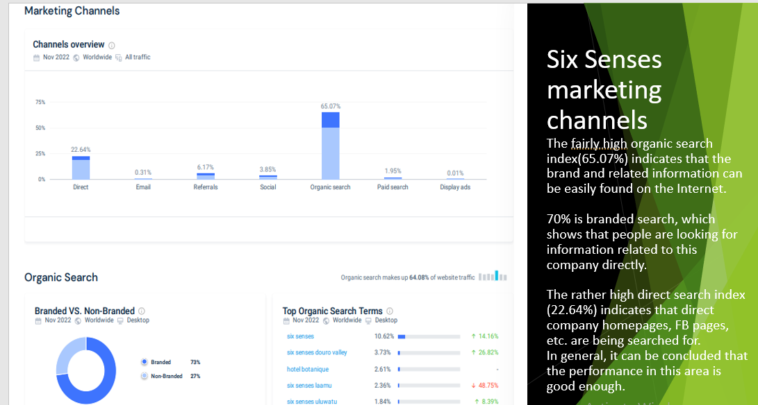
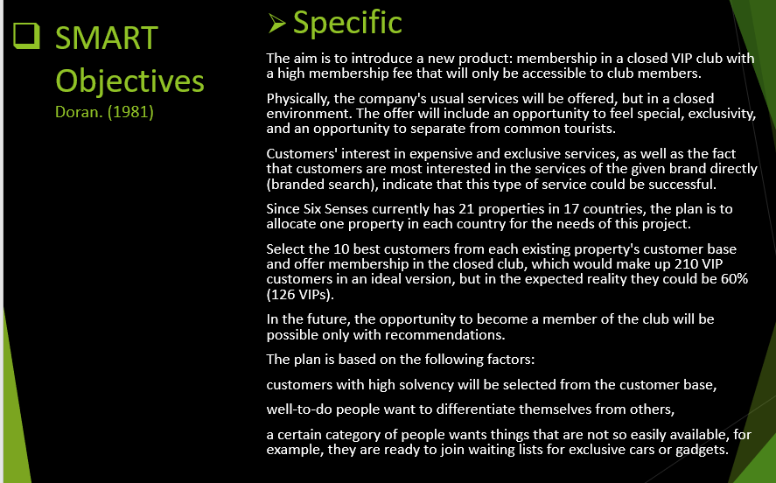
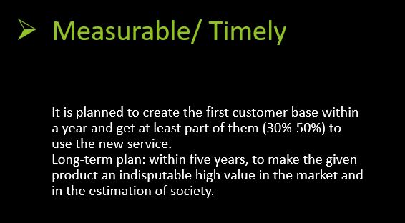
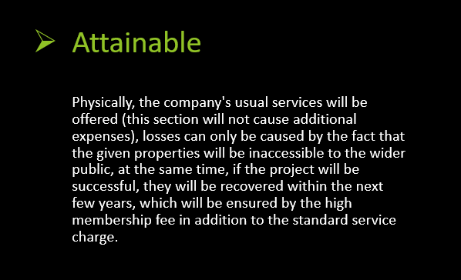
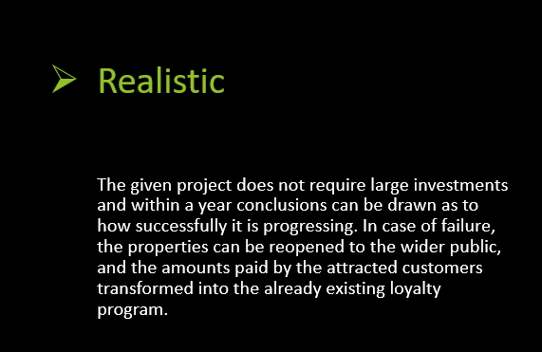
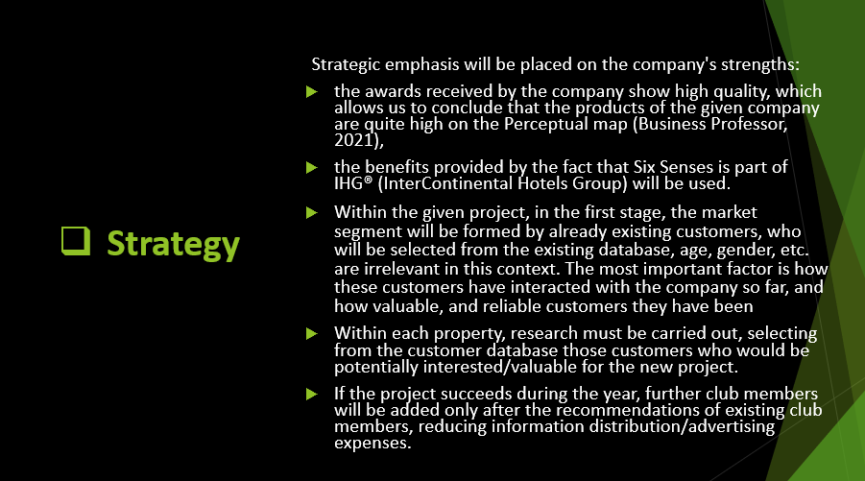

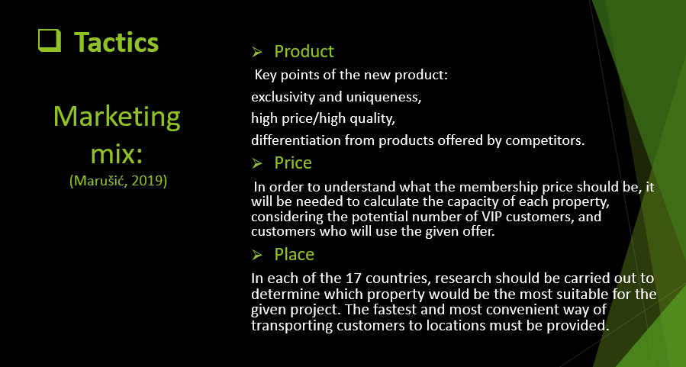
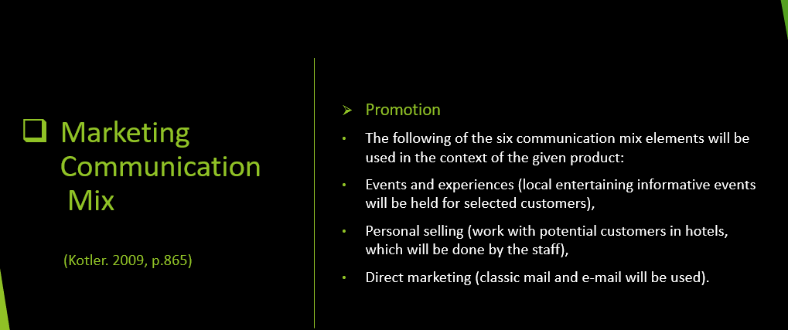

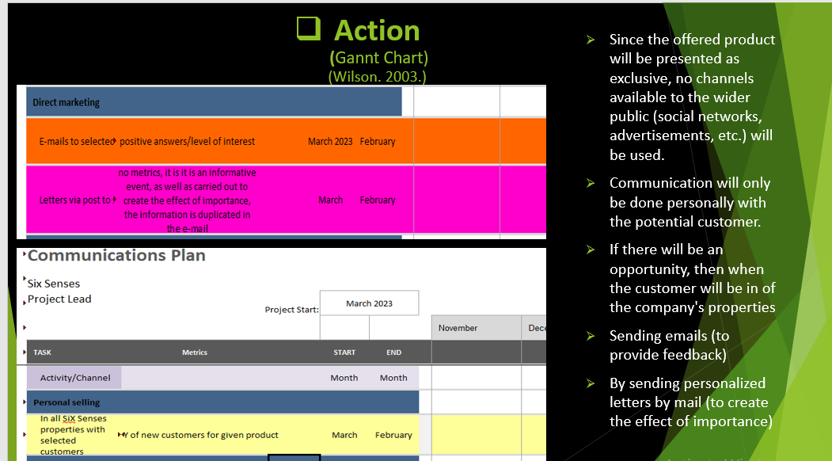
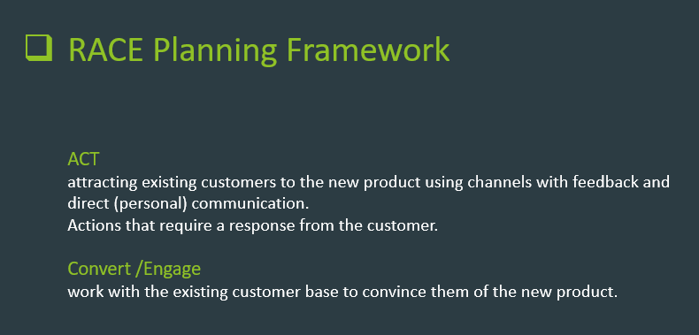
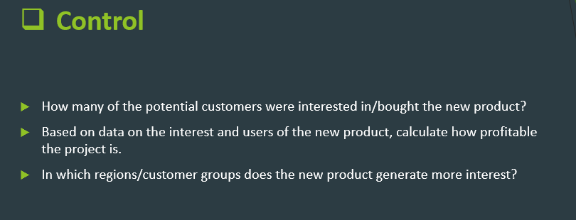
Appendix 2 (Gannt chart)



