Joshua Ford
1701602
Web development
Application development

Contents
1. Introduction 2
2. Application development concepts 2
2.1 Application development concepts 2
Purpose 3
Communication 3
Typefaces 3
Colours 3
Images 3
Navigation 4
Grid based layouts 4
‘F’ pattern design 4
Load time 4
Mobile friendly 4
2.2 Usability and User Experience 5
3. Requirements 5
3.1 introduction 5
3.2 Break Points 5
3.3 content display strategy 6
4. Design section 6
5. Implemention 6
6. Evaluation 15
6.1 Software verification 15
6.2 Final valuation 16
6.3 Reflections 16
7. References 18

Introduction
This report will include the design steps taken to complete the website and the features that have been implemented into the created website to make it fully interactive. Also, the features that have been added into the website to make it easier to use. It will also include information for the website that was created, how it works and how it will be useful to the users.

Application development concepts

2.1 Application development concepts
Web design principles are important because if you create a website and do not follow these principles, your website will not be as effective as someone’s website who did. These principles help the creator design the website so that it suits the design and the layout of a website that you are trying to create.

Purpose
The importance of designing the website around the purpose of the website is important because if a website was being created for a photography website and you included loads of information and not so many photos, people will look on a different website. Therefore, it is important to follow this guideline.

Communication
Communication on a website is vital, if a website has lots of information that makes no sense what so ever, the user will find another website. The information displayed must be able to be understood and easy to digest by the user.
‘make your information easy to read and digest.’ [1]
The reference states that the information must be easy to digest, this is correct because the website stating information about the Gower started talking about other information the website would be useless.

Typefaces
Using the correct typeface is important because if you use the wrong font on a website and it turns out to be too small, too big or the font cannot be read, the website will not get as many views and the website will be a waste and not as popular. Font choices are vital because ‘font choices often set the tone for the whole design and can influence viewers feelings towards your design’ [2].

Colours
The colours on a website are important because a good colour scheme attracts users, if a user looks at a bad design or bad colour scheme, they will not use the website. ‘The most impactful websites are the ones that keep colours to a minimum’ [3], this backs up the point made that basic and minimal colours on a website are better than lots of different colours. For example, the colour scheme used was very basic and the main colours was a blue header and footer and all the rest was white following this design principle.

Images
Images are one of the most important things on a website, they will make the user decide if they will use the website or not. If you use to many images it will not look professional, use too less and the user will see lots of text and go elsewhere. Some people prefer to look at images rather than words to tell them what is going on, ‘if 65% of the population describes themselves as visual learners, then you have to plan for people who want to look at pictures instead of reading words’ [4], this means that some people like images to tell the story of what’s going on.

Navigation
Navigation is an important part of a website because without it, the user will not be able to navigate through the website and will not see all the content on the different pages. e.g. Dropdown menus on a navigation bar. ‘An organised and transparent navigation system acts as a road map to direct visitors to various pages and information on your site’ [5], this helps the points made by stating that good navigation helps the user navigate around the web site and acts as a map.

Grid based layouts
Grid based layouts are a good way of displaying information because it will display content in a grid so it looks more professional and will ‘arrange content into sections, columns and boxes that line up and feel balanced.’ [1]. This backs up that it makes the content look more professional and when it is in a grid layout it looks more neat, easier to see, and not to close together or too far apart.

‘F’ pattern design
The F pattern design is a layout that the user reads from left to right and from top to bottom which resembles the letter F. If you set up your web page in this pattern, it is more likely for the user to view all the content on the screen. This could be by setting all your content so that part of it starts on the right-hand side or so that the viewer can see it. This is a more efficient way of displaying information because not only does it look more professional,

Load time
Load time is the time that a webpage will load when you open or decide to view it. Depending on what you have on the website it will load quicker, if you have smaller images in size, both actual size and file size. Also, “combining code into a central CSS or JavaScript file (this reduces HTTP requests)” [1] this is a point which means that putting code into a central CSS or JavaScript file, this is because instead of loading up code for each web page, for example loading up the header and footer, you could put them into one file and use JavaScript and jQuery to load them into the pages using one line of code rather than a number of lines. ‘…present images as part of the background, called up through external CSS stylesheets’ [6], this helps sped up the page because there is less to load on the html page and it is just pulling it across from the stylesheet.

Mobile friendly
Having a mobile friendly website these days is the most important part of the website because, there are now just as many people looking at a website through a website on a phone as there are people looking on a computer. When coding a website there are now several ways to make the website responsive. Almost every feature on a website can be made responsive. Having a responsive website is the difference between someone clicking on your website and seeing the desktop view and clicking off to find another website.

2.2 Usability and User Experience
Usability ‘refers to how easy a website is for visitors to interact with’ [7], this means that your website could look really good but it could be awful to navigate around, not having effective navigation and having useless information. Having a good usability will both make your page look attractive and make people want to read through it.
User experience is ‘…all about the way visitors feel about interacting with your website’ [7], this means that if your website was not great to navigate around or if the user cant find something like information or a certain page, they might get fed up and find another page.

Requirements

3.1 Introduction
The website that was created was a website with six separate pages which included one home page and five other pages with relative content on them. The website created was a visit website on The Gower and the best things to do and the overall beauty of the Gower. The pages include an introduction which tell the user a brief history about the Gower and what this website is going to do to help the user, and state that it will help them have a better understanding of the Gower. The target audience of the website will be for people who like exploring and would like to come visit the Gower and would like a brief overview and some background information. The relevance of this website is good because having a website like this to give a guide and an overview of the Gower is useful because it will give information and opinions of places that you might not get on other websites.

3.2 Break Points
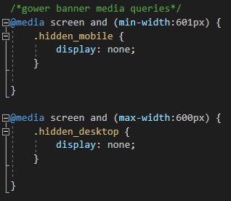
The break points that were used in the website created was, firstly when the website went smaller that 601 pixels, the home page banner image would display a more portrait image of the banner so that the banner image didn’t look stretched when it went into a phone size width, also, so that you could see the image more clearly. The screenshot show that when it would get below 601 pixels it would hide the banner image and instead display the portrait image.

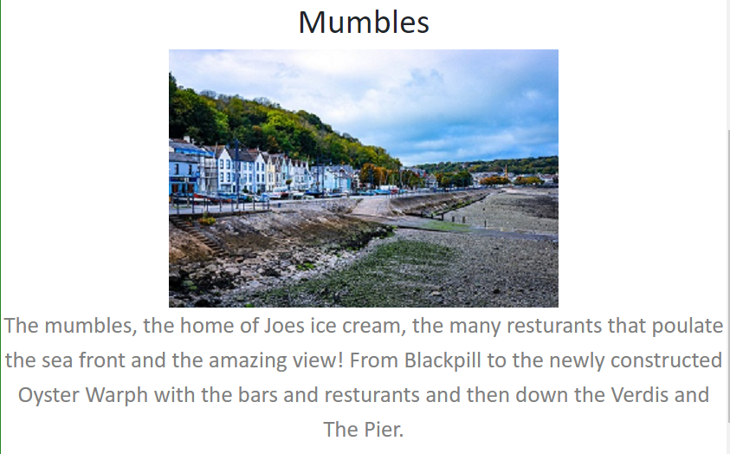
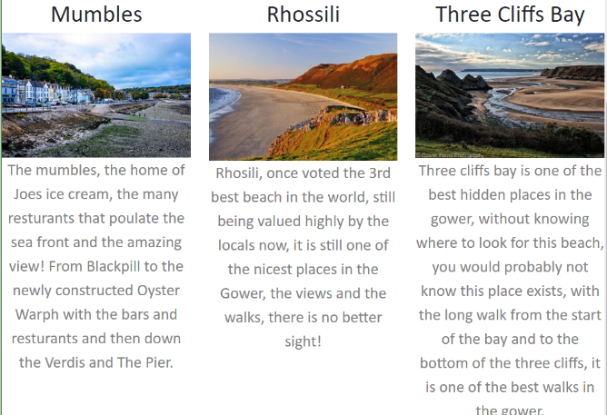
Also I made the grid layout on some of the pages so that when they would get past a certain width they would alter so they would not over lap or look squished. As shown on the screenshots, it shows that when it gets to small each box in the grid will move onto a new line like so that it can be displayed propperly with an ease to read.

3.3 Content display strategy
The content display strategy that was used for this website was that the information on the page would be displayed so that everything on the website could be seen no matter what viewport it was in. this means that it was in a mobile size, the information would be together with the photos being above or bellow and not to the side like it was in the desktop view, this is because it would then suit the user and they would be able to view everything comfortably. Also, in the medium view which would be used for tablets, the information would be displayed more similarly to the desktop view. If there were images that would make the page look uncomfortably, the images or text would be moved to a place that they would no longer. The strategy also was for no matter what view it was in, for there to be a small margin either side, to make it look comfortable.

Design section
When creating the website, the creator followed the following steps of the web design principles:
The purpose of the website was exactly what the website was about, it was a visit website in which it was intended to guide the viewer around the Gower. The information was relevent and not rubbish. The colours used were basic and not too colourful. Minimul colours were used to make it look as professional as possible. Suitable images were used for the each page. Also, the navigation was appropriate and was very easy to use.

Implemention
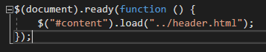
Using JavaScript to display header and footer –
JavaScript was used to display the header and footer using this function which would display the header which was in a separate html file. It was then called in the body of the html and was displayed.

The same was done with the footer, as shown below.
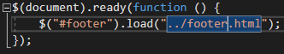

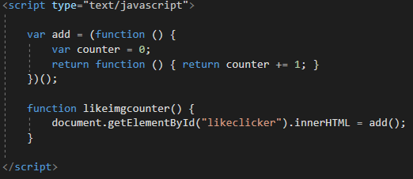
A like counter was also used for the photos on the website, this was done by adding a like picture and every time it is clicked the number would go up. This was used on a number of pages and could be used for feedback.


Pages
Homepage
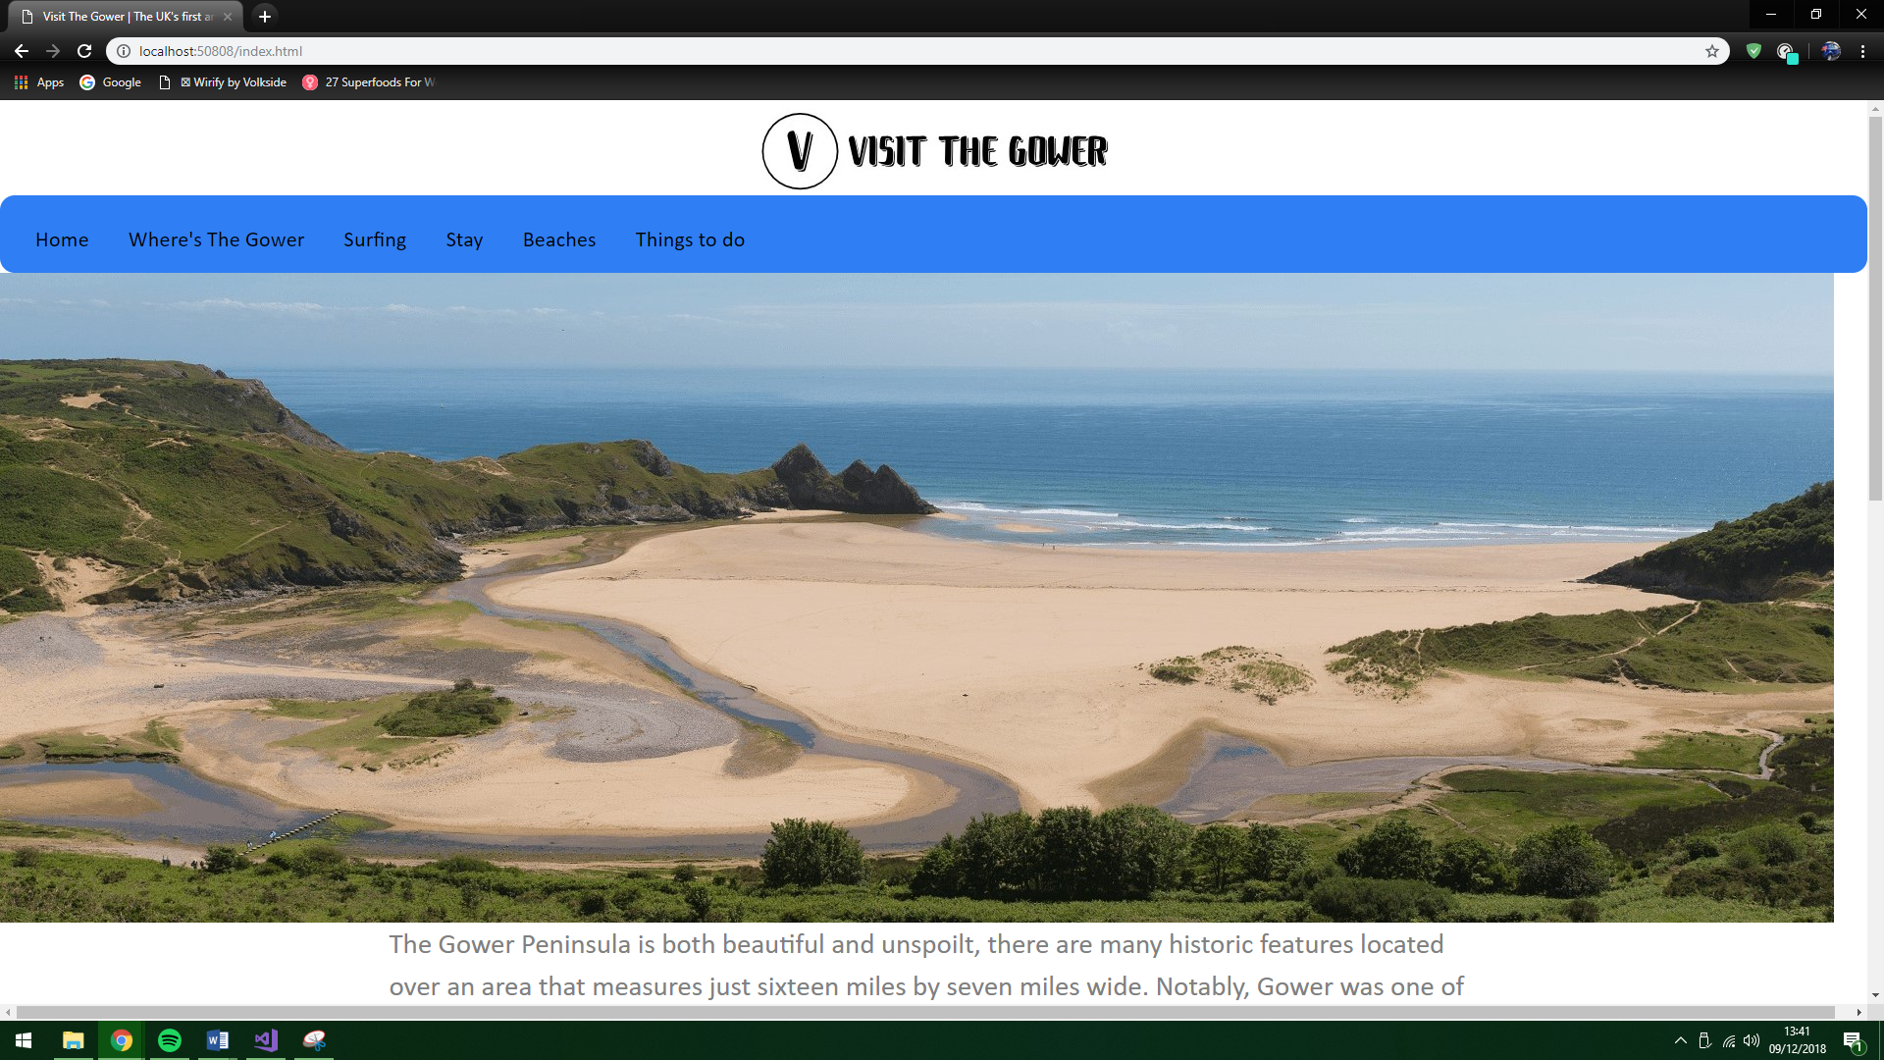

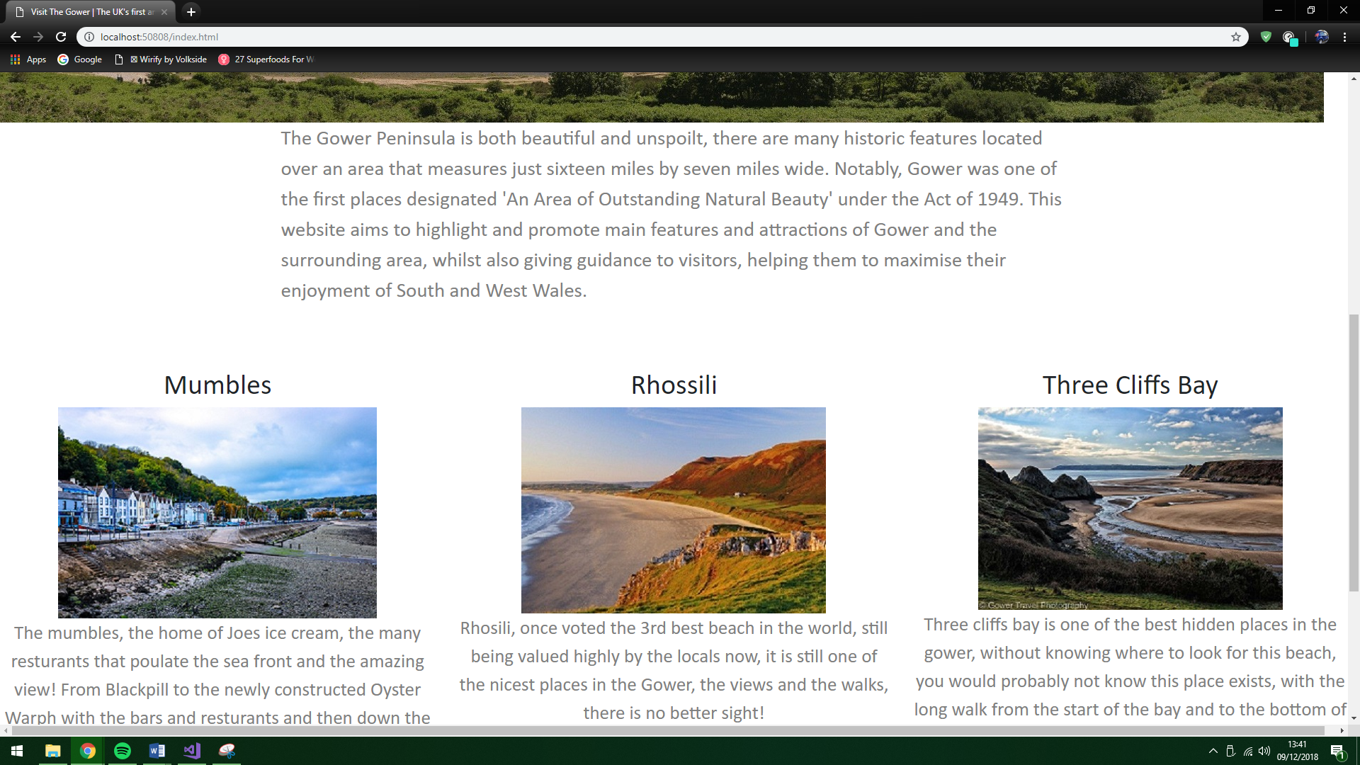

Where is the Gower? page
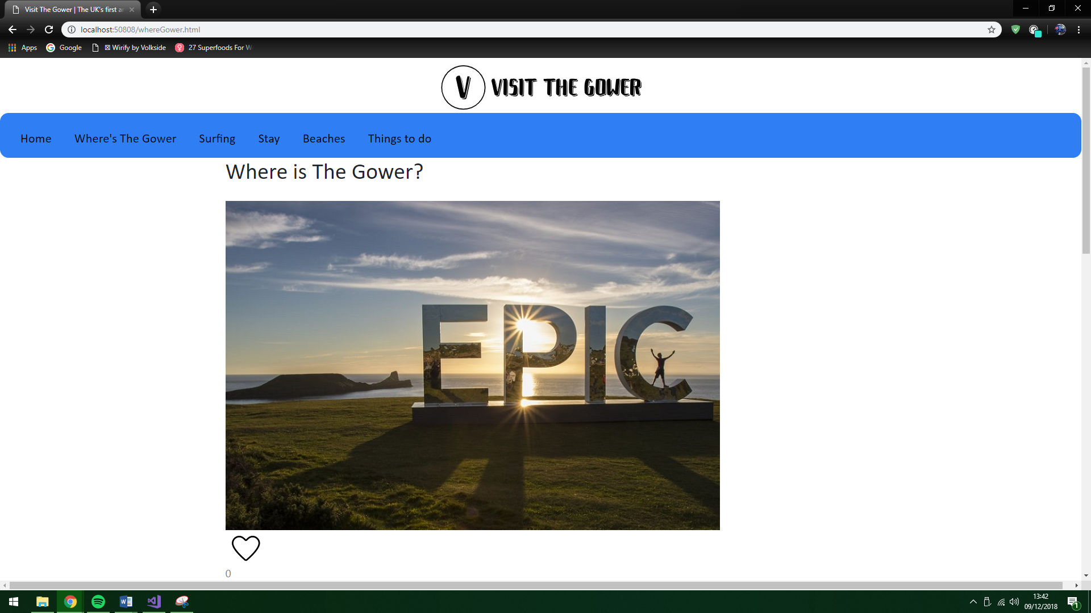
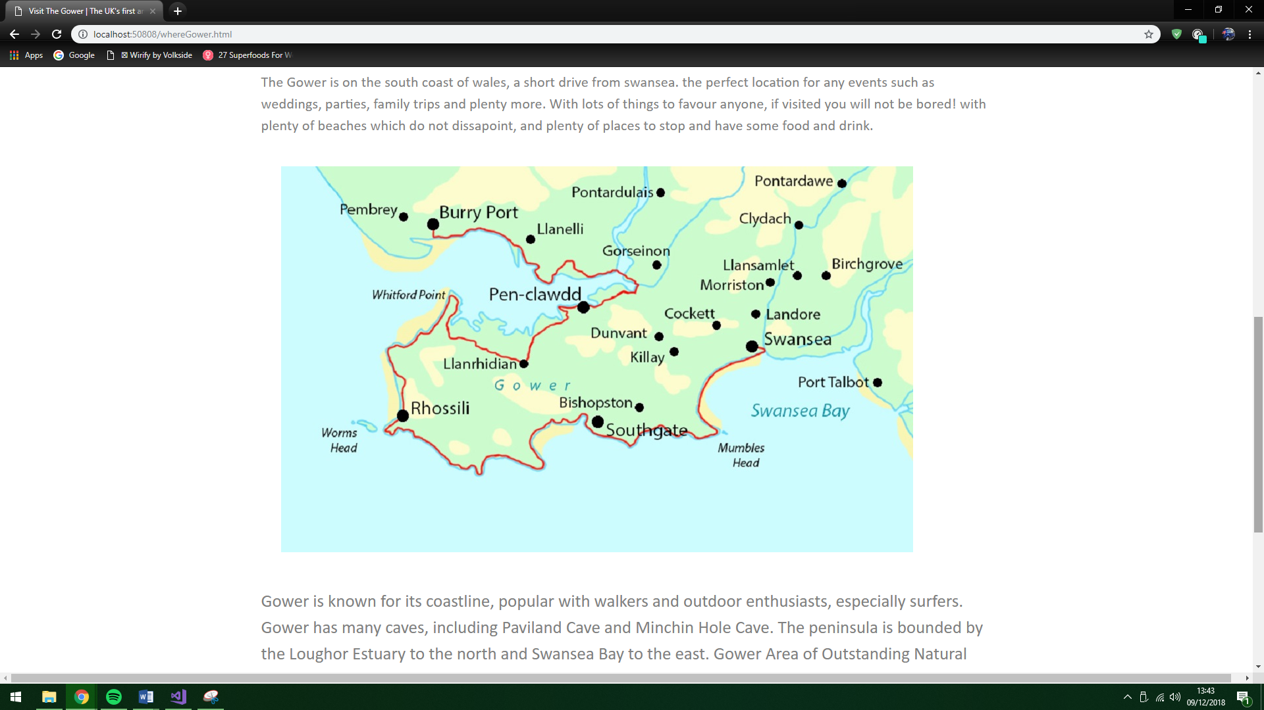
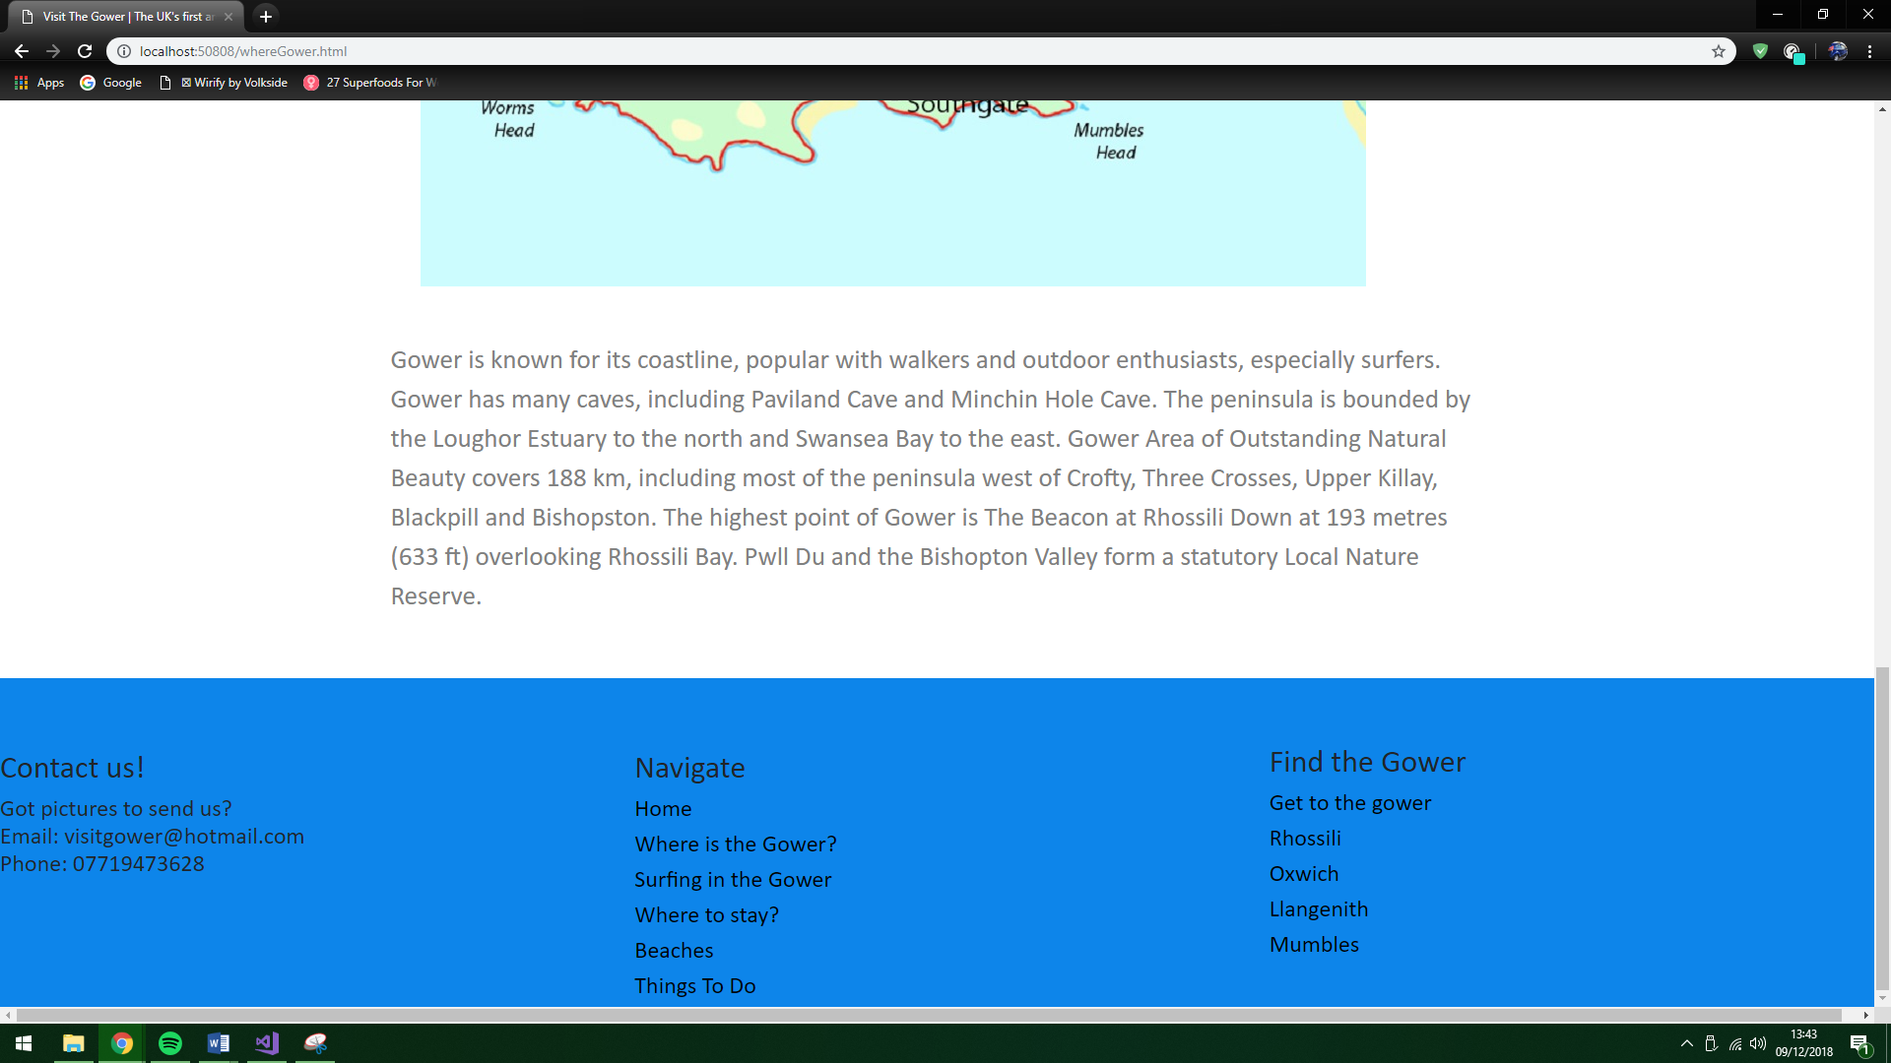
Surfing page
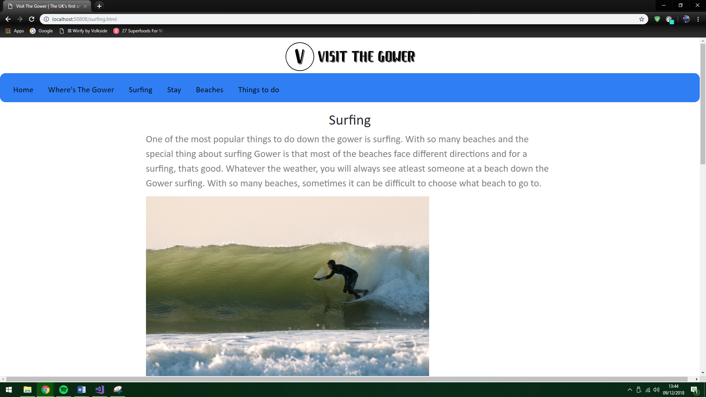

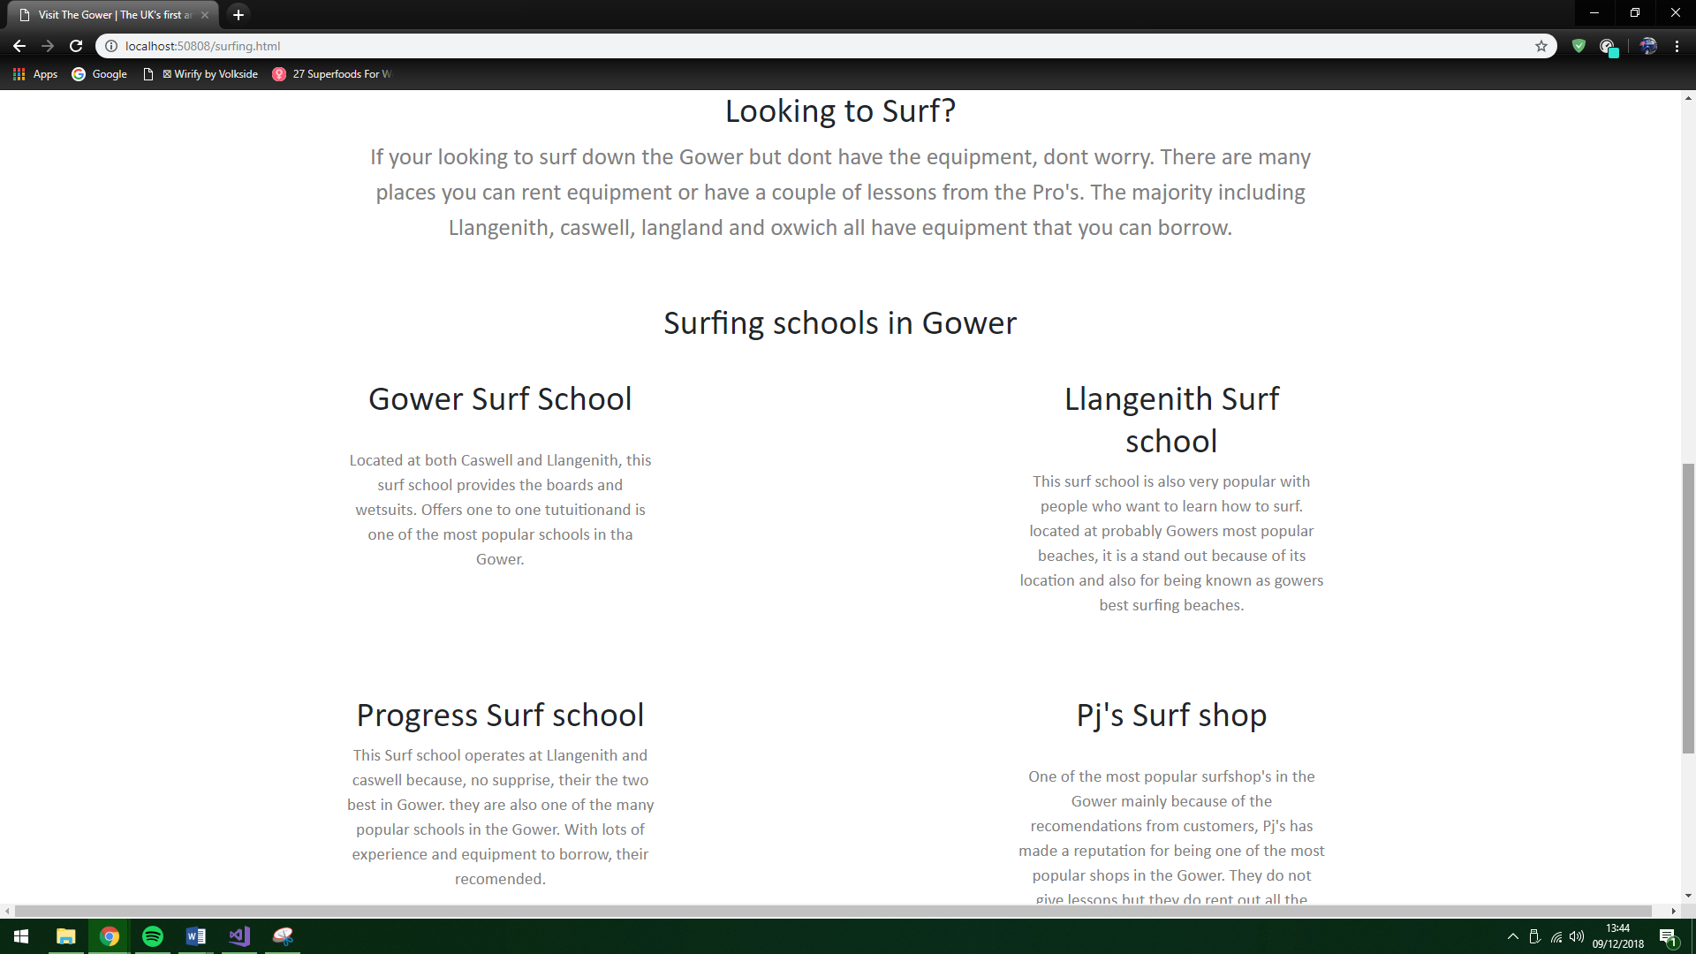

Staying in the Gower page
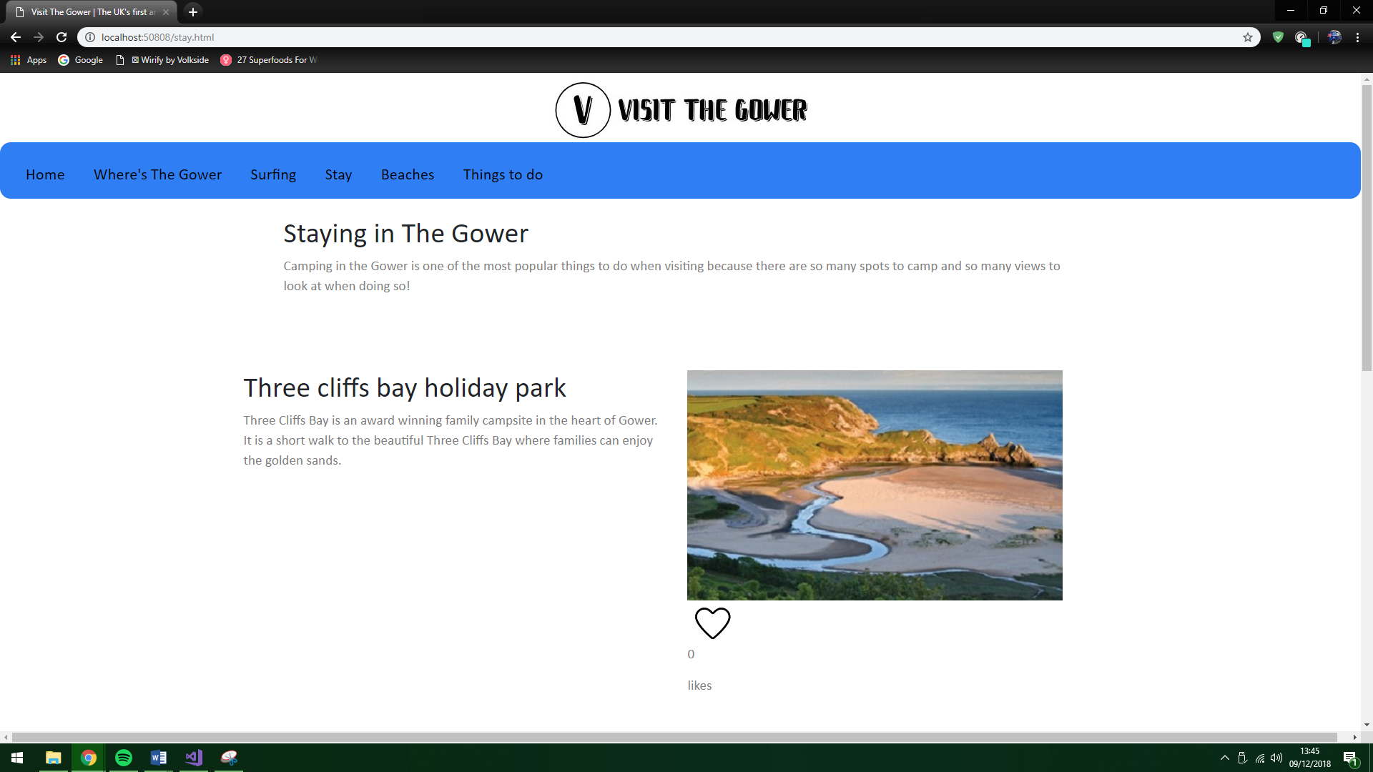
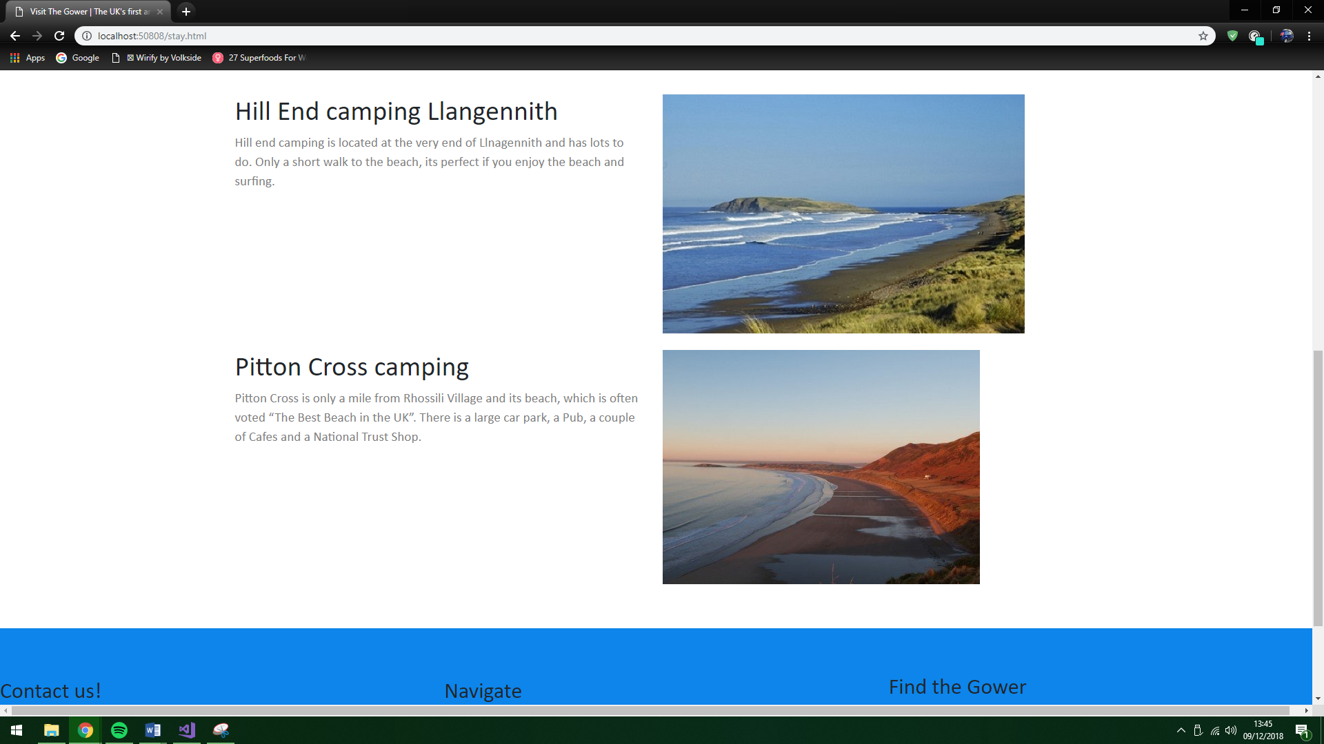

Beaches page
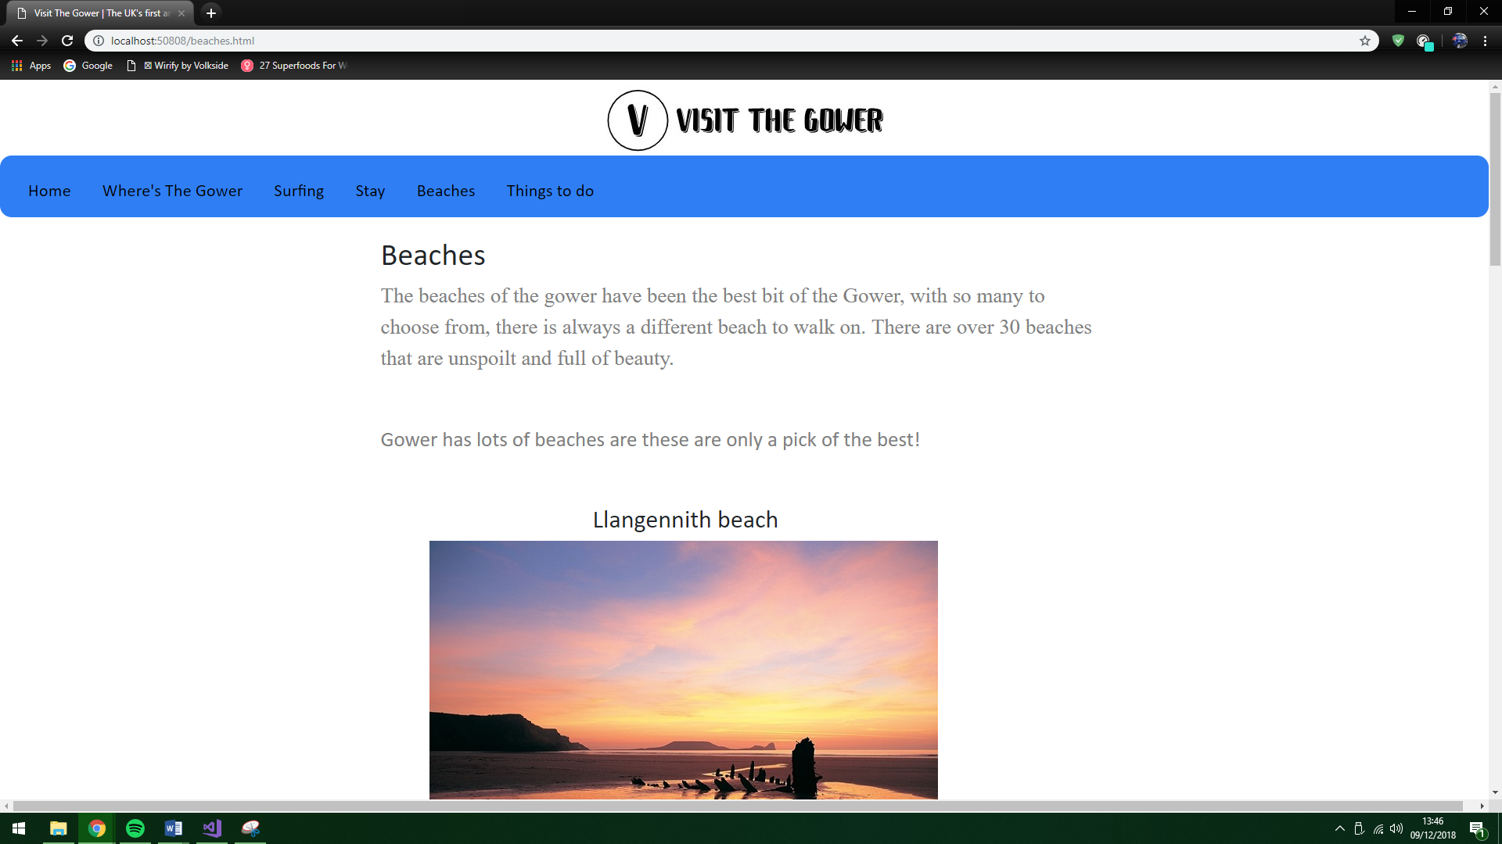

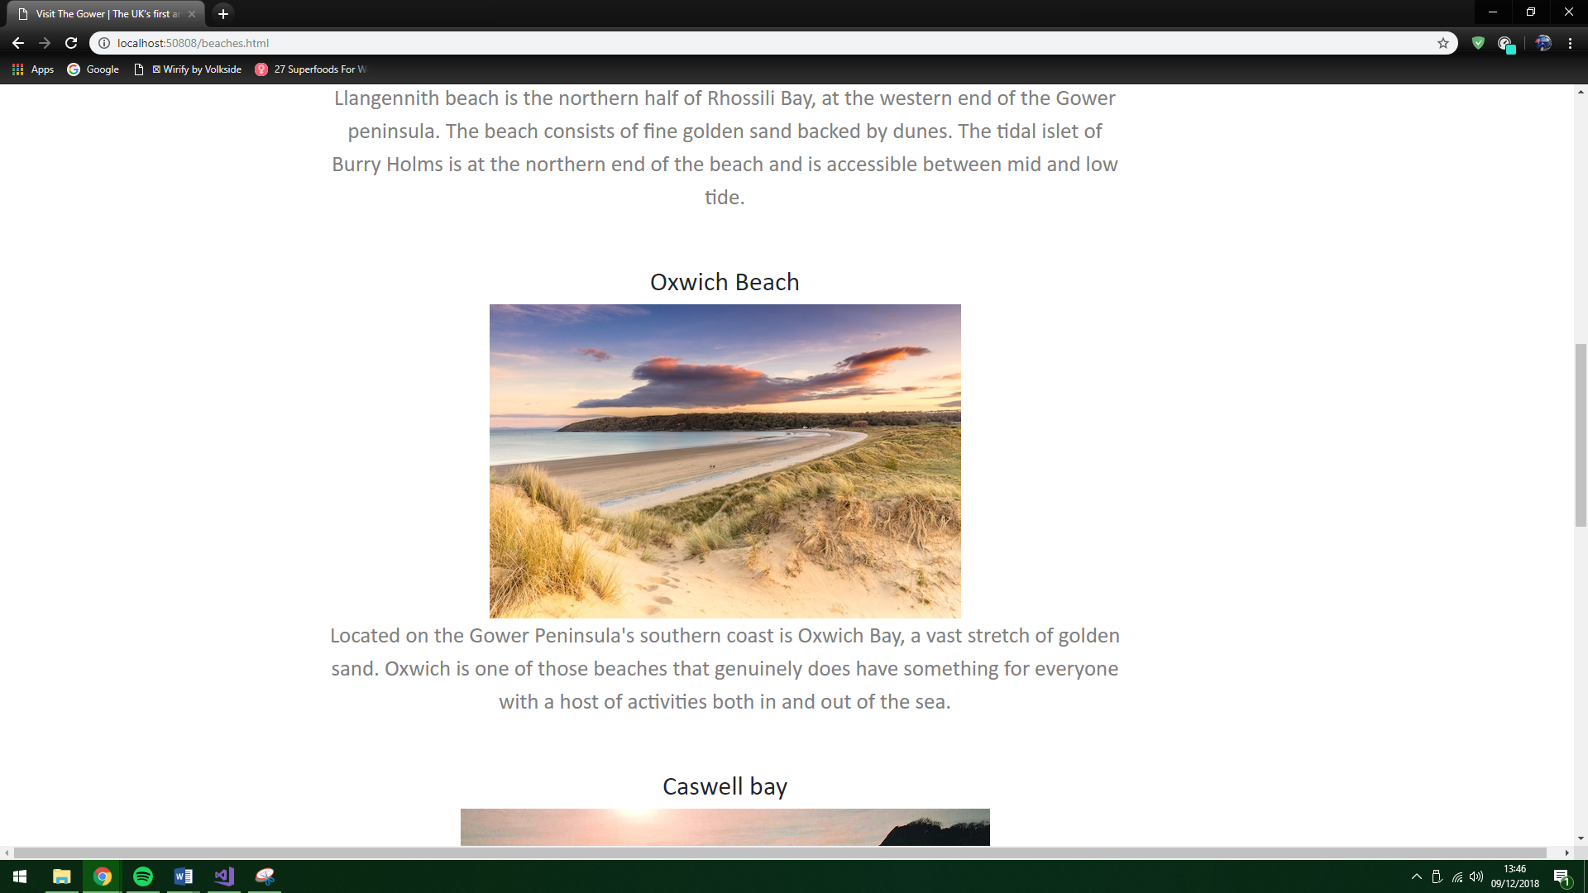

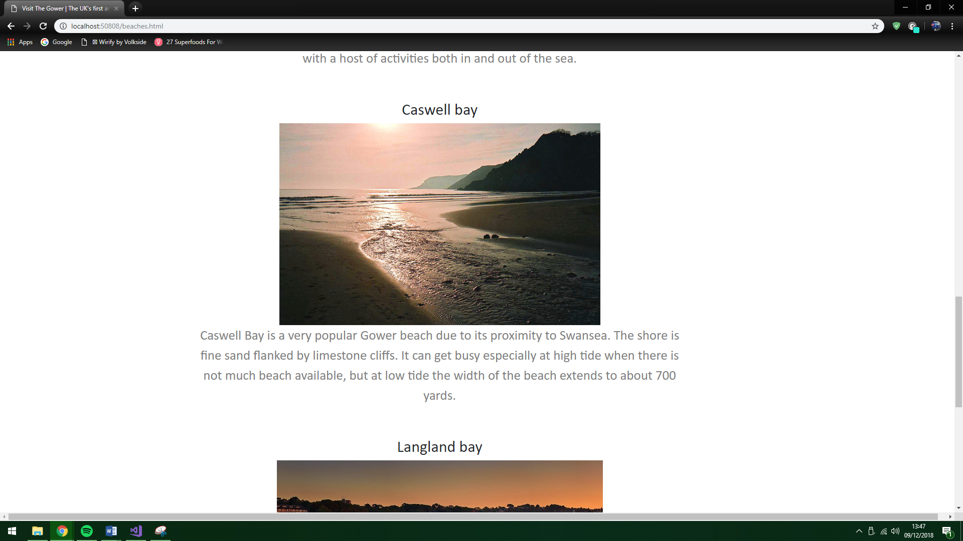

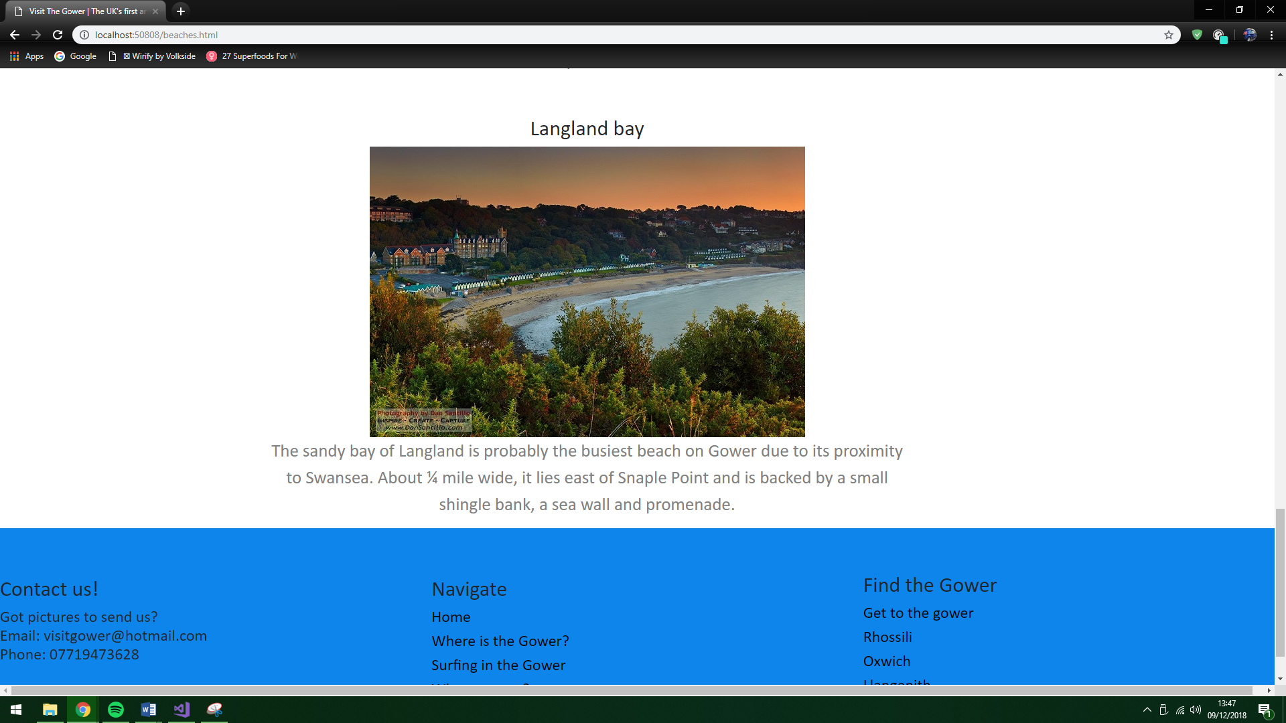

Things to do page
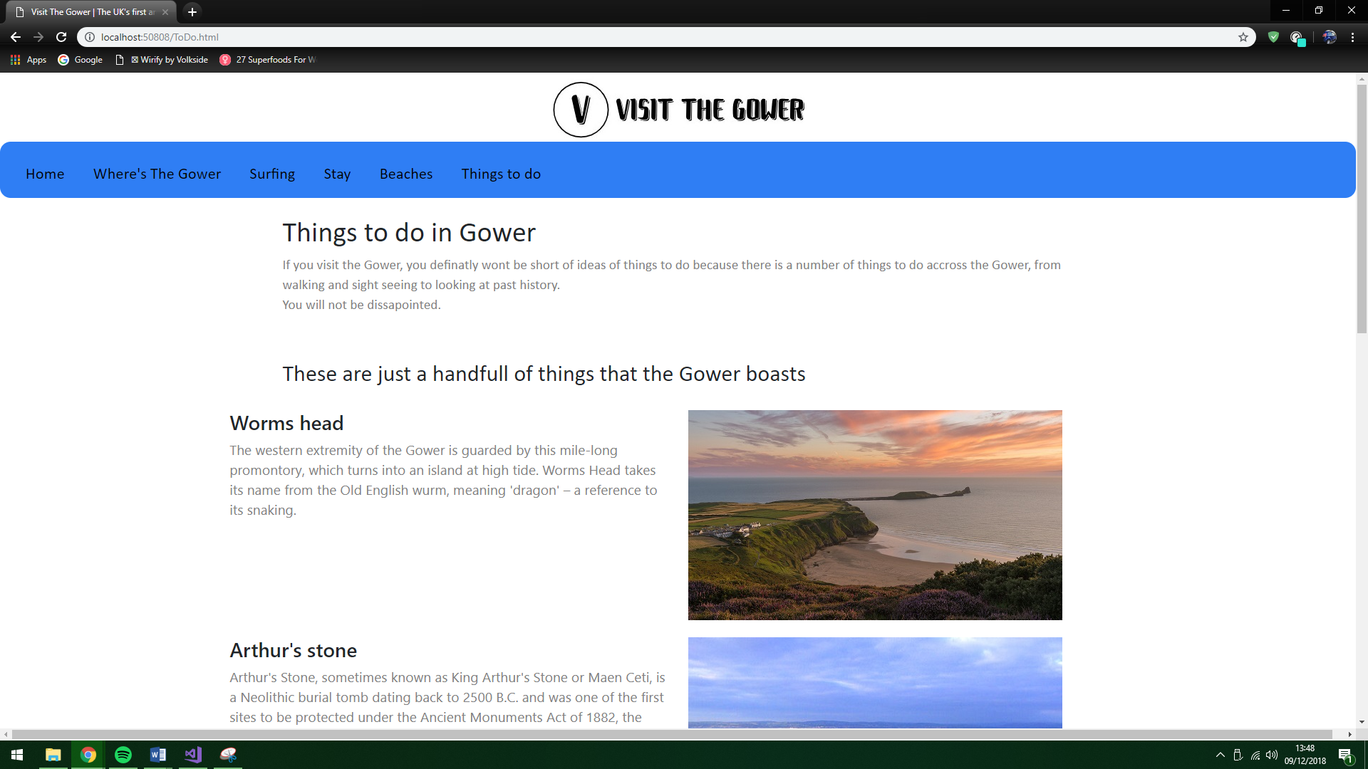

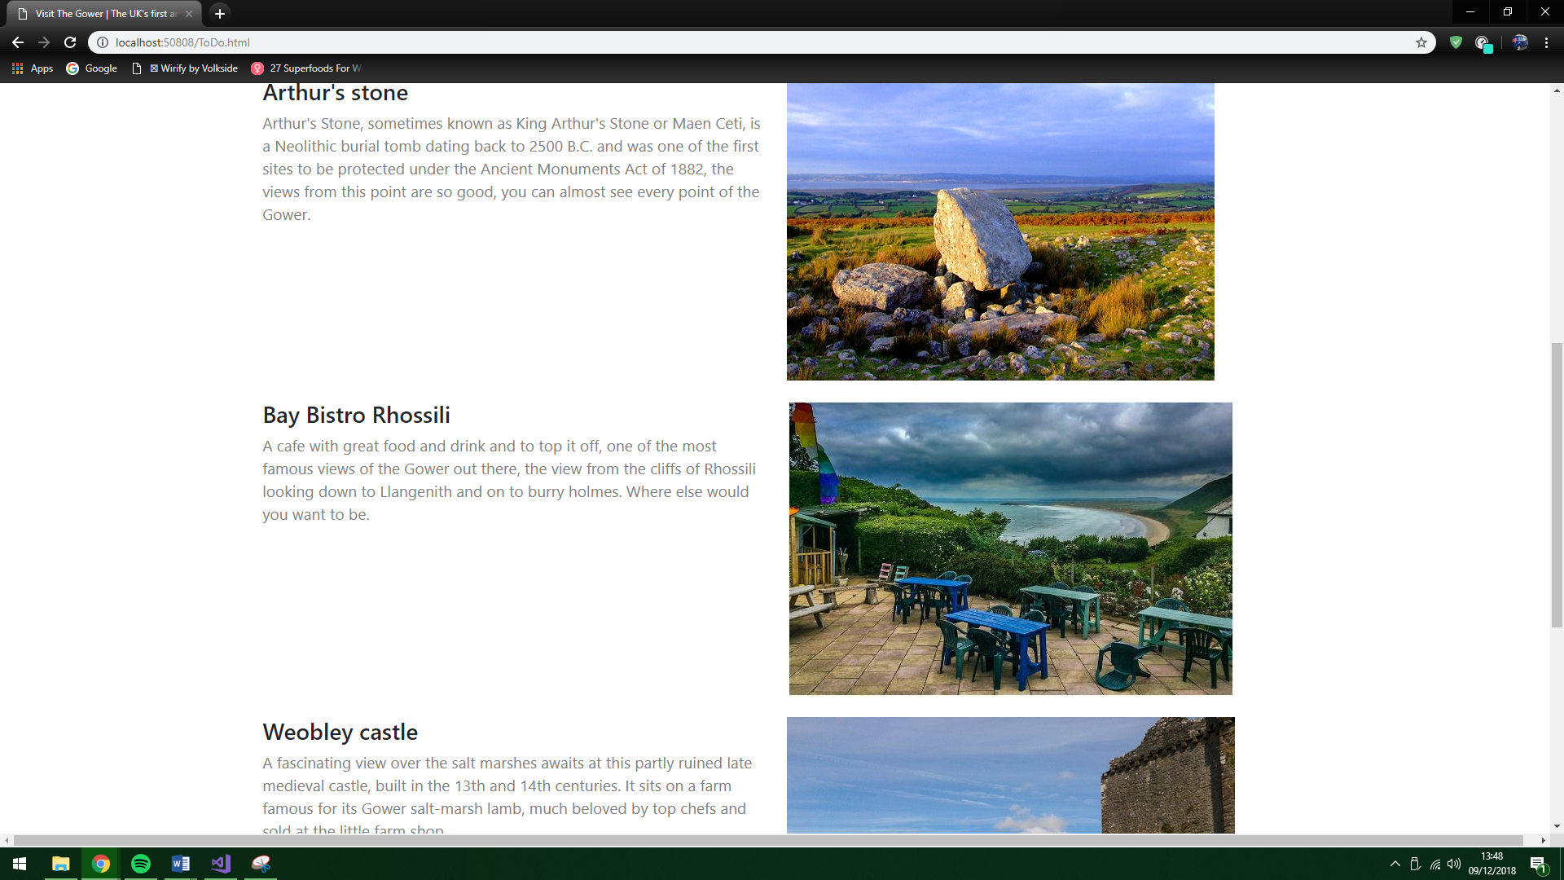

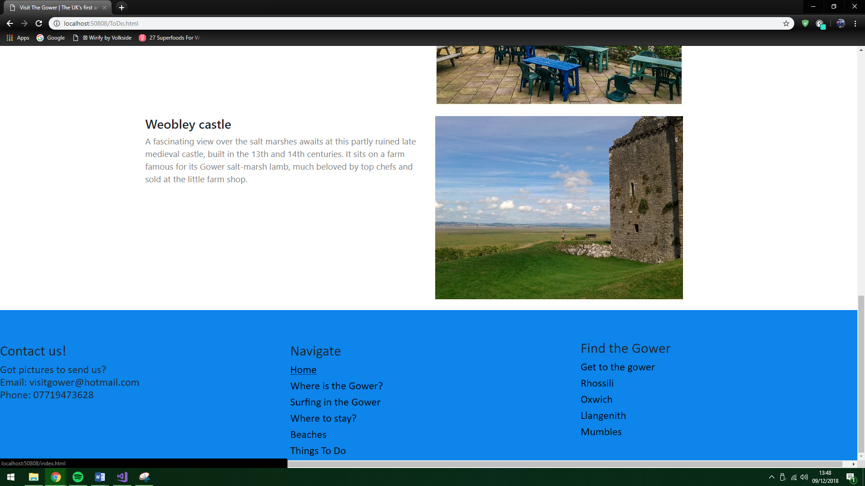

Evaluation

6.1 Software verification

- Testing the home page image change –
The images successfully change to the smaller image as shown in the screenshot.
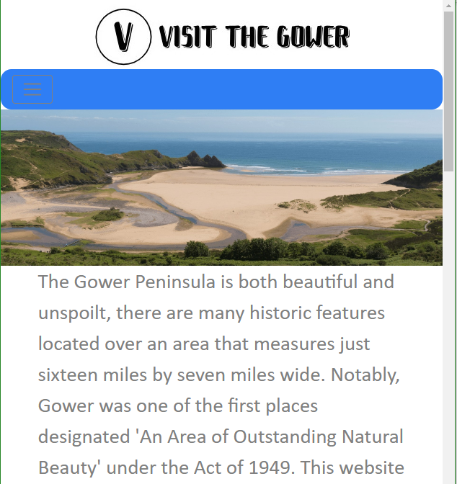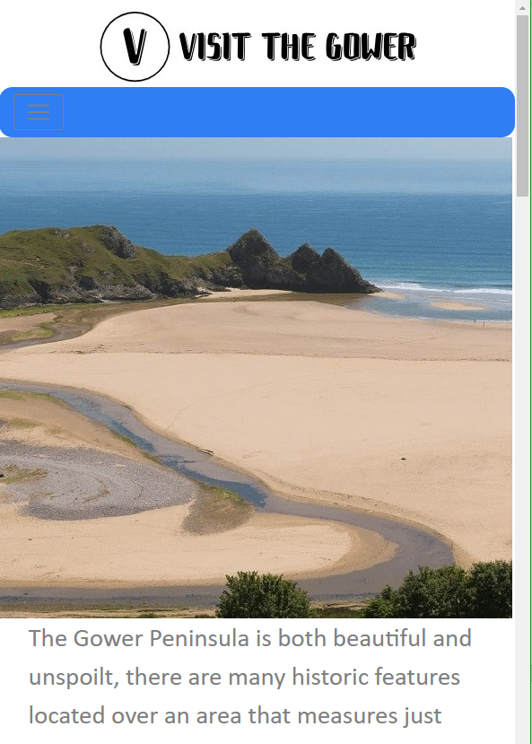

- Testing the header and footer using JavaScript-
The header and footer loaded on the website when opened in visual studio.



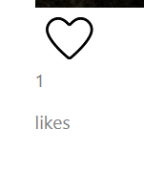
- Testing the like counter on images –
The like counter went up when the like image was pressed.

All the tests were successful when tested, and all work correctly.

6.2 Final valuation
After looking at the final design of the website and how it was planned, it has been a success. The design is good and attractive and goes by the design guidelines, it is not too colourful but looks professional. The design also feels good, the layout of the content is efficient and is easy to locate and not to spaced out or squished together. The usability of the website is good to locate around, and a user will feel comfortable locating and looking for information on this page. Finally, the content used was appropriate and very useful.

6.3 Reflections
The changes that would be made if done again, more detail in content, meaning more interactivity, more information that could be used as vital information when traveling and using this website. A slightly better navigation menu that would include dropdown menus so that the user could find more in-depth information on the topic.

References

[1] | S. Woods, “10 TOP PRINCIPLES OF EFFECTIVE WEB DESIGN,” 4th march 2014. [Online]. Available: https://shortiedesigns.com/2014/03/10-top-principles-effective-web-design/.
[2] | “fonts,” [Online]. Available: https://www.canva.com/learn/font-design/.
[3] | Cyriac, “Importance Of Color Selection In Website Design,” 23rd February 2009. [Online]. Available: https://www.techwyse.com/blog/website-design/importance-of-color-selection-in-website-design/.
[4] | M. Lieberman, “How important are images in your web design?,” 22nd March 2012. [Online]. Available: https://www.square2marketing.com/blog/how-important-are-images-in-your-website-design.
[5] | Michaela, “Importance of web navigation,” 1st August 2017. [Online]. Available: https://blog.wurkhouse.com/importance-website-navigation-best-practices.
[6] | S. Anderson, “How fast should a website load in 2018,” 9th March 2018. [Online]. Available: https://www.hobo-web.co.uk/your-website-design-should-load-in-4-seconds/.
[7] | B. Litwin, “Why Usability and User Experience Are Vital,” 11th July 2018. [Online]. Available: https://www.a2hosting.com/blog/usability-and-user-experience/.

*the links for the pictures, and information are in a separate word file in the folder called ‘website links’ in the website.

marking criteria and Student FEEDBACK

This section details the extent to which the assessment criteria are demonstrated by you, which in turn determines your mark. The marks available for each category of skill are shown. Lecturers will use the space provided to comment on the achievement of the task(s), including those areas in which you have performed well and areas that would benefit from development/improvement.

Common Assessment Criteria Applied (Assignment 1) | Marks available | Marks  awarded
1. Engagement with Literature Skills

There is good evidence of a number of reference sources consulted. For additional improvements, expand the range of reference sources consulted to include more academic reference sources and not just websites. (Grade mark: 60.00%) | 5 | 3
2. Knowledge and Understanding Skills

A good discussion of a variety of web design principles, but I would have liked to see some more on your discussion of website usability and user experience and a clearer distinction of the two concepts. (Grade mark: 56.00%) | 25 | 14
3. Cognitive and Intellectual Skills

A basic evaluation of the implemented website has been provided, while documentary evidence of testing is rather brief. The documentary evidence of testing could also be improved beyond screenshots to further demonstrate test cases for the interactive functionality. (Grade mark: 40.00%) | 20 | 8
4. Practical Application Skills

A very good attempt featuring a simple website. The implemented solution demonstrates a fairly good understanding of RWD and a mobile-first strategy, but there is room for improvement in terms of the layout and using the responsive grid. Note the correct way to order the grid column classes and how to use responsive images properly - see your report. Very good use of JavaScript to define reusable header and footer content once and load into the different pages, but note the correct format for specifying the URL - again, see your report. The counter is also a good idea, but not quite practical. Overall, a very good attempt. (Grade mark: 62.22%) | 45 | 28
5. Transferable Skills for Life and Professional Practice

The report is of average standard. See your report for suggested improvements. (Grade mark: 50.00%) | 5 | 2.5

Assignment Mark (Assessment marks are subject to ratification at the Exam Board. These comments and marks are to give feedback on module work and are for guidance only until they are confirmed. ) | Late Submission Penalties (tick if appropriate) |  | 55.5%
 | Up to 1 week late (40% Max) |  | 55.5%
 | Over 1 week late (0%) |  | 55.5%

