Promoting reflective practice in early years.

“The reflective practitioner allows himself to experience surprise, puzzlement, or confusion in a situation which he finds uncertain or unique. He reflects on the phenomenon before him, and on the prior understandings which have been implicit in his behaviour. He carries out an experiment which serves to generate both a new understanding of the phenomenon and a change in situation.” – Donald Schon.
When working in early years it is vital to reflect on professional practice – this is because no child or setting is the same so the need to bend and adapt to suit each individual or situation is essential. Knowing how, and when to reflect is a skill that is learnt through own experience and knowledge passed from others. It could be that the practitioner needs to adapt the way that they speak to individuals in their care to ensure that they know what is being asked of them. For example, the practitioner may not be being 100% clear on what they want a class to do. To promote reflective practice colleagues could sit in on class tasks to learn from each other and provide feedback on how it went and how it could be adapted to suit the needs of the audience better. Teams of practitioners are better equipped to reflect as a group than they are if they work solely. Communicating well as a team is paramount in the adaption of the work a practitioner delivers. Being able to listen, watch, feedback and address reflection takes a lot of effort but after a period of practising this it will become more fluid, and it will take a lot less effort. It is also important to ensure the environment and surroundings are suitable for the tasks to ensure that they are engaging for the children but also assists in keeping their focus when needed.
“Children need to be engaged with the environment, so it is important to reflect on this each day; Are the children engaged? If not, why not? What can we do to engage them? What resources would challenge them? What are their interests?” Houghton, 2017, https://www.earlyyearsstaffroom.com/reflective-practise-aspects-early-years-important-reflect/

What is reflective practice and why is it important?

“Reflective practice is the ability to reflect on one’s actions so as to engage in a process of continuous learning” – Donald Schon
Having that ability to reflect on moments gone by will set the practitioner in good stead to be able to adapt and change the way that they work or learn. It is a discipline that is adapted to ensure that the person reflecting has the opportunity to redo the task and to change it for the better. Each time we complete a task, and it goes well, without issue, we tend not to reflect on it, however, if we were to complete a task and it was hampered by issues then you would naturally find a simpler way of completing it. That is reflective practice. Having the ability to adapt and change a way that we work can be difficult but having the grit and determination to adapt and change a way of working/learning will always be a positive, regardless of the situation it is applied to. Each time that a practitioner reflects on a scenario that has happened they are increasing their level of understanding of the subject area and improving their professional practice. The reflection can be as small minute or as big as desired but picking up on the need for reflection is how the practitioner knows they are improving. The importance of reflection stands alone – if the practitioner doesn’t reflect, they will not continue to learn. The practitioner may find themselves stagnating in old, outdated knowledge and techniques instead of evolving and changing.

How to be reflective in the early years setting

There are a number of diverse ways in which a practitioner can practice being reflective in the early years setting, one of the most common methods to use would be asking simple questions. Reflection starts with a simple ‘taking stock’: the process of stepping back, thinking about what we have been doing, what has gone well, and what could be better. Here are some helpful ‘taking stock’ questions:
What have we been doing? Review the task that was set and ensure it was suitable for all involved. If the task was not suitable, what can be changed for everyone to be included and achieve the same outcome. Who benefits from doing it this way? Is the task that has been set made for the practitioner to enjoy or the task taker to enjoy? If the practitioner is looking for an easy-going day this will not produce superior results. If it is set for the task taker to enjoy the practitioner is more likely to achieve a good outcome. What has gone well? This is a chance for the practitioner to make a list of the things that have gone well during the task and evaluate if anything needs to change to gain a better result. What needs improving and why? By gauging what needs to be changed in the task and the things that are holding superior results back, the practitioner can improve the task set and ensure everyone has a good chance at completing the task. Who/what else do we need to think about? Is this accessible for all learners in the group? If it is not, task takers may feel uninvolved and not make a good effort for a good result. By making sure this is accessible to all task takers the practitioner is participating in promoting equal rights and ensuring everyone in the group is included.
What can we keep/adapt to meet these needs? Evaluate the task and compare the stages against the task takers to ensure they are learning at the correct pace and level for their ability. How are we going to do this? Through asking these questions with the pupil, parent, or peer the practitioner can get analysis from every point of view and input results for a better outcome to meet the needs of the person they are teaching.
When ever a practitioner completes tasks, it is important to celebrate when things go right. Regardless of how big or small the ‘win’ is, always ensure to celebrate the fact that it went right in the first place and ensure to congratulate others on their successes too. When tasks go right, this improves on the practitioner’s confidence, and it will also help those that the practitioner praises or criticises. If the practitioner’s setting has them, practitioners should document their reflections as these can be used for future references for the practitioner themselves, or for current or future colleagues who are also looking to reflect. It is an effective way of keeping a record of the process that the practitioner took and how they improved to make the learning opportunity better.

Conclusion

So, in conclusion, to be a reflective practitioner is to follow the frameworks or models set out by Gibbs (1988) or Kolb (1984) or the CARL framework of reflection. By using these the practitioner is continually developing and adapting their professionalism and knowledge to ensure that they are well equipped and understand the regular classroom activities to ensure that all children in their setting are thriving. The practitioner will then find themselves being able to teach any child in any setting. Being able to adapt and change the way of thinking and learning is paramount, not just in a learning environment but home life too. Nothing is ever as black and white as they seem so learning ways in which you can adapt to whatever it is that is being thrown at you is a great skill to possess. Confidence is a key factor in all of this too. Being able to reflect on their own work, dissect it and reproduce to a higher standard takes guts and determination so the more that the practitioner does this, the more confident they will be being able to reflect on future situations. The more professional the practitioner is in their practice, the easier it will be for them to reflect on their peer’s work.
Theories of Reflection.

There are several models and theories that you can explore when attempting to learn how to reflect. In 1988, Gibbs formed a theory to give structure on how to learn from experiences. Gibbs breaks down the experience into 6 sub-categories – Description, Feeling, Evaluation, Analysis, Conclusion, and action plan. In each of these sub-categories the practitioner breaks down the task and asks valuable questions that could lead to the practitioner learning better. By breaking down the tasks the practitioner can see the tasks strengths and weaknesses and then how to adapt the task to improve the result. Only when a practitioner can breakdown their work, can they begin to reflect and adapt. Sometimes this process is done instinctively but sometimes this needs to be prompted.

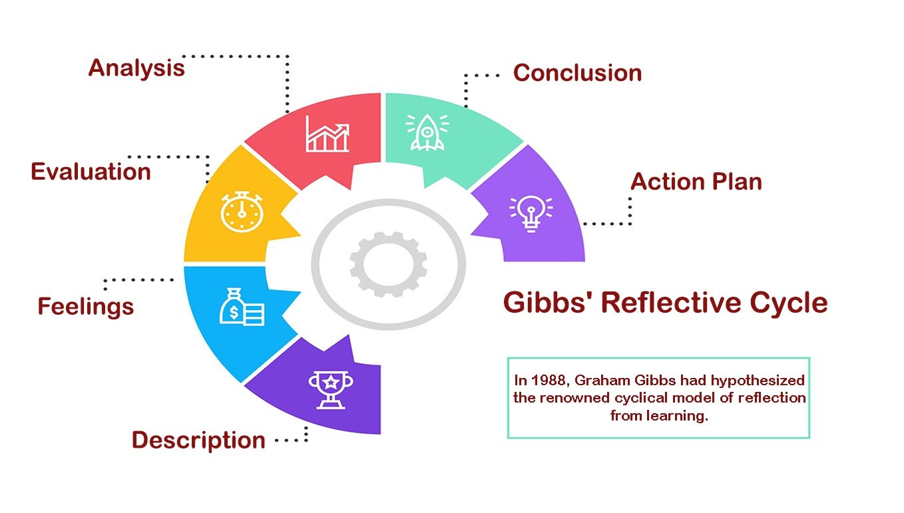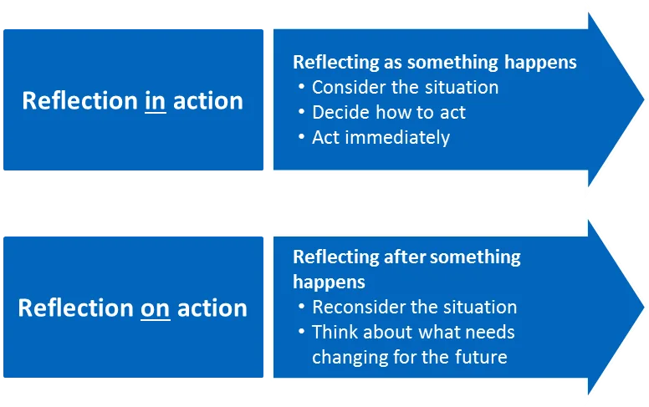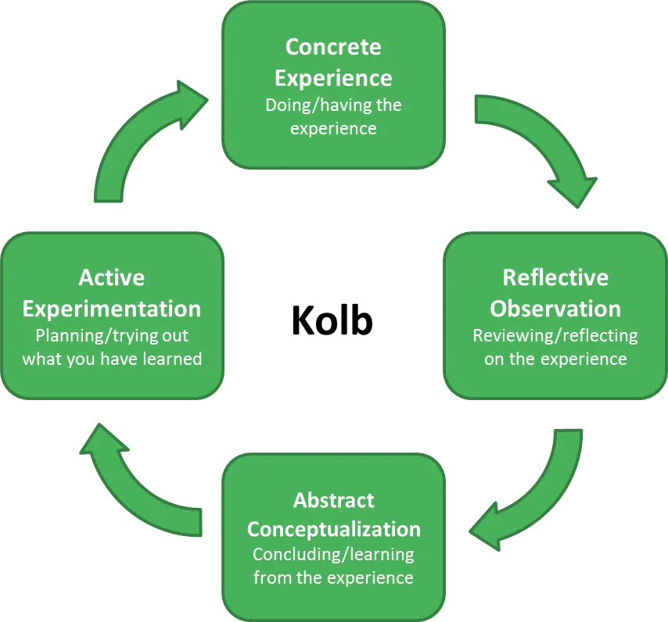

Another reflective theory is a theory led by David Kolb, who is an educational researcher. Kolb developed a four-stage reflective model in 1984 that is still used today. Kolb’s Learning Cycle (1984) is a tool that highlights that reflective practice is a tool that assists those that use it gain conclusions and ideas from any experience that the individual has been through. Kolb’s stages are set out as, Concrete Experience, Reflective Observation, Abstract Conceptualisation and Active Experimentation.
Concrete Experience – This is the task it’s self
Reflective Observation – This is where the practitioner would break down the task, asking the valuable questions such as “How did it go?”, “How could [I] have done that better?” “How did the children interact?”
Abstract Conceptualisation – This is the stage where the practitioner would conclude on what the outcome was for the previous stage.
Active Experimentation – The fun part – the practitioner would now try the new ways developed in the previous 2 stages to ensure that these methods work better. If it does not, then the practitioner can repeat the process until the practitioner gets the desired outcome.
Donald Schon devised the theory of reflection-in-action and reflection-on-action. Reflection-in-action is where the practitioner reflects whilst they can still actively change what they are doing, this is because they would reflect whilst doing the task and adapt it whilst the task is still being completed. This would be especially useful to use in the childcare setting as no two children are the same and no two settings are the same. It gives the practitioner the upper hand in reflective terms. Schon’s second theory is reflection-on-action and it is very similar to others where the practitioner finishes the task and then reflects and evaluates what they have done and how they could produce it better next time.
The CARL framework of reflection is also readily used throughout early years. Context, Action, Results and Learning are the four simple stages that are followed. These four steps have been adapted from interview techniques but without the learning aspect. However, the Learning stage is essential in evaluating progression.

Reference List
Cambridge International Education Teaching and Learning Team. ‘Getting started with Reflective Practice’ Available at: https://www.cambridge-community.org.uk/professional-development/gswrp/index.html (accessed on 27th October 2022)
Cambridge University Libraries. Reflective practice toolkit. Available at: https://libguides.cam.ac.uk/reflectivepracticetoolkit/whatisreflectivepractice (accessed 14th October 2022)
Dr Helen Edwards. Reflective practice – How to us it in your Early Years setting. Available at: https://www.teachearlyyears.com/learning-and-development/view/reflective-practice-how-to-use-it-in-your-early-years-setting (Accessed on 27th October 2022)
Good Therapy. Understanding Difficult Behaviour: For Foster and Adoptive Parents. Available at: https://www.goodtherapy.org/blog/therapy-adoption-child-behavior/#:~:text=These%20include%3A%201%20Withdrawn%20or%20depressed%20mood%202,connecting%20with%20others%208%20Property%20destruction%20More%20items (accessed on 30th October 2022)

The University of Edinburgh. Gibbs Reflective Cycle. Available at: https://www.ed.ac.uk/reflection/reflectors-toolkit/reflecting-on-experience/gibbs-reflective-cycle (accessed 24th October 2022)
The University of Edinburgh. The CARL framework of reflection. Available at: https://www.ed.ac.uk/reflection/reflectors-toolkit/reflecting-on-experience/carl (Accessed on 27th October 2022)
UNICEF. A summary of The UN Convention On The Rights Of The Child. Available at: https://www.unicef.org.uk/rights-respecting-schools/wp-content/uploads/sites/4/2017/01/Summary-of-the-UNCRC.pdf (accessed on 30th October 2022).

