l5 - Change Makers: Creativity and Value Creation
Assignment 1: E Portfolio
May Davies (1902699)
Computer Games Development
Contents
e-Portfolio 2
Task 1: Mind Map 4
Task 2: Image-Based Video Presentation 6
Task 3: Video Presentation 7
Task 4: Academic Poster 8

e-Portfolio
The following is the link to my e-Portfolio: https://1902699.wixsite.com/website
This is several screenshots of my e-Portfolio, as everything is on a one page format.
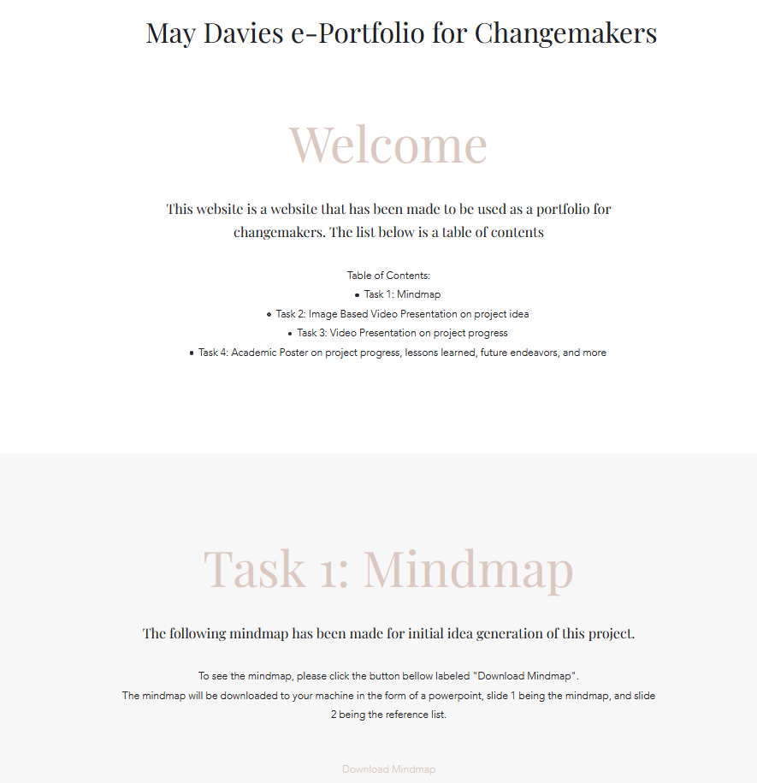
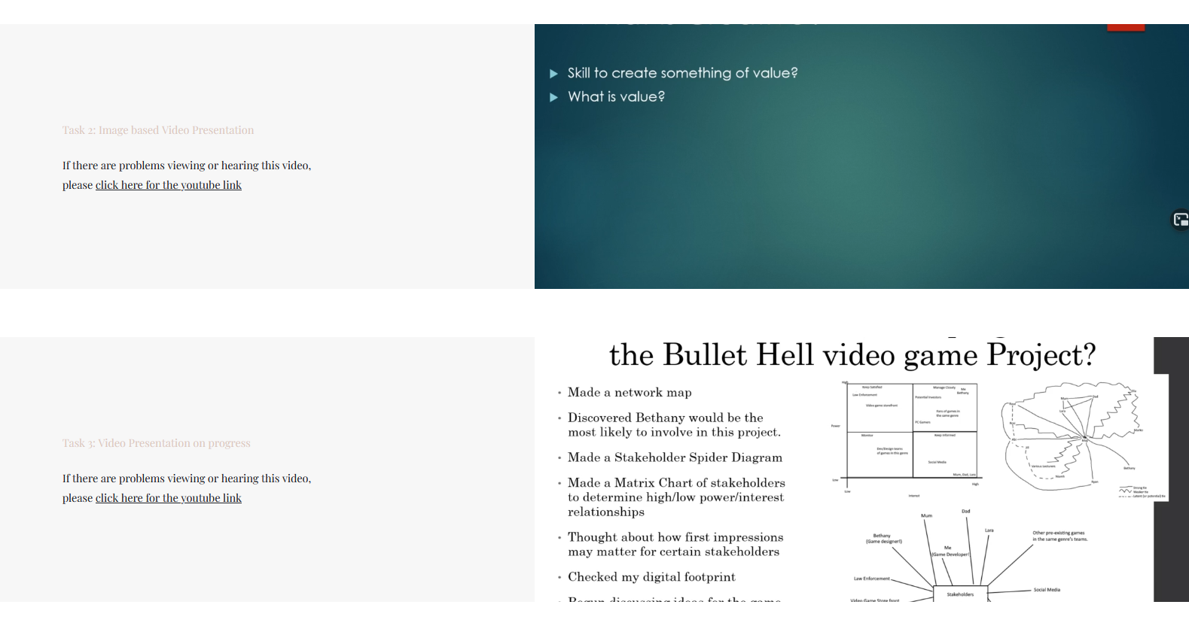
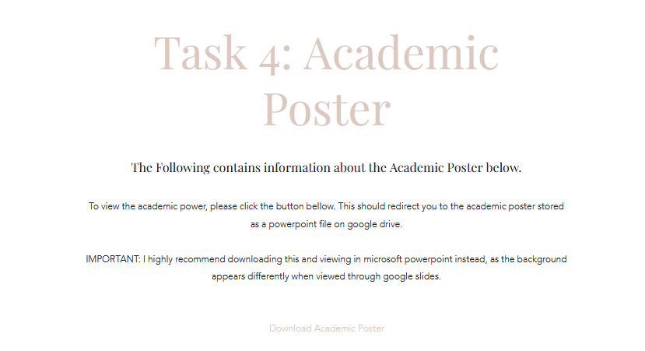

Task 1: Mind Map
Link to task on page: https://1902699.wixsite.com/website
Direct file link: https://drive.google.com/file/d/1fJ-VzLIJnY7WNCRfBrBYAStcZakkUWBW/view
Screenshot on e-Portfolio: 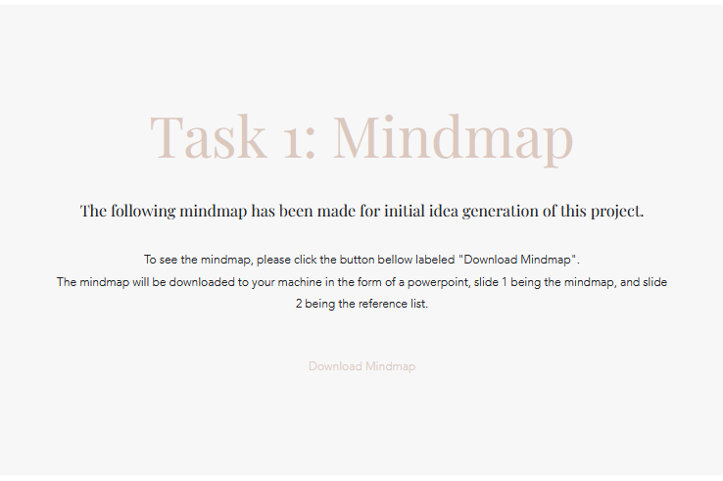
Screenshot in Powerpoint:
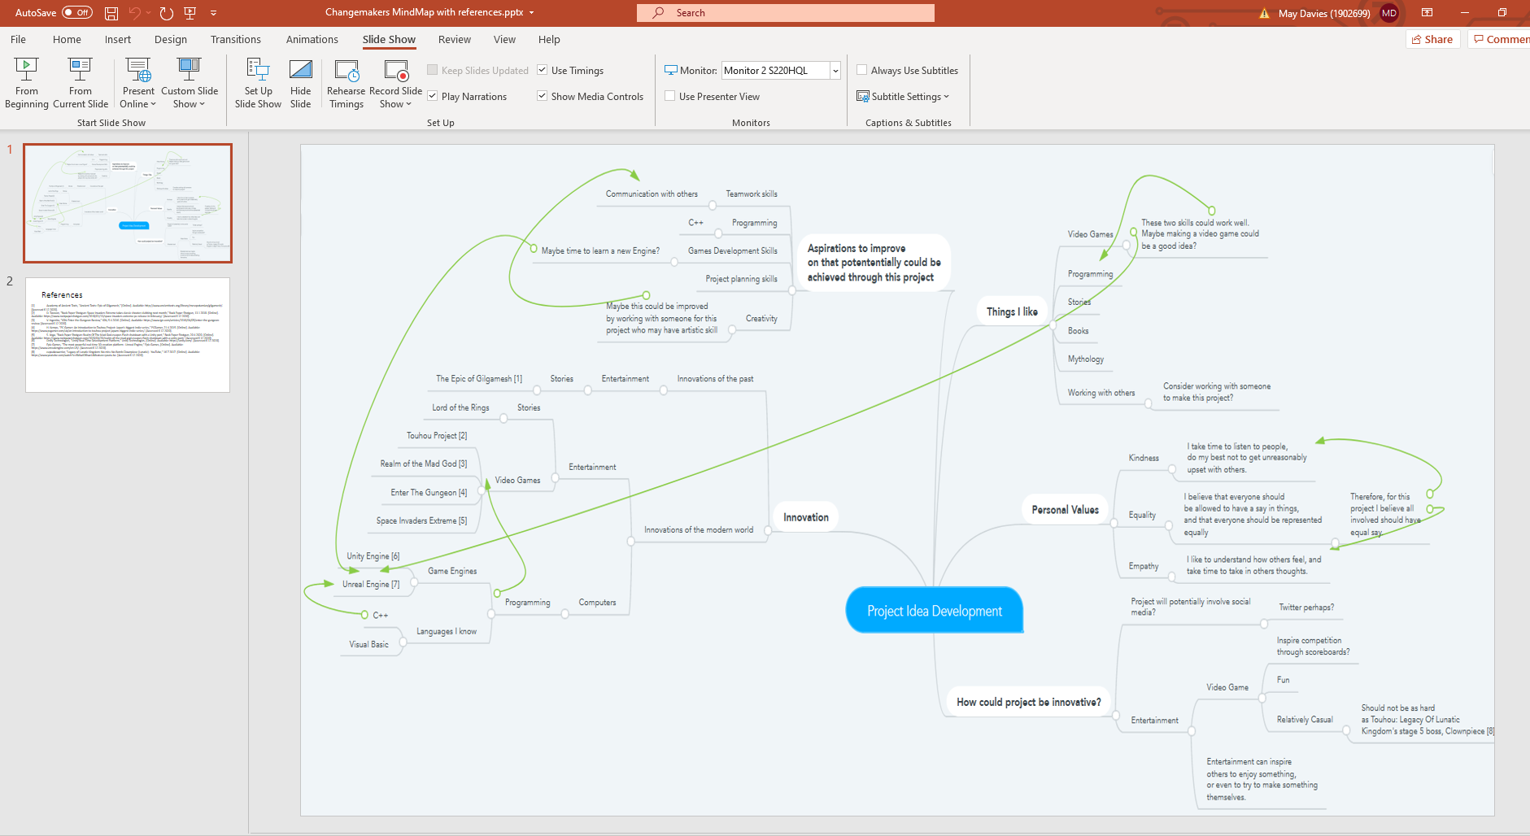
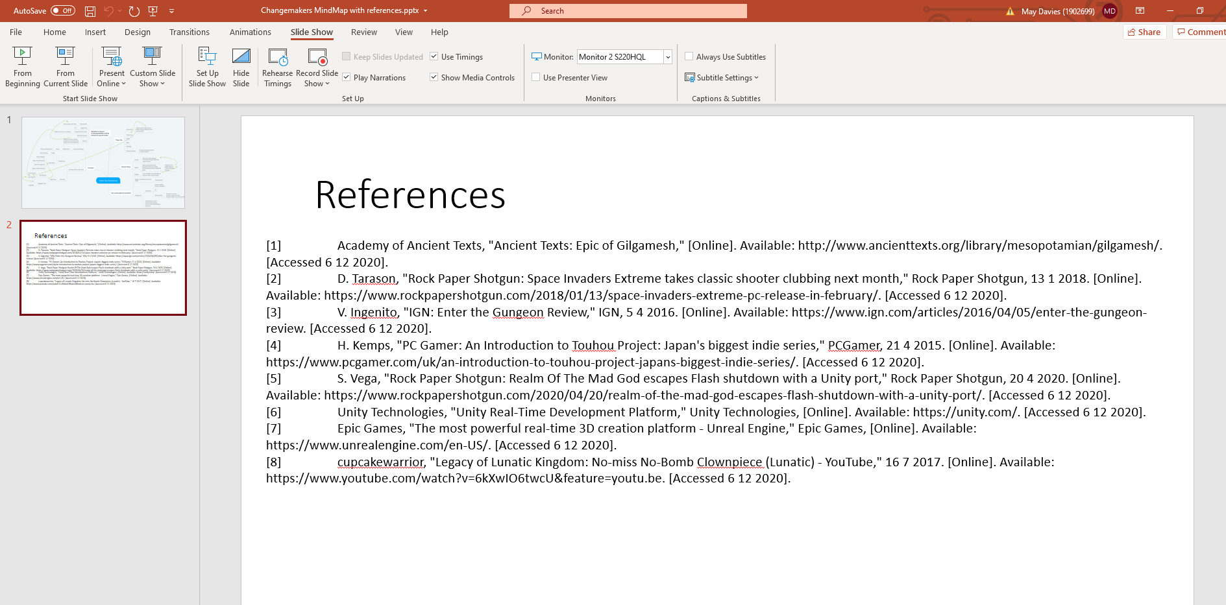

Task 2: Image-Based Video Presentation
Link to task on page: https://1902699.wixsite.com/website
Direct link to video hosted on youtube (the volume doesn’t work on wix for some reason): https://www.youtube.com/watch?v=S0LjD5dkl9g&feature=youtu.be
Screenshot in ePortfolio:
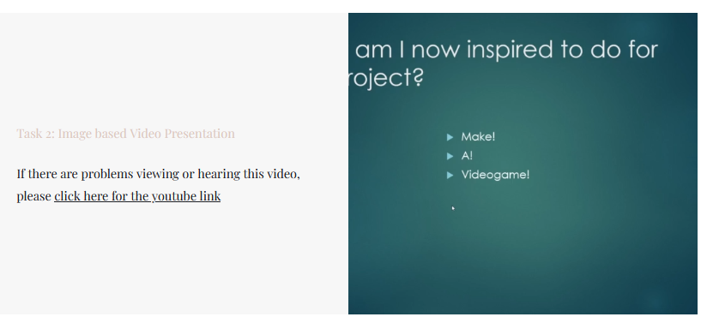
Screenshot on youtube:
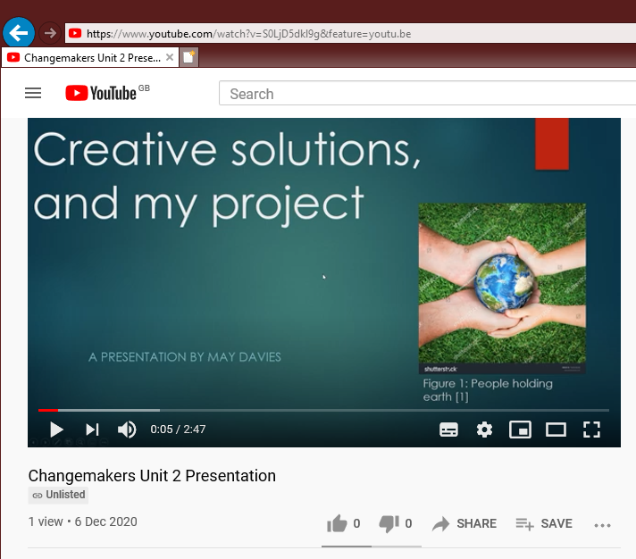

Task 3: Video Presentation
Link to task on page: https://1902699.wixsite.com/website
Direct link to video on youtube: https://www.youtube.com/watch?v=tS-YFC3_sRE&feature=youtu.be
Screenshot in e-Portfolio:
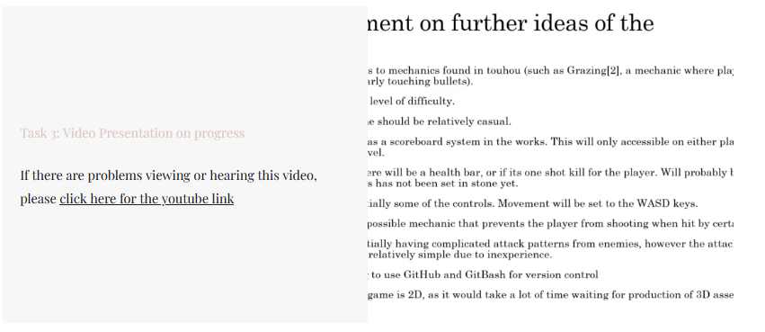
Screenshot of video on youtube:
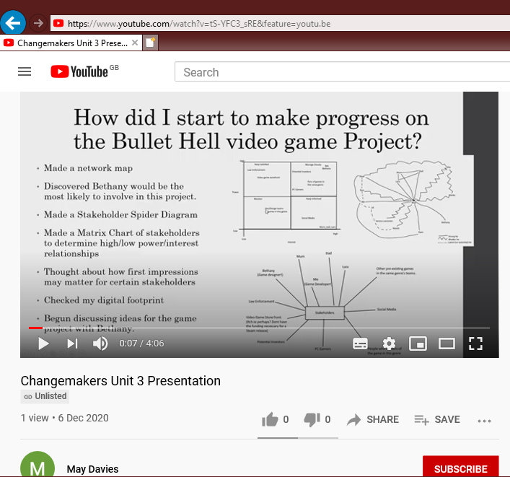

Task 4: Academic Poster
Link to task on page: https://1902699.wixsite.com/website
Link to poster in its online storage location: https://drive.google.com/file/d/1ylzgDlkY9LmoAVGAKnEzODa3D8WUBJf3/view
Screenshot on e-Portfolio: 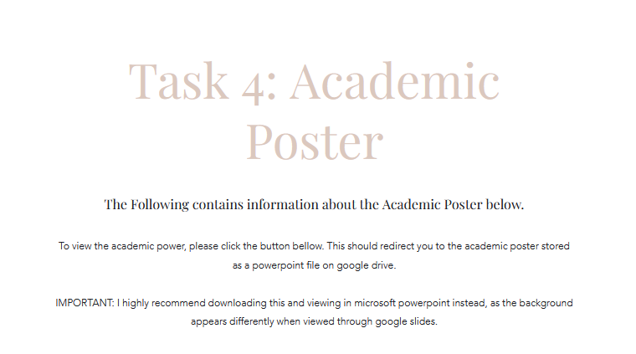
Screenshot in Microsoft Powerpoint:


