Learning In a digital Era | Assignment 1: E-Portfolio.
Samuel Jackson | 1802975
 | ACCA4025

Link to E-Portfolio:
https://sway.office.com/pv1dS5WifKetqEuY?ref=Link

Screenshot of homepage:
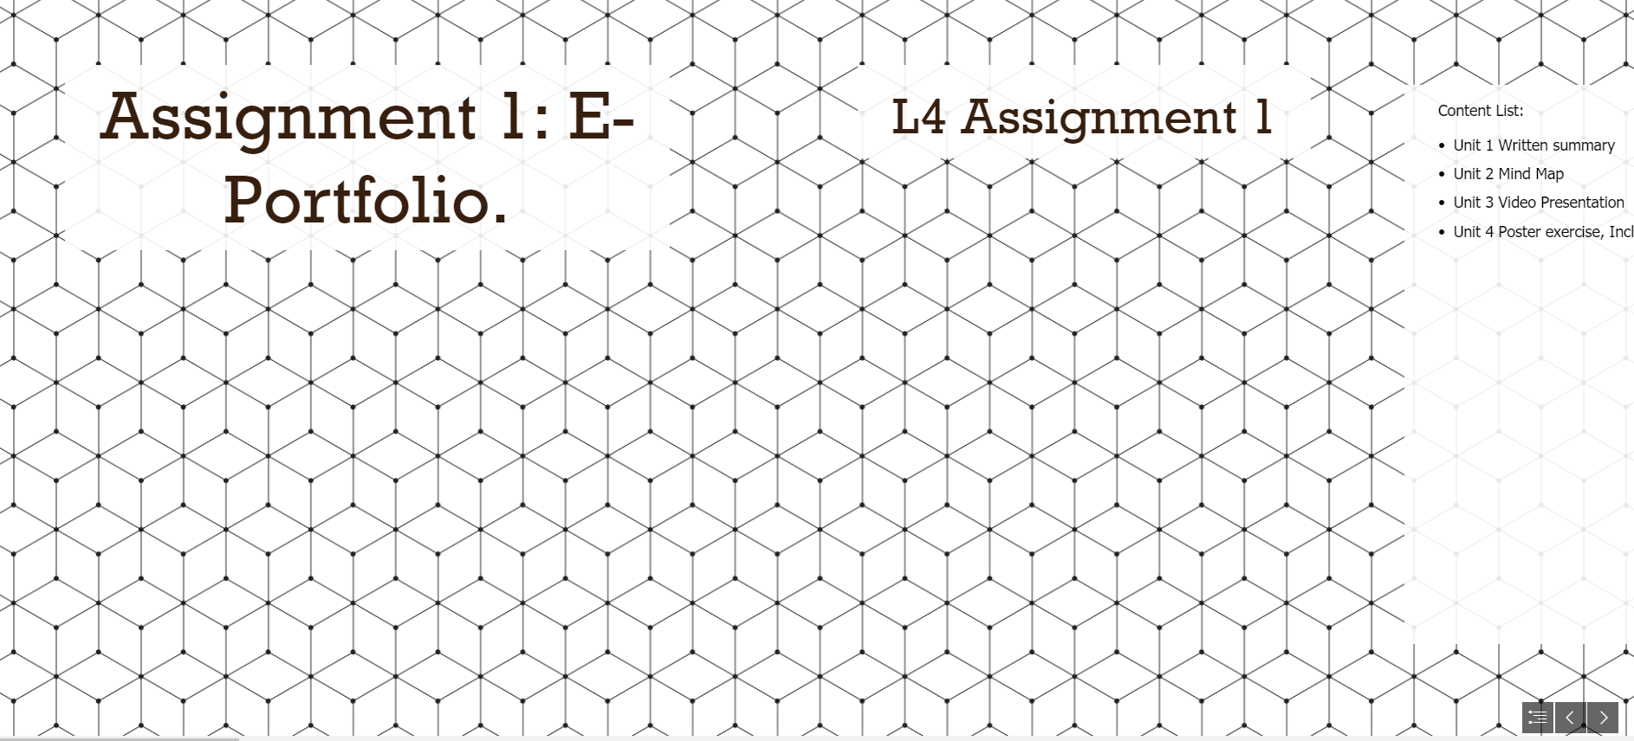

Task 1
Link to Written summary:
https://sway.office.com/pv1dS5WifKetqEuY?ref=Link

Screenshot Written summary:
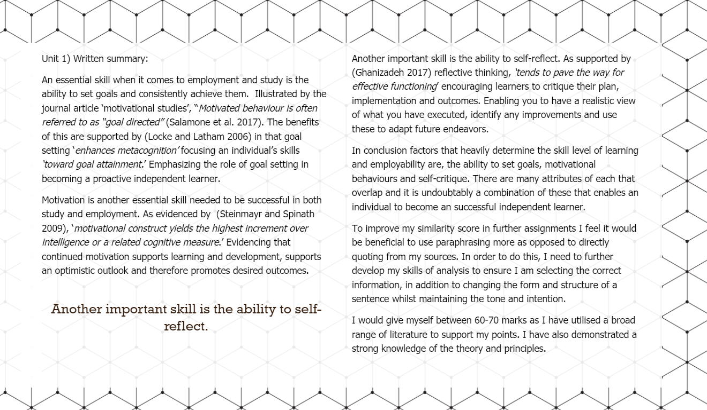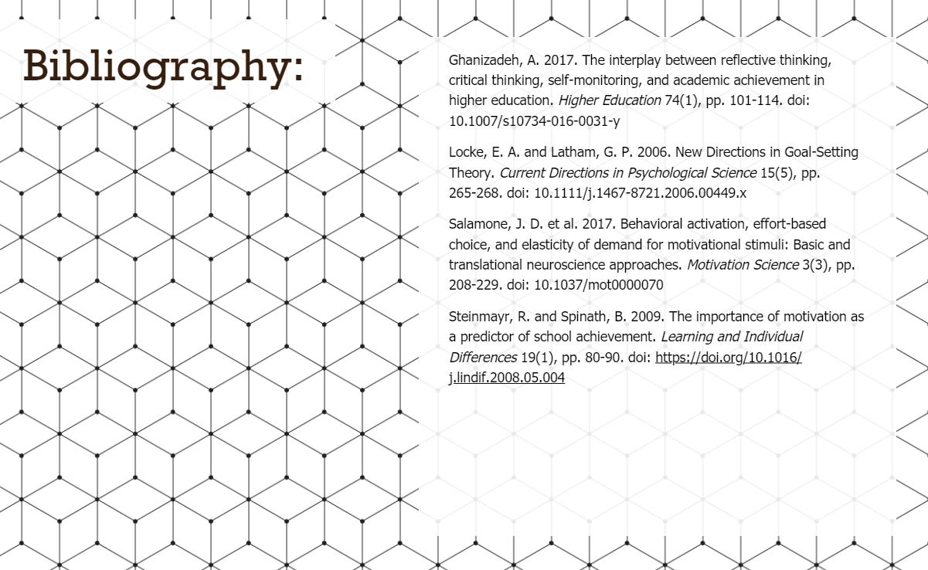

Task 2
Link to Mind Map to e-portfolio https://sway.office.com/pv1dS5WifKetqEuY?ref=Link
Screen shot of Mind Map
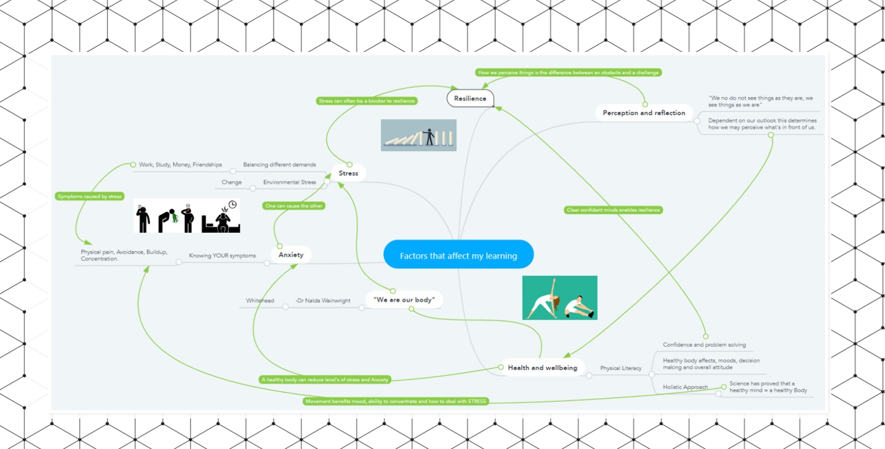

Task 3
Link to Video presentation (1) Assignment 1 Unit 3 - YouTube

Screenshot of Video Presentation 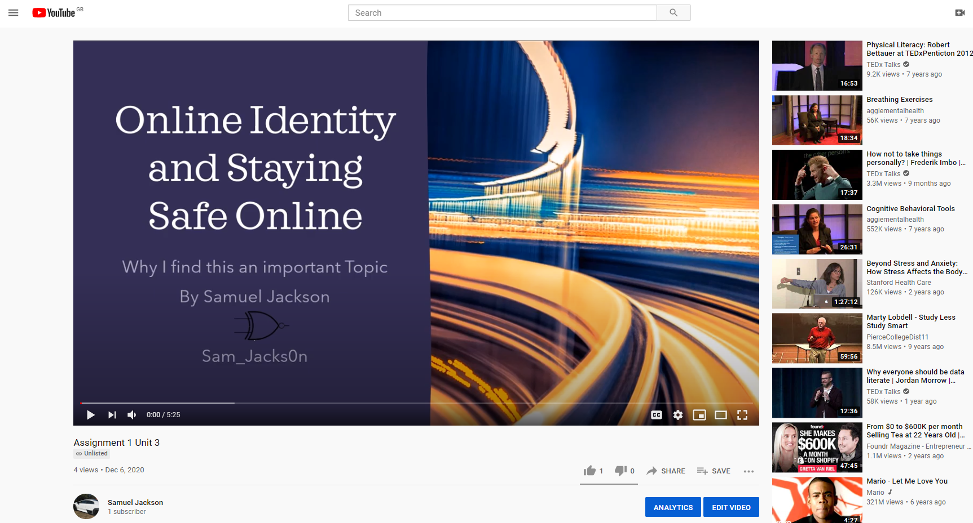

Task 4
Link to Academic Poster Assignment 1: E-Portfolio. (office.com)
Click here for Academic poster.
Screenshot of Academic poster


