Assessment Report

Analysis of management practice in contemporary organisations

Assessment title: Final Draft
Student name: Xinyu Wang (Naomi)
Student ID number: 2010660
Submission date: 19 January 2022
University/Programme: University of Wales Trinity Saint David
Word count: 7958

Table of Contents:
Part 1: THREE varying perspectives or theorists
- Taylorist
- Feminist
- Hofstede analysis
Part 2: TWO case study organisations
Hilton Worldwide Holdings Company
- General knowledge of the Hilton
  - Introduction to Hilton....………………………………………………………
  - The situation of employees affected by COVID-19
- Applied Theoretical models from Hilton
  - The fourth industrial Revolution (4IR)
2.2 Atkinson’s flexibility
2.3 Hilton’s Business Model
3. Strategic and competitive direction
3.1 Porter's five forces model for Hotel Hilton
3.2 People strategy Hilton
3.3 Social strategy Hilton
4. Criticisms of Hilton HRM models
Yunnan Energy Investment Group (YEIG)
- Strategic and cultural context
- The effectiveness of approach
- Conduct a critical comparison

Part 3: Leadership - Female Leadership in modern State Owned Companies(SOCs) Administration
- Introduction
2.1 Embodiment of Female Leadership
2.2 Advantages of Female Leadership
2.3 Practical application of Female Leadership
3. Conclusion
Reference List
Part 1: THREE varying perspectives or theorists
- Taylorist
Taylorism and interpersonal relationship influence each other. To put it simply, interpersonal relationship theory regards people as "social people", which means it will pay attention to people's needs and improve economic benefits through people's needs. Taylor's "scientific management" treats people as "machines" from the perspective of managers or capitalists. There are differences, but there are also similarities. The ethical orientation of enterprises is consistent, and the two are complementary rather than exclusive. The growing concern for the human factor began within the ethics and objectives of scientific management. Similar to Taylor's approach in scientific management, the interpersonal relationship school also uses scientific methods to study organizational behavior, focusing on the observable study of interpersonal behavior within an organization. Especially industrial psychology, which originated from experimental psychology, is highly consistent with scientific management in its guiding ideology and technical methods. Both emphasize the individual, both emphasize efficiency, and both advocate the use of scientific methods to achieve social benefits. Usually in the application of enterprise actual management, the combination of the two to use. Taylorism is very focused on how do people make the company profitable and reduce the cost, increase the productivity and make money for their shareholders. And the human relations approach is really talking about how do people change work so that work is more satisfying and allows participation. But also that will then increase productivity as well in some ways and enable the company to succeed.
In addition, lean management theory has a very powerful application efficiency in the operation of modern organizations. It can maximize the value of organizational sociality by improving customer satisfaction, reducing costs, improving quality, speeding up processes and improving capital investment. It is a revolutionary production management and practice. Its core idea is to reduce waste and establish a highly flexible and efficient production system. It represents the development direction of current manufacturing industry and is known as "the standard production mode of manufacturing industry in the 21st century". Hope to promote the level of enterprise management in Our country.
The managers of many enterprises know lean production management and its practical theory, but it often does not have the desired effect once it is implemented. Our survey found that many enterprises implementing lean production management often implement lean tools, such as 5S, TPM, QCC, TQM and so on, but ignore the core of lean production management: continuous improvement. Although many enterprises also stressed that they have been promoting continuous improvement, with little success, a careful study found that successful implementation of lean production management of some outstanding Japan or Europe and the United States have continued to improve supporting system in the company, does not exist in these enterprises, it gives us the answer, why lean management implementation. According to many of our practices, to successfully implement lean production management, the following supporting systems must be established: First, an improved proposal system with full participation. You may be familiar with it. We have a proposal system. But the improvement proposal here is different from the proposal improvement, rationalization proposals, etc., the improvement proposal is to improve after the proposal, that is to do first, first to improve, and then the proposal, this is our original proposal system is completely different. Improving the proposal system is the basis for full participation in continuous improvement. Start by cutting waste across the board. The second is the subject improvement system at the grass-roots level. Every middle-level cadre needs to lead a topic, which is called a big topic, a focus topic, most of which involves the improvement of process improvement and other larger aspects. The third is the presentation system of all staff. Whether it is a proposal for improvement or a major project for improvement, the release of the results should be used as a way to evaluate achievements. The way of publication is not just reporting, but also on-site demonstration. Present the improvements on site and share the journey with the participants. Fourth, expert diagnosis, general manager, chairman of the diagnostic system. What are the current problems? Where do we need to go next? This requires guidance from outside experts, general managers, and chairmen. At the same time, the process of diagnosis is also the process of testing the improvement effect of the anterior segment. Fifth, the training of all staff on relevant improvement tools is the basis. You can't improve without mastering the tools, and even if you do, you can't start. So the training of improving tools is a required course. This includes training at all levels, from newcomers to old employees, to promoters, from grassroots to leaders. The above five aspects, including improvement proposal, major subject improvement, publication, expert diagnosis and tool training, constitute a continuous improvement cycle, which is the continuous improvement support system of lean production management and the institutional guarantee of lean production management.

- Feminist
In British writer William Perez’s book 《Invisible Women》, her pointed out that people live in a world based on male data. The absence of data on women has allowed a business world built increasingly on big data and algorithms to systematically ignore the needs of the other half of the population. This neglect is not malicious or even intentional, but when men make decisions throughout society and companies, the technologies and products that lead development are inevitably biased in favor of men. For example, women can use toilets for a long time in menstrual period and pregnancy, so it is not appropriate to use the same area standard as men's toilets when designing them. Women are 50 percent more likely to be injured or killed in accidents than men, largely because automakers use mostly male dummies in safety tests. Even though women make up 50 percent of doctors and up to 90 percent of nurses during the pandemic, they struggle to find protective clothing of the right size, as protective clothing is designed for men's bodies. Due to structural inequality caused by gender imbalance in power, people need more women to participate in decision-making, eliminate bias in sample data collection from the very beginning, and face up to women's real needs, so as to design more suitable products for women.
A 2018 Study by The Boston Consulting Group found that women-owned companies make twice as much money per dollar invested as male-owned ones, yet most investors steer clear of them. According to Crunchbase News, only 2% of global venture capital funds in 2020 went to all-female startup teams.
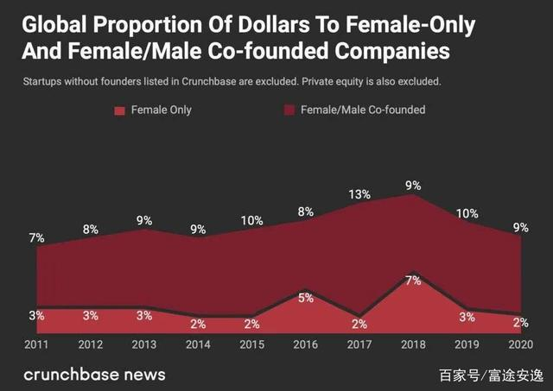
The reason why people are prejudiced against female leaders is essentially due to stereotypes about leadership. In the early industrial age, the pyramid of organisations gave birth to a host of authoritative leaders, most of whom were independent, rational, powerful and aggressive. By such standards, men naturally have an advantage. However, in the Internet era, the organizational structure is flat and networked, and the top-down management mode is gradually broken, and the feminine leadership needs to be re-examined under the new business model.
In the past two years, ESG concepts have been pushed to the forefront: environment, social responsibility and corporate governance. A company's value is no longer judged solely by its financial performance. How to generate positive feedback and value to the environment, society and consumers while making money has become another important dimension to measure enterprises. There is a growing awareness that a new economic logic is being established and that the traditional profit-driven business perspective needs to be adjusted, and adding more female executives to decision-making is undoubtedly one of the most effective ways to adjust corporate strategy.
Studies have shown that the presence of female executives can have a positive impact on corporate social responsibility, as they are more sensitive to charity, employee welfare and environmental issues. In fact, the very existence of female executives sends a signal to society that companies value women and minority groups and are willing to seek balance and win-win results in business development and social problems. Women, on the other hand, have been questioned by the market for their low risk appetite and conservative decision-making styles. But when academics analyzed the investment teams of 50 venture charities, they came up with the surprising conclusion that when it comes to social impact, women are more likely to consider and take such risks. Especially in the wake of rapid economic growth, social problems such as low desire, introspection and widening income gap are cropping up frequently. The risks behind these problems are difficult to quantify, but they are as important as financial considerations.
The extreme pursuit of efficiency and interests makes enterprise management unknowingly practice the cruel law of the jungle. On the other hand, the lack of humanistic care of enterprises also causes many bad social events. At a time when money is no longer the only guarantee of life, more and more employees are resisting an unsatisfactory workplace environment. While excellent enterprises are often the ultimate "altruism", the core of leadership is to achieve the value of others. Therefore, empathy, as an important missing link in traditional leadership, may help leaders better avoid risks. Here, women have a natural advantage, with a greater capacity for empathy. MRI studies have found that women have larger gray matter volumes in the posterior lower frontal and anterior inferior parietal cortices, which are closely associated with mirror neurons that produce empathy. Therefore, compared with men, women can more accurately detect delicate emotional needs, better communicate with employees, create a more comfortable and pleasant working atmosphere, and stimulate the creativity of the team.
The first Nankai University MBA Alumni Development Forum Women's Leadership Sub-Forum 2018 was held in Tianjin. At the forum, Zhang Chen, chairwoman of Mahua Funage, pointed out that mahua Funage is a comedy industry company, where more than 60 percent of the management are women and important positions are held by women. Cultural industry is suitable for women's development, while the core of management is the management of people, which is greatly affected by emotions. Once women can maintain emotional stability, the probability of success in management will be greater than that of men. With the development of economy and the change of times, today's society has been dominated by men and become more equal, and the leadership styles of multinational enterprises are also merging. The organic combination of women's perceptual thinking ability and men's abstract thinking ability is an important direction of future leadership development. And women leaders are often criticized for showing an unprofessional side in the workplace. When a female leader manages her emotions well and performs well in the workplace, people naturally focus on her leadership skills and career charisma.
The history of women's leadership development laid the foundation for the current situation, then reveals the sensibility of women have, soft, tough men do not have the advantage of, such as facing the workplace discrimination, family balance, workplace issues such as the ceiling, professor yan finally suggests that under the background of a certain age, may be can help women leaders breakthrough career development bottleneck.

- Hofstede analysis
According to the 6 dimensions model of national culture, combined with the actual case of Hilton Worldwide Holdings Company, it can reflect that Hofstede analysis’s relative influence on contemporary management practice. From the perspective of power distance index (PDI), Hilton's culture is generally low power distance. From the perspective of individualism versus collectivism (IDV), Hilton maintains a healthy balance between individualism and collectivism, and an organizational culture that promotes the best performance of employees, as well as the appropriate growth of the business. Hilton's MAS score was low in terms of masculinity versus femininity (MAS), meaning that the organization of job responsibilities often overlaps between men and women, and that the job descriptions often overlap without gender bias or stereotypes. From the perspective of uncertainty avoidance index (UAI), Hilton has practiced the combination of both in its culture and tends to have a lower score of uncertainty avoidance. Hilton employees generally have similar educational background and intelligence level, as well as similar personality characteristics. Therefore, their different answers to the same question probably reflect the influence of the cultural environment in which they grew up on their value orientation.
With the advance of enterprise globalization, cross-cultural management has gradually been paid more and more attention by enterprises. Cross-cultural is common in wholly foreign-owned enterprises, sino-foreign joint ventures and sino-foreign cooperative enterprises in China. With the entry of foreign culture and western management mode into China, Chinese and foreign cultures are in an inevitable cross-cultural state. In addition with the implementation of the strategy of large enterprise groups in China, as a cross-regional, cross-trade and transnational group enterprise, a variety of multilingual, multicultural integration, and many different countries, different regions, different nationalities, different members of the industry gathered in the same enterprise, cultural conflict will no doubt lead to corporate culture management is complex. But it also often collides with a culture of innovation.
Some of the differences in the concept of time have significant implications for organizational management, such as the flow and planning of work tasks. For example, western cultures view time as a scarce resource. "Time is money" and must be used efficiently. Americans are focused on the present and the near future. One can see this in the short-term orientation of performance appraisals, where the typical North American organization reviews employees every six months or a year. The Japanese, on the other hand, take a longer view of time and that is reflected in their performance appraisal methods. Japanese workers often take more than a decade to prove their worth. Other cultures have a different view of time, that is, they focus on the past. The Italians, for example, followed their traditions and sought practices that preserved their history. In addition, there is a time linear difference that makes Americans accustomed to do one thing in a certain period of time, and then do another thing after finishing one thing. Italians and Middle Easterners, on the other hand, tend to do more than one thing at a time, allowing them to adjust their schedules accordingly.
Part 2: TWO case study organisations
Hilton Worldwide Holdings Company

- General knowledge of the Hilton
1.1Introduction to Hilton
Hilton Worldwide Holdings is the world's leading hotel management company with 18 world-class brands in 119 countries and territories, including more than 6,500 hotels and more than 971,000 rooms.
Hilton is committed to fulfilling its mission of being the world's most hospitable company, hosting more than 3 billion guests in its 100-year history, ranking 10th in the world and making the Fortune 100 Best Companies to Work for in 2021. Through the award-winning Hilton Honor Membership loyalty program, more than 103 million Members who book directly with Hilton can earn hotel stay points and experiences that money can't buy, and enjoy instant benefits, including digital check-in through choice of rooms, digital keys and connected rooms.

1.2 The situation of employees affected by COVID-19
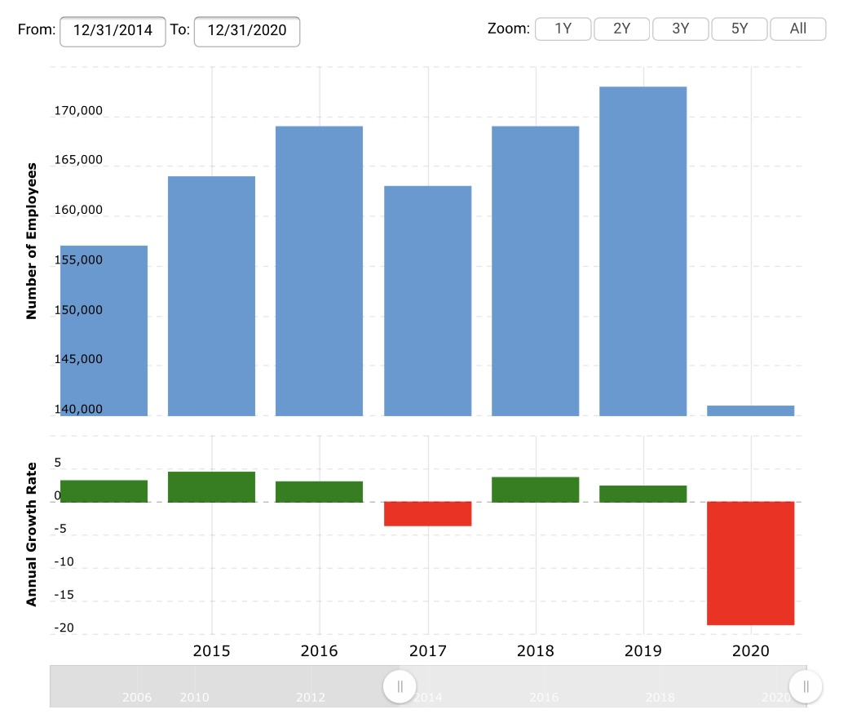
The following bar chart gives information about the number of employees and annual growth rate. In the picture, the blue bar is number of employees, the green bar and red bar are annual growth rate. According to the graph, when people look at the number of employees, the largest number is in 2019, at the end of 2019, it had 173,000 employees worldwide. While the smallest number is in 2020, which is 141, 000 people. When we look at the annual growth rate, the largest growth rate is in 2015, which is 5%. While the smallest growth rate is in 2020, which is -22% of its total directly employees. In conclusion, the graph is very informative and the number of employees fell sharply in 2020.
After the COVID-19 outbreak in 2020, the global tourism industry was hit hard. The hotel industry has reportedly been one of the hardest hit by the outbreak, with travelers forced to cancel their bookings as governments across the country implement home-quarantine policies. As a result, Hilton, an American hotel chain, is cutting 2,100 jobs. Hilton also extended its "mandatory" unpaid leave policy for many employees for another 90 days. But they will still receive medical benefits, and employees who do not take time off will have their pay cut by 20% during the pandemic. "In 101 years of Hilton's history, we have never faced a global crisis that shut down the travel industry." said Christopher Nassetta, CEO of Hilton. He gave up his salary for the rest of 2020, and the executive committee took a 50% pay cut during the crisis.
Hilton's rivals, including Marriott and Hyatt, are no exception, laying off workers or furloughing thousands due to plummeting bookings. But Hilton has also started a similar "shared employee" program to find temporary jobs for its tens of thousands of furloughed employees. In the past few weeks, Hilton has been working with companies that have seen increased demand for services during a public health crisis to find temporary jobs for hotel employees.

- Applied Theoretical models from Hilton
  - The fourth industrial Revolution (4IR)
Hilton remains a leader in this disruptive world and a true innovator in the hospitality industry. Artificial intelligence (AI) and machine learning will play a key role. AI and machine learning will take the hospitality industry's customer service experience to the next level in the coming years. The AI robot Hilton adopted was Connie. Connie's design is to learn and adapt to human beings, so the more it interacts with human beings. It will be more effective in the future.
In addition, there is the pace of technological change. For example, Hilton hotels has launched a new mobile Web application that gives iPhone users access to the hotel chain's Internet capabilities.
Notably, Amazon has struck a deal with Hilton hotels to offer virtual healthcare services to its employees. This marks Hilton's first customer for Amazon Health services in the hotel industry, and the second open customer after fitness product maker Precor. Being able to work with Hilton's large and diverse corporate staff and hotel chain employees is a milestone, Said Kristen Helton, director of Amazon Medical Services, according to the report. All of its U.S. employees enrolled in corporate health plans will be able to take advantage of benefits offered by Amazon Health Next year. Attracting and retaining talent is now critical for businesses, Says Helton. Amazon's Virtual health clinic, Amazon Care, will open in 2020. Amazon Care APP will not only offer virtual medical consultations, but also arrange follow-up visits by healthcare professionals at a patient's home or office, and even deliver prescription drugs to a patient's home.

2.2 Atkinson’s flexibility
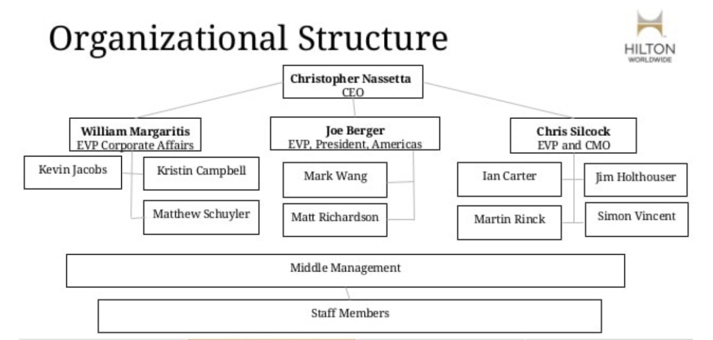
Hilton's organizational structure is hierarchical, due to the sheer scale of its business, which includes 13 brands and served 140 million guests in 2015 alone. In addition, Hilton's organizational structure can also be described as divisional, with the business divided into the following parts: The ownership segment consists of 146 hotels and 59,463 rooms owned or leased by Hilton worldwide; The Management and Franchise Division has 4,419 hotels with 691,887 rooms; The timeshare segment comprises 45 properties and 7,152 units. Each region has its own regional president and executive team, and the decentralized organizational structure means Hilton relies on a clear brand direction, which makes the company's decision-making process more flexible.

2.3 Hilton’s Business Model
Hilton's business is divided into three parts: management and franchising; Ownership; Time-sharing. The Company believes that these business units are complementary and provide the ability of the business to leverage its strong brand and operational scale. The company focuses on growing its management and franchise units, where third parties own hotels, while Hilton takes a fee for allowing owners to use the Hilton system to tag and manage assets. Hotel owners choose to label their properties with the Hilton flag because the company has proven its ability to provide consumers with a consistent consumer experience, no matter where they travel around the world. Many of these customers became HHonors members, and their strong brand loyalty to the Hilton Hotel system helped drive up the hotel's average room rate premium of 15% compared to its global competitors.
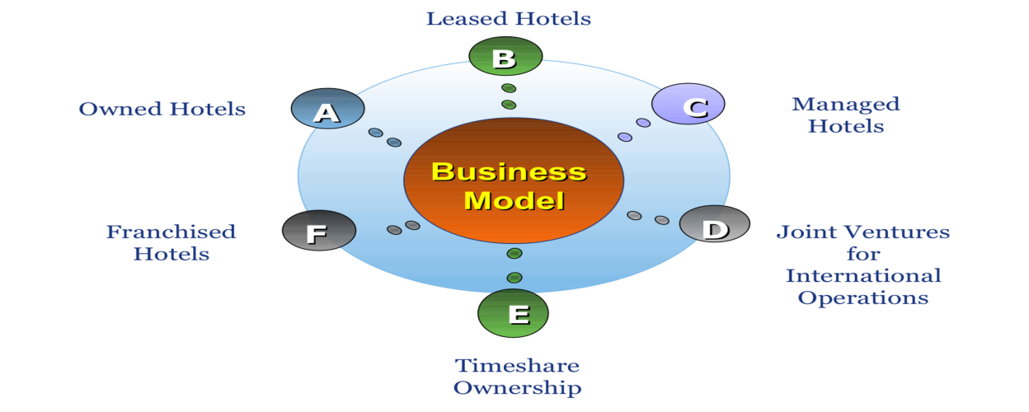
Franchised portfolio includes commercial/convention hotels, resort hotels, airport hotels and Hilton suites.

- Strategic and competitive direction
  - Porter's five forces model for Hotel Hilton
Hilton's vision is to be the first choice for travelers around the world. Based on its long history and brand strength, Hilton hotels are committed to consistently delight customers, invest in team members, provide innovative products and services, expand the brand family, and continuously improve balanced scorecard performance. Hilton's mission is to provide business and leisure travelers with quality hotel products that provide value for money choices while ensuring good returns for owners and shareholders, and motivating employees.
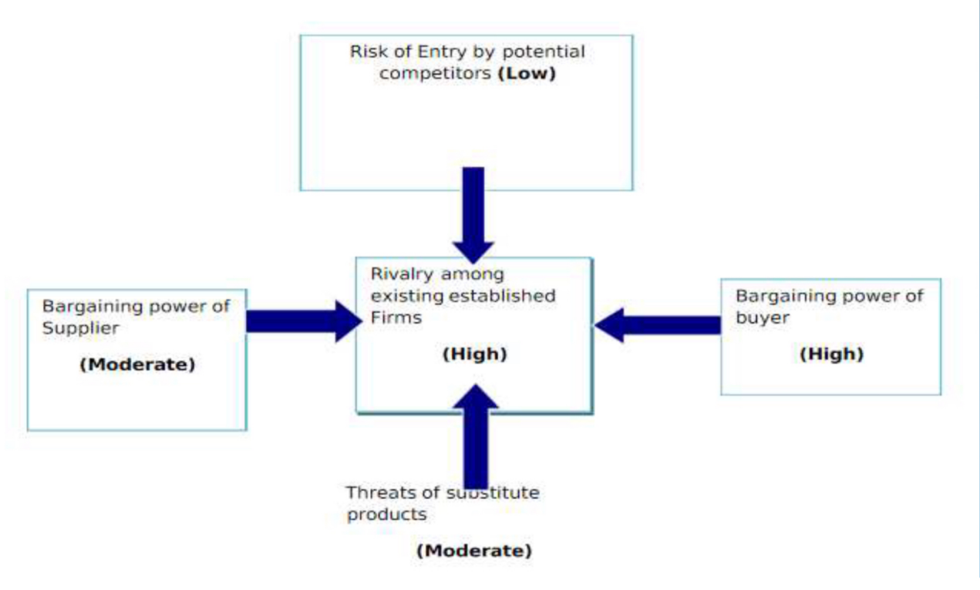
The bargaining power of consumers gives them more opportunities to choose the service they want from different hotels. So the bargaining power of the buyer is quite high. In terms of competitors, Marriott International Group (MAR), Starwood Hotels & Resorts International Group (HOT), WYN, Four Seasons Hotels Group (Four Seasons Hotels), Accor S.A are all competitors of Hilton Hotels. As a result, we believe Hilton is highly competitive with its competitors. In terms of the entry risk of competitors, the entry risk of potential competitors is relatively low, due to the high initial cost of establishing a hotel business and the fierce competition among existing hotel companies. In terms of the alternative threat, which Hilton has a strong competitive advantage in its wide range of outlets, the threat can be considered modest. In terms of the bargaining power of suppliers, they have many supplier resources available to run their business.

3.2 People strategy Hilton
For human resources (HR) recruitment, establish a core school alliance, which is 16 schools where recruiters look for potential interns. And Indeed.com, Hilton Worldwide's career page, offers direct job search. Hiring applications send resumes online to different departments, looking for opportunities and interests around the world.
For HR training and development, Hilton Worldwide University has five different colleges. There are part-time 20 hours and full-time 45 hours available. Among them, Hotel College and Owners College provide branding requirements, compliance, and other training programs and information to enable hotels to meet and exceed guest requirements and Hilton Worldwide standards. Commercial College provides comprehensive sales revenue management, customer training and e-commerce training programs and information, enabling the hotel to generate significant revenue. Leadership College provides executive and leadership development programs and experiences to senior leaders worldwide to ensure that managers are provided with a good program that is more appropriate for grassroots leadership. General Studies College provides a wide variety of training courses and learning experiences for all team members to adapt to the ongoingprofessional development of the school's management.

3.3 Social strategy Hilton
As time goes on, in addition to the daily competition Hilton faces with other brands during the pandemic, the challenge now shifts to people's hesitation and opposition to travel schedules. In order to regain the trust of guests in the tourism industry and brand building, Hilton proposed product innovation, marketing creativity and customer contact three points of view. Social insights can be used to drive similar business strategies.
Product innovation can be seen in the changing priorities of travellers choosing hotels during the pandemic, who are more concerned with cleanliness and prevention and control measures than with amenities and services. Hilton has created the Hilton CleanStay guest room seal program and partnered with reckitt Benckiser, a trusted home cleaning brand. We can timely understand the public's attitude towards the brand and demand for visual prompts through the keywords of feedback of comments on media platforms and social networking sites. The project has a direct impact on brand loyalty and revenue, which may reveal a gap in the market or provide an opportunity to create something new for customers.
Marketing creativity is reflected in Hilton's global marketing campaign "To New Memories" launched in 2020, which appeals To customers' emotions. Customer surveys show that nearly 90 percent of travelers say the memories of their trips are the happiest part of their lives, 95 percent of travelers miss their trips very much, and 90 percent believe they are currently facing a travel memory shortage. Social listening, on the other hand, doesn't require a lot of time and money to learn about users' real feelings in their daily social activities, resonate with messages and ideas, and motivate the audience to take action.
Customer contact is reflected in the fact that many people are working from home during the pandemic, and the business opportunity is to provide guests with a distraction-free "Workspaces" to improve the efficiency of working remotely. Fans are then encouraged to interact so that the team can provide value or solve a problem for the audience, which creates a lasting connection with both the directly involved guests and everyone who happens to hear it, positively affecting their perception of the brand. There are also cases where news reports advertise hotels for free.

- Criticisms of Hilton HRM models
Internally centered management development programs, such as SHINE program and Elevator Program, are designed to train employees into management cadres, so that these managers are trained from the beginning to the final choice of management positions, so that there is little room for the inflow of fresh ideas from outside. But without an influx of external talent, innovation may be stifled and hotels may be forced to acquire these new talents at a very high cost when needed, whether in terms of employee compensation, affecting the morale of other employees, or externally. (GMJ, 2001; Eye of Dubai 2010)
On the other hand, Hilton don't take disability into account. Unlike their rival, Hyatt Regency, which was named best hotel in 2010, Hilton's human resources program does not provide disability services. And human resources development is also inadequate. This is mainly reflected in the indifference of employees' sense of ownership, the low degree of participation in corporate hotel management and decision-making, and the serious loss of technical talents.

Yunnan Energy Investment Group (YEIG)
- Strategic and cultural context
Yunnan Energy Investment Group (YEIG) is a state owned company (SOC) in China. In order to accelerate the implementation of the strategy of strengthening the province by industry, expand and strengthen the energy industry, and promote the comprehensive, coordinated and sustainable development of Yunnan's economy and society, IT was established in 2012 with the approval of the Provincial government and supervised by the Provincial SasAC. The Group comprehensively implements Xi Jinping Thought on Socialism with Chinese Characteristics for a New Era and the spirit of the 19th National Congress of the Communist Party of China, firmly implements the new strategy of national energy security, closely adheres to the requirements put forward by the General Secretary during his visit to Yunnan, and actively integrates services into the national strategy and the overall development of Yunnan. With the goal of building a competitive multinational group in the national energy sector, the reform of state-owned enterprises will be accelerated and more efficient, international development will be accelerated, and social responsibilities will be actively fulfilled to help fight poverty. We will strengthen and improve the three major industries of green energy, modern logistics and digital economy, and accelerate the development of collectivization, securitization, internationalization and digitalization.
- The effectiveness of approach
Companies around the world are facing an unprecedented crisis as a result of the COVID-19 pandemic. Since 2020, YEIG has implemented democratic management and focused on high-level opening-up and cooperation to build a world-class green energy industry group with core competitive advantages, striving to become a model of state-owned enterprise reform and transformation and upgrading in the province, and strive to enter the world's top 500 enterprises. For the province's high-quality and leap-forward development of industry and economy and society, it has been continuously rated by the Provincial Party Committee and the Provincial State-owned Assets supervision and Administration Commission as the Excellent Unit of Party conduct and clean government construction, a-level enterprise and outstanding leadership.
- Conduct a critical comparison
The difference between YEIG and Hilton is that the company is different in nature. YEIG is a state-owned enterprise and undertakes certain political tasks. The latter are multinationals with a commercial bias. YEIG is divided into school recruitment and social recruitment. For fresh graduates, they sign a labor contract for three years for the first time, including one year for probation and internship, during which there is only basic salary but no merit pay. Open recruitment of staff for the society, probation period of one month. Among them, the basic salary is different according to different educational background, but they all have five insurances and one housing fund, and the interview is also unified. The products provided by YEIG are different. Under the structure of state-owned capital investment company, YEIG realizes the coordinated development of several key fields and sub-groups, such as electric power, coal, natural gas, distributed electricity, salt industry, chemical industry, modern logistics, digital economy, finance and international development.
The similarities between the two are that they both have a sound training system. For example, employees have to undergo unified training for a period of time before formal entry and then carry out corresponding training courses at work. On the one hand, it adopts the customer-centered service concept, on the other hand, it adopts the people-oriented staff management concept.
Part 3: Leadership - Female Leadership in modern State Owned Companies(SOCs) Administration

- Introduction
Female leadership is increasingly sought after within State Owned Companies(SOCs) in the new era. Recent global leadership studies have shown that the most effective balance of male and female leadership is between 40% and 60%. The World Economic Forum (WEF, 2015) shows that gender parity only about 60% in economic and 21% in political. The importance of this topic is on the value that female leadership brings to administration. Therefore, the aims of this project are to consider previous research to analyse the nature of female leadership by using bar chart and data from different countries. Furthermore, the project will state that developing countries should learn from advanced western countries to improve female leadership. This project has three main themes. First, embodiment of female leadership is discussed. Secondly, advantages of female leadership in modern SOCs management are considered. Finally, some representative countries with typical cases are introduced.
The COVID-19 pandemic has made people realize the importance of sustainable social development, and how to balance the business value and social value of enterprises has become a question on the minds of entrepreneurs and investors. Allowing more female executives to participate in corporate decision-making, to some extent, offers a solution to this dilemma. The unique and scarce business perspective of female executives can bring win-win financial and social value to companies. Through investigation and research, there are general issues related to women’s lives that impact and that can be helped to keep female mangers in work and encouraging their promotion. People also can see that feminist approach to leadership and management, and current debates and emerging thinking around management practice.

2.1 Embodiment of Female Leadership
Women have many more new opportunities to bring their power and rights in leadership in the new era than ever before (Nannerl, 2020). The present study covers a similar range of topics to many other female leadership studies. It does, however, focus particularly on the new status of women working in their field who will find this a valuable resource for getting ahead and developing creative power. In particular, we will find that leadership of a group of strong women in craft. As everyone know, there are many cases from many different places and characters. For example, the existence of U.S. Secretary of State Hillary Clinton, German Chancellor Angela Merkel, Australian Prime Minister Julia Gillard, Brazilian President Dilma, Argentine President Cristina Fernandez de Kirchner, and Thai Prime Minister Yingluck shinawatra. In addition, Chen et al. (2018) stated that the emergence of female leaders in companies can be used to compare with male leadership. To some extent, female leadership can embody the concept and culture of equality and multiformity between male and female. So the feminism is not about female having more power than male, it is just about equality. There is no denying that men and women think differently, but the new era of female managers may be more strategic and adventurous than the old stereotype of women.
However, according to Gender Parity Project of The WEF (2015), although the economic gender gap around the world will close possibly, but it will still take a long time. But it is just a prediction, and there is not enough evidence to prove that the conclusion is true in the whole world or all respects. So the report is perhaps too absolute to propose that “the economic gender gap is predicted to close in 2133”. The study also shows that gender parity only about 60% in economic and 21% in political.
The latter study focused on the rate of change and parity between men and women as leaders. Some published literature focused on the modern women who are much likely to provide important leadership in SOCs, compared with any time in history (Nannerl, 2020). When discussing female leadership, we can jump out of the one-dimensional gender perspective and interpret and learn the current quality leadership of women. Both male and female leaders can be emotional, but they come in different forms due to differences in mindset and communication styles. If male leaders have some female characteristics, female leaders will learn the way of thinking of male leaders and believe that both men and women will become better leaders. Now may be the best of times for women, as traditional notions of gender are being undermined by new business perspectives. More women are participating in business and seeing the world through women's eyes.

2.2 Advantages of Female Leadership
The work style of modern female leader is often considered to be the flexible management when they come to implementing SOCs rules. In support of this argument, AcevedoDuque et al. (2021) and Chen et al. (2018) point out that female leadership in business is more likely to work with subordinates to complete the plan, rather than simply dictate it. And business management shows their communication, technological and leader skills. As shown below, the bar chart of female leadership characteristics grouped by leadership style. People can see these two items that high and very high presence of female leadership with participatory, helmsman, coaching and visionary styles, without coercive style. It means female leaders also are good at setting direction, offering help and planning for the future.
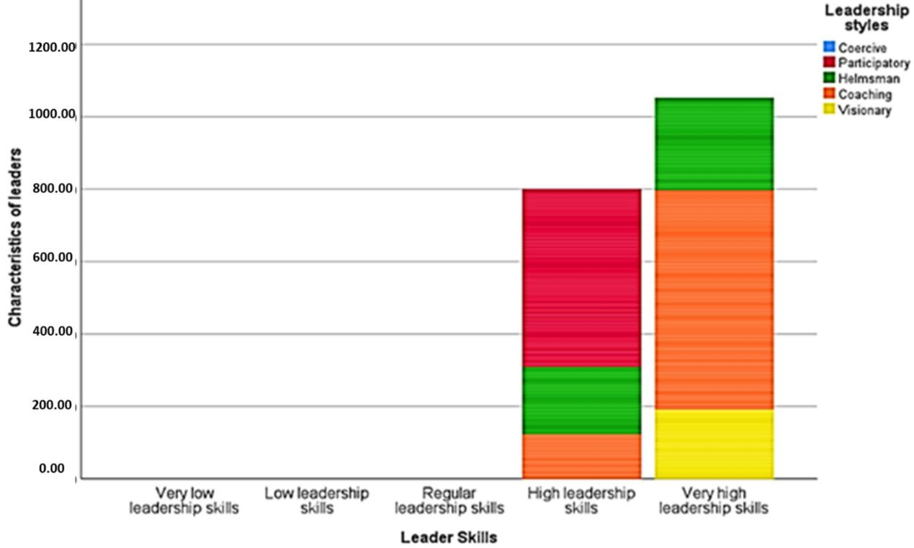
Filtering by multiform Female Leadership. Source: elaborating by AcevedoDuque et al. (2021)
However, others argue that despite women have many more new opportunities to bring leadership in the new era than ever before, there are many difficulties when the difference between women and men such as family factors are taken into account (Nannerl, 2020). It is probable that the family limits women's career development, and the workplace prevents women from taking care of their families. Thus, one of the most important things is the balance between work and life (Le Ha et al, 2020). But not everybody raise a child now, they don't necessarily make women do everything. If they make the woman do all the work, then there's no time to be working in a company where as if the society helps men and women look after children. Look after the baby then everybody is able to work in the company. And one of the things that people know it's across Europe. It's the Scandinavian countries that do that very well. In Sweden and Finland, those countries have a society solution to help men and women raise the children and provide the care, so that men and women are able to work in the workplace achieve more equally. And one of the things that people can study is all sorts of the policies that organisations can bring in to encourage men to look after children and women to to get involved in management.
Indeed, while this argument is persuasive, the fact that female leadership is used as a management skill in such a range of workplace seems to support its trend as the positive development. This endows the management level with a sense of maternal characteristics and makes it easier for partners to have empathy at work. It seems that this and people commonly known as "strong woman" and different, but a can run through the people-oriented concept of "weak" management mode. Sometimes, some women do not dare to pursue a career oriented life, even if these women have this idea in their heart, but they can not show it, maybe because of the fear of being labeled as "strong woman", in daily life, it is easy to be looked at by the opposite sex or the same sex and afraid to approach.
Take Li Xin (Chongqing) Data Technology Co., LTD., a company committed to becoming a leading data service provider in China. In the Kunming branch of Yunnan Province, all the market research interviewers are women, including the supervisors. With data collection, data analysis and data application as the core, they focus on market, public opinion and social research, and provide one-stop data analysis application solutions for governments and enterprises with the "product + service" strategy combining cloud platform, application products and data services. This shows that women are more approachable, patient, careful, trustworthy and good at communicating with the market and people. It is not easy to imagine that even such high-tech small and medium-sized enterprises need so many female employees and managers. It can be seen that women have penetrated into all walks of life and all positions, and the training and management system for women has been developed more perfect and sound.
Furthermore, some SOCs have regulations to help female make “family-friendly lifestyles” (Nannerl, 2020). Such regulations are implemented in some European and Chinese workplace. Take Yunnan energy investment group for example, it is known SOC in China by its large scale and good efficiency. There is a regulation has been implemented to allow female office staff to bring their children to work. Moreover, many departments such as market management department and union are headed by female. It also means that female's social status has improved, and they can realize the self-worth in modern SOCs. To some extent, this reflects the tolerance and tolerance of women, which means that women are gradually respected. Thus, the increasing coverage of female workers and managers is conducive to promoting more humanized management methods, which is undoubtedly a kind of progress and innovation in work.

2.3 Practical application of Female Leadership
During the COVID-19 pandemic, female's participation in globalization is even more needed to mitigate the long-term impact of the pandemic. Wittenberg-Cox (2020), claims that countries led by female were safer, there are approximately 6 times as many deaths in countries led by male. Thus many countries are addressing female's rights and making some progress. As everybody know that everything has changed in the COVID pandemic. In Europe and the US, more than 40% of large companies have adopted flexible working arrangements for women. For female employees and leaders, it is one of the better benefits for companies to provide certain suitable positions for women to engage in flexible working. The government could also encourage the establishment of flexible working arrangements for female employees who have been nursing for two to three years, which could be linked to the care policy for infants aged 0 to 3 years. In the same, this time patterns will happen in that women will work from home and work online, then their career will suffer. And the men who go into the office still will get promoted.
On the other hand, unfortunately, female might still face problems in recognizing their skills when they comes to SOCs leadership roles in some developing countries like India, Vietnam, China and Latin America (McGowan, 2021; Le Ha et al, 2020; Chen et al, 2018; AcevedoDuque et al, 2021). Shockingly, even then, the Taliban do not allow Afghan female to get an education or job, and leave their homes. It is difficult for female to become SOCs leaders when their status is low (Nannerl, 2020). Similarly, China has yet to fully achieve equal pay for equal work and increase access to decent jobs, although the Chinese government's recent commitment to prioritise women as much as possible in future development cooperation and global engagement has helped Chinese women move up the ladder. Hkex's IPO guidance specifically upgrades the diversity policy from a corporate governance code provision to a mandatory listing rule, requiring new applicants to pay particular attention to gender diversity in their IPO prospectuses. While exchanges are urging companies to appoint more women to board positions, one has to face the fact that the market is biased against female leaders. These biases come not only from established stereotypes, but also from new ideas that have sprung up in a new age.
In the situation, they might learn from western developed countries, because western countries are more democratic. Whether it is poverty, maternal health, livelihoods, food security, or access to continuing education, developing countries still have a lot of room for progress. But either way, gender equality and women's empowerment are a driving force for change and a prerequisite for achieving all the Sustainable Development Goals, so they must be given the attention they need. Here is a typical information in the United States, there were more female candidates in 2018 and 2019 than ever before, including 117 female elected in 2018 (Nannerl, 2020). So, we're seeing positive changes in society. In 2021, the SEC formally approved nasdaq's board diversity policy, stipulating that listed companies' boards should include at least one woman and one self-identified underrepresented minority or LGBTQ+. Today, in different Settings, or in different parts of the world, more and more women are becoming more comfortable with exercising and holding power, and openly ambitious to do so. Global cooperation enables countries to exchange and share experience with each other anytime and anywhere.
For women themselves, if they want to improve the phenomenon that has long equated leadership with masculinity and realize social value, they need to improve their management ability. No matter how the environment changes, the advantage of women's inclusiveness can be used to quickly adapt to the environment and make the whole organization run efficiently. At the same time, do their own career and life planning, determine the direction of progress. When faced with difficulties or challenges, women are good at psychological counseling, providing emotional value and giving team members some help. This helps team members to trust each other and bond. The aim here is to provide SOCs of developing countries an empirical that can be used and improved as the female talent selection and training, and leave it to people to promote development in all parts of the world.

3. Conclusion
In today's world of dramatic change, it is necessary to have an excellent leader so that organizations can confidently face the great challenges ahead. No matter female is superior, increasing the number of female leaders and strengthening the multiformity of management has become an obvious trend. Nevertheless, female leaders need to balance many things like family and work, body state and work intensity, personal interests and responsibilities, time management, public evaluation and social conventions, then they face greater challenges. In the light of related research and evidence, flexible leaders have an advantage in communication and innovation, and the economic gender gap might be closed, but it may take a long time to throughout the whole world.
It is necessary to see through the surface into the heart of the matter. Since ancient times, culture and cognition have influenced women's social status. In addition, women's career development is restricted to a certain extent due to the different education levels in different regions. Family background also determines whether women have the ambition to compete for leadership positions. Some political systems influence the way women participate in management. Therefore, female talent selection and training programs should be planned carefully to ensure further play a unique role of female leadership. Perhaps only by improving myself first and then participating in the work, can the management effect be optimized. In my view, modern SOCs administration may have strong health prospects promote female leadership.
Reference List (example)
AcevedoDuque, Á., GonzalezDiaz, R., Vargas, E.C., PazMarcano, A., MullerPérez, S., SalazarSepúlveda, G., Caruso, G. & D’ Adamo, I. (2021) ‘Resilience, Leadership and Female Entrepreneurship within the Context of SMEs: Evidence from Latin America’, Sustainability, 13 (15). pp. 8129-8129. DOI: 10.3390/SU13158129 (Accessed: 19 August 2021).
Chen, S., Fang, H.C. & Wu, B. (2018) ‘Female leadership in contemporary Chinese family firms’, Asia Pacific Journal of Management, 35 (1). pp. 181-211. DOI: 10.1007/s10490-017-9515-2 (Accessed: 20 August 2021).
Le Ha, N.T., Doan, T. & Linh, T.K. (2020) ‘FACTORS AFFECTING WOMEN LEADERSHIP IN VIETNAM’, International Journal of Information, Business and Management, 12 (4). ISSN: 2076-9202 (Accessed: 20 August 2021).
McGowan, A. (2021) ‘Mothers and Godmothers of Crafts: Female Leadership and the Imagination of India as a Crafts Nation, 1947–67’, South Asia: Journal of South Asian Studies, 44 (2). pp. 282-297. DOI: 10.1080/00856401.2021.1876589 (Accessed: 20 August 2021).
Nannerl, O.K. (2020) ‘Women, power & leadership’, Daedalus, 149 (1). pp. 236-250. DOI: 10.1162/DAED_a_01785 (Accessed: 19 August 2021).
Wittenberg-Cox, A. (2020) ‘Will the Pandemic Reshape Notions of Female Leadership?’, Harvard Business Review. Available at: https://hbr.org/webinar/2020/10/will-the-pandemic-reshape-notions-of-female-leadership (Accessed: 7 September 2021).
World Economic Forum (2015). ‘Gender Parity’. Available at: https://www.weforum.org/agenda/archive/gender-parity (Accessed: 1 September 2021).

